2020 IEEE 19th International Conference on Trust, Security and Privacy in Computing and Communications (TrustCom)

Implementing Network Attack Detection with a Novel NSSA Model Based on Knowledge Graphs

Yixuan Wang, Yujun Li*, Xiang Chen, Yeni Luo
School of Computer Science and Engineering University of Electronic Science and Technology of China
Chengdu, Sichuan, China E-mail: liyujun@uestc.edu.cn

Abstract—With the rapid development of networks, cyberspace security is facing increasingly severe challenges. Traditional alert aggregation process and alert correlation analysis process are susceptible to a large amount of redundancy and false alerts. To tackle the challenge, this paper proposes a network security situational awareness model KG-NSSA (Knowledge-Graph-based NSSA) based on knowledge graphs. This model provides an asset-based network security knowledge graph construction scheme. Based on the network security knowledge graph, a solution is provided for the classic problem in the field of network security situational awareness — network attack scenario discovery. The asset-based network security knowledge graph combines the asset information of the monitored network and fully considers the monitoring of network traffic. The attack scenario discovery according to the KG-NSSA model is to complete attack discovery and attack association through attribute graph mining and similarity calculation, which can effectively reflect specific network attack behaviors and mining attack scenarios. The effectiveness of the proposed method is verified on the MIT DARPA2000 data set. Our work provides a new approach for network security situational awareness.

Keywords—Knowledge graph, Network attack detection, Intrusion detection, Network security situation awareness
- INTRODUCTION
Network Security Situation Awareness (NSSA) is designed to monitor the network situation in real time, issue warnings before potential and malicious network behaviors are out of control, and give corresponding countermeasures. Network threat alerts that are generated by IDS (Intrusion Detection Systems) play an important role in traditional network security monitoring solutions, including NSSA. Since such alerts are highly redundant for the further threat analysis, many cybersecurity researchers turn to explore ways of alert analysis to overcome such limitations.
- BACKGROUND
- NSSA
This paper analyzes existing applications of cybersecurity knowledge graphs in the field of NSSA, especially the problem of network attack detection, to achieve the goal of finding more specific network attacks and reconstructing potential attack scenarios. Ultimately, a novel threat model

named KG-NSSA based on a special cybersecurity knowledge graph is evaluated. This novel model is implemented through exploiting APIs and useful cybersecurity knowledge such as kill-chains provided by the cybersecurity knowledge graph.
NSSA derives from situational awareness. The concept of situational awareness was first proposed by Dr. Endsley[1] in 1988. Situational awareness refers to "cognition and understanding of environmental factors within a certain time and space, and prediction of future development trends".
Based on situational awareness, Bass[2] proposed the concept of NSSA in 1999 and pointed out that "the new generation of network intrusion detection systems should fuse data from a large number of heterogeneous distributed network sensors to achieve situational awareness in cyberspace", and the NSSA model based on multi-source data fusion was proposed, as shown in Fig. 1.

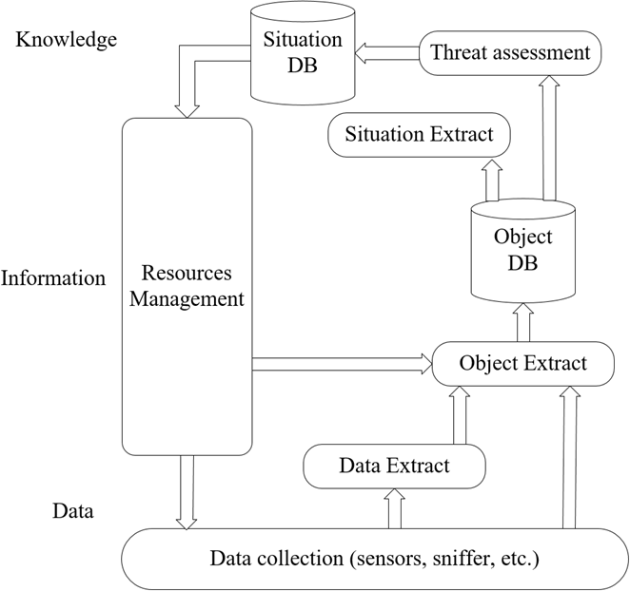

Fig. 1. NSSA Model

The NSSA Bass functional model is generally recognized. Nowadays, most research on network security situational awareness system is based on this functional model for in- depth research. Starting from the Bass functional model, prevalent research mainly focuses on the following ways: technologies related to data collection[3], technologies related to object extraction, technologies related to situation extraction and technologies related to threat assessment[4].
- Knowledge Graph
Google proposed the concept of knowledge graph in 2012

and applied it to search engines. However, knowledge graph

This work was supported by the National Key Research and Development Program of China (no. 2019QY1406).
(Corresponding author: Yujun Li, E-mail: liyujun@uestc.edu.cn.).
technology itself is not a new technology, it covers technologies such as semantic web, ontology and natural

978-1-6654-0392-4/20/$31.00 ©2020 IEEE
DOI 10.1109/TrustCom50675.2020.00237

1727

language processing[5]. Google defines the knowledge graph as "a technology that uses graph models to describe the relationship between things"[6]. It emphasizes that knowledge graphs show things, instead of strings. Some experts call the knowledge graph "a computable model of the relationship between things".
In recent years, people have made some achievements in the study of knowledge graph. People have tried to build an encyclopedia knowledge graph based on the existing knowledge base. For example, the semantic web project Schema.org[7] has adopted a crowdsourcing method to collect knowledge graph data, which can quickly collect high-quality data from Bing, Google and other search engines.
- Network Security Knowledge Graph
The cybersecurity knowledge graph is a domain knowledge graph oriented to the field of network security. People's research on the cybersecurity knowledge graph is still in the exploration stage. At present, the representative work is the STUCCO project proposed by Stanford University[8]. In addition, Jia Yan[9] proposed a cybersecurity knowledge graph construction method based on conditional random fields and a relation deduction method based on quintuples.
- CONSTRUCTION OF CYBERSECURITY KG
- Overview
A method of constructing an asset-based cybersecurity knowledge graph is proposed in this paper, which plays an important role in further NSSA applications. As shown in Fig. 2, this asset-based cybersecurity knowledge graph consists of three parts: cybersecurity knowledge graph (GCKG), basic network event graph (BNEG) and network attack feature graph (NAFG). Compared with the current cybersecurity knowledge graph, the asset-based cybersecurity knowledge graph considers the asset information of the monitored network and the traffic information on such asset. This design scheme enables the knowledge graph to provide data support for subsequent NSSA implementation.
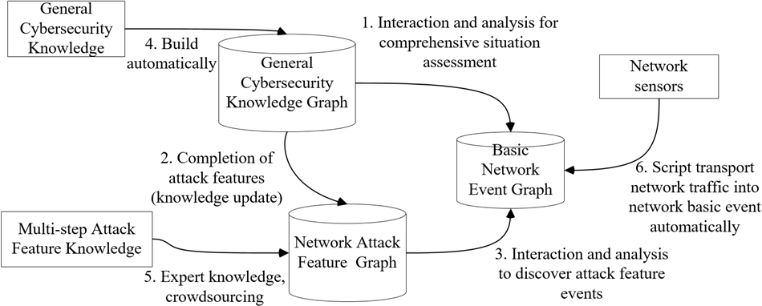
Fig. 2. Asset-based Cybersecurity KG

The relationship between the three parts of the asset-based network security knowledge graph is shown in Fig. 2. The general cybersecurity knowledge graph is constructed automatically based on the exogenous data acquired by the crawlers. The data of network attack feature graph comes from multi-step attack feature knowledge, which can also be complemented by the general security knowledge graph. The data of the network basic event graph comes from the security tools such as sensors deployed in the monitored network, and the network traffic information is converted into the network basic event information. The system can use the network attack feature graph to mine subgraphs in the network basic event graph to match the attack events. Meanwhile,it can
perform situation assessment on the asset information based on the general cybersecurity knowledge graph.
- Construction of Each Part
GCKG: Design an appropriate general cybersecurity knowledge ontology that can effectively describe the schema of GCKG and construct GCKG using the ontology. The data layer of GCKG is used to set labels for the vertices and the edges in the graph model. The labels of vertices are set according to different entities in the ontology model, and the labels of the edges are set according to the association relationship between entities in the ontology model, and set the properties of the point according to the attributes of the entities.
BNEG: It collects network traffic from the monitored network, analyzes and converts such traffic information into basic network events that are represented in the form of directed arc in BNEG.
NAFG: It gains network attack feature from GCKG or expert knowledge. High quality of NAFG must be confirmed during the construction of NAFG.
- DEVELOPMENT OF A NOVEL NSSA MODEL KG-NSSA BASED ON CYBERSECURITY KG
- Overview
A novel model that can correlate cybersecurity knowledge graph and NSSA must be drafted to direct the further development of NSSA. How to solve problems in practical NSSA work and how to utilize the value of cybersecurity knowledge graph sufficiently are the main goals of this novel model.
- Development of A Novel Model
A novel model called KG-NSSA was proposed in this paper. It can be seen from Fig. 3 that the KG-NSSA model takes exogenous data and endogenous data from the monitored network as input and performs data preprocessing. The KG-NSSA model is roughly divided into two parts: the construction of network security knowledge graph and the network security situation analysis. In Fig. 3, the Cybersecurity KG is equivalent to GCKG. Besides, the result of Attack Events Mining module equals to NAFG.
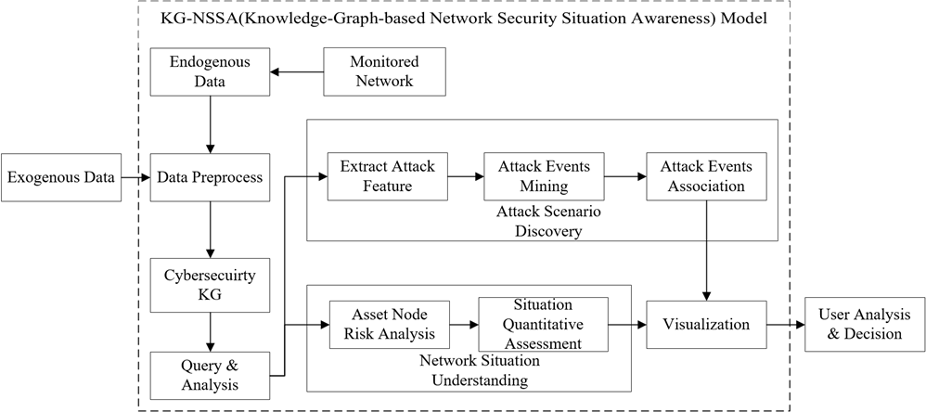
Fig. 3 KG-NSSA Model

The network situation comprehending part completes the situation assessment of the asset nodes and the cybersecurity knowledge graph receives the asset information from the monitored network, which provides the foundation for the situation assessment of the asset nodes. The attack scenario discovery is also centered on the network security knowledge graph. To achieve this goal, the cybersecurity knowledge graph needs to flexibly use external data around the internal

1728

data from the monitored network, and exploit the graph query analysis provided by the knowledge graph features.
- APPLYING THE NOVEL MODEL TO NSSA
How to implement such network security situation analysis parts efficiently is the significant problem of the application of the novel model. The method of implementing the attack scenario discovery part is roughly divided into three parts: extract attack feature, attack events detection and attack scenario mining.
  - Extract Attack Feature
All nodes in the graph describing a single attack feature event are directly or indirectly reachable, so the graph is a weakly connected branch. It constitutes the entire attack feature event graph, and each weakly connected branch constitutes a division of the complete set of NAFG data. As attack features in the NAFG have their unique identification numbers, the system can traverse each weakly connected branch of the NAFG. If E represents the attack characteristic event graph, G_{i} (where i E N+ and 1 ::; i ::; M , M is the number of weakly connected branches) represents a single attack characteristic event. Through the system's traversal of the network attack feature event graph, we can get G_{i}, and use G_{i} as the input of the network attack feature event feature extraction. Suppose we have a G_{i} as shown in Fig. 4, we take G_{i} as an example to introduce the process of feature extraction of network attack features:
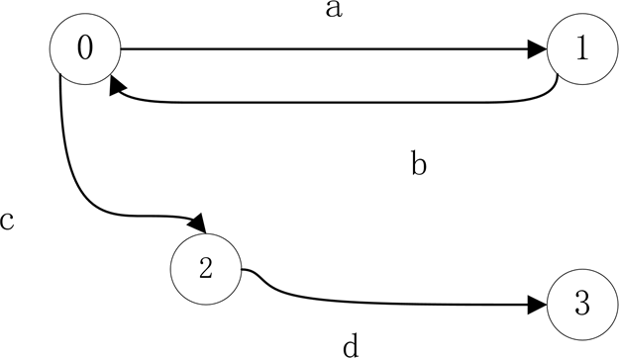
Fig. 4 Characteristic Event Graph

In Fig. 4, the numbers in the set {O,1,2,3} are the node numbers, and the letters in the set {a,b,c} represent the basic types of network events on the edge. The process of network attack feature event feature extraction can be divided into the following six steps:
    - Divide the nodes in G_{i} into two types: malicious nodes and other nodes according to the number. In the subgraph G_{i}, it is obvious that the malicious node set is {O}, and the other node set is {1,2,3}. It can be seen that the count of the malicious node set is 1 since G_{i} only contains the only malicious node.
    - Extract all possible basic network event types from malicious nodes. Malicious nodes are the initiators of attacks. In general, the events starting from malicious nodes are executed first, so these events play a very important role in the whole attack characteristic events.
    - Calculate the longest distance from malicious nodes to other nodes, which uses positive integer MAX—DISTANCE means.
    - Analyze the ring information and event timing information in the graph. The temporal information of events is the sequence of the occurrence of network basic events.
    - Extract cyclic event sequence information and general event sequence information.
    - Encapsulate the above information and store it in the message queue. The information obtained in the first five steps is encapsulated into a message object, which is a five-tuple data.
  - Attack Event Detection
After obtaining the quintuple attack feature data, the attack event needs to be discovered based on the feature data, and the attack discovery method based on attribute graph mining is adopted.
The main difference between scenario discovery method based on the network security knowledge graph and traditional attack scenario discovery method is the analysis object. The traditional attack scenario discovery is based on alert, while the attack scenario discovery in this paper is based on network basic events. Traditional attack scenario discovery can be strictly divided into three steps: alert filtering, alert aggregation, and alert correlation analysis. Some documents also regard alert filtering as part of the alert aggregation work. Alert filtering is mainly to filter the original alerts, which plays a role of de-redundancy to a certain extent. The dotted line in Fig. 5 reflects the correspondence between the steps of the traditional alert-based attack scenario discovery and the network security knowledge graph-based attack scenario discovery.

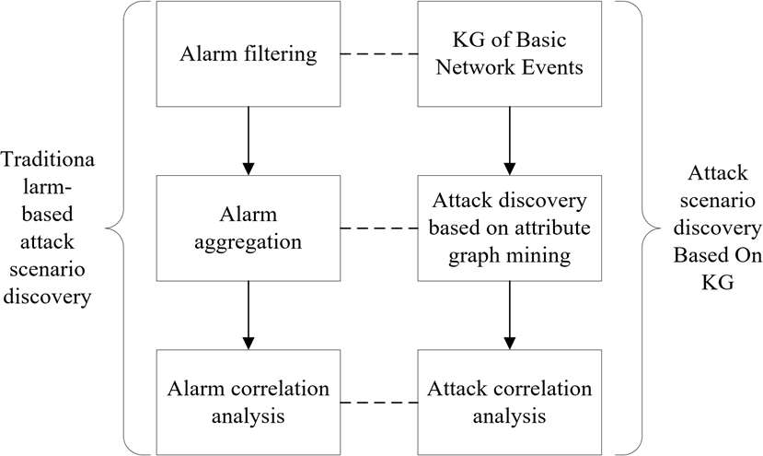
Fig. 5 Steps of Attack Scenario Discovery

Corresponding to the attack scenario discovery based on the network security knowledge graph in this paper, alert filtering is equivalent to the process of constructing a basic network event graph.
The traditional alert aggregation processing is the asset- related alerts obtained through filtering. The attack discovery method based on the attribute graph in this paper is similar to the traditional alert aggregation. It aims to find a subgraph that matches the characteristics of a certain attack in the basic network event graph. This subgraph contains the information of the assets involved in the attack, which can be used for follow-up association analysis.
When searching for the subgraph corresponding to the attack event in the network basic event graph, it cannot achieve isomorphic matching. This is because the basic event graph of the network is a dynamic graph, and the isomorphic matching of subgraphs based on the dynamic graph is an NP- complete problem. At the same time, the subgraph query algorithm that considers structural approximation and semantic approximation is more comprehensive. The attack discovery method in this paper uses a subgraph query method that considers both structural approximation and semantic

1729

approximation because the G_{i} feature graph in the network attack feature graph contains both structural information and semantic information, and this information is wrapped in the feature extraction stage as five-tuple data. The attack discovery process based on attribute graph mining is completed in the following four steps:
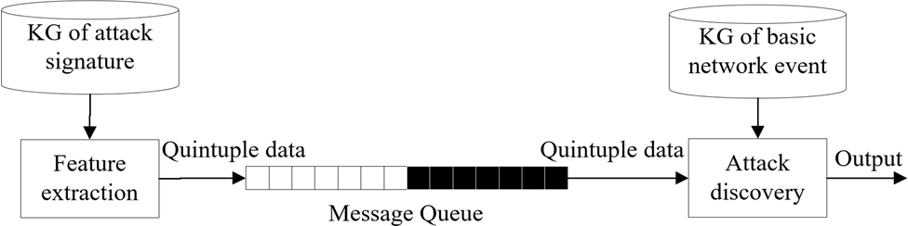
Fig. 6 Extract Quintuple Data

- Extract quintuple data from the message queue, as shown in Fig. 6.
- Set TIME—WINDOW and K parameters. The attack discovery process requires two other input parameters: the time window size TIME—WINDOW and the K value parameter. The time window size is similar to the time window used by traditional alert aggregation processing.
- Find suspicious nodes. Suspicious nodes are candidates for malicious nodes. The malicious node here refers to a malicious node that can be mapped to a specific existing network node.
- Identify malicious nodes and record attack events. Malicious nodes are hidden in the network basic event graph, and the malicious node in the network basic event graph is MALICIOUS—NODES. In the process of searching for suspicious nodes in the third step, K suspicious nodes have been obtained. The next step is to determine the malicious nodes among the K suspicious nodes. Under this premise, the final number of malicious nodes obtained is N_{O} (O：N_{O}：K).
represented by the attribute graph, this method is called attack correlation based on the similarity calculation of the attribute graph in this paper.
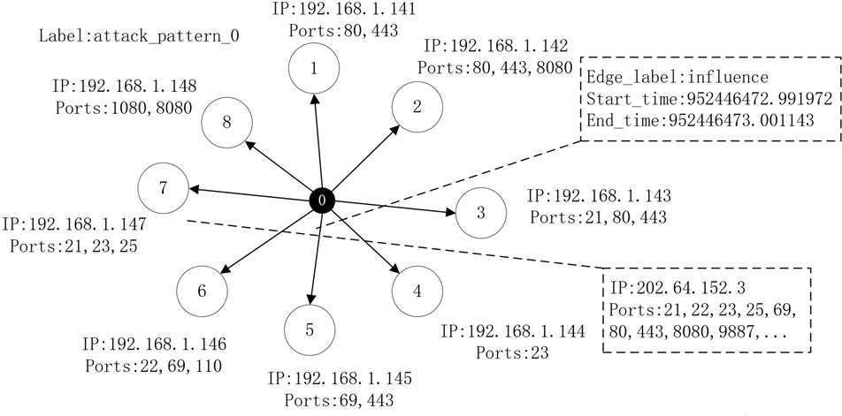
Fig. 8 Attribute Graph of Attack Event

Fig. 8 shows an example of an attribute graph describing an attack event. The node numbered O is a malicious node, the remaining nodes are affected nodes, and the nodes have the attributes of IP address and port number. The relationship represented by the directed edges in the figure is an influence relationship, and the directed edges have start time and end time attributes. In summary, the attribute graph of an attack event has a "star" structure, which records the four dimensions of an attack event: time, space, service, and type. The attack correlation method based on attribute graph similarity calculation is roughly divided into the following four steps:
- Construct a time diagram of attack events. The time relationship graph G₃ of the attack event is constructed according to the time attribute of the attack event. The construction of G₃ is based on the assumption that when a hacker performs a multi-step attack, the time interval between two adjacent single-step attacks will not exceed T_{B}. After going through the attack discovery step in the previous section, the system will get a series of attack events E₁, E₂, ..., E_{n}.

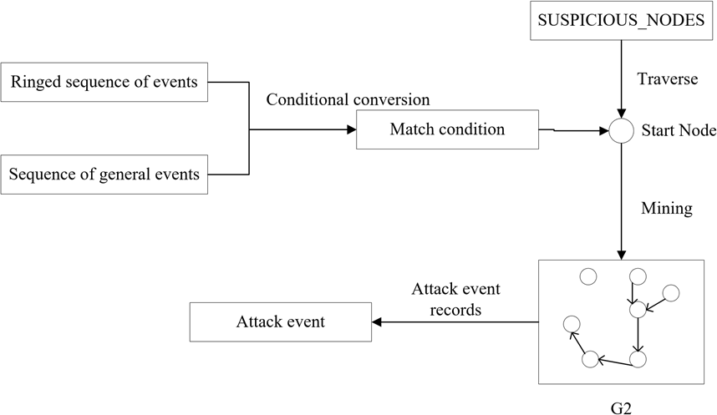
- Determine the degree of correlation between attack events based on the similarity. Potential multi-step attack mining can be carried out on the basis of G₃. G₃ is created based on the time dimension of the attack event. Assume that the correlation measure between any two different attack events in G₃ is

Fig. 7 Identify Malicious Nodes

As shown in Fig. 7, the process of attack event detection

4
Corr(E_{i}, E_{j}) = L w_{k} · C_{k} , 0 ::; i < j ::; 九 (1)
k=1

where co_{k} is the weight corresponding to each of the above correlation measures and I4 w_{k} = 1. The definitions of C₁,
k=1

contains two module: identify malicious nodes and record attack events. G₂ is an edge-derived subgraph obtained by the suspicious node search process in this figure. The basis of attack event mining is the edge-derived subgraph G₂. The obtained attack events are temporarily stored by the system
C₂, and C₃ are as follows.
C (E , E ) = 1
1 i j et_{j} - st_{i} + 1
C (E ,E ) = IVi n VjI
(2)
(3)

and handed over to the subsequent attack correlation module for processing.
2 i j
IV_{i} U V_{j}I
IP_{i} n P_{j}I

  - Attack Scenario Mining
C₃(E_{i}, E_{j}) =
IP_{i} U P_{j}I
(4)

After obtaining the network attack events, it is necessary to find the possible association relationships between the network attack events and explore the attack scenarios, and use the method of calculating the attack association based on the similarity of the attribute graph. Since the attack event is
In Equation (2), et_{j} and st_{i} represent the end time of the attack event E_{j} and the start time of the attack event E_{i} , respectively. It can be seen that the shorter the time interval

1730

between attack events E_{j} and E_{i} , the greater the time correlation between E_{j} and E_{i}.
In Equation (3), V_{i} and V_{j} represent the set of node IP addresses involved in the attack events E_{j} and E_{i} , respectively. The nodes—involved attribute of the six-tuple data is represented by a set, which is extracted from the attribute graph of the attack event. Jaccard similarity is an important indicator to describe the similarity of set samples, which is defined as
attack model described by the kill chain belongs to the category of expert knowledge.
Due to space limitations, step (3) and step (4) are not list here, please refer to the literature[1O].
- TEST AND EVALUATION OF THE NOVEL MODEL
To verify the effectiveness of the method proposed in this paper, this chapter uses the MIT DARPA2OOO data set for simulation verification.

IA n BI
IA n BI
  - Experimental Environment

J(A, B) = IA U BI = IAI + IBI - IA n BI (5)
Therefore, the definition of the spatial correlation measure C₂ between attack events is the Jaccard similarity of the sets V_{i} and V_{j}.
In Equation (4), P_{i} and P_{j} represent the set of port numbers of the services involved in the attack events E_{i} and E_{j} , respectively. The set similarity of port numbers is still described by Jaccard set similarity, which has a good performance in reflecting the degree of overlap between the services involved in the two attack events.
The type correlation measure between attack events C₄ mainly considers the last two components in the six-tuple data: attacker and label, which respectively reflect the difference between the two attack events on the attacking side and the causal relationship of the attacking behavior. It is defined as
In order to verify the effectiveness of the method of discovering network multi-step attacks proposed in this paper, it is necessary to set the environment required for simulation experiments. The software and hardware environment required during the test is shown in Table I:

TABLE I. CONFIGURATION OF EXPERIMENT

Configuration item | Configuration details
CPU | Intel向Core™ i5-42OOU CPU@1.6OGHz
RAM | 8G
Hard disk | 5OOG
Operating system | Ubuntu 16.O4 LTS(Xenial Xerus)
  - Introduction of Data Set
The data used in the experiment is a sample of the LLDosl.0 attack scenario from DARPA2000. Although this

1
C₄(E_{i}, E_{j}) =
2
1
- a_{ij} · w₄ + 2

· b_{ij} · w₄ (6)
data set is relatively out of date, most people still choose this data set as the research object because of the lack of a new representative multi-step attack data set. The sample data

where a_{ij} is a real number in the interval [O,1], b_{ij} is a bool
type variable. a_{ij} represents the distance measurement relationship between the attackers of the attack events E_{i} and E_{j}, and b_{ij} represents the type relationship between the labels of attack events E_{i} and E_{j}, which are defined as follows:
1, d_{ij} = 0;
describes the adversary's attempt to invade the monitored network, infiltrate the nodes in the monitored network, and then use the monitored nodes to launch DDoS attacks. The five stages of its attack scenario are shown in Table II:

TABLE II. STAGES OF ATTACK SCENARIO

a_{ij} =
1 , 0 < d
ij
d
2
ij
::; N;

(7)
Stage l | A remote node launches IPsweep to detect surviving  nodes
Stage 2 | send probes to surviving nodes to obtain information  about the host running the sadmind daemon
Stage 3 | Invade the target host through the vulnerability of the  sadmind daemon to obtain the root execution permission of the target host
Stage 4 | Install DDoS malware on the target host
Stage 5 | launch DDoS attack

� 0, d_{ij} > N
0, L_{i} is the Lis precursor;
b_{ij} = { ^{j} (8)

1, otherwise
In Equation (7), d_{ij} represents the distance between the attackers E_{i} and E_{j} , that is, the shortest distance from the attacker of E_{i} to the attacker of E_{j}. N is the threshold of the distance metric. If it exceeds N, a_{ij} is O. Let a_{ij} be an inverse proportional function of the distance squared; if the two attack events are not initiated by the same malicious node, and the distance between the two malicious nodes. When a certain threshold N is exceeded, the correlation between the two is considered to be very low, and a_{ij} is set to O.
In Equation (8), the value of b_{ij} depends on the predecessor-successor relationship of the two types of attack events. The type of attack event is indicated by its label. In the network attack characteristic event graph, each attack event is represented by a weakly connected branch, with its unique label information. The so-called "L_{i} is the precursor of L_{j}" means that L_{i} corresponds to the previous step of the corresponding step of L_{j} in the kill chain. The multi-step

This data set is divided into DMZ data and Inside data according to the location of data collection. Among them, the DMZ data is the data in the quarantine zone, which can reflect the attack behavior from the external node to the inside of the network; Inside data is the data inside the monitored network, which can reflect the malicious behavior of the invaded node inside the network.
  - Experimental Process
The experimental process is divided into four steps.
The first step is to enable monitoring and recording of some key events in this data set in a strategy script.
The second step is to replay the network traffic of the data set. The system will generate network basic event records according to the policy script set in the first step, which also includes events related to network protocols. The system then uses the generated records to construct a graph of basic network events.

1731

The third step is to set the attack characteristics for the malicious behavior of malicious nodes in the data set as shown in Fig. 9.

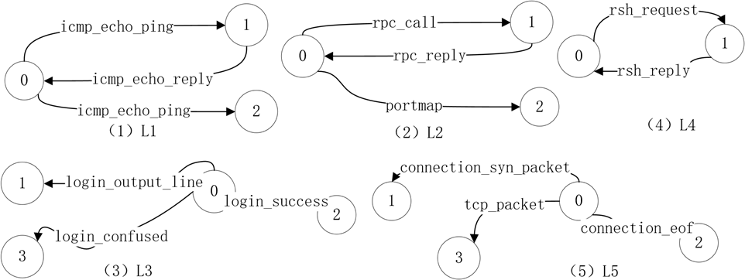

Fig. 9 Set Network Attack Characteristics

In Fig. 9, Ll reflects the malicious node's PING scanning behavior. Similarly, if the edge label in feature l is replaced with a tcp port access event, Ll can reflect the malicious node's port scanning behavior. In addition to the above attack characteristics, other attack characteristics need to be set. In the experimental stage, it is expected that the multi-step attack obtained from the analysis is Ll---L2---L3---L4---L5.
The fourth step is to discover the attack scenario. This step needs to verify two items: first, whether the system can accurately and quickly find the attack event corresponding to the attack feature in the network basic event graph; second, whether the system can find the attack scenario corresponding to the data set description Multi-step attack.
The key parameters required in setting up the experiment are shown in Table III:

TABLE III. VALUE OF KEY ARGUMENTS

Argument | Value
TIME WINDOW | 20min
K | 3
T_{f]} | 4h
w_{l} | 0.2
w₂ | 0.2
w₃ | 0.2
w₄ | 0.4
a | 0.85
The first two items are the parameters required for the attack discovery process, the last item a is the parameter of the PageRank algorithm.
  - Analysis of Result
The main research object of the experiment in this paper is the basic network events obtained through a series of processing of raw data. However, this section still compares the results of this experiment with the results of traditional attack scenarios to illustrate the unique advantages of this method.
The network attack scenario discovery experiment results are shown in Table IV:

TABLE IV. RESULT OF ATTACK SCENARIO MINING

Reference indicator | Frequent pattern mining method | Method of this paper
Num of event/alert | 39269 (alert) | 8 (event)
Uptime | 832.87 (s) | 257.42 (s)
Number of multi-step attack chains | 28 | 6
Number of error chains | 24 | 3

L1-L5 Feature event matching success rate |  | 100%
As shown in the above table, take the frequent pattern mining method[11] in the traditional alert analysis method as an example to compare the effects of the traditional alert analysis method and the method in this paper. The experimental results show that this experiment can effectively find the attack events corresponding to L1-L5, and the success rate of matching L1-L5 attack feature events reaches 100%, which provides a basis for attack association. In the entire attack scenario discovery process, the number of attack events matched by the system is significantly less than the number of alerts. Compared with the traditional alert analysis method, the number of redundant alerts is greatly reduced and the accuracy of the correlation analysis of attack events reaches 50%. The running time of the system's execution of the attack scenario discovery is proportional to the amount of data in the basic network event graph in the current time window.
It can be seen from the experimental results that the attack scenario discovery method proposed in this paper can effectively dig out attack events, discover multi-step attack chains and overcome the high redundancy shortcomings of traditional alert aggregation methods.
- CONCLUSIONS
In this paper, to address the challenges of the comprehension of situation, we propose a network security situational awareness model KG-NSSA which provides an asset-based network security knowledge graph construction scheme. Then a solution for network attack scenario discovery is provided through attribute graph mining and similarity calculation. The effectiveness of the proposed method is verified on the MIT DARPA2000 data set. Our work provides a new approach for network security situational awareness. In our future work, we would like to focus more on the prediction of network security situation based on this proposed model.
REFERENCES
- M.R. Endsley. Toward a Theory of Situation Awareness in Dynamic Systems[J]. Human Factors: The Journal of the Human Factors and Ergonomics Society, 1995, 37(1): 32—64.
- T. Bass, D. Gruber. A glimpse into the future of ID[J]. login The Magazine of USENIX and SAGE, 1999, 24.
- S. Salah, G. Macia-Fernandez, J.E. Diaz-Verdejo. A model-based survey of alert correlation techniques[J]. Computer Networks, 2013, 57(5): 1289—1317.
- P Xie, J Li, X Ou, P Liu, R Levy. Using Bayesian networks for cyber security analysis[C]. IEEE/IFIP Int'l Conf. on Dependable Systems & Networks, 2010, 23(3): 211-220.
- Wang Haofen, Qi Guilin, Chen Huajun, Editor-in-Chief. Knowledge Graph: Methods, Practice and Application [M]. Beijing: Publishing House of Electronics Industry, 2019.
- Xu Zenglin, Sheng Yongpan, He Lirong, etc. Overview of Knowledge Graph Technology [J]. Journal of University of Electronic Science and Technology of China, 2016, 45(04): 589—606.
- R.V. Guha, D. Brickley, S. Macbeth. Evolution of structured data on the web[J]. ACM Queue, 2015, 13(9): 44-51.
- R.A. Bridges, C.L. Jones, M.D. Iannacone et al. Automatic Labeling for Entity Extraction in Cyber Security[J]. arXiv: Information Retrieval, 2014: 11.
- Qin Ya, Shen Guowei, Zhao Wenbo, etc. Network security entity recognition method based on deep neural network [J]. Journal of Nanjing University (Natural Science), 2019, 55(01): 29—40.
- Wu Dong, Guo Chun, Shen Guowei. A multi-factor-based alert correlation method[J]. Computer and Modernization, 2019(06): 30-37.
- Wu Dong. Research on Key Technologies of Alert Correlation Based on Data Mining[D]. Guiyang: Guizhou University, 2019.

1732

