All outputs from my compiler will be compared with outputs from AWK run in the Linux terminal. Please note that all awk programs and text files used will be attached to the submission.

Test #1 User Defined Functions/While Loops/Print
Awk Program Used: UserDefinedFunctionTest.txt
{
i = 0;
while(i<9){
print i;
i = increment(i);
}
}
function increment(number){
return ++number;
}

Text File Used: textfile.txt (just a simple text file with 3 lines of text)
line 1
line 2
line 3

Awk Output:
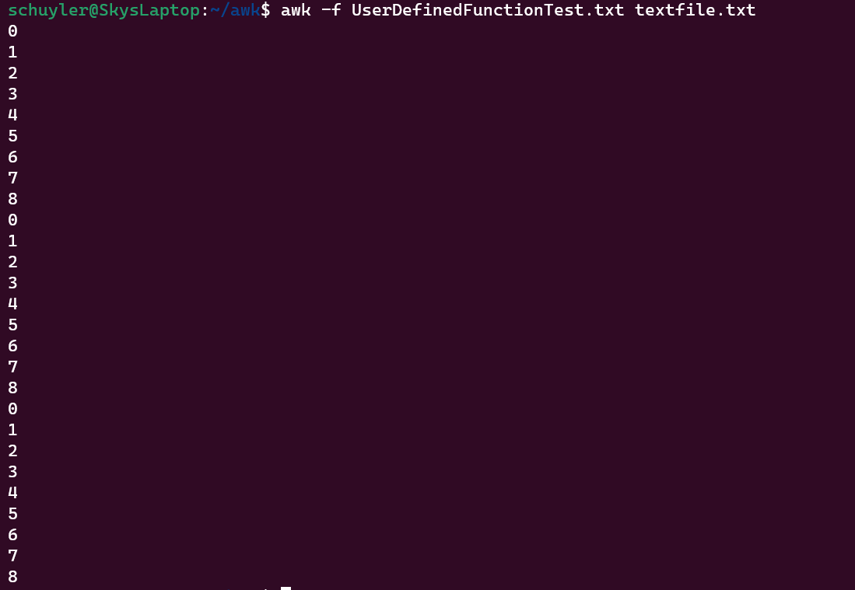
My Output:
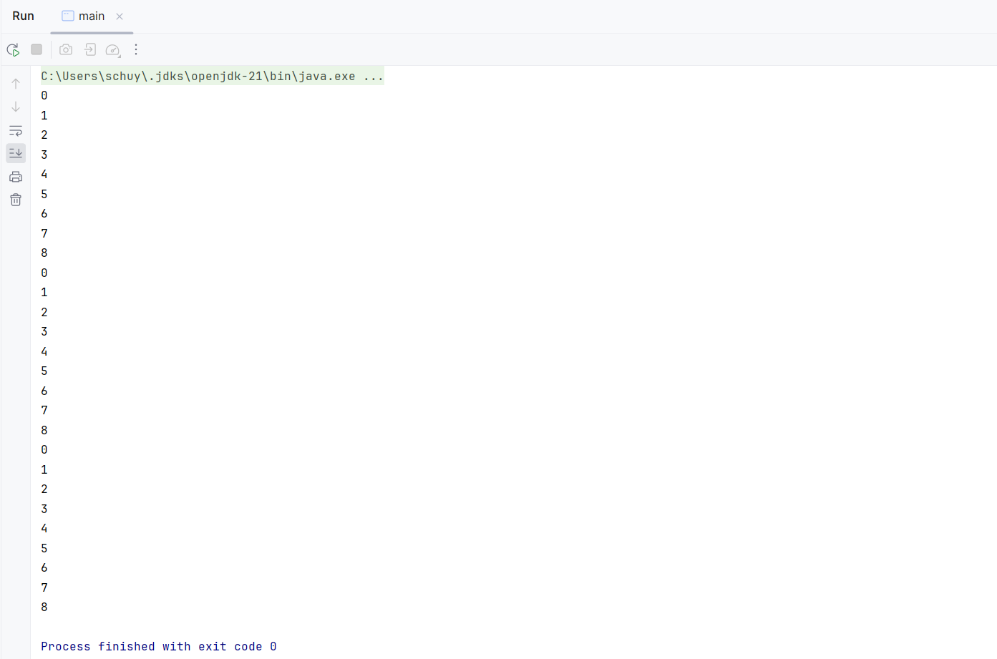

Test #2 User Defined Functions/For Loops/Printf/Addition
Awk Program Used: UserDefinedFunctionTest2.txt
{
for(i = 0; i < 3; i++){
for(j = 0; j < 3; j++){
printf "%s\n", add(i,j);
}
}
}
function add(number1, number2){
return number1 + number2;
}

Text File Used: textfile.txt (just a simple text file with 3 lines of text)
line 1
line 2
line 3

Awk Output:
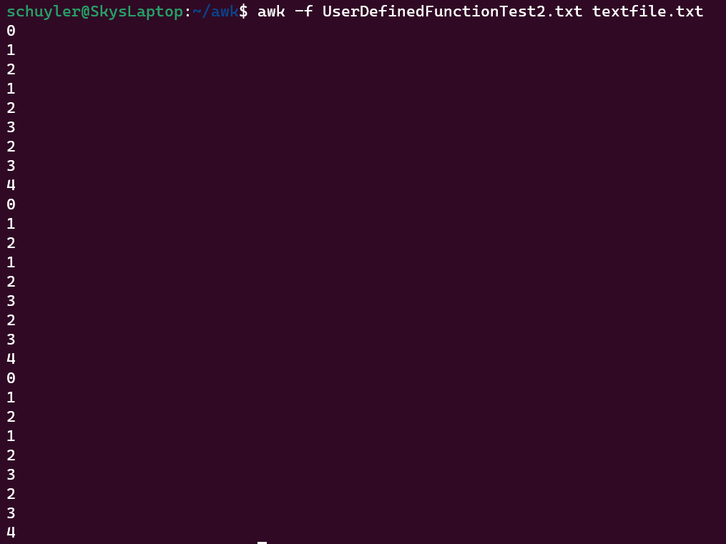
My Output:
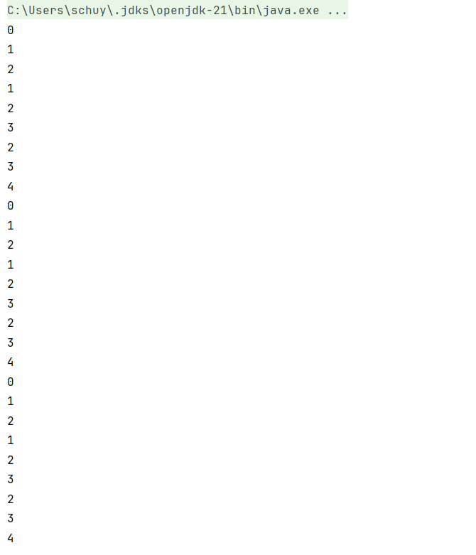
As you can see the numbers match, and it appears to be working as intended.
Test #3 Do While Loop/toUpper/toLower
Awk Program Used: DoWhile.txt
{
i = 1;
do{
$0 = toupper($0);
print $0;
print tolower($0);
i++;
}while(i<2);
}
Text File Used: textfile.txt (just a simple text file with 3 lines of text)
line 1
line 2
line 3
Awk Output:
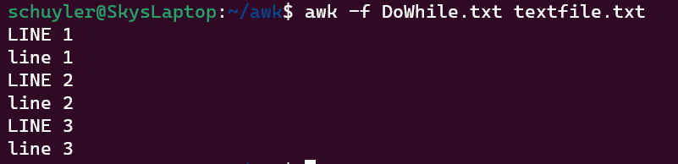
My Output:
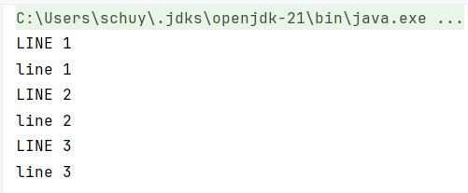

Test #4 Block Condition/substr
Awk Program Used: ConditionsTest.txt
($1>0){print substr($0, 2)}

Text File Used: conditionalText.txt
1 This Should Print
0 This Should Not Be Printed
1 This should print

Awk Output:

My Output:
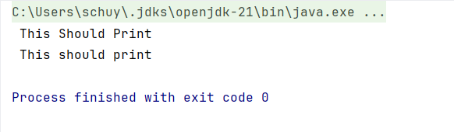

Test #5 Booleans/sprintf
Awk Program Used: BooleansTest.txt
{
if($1 && $2){
a = sprintf("%s: hello from $1 && $2", $0)
print a
}else if($1 || $2){
b = sprintf("%s: hello from $1 || $2", $0)
print b
}else if(!$1 && !$2){
c = sprintf("%s: hello from !$1 && !$2", $0)
print c
}
}

Text File Used: booleanstext.txt
3 4 this should print for &&
7 0 this should print for ||
0 0 this should print for the ! && !

Awk Output:
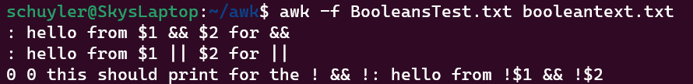
Strangely enough awk messes up the first two sprintf somehow, but the third works identically to mine. I’m not entirely sure what’s up with this.
My Output:
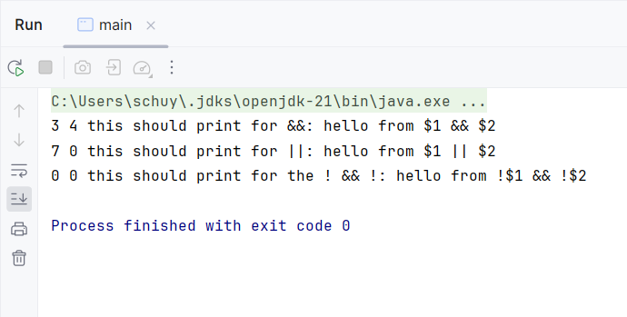

Test #6 length/index
Awk Program Used: lengthIndex.txt
{
a = "hello there"
print length(a);
print index(a, "there");
}
Text File Used: textfile.txt (just a simple text file with 3 lines of text)
line 1
line 2
line 3
Awk Output:
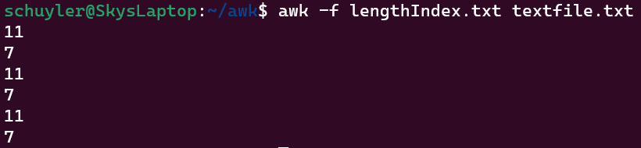
My Output:
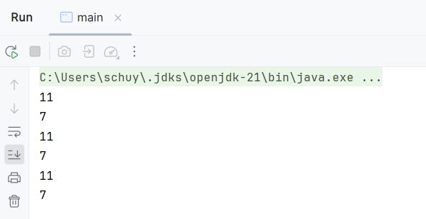
Test #7 gsub/sub
Awk File Used: gsubSub.txt
{
gsub(`hi`, "hello there general Kenobi")
print $0
}
{
sub(`hello`, "hi")
print $0
}

Text File Used: subtext.txt
hi hi

Awk Output:
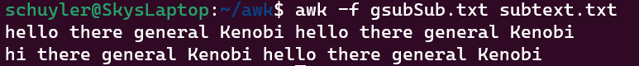

My Output:
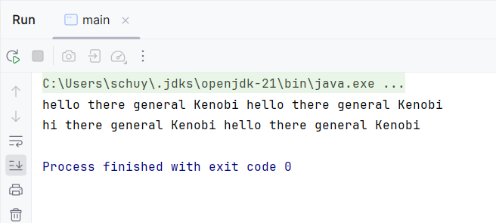

Test #8 split/match
Awk Program Used: splitMatch.txt
{
a[1] = "hi";
split("Hello-there-General-Kenobi", a, "-");
for(j=1;j<5;j++){
print a[j]
}
}
{
print match("howdy", "ow")
}

Text File Used: textfile.txt (just a simple text file with 3 lines of text)
line 1
line 2
line 3
Awk Output:
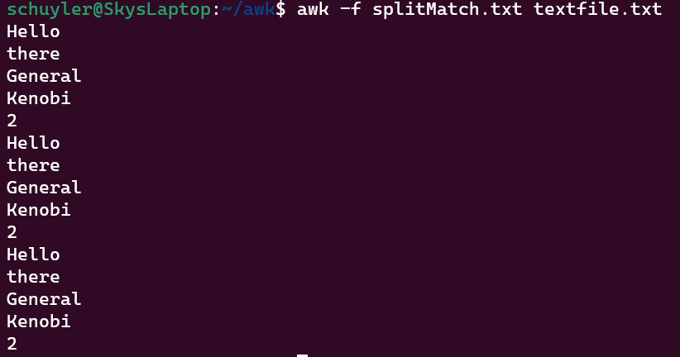
My Output:
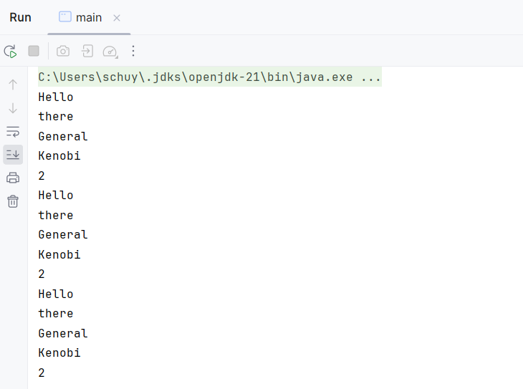

Test #9 Input Processing
Awk Program Used: inputProcessing.txt
{
print NF
printf "%s:%s:%s\n", $1, $2, $3
}
Text File Used: inputText.txt
Jane Doe 1969
John Hammond 1913
Alfred Hitchcock 1899
Lucille Ball 1911

Awk Output:
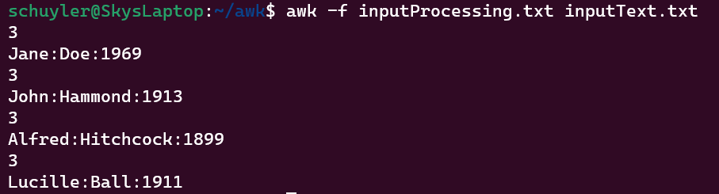
My Output:
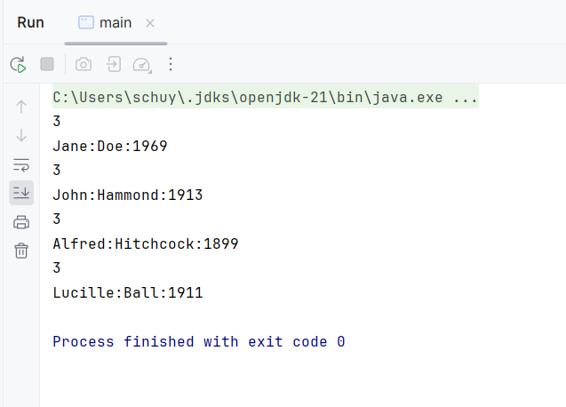

Test #10 Math/Logic
Awk Program Used: mathLogic.txt
($1<$2){ print $3 + $4}
($1<=$2){ print $3 / $4}
($1>$2){ print $3 * $4}
($1>=$2){ print $3 - $4}
($1==$2){ print $3 % $4}
($1!=$2){ print $3 ^ $4}
Text File Used: mathLogicText.txt
1 2 5 7
2 1 6 9
1 1 2 3
Awk Output:
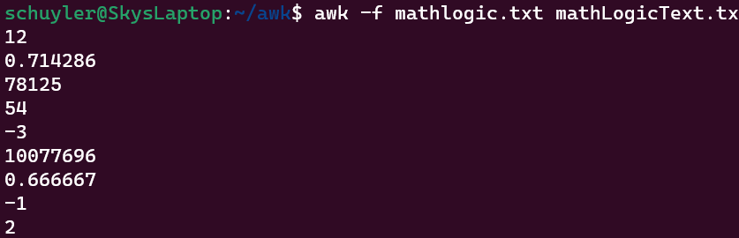
My Output:
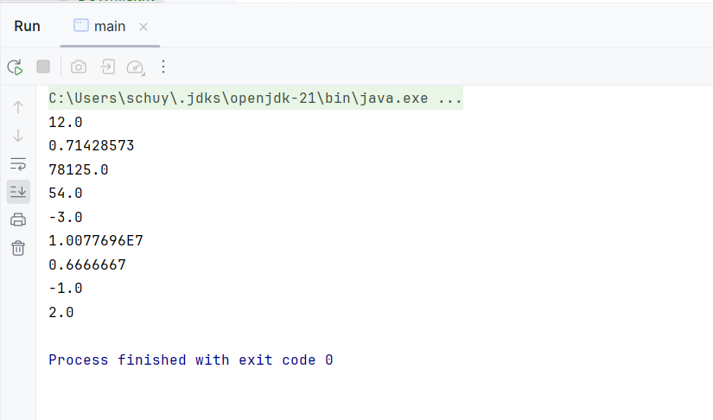
My interpreter performs all of the mathematical operations properly, but it is apparent that I should reconfigure it to convert whole numbers into integers much like awk does.
Test #11 Bonus

Awk Program Used: duplicateWords.txt
{
#Sourced from https://www.gnu.org/software/gawk/manual/html_node/Miscellaneous-Programs.html
$0 = tolower($0);
gsub(`[^[:alnum:][:blank:]]`, " ");
$0 = $0 # re-split
if(NF == 0){
next;
}
if($1 == prev){
printf "%s:%s: duplicate %s\n", FILENAME, FNR, $1
}
for (i = 2; i <= NF; i++){
if ($i == $(i-1)){
printf "%s:%s: duplicate %s\n", FILENAME, FNR, $i
}
}
prev = $NF
}

Text File Used: duplicateWordsText.txt
hello there there general kenobi
kenobi
Awk Output:
My Output:


