Personal Music Sorter

Design Document

CS 246 WINTER 2014

Skylar Summers, Jason Stockham, & Devin LaCrosse

*Project design*

Executive summary

SkippiGoat is a simple program for finding, sorting, and editing music files on a computer.

Sponsor

This project is sponsored by Adam Harper and Jordan. Computer Science Students at Brigham Young University – Idaho.

Problem

When downloading mp3 files sometimes the file information is lost during download and the header titles such as; Artist name, song, or title, are missing or simple nonsense. This program will search through the mp3 file and correct these problems

*Functional Description*

* Automatically rename files according to how the user wants them.
  + E.g. %artist -- %title
* Search an online database to find title and artist from the id3 tags.
* Search an online database using provided information to find missing id3 tags.
* Sort the files according to how the user wants them categorized.
  + E.g. if they wanted %alpha %artist %file ---->
  + A/Aerosmith/Aerosmith -- Janie’s got a gun.mp3
* Allow the user to change id3 tags, filename, and extension.

Additional Goals:

* A good looking and effective GUI.
* Play music/movies from the GUI.
* A preview button to play a small portion of the song.
* An undo option.
* Support command line as well as GUI.
* Make it work on Windows and/or Linux.
* Find duplicates and put them in a duplicates folder for the user to review later.

*Technical Description*

UML

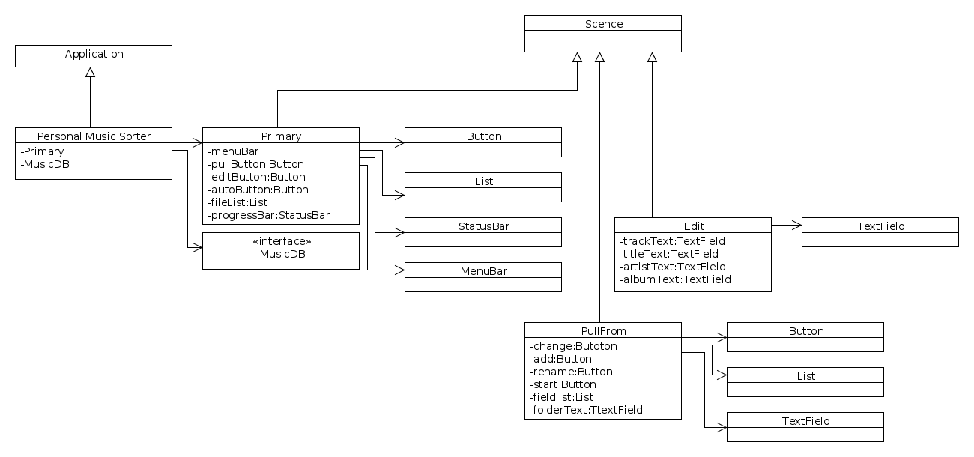

Class descriptions

Primary

This is the starting window where the user will be able to rename files, edit metadata, modify file names, and access all other windows.

Edit

This allows the user to edit the metadata of an individual file.

Pull From

This is used to specify directories to search for music files.

Once pulled these files will be moved to the default “home” folder of the user using the folder hierarchy specified in the Style window.

Advanced Settings

Allows the user to change the program settings such as whether or not to automatically rename files when they are pulled in, what file extensions to pull in, and whether or not to pull in files automatically when the program starts up.

User Interface Design

Primary Window

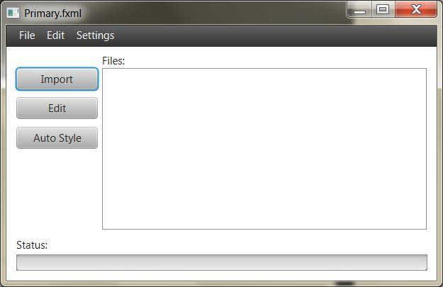

Advanced Settings window (accessed from settings tab in the menubar on Primary)

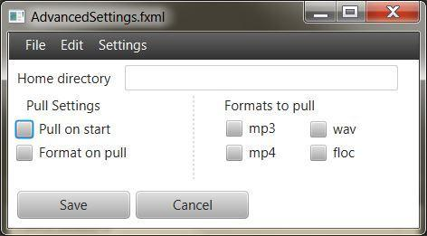

Style Settings (accessed from settings tab in the menubar on Primary)

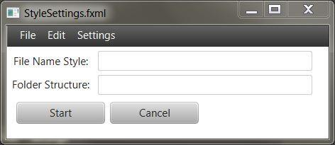

Edit File Window

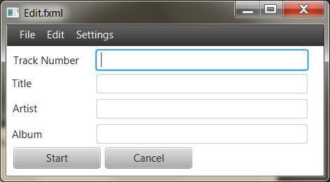

Pull From Window

