# Home64 – make your C64 Userport available as a smart home device

This software uses the network interface of Ultimate-64 computer or UltimateII+ cartridge for C64.

Via network the C64 Userport Pins PB0..PB7 can be accessed. The Port Pins are controlled low active. That means a low level on PB0..7 is assumed as active state for driven relays or power stages.

For controlling the user port as a smart home device you need the home64 program running on C64 and the sample server application for running a kind of gateway between your smart home and C64 on a Linux x64/Arm64 or Windows computer. “Server.pcc” can handle up to ten C64 instances running home64.

The sample server application parses http requests from your smart home system through C64 instances.

*This gateway server software is necessary because currently Ultimate64/II+ does not support listener mode on the network interface and therefore cannot act directly as a home device (server).*

**Software Package contains:**

***home64.d64:*** ready to use C64-d64 image and all source code for cc65 compiler

***server.pcc:*** gateway software example implemented as a pico-c script

***picoc:*** c-interpreter executables for Linux Arm64/X64 and Windows

## Starting home64 on a C64

First ensure that the “command interface” is enabled (see Ultimate Menu: C64 and cartridge settings).

You need to mount the d64 image (read/write) as drive 8 and type in: Load”*”,8,1

*! Attention: home64 program reads and writes configuration to disk image !*

## Starting home64 server sample on a Linux or Windows machine

Linux: open a terminal in the folder where the script and picoc is located.

Type in “sudo ./picoc server.pcc”

You may need to grant some executable rights for the picoc application before

Windows: open a command prompt in the folder where the script and picoc is located.

Type in “picoc.exe server.pcc”

## Setup Server IP and Device Name on C64

After starting home64 on C64 you need to tell C64 the server IP name from that machine where the “server.pcc” script is running.

Type “c” for configuration.

*! Attention: it may take some time until C64 will react on configuration command !*

Choose “i” for IP address. Then confirm with “y” and type in server IP. The IP is automatically saved to the disk image and loaded after each start.

## Setup device Name for C64

Type “c” for configuration.

*! Attention: it may take some time until C64 will react on configuration command !*

Choose “n” for device name. Then confirm with “y” and type in a device name. The name is automatically saved to the disk image and loaded after each start.

## http requests for switching Userport Pins

You can switch userport pins with your browser or embedding following command syntax in your home control system. Below example is taken from Devolo Home control.

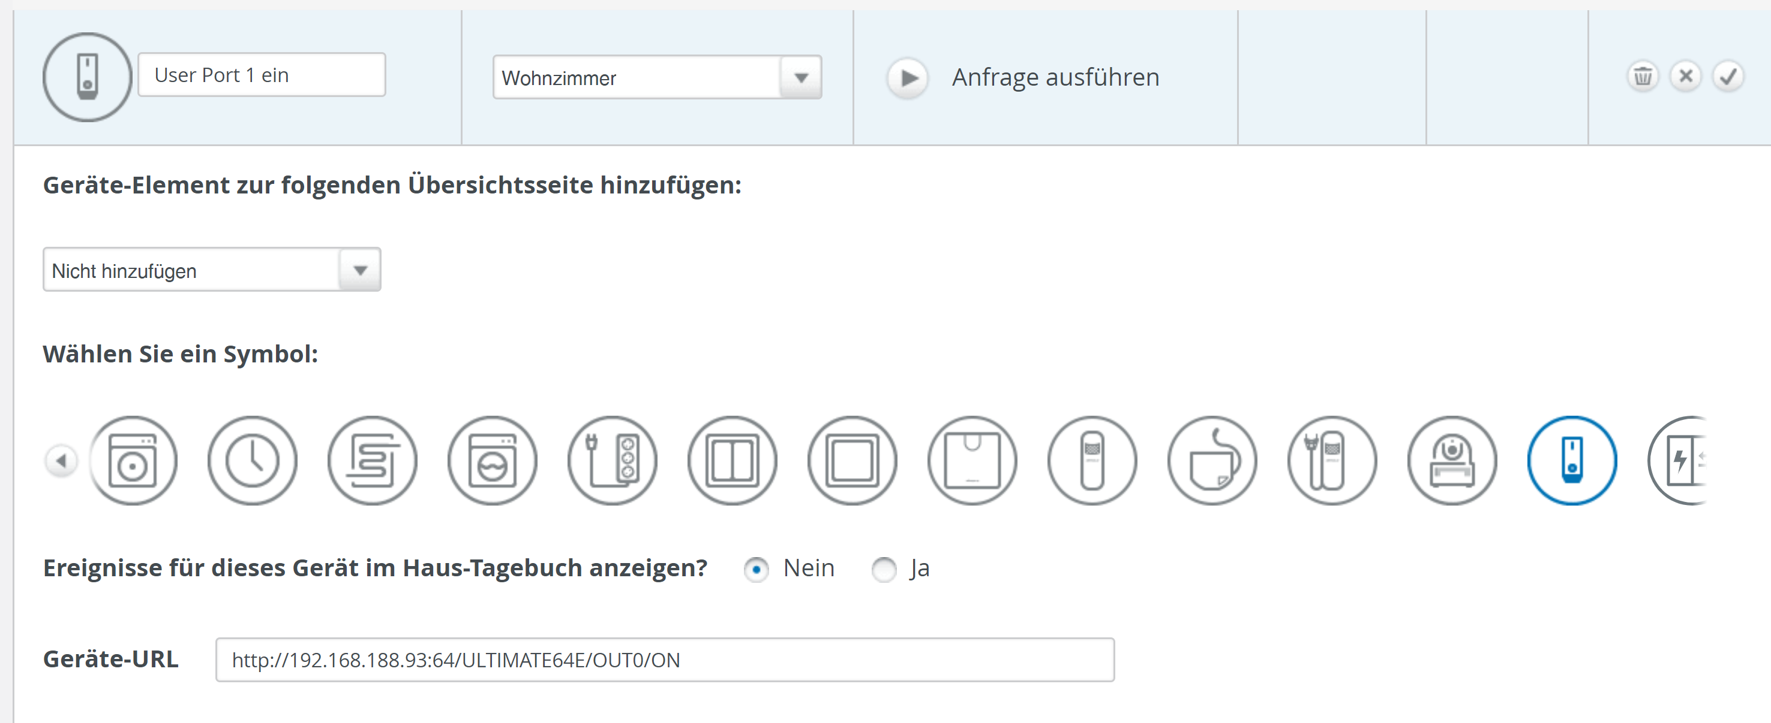

*Example : http://192.168.188.93:64/ULTIMATE64E/OUT0/ON*

***http://XXX.XXX.XXX.XXX:64/*** - IP Address is that one from the machine where “server.pcc” is running. Port number must be always 64

***MyName/*** - Device Name of C64 home64

***OUTx/*** - PB0…PB7 Userport

***ON/OFF*** - requested state for OUTx (PB0..PB7)

Those requests can be embedded in scenes and finally scenes could be activated by google home or similar systems.