Images and Tables Test
EL-342 - Pictures in description
Small (Resized 20%):
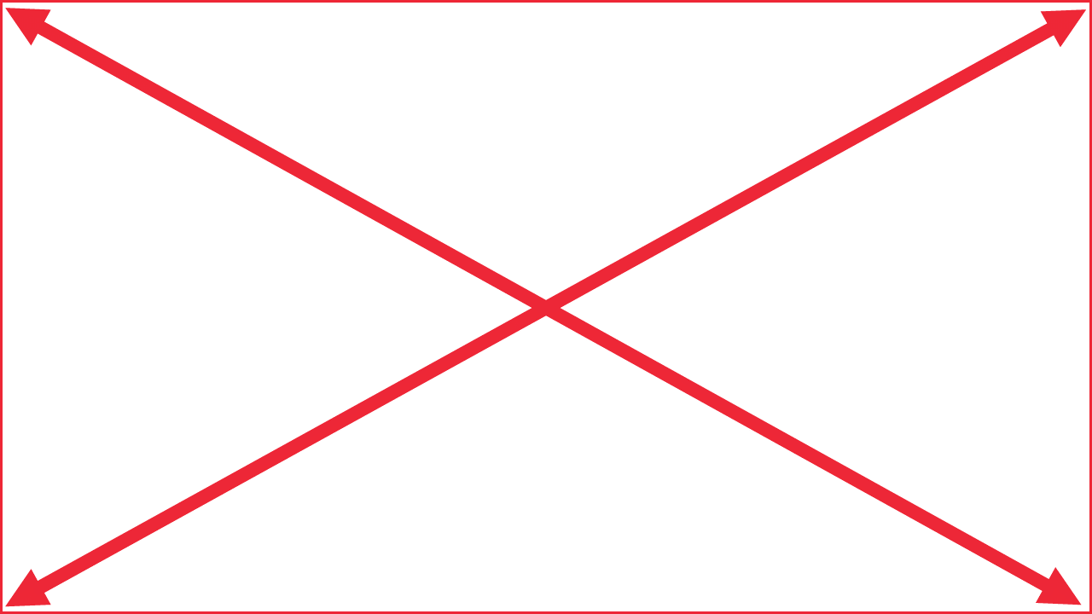
Not Resized:
Big (Resized 200%):
Status | Draft

EL-344 - Pictures in attribute
Status | Draft
Rationale | Small (Resized 20%):  Big (Resized 200%):

EL-345 - Pictures in Description and Attribute
Small (Resized 20%):
Big (Resized 200%):
Status | Draft
Rationale | Small (Resized 20%):  Big (Resized 200%):

Images and Tables
Step | Step Description | Expected Result
Small
Big
Small
Big
 | Small  Big | Small  Big

