SVG Test Document

SVG in the document body:
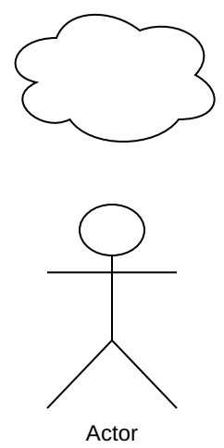
The same SVG, made smaller in the editor:
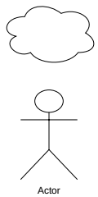
The same SVG, made larger in the editor:
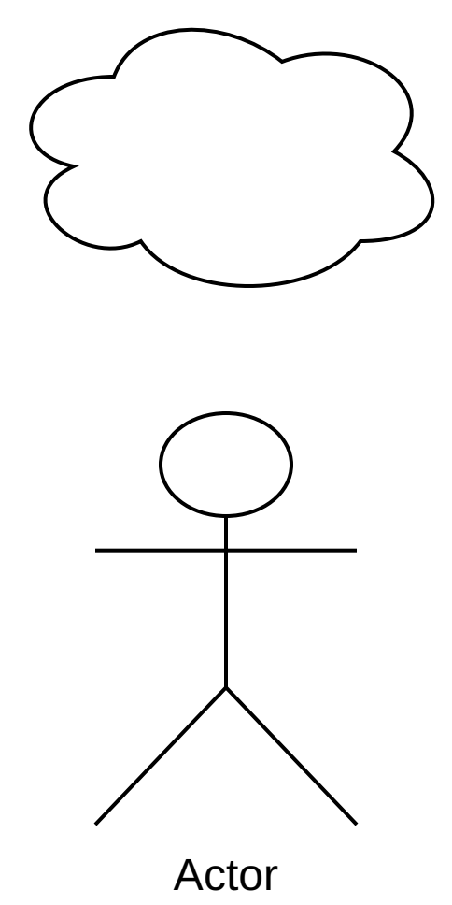

EL-271 - SVG Inside doc:
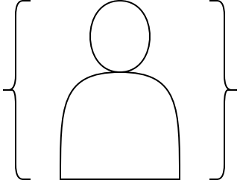 [ Draft ]

