Tux and the OpenStreetMap logo. Both blur their shadows, which Word does not draw in an SVG.
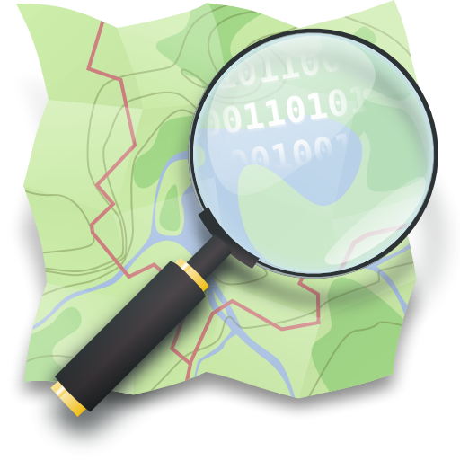
Tux: Larry Ewing, Simon Budig, Anja Gerwinski, free use with attribution to Larry Ewing and The GIMP. OpenStreetMap logo: Ken Vermette, CC BY-SA 2.0.

