西安电子科技大学
考试时间 120 分钟
试 题
题号 | I | II | III | IV | 总分
分数
1.考试形式：闭卷；2.本试卷共4大题，满分100分。

班级 学号 姓名 任课教师

I. Single Choice (2 * 15 = 30 points)
- We do NOT consider quality software in the way ( )
A. The quality of the product
B. The quality of the process
C. The quality of the development team
D. The quality in the context of the business environment
- The prototyping model of software development is ( )
A. A reasonable approach when requirements are well defined.
B. A useful approach when a customer cannot define requirements clearly.
C. The best approach to use for projects with large development teams.
D. A risky model that rarely produces a meaningful product.
- Which of the following software development process concerns the risks? ( )
A. Waterfall model
B. V model
C. Prototyping model
D. Spiral model
- ( ) is NOT an activity of risk assessment
A. Risk identification
B. Risk analysis
C. Risk prioritization
D. Risk management planning
- About project plan, which of the following statement is NOT correct? ( )
A. It contains the customer’s needs.
B. It contains what the developers hope to meet the customer’s needs.
C. The customers are not permitted to read it.
D. The developers use it to confirm with the customer any assumptions they are making, especially about cost and schedule.
- “What are the appropriate reactions to possible stimuli” is a question corresponding to ( )
A. Functional requirements
B. Quality requirements
C. Design constraints
D. Process constraints
- The UML notation – ( ) can be used to represent an E-R diagram.
A. Use case diagram
B. Class diagram
C. Sequence diagram
D. Collaboration diagram
- Which of the following is NOT a characteristic of requirements ( ).
A. Correct
B. Consistent
C. Testable
D. Understandable
- ( ) is suitable for designing a compiler.
A. Pipes and filters
B. Implicit invocation
C. Layering
D. Interpreters
- When a data structure is used to pass information form one component to another, and the data structure itself is passed, there is a ( ) between the two components.
A. Content coupling
B. Common coupling
C. Stamp coupling
D. Data coupling
- Typical exception does NOT include ( ).
A. Failure to provide a service
B. Providing the wrong service or data
C. Corrupting data
D. Corrupting system
- A(n) ( ) occurs when a component’s algorithm or logic does not produce the proper output for a given input because something is wrong with the processing steps.
A. Algorithmic fault
B. Computation fault
C. Documentation fault
D. Syntax fault
- The best reason for using independent software test teams is that ( ).
A. Software developers do not need to do any testing
B. Testers do not get involved with the project until testing begins
C. Strangers will test the software mercilessly
D. The conflicts of interest between developers and testers is reduced.
- ( ) is the probability that a system is operating successfully according to specification at a given point in time.
A. Software reliability
B. Software availability
C. Software scalability
D. Software maintainability
- ( ) address the handling of large amount of data in the system.
A. Stress tests
B. Volume tests
C. Regression tests
D. Quality tests

II. T(True) or F(False) (1 * 10 = 10 points)
- ( ) A computer engineer focuses on the computer as a problem-solving tool.
- ( ) Whereas the focus of the waterfall is often documents and artifacts, the focus of the V model is activity and correctness.
- ( ) If we get behind schedule, we can add more developers and catch up.
- ( ) A Gantt chart can be used to represent the work breakdown structure of a project.
- ( ) By combining expert judgment and machine learning methods, a team can get accurate cost- and schedule-estimation for a project.
- ( ) In rapid prototyping, the prototype will never be part of the delivered software.
- ( ) A UML class diagram can be used to represent the E-R diagram of a project.
- ( ) No matter the design approach, each kind of decomposition separates the design into modules.
- ( ) In pipes and filters, concurrent execution of filters is not allowed.
- ( ) Testing is the first place where fault finding occurs.

III. Questions（6 * 5 = 30 points）
- List the software development steps and the corresponding development roles.

- Briefly describe the following requirement modeling notations, E-R diagram, event trace and state machine. And which UML diagrams can be use to represent them, respectively?

- Please enumerate at least 3 kinds of component cohesion.

- What is regression test? Why is regression test needed?

- Briefly describe testing steps.

IV. Problem Solving（10 * 3 = 30 points）
- According to the weather data, we decide whether to go out for playing.
(1) If the outlook is sunny and the humidity less than or equal to 75%, we will play; if the outlook is sunny and the humidity is larger than 75%, we will not play.
(2) If the outlook is overcast, we will play.
(3) If the outlook is rainy and the windy is TRUE, we will not play; if the outlook is sunny and the windy is FALSE, we will play.
You are required to draw the decision table modeling these conditions.

- This is an activity diagram for a software development project. The number on each edge represents days required to complete this activity.
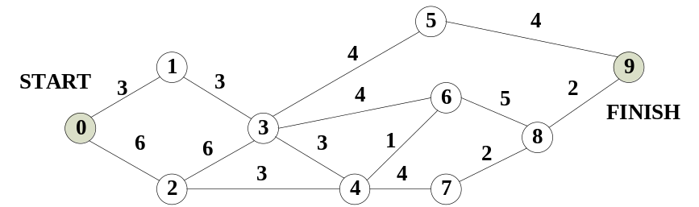
You are required to find out the critical path(s).

- This is a logic flow in a component to be tested.
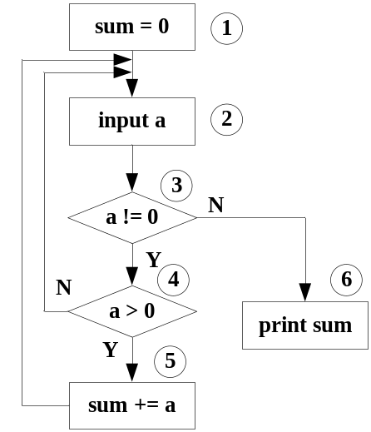
You are required to write down all the possible paths through the logic flow.

