《软件工程概论》平时作业参考答案

Chapter 1 Why Software Engineering ?
Part 1 Fill Blanks
- Programs (Instruction), data (structures), documents
- systematic, disciplined, measureable development, operation, and maintenance
- analyzing synthesizing
- the software product, the process of development software product, in business environment
- customer， client, user
- analysis, design, construction, verification, management
Part 2 Brief Description
Briefly describe the roles of analyst, designer, programmer, tester, and trainer.
答案：
- the requirement analyst work with customer, break down what the customer wants into discrete requirement.
- the designer generate the system-level description of what the system is to do
- the programmer write line of code that implement what requirement specify.
- the tester catches faults that programmer overlook
- the trainer shows users how to use the system

Chapter 2 Modeling the Process and Life Cycle
Part 1 Fill Blanks
- process, steps, activities, constraints, resources
- Product, lifecycle
- conception, implementation, delivery, use, maintenance
- requirement analysis and definition, system design, program design, program implementation, unit testing, integration testing, system testing, system delivery, maintenance
- requirement analysis, system design, program design, coding, unit & integration testing, system testing, acceptance testing ,operation & maintenance
- validation, verification
- iteration , rework
- risk, risk control
- prototype

Part 2 Brief Description
Briefly describe the advantage and disadvantage of the WatterFall model.
答案：
Advantage: As described in the bottom paragraph of test book P49.
Disadvantage of the WatterFall model: See the PPT of this section.

Chapter 3 Planning and Managing the Project
Part 1 Fill Blanks

- Project schedule, phases, tasks , activities
- Time line
- Items
- Activity, milestone
- Gantt chart
- Real time ,actual time ,available time, slack time, float time, available time , real time
- CPM
- schedule
Part 2 Brief Description
- See middle items in the Page 83 of the test book.( four types of deliverable)
- See middle items in the Page 96 of the test book.( ten aspects)
- Exercise 2
No | Activity leading to | Precursors
1 | A
2 | B | A
3 | C | A
4 | D | A,B
5 | E | A
6 | F | A,C
7 | G | A,E
8 | H | A,C,E,F,G
9 | I | A,B,D
10 | J | A,B,D,E,G,I
11 | K | A..J
12 | L | A..K

No | Activity leading  From..to.. | Earliest Start  Time | Latest Start Time | Slack
1 | A..B | 1 | 1 | 0
2 | B..D | 4 | 4 | 0
3 | B..I | 4 | 5 | 1
4 | D..I | 9 | 9 | 0
5 | I..J | 11 | 11 | 0
6 | A..C | 1 | 5 | 4
7 | C..F | 6 | 10 | 4
8 | F..H | 9 | 13 | 4
9 | A..E | 1 | 4 | 3
10 | E..G | 5 | 8 | 3
11 | G..H | 8 | 14 | 6
12 | G..J | 8 | 11 | 3
13 | H..K | 10 | 14 | 4
14 | J..K | 13 | 16 | 3
15 | J..L | 13 | 13 | 0
16 | K..L | 15 | 18 | 3
17 | L | 21
Critical Path: A-B-D-I-J-L 20 days
- Exercise 3
Critical Path: A-B-C-E-D-I-K-L
24 days

Chapter 4 Capture the Requirements ?
Part 1 Fill Blanks
- Expression, software behavior
- Elicitation, analysis, specification, validation
- clients, customers, users, domain experts, market researcher, lawyers or auditors, software engineers.
- stakeholders wants and needs, domain models, current situation models,Reusable requirements, suggested type of requirements, existing documents, current organization and systems.
- functional requirements, quality (non-functional)requirement, design constrains, process constrains
- requirement definition , requirement specification.
- entity, attribute, relation
- process, data flow, data store, actor
- boundary
- throwaway prototype, evolutionary prototype
Part 2 Brief Description and Exercises
- See the Page 146-147 ( Fourth Edition)
- See the page 148-149 ( Fourth Edition )
- See the page 158 ( Fourth Edition )
- See the page 192 ( Fourth Edition )
- Exercise 12
UML use-case diagram for an on-line telephone directory.
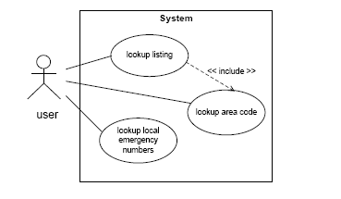
Exercise 13
Data-Flow diagram to illustrate the functions and data-flow For an on-line telephone directory system
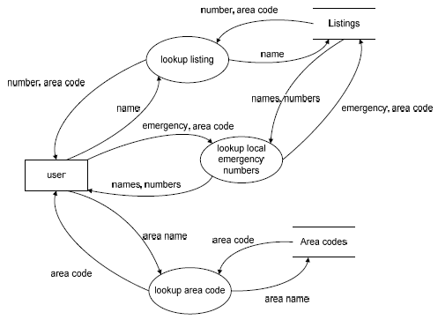

Chapter 5 Design the Architecture
Part 1 Fill Blanks
- resulting
- components, connectors, constrains
- filter,pipe.
- Server, client
- peer
- subscribing, pubulish
- central data store, data accessing
Part 2 Brief Description and Exercise
- See the Figure 5.4 and its description..
- The answer is figure 5.9 in the page 243( Fourth Edition)
- (1) Piper and Filter:
MIS system of XIDIAN University
(2) Client/Server:
Most transaction processing system(事务处理系统)
Eg. Bank System
(3) Peer to Peer:
Military Individual equipment system
(4) Publish Subscribing:
- Field ( Reiss 1990),
- Subscribed Weather Forecast
(5) Repositories
Intelligence Diagnostic and Cure System
(6) Laying
(1) Unix Operating System
(2) OSI model for network communication

Chapter 6 Design the Modules
Part 1 Fill Blanks
- Individual component, write code, implement
- principles , conventions
- sharp boundary
- decomposing
- separation of concern
- See the Fig.6-2 ( Fourth Edition P. 298)
- See the Fig.6-5 ( Fourth Edition P. 300)
- stamp coupling, data coupling
- temporal
Part 2 Brief Description and Exercises
In next text, the No. 4 is the reference answer for Exercise 7
and No.5 is the reference answer for Exercise 8

Chapter 7 Writing the Programs
Part 1 Fill Blanks
- coorperation, coordination
- style, format, content standard, read
- control structure, algorithm, data structure
- documentation, internal documentation, external documentation
- who, what, why, when, where, how
Part 2 Brief Description and Exercise
1、See the six aspects in the page 387( Fourth Edition)
2、Reference answer for exercise 6.

Chapter 8 Design the Modules
Part 1 Fill Blanks
- Mistakes, inside, developer
- Departure, outside, user
- Determining, making changing
- algorithm or logic
- implementation, decimal
- documentation
- capacity
- function
- performance
- acceptance
- installation
- feed, output
- structure
- input data
- component driver
- component
Part 2 Brief Description and Exercises
- See the content of the P.413 of the text book .
- See the content of the P.422 of the text book .
- Top-Down: Test: A
Test: (A,B,C,D,E)
Test: (A,B,C,D,E,F,G,H,I,J,K)
Test: (A..N)
Bottom-Up: Test: (E,G,H,J,K,L,M,N)
Test: (F,L) and (I,M,N)
Test: (B,F,L,G),(C,H), and (D,I,J,K,M,N)
Test: (A..N)

4. (1) Statement Testing: [ 2,0,4]
(2) Branch Testing: [2,0,4]; [1,1,1]
(3) Test Path:
a-c-e
a-b-d
a-b-e
a-c-d

Chapter 9 Testing the System
Part 1 Fill Blanks

- Components
- Conditions, time
- point
- time ,procedure, resources
- alpha, beta

Part 2 Brief Description and Exercise
See the content of P.489, especially the content of Figure 9.10( Fourth Edition)

Chapter 10 Delivering the System
Part 1 Fill Blanks
1、User, operator

Part 2 Brief Description and Exercise
- See the content of Table 10.1of P.520 ( Fourth Edition)
- See the content of PP520-521. ( Fourth Edition)

Chapter 11 Maintaining the System
Part 1 Fill Blanks
- Change
- Formally
- Implementation
- Corrective
- Adptive
- perfective
Part 2 Brief Description and Exercise
See the 10 points listed in Page 550-551 ( Fourth Edition) .

