DESIGN OF ASSISTIVE SPELLER MACHINE BASED ON BRAIN COMPUTER INTERFACING

Suryoday Basak

PESIT Bangalore South Campus, India

ABSTRACT

Machine Learning (ML) has assumed a central role in data assimilation and data analysis in the last decade. Many methods exist that cater to the different kinds of data centric applications in terms of complexity and domain. Machine Learning methods have been derived from classical Artificial Intelligence (AI) models but are a lot more reliant on statistical methods. However, ML is a lot broader than inferential statistics. Recent advances in computational neuroscience has identified Electroencephalography (EEG) based Brain Computer Interface (BCI) as one of the key agents for a variety of medical and nonmedical applications. However, efficiency in analysing EEG signals is tremendously difficult to achieve because of three reasons: size of data, extent of computation and poor spatial resolution. The book chapter discusses the Machine Learning based methods employed by the author to classify EEG signals for potentials observed based on varying levels of a subject’s attention, measured using a NeuroSky Mindwave Mobile. It reports challenges faced in developing BCIs based on available hardware, signal processing methods and classification methods.

Keywords: Brain Computer Interfacing (BCI), Electroencephalography (EEG), NeuroSky Mindwave Mobile, Machine Learning, Classification, Dimensionality Reduction, Wavelet Transform, Common Spatial Patterns (CSP), Decision Tree, Random Forest, Support Vector Machine (SVM)

- INTRODUCTION

A Brain Computer Interface (BCI) is any system that does not rely on the conventional communication routines for a user to interact with a computer such as a mouse, keyboard, touchpad, etc. Instead, it utilizes signals from the brain to control a computer. Based on an imagined action, thought, or perception, signals are generated in specific regions of the brain and in turn, these signals may be used to control computers. Consequently, a BCI does not require physical motion of a user. The primary goal of any BCI, hence, is to provide an appropriate control interface, without requiring the usual communication pathways, such as gestures, voice, button clicks, etc.; the patient is required to be still, relaxed, and focussed on a single mental task, or a series of mental tasks.

In the recent years, hype has surrounded the study of Brain Computer Interfaces as its indispensable usefulness in many scenarios opens up a world of possibilities: many users are unable to communicate with people, or with computers due to various physiological conditions, such as amyotrophic lateral sclerosis (ALS), locked-in syndrome (LIS) or severe paralysis. For them, life becomes a burden; the inability to communicate and convey one’s wishes to others is extremely daunting. BCI poses numerous solutions that may allow them to live better lives and communicate effectively. Over the past decade, scientists have developed voice translators that can translate thoughts to speech, wheelchairs, exoskeletons and games that work on the basis of imagined motion, amongst many other things. Such developments are on the rise and show promise to provide for better communication mechanisms in people who are unable to communicate.

Among the possible methods of acquiring signals from the brain are electroencephalography (EEG), magnetoencephalography (MEG) and functional magnetic resonance imaging (fMRI). The most popular signal acquiring method for Brain Computer Interfaces in use today is EEG, primarily due to its low cost, ease of setup and good temporal resolution; in contrast, MEG and fMRI are relatively expensive to setup, and are primarily used for medical research and diagnosis but this does not undermine their potential as acquisition systems for BCIs. The origin of the word electroencephalography is as follows: electro: denoting the electrical signals, encephalo: which refers to a phenomenon of the brain, and graphy: which denotes a drawing or a representation of a quantifiable phenomenon. EEG was discovered by Richard Canton (1842–1926). He experimented on rabbits and monkeys, and presented his findings of electrical activities of their brains. The first EEG recording of a human was presented by Hans Berger in 1942. EEG has seen innumerable uses in medical science, and researchers have tried to use EEG to understand the roots of epileptic seizures, analyse comas, etc. As an EEG recording would reflect the mental state of a subject, the EEG of a subject is altered by neurological conditions, disorders, drowsiness, drug actions, etc. EEG, due to its low cost, is also popular in numerous non-medical applications (a BCI is generally a non-medical application).

It is but natural for the reader to ponder that just like all other biological traits, even the electrical activity in the brain must be unique to each individual. Such is the case, and for a system to discern intentions from different brain signals of different subjects, Machine Learning (ML) techniques are employed. Machine Learning has its roots in classical Artificial Intelligence (AI) approaches, where the goal is to make a computer learn trends and discerning features in data (one of the prime differences between AI and ML is that AI generally refers to a replication of human abilities, whereas ML is used in data analytics across a broad spectrum of domains). However, ML techniques are more reliant on statistical measures. In a typical BCI setup, data corresponding to different intentions for each subject is collected several times, over multiple recording sessions. The author defines intention or intent in the current context to be any action that the user of a BCI would want the computer to perform, corresponding to a single and unique mental state. This will be further explained later in this section. The duration of each recording session is specific to each application. Once an adequate amount of data is collected for each intention, appropriate signal processing and machine learning approaches are used to teach the system the characteristics of the signals corresponding to each intention. In this chapter, the signal processing techniques that are featured are the Wavelet Transform, and Common Spatial Patterns (CSP). The Wavelet Transform essentially finds regions of maximum correlation of a signal to a wavelet, which is a small wave; the CSP algorithm is used to find spatial patterns in the processed data after the Wavelet Transform. The CSP is a dimensionality reduction algorithm, that is, it helps us to find the discriminatory features in the data, which may be used to optimally differentiate between data from different classes. The ML algorithms featured in this chapter are Decision Trees, Random Forests, Support Vector Machines and k-Nearest Neighbours. The popularity of ML and the resurgence of AI, surrounding Deep Learning is because of the large volume data in the world today. In many digital repositories all over the world, a lot of data is stored from the research of many scientists, and to effectively extract information from this data, Machine Learning, Data Mining, etc. have been encompassed comprehensively under the generic domain of Data Analytics. Data Analytics provides refers to trend analysis and predictive analysis in numerous fields as business, astronomy, biology, etc.

Machine Learning approaches are further classified as supervised and unsupervised methods.

Supervised Methods: In supervised methods, class labels are associated with data, so that the system can understand the features associated with every class of data present in the dataset. The prediction from any supervised learning method, or classification, is essentially the class label of the class that the system thinks that the input data would belong to.

Unsupervised Methods: Contrary to supervised methods, data without associated class labels is used in unsupervised methods. The task of the system here is to identify classes that may exist in the data, based on similarity of features in the data.

In the current work, supervised learning methods are used. The class labels in the data correspond to the intention of the user. The ML techniques used in the current work is briefly explained below:

Decision Trees: Decision trees use tree data structures to model decisions. These can be used for classification or regression; for the task of classification, it takes labelled data for training. Each split at a node is based on a feature (attribute) of the data set, the first node is called the root node, which can be any important feature and hence considered as best predictor. Every other node of the tree is then split into child nodes based on certain splitting criteria or decision rule, which identify the belongingness of the particular object (data entity) to the feature class. The leaf nodes represent pure nodes, and each entity in a leaf node is assigned the class label of the corresponding node. Typically, an impurity measure is defined for each node and the criterion for splitting a node is based on increase in purity of child nodes as compared to the parent node i.e. splits that produce child nodes which have significantly less impurity as compared to the parent node are favoured. The Gini index and entropy are two popular impurity measures. Entropy may be interpreted as a descriptor of information gain from that node. One significant advantage of decision trees is that both categorical and numerical data can be handled; a disadvantage is that decision trees tend to over fit the training data.

Random Forests: Classifiers may be combined in order to improve the classification results from each classifier. Systems which use combinations of classifiers are called ensemble learning systems. A Random Forest classifier is an ensemble of multiple decision trees, where the features are sampled from the set of all features in a given dataset. Each tree enunciates a classification and decision is taken based upon majority voting for the task of classification. When a new object from the dataset needs to be classified, data is classified using each of the trees. Classification implies a tree voting for the corresponding object. Random forest works efficiently with large datasets. It gives accurate results even in the cases of missing data. As an illustrative example, consider that we have a dataset with a feature-set 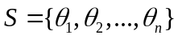. Decision trees are constructed with a feature set S’, and |S’| < n. This process is repeated many times and at the end of every iteration, the predicted outcome for each instance of certain test data is accumulated. At the end of k iterations, the most recurring outcome for each instance of the test data is selected as the corresponding class label.

Support Vector Machine: SVM classifiers are candidate classifiers for binary class discrimination. The basic formulation is designed for the linear classification problem; the algorithm yields an optimal hyperplane i.e. one that maintains largest minimum distance from the training data, defined as the margin. It can also perform non-linear classification via the use of kernels, which involves the computation of inner products of all pairs of data in the feature space; this implicitly transforms the data into a different space where a separating hyperplane can be found. One advantage of the SVM is that the optimization problem is convex. The result may not be transparent always which is a drawback of this method. The significant challenges in analysing the EEG signals are low signal-noise ratio: they are prone to internal and external noise, and volume conduction: the activation of different regions of the brain for the same thought, leading to redundant data. In addition, as the number of mental states to be classified increases, we need to build intelligent algorithms that learn the most discriminatory features.

k-Nearest Neighbours: The kNN classifiers work on the basis of the maximum similarity to a class of data amongst the k nearest neighbours. The parameter k is fed to the classifier and in the classification process. For classifying any arbitrary test sample, the k closest neighbours are considered. Out of these k closest neighbours, the class pertaining to the highest number of occurrences is assigned as the class of the respective test data. For example, for k = 7, and for a data set with two classes, Class1 and Class2, if four out of the seven closest neighbours belong to Class1 and three out of the seven closest neighbours belong to Class2, then the test data is classified as a member of Class1; likewise, if a larger fraction of the nearest neighbours belong to Class2, then the instance of the test data is classified as a member of Class2.

Much of the work involving research in BCI involves setups with multiple electrodes. In the current work, the hardware interface used is the NeuroSky Mindwave Mobile. The said device has a single electrode placed on the forehead and an ear-clip. The device measures the potential difference between the two points. The inspiration to use a smaller device is from the fact that with any technological appliance, the trend is to reduce the form-factor optimally. With an optimal form factor, the ease of use increases, thus attracting more users of any given system. The NeuroSky Mindwave Mobile is easy to use and transmits data using Bluetooth. The protocol used by the Mindwave is provided by the company NeuroSky, as a part of the Thinkgear bundle. An open-source python library exists for the Mindwave, under the name of NeuroPy; it uses callback functions to receive data over Bluetooth. Callback functions are event driven functions that operate asynchronously in their own threads.

The chapter explains an architecture for a brain-controlled speller machine. The proposed system displays a letters from the English alphabet and allows the user to select characters which are displayed. A cursor moves over individual letters, allowing the user to select an appropriate character at any given time. Characters may be used to form words, and words may be used to form sentences. The intention of a user in this context is binary in nature: a positive intent would result in the selection of a character, and appending it to a string of words, whereas a negative intent would overlook a character when the cursor indicates it. By progressively building up meaningful words and sentences this way, a patient who is suffering from ALS or LIS may be effectively communicate with others around her. Although, the current system is not robust in itself, it provides insights to how such a system may be designed and developed. This application was developed to make the process of signal acquisition corresponding to every intent easier.

In Section 2, the underlying principles of developing a Brain Computer Interface are briefly explained. The development of a Brain Computer Interface depends on various factors such as the subject for whom it is being developed, the region of the brain from which the signals are to be acquired, the task that is to be performed by the system, etc. Through Section 3, the methods used by the author are explained: signal acquisition, signal processing, data classification. Results are reported as a part of Section 3.4 which provides insights to the challenges faced by engineers who work in the field and the required sophistication that is required to develop an acceptable BCI that may be used for the simplest of tasks. This section and the conclusion following it are important as a naïve reader may be illusioned in many ways about how Brain Computer Interfaces are developed and need some solid evidence of the shortcomings of consumer grade signal acquisition devices.

This chapter targeted serves as a primer for those interested in Brain Computer Interfaces. The illustrations of signal processing and machine learning algorithms are for naïve readers, assumed to have no background in the same.

- BCI DESIGN PRINCIPLES

BCI research is a young and eclectic field of research. Researchers from various backgrounds such as engineering, science, mathematics, neuroscience and biology are involved in developing Brain Computer Interfaces of the future. The reason for this is that since a BCI involves an interaction of a subject with a computer by means of signals from the brain. Hence, it is important to incorporate elements from all the mentioned fields to acquire signals that can be used to develop a control system.

2.1. Types of BCI

The hardware interface for BCI systems may be broadly classified into invasive and non-invasive methods.

Invasive: Invasive Brain Computer Interfaces require an electrode to be surgically implanted inside the brain of a subject. Invasive methods provide the best signal-to-noise ratio, but the involved risks are profound. This method poses many dangers due to the formation of scar tissues around the electrode as it is a foreign body, or impairment of certain neurological functions. Although cochlear implants for hearing has gained popularity in the recent years, it does not eradicate the many hazards involved in having a foreign body in the brain.

Non-Invasive: Non-invasive Brain Computer Interfaces do not require an electrode implant inside the brain. It utilizes signals appearing on the scalp. The bulk of tissues and skull bone interceding the surface of the brain from the electrode in this case reduces the efficacy of this method, resulting in more noise. The advantage, of course, is that it is a much safer alternative to invasive methods, and cheaper, too.

An intermediate to the above mentioned genres of hardware is to use a partially invasive electrode: one that is placed inside the skull, but not hampering the brain. This method reduces the risk of damage to the brain, but nonetheless, requires a surgical procedure for implanting. Though non-invasive methods incorporate a larger amount of noise in the acquired signals, it is preferred when experimenting on humans. Invasive methods are often employed when the experiments performed on animals such as rats, rabbits or monkeys. Other methods of signal acquisition include magnetoencephalography (MEG) and functional magnetic resonance imaging (fMRI).

2.2. Non-Invasive EEG based BCI

In methods that use Non-Invasive EEG based BCI, EEG recordings are done as a subject performs a mental task. The nature of the task may be any of these, but not restricted to:

- Motor Imagery: This type of task involves imagining the movement of an appendage (Mohanachandra, Saha and Deshmukh, 2014)

- Steady State Visually Evoked Potentials (SSVEP): In this genre of task, potentials in the visual cortex are stimulated by flickering lights at different wavelengths and flickering frequencies.

- Subvocalization: This involves a subject saying out a word in her mind, without articulation (Mohanchandra and Saha, 2016).

A lot of data for each unique task is collected over multiple sessions, usually spanning days. Once an adequate amount of data is collected, the signals are pre-processed and dimensionality reduced, before ML techniques are applied to associate EEG signals with specific intents of the subject.

For the purpose of standardization, there exists a system of electrode placement called the 10-20 system of electrode placement. The '10' and '20' represent 10% or 20% respectively of the distance between electrodes, as the distance between the front-to-back or right-to-left distance of the skull of the subject. The diagram below shows the standard positions of electrodes in the various lobes of the skull.

Figure 1. The standard 10-20 system of electrode placement (top-view of head)

EEG Bands | Frequency (Hz) | Distribution | State of Mind
Delta | 0.5-4 | Central cerebrum and parietal lobes | Deep sleep, non-REM sleep
Theta | 4-8 | Frontal, parietal and temporal lobes | Drowsiness, first stage of sleep
Alpha | 8-13 | Most prominent at occipital and parietal lobe | Relaxed wakefulness with eyes closed
Mu | 8-12 | Central electrodes, over motor and somatosensory cortex | Shows rest state motor neurons
Beta | 13-30 | Frontal and central regions | Highly alert and focused
Gamma | >30 | Very localized | Higher mental activity, including perception and consciousness

Table 1. The different frequency bands of EEG signals and their corresponding mental states

The table above shows the different frequency bands of EEG signals and their significance. In multichannel EEG systems, the number of electrodes employed may be up to about 256. As the electrodes in the non-invasive system are present on the surface of the scalp, they are called dry electrodes, and are generally made of silver chloride. To facilitate conduction, an electrode gel is used. Though the NeuroSky Mindwave Mobile device does not require an electrode gel, its electrode is made of silver chloride. The tasks mentioned earlier in this section may be used to appropriately alter the EEG and these signals can then be used to control a computer.

2.3. NeuroSky Mindwave Mobile

The signals are acquired from the Neurosky Mindwave Mobile device. The Thinkgear bundle is comprised of the sensors and a chip to process signals. The device has capabilities to send packets of data over Bluetooth. The Radio Frequency Communication (RFCOMM) protocol is used to establish a link between the device and a computer. The RFCOMM protocol serially transfers data by emulating a serial cable line setting and the status of an RS-232 serial port. The RFCOMM connects to lower layers of the Bluetooth stack through the Logical Link Control and Adaption Protocol (L2CAP) layer. The L2CAP layer is used within the Bluetooth stack, and passes data to a Host Controller Interface (HCI). In our case, the HCI is the computer which records the data, and the device is the Mindwave Mobile.

The RFCOMM protocol finds wide use in devices that need to communicate serially, such as Bluetooth robotics projects, keyboards, etc., and is supported by all major Operating Systems. A link between the device and a Linux computer is set up by using the rfcomm command, and by specifying the device's address, port number and number of channels.

The format of the command to establish the link between the Linux Computer and the Mindwave device is

sudo rfcomm bind <device index> <physical address> <channel>

The device index is a unique number used to recognize a Bluetooth device that is bound to the computer. The physical address is the Mindwave's physical address. The default value of channel is 1; it is an optional argument. An example of the command in use is:

sudo rfcomm bind 0 20:68:9D:88:C0:C6 1

Following this, raw data is sampled from the device at 512 Hz, using the NeuroPy module for Python, which uses callbacks to receive data asynchronously.

2.4. Supplementary Target BCI Applications

Researchers have experimented with the NeuroSky Mindwave Mobile to develop brain computer interfaces. Much of the related work is directed towards developing games for mobile platforms, or interfaces for robots. Anupama H. S. et al. (2014) have proposed a design of a wheelchair using the same device, which is based on using the values of attention and meditation returned by the device as features for an associated action. Along the same lines, Nilay Yildirm et al. (2015) have developed a game similar to the popular mobile phone game Flappy Bird, utilizing values of attention and meditation. In his Master of Science in Computer Science thesis, Erik Andreas Larsen (2011) has attempted to build a game by classifying mental states using a Neural Network, based on values of alpha, beta, delta, theta and gamma, and eye blinks returned from the device; classification and detection of eye blinks yielded a 91% accuracy, but classification of mental states yielded a 60% accuracy.

Despite all the shortcomings of the device, its merits are low cost and ease of use. Classification of EEG signals becomes more difficult as the number of electrodes reduces. The current work, the author used minimal hardware and proposes a method to classify EEG signals.

2.5. Overview of the Proposed System

Figure 2. Flow of data in the experimental setup

The flowchart above describes the setup of the proposed system, based on the author’s experiments.

- The data is acquired from the NeuroSky Mindwave Mobile device.
- The data is pruned appropriately and the Wavelet Transform is applied, by considering segments of length 1024 values.
- CSP is applied to the data; the CSP Matrices are calculated from the training data.
- Once the inter-class variance is increased between classes, the response is classified.
- Based on the classification, the appropriate action is performed by the computer.

- METHODOLOGY

3.1. User Interface

A graphical interface for the device was built using the pygame module in Python 2.7. The interface consists of English alphabets, and two special characters for space and clear. All the characters are displayed in rows of seven characters. While recording the test data, the subject is shown a colour coded cursor-box: red denoting that the subject's response should be negative; for a positive response yellow is an indicator for the subject to get ready, following which, a green box denotes that a positive response is being recorded. After a positive response to a row, only the characters from that row are displayed and recorded with; the responses on a character may be positive or negative. Upon a negative response to a row, the cursor moves to the next row in sequence. The colour indicator of the cursor is generated randomly.

A recording session comprised of about twenty to twenty five recordings, each individual recording lasting thirteen seconds, including time for the subject to get ready for a positive or negative response. Between each individual recording, a 10s break is provided. For each subject, about 200 recordings have been done, 100 for each class of response. Once recorded, the data is pruned from the end appropriately.

Figure 3(a). Selection of a group of characters

Figure 3(b). Selection of a single character from a group of characters

3.2. Feature Extraction

In the current work, a combination of methods for signal pre-processing and feature extraction is explored to achieve best possible results using minimal hardware. The performance and accuracy of the classifiers are quantitatively measured. The primary focus of the present work is to develop a prototype of a system that may assist in communication of subjects who are incapable of speech or gesture communication. In this section, the underlying principles of the methods used to extract features from the acquired signals are explained. Reiterating, the text is targeted towards naïve readers looking for a gentle introduction to the subject. Norms and sequences are explained: although they are not of direct consequence, they are used in Wavelet Transforms. Having an idea of the same is necessary and hence these topics are introduced as a part of this section.

3.2.1. Norms

In mathematics, a norm is a function that gives us an index of the size or magnitude of a vector or a matrix. For a vector v, the norm is generally represented as ||v||. Norms for vectors and matrices are explained below.

3.2.1.1. Vector Norms

The most commonly used norm for vectors is the Euclidean norm. Consider a vector u_{in} a two-dimensional Euclidean vector space.

Figure 4. A vector making an angle in a two-dimensional space

Here, and 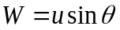, by considering the vector components.

The norm of u, given as ||u|| = H² + W², which is the length of u, by Pythagoras’ Theorem. Expanding the above equation by substituting for H and W,

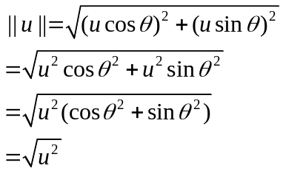

Thus, in a two dimensional Euclidean space, 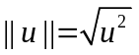. Similarly, if a vector is a resultant of n vectors u₁, u₂ , … , u_{n} the norm of v is given as 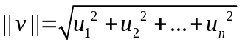. The 2D Euclidean norm is a very specific case of vector norms. There are different norms that exist that provide a measure of distance in various circumstances. Some of the commonly used norms are explained below. For each of these, we assume a vector v to be a resultant of n vectors, u₁, u₂, … , u_{n.}

- 1-norm:

The 1-norm is defined as the sum of the absolute values of all the vector components.

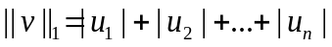
2. 2-norm:

The 2-norm is the special case of Euclidean norm.

3. p-norm:

The p-norm is the most general case of norms, defined as follows:
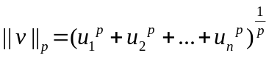
4. Infinity Norm:

The infinity norm is defined as the maximum of the absolute values of the components of vector v.

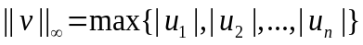

3.2.1.2. Matrix Norms

The concept of vector norms can be extended to matrices. The fundamental properties of norms does not change for matrices: a matrix norm is an index of size or magnitude. In this section, we describe norms for two-dimensional matrices.

1. The 1-norm

The 1-norm in the case of matrices is the maximum of the column sums.

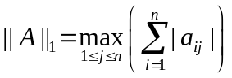
2. The Frobenius Norm

The Frobenius norm is analogous to the Euclidian norm for vectors. It is the square root of all squares of all the elements in a matrix.

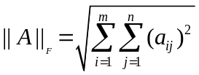
3. p,q-Norm

The p,q-Norm in matrices is analogous to the p-Norm in vectors. Here, the values of the symbols p and q may or may not be the same, and generally, the indices i and j are treated differently (rephrase)

The p,q-norm is defined as:
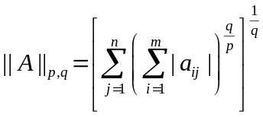
4. Infinity Norm

The infinity norm in the case of matrices is similar to the infinity norm for vectors. It is the greatest of all the row sums in a matrix.

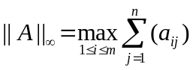

3.2.1.3. Properties of Norms:

Let represent a field of real or complex values. Let denote the vector space of all matrices.

- 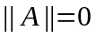, iff A = 0, else ||A|| > 0
- 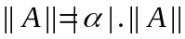 for all 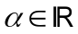 and all matrices in 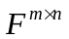
- 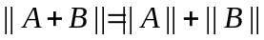, for all matrices A and B in
- 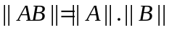 for all matrices A and B in , where m = n. This is not satisfied by all matrices; the matrices which satisfy this relation are said to be in the submultiplicative form.

3.2.2. Sequences

In Mathematics, a sequence is a set of ordered objects. For example, the following is a sequence:

1, 2, 3, 4, 5…
Sequence (1)
Another example of a sequence:

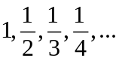
Sequence (2)

Numerical sequences are generally denoted by an expression of the i^{th} term. The sequences above may be represented as 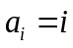 and 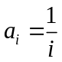, respectively, for 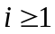.

A very popular example of sequences is the Fibonacci sequence. The elements of the Fibonacci sequence are:

0, 1, 1, 2, 3, 5, 8, 13, 21, …

The elements in the Fibonacci sequence are given as:

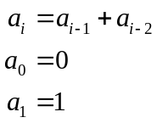

3.2.2.1. Convergence and Divergence of Sequences:

A sequence, whose 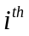 element is given as 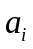 is said to converge if for an arbitrarily large i, the corresponding element is defined. In other words, a sequence is said to be convergent if it has a defined limit. Else, it is divergent.

Consider Sequence (1). Here, the element is given as for . Hence, the limit is given as:

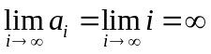

This is a divergent sequence as it does not have a well-defined limit. The larger the value of i, the greater the value of a_{i}. Hence, for an arbitrarily large value of i, the i^{th} element in the sequence is not defined.

Consider Sequence (2). Here, the i^{th} element is given as , for 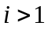. Hence,
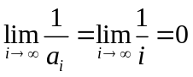

This is a convergent sequence as for an arbitrarily large i, the value of a_{i} tends to zero. In this sequence, the larger the value of i, the smaller the value of a_{i}, and as it progressively nears zero, we say it is convergent.

3.2.3. Wavelet Transform

3.2.3.1. The Fourier Transform and its Limitations

The Fourier Transform of a time-series signal decomposes it into its corresponding frequency components. In the 19th century, Joseph Fourier proved that any signal can be represented as a summation of sinusoidal signals, thus laying the foundation for representing a signal using sines and cosines only.

The Fourier Transform of a signal is:

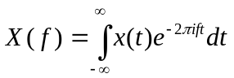

Here, X is in hertz (Hz) and x is in seconds. The signal, which is a function of time, is transformed to its frequency components. The inverse Fourier Transform is given as:

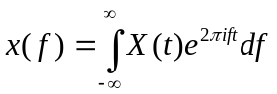

The Fourier Transform is one of the most important transformations in the fields of Mathematics, Signal Processing and Electrical Engineering. In brief, some of the applications are finding the fundamental frequency and harmonics in musical notes, electrical supply mains, voice, etc. In the field of Machine Learning, the Fourier Transform is widely used to extract the fundamental frequency and harmonics, and to use them as features for classification, clustering, etc.

However, the Fourier Transform suffers from some limitations.

- Time - Frequency Resolution Trade-off

In the Fourier Transform, once we have information about the frequencies for a signal, or for a part of a signal, we cannot say with certainty where in time each frequency component occurs. This is illustrated with an example.

Consider two signals S1 and S2 as shown in Fig.5. As illustrated, the characteristics of S1 and S2, such as amplitude at different points, frequency are different. The frequency components of S1 and S2 are also illustrated below the respective plots of the signals. The frequency components are also distinct, and are found using the Fourier Transform. For S1, the most prominent peaks occur at around 3Hz and 10Hz, whereas for S2, the peaks occur at around 10Hz and 30Hz, ignoring the components of lesser importance, which make the plots look jagged. The frequency components are found by using the Fourier Transform.

Figure 5. Two signals and , and their corresponding frequency components

Now consider two signals Signal-1 and Signal-2, which are constructed using S1 and S2 in series. Signal-1 is constructed such that the first five seconds are comprise of S1, and the last five seconds comprise of S2. Signal-2 is constructed such that the first five seconds comprise of S2, and the last five seconds comprise of S1.

Figure 6. Two signals and comprising of and and their corresponding frequency components

Signal-1 and Signal-2 are shown in Fig.6. However, the frequency components of Signal-1 and Signal-2, as found by the Fourier Transform, are the same. So based on the Fourier Transform, the characteristic frequencies of Signal-1 and Signal-2 are the same, whereas the signals themselves are not the same.

This is in fact a consequence of Heisenberg’s Uncertainty Principle, which states that the position and the velocity of a body cannot be accurately determined simultaneously; if we can determine the velocity of a body with a high degree of certainty, we will be unable to determine its position accurately and vice versa. Applied to the context of time-frequency transformations, if we can resolve the signal in time with a high degree of certainty, we lose information about the frequency components of the signal, and vice versa.

One method to overcome the limitations of the Fourier Transform is to divide the signal into bins occurring at regular intervals from the starting point of the signal, and then applying the Fourier Transform to each bin. This approach results in the Short Term Fourier Transform (STFT). The trade-off here is that while the higher frequencies will be adequately detected, any frequency component that is larger than the size of a bin will not be adequately detected.

- Sinusoidal Basis Vectors

The basis vectors in Fourier transform are always sinusoidal in nature, that is a signal is always decomposed into its sine and cosine components. This is a limitation as the Fourier Transform does not allow the usage of any other vectors as basis functions. The usage of sinusoidal basis functions only returns the components in the signal that are sinusoidal in nature.

3.2.3.2. Wavelets

The term wavelet refers to a small wave. Wavelets occur in various fields of study, including signal processing, mathematics etc. Generally, a wavelet is a wave that spans over a short period of time. The wavelet Daubechis-4 (‘db4’) is illustrated below. The x axis represents time, and the y axis represents amplitude.

Figure 6. The Daubechis-4 Wavelet

In the Wavelet Transform, the wavelets form the basis vectors for the decomposition of a signal, which is a function of time. The advantage of this is that signals need not be approximated by their sine and cosine components only. Depending on the application, a wavelet may be selected appropriately for signal decomposition. Since a wavelet has a finite duration, the time and frequency resolutions are improved - a sinusoidal wave, as used in the Fourier Transform, is infinite, and hence approximating a signal using a sinusoidal wave of frequency f would return how strongly the signal can be approximated to that signal, but not the instances in time where the frequency f occurs.

In the Wavelet Transform of a signal, a wavelet is selected as the mother wavelet, and is dilated over successive iterations of approximating the signal. Based on how well the signal correlates to the mother wavelet, or to a dilated wavelet at different instances, we can find out the instances in time where a certain frequency occurs.

3.2.3.3. The Continuous Wavelet Transform

The idea of the Continuous Wavelet Transform (CWT) arises from Multiresolution Analysis (MRA). MRA provides a better time resolution and poor frequency resolution at high frequencies, and better frequency resolution and poor time resolution at lower frequencies.

In the case of the CWT, this is achieved by dilating the wavelet. In the wavelet transform, this process is called the scaling of the wavelet. The CWT is calculated using the following using:

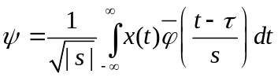

Here 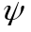 denotes the transformation and x(t) is the original signal, which is a function of time. 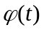 represents the mother wavelet, which is scaled using the scaling factor s, and translated using the translation factor over the entire signal. The translation may be thought of as similar to applying the Fourier Transform for a bin as in the case of the STFT.

Figure 7. The wavelet transform applied to Signal-1 and Signal-2 and their corresponding
wavelet plots

Consider the same signals, Signal-1 and Signal-2, used in explaining the limitations of the Fourier Transform in section 3.2.3.1. Now, the wavelet transform is applied using the Mexican Hat wavelet, and the results are illustrated in Fig.7. The darker regions in the corresponding wavelet plots represent regions of better correlation with the wavelet, and the y-axis represents the iteration of dilation of the mother wavelet. Without going into the intricate details of the plot, it can be noticed that the darker regions for both the signals occur in different regions, unlike in the case of the Fourier Transform, which in essence, signifies that better correlations occur in different regions of the signal. In this case, the wavelet is better correlated with the S1 component.

How do we guess the characteristic components? The mother wavelet has certain characteristic features, and the more correlated a region of the signal is to the wavelet in any iteration, using the characteristics of the mother wavelet, we can guess the characteristic features in different regions of the signal.

3.2.3.4. The Discrete Wavelet Transform

A discrete wavelet transform is any wavelet transform for which the wavelets are sampled discretely. Wavelets characterised by a low pass and a high pass filter bank is a feature extraction method applied in the current work. Daubechies wavelet of type 17 is used for feature extraction in the current work. The signal is decomposed as approximation A and detail D components and analysed in the 15-30Hz frequency band. The decomposition can be described as:

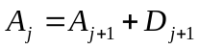
where the approximation is again decomposed into approximation and detail.

Figure 9. The filter bank structure of the DWT

The decomposition may be done more than once for a better frequency resolution. The approximation coefficients are further decomposed with low pass and high pass filters. This may be represented as a binary tree where the approximation at each level is decomposed into the approximation and detail of the next level. Each node has a different frequency localization. This structure is called a filter bank.

3.2.4. Common Spatial Patterns

Common Spatial Patterns (CSP) is used to further increase the inter-class variance (Mohanachandra and Saha, 2016). In essence, the wavelet transform measures the correlation between a wavelet at every time instance of the acquired signal, and CSP maximizes the separation between classes by increasing the variance of one class and simultaneously minimizing the variance associated with the other class. The CSP algorithm is commonly used in optimal channel selection from two classes of data, to reduce dimensions. Its working is based on simultaneous diagonalization of two covariance matrices.

Let ch represent the number of channels and t be the number of recorded samples per channel. Then the size of the data acquired from one trial will have a size of 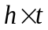 . The data from one trial may be represented as 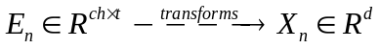. A set of feature vectors can be represented as a matrix 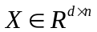.

The CSP Algorithm projects E_{n} to a spatial filter S such that 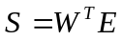 where 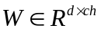 and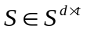.

The selection of appropriate weights using the characteristic values and characteristic weights can be done using 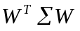, such that 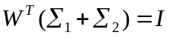.

The projection matrix W is computed by the simultaneous diagonalization of two the covariance matrices from the two classes. The covariance matrices 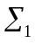 and 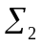 are calculated in the following way:
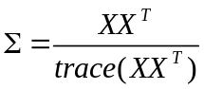

for the corresponding class as 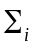 where 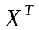 represents the transpose of the matrix X, and trace(XX^{T}) gives the sum of the diagonal elements of the matrix XX^{T}. The average covariance matrices 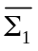 and 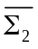 of multiple trials is computed for each class. Following this, the eigen value decomposition is performed on composite covariance matrix 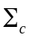 using:

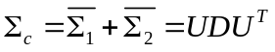

U is a matrix of normalized eigenvectors, such that 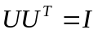 and D is the corresponding matrix of eigenvalues. The obtained eigenvalues are sorted in ascending order. Following this, the whitening transform is performed using:
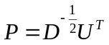

The matrix P transforms the average covariance matrix for fast convergence. The whitening transformation is applied to the original covariance matrices of the two classes as shown below. The matrix P transforms the average covariance matrix to 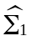 and 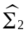 as shown:

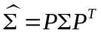

The steps in the whitening transform are shown below.

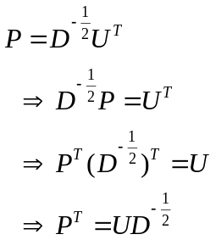

Thus,
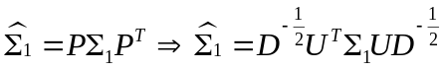

and,
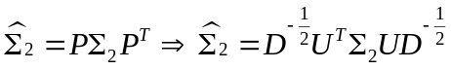

Therefore, from Equations 2, 6 and 7,
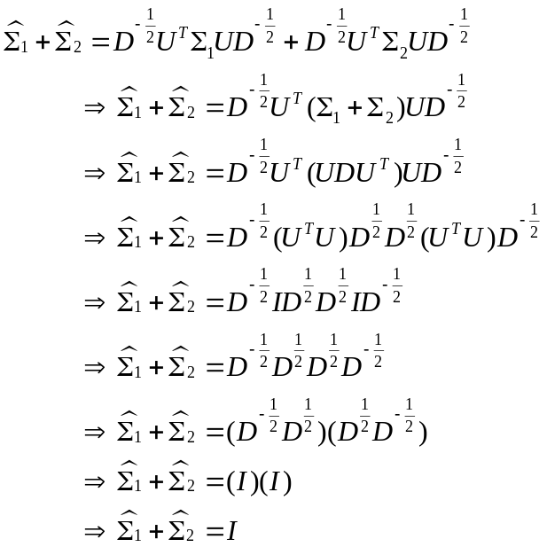

Hence, any orthonormal matrix I will obey:

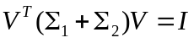

Following this, CSP is formulated as an optimization problem using sequential programming. Using the theory of the Hessian matrix, the local minima is found from the covariance matrices.

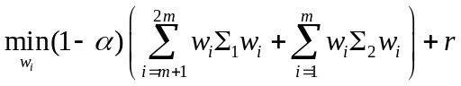
where,
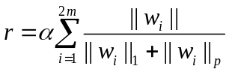

is the regularization term, used to induce sparsity.

Here,

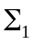 and 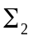 are the covariance matrices of Class1 and Class2 of our data. The weights w_{i} are computed using Equation 12, such that 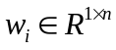, 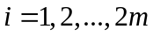. w_{i} represents the first and last m rows of the CSP projection matrix, denoting m largest characteristic values of 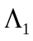 and 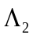, where and are the diagonal matrices of Class1 and Class2 respectively. The characteristic values are ordered in descending order. The optimal value of is found from the local or global minima of the convex optimization problem.

Lastly,
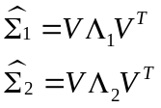
where V is a set of characteristic vectors. The CSP projection matrix W is computed as shown in Equation 14. The rows of W are the spatial filters and the columns of W⁻¹ are the common spatial patterns.

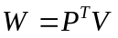

The original EEG trial is transformed into uncorrelated, linearly independent components with the projection matrix W from Equation 14 as .

3.3. Classification Methods

3.3.1. Decision Tree

Decision trees use a tree data structures to model decisions and predict outcomes. Decision trees are helpful in cases where one decision leads to a series of choices. When we deal with a lot of data, there may be certain feature points which may be used as boundaries that help us to separate one type of data from another.

As an illustrative example, let us consider a student's dinner habits. We have the data for two weeks of her attendance to the dining hall of her hostel. On the days she doesn't have dinner at the hostel, she eats out. We are trying to relate her attendance based on what is served for dinner: the main course, the side dish and the dessert. The following table shows all the data.

Day | Main Course | Side Dish | Dessert | Action
1 | Pasta | Meat | Ice Cream | YES
2 | Rice | Mashed Potatoes | Custard | NO
3 | Bread | Mashed Potatoes | Chocolates | NO
4 | Bread | Veg Salad | Ice Cream | YES
5 | Pasta | Mashed Potatoes | Chocolates | NO
6 | Bread | Mashed Potatoes | Ice Cream | YES
7 | Rice | Veg Salad | Chocolates | NO
8 | Bread | Meat | Custard | YES
9 | Rice | Veg Salad | Ice Cream | NO
10 | Pasta | Veg Salad | Custard | YES
11 | Pasta | Mashed Potatoes | Custard | NO
12 | Rice | Meat | Custard | YES
13 | Bread | Meat | Chocolates | YES
14 | Pasta | Meat | Custard | YES
15 | Bread | Veg Salad | Chocolates | ?

Table 2: A student’s dinner habits based on her food preference

The data for the days from 1 to 14 are the training set. Based on observations from the training set, we will predict her attendance on day 15.

On the whole, we observe that she had dinner at the hostel on 8 out of the 14 days, and she ate out on the remaining 6 days.

Figure 10: Days when the student had and did not have dinner in her hostel dining hall

We represent the root node of our decision tree as the blue box. We have also enlisted the days that she ate at the hostel in green colour, and the days she did not eat in hostel in red colour, beneath the box.

Just based on the number of days that she ate at the hostel, we will be unable to predict with a high level of certainty if she will eat on day 15 or not. So as our first split point, i.e the feature that we will use to predict the next level of outcomes, let us consider the main course. We extend branches in the tree, based on it.

Figure 11: Growing the decision tree based on main course only

As we can see in the above tree, that under each of the nodes, there are still uncertainties. Hence, these nodes are called impure nodes or impure sets. So to make our prediction more robust, let us also include the attribute of side dish and extend our decision tree further.

When we further add nodes branching from Pasta, we see that for the attributes Meat and Veg Salad, all the decisions are true, whereas for the attribute Mashed Potatoes, all the decisions are false. All the pure nodes, wherein she ate at the hostel are coloured green, and all the pure nodes wherein she ate outside are coloured red. Hence, these two leaf nodes are pure sets. This means that whenever pasta was served with meat or veg salad, the student ate at the hostel's dining hall, and whenever pasta was served with mashed potatoes, she ate out. Similarly, we branch out the tree from the nodes Rice and Bread, and get the tree below.

Figure 12: Growing the tree further by considering the side dish attribute

But when we look at the node Bread and its branch Mashed Potatoes, we see that the set isn't pure. Hence, under this attribute, we extend the tree further, by considering the Dessert attributes.

Figure 13: Fully grown decision tree, incorporating all attributes

Now, all the nodes in the tree are pure. This is a necessary condition for a decision tree to be used.

We can now predict if the student will be present on day 15. Looking at the table, we see that on day 15, the Main Course is Bread, the side dish is Veg Salad and the Dessert is Chocolates. Tracing these attributes in the tree, we observe that whenever Bread was served with Veg Salad, the student dined at her hostel. So according to this decision tree, the prediction is that she will eat at her hostel dining hall on day 15.

In the above example, the choice of the split points is not necessarily optimized. For all practical cases, the data is a lot more than this! Some of the most popular algorithms for selecting split points and generating decision trees are:

- ID2
- C4.5
- CART
- Best First Tree
- SLIQ
- SPRINT

Generally, the optimization of all learning approaches involves minimization of an error term. By minimizing an error, the algorithm ensures better classification accuracy, and yields better results. One of the most popular measures of impurity or error is the Gini Impurity (Duda, Hart, Stork, 2001). For the task of classification, it is given as:

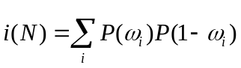

where 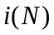 represents impurity at a node N
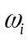 represents an element from class i

The Gini Impurity index is calculated by considering the probability of the elements from a class i occurring at a node N. The probability of at a node would be given by:

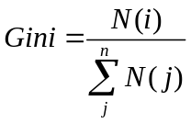
where N(i) represents the number of elements belonging to class i.

3.3.2. Random Forests

A Random Forest is an ensemble of many Decision Trees. The purpose of doing this is to increase accuracy, as the prediction from a combination of learning models is generally better than single-model paradigms (Duda, Hart, Stork, 2001).

A random forest algorithm works as a large correlation of decorrelated decision trees. If we are presented with N training samples, then we sample n cases from the original data at random, with repetition. If there are M attributes, a number m < M is specified such that in each smaller tree that is created, m attributes are selected at random out of the M and the best split points on these m are used to split the node. The value of m is held constant during the forest growing and each tree in the forest is grown to the largest extent possible.

Let us consider the following matrix S, with M columns, and N rows.

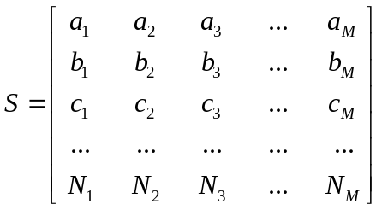

The Random Forest algorithm will generate subsets of S, having m columns and n rows. For example, let us assume that the following matrices are generated.

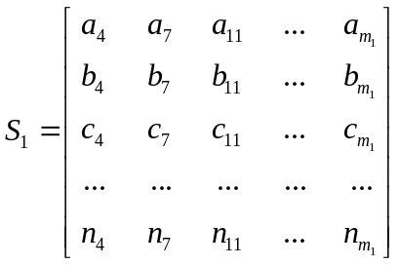
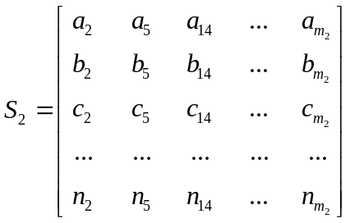

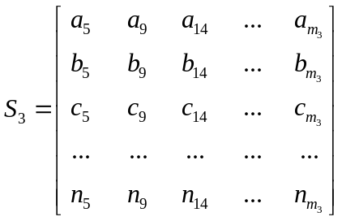

From each of the above subsets, a corresponding decision tree is constructed, and the test data is passed as an input to all the decision trees. The outcomes from each tree is recorded, and the outcome with the most occurrence is assumed to be the correct output. Each decision tree votes for a certain outcome, and the outcome with the higher number of votes is assigned as the class label of the test data.

3.3.3. Support Vector Machine

Watson and Nadaraya introduced kernel methods for predictive learning in 1964. Based on a training dataset or a predictor dataset, the estimated response variable for a given input is defined as the weighted average of the training response. A vector space V is spanned by the predictor variables and their location and the weight kernel is assigned to each response variable, defining the weights and is called the kernel function. The kernel function is often represented as a monotonic decreasing function of some scaled parameter and distance, weights being adaptive, aiding the kernel value to diminish with distance between points.
Kernel methods suffer from two major drawbacks: model insufficiency and statistical inaccuracy. Since the kernel function is not explicitly defined, the method lacks a detailed explanation of the dependence of the kernel function on the predictor variables. Each prediction requires scanning the entire database rendering the computation time intensive for large datasets. If the distance function is not chosen carefully, the regression model performs inadequately, inducing sparsity in extremely large datasets but a handful of predictor variables.

Support Vector Machines is one of the more recent kernel methods and overcomes some of the critical limitations of elementary kernel methods. Define y = f(x), where 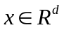, f is a non-linear map and unknown 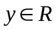; the training dataset (x_{i}, y_{i}); 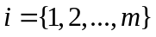 is the only interpretation available. The model is regression-like, except for the fact f is not known. The problem definition resembles a traditional inferential statistics problem. However unlike an inference problem, parametric structure (linear or otherwise) in learning from the training data is absent. Also, SVM doesn't rely on SSE and MLE since the default assumption of stochastic data being normally distributed is not encouraged.

The dataset in the exercise of classification of mental states, following the Wavelet Transform is multidimensional and the underlying relation or mapping is not very smooth. Therefore, regression models or assumptions about normality in data are not favoured. Kernel based methods like SVM, which constructs a hyperplane to separate two classes and may be extended later to discriminate among multiple classes, prove to be extremely useful for this kind of problem problem (Mohanachandra et al., 2014; Mohanachandra, Saha and Murthy, 2014).

So how does an SVM work? Let us consider linearly separable binary datasets with features and (easily extensible to ). The task is to classify the elements shown in Figure 14.

Figure 14: The use of a hyperplane in SVM

But consider the following case (Figure 15):

Fig 15: Multiple hyperplanes constructed to segregate two classes

In this case, both the hyperplanes classify all the data points correctly but the best hyperplane is the one which leaves a maximum margin from both classes. Now, what is a margin?

A margin is the distance between the hyperplane and the closest element (data point) (Manning, Raghavan and Schütze, 2008)
. As observed from Figure 2, margin1 is larger than margin2 and hence is the best candidate hyperplane among the two. Going back to Figure 1, a hyperplane is mathematically represented as:

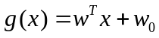

where, w is the weight vector; and
x is the training dataset

The hyperplane is scaled such that
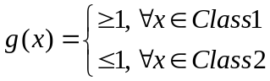

and the distance (margin), z is computed by:

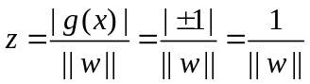

such that the total margin becomes 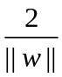.

This implies that the classification problem is an optimization exercise where the margin w has to be minimized for maximum separability.

This implies,
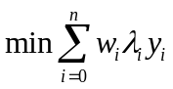
subject to the constraints
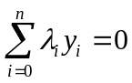

This method is known as the Lagrangian Multiplier method.

As a simple example, let us consider the following two data points. The green dot represents the point (5,3.5) and the blue dot represents the point (11,12) in the coordinate system. We have to classify these two points into two separate classes and accordingly, find the best hyperplane to do so.

Here, we have:
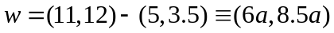

From the above equation, we arrive at (from Equation 15):

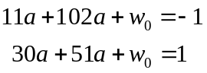

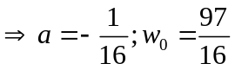

Figure 16: Selecting optimal hyperplane between the two given points

Therefore, the best hyperplane may be defined by:

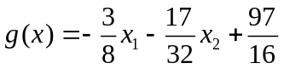

From the above equations (Equations 16 and 17), we arrive at:

g(5,3.5) = -1 ~Class1
g(11,12) = 1 ~Class2

The classification task in the current work involved a binary classification, that is, classification into two classes. Thus, the above approach was used to classify data into two classes, based on the levels of attention.

    - K Nearest Neighbours

The k-NN is a vector classification technique that classifies feature vectors based on the nearest training samples in a feature space. The advantage of the k-NN method over other learning methods is its ability to deal with multiple class problems (Yazdani, Ebrahimi and Hoffmann, 2009). The algorithm is robust to noisy data as it averages the k nearest neighbours. The vector is classified by a majority vote of its neighbours. Typically, the value of k is chosen as a small positive integer in order to make the boundaries between various classes in the feature space more distinct.

In the training phase, the feature vectors are assigned a corresponding class label. The training samples are vectors in a multidimensional vector space, each with an assigned class label. In the classification phase, an unclassified vector is assigned the label as that of the k nearest neighbours.

Figure 17: Classification using the k Nearest Neighbours approach

As an example, from (the above) figure, the test sample (colour: blue) should be assigned the same label as the class represented by red stars or green circles. The test sample is assigned the same label of the class represented by red stars when k = 3, as it looks only for the three nearest neighbours. If k = 5, the same test sample looks for the five nearest neighbours and is assigned the label as the class represented by the green squares.

3.4. RESULTS AND DISCUSSION

The proposed system was tested on four healthy subjects. The results from each classifier is given below: mean accuracy, sensitivity and specificity. In each case, the accuracy varies from subject to subject, as the signals obtained depends on the test subject as well as the test case. Each subject had approximately a hundred trials of each task, contributing to a total of 200 trials for two mental states of each subject. For every subject, the dataset was divided in the ratio of 4:4:2 of each task: The first 40% of the data was used to generate the spatial filters for the CSP algorithm. This, along with the next 40% were used to generate training data from the spatial filters. The last 20% for each iteration was the training data and was used to evaluate the results from each classifier. A total of 1000 iterations were performed for each subject for each classifier.

3.4.1. Results from Random Forests Classifier

Subject | Mean  Accuracy(%) | Maximum Accuracy(%)  (in one iteration) | Minimum Accuracy(%)  (in one iteration) | Sensitivity | Specificity
1 | 68.210 | 100.0 | 22.22 | 0.772 | 0.582
2 | 54.111 | 100.0 | 10.0 | 0.766 | 0.317
3 | 52.509 | 100.0 | 7.143 | 0.692 | 0.366
4 | 51.931 | 93.75 | 8.33 | 0.760 | 0.286

Table 3: Results from Random Forests Classifier

3.4.2. Results from Support Vector Machine Classifier

Subject | Mean  Accuracy(%) | Maximum Accuracy(%)  (in one iteration) | Minimum Accuracy(%)  (in one iteration) | Sensitivity | Specificity
1 | 60.447 | 100.0 | 16.667 | 0.884 | 0.288
2 | 49.746 | 93.75 | 6.667 | 0.933 | 0.066
3 | 51.775 | 90.909 | 7.692 | 0.847 | 0.204
4 | 49.481 | 100 | 6.25 | 0.914 | 0.088

Table 4: Results from Support Vector Machines Classifier

3.4.3. Results from k-Nearest Neighbours Classifier

Subject | Mean  Accuracy(%) | Maximum Accuracy(%)  (in one iteration) | Minimum Accuracy(%)  (in one iteration) | Sensitivity | Specificity
1 | 68.193 | 100.0 | 21.429 | 0.743 | 0.612
2 | 53.041 | 94.737 | 0.0 | 0.708 | 0.354
3 | 47.985 | 92.857 | 7.692 | 0.620 | 0.347
4 | 50.883 | 92.308 | 10.0 | 0.722 | 0.303

Table 5: Results from k-Nearest Neighbours Classifier

The results of the experiment show that the sophistication required to develop a well-functioning Brain Computer Interface is far beyond a single electrode system, with the electrode placed on the forehead. As for existing work which have made used of the NeuroSky Mindwave devices: most of them rely on a level of attention to perform a simple task, not the different classes of attention. While this popularization of BCI is useful to attract attention towards the study of the field, a system like this is not particularly useful in itself.

The results of the experiment reflect almost a random experiment where success is as likely as failure. With only Subject 1 the results are close to 70% accuracy: this is encouraging. However, this accuracy is far less than what can be achieved using sophisticated signal acquisition devices like the Skull Cap.

4. FUTURE RESEARCH DIRECTIONS

With time, technology becomes smaller and more compact. We can appreciate this by comparing the first generation computers to the computers of the present: today, our machines are much smaller, portable, cheap, and are more powerful than the supercomputers of previous generations. Such is the trend with any technological application. In BCI as well, with time, headsets and applications have become more compact, and this is triggered by developments at the hardware end as well as the analyses’ end. This chapter provides insights about attempts at making EEG hardware cheaper and with a more effective form factor. The author’s research involved using this hardware to analyze subjects’ mental states based on their level of attention.

Subjects need to be adequately trained for tasks pertaining to interaction with computers based on brain waves. Even with the best of the current technology, subjects need to be still, relaxed and focused on a certain task. It is particularly difficult to classify mental states based on attention alone: more popular approaches include motor imagery, visually evoked potentials and subvocalization. Motor imagery is based on imagined motion of certain body parts such as an arm, or a leg; subvocalization is the act of silently pronouncing a word in the mind, without actually saying it out loud; Steady State Visually Evoked Potentials (SSVEP) is an approach where brainwaves are triggered by visual cues, such as flickering lights of different frequencies. These approaches are preferred as the related tasks activate certain regions of the brain, and based on which regions are activated, a brain-computer interface may be effectively developed. The key direction in which the development of more compact hardware must be driven is to utilize specific genres of mental tasks, such as motor imagery, subvocalization, SSVEP or other similar approaches.

While the classification accuracy achieved in the present work is not very high, the results show promise to drive research in the fields of non-medical applications, using portable hardware with less electrodes to reduce the cumbersome nature of traditional BCI setups. Other headsets like the Emotiv EPOC and the Muse headbands should also be experimented with. When the number of electrodes in a BCI setup is reduced, the placement of the electrodes in the appropriate positions over a subject’s scalp is of foremost importance. This is one of the major limitations of the aforementioned EEG headsets: the positions of the electrodes are fixed.

The direction of work following this would be to increase the flexibility of usage in EEG headsets, and to better analyse the signals acquired from subjects. The current setup serves as a prototype which may be extended to various applications such as games and other entertainment for locked-in or paralyzed patients.

5. CONCLUSION

The greatest challenges of EEG based Brain Computer Interfaces are their non-stationarity, low signal-to-noise ratio and the variety of noise resources such as muscle artefacts, eye blinks, etc. A demand for robust signal and data processing methods subsists, to obtain accurate results in and other cognitive tasks, wherein no external stimulus is used to enhance the signal amplitude. In the current work, different methods of signal pre-processing (wavelet transform, CSP) and classification (Decision Trees, Random Forests, SVM, kNN) are used, and their performance accordingly evaluated, using statistical parameters. Test subjects need to be rigorously trained in order to be able to perform the necessary mental tasks, and give good results. A lack of concentration, or muscle artefacts may lead to more noise and as a result, may affect the quality of the result. Research must also be driven to develop smaller, more usable and more robust hardware devices that may pertain to specific needs as per a user’s requirements. Better hardware, developed with time, such as better quality electrodes, wiring, amplifiers, etc. will also play a significant part in the development of BCI in the future.

The priority of methods according to their capability is difficult to acclaim as each method has significant advantages and shortcomings for specific applications. The findings of the current work may be extended to drive an object, provided the appropriate interface, or be used with a system with more electrodes and be implemented as a full-fledged speller machine.

REFERENCES

Mohanchandra K., Saha S. (2014). Optimal Channel Selection for Robust EEG Single-trial Analysis, AASRI Conference on Circuit and Signal Processing

Mohanchandra K., Saha S. (2016). A Communication Paradigm Using Subvocalized Speech, Augmented Human Research, Springer Singapore

Mohanchandra K., Saha S., Deshmukh R. (2014). Twofold Classification of Motor Imagery using Common Spatial Pattern. Paper presented at the International Conference on Contemporary Computing and Informatics, Mysore, Karnataka, India

Mohanchandra K., Saha S., Murthy K. S., Lingaraju G.M. (2014). Distinct adoption of k-nearest neighbour and support vector machine in classifying EEG signals of mental tasks, International Journal of Intelligent Engineering Informatics, (Vol. 3, Issue 4, p313-329), Inderscience Publishers (IEL), Geneva, Switzerland

Mohanchandra K., Snehanshu Saha, Murthy K. S. (2014). EEG based Brain Computer Interface using Wavelets and SVM. Paper presented at Grace Hopper Conference India (GHCI), Bangalore. Karnataka, India

Anupama H. S., Cauvery N. K., Lingaraju G. M. (2014). Brain Controlled Wheelchair for Disabled, International Journal of Computer Science Engineering, (Vol. 4, Issue 2, p157-166)

Larsen E. A. (2011). Classification of EEG Signals in a Brain-Computer Interface System. (Unpublished masters’ dissertation). Norwegian University of Science and Technology (NTNU), Norway

Yildirim N., Ulas M., Varol A. (2015). A Game Development for Android Devices Based on Brain Computer Interface: Flying Brain, Proc. of the Intl. Conf. on Advances in Applied science and Environmental Technology (p77-81)

Theodoridis S., Koutroumbas K (2009). Pattern Recognition, Academic Press

Manning C. D., Raghavan P. and Schütze H. (2008). Introduction to Information Retrieval, Cambridge University Press
Yazdani A., Ebrahimi T., Hoffmann U. (2009), Classification of EEG Signals Using Dempster Shafer Theory and a K-Nearest Neighbor Classifier. Paper presented at the International IEEE EMBS Conference on Neural Engineering Antalya, Turkey
Duda R. O., Hart P. E., Stork D. G. (2001), Pattern Classification, Wiley

