Part 2:

Population stops growing whenever it reaches the initial population of the virus (500).

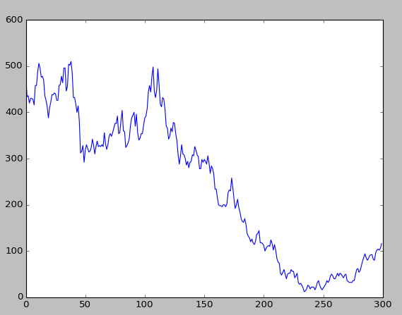

Part 4:

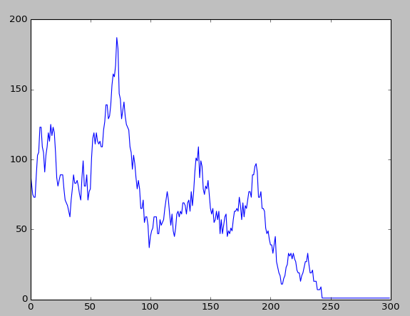

Total Population Graph

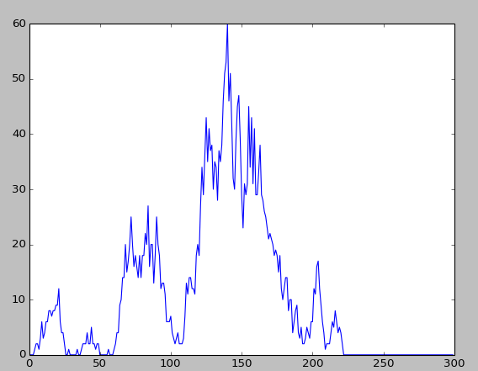

Guttagonol-resistant graph

Intuition: Total population should gradually drop, even with the existence of a few guttagonol-resistant viruses.

Part 5:

|  |  |
| --- | --- |
|  |  |
| Treatment at 0 | Treatment at 75 |
|  |  |
| Treatment at 150 | Treatment at 300 |

From a total of 20 patients, 15 are cured/in remission. From the tables presented, given the 5 runs, the total number of viruses present in the patient is generally reduced when starting treatments earlier.

Part 6 (reduced from 30 to 5, as it takes an unreasonable amount of time and resources [CPU processing and RAM] to actually have the program run 30 times):

|  |  |
| --- | --- |
|  |  |
| Treatment at 0 | Treatment at 75 |
|  |  |
| Treatment at 150 | Treatment at 300 |

Percentage of cured/in remission: 65% (13/20)

There seems to be no effect on time applied and the total number of viruses.

Part 7:

Patient 1:

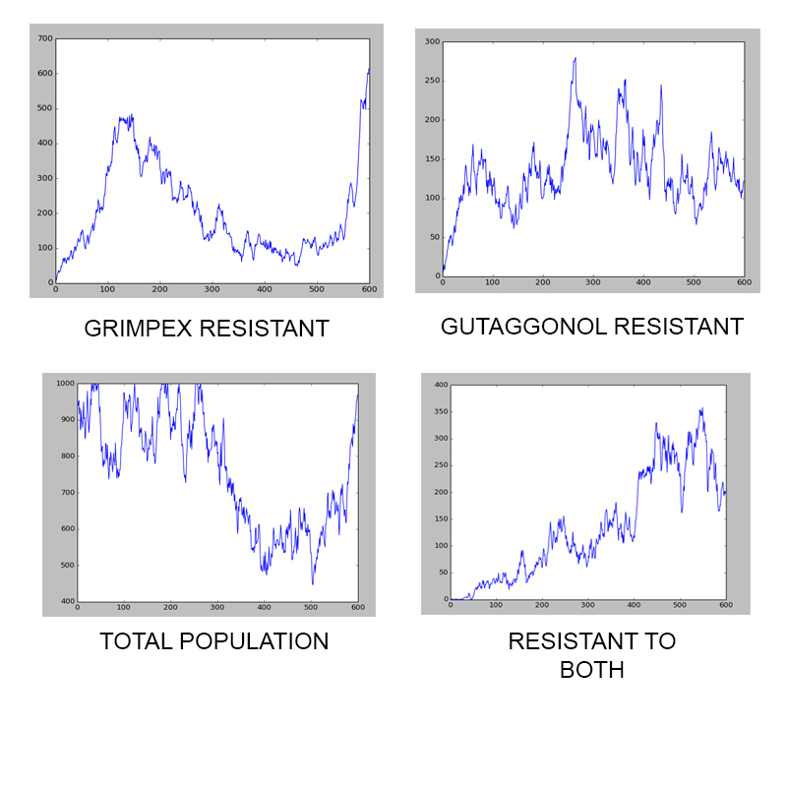

Patient 2:

Part 8:

We would randomize the application of the prescribed drug; that is, remove all the prescribed runs every timestamp and have a randomly generated number that checks for the probability of the patient actually taking the drug.

If the randomly generated number is greater than the probability criteria, then the drug is considered to be taken, otherwise treat the timestamp cycle as if the patient had not taken the drug for that particular cycle.

Otherwise, it is also possible to implement a mathematical progression for the 'gap-cycles', that is, the number of cycles skipped by the patient should they decide to not take the drug for a certain period of time. For example, the patient would first skip one cycle, take the drug, then skip another cycle, then take the drug, then skip two cycles, take the drug, then skip three, then five, and so on.

Of course, it is also possible to implement a combination of both proposed solutions.

Part 1: Jim Francinilla (2 hours)

Part 2: Jim Francinilla, James Dizon (8 hours due to bugs present)

Part 3: Jim Francinilla, Kurt Bacalso, Marielle Banawan, James Dizon (2 hours)

Part 4: Jim Francinilla, Kurt Bacalso, Marielle Banawan, James Dizon (2 hours)

Part 5: Kurt Bacalso (2 hours)

Part 6: Marielle Banawan (2 hours)

Part 7: Marielle Banawan, Jim Francinilla, Kurt Bacalso (2 hours)

Part 8: James Dizon (1 hour)