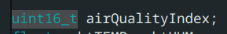

VOC Index
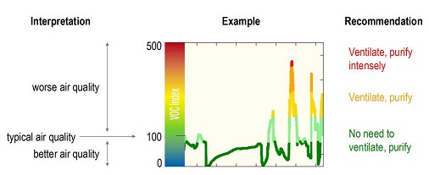
VOC Index | Air Quality | Suggested Action
0-100 | Excellent | No measures needed
100-200 | Good | No measures needed
200-300 | Lightly Polluted | Ventilation suggested
300-400 | Moderately Polluted | Increase ventilation with clean air
400-500 | Heavily Polluted | Optimize ventilation
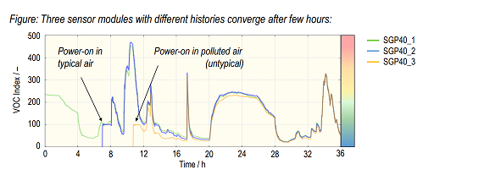
- The sensor provides the change of air quality trend, and the algorithm will continuously adjust the baseline of typical air according to historical data. The longer the sensor is used, the better the sensitivity and accuracy of trend and change.
- In the normal air environment, the sensor can obtain the accurate VOC index immediately after use; in the heavily-polluted environment, the sensor can obtain the accurate VOC index after use for about 1 hour. It is recommended to integrate it into the long-term indoor projects.
https://wiki.dfrobot.com/Gravity_SGP40_Air_Quality_Sensor_SKU_SEN0394

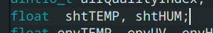

Temperatura I wilogtnosc po porstu
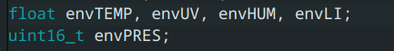

Atmospheric pressure sensor
Atmospheric pressure unit relationship: 1000pa = 10hpa = 1kpa
- Sensor chip model: BMP280
- Atmospheric pressure measurement range: 300~1100 hPa
- Relative accuracy of atmospheric pressure: ±0.12 hPa
- Absolute atmospheric pressure accuracy: ±1 hPa

Temperature & Humidity Sensor
- Sensor chip model: SHT-C3
- Relative humidity accuracy: ±2%RH
- Relative humidity resolution: 0.01%RH
- Relative humidity measurement range: 0~100
- Temperature accuracy: ±0.2℃
- Temperature resolution: 0.01℃
- Temperature measurement range: -40~125℃

Ultraviolet Sensor
- Sensor chip model: ML8511
- Ultraviolet sensitive wavelength UV-A (320-400nm), UV-B (280-320nm)
- Ultraviolet output unit: mW/c㎡

Ambient light sensor
- Sensor chip model: VEML7700
- Ambient light accuracy: 0.0036 lx/ct
- Ambient light range: 0~120 klx
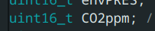

CO2
- Accuracy: ±(40 ppm + 5% MV)
- Measuring Range: 400 - 5000 ppm
- Response Time: 60s

https://wiki.dfrobot.com/AS7341_Visible_Light_Sensor_SKU_SEN0365

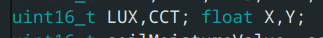

https://wiki.dfrobot.com/SKU_SEN0611_Gravity_Color_Temperature_and_Ambient_Light_Sensor

te należałoby skalibrować żeby wiedzieć jaką wartość dają

