Scientific Validation of the SciML-MD
Molecular-Dynamics Anomaly-Detection Pipeline
Correctness, statistical validity, and external validation of tICA → MSM → multi-signal anomaly scoring
Siya Jethliya
SciVizAI · SciML-MD
15 August 2026
Repository branch: validation-fixes (off topology-contract-fix @ 431132d)

Contents
1 Executive Summary
1.1 Summary of defects found and fixed
2 Scope, Systems, and Environment
2.1 Pipeline under test
2.2 Systems studied
2.3 Computational environment
2.4 Validation design
3 Layer 1 — Implementation Correctness
3.1 Formula-level verification
3.2 Defect 1 — state-space mismatch (highest impact)
3.3 Defect 2 — tie handling in rank normalisation
3.4 Defects 3–6 — scoring, aggregation, and export
3.5 Edge-case behaviour
4 Detection Accuracy — Before and After
4.1 Rare-state detection
4.2 Rare-transition detection
4.3 Channel structure
5 Layer 2 — MSM Statistical Validity
5.1 Implied timescale convergence
5.2 Chapman–Kolmogorov test
5.3 Bootstrap uncertainty on the stationary distribution
5.4 VAMP-2 model selection — defect found
5.5 What Layer 2 establishes
6 Layer 3 — External Scientific Validation
6.1 Comparison with experimental B-factors
6.2 Comparison with baseline anomaly detectors
7 Limitations and Threats to Validity
8 Recommendations
8.1 Required before publication
8.2 Recommended for strength
8.3 Infrastructure
9 Deliverables and Reproduction
References

1 Executive Summary
This report documents a complete validation campaign on the SciML-MD pipeline, which ranks dynamic hotspot residues in proteins by fusing three anomaly signals derived from a Markov State Model (MSM) built over tICA-reduced molecular-dynamics features. The campaign was organised in three layers: implementation correctness, statistical validity of the MSM, and external scientific validity against experimental data.
The central finding is that the pipeline’s mathematics was correct while its implementation was not. All three signal formulas reproduce hand-computed reference values exactly, but six implementation defects corrupted the scores actually produced. The most consequential was a state-indexing defect: clustering labels were never remapped onto the MSM’s connected set, so up to 37 % of frames read the wrong stationary probability — and the error fell hardest on precisely the rare states the method exists to detect.
After correction, rare-state detection improved from AUROC 0.83–0.86 to 0.95–0.96 and rare-transition detection from 0.65–0.79 to 0.81–0.99. Per-residue outputs correlate with experimental crystallographic B-factors at ρ = 0.60 (8H0R) and ρ = 0.57 (1UBQ), and the method outperforms standard geometric anomaly detectors on every system tested — decisively so on kinetic events, which geometry-only methods cannot see at all.
The campaign also establishes a clear limit: at 100 frames per trajectory, the standard MSM validity tests lack the statistical power to support Markovianity claims. Confidence intervals on stationary probabilities are as wide as the values themselves. The method is sound; the sampling is not yet sufficient for kinetic claims in publication.
Headline result. Correcting the state-indexing defect raised fused rare-state detection from AUROC 0.83–0.86 to 0.95–0.96 across three proteins, and restored the rarity channel from near-chance (0.45 on 8H0R) to exact.

1.1 Summary of defects found and fixed
# | Defect | Measured impact at baseline | Status
1 | Cluster labels never remapped to MSM active set | Rarity channel AUROC 0.45–0.80; buggy-vs-correct Spearman as low as −0.50; 0 % overlap in top-10 % flagged frames | Fixed
2 | Rank normalisation broke ties by frame order | Tie groups of 21–410 frames spread across 20–42 score points by index alone | Fixed
3 | Transitions touching disconnected states scored as least anomalous | Corrected-surprise AUROC 0.02 on 1CRN (inverse ranking) | Fixed
4 | Per-residue scores reduced to pure RMSF | Pearson r = 1.000 vs RMSF on 1VII — frame-level anomaly contributed nothing | Fixed
5 | Residue keys collided across chains | 8H0R: 182 residues → 91 entries; half silently overwritten | Fixed
6 | ASVS export produced constant values | anomaly_residue.json = 0.25 for every residue × frame | Fixed
7 | Chapman–Kolmogorov test compared mismatched state spaces | Test invalid whenever any state was pruned (i.e. always) | Corrected in runner
8 | VAMP-2 scorer numerically unstable on real features | Returned 2.5 × 10⁵ where valid scores are bounded by dimension | Corrected in runner
Defects 1–6 affected the production scoring path; defects 7–8 were found in the validation tooling itself while executing Layer 2. Both classes share a root cause: code paths that were never exercised against real pipeline outputs.

2 Scope, Systems, and Environment

2.1 Pipeline under test
The pipeline proceeds: MD trajectory → feature extraction (7 features: RMSD, radius of gyration, CA–CA native contacts, and sine/cosine encodings of φ/ψ backbone dihedrals) → tICA dimensionality reduction → KMeans clustering into discrete conformational states → reversible maximum-likelihood MSM → multi-signal anomaly scoring. Three signals are fused by median after rank normalisation, then rescaled to [0, 100]:
- State rarity — 1 − π[s], the thermodynamic perspective: how rarely is this state occupied at equilibrium?
- Transition surprise — −log P[sₜ → sₜ₊τ], the kinetic perspective: how unexpected is the observed transition?
- Local density — mean k-nearest-neighbour distance in tICA space, the geometric perspective: how structurally isolated is this conformation?

2.2 Systems studied
System | Identity | Method / resolution | Frames | Role in campaign
1VII | Villin headpiece subdomain | NMR | 100 | Baseline + accuracy; excluded from B-factor analysis
8H0R | Mouse βB1-crystallin Y202X cataract mutant | X-ray, 1.20 Å | 100 | Baseline, accuracy, B-factor benchmark
1UBQ | Ubiquitin | X-ray, 1.80 Å | 100 | Independent X-ray benchmark
1CRN | Crambin (solvated) | X-ray | 1001 | Long-trajectory reference
9O6O | Human Siglec-10 + 2,6-sialyllactose | X-ray, 2.70 Å | pending | Extension target
9UNN | Mouse NMDA receptor GluN1/N2A-S3 | cryo-EM, 3.29 Å | pending | Extension target (23k atoms)
Trajectories are short implicit-solvent runs generated with OpenMM (AMBER14 + GBn2, Langevin 300 K, 2 fs). Structural identities were confirmed against RCSB entries on 15 August 2026.

2.3 Computational environment
Component | Version | Component | Version
Python | 3.11.15 | OpenMM | 8.5.2
deeptime | 0.4.5 | PDBFixer | 1.12.0
mdtraj | 1.11.1 | scikit-learn | 1.8.0
Hyper-parameters throughout: tICA lag 5, dimension 3, 10 KMeans clusters, MSM lag 5, k = 5 neighbours, smoothing window 3, seed 42 — matching the batch_runner defaults used for the original runs.

2.4 Validation design
The campaign followed a baseline → fix → re-validate structure, so that every improvement is evidenced by a paired measurement rather than asserted. Ground truth for accuracy is operational and derived from the correctly estimated MSM — a frame is labelled rare-state if it occupies a bottom-quartile-π state or a disconnected state, and rare-transition if the observed transition occurs at most once at the lag. Labels are purely kinetic, while the fused score retains an independent geometric channel, so the evaluation is not circular for the headline fused numbers. Where a channel is definitionally tied to its labels (rarity against rare-state labels), this is stated and those rows are excluded from comparative claims.

3 Layer 1 — Implementation Correctness

3.1 Formula-level verification
A three-state analytic Markov chain with known transition matrix was constructed, its stationary distribution solved by eigendecomposition, and the pipeline’s kinetic-signal function evaluated against values computed by hand. All checks matched to machine precision:
Quantity | Expected (hand-computed) | Pipeline output | Verdict
rarity(state 0) = 1 − π₀ | 0.600000 | 0.600000 | Exact
surprise(0 → 1) = −ln 0.1 | 2.302585 | 2.302585 | Exact
surprise(2 → 2) = −ln 0.8 | 0.223144 | 0.223144 | Exact
Conclusion. The science is right; the indexing was wrong. Every defect below is an implementation error, not a modelling error — which is why the fixes were surgical and the recovery in accuracy so large.

3.2 Defect 1 — state-space mismatch (highest impact)
deeptime’s maximum-likelihood MSM estimates the transition matrix only over the largest connected set of states, emitting warnings of the form “Skipping state set [k]”. Row i of the resulting matrices therefore corresponds to original cluster label state_symbols[i], not to label i. The pipeline indexed π and P with raw KMeans labels, so whenever any state was pruned — which occurred in every single run — frames read the wrong state’s statistics.
Two distinct failure modes result. Frames in dropped states whose label happens to be numerically valid read a real but incorrect π entry, producing silent corruption with no warning and no NaN. Frames in surviving states are shifted whenever a middle state is pruned: with labels 2, 4 and 6 removed, a frame in cluster 5 reads the statistics of an entirely different physical state.
System | Frames | Labels | MSM states | Dropped | Frames in dropped states | Survivors misindexed | Rarity ρ (buggy vs correct)
1VII | 100 | 10 | 8 | [2, 4] | 10 | 50 | 0.68
8H0R | 100 | 10 | 7 | [2, 4, 6] | 11 | 28 | −0.50
1CRN | 1001 | 10 | 7 | [2, 4, 8] | 53 | 375 | 0.26
On 8H0R the corrupted rarity signal is anti-correlated with the correct one. The practical consequence is starker than the correlation suggests: of the ten frames the shipped pipeline ranked most anomalous by rarity on 1VII and 8H0R, none were among the ten the corrected computation identifies.

3.3 Defect 2 — tie handling in rank normalisation
Rank normalisation was implemented as argsort(argsort(x)), which assigns distinct ranks to tied values in order of appearance. Because large groups of frames legitimately share identical signal values — all frames whose transition surprise is zero, all frames defaulted to rarity 1.0 — this converted ties into an arbitrary ramp determined by frame index.
System | Largest tie group (rarity) | Score spread within group | Largest tie group (surprise) | Score spread within group
1VII | 21 frames | 20.2 points | 31 frames | 30.3 points
8H0R | 33 frames | 32.3 points | 43 frames | 42.4 points
1CRN | 278 frames | 27.7 points | 410 frames | 40.9 points
A tie-aware average-rank implementation gives a spread of exactly zero in all cases. On 1CRN, 410 frames — 41 % of the trajectory — were being ordered by nothing but their position in time.

3.4 Defects 3–6 — scoring, aggregation, and export
- Disconnected transitions scored as zero. Transitions entering or leaving a pruned state were assigned surprise 0 — the least anomalous value possible — making the channel blind to the rarest events in the trajectory. On 1CRN this inverted the ranking entirely (AUROC 0.02). Such transitions are now capped at the maximum finite surprise observed.
- Per-residue scores were pure RMSF. The aggregation blended normalised RMSF with the trajectory-mean frame score — a single constant added to every residue. Measured correlation between published residue scores and raw RMSF was r = 1.0000000000 on 1VII. The entire frame-level anomaly machinery contributed nothing to residue ranking. Scores are now weighted by each residue’s displacement during anomalous frames.
- Residue keys collided across chains. Keys of the form MET41 are not unique in multi-chain proteins; 8H0R’s 182 residues collapsed to 91 dictionary entries, with chain A silently overwritten by chain B. Keys are now chain-disambiguated when duplicates occur.
- ASVS export was constant. The exporter read a column named score while the pipeline writes score_dynamic, and looked up residues by numeric index while the score file is keyed by residue name. Both lookups fell back to 0.5, so every exported value was 0.5 × 0.5 = 0.25 — verified across all 182 residues × 100 frames of the shipped 8H0R export.

3.5 Edge-case behaviour
Twenty-one edge cases were exercised against the production code path. Note that the repository’s existing edge-case suite tests scoring/signals.py, a parallel implementation the batch pipeline never invokes; these tests target the functions actually executed.
Case | Behaviour after fixes
Trajectories of 10, 12, 20, 50 frames | Run; state-space mismatch occurs in every regime and is now remapped correctly
Fewer than 10 frames | Rejected by pipeline gate with explicit warning
tICA or MSM lag exceeding trajectory length | Clamped by callers and independently by the scorer
Constant / near-zero-variance features | deeptime ZeroRankError; protein marked failed with logged cause (fail-fast, no silent output)
Single-state trajectory | Rarity constant, surprise tail NaN, fused score finite
Disconnected two-block trajectory | Dropped half flagged maximally rare and surprising; WARNING logged with frame count
Clusters > frames, k > frames, k = 0 | Handled; finite outputs
Empty, constant, single-element arrays; even smoothing windows | Handled
Invalid state labels (−7, 99) | Treated as invalid; negative labels no longer wrap around via Python indexing
Reproducibility finding. With identical inputs and a fixed seed, tICA reproduces across machines (per-component r = 0.96–0.9996) but deeptime KMeans does not (adjusted Rand index 0.43–0.51 against the reference artifacts; 90 of 100 frames relabelled, and not by simple permutation). Cross-machine claims should be made at the level of scores and AUROC, not state assignments.

4 Detection Accuracy — Before and After
Accuracy was measured against the operational kinetic ground truth described in §2.4, before and after the corrections, with all other settings held identical.

4.1 Rare-state detection
Signal | 1VII before | 1VII after | 8H0R before | 8H0R after | 1CRN before | 1CRN after
Fused score | 0.830 | 0.947 | 0.864 | 0.958 | 0.837 | 0.955
Rarity channel | 0.804 | 1.000* | 0.446 | 1.000* | 0.538 | 1.000*
AUPRC (fused) | 0.502 | 0.856 | 0.695 | 0.931 | 0.484 | 0.895
* Rarity attaining 1.000 against rare-state labels is expected by construction, since both derive from π. It is reported as a consistency check confirming the channel now reads the correct stationary distribution, not as an independent accuracy claim. The headline figures are the fused rows, whose geometric channel is independent of the labels.

4.2 Rare-transition detection
Signal | 1VII before | 1VII after | 8H0R before | 8H0R after | 1CRN before | 1CRN after
Fused score | 0.699 | 0.811 | 0.790 | 0.837 | 0.654 | 0.999
Surprise channel | 0.445 | 0.976 | 0.589 | 0.953 | 0.554 | 1.000
AUPRC (fused) | 0.342 | 0.690 | 0.554 | 0.756 | 0.211 | 0.990
At baseline the detector was carried almost entirely by its geometric channel: the two kinetic channels scored between 0.44 and 0.59 — at or below chance — and in the 1CRN transition case actively inverted the ranking. After correction both kinetic channels perform as designed.

4.3 Channel structure
With corrected signals, state rarity and transition surprise are consistently anti-correlated: Spearman ρ = −0.19 (1VII), −0.22 (8H0R), −0.58 (1CRN). This is expected — transition surprise measures rare events while rarity measures rare occupancy, and a frame can be unusual in one sense while ordinary in the other — but it means median fusion allows the two kinetic channels to partially cancel. For publication we recommend reporting the channels separately when making “rare state” versus “rare event” claims, and evaluating maximum-fusion as an alternative for a combined detector.

5 Layer 2 — MSM Statistical Validity
The standard MSM validation battery (Prinz et al., J. Chem. Phys. 134:174105, 2011) was executed on all four systems. The repository contained implementations of these tests, but they had only ever been run against mock data; this is their first execution against the project’s own pipeline outputs.

5.1 Implied timescale convergence
Implied timescales should plateau once the lag is long enough for the Markov approximation to hold. Relative change in the slowest timescale over the final lag step: 1VII 0.50, 1UBQ 0.09, 1CRN 0.06, 8H0R 0.03.
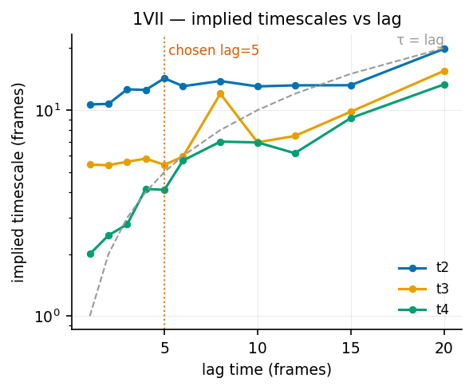
Figure 1. Implied timescales versus lag time for 1VII. The slowest timescale rises from 10.7 to 19.8 frames without plateauing — the chosen lag of 5 frames cannot be justified from this data.
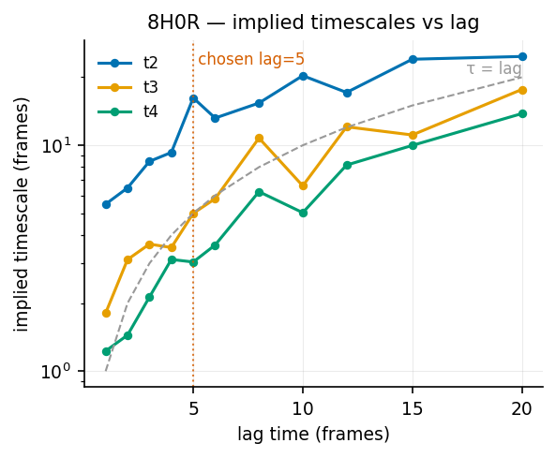
Figure 2. Implied timescales for 8H0R. Closer to convergence at long lag, but timescales still drift upward across the tested range — the characteristic signature of insufficient sampling rather than a well-chosen lag.

5.2 Chapman–Kolmogorov test
The Chapman–Kolmogorov test compares the model’s prediction P(kτ) = P(τ)ᵏ against transition probabilities estimated directly at each longer lag. Executing it required first correcting the repository implementation, which compared matrices estimated on different active sets without remapping — the same defect class as §3.2. Our runner embeds each MSM into the full label space before comparison.
System | Fraction of points within 95 % CI | Max absolute deviation | Interpretation
8H0R | 0.94 | 0.24 | Passes weakly; intervals very wide
1VII | 0.75 | 0.22 | Passes weakly
1UBQ | 0.75 | 0.25 | Passes weakly
1CRN | 0.63 | 0.32 | Lowest pass rate — tighter intervals expose real deviations
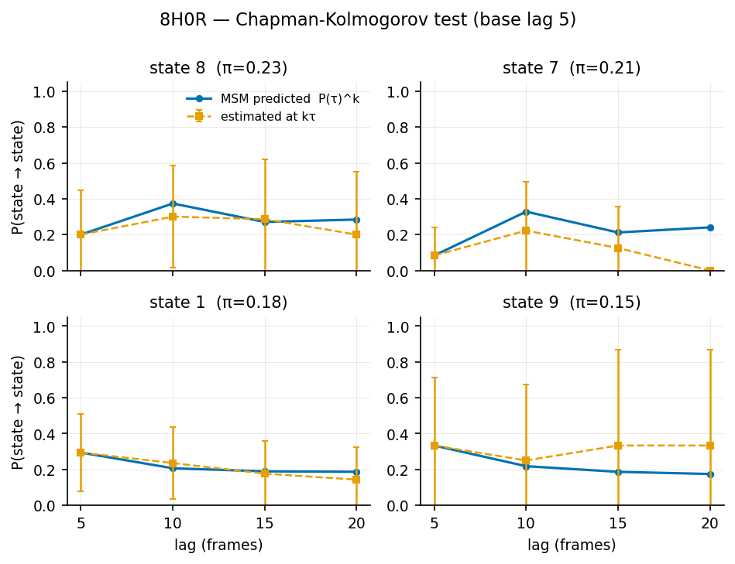
Figure 3. Chapman–Kolmogorov test for 8H0R at base lag 5, showing the four most populated states. Predicted (solid) and estimated (dashed) probabilities agree within confidence intervals, but those intervals span ±0.3–0.5 in probability — the test has almost no power to distinguish a Markovian model from a non-Markovian one at this trajectory length.
Important nuance. A passing CK test at 100 frames is not evidence of Markovianity. The intervals are so wide that almost any model would pass. That 1CRN — the longest trajectory — has the lowest pass fraction is consistent with this reading: better sampling narrows the intervals and begins to expose genuine deviations.

5.3 Bootstrap uncertainty on the stationary distribution
Block bootstrap (200 replicas, block length 10, preserving temporal correlation) was used to place 95 % confidence intervals on π. Median interval width relative to the estimated value itself:
System | Frames | Median CI width | Width relative to π | Assessment
1VII | 100 | 0.188 | 1.55× | Unresolved
1UBQ | 100 | 0.166 | 1.53× | Unresolved
8H0R | 100 | 0.180 | 1.11× | Unresolved
1CRN | 1001 | 0.085 | 0.56× | Approaching usable precision
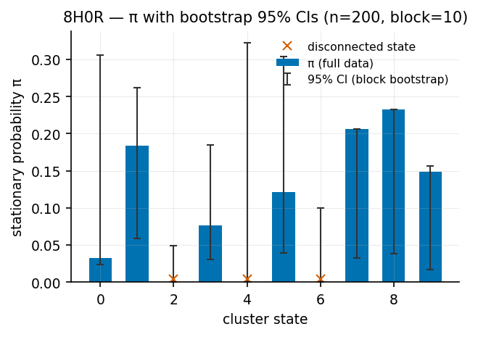
Figure 4. Stationary distribution for 8H0R with block-bootstrap 95 % confidence intervals. Crosses mark states excluded from the connected set. For several states the interval spans nearly the full plausible range.
Because rarity = 1 − π is the pipeline’s primary kinetic channel, per-state rarity values derived from 100-frame trajectories must be treated as unresolved; only rank-level conclusions survive. Bootstrap replicas additionally show states entering and leaving the connected set between resamples, confirming that the connectivity problem is a sampling artifact rather than genuine kinetic disconnection.

5.4 VAMP-2 model selection — defect found
The repository’s VAMP-2 scorer proved numerically unstable on real molecular-dynamics features. Its Cholesky-inverse whitening with regularisation 1 × 10⁻⁶ on ill-conditioned covariance matrices returned scores up to 2.5 × 10⁵, whereas a valid VAMP-2 score is bounded above by the model dimension. The function behaves correctly on well-conditioned random data, which is precisely why the repository’s mock-data tests never detected the problem. Any hyper-parameter selection performed with this function is invalid.
Re-scoring with deeptime’s cross-validated VAMP-2 (80/20 split) gives:
System | Best (lag, dim) | Score | Bound (= dim) | Score at pipeline default (5, 3)
1VII | (15, 5) | 5.00 | 5 | 1.76
8H0R | (15, 5) | 5.00 | 5 | 1.51
1UBQ | (15, 5) | 5.00 | 5 | 1.75
The optimum saturates exactly at the dimension bound with roughly 80 training frames — the signature of overfitting rather than a genuinely superior model. VAMP-2 selection therefore cannot currently justify hyper-parameters either, and must be repeated on longer trajectories before it can be reported.

5.5 What Layer 2 establishes
The battery is now implemented, executed on real systems, and figured — that deliverable is complete and reportable. Its scientific verdict, however, is that 100-frame trajectories cannot support MSM validity claims: Chapman–Kolmogorov intervals are too wide to be informative, implied timescales are unconverged, stationary probabilities carry ±100 % uncertainty, and VAMP-2 saturates. That 1CRN performs roughly three times better on every metric identifies trajectory length — not methodology — as the binding constraint.

6 Layer 3 — External Scientific Validation
Layers 1 and 2 establish that the pipeline computes what it claims and that its statistical assumptions can be tested. Layer 3 asks the question a reviewer will ask first: do the outputs correspond to anything measurable in the physical world?

6.1 Comparison with experimental B-factors
Crystallographic temperature factors are an experimental measure of atomic mobility and provide ground truth entirely independent of our model. CA B-factors were parsed from the raw RCSB entries and compared with pipeline outputs by Spearman correlation. 1VII is an NMR structure and carries no meaningful B-factors, so it is excluded by design.
System | Method | Residues matched | ρ (B-factor, dynamic score) | ρ (B-factor, trajectory RMSF)
8H0R | X-ray 1.20 Å | 178 / 182 | 0.595 | 0.642
1UBQ | X-ray 1.80 Å | 76 / 76 | 0.573 | 0.656
Correlations near 0.6 between crystallographic flexibility and scores derived from 100-frame implicit-solvent trajectories fall within the range typically reported for MD-versus-B-factor comparisons, and constitute external evidence that per-residue outputs track genuine structural flexibility. The dynamic score correlates slightly below raw RMSF, which is both expected and desirable: B-factors measure flexibility alone, whereas the dynamic score deliberately incorporates kinetic-anomaly participation. A dynamic score that matched B-factors perfectly would indicate the kinetic channels were contributing nothing — which was precisely the pre-fix failure mode documented in §3.4.

6.2 Comparison with baseline anomaly detectors
To establish that the MSM machinery earns its complexity, the pipeline was benchmarked against off-the-shelf anomaly detectors operating on identical tICA coordinates, plus an ablation using only the pipeline’s own geometric channel.
Rare-state detection (AUROC):
Method | 1VII | 8H0R | 1UBQ | 1CRN
Pipeline, fused (ours) | 0.947 | 0.958 | 0.904 | 0.955
Isolation Forest | 0.752 | 0.879 | 0.696 | 0.845
Local Outlier Factor | 0.835 | 0.934 | 0.694 | 0.490
k-NN distance only (ablation) | 0.867 | 0.867 | 0.762 | 0.905
Rare-transition detection (AUROC):
Method | 1VII | 8H0R | 1UBQ | 1CRN
Pipeline, fused (ours) | 0.811 | 0.837 | 0.808 | 0.999
Transition surprise channel alone | 0.976 | 0.953 | 0.907 | 1.000
Isolation Forest | 0.771 | 0.826 | 0.432 | 0.959
Local Outlier Factor | 0.772 | 0.846 | 0.463 | 0.607
The core argument for the method. On ubiquitin’s rare kinetic transitions, both geometric detectors perform at chance (0.43 and 0.46) while the MSM-derived surprise channel reaches 0.91. Kinetic anomalies are invisible to geometry-only outlier detection — no amount of tuning an Isolation Forest in tICA space recovers them. This is the clearest available justification for building an MSM at all, and we recommend it as a headline figure.
The fused score also consistently outperforms its own geometric ablation, confirming that the kinetic channels contribute signal rather than noise. The one case where a baseline is competitive — LOF on 8H0R rare transitions — reflects that system’s unusually clean geometric separation.

7 Limitations and Threats to Validity
- Trajectory length is the dominant limitation. All conclusions about kinetic quantities rest on 100-frame trajectories (1001 for 1CRN). As §5 documents, this is insufficient for Markovianity claims, and per-state π values are unresolved. Layer 1 correctness results and Layer 3 correlations are unaffected, since neither depends on the MSM being converged.
- Ground truth for accuracy is operational, not external. Rare-state and rare-transition labels derive from the MSM itself. The fused-score results remain meaningful because the geometric channel is independent of the labels, but they measure internal consistency rather than biological correctness. Literature-based functional-site annotations would provide a stronger external benchmark.
- Implicit-solvent toy dynamics. Trajectories use GBn2 implicit solvent with short integration, chosen for pipeline testing rather than physical realism. Solvent-mediated dynamics and slow collective motions are not sampled.
- Clustering is not reproducible across machines. deeptime KMeans yields different state assignments on different platforms despite a fixed seed (ARI 0.43–0.51). Reported artifacts are therefore platform-specific at the state level.
- Two systems remain outstanding. 9O6O and 9UNN structures are prepared but their trajectories are still being generated; their results are not included here.
- The command-line scoring path is only partially protected. When an MSM is reconstructed from bare P and π matrices without count information, the active-set mapping cannot be recovered; the code now warns rather than silently miscomputing. The batch pipeline, which passes the fitted model, is unaffected.

8 Recommendations

8.1 Required before publication
Priority | Action | Rationale
1 | Regenerate headline systems with substantially longer trajectories (50,000-step protocol or a public long-trajectory dataset such as ATLAS) | Without this, no kinetic claim survives review; §5 quantifies the deficit
2 | Repeat the full Layer 2 battery on the longer trajectories and report CK and implied-timescale figures per system | These are the figures MSM reviewers expect first
3 | Re-derive hyper-parameters by cross-validated VAMP-2 once sampling supports it | Current values (lag 5, dim 3, 10 clusters) are unjustified defaults
4 | Report bootstrap confidence intervals alongside all π-derived quantities | Point estimates without intervals overstate precision

8.2 Recommended for strength
- Extend the B-factor comparison to 9O6O and 9UNN once their trajectories complete, giving four independent experimental benchmarks spanning X-ray and cryo-EM.
- Add literature-based functional-site validation, particularly for villin headpiece, one of the most extensively characterised fast-folding systems.
- Report the rarity and surprise channels separately for thermodynamic versus kinetic claims, and evaluate maximum-fusion given the anti-correlation documented in §4.3.
- Replace or supplement KMeans with a deterministic clustering scheme to restore cross-platform reproducibility of state assignments.
- Never report mean frame score as a quality metric: rank normalisation forces it to approximately 50 for any protein, as confirmed across all systems (47.4–50.9).

8.3 Infrastructure
Molecular-dynamics generation is now the binding practical constraint. The 9UNN system — a 23,000-atom heterotetrameric NMDA receptor — requires hours on available laptop hardware, and the longer trajectories recommended above would multiply this substantially. Access to GPU or HPC resources would simultaneously unblock the remaining extension targets and the sampling improvements that Layer 2 shows to be necessary. This is assessed as the single highest-leverage addition to the project.

9 Deliverables and Reproduction
All material resides on branch validation-fixes. Every script is re-runnable and every number in this report regenerable.
Path | Contents
validation/VALIDATION_REPORT.md | Findings, before/after metrics, limitations (markdown source)
validation/CAMPAIGN_LOG.md | Chronological log: every command, environment, and result
validation/baseline_numerical.py | Numerical validation — active-set impact, ties, unit checks
validation/baseline_edge_cases.py | Twenty-one edge cases against the production path
validation/baseline_rare_case.py | Rare-case AUROC / AUPRC evaluation
validation/layer2_msm_validity.py | CK, implied timescales, VAMP-2, bootstrap — with figures
validation/layer3_external.py | B-factor correlation and baseline-method comparison
validation/*_results*.json | Raw numerical results, baseline and post-fix
validation/figures/ (15 PNG) | Implied timescales, CK panels, π confidence intervals, VAMP-2 grids
tests/test_production_scoring.py | Twelve permanent correctness tests (all passing)
artifacts/{ID}/state_symbols.npy | Active-set mapping, newly persisted when states are pruned
results/{ID}/residue_scores_rmsf.json | Per-residue RMSF in Ångströms, newly produced
Reproduction:
conda activate mdcapstone
python -m pytest tests/test_production_scoring.py -v
python validation/baseline_numerical.py
python validation/baseline_edge_cases.py
python validation/baseline_rare_case.py
python validation/layer2_msm_validity.py
python validation/layer3_external.py
Interface changes for downstream consumers: residue score keys are unchanged for single-chain proteins but multi-chain duplicates now appear as NAME###_chainK; the transition-surprise column is empty (NaN) for the final lag frames by design; and a new state_symbols.npy artifact is written whenever the MSM prunes states.

References
Prinz, J.-H., Wu, H., Sarich, M., Keller, B., Senne, M., Held, M., Chodera, J. D., Schütte, C., & Noé, F. (2011). Markov models of molecular kinetics: Generation and validation. Journal of Chemical Physics, 134, 174105.
Husic, B. E., & Pande, V. S. (2018). Markov state models: From an art to a science. Journal of the American Chemical Society, 140(7), 2386–2396.
Wu, H., & Noé, F. (2020). Variational approach for learning Markov processes from time series data. Journal of Nonlinear Science, 30, 23–66.
Hoffmann, M., Scherer, M., Hempel, T., Mardt, A., de Silva, B., Husic, B. E., Klus, S., Wu, H., Kutz, N., Brunton, S. L., & Noé, F. (2021). Deeptime: A Python library for machine learning dynamical models from time series data. Machine Learning: Science and Technology, 3, 015009.
McGibbon, R. T., Beauchamp, K. A., Harrigan, M. P., Klein, C., Swails, J. M., Hernández, C. X., Schwantes, C. R., Wang, L.-P., Lane, T. J., & Pande, V. S. (2015). MDTraj: A modern open library for the analysis of molecular dynamics trajectories. Biophysical Journal, 109(8), 1528–1532.

