SUPPLEMENTAL MATERIAL

MicroRNAs induced in melanoma treated with combination targeted therapy of temsirolimus and bevacizumab

Aubrey G. Wagenseller¹, Amber Shada¹, Kevin M. D’Auria², Cheryl Murphy¹, Dandan Sun³, Kerrington R. Molhoek¹, Jason A. Papin², Anindya Dutta³, and Craig L. Slingluff, Jr.*¹

Departments of ¹Surgery, Division of Surgical Oncology, ²Biomedical Engineering, and ³Biochemistry and Molecular Genetics, University of Virginia School of Medicine, Charlottesville, VA, USA

Contents

- Patients, their clinical responses, and availability of associated miRNA data
Table S1

- Clustering analyses
Table S2
Figures S1 to S16

- Explanation of R code to reproduce all analyses

Table S1 Patients, their clinical responses and availability of associated miRNA data
Patient # | Pre-tx | Post-tem | Post-combo | Outcome | BRAF | Notes
1 |  |  | X | SD | ?
2 | X | X | 2X | SD | m | Withdrew consent
3 | X | X |  | SD | m
4 | X | X | X | SD | m
5 | 2X | X | X | PD | m
6 | 2X | X |  | PR | wt | (unconfirmed PR)
7 | X | 2X | X | PD | wt
8 | X | X | X | PD | m
9 | X | X | X | PR | wt
10 | X | X | 2X | NE | wt | Off study prior to cycle 4 due to staph infection
11 | X | X |  | SD | wt | Off study due to new cutaneous lesion
12 | X | X | X | SD | wt
13 |  |  |  | SD | ? | Off study due to non-compliance
14 |  |  |  | SD | ?
15 |  |  |  | PD | ?
16 |  |  |  | PR | ?
17 |  |  |  | SD | ?
 | 13 | 12 | 11 | Microarrays per condition (36 microarrays total)
 | 11 | 11 | 9 | Patients per condition whose miRNA expression was measured

Stable disease (SD), progressive disease (PD), partial response (PR), not evaluable (NE)
BRAF^{wt} (wt) and BRAF^{V600E} (m)
X – miRNA expression values were quantified for these patient samples
2X – Five samples were resubmitted to Exiqon to be compared with the original samples. Hence, five sample groups have two arrays.

Cluster Analyses
Table S2 lists all of the cluster analyses that were performed. Following the table, the dendrograms and heatmaps for each of the analyses are shown. For several analyses, subsets of miRNAs were selected by t-tests with p-value and effect size cutoffs. These cutoffs are also listed in Table S2. The clustering with all miRNAs and the miRNA subset is shown in part a and b, respectively, of each of the following figures. With two panels for each of 16 figures, there should be 32 cluster analyses. Since Figures S5a and S6a would include the exact same samples and miRNAs as Figure S2a and S4, what would be Figures S5a and S6a are not shown. Hence, there are only 30 cluster analyses (3 shown in Figure 4 of the manuscript). In the last section, a description of the R code to reproduce all of the results is documented.

Table S2 Cluster analyses were performed for the combinations of patient groups listed below. For each combination, an unsupervised clustering was performed using all of the miRNAs and a second “semi-supervised” clustering was performed using a subset of miRNAs. The subset was selected using a t-test p-value and the unstandardized effect size (the difference between the means of each sample group). If cutoffs of p<0.05 and effect size>0.5 were too stringent, then the cutoff for the effect size was decreased and, if necessary, p-value cutoff increased. If the cutoffs were too lenient, the p-value cutoff was decreased. The pair of cutoffs was chosen so to have enough miRNAs for clustering yet still fewer than 20 miRNAs.

Comparison 1: before and after treatment |  | Cutoffs |  |  |  | Data for |  | Patients/samples
Figures | Selection of miRNAs | p < | Effect  size > | # miRNAs  selected |  | miRNA  selection | Clustering | 1 | 2 | 3 | 4 | 5 | 6 | 7 | 8 | 9 | 10 | 11 | 12
S1 | Paired t-test, pre-treatment  versus post-com | 0.01 | 0.5 | 15  (Table 1) |  | LMR  paired | dLMR |  | c-p |  | c-p | c-p |  | c-p | c-p | c-p | c-p |  | c-p
S2 |  |  |  |  |  |  | LMR |  | pc |  | pc | pc |  | pc | pc | pc | pc |  | pc
S3 | Paired t-test, pre-treatment  versus post-tem | 0.05 | 0.1 | 7 |  | LMR  paired | dLMR |  | t-p | t-p | t-p | t-p | t-p | t-p | t-p | t-p | t-p | t-p | t-p
S4 |  |  |  |  |  |  | LMR |  | pt | pt | pt | pt | pt | pt | pt | pt | pt | pt | pt
S5 | Unpaired t-test, pre-treatment  versus post-com | 0.1 | 0.5 | 11 |  | LMR |  |  | pc |  | pc | pc |  | pc | pc | pc | pc |  | pc
S6 | Unpaired t-test, pre-treatment  versus post-tem | 0.1 | 0 | 3 |  | LMR |  |  | pt | pt | pt | pt | pt | pt | pt | pt | pt | pt | pt
Comparison 2: responders versus non-responders |  |  |  |  |  | Outcome |  | SD | SD | SD | SD | PD | PR | PD | PD | SD | NE | SD | SD
S7, 4B | Unpaired t-tests  SD/PR samples versus  PD samples | 0.04 | 0.5 | 7 |  | dLMR |  |  | c-p |  | c-p | c-p |  | c-p | c-p | c-p |  |  | c-p
S8 | Unpaired t-tests  SD/PR samples versus  PD samples | 0.05 | 0.2 | 5 |  | dLMR |  |  | t-p | t-p | t-p | t-p | t-p | t-p | t-p | t-p |  | t-p | t-p
S9, 4A | Unpaired t-tests  SD/PR samples versus  PD samples | 0.01 | 0.5 | 4 |  | LMR |  |  | p | p | p | p | p | p | p | p |  | p | p
S10 | Unpaired t-tests  SD/PR samples versus  PD samples | 0.03 | 0.5 | 8 |  | LMR |  |  | t | t | t | t | t | t | t | t |  | t | t
S11 | Unpaired t-tests  SD/PR samples versus  PD samples | 0.03 | 0.5 | 6 |  | LMR |  | c | c |  | c | c |  | c | c | c |  |  | c
Comparison 3: BRAF^{wt} versus BRAF^{V600E} |  |  |  |  | BRAF mutational status |  |  | wt | m | m | m | m | wt | wt | m | wt | wt | wt | wt
S12 | Unpaired t-tests  BRAF^{wt} samples versus  BRAF^{V600E} samples | 0.05 | 0.5 | 10 |  | dLMR |  |  | c-p |  | c-p | c-p |  | c-p | c-p | c-p | c-p |  | c-p
S13 |  | 0.05 | 0.2 | 8 |  | dLMR |  |  | t-p | t-p | t-p | t-p | t-p | t-p | t-p | t-p | t-p | t-p | t-p
S14, 4C |  | 0.02 | 0.5 | 16 |  | LMR |  |  | p | p | p | p | p | p | p | p | p | p | p
S15 |  | 0.05 | 0.5 | 11 |  | LMR |  |  | t | t | t | t | t | t | t | t | t | t | t
S16 |  | 0.05 | 0.5 | 8 |  | LMR |  | c | c |  | c | c |  | c | c | c | c |  | c

Key:
Pre-treatment (p), Post-temsirolimus treatment (t), post-combination treatment (c). The combination of letters ‘pt’ indicates that both pre-treatment and post-temsirolimus treatment samples are included.
dLMR calculated from post-combination LMR minus pre-treatment LMR (c-p)
dLMR calculated from post-temsirolimus LMR treatment minus pre-treatment LMR (t-p)
Other abbreviations are explained in Table S1.
Notes for hypothesis testing for miRNA selection
For Figure S1-4, duplicate arrays were not averaged and miRNAs with any missing values were excluded.
For Figures S5-16, duplicate arrays were averaged. Also, for miRNAs with fewer than half of the samples having missing values, KNN imputation (k=10) was used.
Figure S1
miRNA subset selection: Paired LMR, Post-combination versus pre-treatment
Data for clustering: dLMR (Post-combination minus pre-treatment)

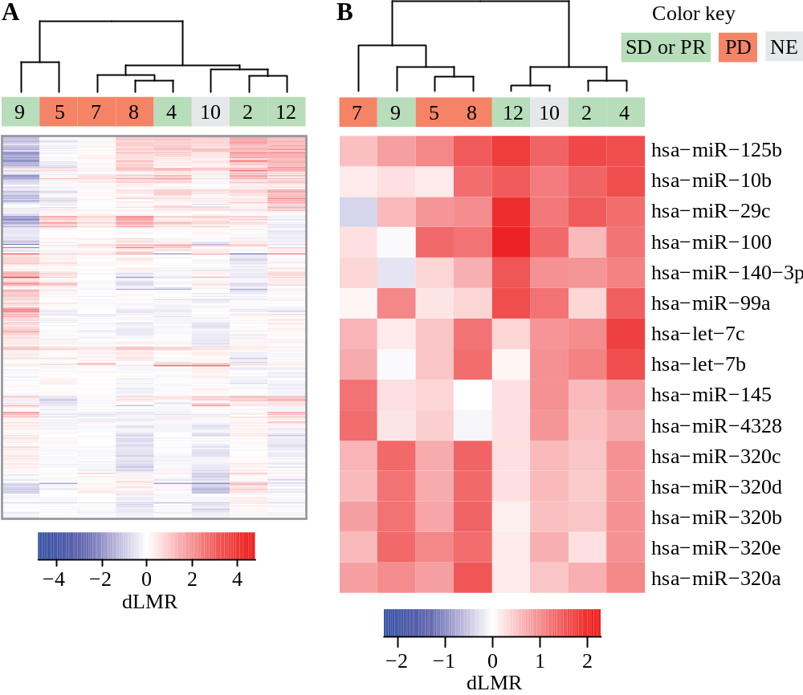

Figure S2
miRNA subset selection: Paired LMR, Post-combination versus pre-treatment
Data for clustering: LMR

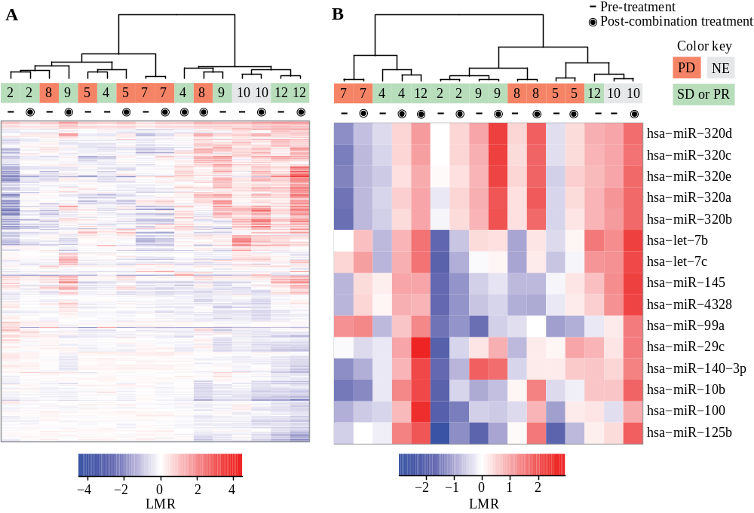

Figure S3
miRNA subset selection: Paired LMR, Post-temsirolimus versus pre-treatment
Data for clustering: dLMR (Post-temsirolimus minus pre-treatment)

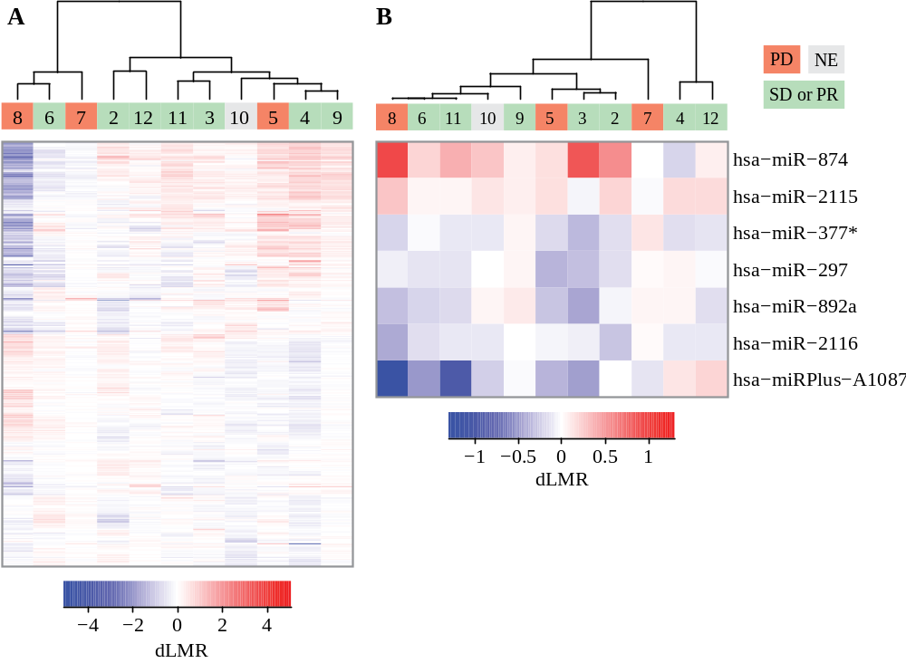

Figure S4
miRNA subset selection: Paired LMR, Post-combination versus pre-treatment
Data for clustering: LMR

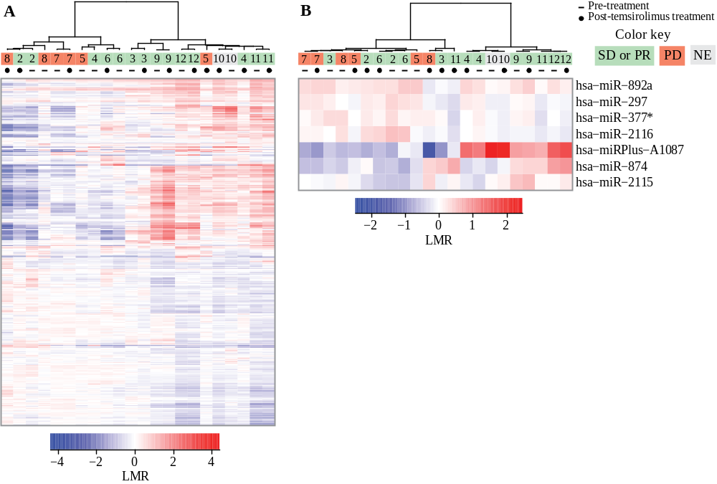

Figure S5
miRNA subset selection: Unpaired LMR. Post-combination versus pre-treatment
Data for clustering: LMR

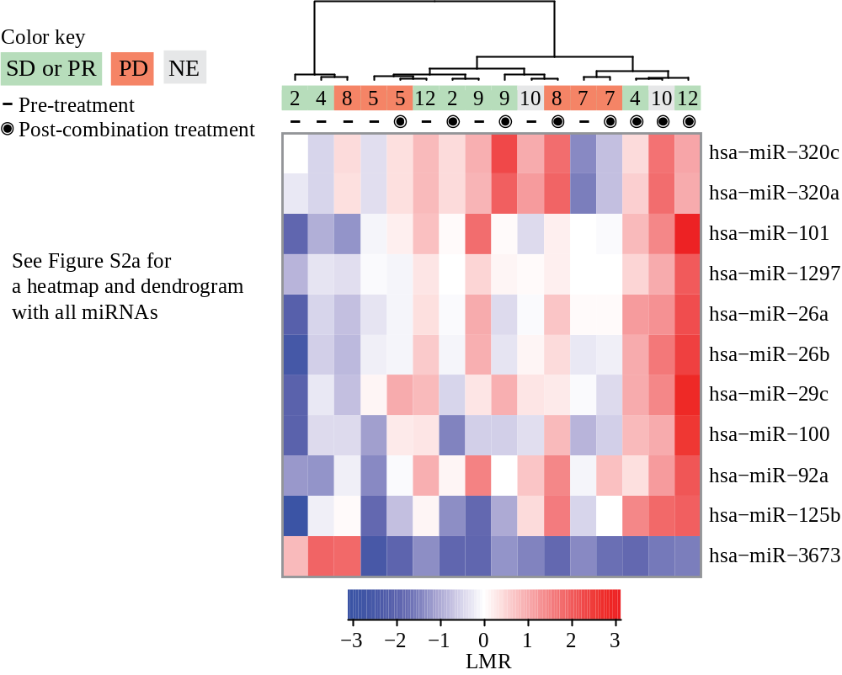

Figure S6
miRNA subset selection: Unpaired LMR. Post-temsirolimus versus pre-treatment.
Data for clustering: LMR

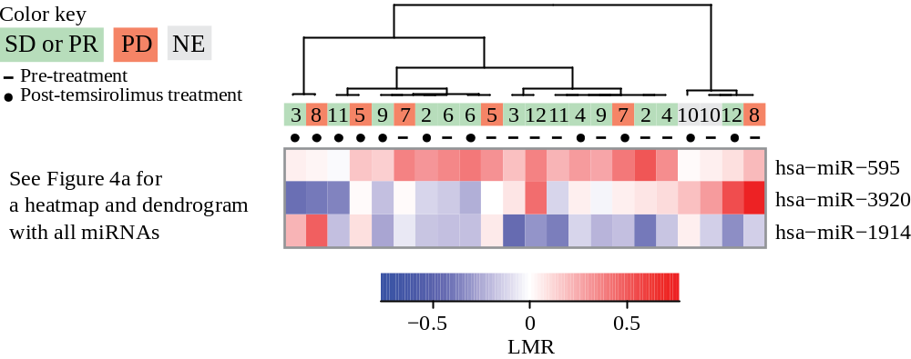

Figure S7
miRNA subset selection: Unpaired dLMR (Post-combination versus pre-treatment). SD/PR versus PD
Data for clustering: dLMR

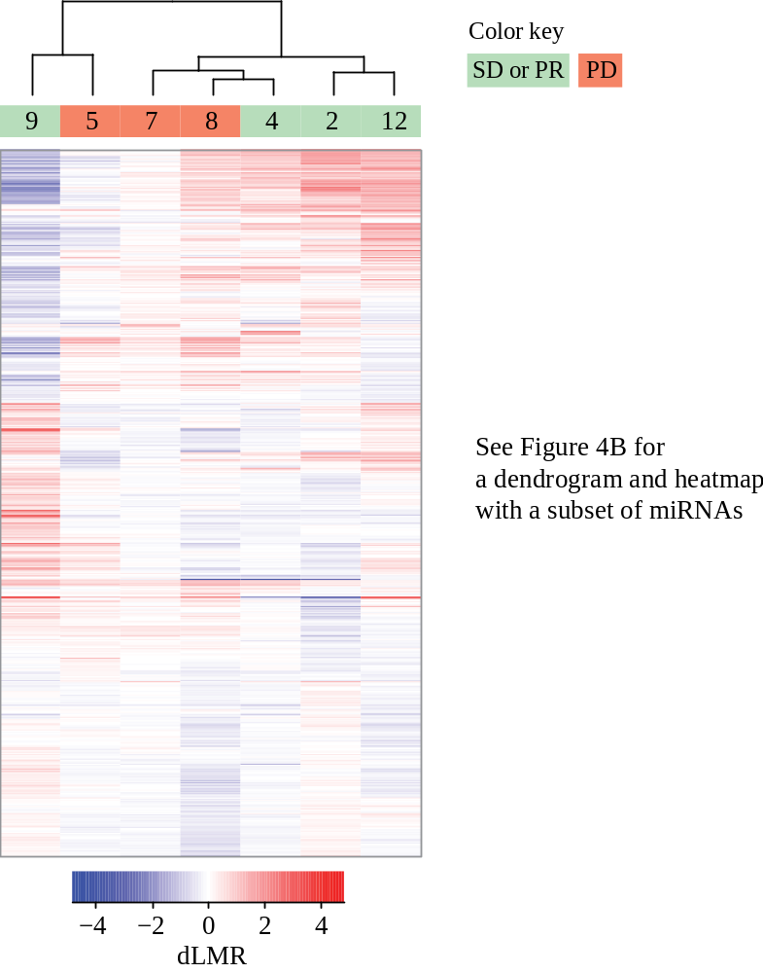

Figure S8
miRNA subset selection: Unpaired dLMR (Post-temsirolimus versus pre-treatment). SD/PR versus PD
Data for clustering: dLMR

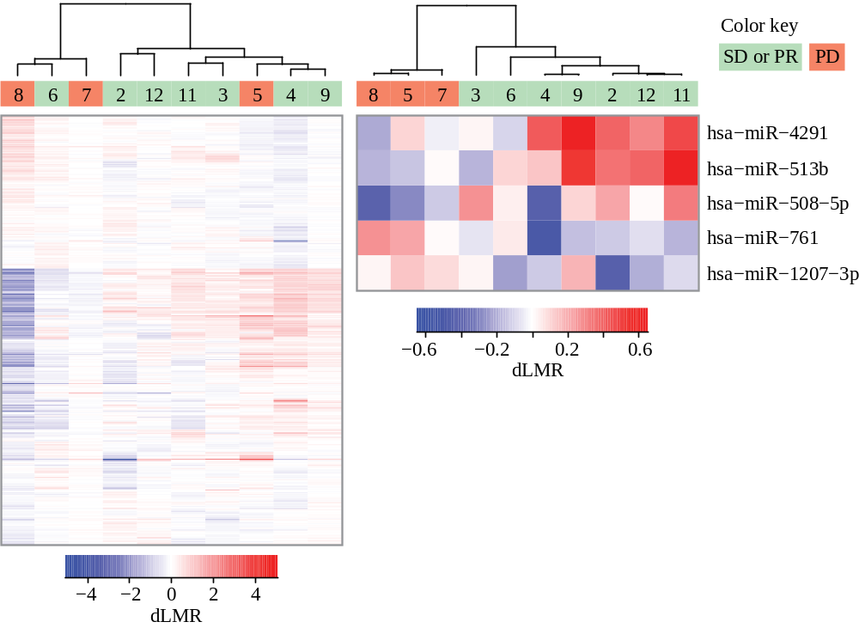

Figure S9
miRNA subset selection: LMR (Pre-treatment)
Data for clustering: LMR

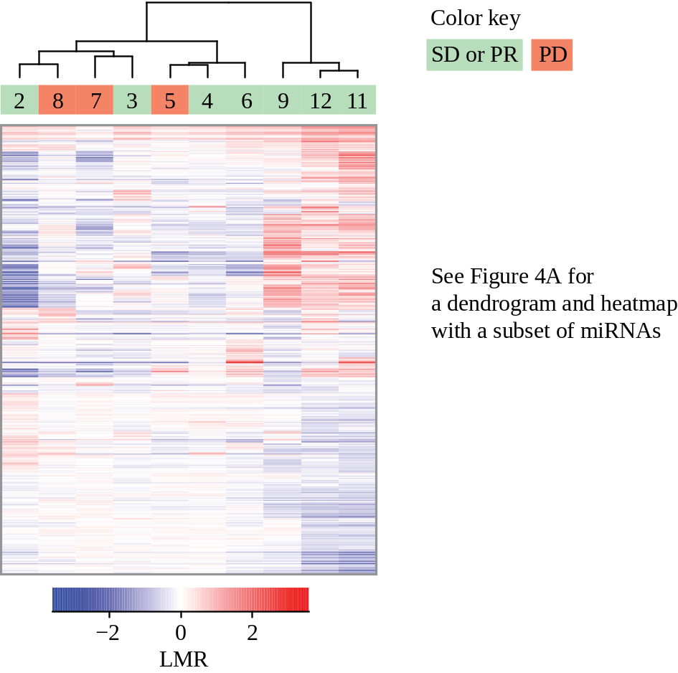

Figure S10
miRNA subset selection: LMR (Post-temsirolimus treatment)
Data for clustering: LMR

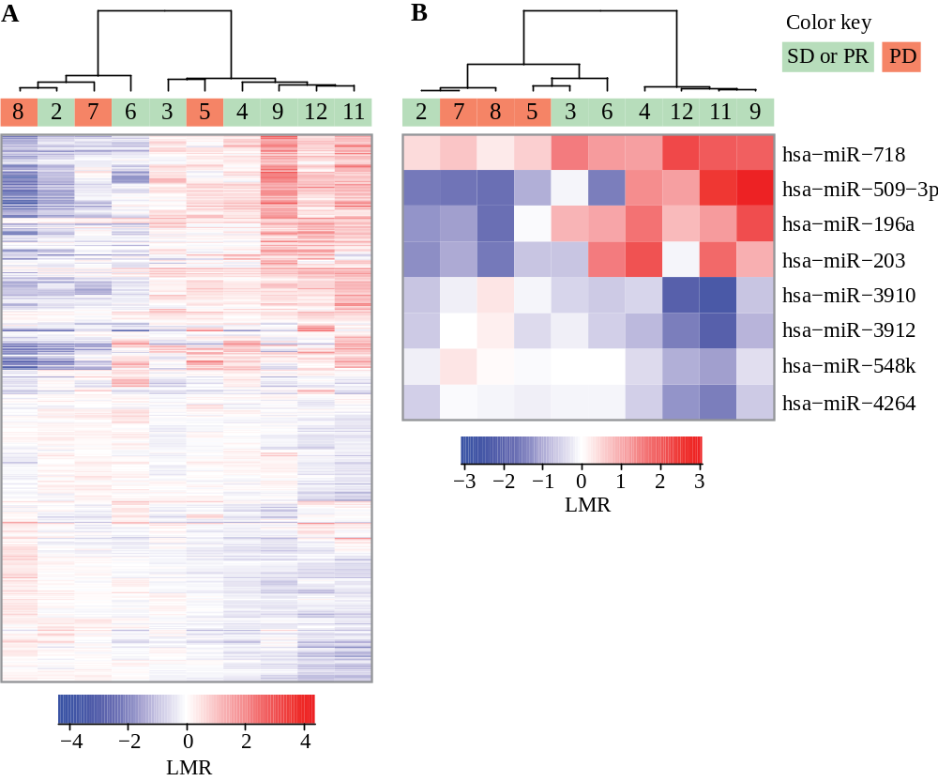

Figure S11
miRNA subset selection: LMR (Post-temsirolimus treatment)
Data for clustering: LMR

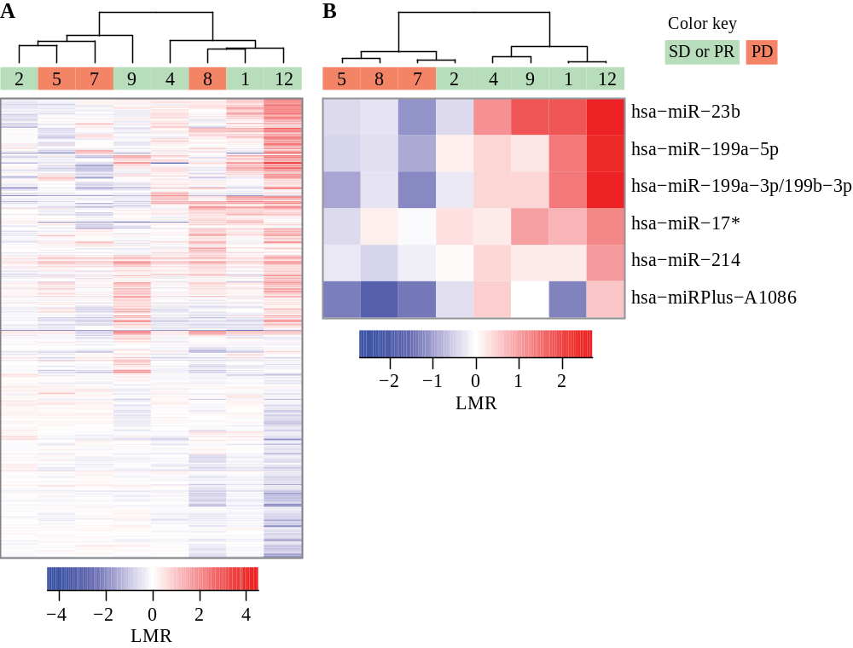

Figure S12
miRNA subset selection: dLMR (Post-combination minus pre-treatment). BRAF^{wt} versus BRAF^{V600E}
Data for clustering: dLMR

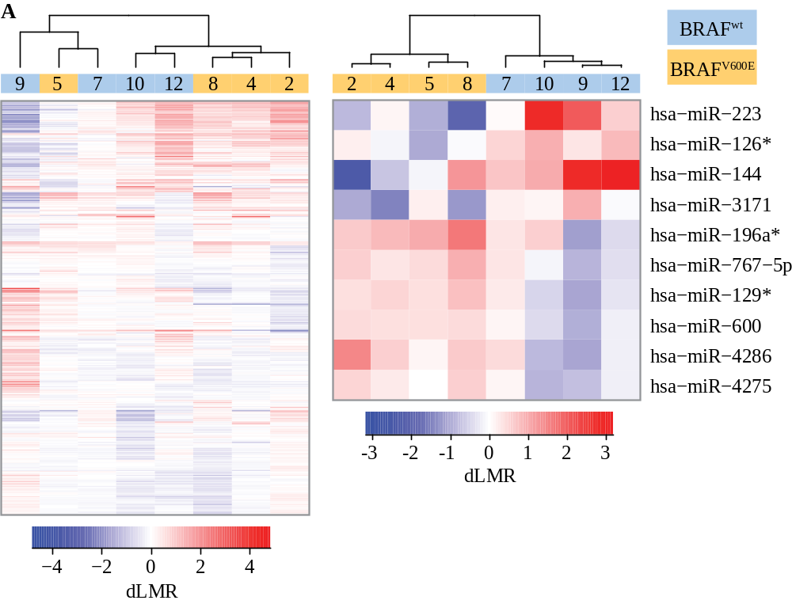

Figure S13
miRNA subset selection: dLMR (Post-temsirolimus minus pre-treatment). BRAF^{wt} versus BRAF^{V600E}
Data for clustering: dLMR

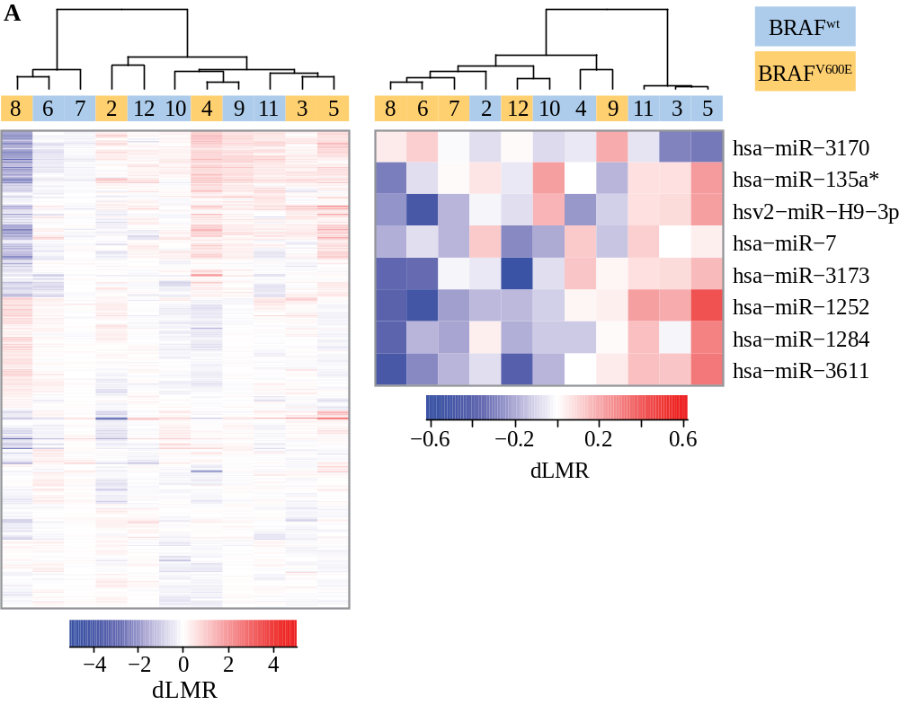

Figure S14
miRNA subset selection: LMR (Pre-treatment). BRAF^{wt} versus BRAF^{V600E}
Data for clustering: LMR

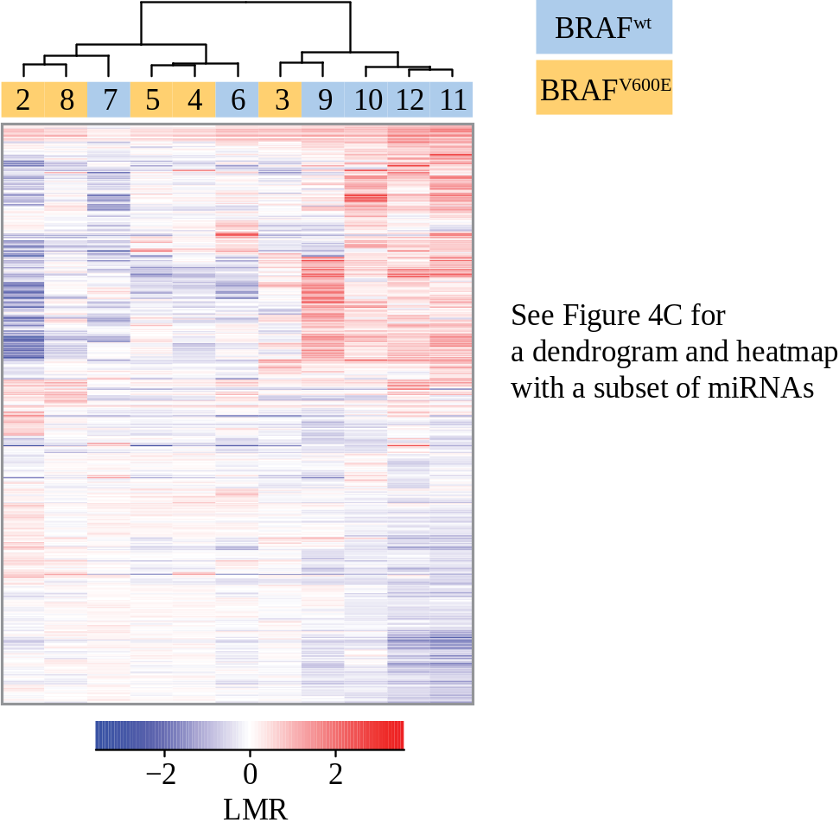

Figure S15
miRNA subset selection: LMR (Post-temsirolimus treatment). BRAF^{wt} versus BRAF^{V600E}
Data for clustering: LMR
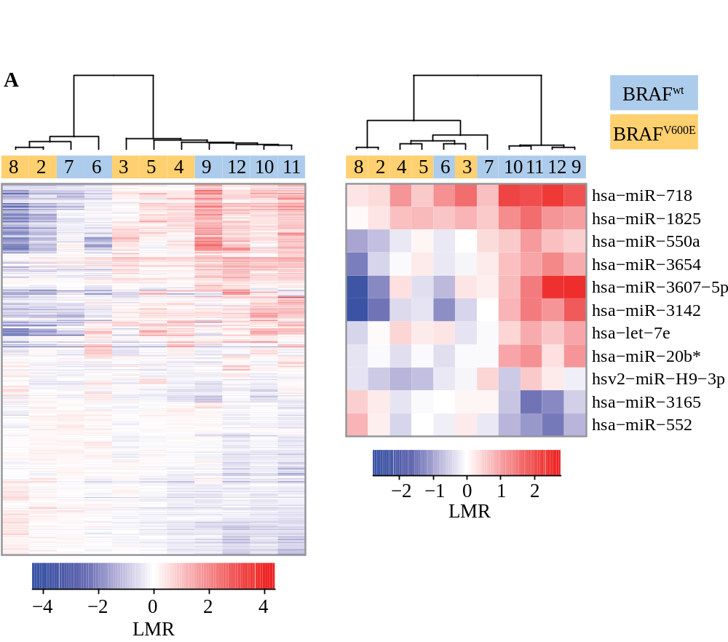

Figure S16
miRNA subset selection: LMR (Post-temsirolimus treatment). BRAF^{wt} versus BRAF^{V600E}
Data for clustering: LMR

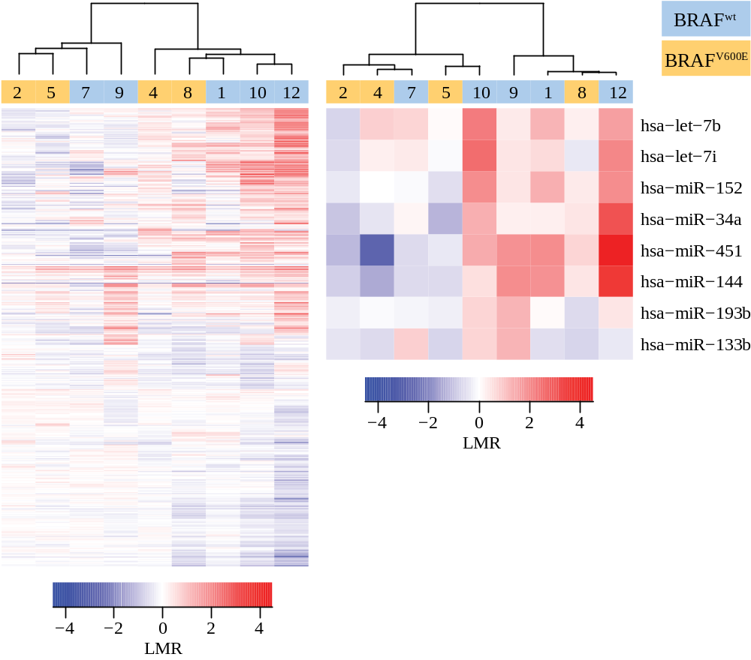

Explanation of R code to reproduce all analyses

The R code is separated into files that each performs one task or step of the analysis:

loadData.R
This file contains the functions loadData, miniML.to.List, and miniML.to.eSet that together parse a miniML file from NCBI GEO into an ExpressionSet object. The getGEO.ids function automatically downloads the annotation mapping the microarray IDs to the miRNA name and saves them in a character vector.

setComparisons.R
This file runs the loadData function to store the data. It then arranges the correct samples and parameters for all comparisons in list objects. Another container object (a list object named comp) holds each of these list objects that were made for each comparison.

helperFunctions.R
This file contains functions that consolidate pieces of code commonly used in all analyses. A short description of each function is given in the comments throughout the file.

HypothesisTests.R
This script automatically runs the code in setComparisons.R. It then uses the list object created by setComparisons.R to run t-tests for every comparison. Each test is separated by a line comments. The volcanoPlot and topTable functions show the results of each t-test. The results from each test are stored in another list object named topHits.

ClusteringAnalyses.R
This script automatically runs the code in HypothesisTests.R which also runs setComparisons.R. The script outputs dendrograms and heatmaps from clustering the samples in each comparison based on the miRNA expression. It also contains the code to perform a “semi-supervised” clustering using the subset of miRNAs defined in the topHits object.

GSE37131.xml
This is the miniML file which can also be downloaded from NCBI GEO.

Figure1.R
Aside from formatting which changes the font and the color labeling each patient, this script reproduces Figure 1.

Figure2.Table1.R
Aside from the formatting of text and labeling of axes, this script reproduces each panel of Figure 2. It also reproduces the significant genes listed in Table 1.

Figure4.R
Aside from formatting which changes the font and the color labeling each patient, this script reproduces Figure 4.

