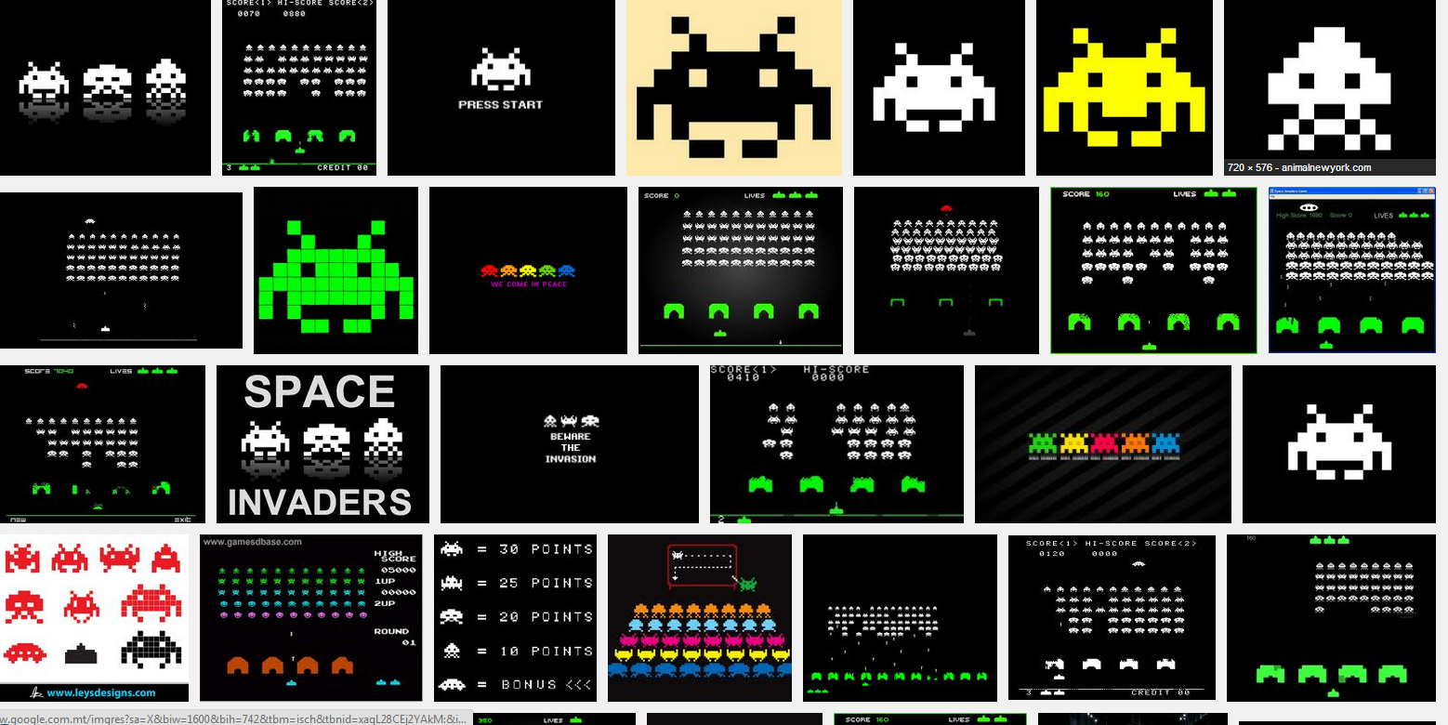

Some early inspiration for the game. Pixilated look graphics with high contrast colours on a dark a background.

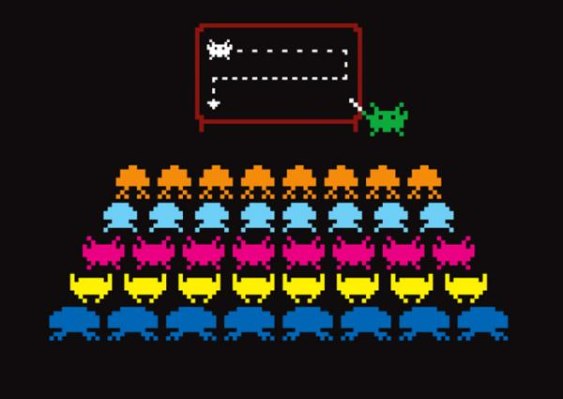

I like the idea of adding some perspective to the game. It gives a sense of depth and enrich the visual of the game.

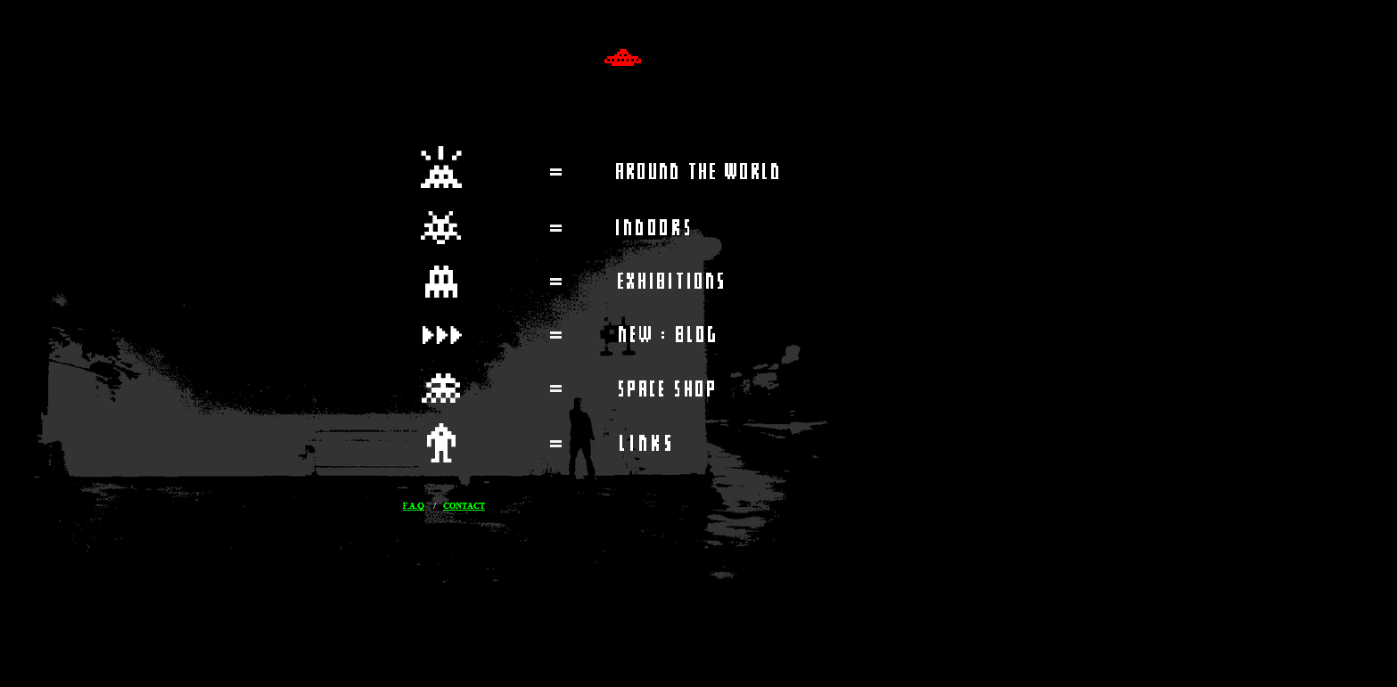

A website I found that has the same style and imagery of the old space invaders.

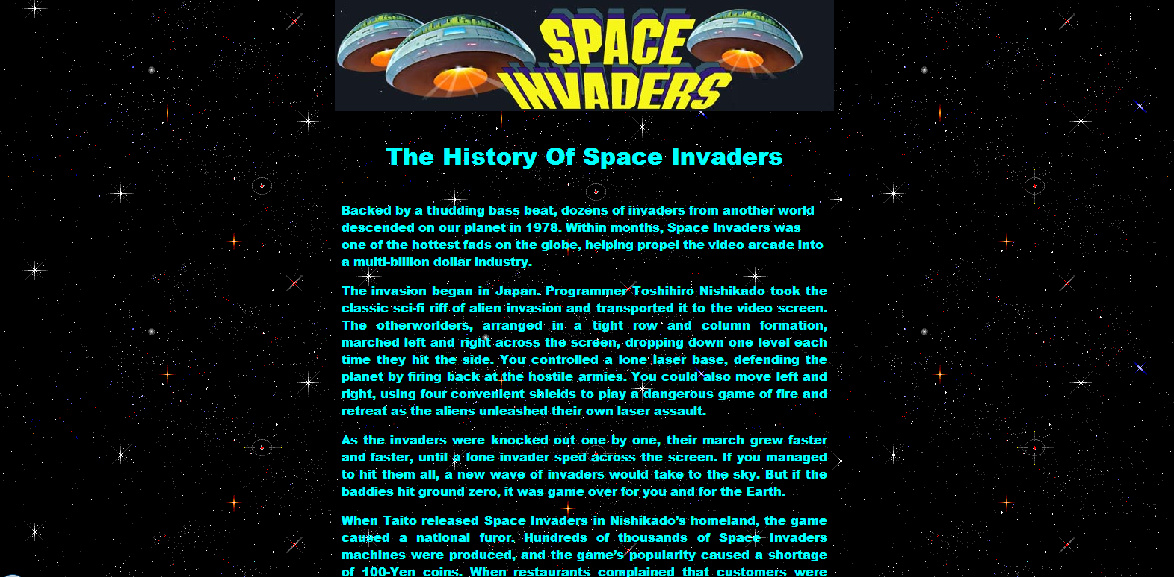

Some research for the game. It was a great hit those days so it could be the key for a successful game for nowadays.

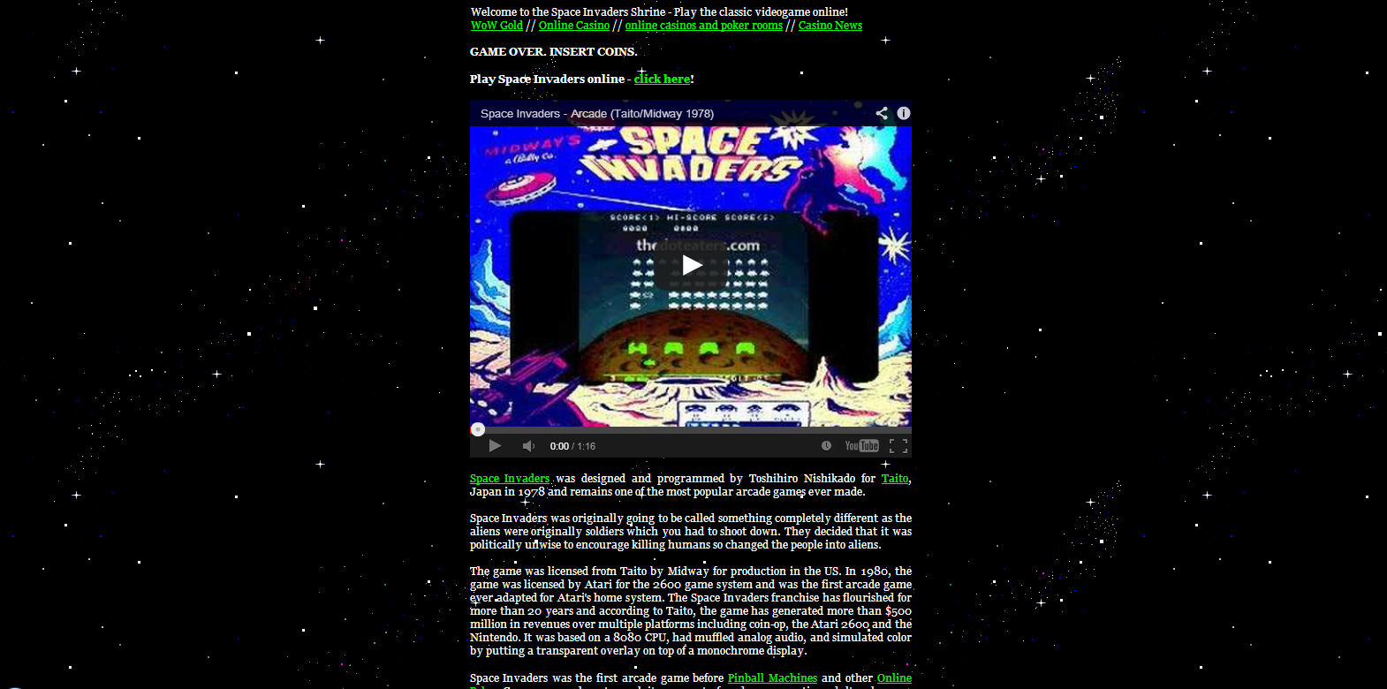

Other interesting information I found on the net about the classic game. It could be useful for the build of the game.

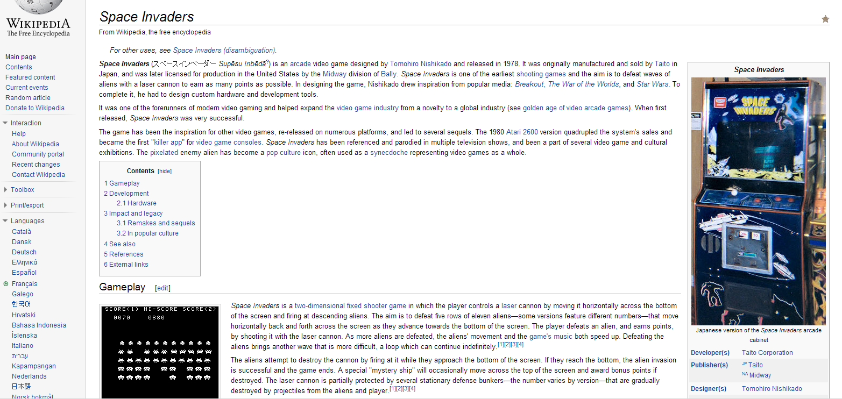

Some other useful information on the classical game found on the most reknown website Wikipedia