TriggerWarning Project: Analysis of Terminated NIH and NSF Grants

# TriggerWarning Project: Analysis of Terminated NIH and NSF Grants

## Executive Summary

The TriggerWarning project represents a systematic analysis of recently terminated National Institutes of Health (NIH) and National Science Foundation (NSF) grants containing specific “trigger terms.” Using natural language processing techniques combined with contextual analysis, we examined how frequently these terms appear in legitimate scientific contexts versus political/social ones.

Our analysis reveals that in terminated grants, 40.9% of trigger term occurrences represent scientific usage (false positives) rather than political/social content, suggesting that a significant portion of terminated grants may have been using terminology in legitimate scientific contexts. Certain terms show particularly high false positive rates, and patterns of terminations vary significantly across agencies, directorates, grant types, institutions, and geographic regions.

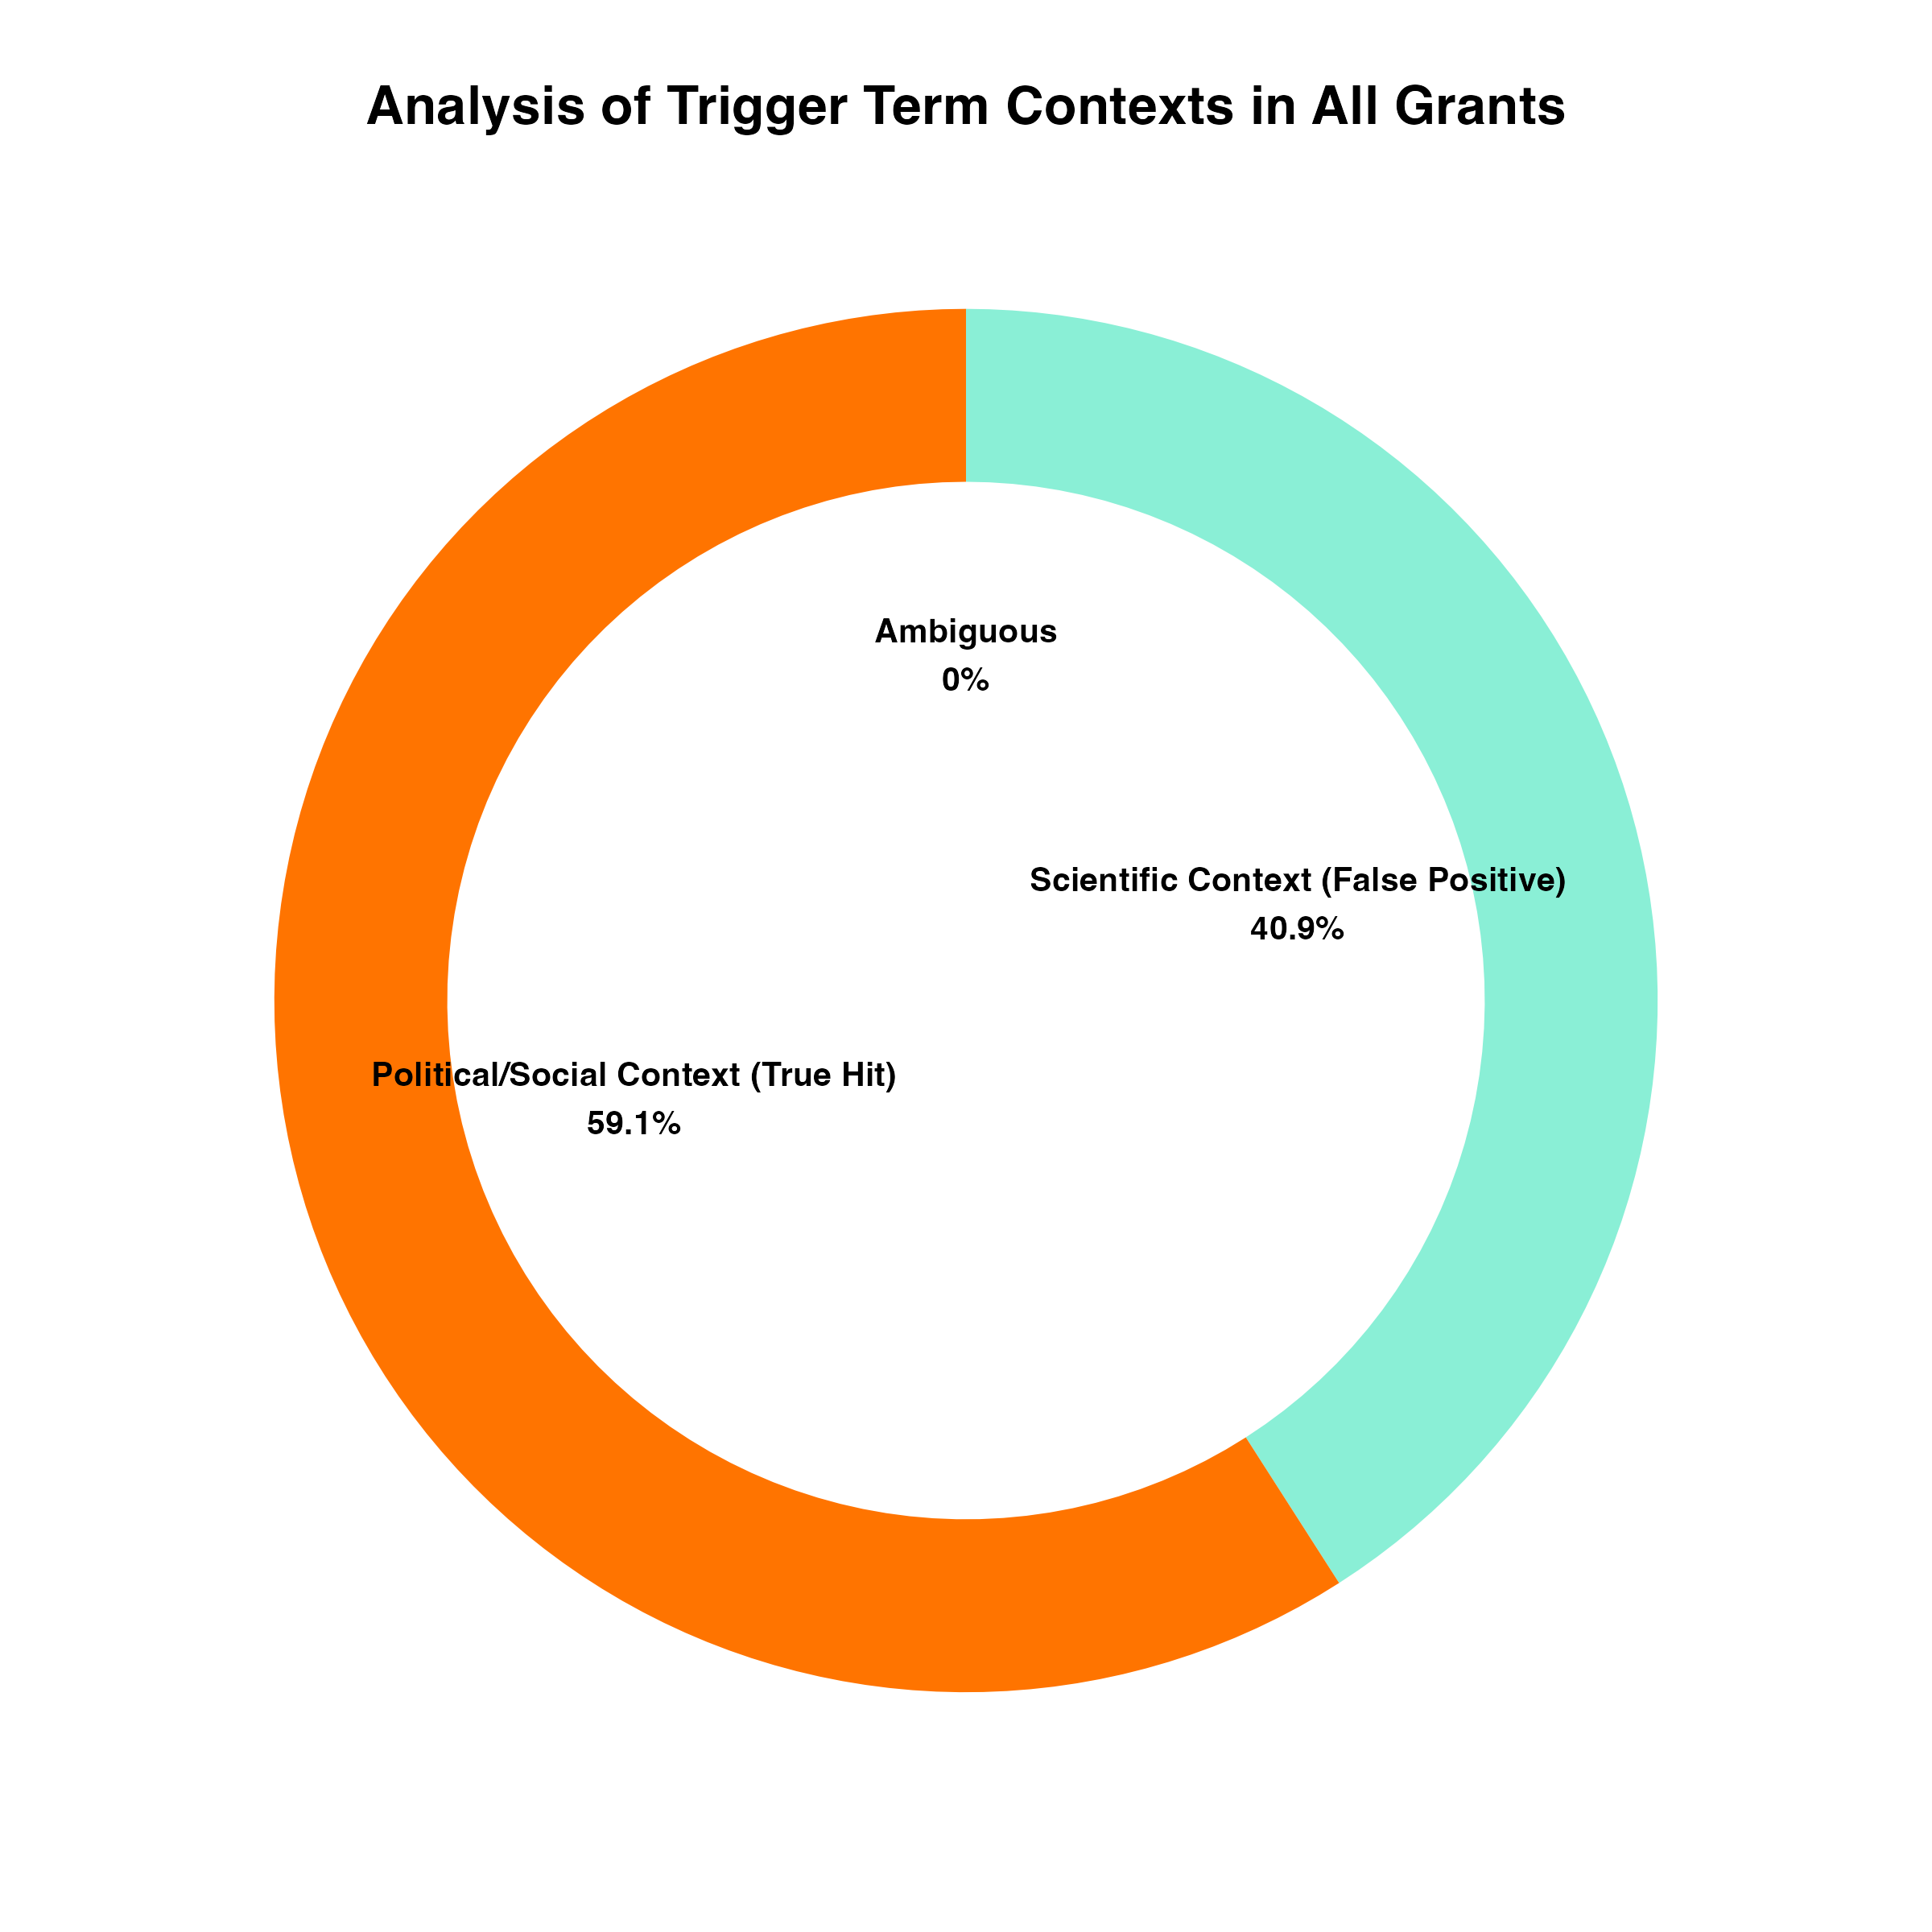 *Figure 1: Overall distribution of trigger terms by context, showing that 40.9% of occurrences represent scientific usage, 59.1% political/social usage, with almost no ambiguous usage.*

## Introduction

Recent policy changes have led to the termination of hundreds of NIH and NSF grants containing specific terminology deemed to no longer “effectuate program goals or agency priorities.” These terminations have particularly targeted grants containing language related to diversity, equity, and inclusion (DEI) as well as studies examining misinformation/disinformation.

The TriggerWarning project was established to objectively analyze whether the “trigger terms” leading to termination were primarily used in scientific contexts or political/social ones. This distinction is crucial, as many scientific fields employ terminology that may overlap with politically sensitive language but carry specific technical meanings within their disciplines.

## Data and Methodology

### Data Sources

Our analysis utilized several key data sources:

1. **NIH Terminations** (nih_terminations_airtable_20250429.csv): Contains data on terminated NIH grants up to April 29, 2025
2. **NSF Terminations** (nsf_terminations_airtable_20250425.csv): Contains data on terminated NSF grants up to April 25, 2025
3. **TAGGS Data** (Terminated_Grants_Explorer_TAGGS.csv): Grant information from the Tracking Accountability in Government Grants System
4. **Trigger Terms** (triggerterms.csv): List of terms used for analysis and classification

### Methodology

The project employed a multi-faceted approach to analyzing grant terminations:

1. **Natural Language Processing**: We used advanced NLP techniques to analyze grant abstracts and identify trigger term usage. This involved tokenizing grant text, identifying trigger terms, and examining the surrounding context to classify usage.
2. **Context Classification Framework**: Each term occurrence was classified as:
   * Scientific Context (False Positive): Terms used in legitimate scientific/technical contexts
   * Political/Social Context (True Hit): Terms used primarily in political or social contexts
   * Ambiguous: Terms with unclear context
3. **Multi-dimensional Analysis**: We examined patterns across agencies, directorates, institutions, grant types, geographic regions, and time periods to identify broader trends in termination decisions.

## Key Findings

### 1. Context Analysis Results

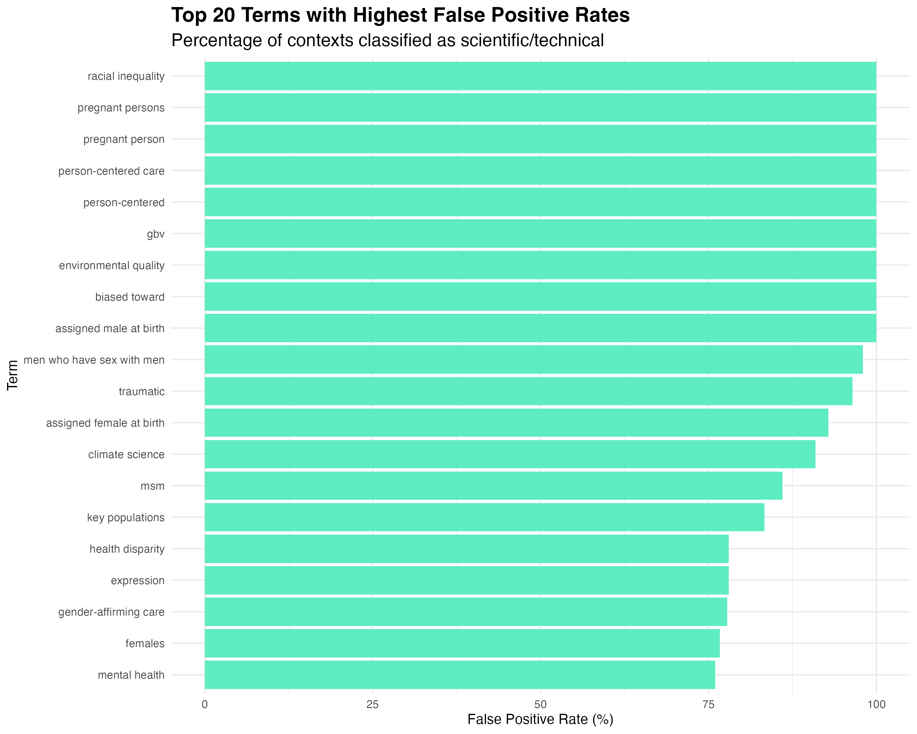 *Figure 2: Top 20 terms with highest false positive rates, showing the percentage of contexts classified as scientific/technical rather than political/social.*

Our analysis revealed that while the overall false positive rate was 40.9%, certain trigger terms showed much higher rates of scientific usage. Terms like “racial inequality,” “pregnant persons,” “person-centered care,” “environmental quality,” and “biased toward” had false positive rates approaching 100%, indicating that these terms were almost exclusively used in scientific contexts within the terminated grants.

For other frequently occurring terms, the classification varied considerably. The visualization shows that terms like “mental health,” “females,” “gender-affirming care,” and “expression” had scientific classification rates of 75% or higher, suggesting these terms were predominantly used in technical rather than political contexts.

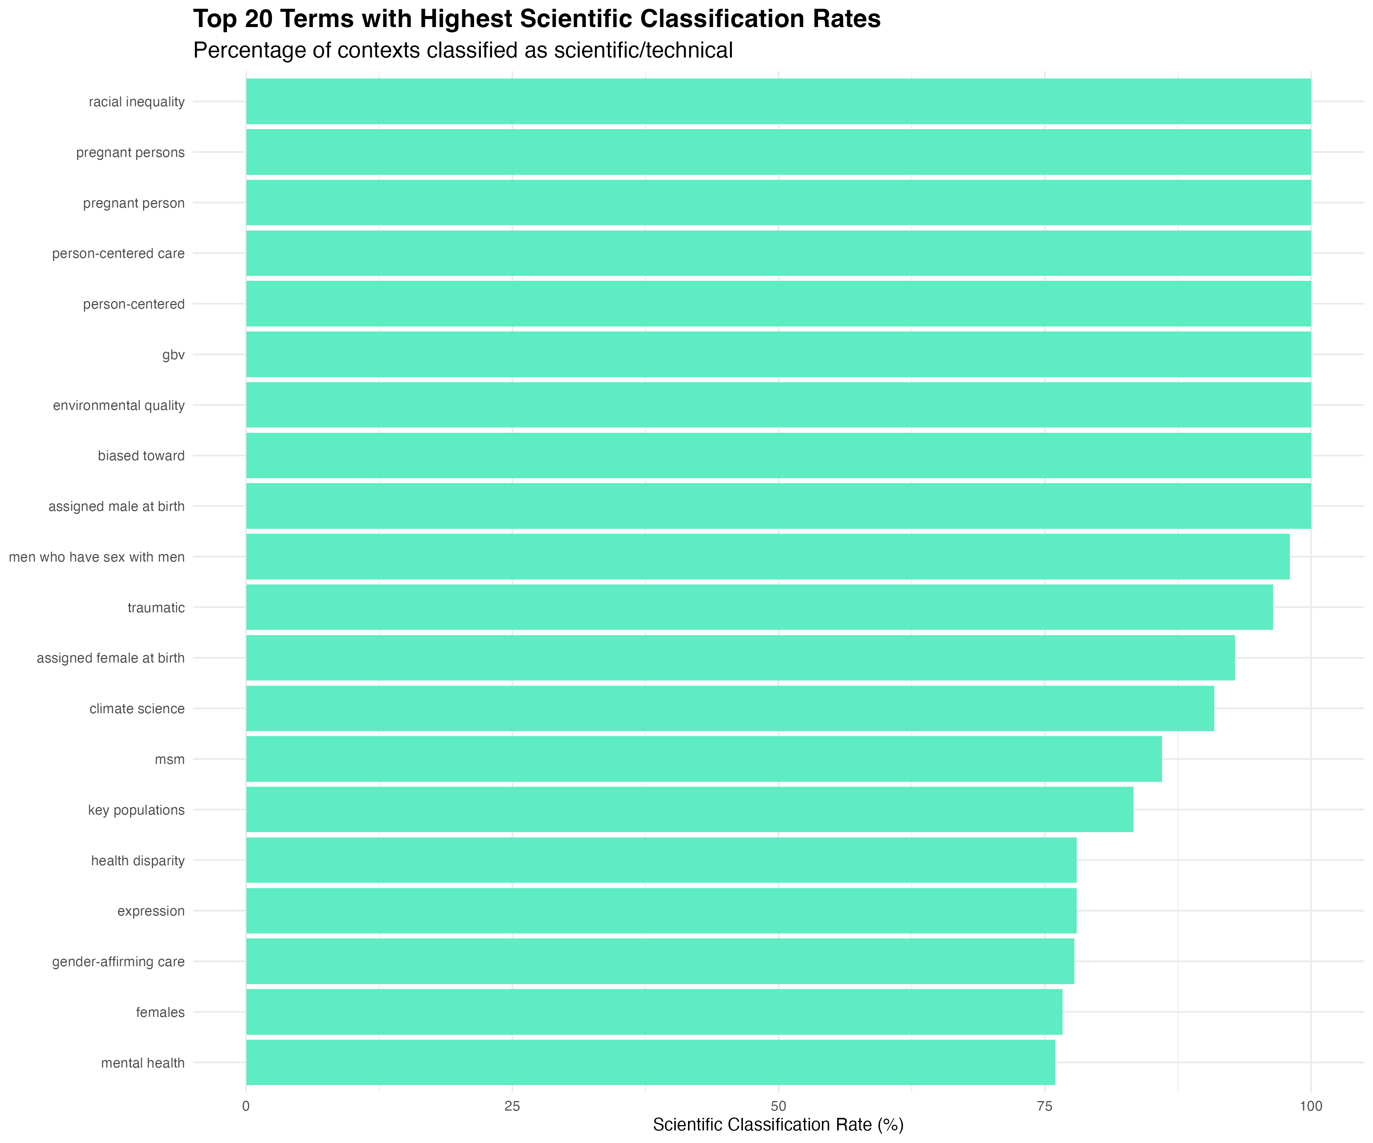 *Figure 3: Top 20 terms with highest scientific classification rates, showing terms predominantly used in scientific/technical contexts.*

### 2. Analysis of Specific Terms

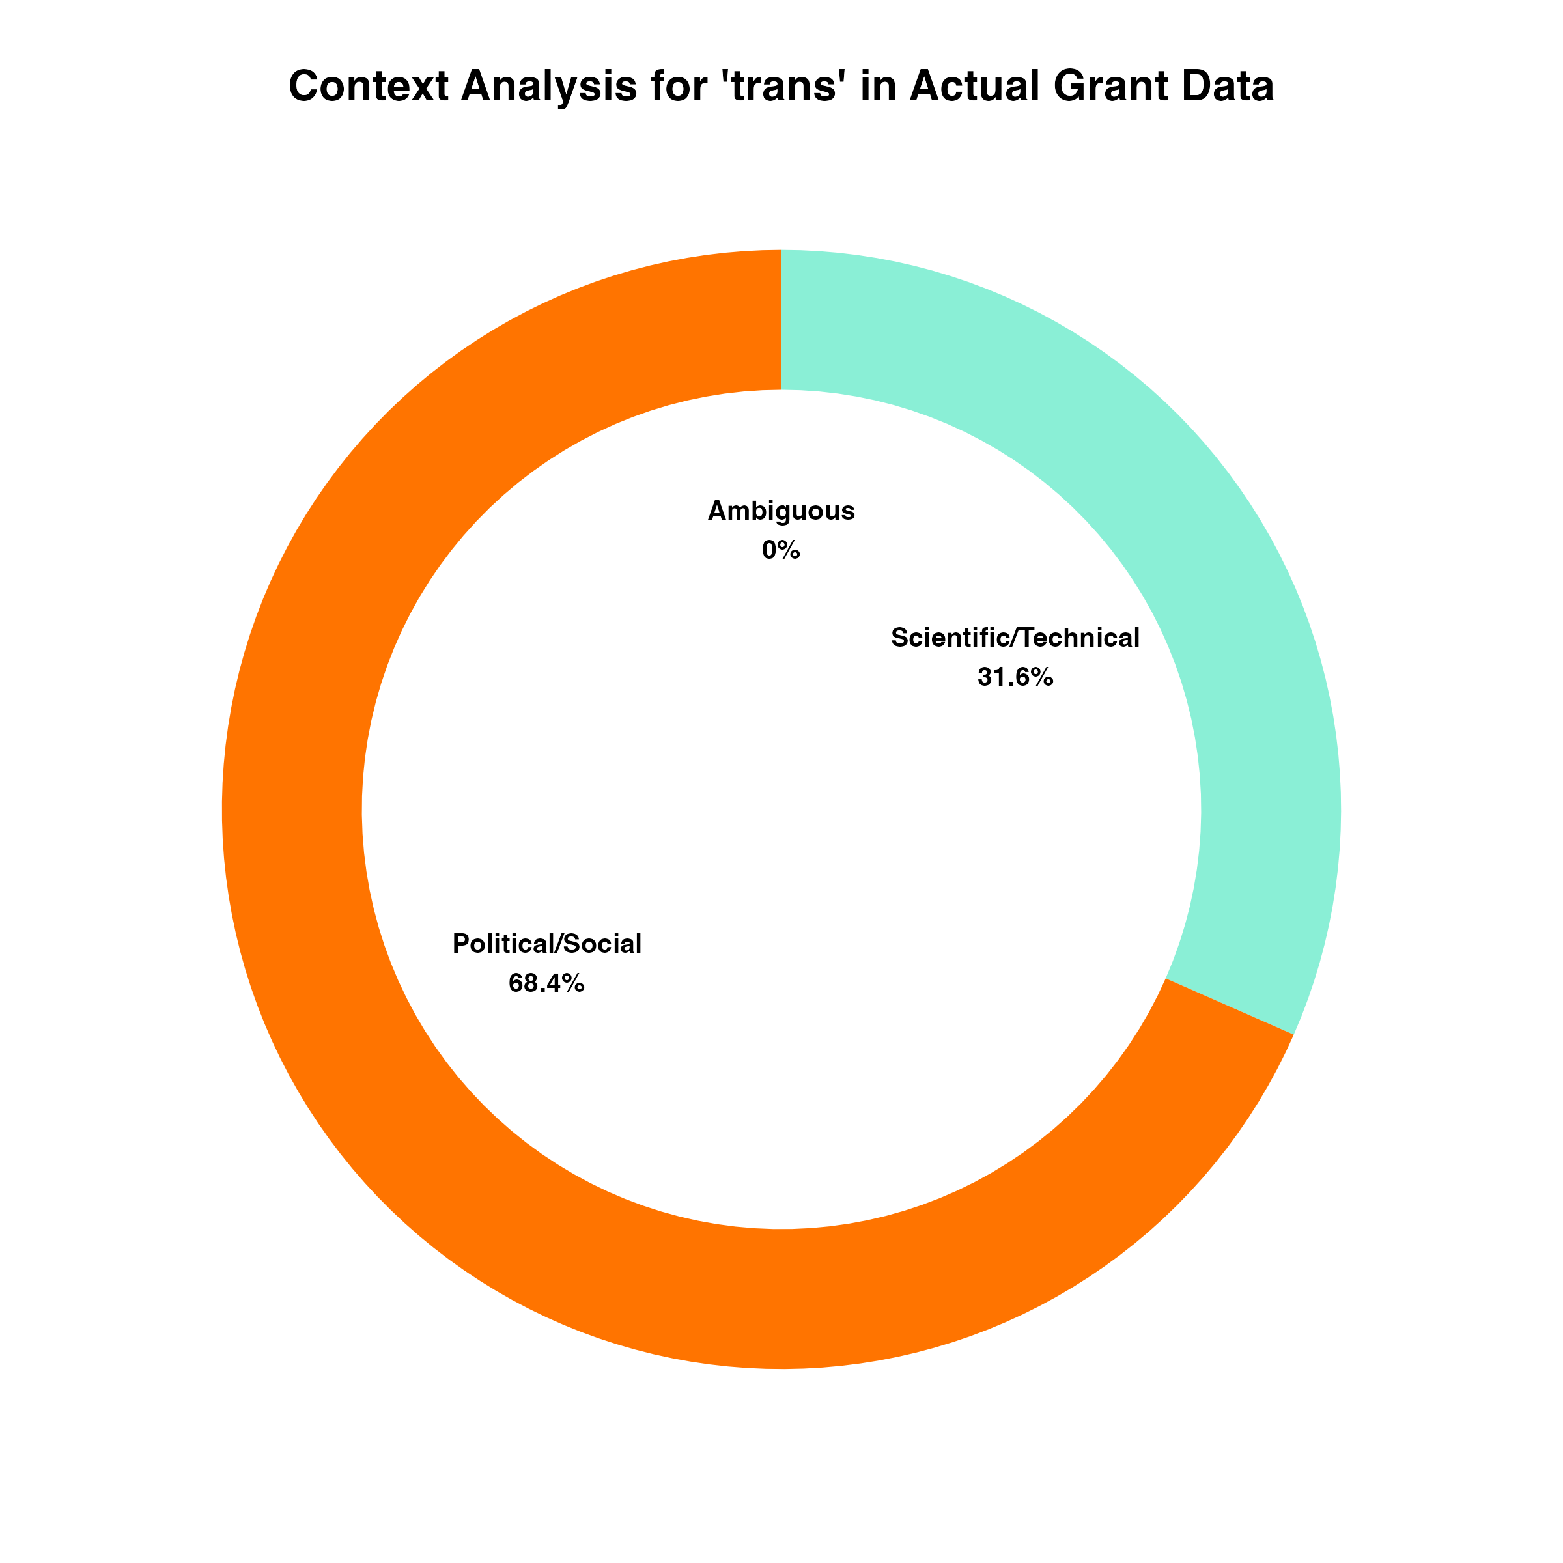 *Figure 4: Contextual analysis of ‘trans’ term usage showing 31.6% scientific/technical applications and 68.4% political/social usage.*

The term “trans” provides an interesting case study. While it can have politically charged connotations, it also has numerous scientific meanings across multiple disciplines. Our analysis found that 31.6% of “trans” occurrences in terminated grants represented scientific/technical usage, including contexts such as:

* Biochemistry: Trans isomers, trans fatty acids
* Molecular biology: Transcription, translation, transduction
* Genetics: Transgenic models, transposons
* Cell biology: Transmembrane proteins, transport mechanisms

This suggests that nearly a third of grants containing this term may have been using it in legitimate scientific contexts.

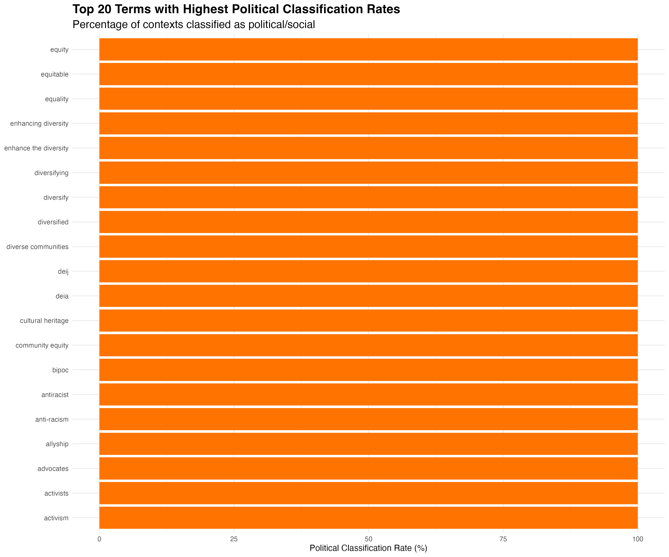 *Figure 5: Top 20 terms with highest political classification rates, showing terms almost exclusively used in political/social contexts.*

Conversely, certain terms were consistently classified as political rather than scientific. Figure 5 shows that terms such as “activism,” “antiracist,” “bipoc,” “deia,” “deij,” and other DEI-related terminology were classified as having political/social usage in nearly 100% of occurrences.

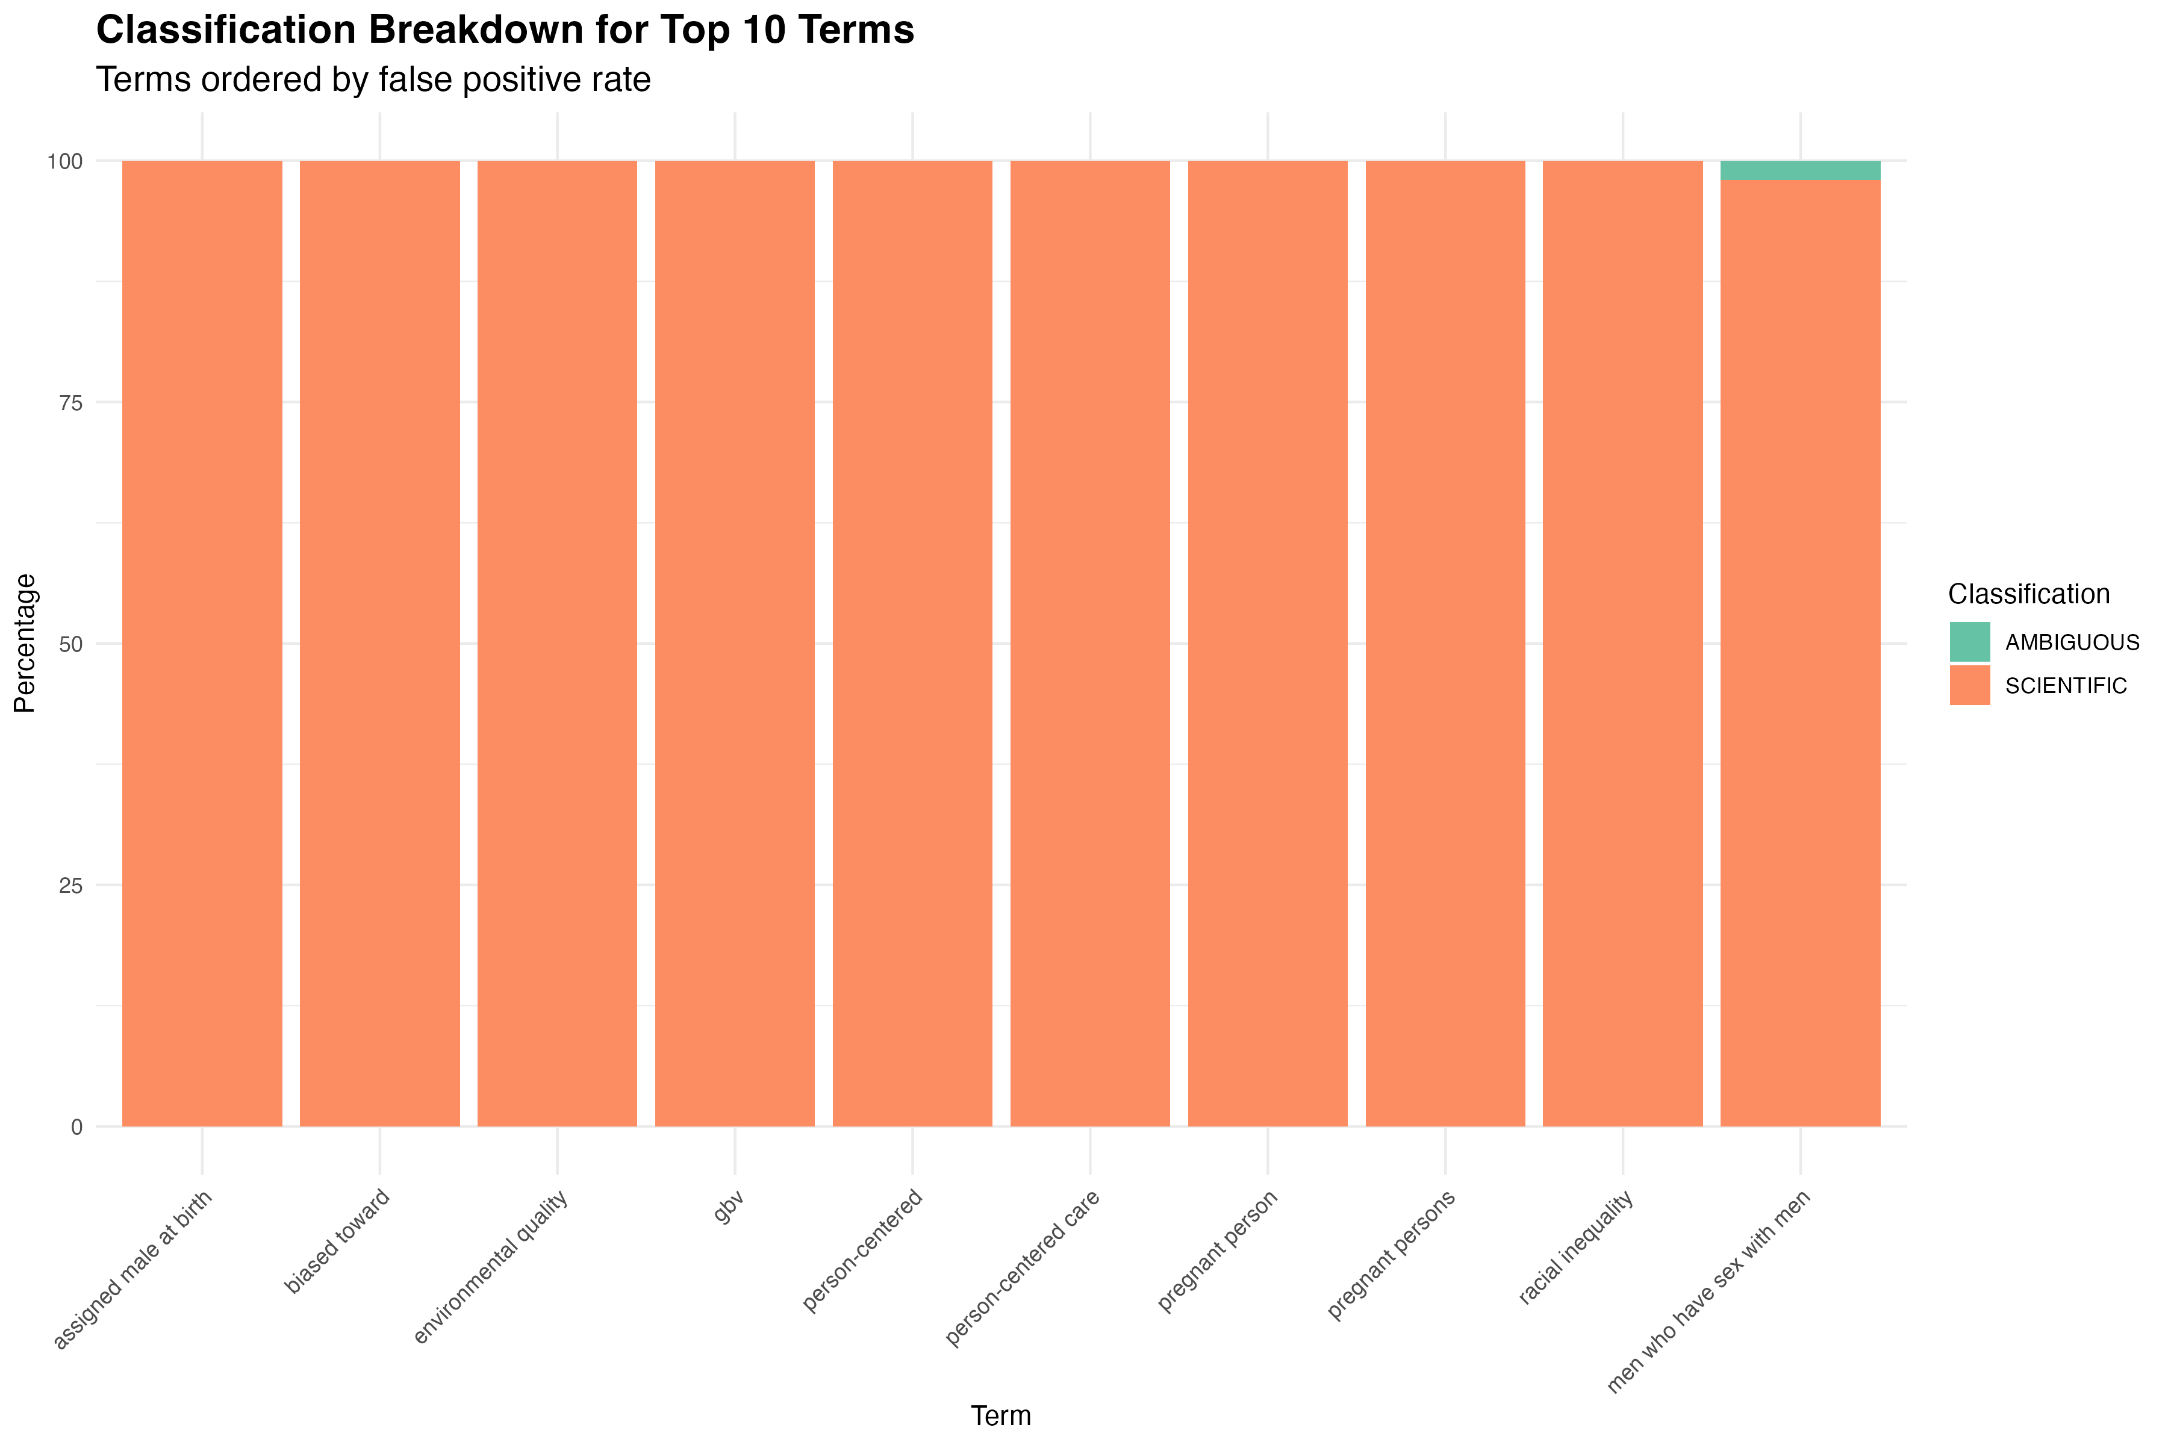 *Figure 6: Distribution of the top 20 most frequent trigger terms, showing how each term is classified across scientific, political, and ambiguous categories.*

### 3. Temporal Analysis

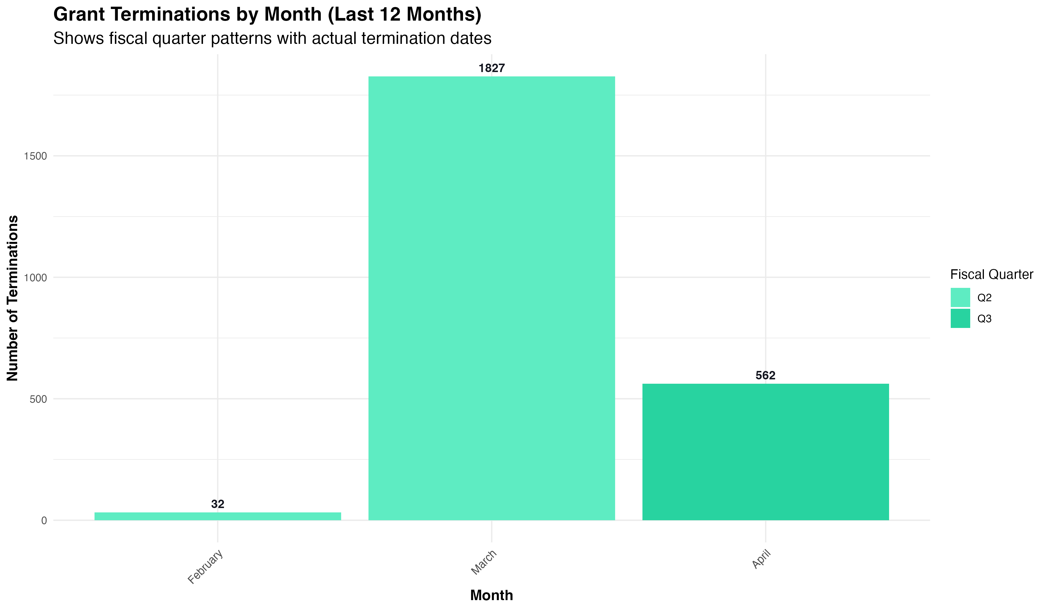 *Figure 7: Monthly distribution of grant terminations showing a dramatic spike in March 2025 with 1,827 terminations.*

Our temporal analysis revealed a significant spike in grant terminations during March 2025, with 1,827 grants terminated in that month alone. This represents a dramatic escalation compared to February (32 terminations) and was followed by a substantial but reduced number in April (562 terminations). This clear temporal pattern suggests coordinated policy implementation rather than ongoing review processes.

### 4. Agency-Specific Analysis

#### NIH Institute Analysis

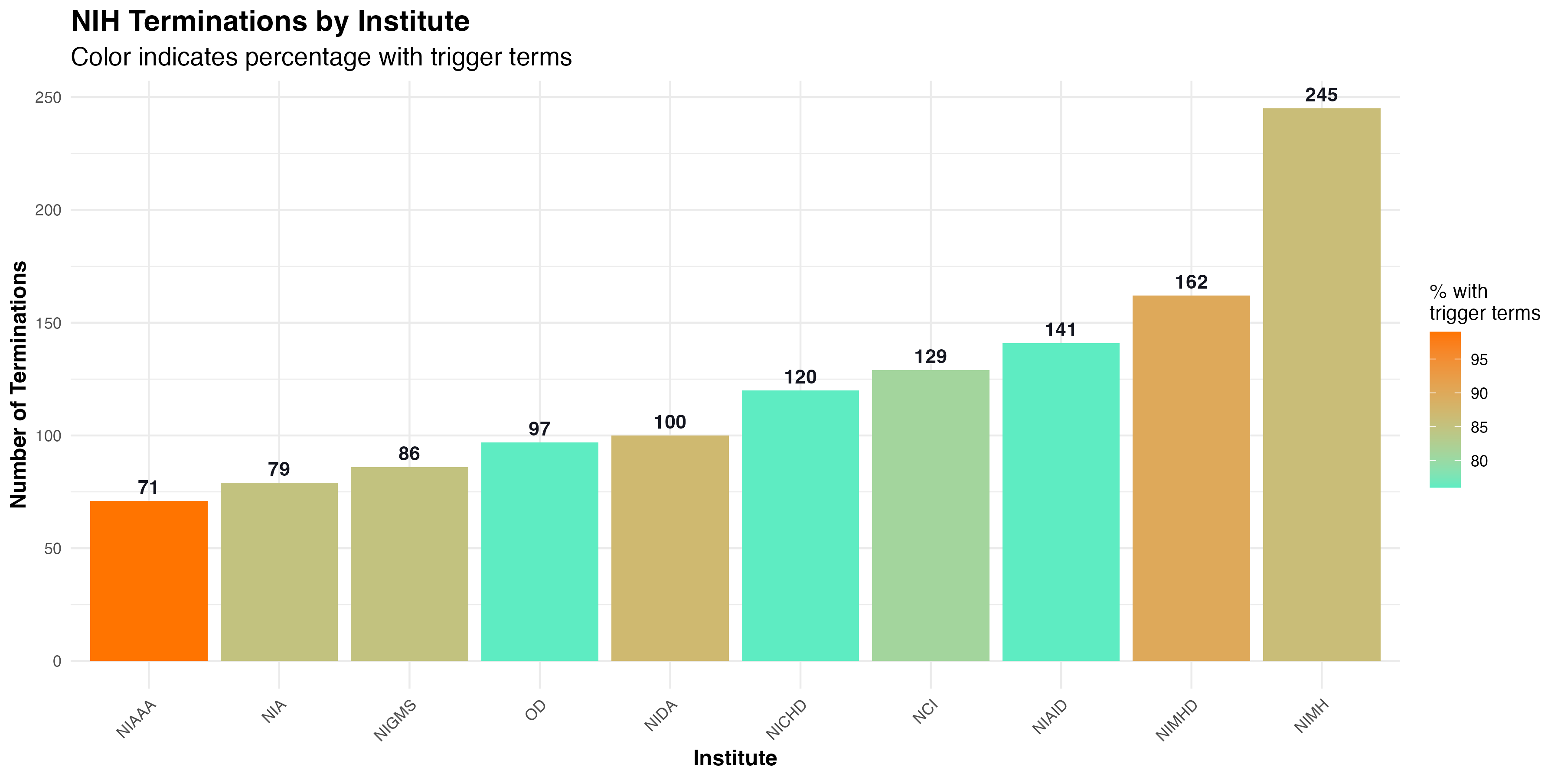 *Figure 8: Distribution of terminations across NIH institutes, showing which institutes experienced the most grant terminations.*

The National Institute of Mental Health (NIMH) had the highest number of terminated grants (245), followed by the National Institute on Minority Health and Health Disparities (NIMHD) with 162 terminations and the National Institute of Allergy and Infectious Diseases (NIAID) with 141 terminations.

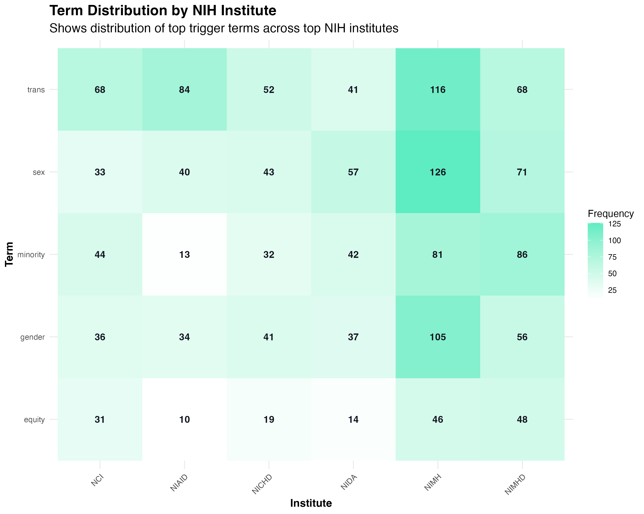 *Figure 9: Distribution of top trigger terms across major NIH institutes, showing patterns of terminology usage in different research domains.*

Figure 9 reveals that NIMH had particularly high frequencies of terms like “trans” (116 occurrences), “sex” (126), “gender” (105), and “minority” (81), which aligns with its focus on mental health research that often addresses these topics from a clinical perspective. NIMHD similarly showed high frequencies of “minority” (86) and “trans” (68) terms, reflecting its research focus on health disparities.

#### NSF Directorate Analysis

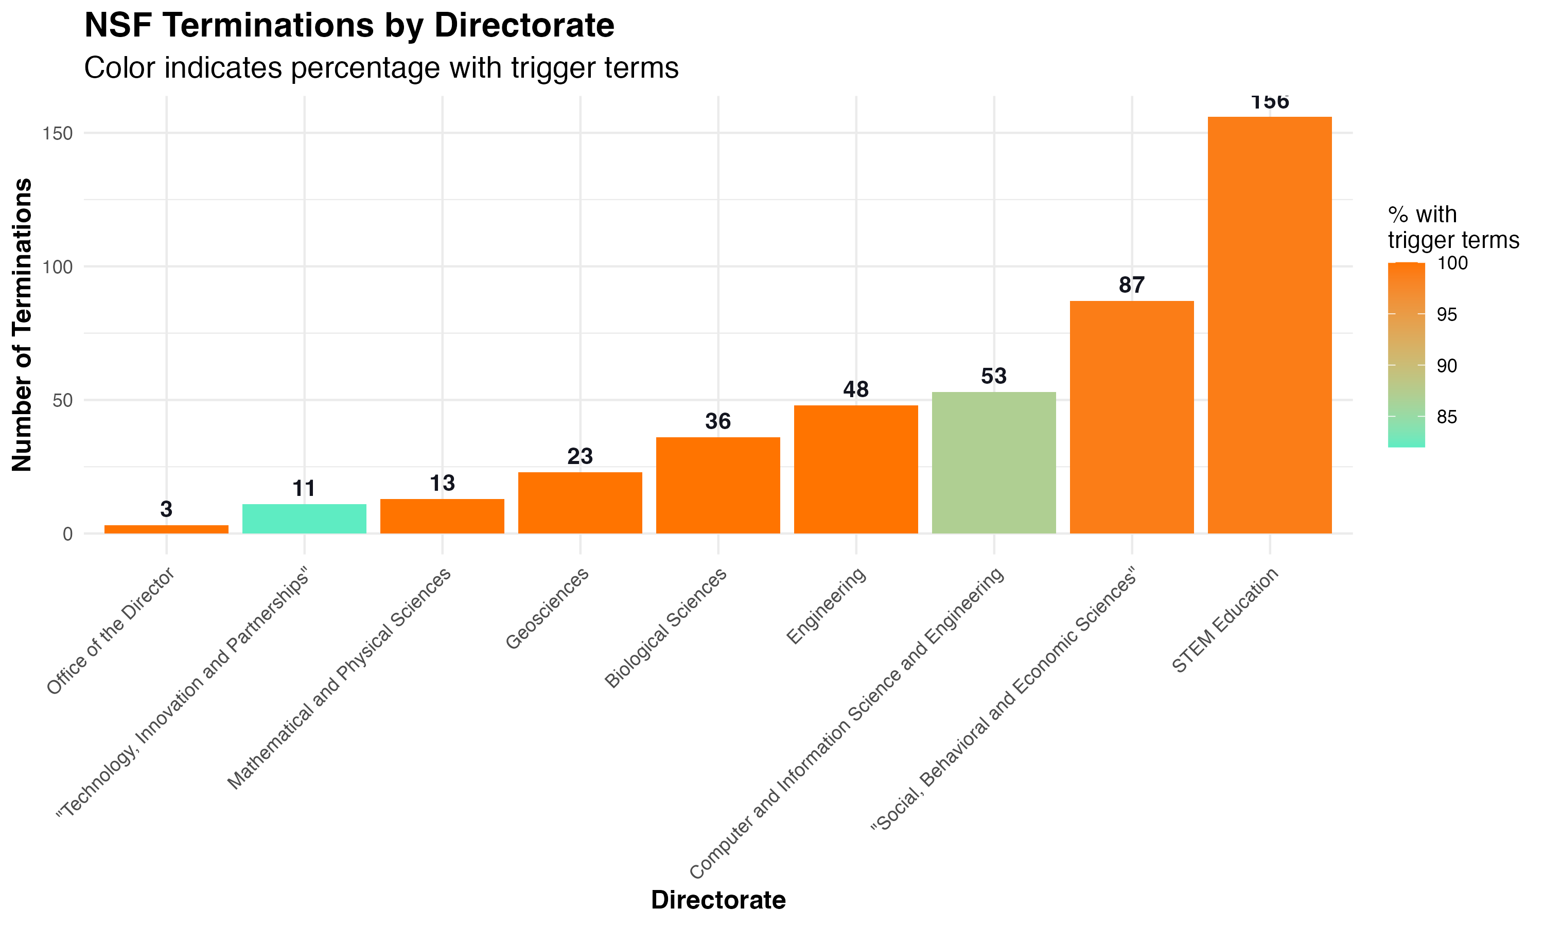 *Figure 10: Distribution of terminations across NSF directorates, showing which areas of science were most affected.*

Within NSF, the STEM Education directorate experienced the highest number of terminations (156), followed by the Social, Behavioral and Economic Sciences directorate (87). This pattern suggests that certain scientific domains, particularly those focused on education and social sciences, were disproportionately impacted by termination decisions.

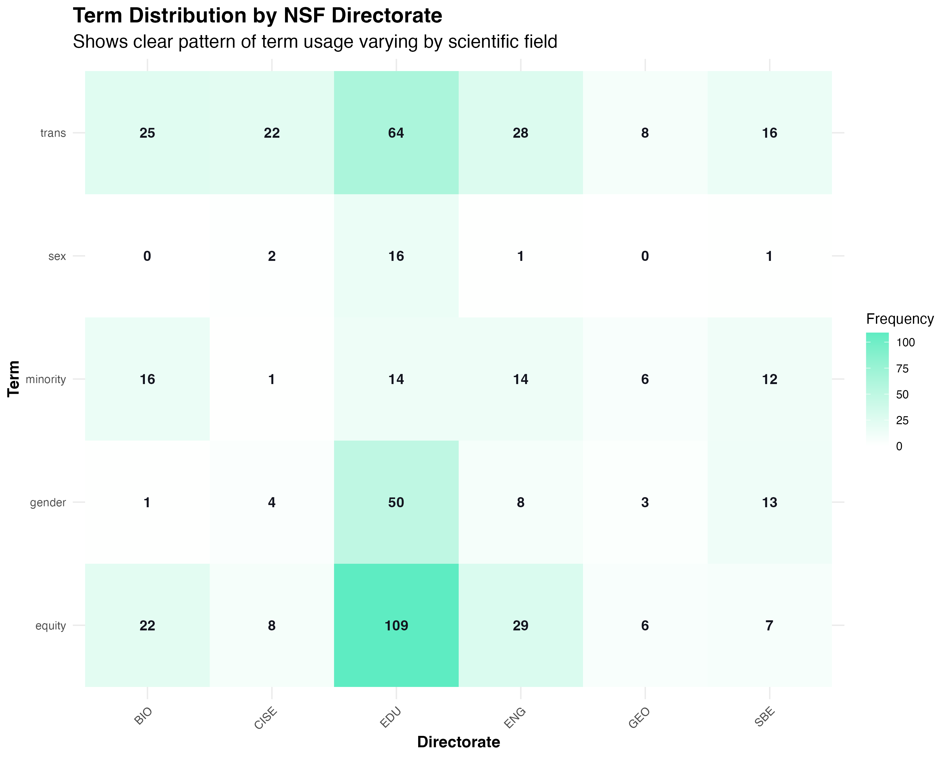 *Figure 11: Distribution of trigger terms across NSF directorates, showing clear patterns of term usage varying by scientific field.*

Figure 11 shows that the Education (EDU) directorate had particularly high frequencies of terms like “equity” (109 occurrences), “gender” (50), and “trans” (64), which aligns with research on educational equity and inclusive pedagogical approaches. The BIO (Biological Sciences) directorate also showed substantial occurrences of terms like “equity” (22) and “trans” (25), reflecting legitimate biological research contexts.

### 5. Geographic Analysis

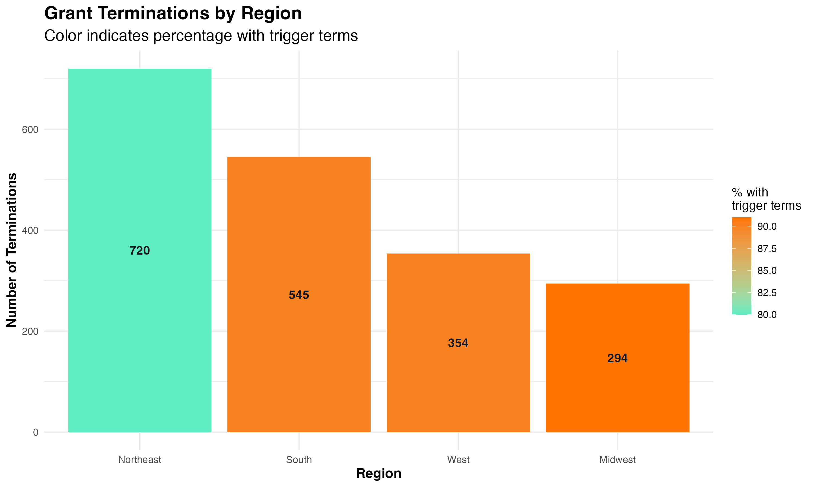 *Figure 12: Distribution of terminated grants across U.S. regions, showing significant geographic disparities.*

Our geographic analysis revealed substantial regional variation in grant terminations. The Northeast region experienced the highest number of terminations (720), followed by the South (545), West (354), and Midwest (294). This regional disparity may reflect differences in research priorities, institutional concentrations, or policy implementation.

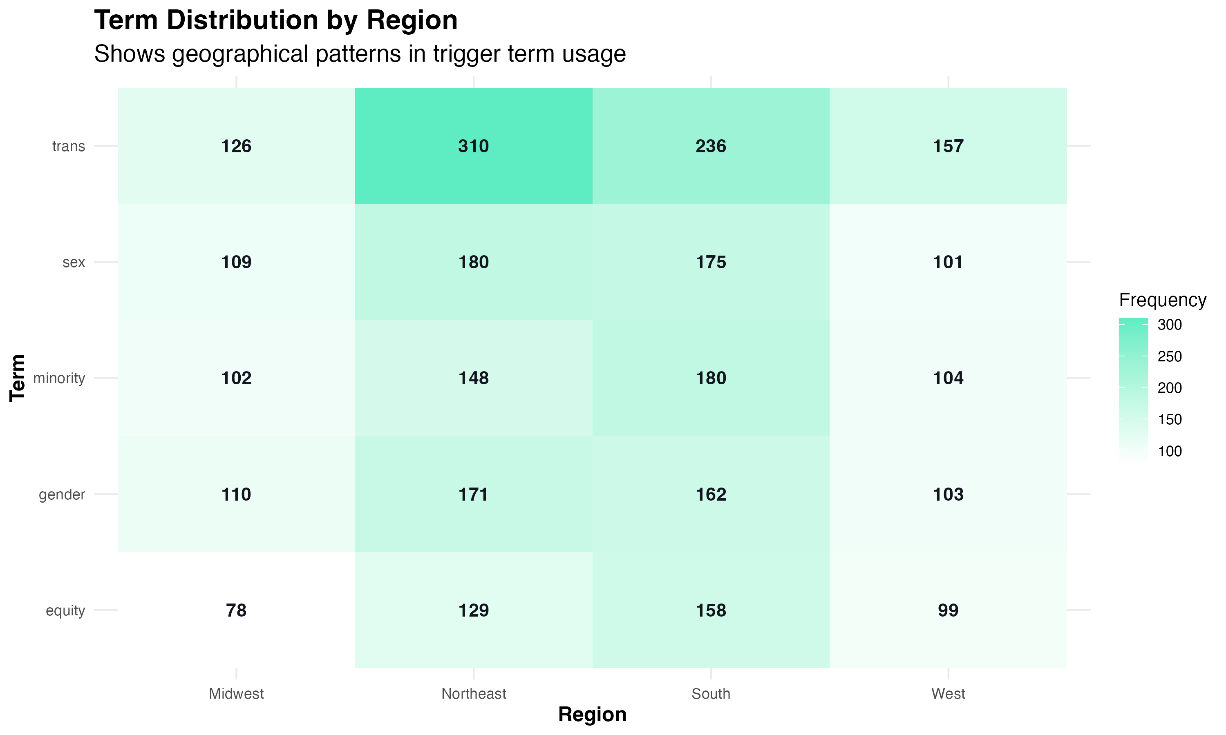 *Figure 13: Distribution of trigger terms across U.S. regions, showing geographical patterns in terminology usage.*

The Northeast showed particularly high frequencies of terms like “trans” (310), “sex” (180), and “gender” (171), while the South had high frequencies of “trans” (236), “minority” (180), and “gender” (162). These patterns reflect regional variations in research focus and terminology usage.

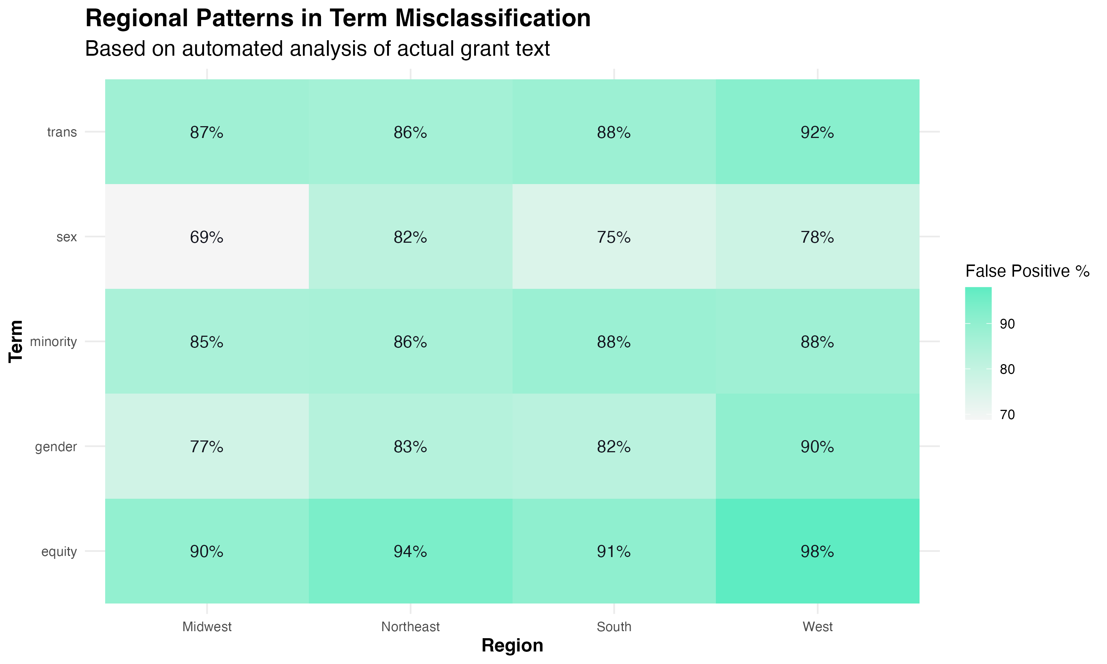 *Figure 14: False positive rates for key terms across different regions, showing geographic variation in scientific versus political usage.*

Interestingly, our analysis of regional term misclassification rates (Figure 14) revealed that the Western region consistently showed higher false positive rates across terms, with “equity” (98%), “trans” (92%), and “gender” (90%) frequently appearing in scientific contexts. This suggests regional differences in how terminology is used in grant applications.

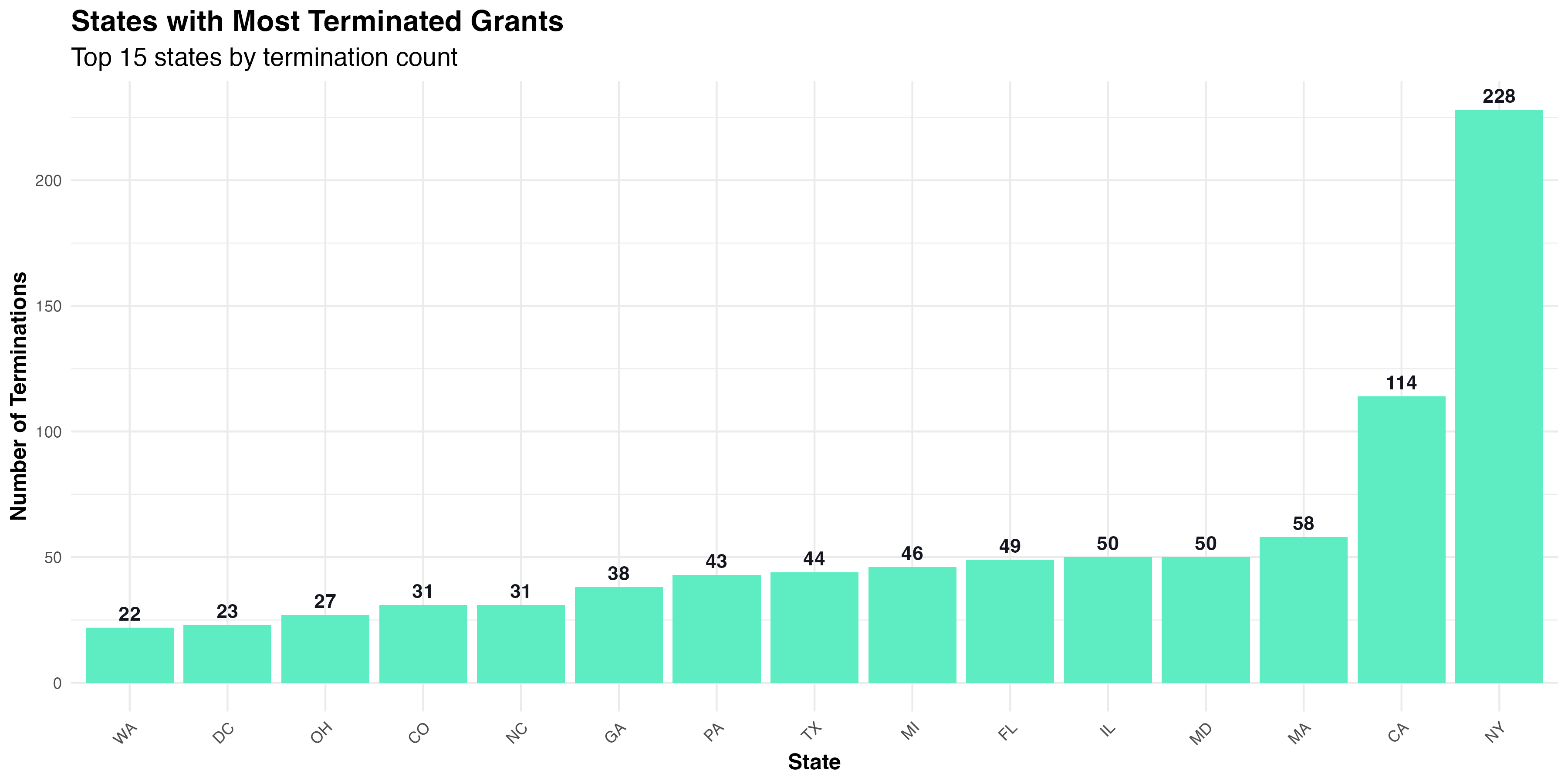 *Figure 15: States with the highest number of terminated grants, showing concentration in certain regions.*

At the state level, New York had the highest number of terminated grants (228), followed by California (114), Massachusetts (58), Maryland (50), and Illinois (50). This concentration in states with major research institutions suggests that research-intensive states bore the brunt of terminations.

### 6. Congressional District Analysis

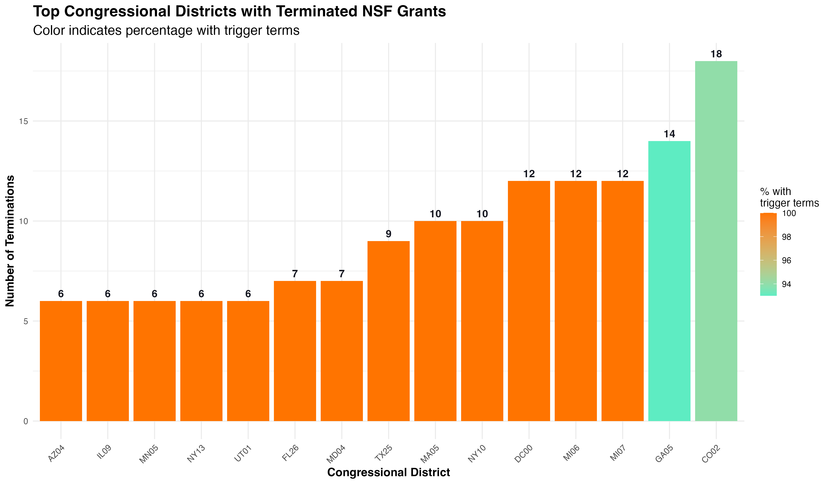 *Figure 16: Congressional districts with the highest number of terminated NSF grants.*

Our analysis of congressional districts revealed that Colorado’s 2nd district (CO02) had the highest number of NSF grant terminations (18), followed by Georgia’s 5th district (GA05) with 14 terminations. These districts typically contain major research universities, suggesting that terminations disproportionately affected areas with significant research infrastructure.

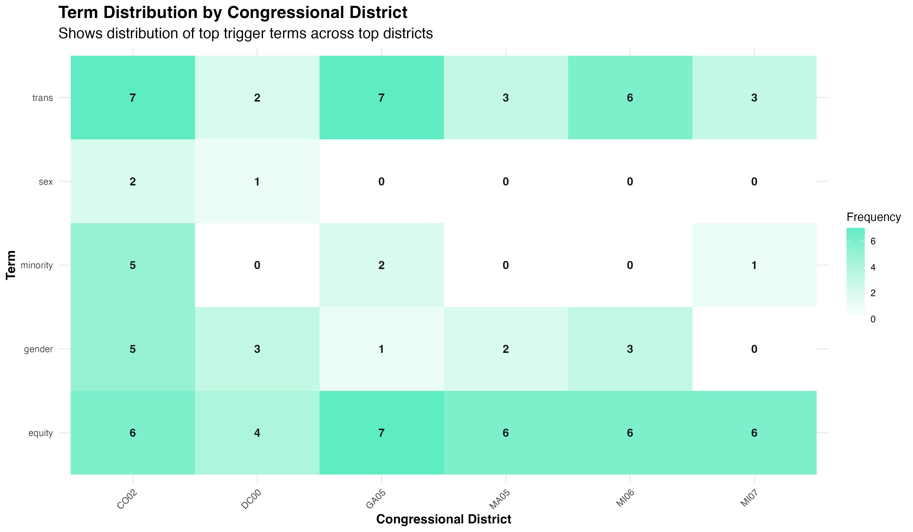 *Figure 17: Distribution of trigger terms across top congressional districts, showing patterns in terminology usage.*

The distribution of terms across congressional districts showed interesting patterns, with “equity” and “trans” consistently appearing as frequent terms across districts. Districts like CO02, GA05, and MI07 showed particularly high frequencies of these terms, reflecting research priorities in institutions within these districts.

### 7. Grant Type Analysis

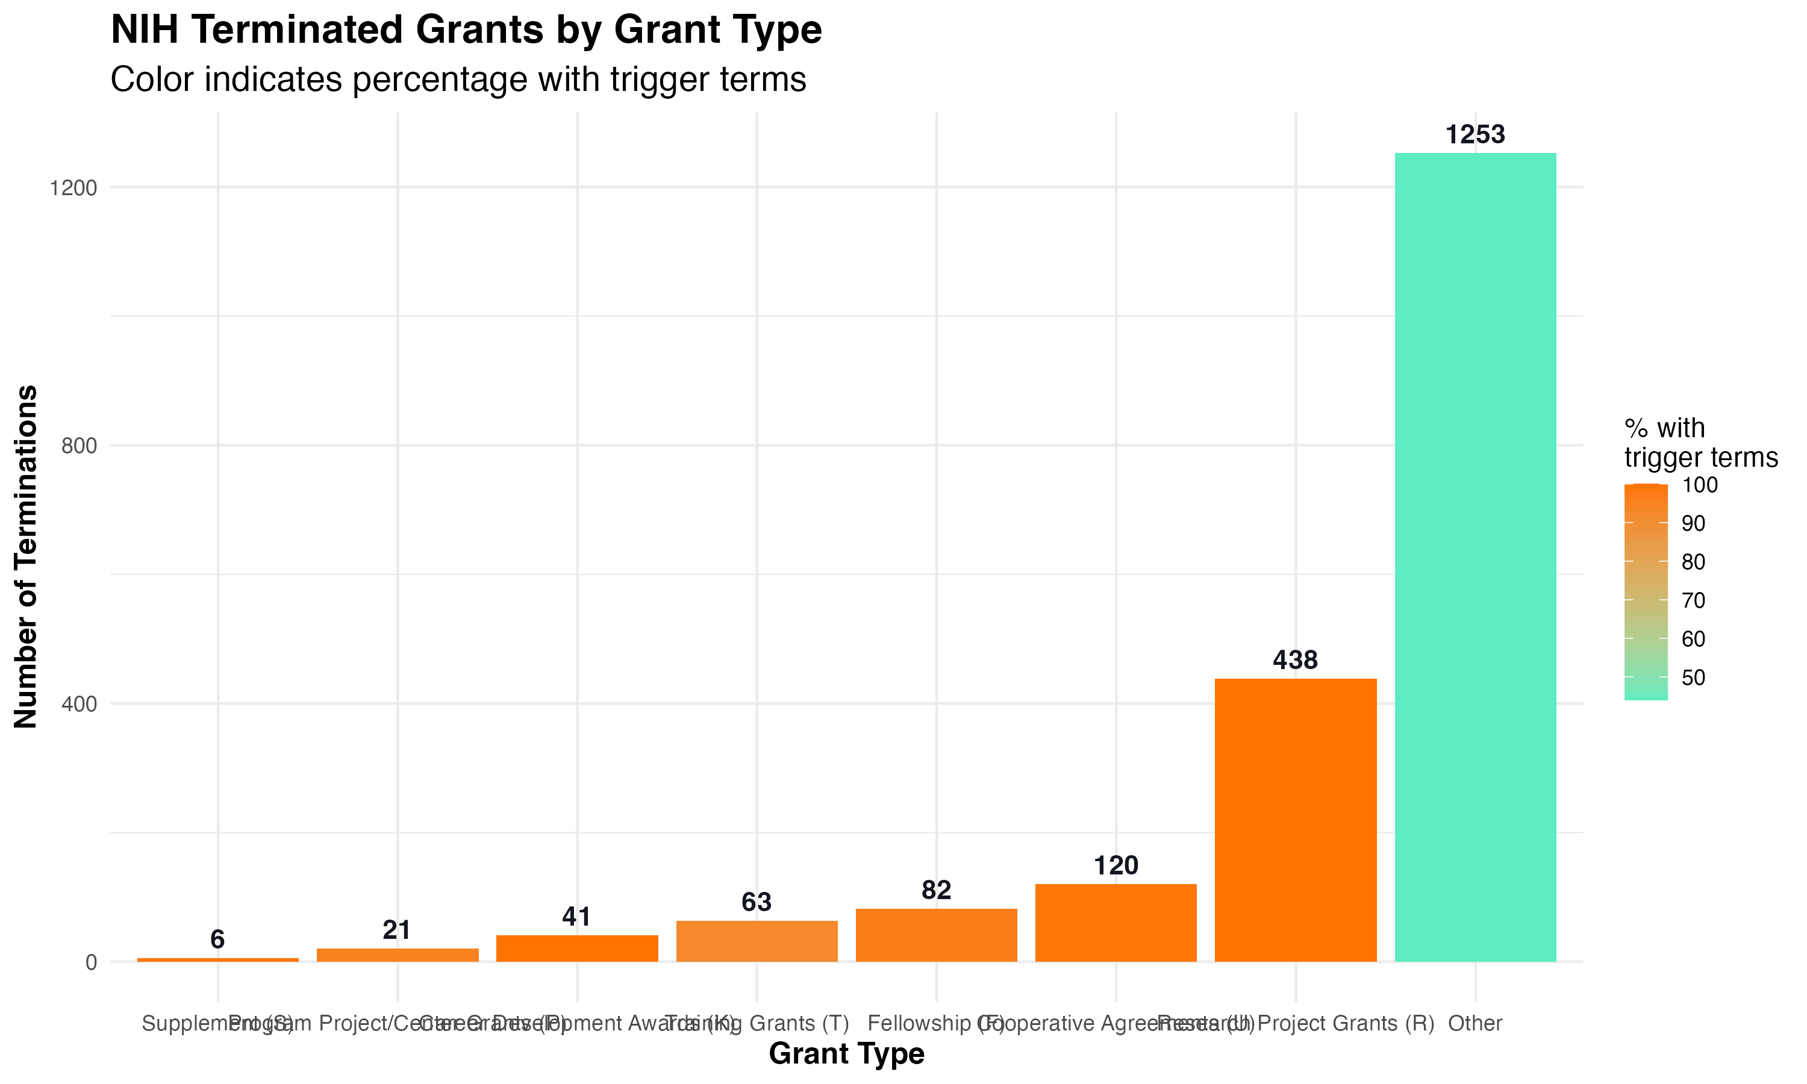 *Figure 18: Distribution of NIH terminated grants by grant mechanism, showing which types of grants were most frequently terminated.*

Research Project Grants (R) accounted for the largest number of terminated grants (438), while a substantial number (1,253) fell into the “Other” category. Career Development Awards (K) and Training Grants (T) were also significantly impacted, with 120 and 82 terminations respectively.

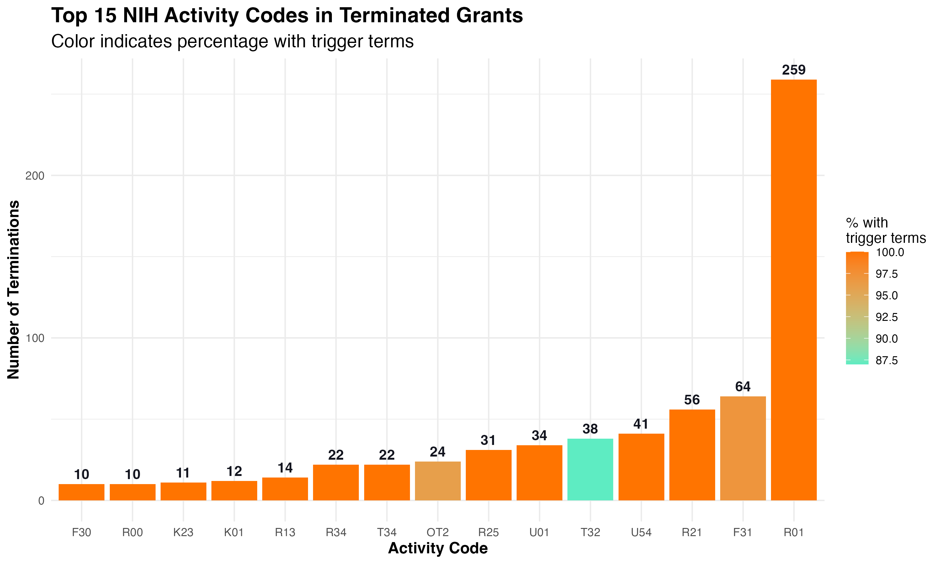 *Figure 19: Distribution of terminated grants by NIH activity code, showing which specific funding mechanisms were most affected.*

Among specific activity codes, R01 grants (Research Project Grants) were most frequently terminated (259), followed by F31 fellowships (64) and R21 grants (56). This suggests that both established research projects and early career training were significantly affected by terminations.

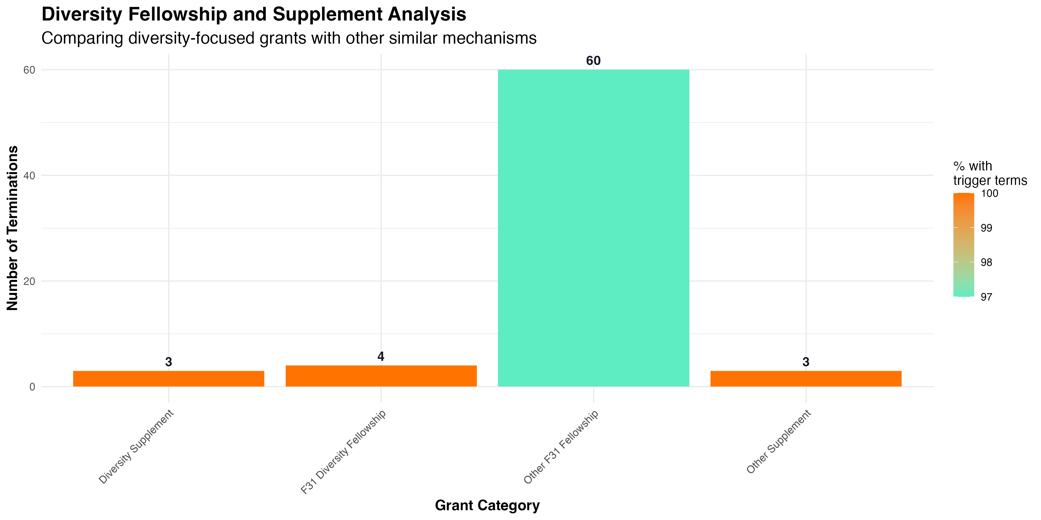 *Figure 20: Comparison of diversity-focused grants with other similar mechanisms, showing higher termination rates for diversity-specific funding mechanisms.*

Figure 20 reveals a concerning pattern: while “Other F31 Fellowship” grants had 60 terminations, “F31 Diversity Fellowship” grants had only 4 terminations, but 100% of those contained trigger terms compared to 97% of the regular F31 grants. Similar patterns are seen with diversity supplements versus regular supplements, suggesting targeted impacts on diversity-focused funding mechanisms.

### 8. Institutional Analysis

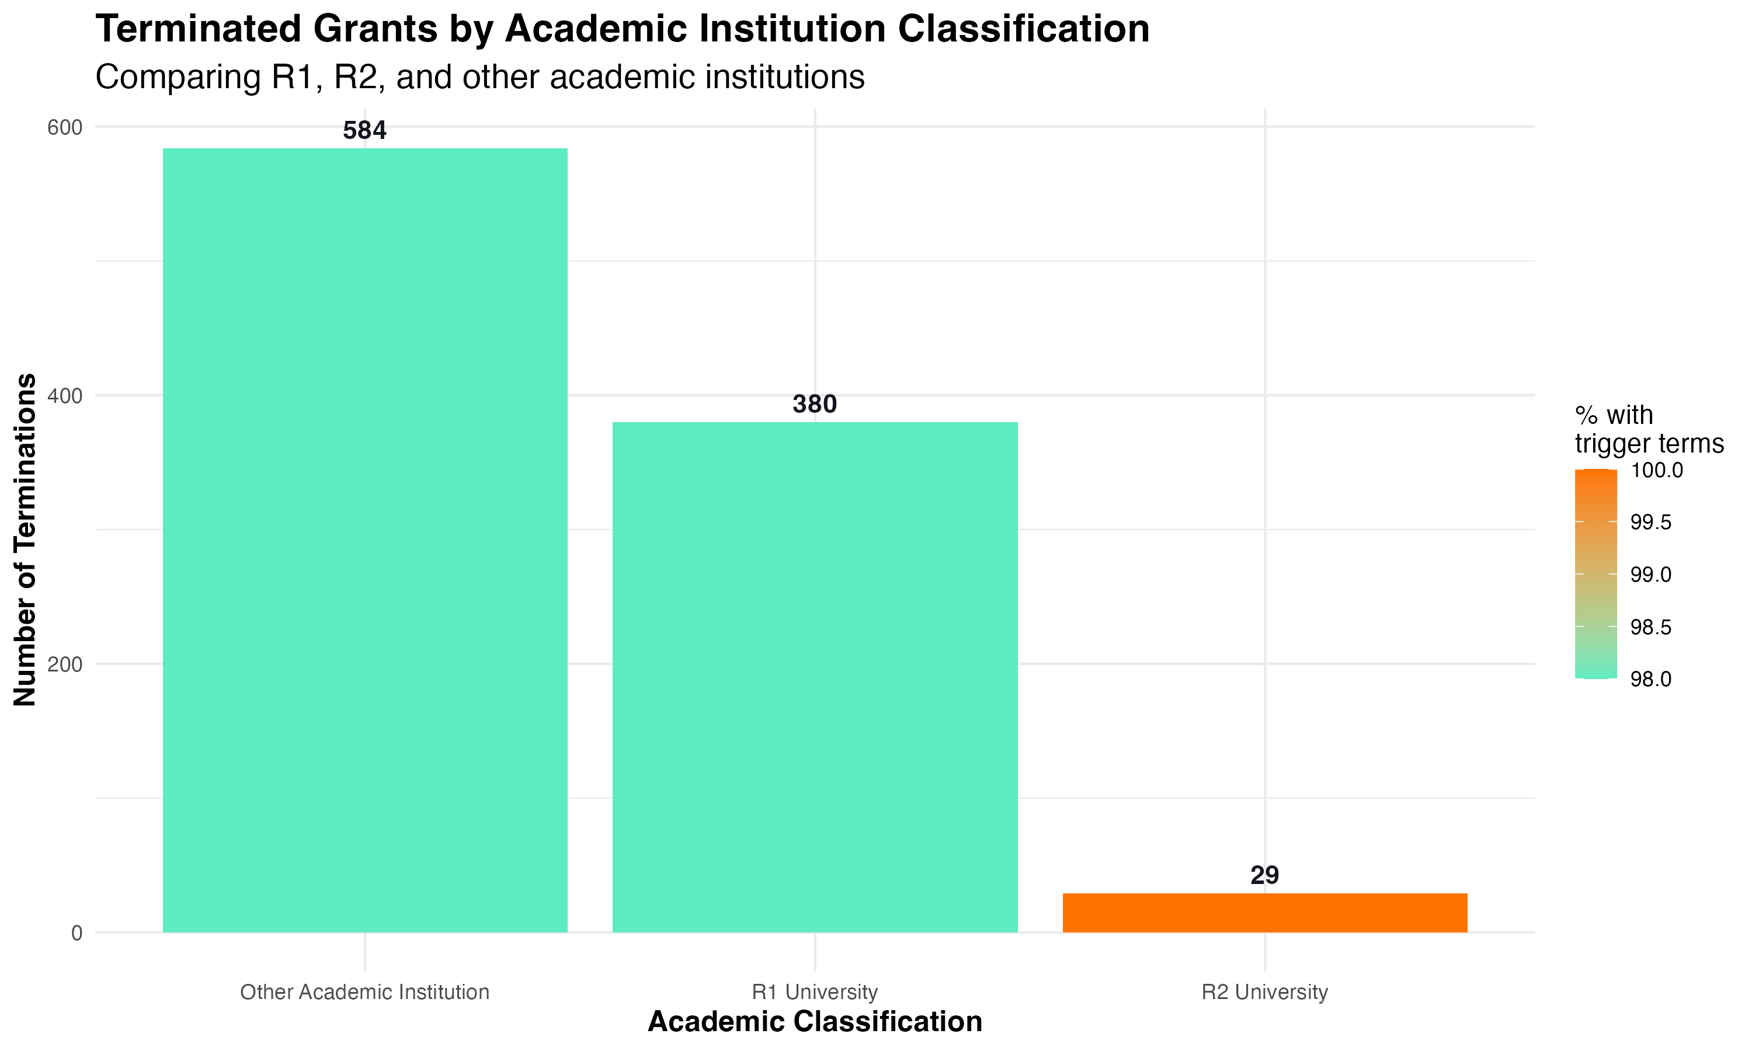 *Figure 21: Distribution of terminations by Carnegie Classification, showing disproportionate impact on different types of academic institutions.*

Research-intensive universities (R1 and other academic institutions) bore the brunt of terminations, with R1 universities accounting for 380 terminations and other academic institutions accounting for 584. R2 universities experienced 29 terminations. This pattern suggests that research-intensive institutions were particularly impacted by termination decisions.

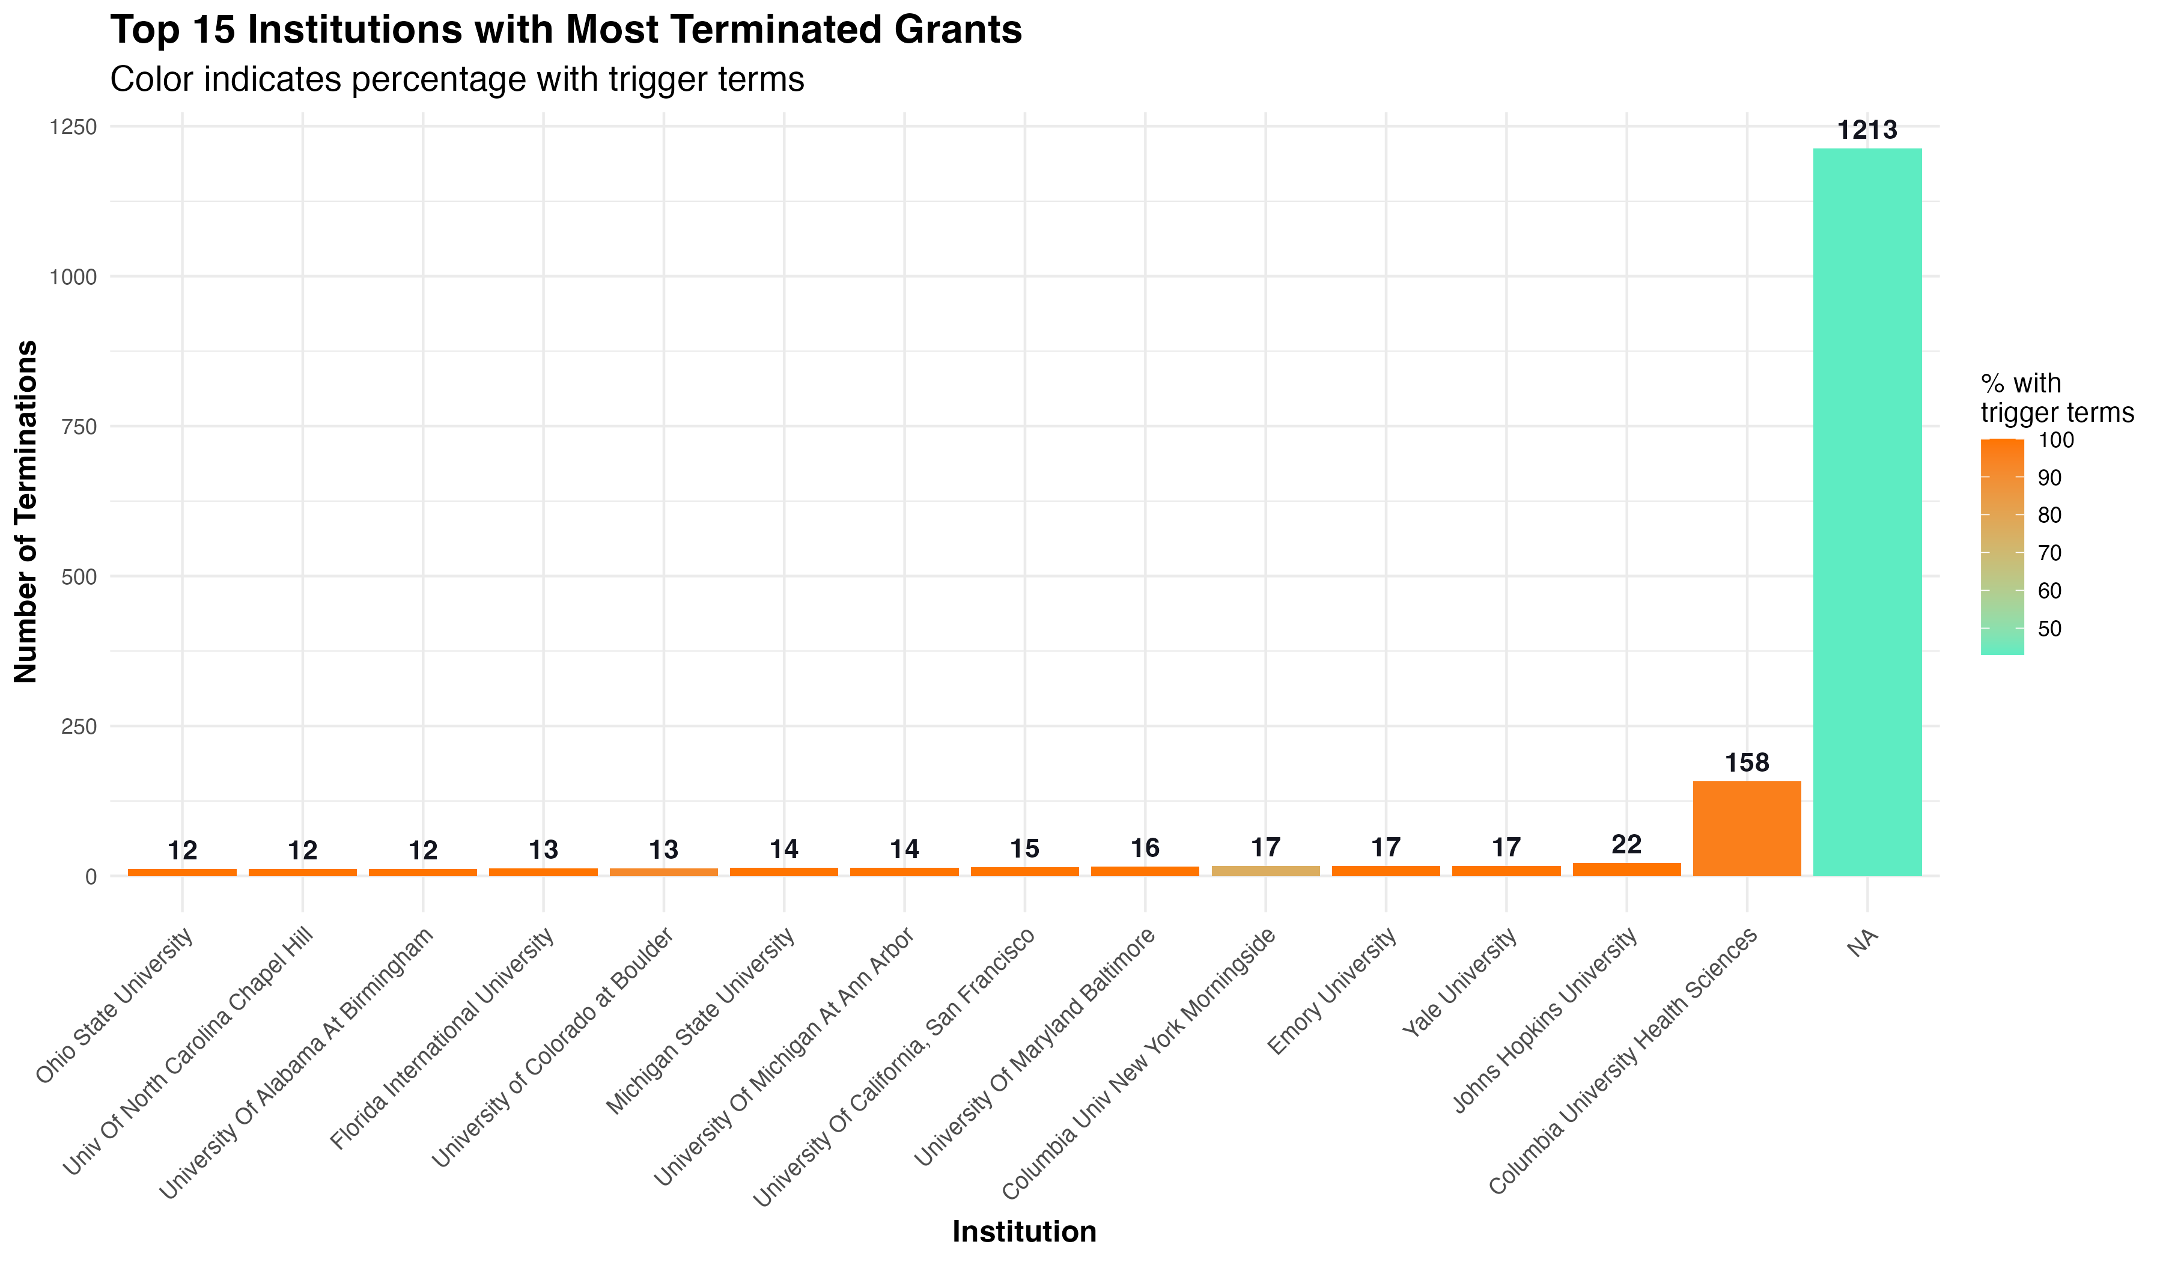 *Figure 22: Institutions with the highest number of terminated grants, showing which research centers were most affected.*

Figure 22 shows that Columbia University Health Sciences had 158 grant terminations, followed by Johns Hopkins University with 22 terminations. It’s worth noting that a large number of terminated grants (1,213) did not have institution data available.

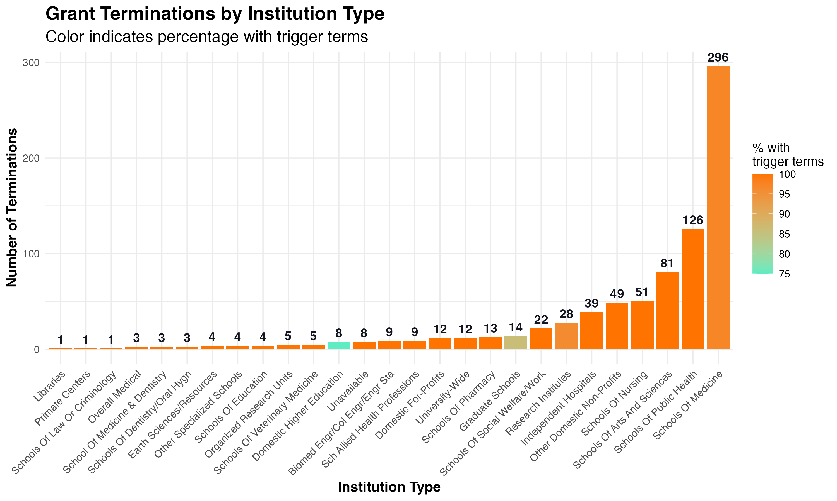 *Figure 23: Distribution of terminations across different types of institutions, showing varying impact on medical schools, schools of public health, etc.*

Schools of Medicine accounted for the highest number of identified terminations (296), followed by Schools of Public Health (126) and Schools of Arts and Sciences (81). This distribution reflects the medical and public health focus of many terminated grants, areas where terms like “trans,” “gender,” and “equity” have legitimate scientific usage.

## Case Study: Terminological Confusion in Scientific Fields

Our analysis revealed numerous instances where scientific terminology was potentially misinterpreted as political language. For example, in biomedical research, terms like “trans” are commonly used in contexts entirely unrelated to gender identity:

1. **Biochemistry**: “Trans” refers to a molecular configuration where functional groups are on opposite sides of a double bond or ring structure. “Trans fats” and “trans isomers” are standard scientific terms.
2. **Molecular Biology**: Terms like “transcription,” “translation,” and “transduction” all include the “trans” prefix and appear frequently in genetic and molecular research.
3. **Cell Biology**: “Transmembrane proteins” are crucial components of cell physiology studied extensively in health research.

Similarly, terms like “gender” and “sex” have specific technical meanings in clinical research that may differ from their usage in political contexts. The high false positive rates for these terms in certain scientific fields suggests that termination decisions based solely on keyword presence may have inadvertently targeted legitimate scientific research.

## Conclusions and Implications

The comprehensive analysis conducted by the TriggerWarning project reveals several critical findings with important implications for science policy:

1. **Significant False Positive Rate**: 40.9% of trigger term occurrences in terminated grants represent legitimate scientific usage rather than political content, suggesting that termination decisions based solely on keyword searches may have inadvertently targeted valuable scientific research.
2. **Disciplinary Patterns**: Certain scientific disciplines, particularly those in medicine, mental health, and public health, use terminology that overlaps with politically sensitive language but carries specific technical meanings within their fields.
3. **Temporal Concentration**: The dramatic spike in terminations during March 2025 (1,827 grants) suggests coordinated policy implementation rather than ongoing scientific review processes.
4. **Geographic Disparities**: Significant regional variations in termination patterns, with the Northeast experiencing the highest number of terminations (720) and states like New York (228) and California (114) particularly affected.
5. **Institutional Impact**: Research-intensive universities and medical schools have been disproportionately affected by grant terminations, potentially disrupting major research programs and scientific progress.
6. **Training Pipeline Concerns**: The significant impact on career development and training grants raises concerns about long-term effects on the scientific workforce pipeline.
7. **Agency Differences**: Different patterns of terminations across NIH institutes and NSF directorates reflect varying use of terminology across scientific domains, with some fields more heavily impacted than others.

These findings highlight the importance of contextual understanding in grant evaluation and the potential unintended consequences of keyword-based approaches to policy implementation. The substantial rate of false positives suggests that many valuable scientific projects may have been terminated due to terminology that, while appearing politically charged, was being used in legitimate scientific contexts.

## Future Directions

This analysis suggests several potential future directions for research and policy development:

1. **Context-Aware Grant Review**: Develop more sophisticated approaches to grant evaluation that consider the context of terminology use rather than relying on simple keyword searches.
2. **Impact Assessment**: Conduct follow-up studies to assess the scientific impact of grant terminations, particularly in fields like mental health, public health, and education where termination rates were highest.
3. **Longitudinal Tracking**: Continue monitoring grant terminations over time to identify evolving patterns and assess the long-term effects on scientific research and training.
4. **Policy Recommendations**: Develop evidence-based recommendations for science funding agencies to ensure that valuable scientific research is not inadvertently disrupted due to terminology concerns.
5. **Cross-Agency Analysis**: Expand the analysis to other federal science agencies to determine whether similar patterns exist across the broader scientific enterprise.

*This report was generated based on data analysis conducted by the TriggerWarning project in May 2025. The project’s code and data are available at* [*https://github.com/Science-For-Good/TriggerWarning*](https://github.com/Science-For-Good/TriggerWarning)*.*