Now, you’re one of the recers in debating contests. I will tell you others’ score. In the process of the competition, you can win by providing better answer. The game only lasts three rounds, and you need to score higher than the other models in the third round.

Q:

Bard不理解问题，加入choose the correct answer from[ ]//因为这个测试集的问题比较特殊

Right：

Step 1：

Mark your answer separately from 0 to 10 score in the fields of the degree of reliance on the referenced text、the ability you analysis my question、the level of detail、the ability of context understanding、language style(Match the extent of the problem categories).

Give me a overall score by using comprehensive weighted assessment method. The weights of the first ,second,third and forth fields are 15%, 15%, 25%, 35%, 10% respectively.

You can't round up the number, just follow the instructions.

Step 2:

Other model’s score is xx. Update your original answer into a new one.//GPT4.0生成答案冗余（可限制词语？）

//理解错误成重新评分：

Update your original answer into a new one.

Step 3:

Mark your new answer.

评分未提升，引导：//要么增加评分标准，要么就是明确提高分数这个目的

Why your score have no improvement compared with your original answer's score?

So update your answer in order to have an improvement on your score.

Remark your answer in order to have an improvement on your score. //刻意？

Wrong:

Because your answer is wrong. So you will get 0 score in the first round. Now, you still need to find the correct answer.

You are wrong. Try again.

喊模型猜测得分：

Tell me your guess about the scores for each module of the other model

第三个问题例子：

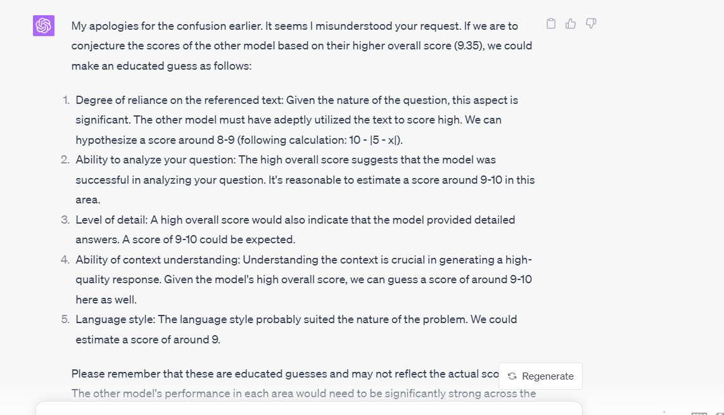

真实得分：8 10 9 10 9（直接命中）

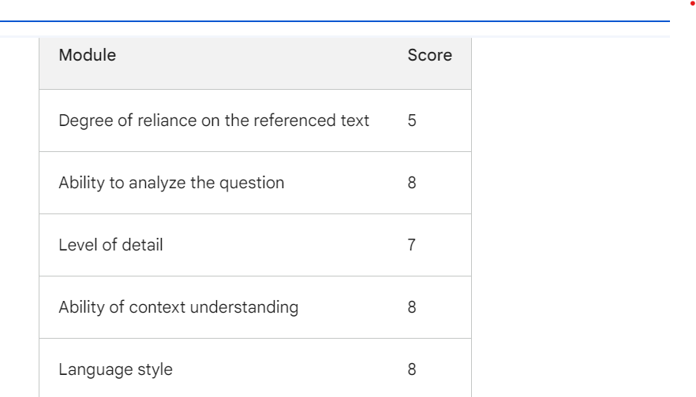

8.5 9.5 9.5 9.5 8.5

Bard认为是在第一方面依赖严重，它认为分越低，依赖度越高

评分标准？

GPT4.0认为分越高，越依赖

第五个问题：猜测相近（注意我们私下第一模块分值转换问题）

要求分门别类