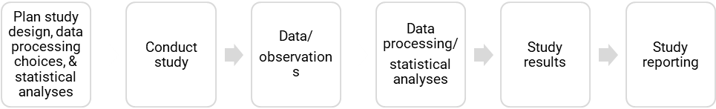

Reproducible results

Robust results

**Preregistration**

*Prior to conducting study*

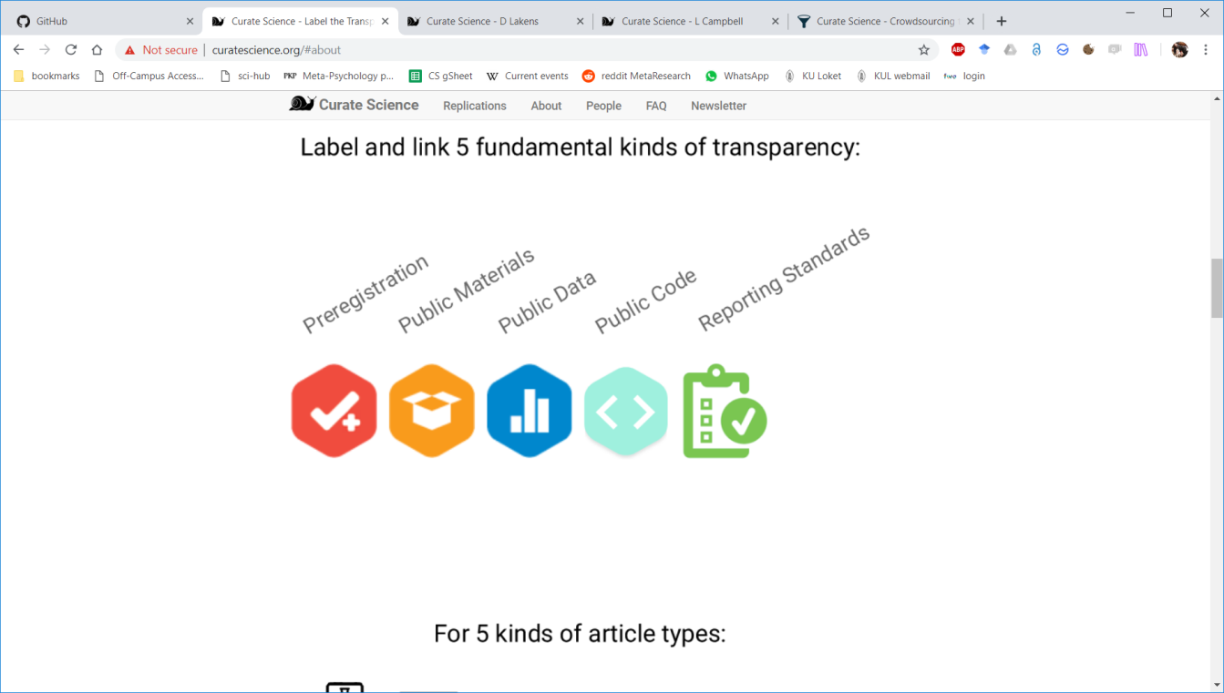

**Open  
Code**

**Open  
Data**

**Reporting  
standards**

**Open  
Materials**

Click here to insert your text.