My Final-term project for SPS 2021
[by: Anni Liu (ali4006)]
Last updated on: 30NOV21
Dataset: Cleaned_data_zhc2006 SAS dataset from Mid-term project.
Objectives: Bivariate association with EBER;
Methods: [in Table-3, two independent sample T-test was used to obtain the p-values of continuous variables Age, Overall Survival (months), and Progression-free Survival (months) between positive EBER group and negative EBER group; Chi-square test was used to obtain the p-values of categorical variables Age_group, Sex, COO, Parenchyma_sites, and cMyc between positive EBER group and negative EBER group; Fisher’s Exact test was used to obtain the p-values of categorical variables Prior_or_concurrent_cancers, PTLD, and Histology between positive EBER group and negative EBER group];
Results:
Table-1: Overall summary

Total
(N = 445)
Age
Mean (SD) | 70.90 (7.60)
Age_group
18 - 65 | 101 (22.70%)
>= 65 | 338 (75.96%)
Missing | 006 (01.35%)
Sex
F | 233 (52.36%)
M | 212 (47.64%)
Missing | 000 (00.00%)
Overall Survival (months)
Mean (SD) | 31.09 (31.17)
Progression-free Survival (months)
Mean (SD) | 25.16 (28.07)
Prior_or_concurrent_cancers
N | 346 (77.75%)
Y | 096 (21.57%)
Missing | 003 (00.67%)
PTLD
N | 425 (95.51%)
Y | 020 (04.49%)
Missing | 000 (00.00%)
Histology
DLBCL | 425 (95.51%)
MZL | 002 (00.45%)
Other | 016 (03.60%)
Missing | 002 (00.45%)
Parenchyma_sites
> Single Site | 233 (52.36%)
Single Site | 187 (42.02%)
Missing | 025 (05.62%)
COO
1_GC | 062 (13.93%)
2_non-GC | 198 (44.49%)
3_Other | 174 (39.10%)
Missing | 011 (02.47%)
cMyc
>40% | 076 (17.08%)
≤40% | 071 (15.96%)
Missing | 298 (66.97%)

Table-2: Stratified by EBER and with overall but without p-values
 | Eber
 | Neg  (N = 227) | Pos  (N = 25) | Total  (N = 252)
Age
Mean (SD) | 71.22 (7.56) | 66.84 (9.58) | 70.77 (7.88)
Age_group
18 - 65 | 050 (22.03%) | 009 (36.00%) | 059 (23.41%)
>= 65 | 171 (75.33%) | 016 (64.00%) | 187 (74.21%)
Missing | 006 (02.64%) | 000 (00.00%) | 006 (02.38%)
Sex
F | 128 (56.39%) | 011 (44.00%) | 139 (55.16%)
M | 099 (43.61%) | 014 (56.00%) | 113 (44.84%)
Missing | 000 (00.00%) | 000 (00.00%) | 000 (00.00%)
Overall Survival (months)
Mean (SD) | 28.02 (29.17) | 31.02 (31.21) | 28.31 (29.33)
Progression-free Survival (months)
Mean (SD) | 22.18 (25.80) | 30.40 (32.46) | 22.96 (26.55)
Prior_or_concurrent_cancers
N | 181 (79.74%) | 020 (80.00%) | 201 (79.76%)
Y | 044 (19.38%) | 005 (20.00%) | 049 (19.44%)
Missing | 002 (00.88%) | 000 (00.00%) | 002 (00.79%)
PTLD
N | 224 (98.68%) | 008 (32.00%) | 232 (92.06%)
Y | 003 (01.32%) | 017 (68.00%) | 020 (07.94%)
Missing | 000 (00.00%) | 000 (00.00%) | 000 (00.00%)
Histology
DLBCL | 219 (96.48%) | 023 (92.00%) | 242 (96.03%)
Other | 007 (03.08%) | 002 (08.00%) | 009 (03.57%)
Missing | 001 (00.44%) | 000 (00.00%) | 001 (00.40%)
COO
1_GC | 038 (16.74%) | 001 (04.00%) | 039 (15.48%)
2_non-GC | 108 (47.58%) | 009 (36.00%) | 117 (46.43%)
3_Other | 077 (33.92%) | 014 (56.00%) | 091 (36.11%)
Missing | 004 (01.76%) | 001 (04.00%) | 005 (01.98%)
cMyc
>40% | 056 (24.67%) | 002 (08.00%) | 058 (23.02%)
≤40% | 046 (20.26%) | 009 (36.00%) | 055 (21.83%)
Missing | 125 (55.07%) | 014 (56.00%) | 139 (55.16%)

Table-3: Stratified by EBER and with overall column and p-values
 | Eber
 | Neg  (N = 227) | Pos  (N = 25) | Total  (N = 252) | P Value
Age
Mean (SD) | 71.22 (7.56) | 66.84 (9.58) | 70.77 (7.88) | 0.008**
Age_group
18 - 65 | 050 (22.62%) | 009 (36.00%) | 059 (23.41%) | 0.14
>= 65 | 171 (77.38%) | 016 (64.00%) | 187 (74.21%)
Missing | 006 (02.64%) | 000 (00.00%) | 006 (02.38%)
Sex
F | 128 (56.39%) | 011 (44.00%) | 139 (55.16%) | 0.24
M | 099 (43.61%) | 014 (56.00%) | 113 (44.84%)
Missing | 000 (00.00%) | 000 (00.00%) | 000 (00.00%)
Overall Survival (months)
Mean (SD) | 28.02 (29.17) | 31.02 (31.21) | 28.31 (29.33) | 0.63
Progression-free Survival (months)
Mean (SD) | 22.18 (25.80) | 30.40 (32.46) | 22.96 (26.55) | 0.15
Prior_or_concurrent_cancers
N | 181 (80.44%) | 020 (80.00%) | 201 (79.76%) | 1.00
Y | 044 (19.56%) | 005 (20.00%) | 049 (19.44%)
Missing | 002 (00.88%) | 000 (00.00%) | 002 (00.79%)
PTLD
N | 224 (98.68%) | 008 (32.00%) | 232 (92.06%) | <0.001***
Y | 003 (01.32%) | 017 (68.00%) | 020 (07.94%)
Missing | 000 (00.00%) | 000 (00.00%) | 000 (00.00%)
Histology
DLBCL | 219 (96.90%) | 023 (92.00%) | 242 (96.03%) | 0.22
Other | 007 (03.10%) | 002 (08.00%) | 009 (03.57%)
Missing | 001 (00.44%) | 000 (00.00%) | 001 (00.40%)
COO
1_GC | 038 (17.04%) | 001 (04.17%) | 039 (15.48%) | 0.046**
2_non-GC | 108 (48.43%) | 009 (37.50%) | 117 (46.43%)
3_Other | 077 (34.53%) | 014 (58.33%) | 091 (36.11%)
Missing | 004 (01.76%) | 001 (04.00%) | 005 (01.98%)
Parenchyma_sites
> Single Site | 128 (58.72%) | 013 (52.00%) | 141 (55.95%) | 0.52
Single Site | 090 (41.28%) | 012 (48.00%) | 102 (40.48%)
Missing | 009 (03.96%) | 000 (00.00%) | 009 (03.57%)
cMyc
>40% | 056 (54.90%) | 002 (18.18%) | 058 (23.02%) | 0.021**
≤40% | 046 (45.10%) | 009 (81.82%) | 055 (21.83%)
Missing | 125 (55.07%) | 014 (56.00%) | 139 (55.16%)

Note:
* P value less than 0.05
** P value less than 0.01
*** P value less than 0.001
- P values were obtained from non-missing values;

Histogram of Age by EBER
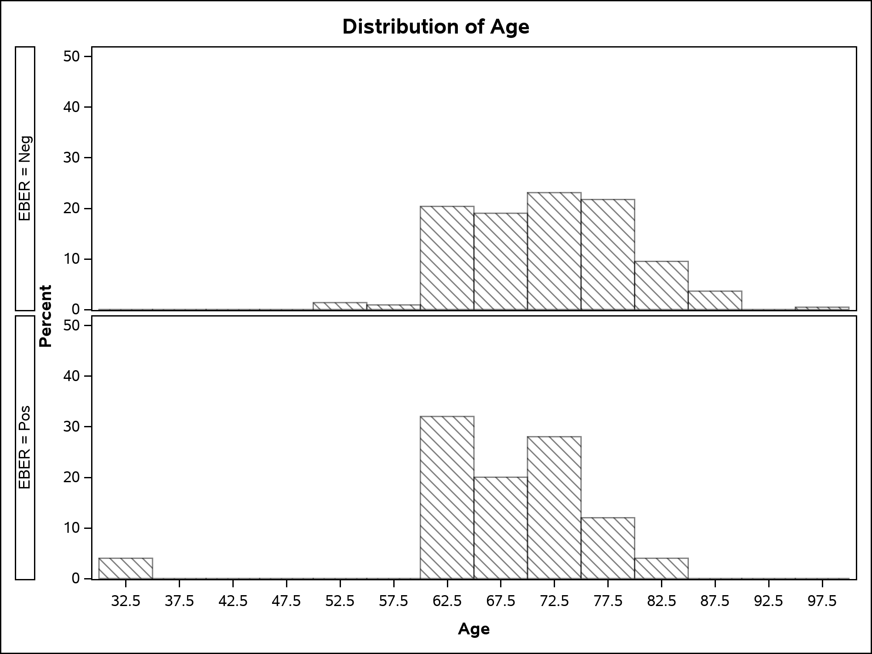

References:
1. Geliang Gan. Create publication-ready variable summary table using SAS® macro. PharmaSUG 2019 - Paper BP-175.

