
SCIENCE HACK DAY INDIA 2018
(2-4 November 2018)
After the spectacular success of first two editions in October 2016 and October 2017, Science Hack Day India, is happening again on 2-4 November 2018 at Belgaum/Belagavi, India.

Science Hack Day is inherently about mashing up ideas, art, media, technology, industries and people to create sparks for future ideas, innovations, collaborations & inspirations to launch from.

Highlights:
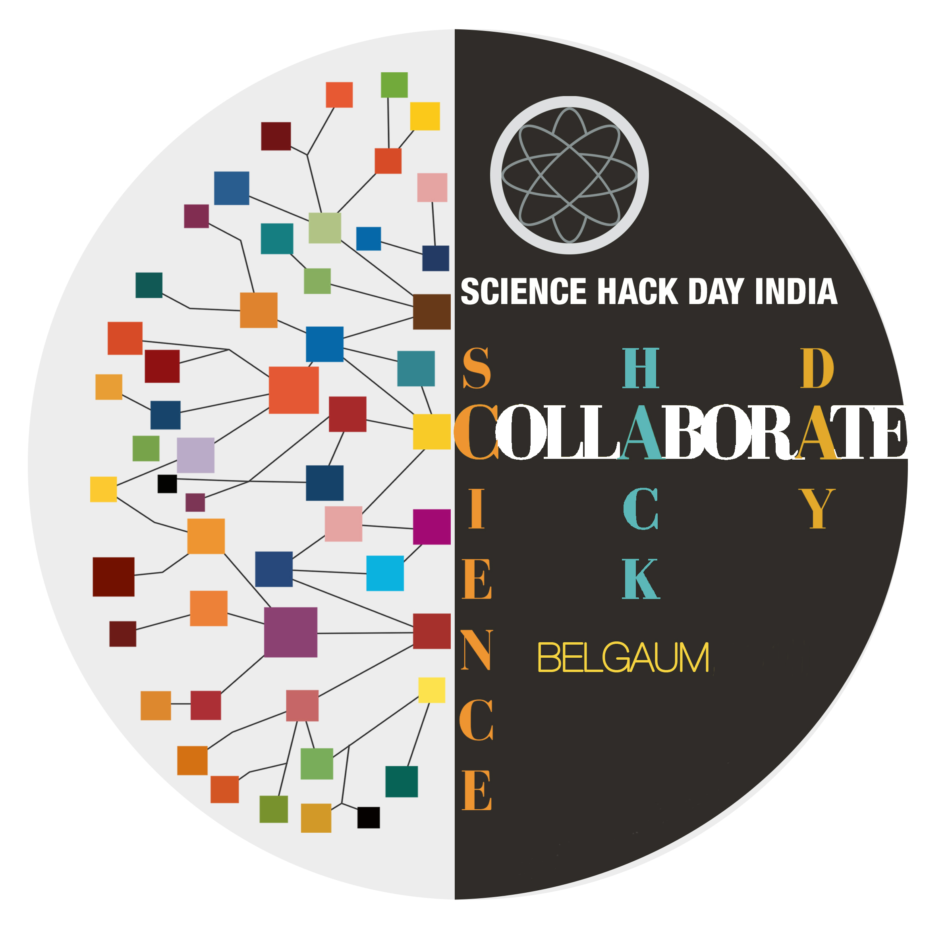
- Science Hacks - various groups work for 36 consecutive hours.
- High altitude weather baloon
- Workshops for high-school kids- Science toys, Soldering and microcontroller programming
- Workshops for undergraduate students - Python 101, Data logging with python
- Geodesic Dome for Planetarium
- Science Demos, Laser Show
- Lightning Talks, All night hacking, Stargazing and many more...
Let's collaborate, learn, hack,
build cool stuff with science and have lots of fun...

Website: http://sciencehackday.in Email: shdbelgaum@gmail.com
Twitter: @SHD_India

What is Science Hack Day?
Science Hack Day is a three-day event where anyone excited about making weird, silly or serious things with science comes together in the same physical space to see what they can prototype within 36 consecutive hours. Designers, developers, scientists, artists and anyone who is excited about making things with science are welcome to attend – no experience in science or hacking is necessary, just an insatiable curiosity.

Science Hack Day is also about getting excited and make things with science! People organically form multidisciplinary teams over the course of a weekend: particle physicists team up with designers, marketers join forces with open source rocket scientists, writers collaborate with molecular biologists, and developers partner with school kids. By collaborating on focused tasks during this short period, small groups of hackers are capable of producing remarkable results.

Mission
Science should be something that is disruptively accessible - empowering people from a variety of different backgrounds to explore, participate in, and build new ways of interacting with and contributing to science. The main goal of Science Hack Day is to breakdown the perception of a barrier to play with science. The event is less concerned with creating new products and startups and more focused on getting people without formal science backgrounds to play and experiment with science for the first time. Equally, scientists who attend the event are often experimenting with new technologies and collaborating outside their domain for the first time. By having a fresh set of eyes from those who solve different types of problems across a variety of industries inside and outside of science, new concepts often emerge and can go on to influence science and our' relationship to science in unexpected ways.

Worldwide
Started in 2010, SHD has now become a worldwide phenomenon. Along with Belgaum, SHD will be happening in many cities in the next few days. San Francisco - USA, Berlin - Germany, Brest – France, Shanghai- China, Bogota - Columbia are some of the upcoming events.

Science Hack Day India - 2018
We are excited to announce second edition of Science Hack Day India! We are proud to share that after the spectacular success of the first and second edition SHD is returning on 2-4 November 2018 at Belgaum, a small city surrounded by some splendid nature, in Karnataka State of India. We welcome you all to join us at SHD India. Let's collaborate, learn, hack, build cool stuff and have lots of fun.

SHD Belgaum isn’t an organization or a company - it's just a loose grassroots network of people who are curious and motivated about ideas and innovations that can bring a positive change the society.

SHD Belgaum will gather about 100 hacker participants and more than 200 high-school and undergraduate students around the mission of getting excited and making things with science. This amazing gathering will have young scientists, engineers, computer programmers, teachers, nature lovers, hackers, makers, and grassroot innovators.

People are flying in from Bangalore, Delhi, Mumbai, Pune, Hyderabad, Kerala, Bengal, Himachal Pradesh and many other places in India. We are also expecting few science enthusiasts from abroad.

Our mentors represent various institutions and communities in the field of hacker/maker movement like Bangalore Maker Space, Maker’s Asylum Mumbai, , Hillhacks, Hackbeach, Anthill Hacks, Python Pune, PyLadies Pune, PyBelgaum, DGPLUG, Reserved Bit, C-spark Research, ICFOSS etc...

Workshops

Science Toys and Soldering Workshops for Highschool Students
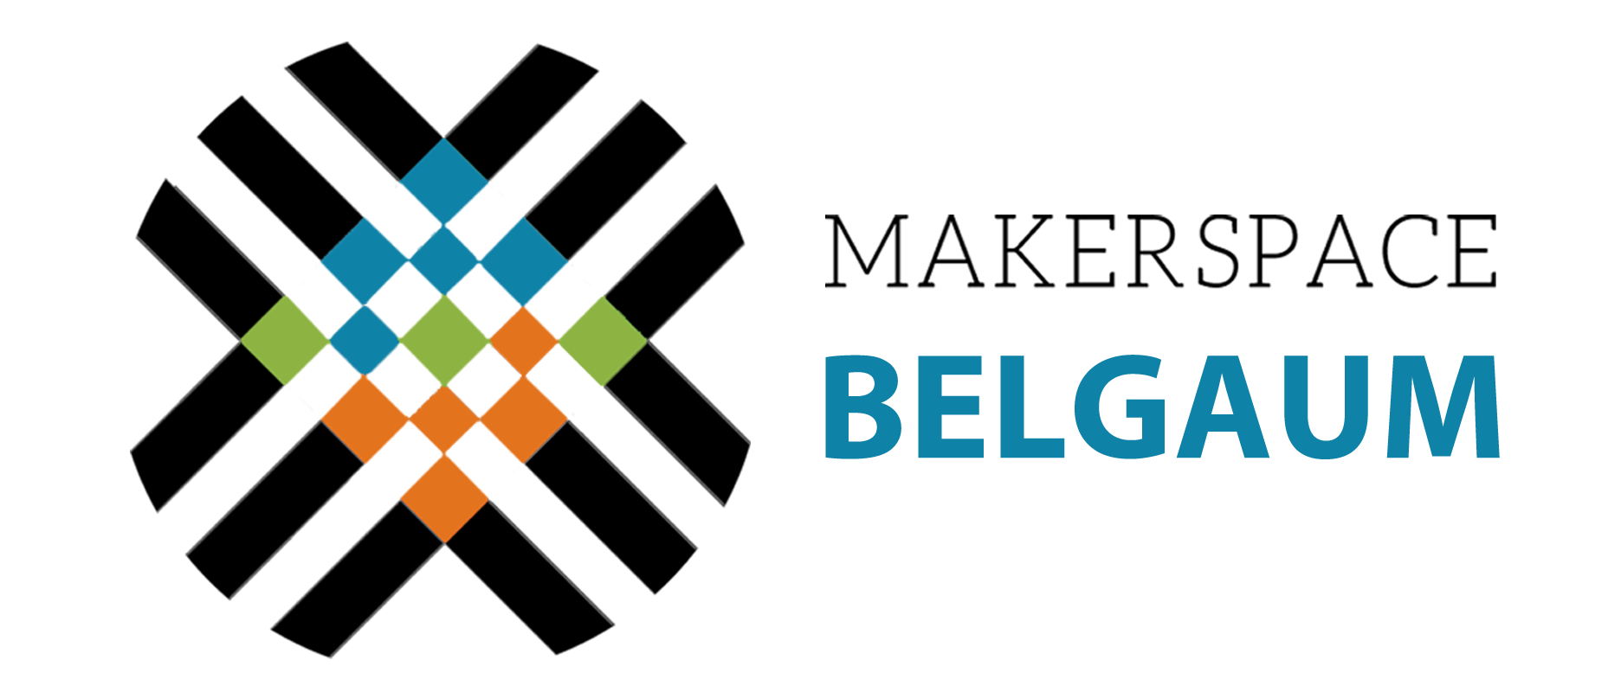
Along with hacking we also have Science Workshops for Highschool kids. Workshops will run parallel to the main event. About 100 students from various highschools in and around Belgaum will participate in the workshops. A dedicated team of volunteers, mainly engineering students and Science teachers, will conduct these hands on workshops. The first hands-on workshop is making Science Toys from Trash, Soldering: Making RBG-LED’s SHD Badge and also Microcontroller Programming. All the material required for the hands-on workshops will be provided to the students.
For undergraduate students there will python programing workshops with focus on experiential learning in science.

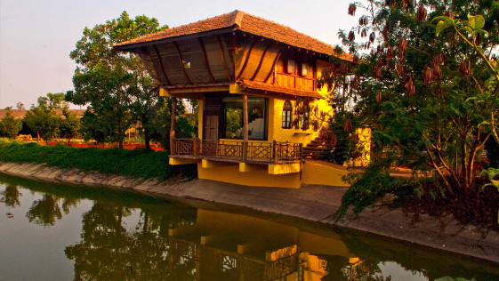
Venue
We have an amazing place called Sankalp Bhumi Farm Resort, Belgaum for this event. The resort resembles an enchanting oasis, with a thick set of trees, sprawling lawns, and a large lagoon
surrounded by picturesque expansive rock walls as backdrop. We have independent places for workshops and hacker’s activities. Shared accomodation will be provided to the partcipants.

Organizing Partners
Makerspace Belgaum : A creative learning centre which enables immersive and experiential learning. In the makerspace visitors are invited to explore a curiosity-driven exhibit, chat with a featured artist, or investigate a range of phenomena with artists, scientists, educators, and others by participating in a collaborative activity. Makerspace also makes available all the tools for kids to facilitate learning by exploring and experimenting.

Mhadei Research Centre is first of its kind Field based Research station based in the Northern Western Ghats of India. MRC fuses biodiversity research with community participation for the benefit of ecology and is helping bring to limelight a hitherto unknown area of high endemism, rich biodiversity and a large mammal corridor.
Website: http://mhadeiresearchcenter.org

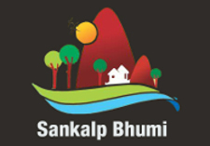
Sankalp Bhoomi : totally in tune with nature in its rustic uncorrupted state, the farm resort stands testimony to saving nature. It was once an abandoned quarry, today natures glory restored. The resort resembles an enchanting oasis, with a thick set of trees, sprawling lawns, and a large lagoon surrounded by picturesque expansive rock walls as backdrop.
Website: http://sankalphospitality.in
Sponsor Us

Science Hack Day India is volunteer-organized event. We are team of passionate volunteers and we know what it takes to make a great event. This is the 3rd edition of the event happening at Belgaum on 2-4 November 2018.
It is all-day-all-night event that brings together inquisitive and creative minds to one place, to make wonderful things. Designers, developers, engineers, scientists and artists proudly bring their A-game to the same physical space for a brief but intense period of collaboration, making, hacking, and building of ‘cool stuff’.
Major components of our expenses are Accomodation for our national / international participants , Food arrangements for about 325 members and tools and materials required for hacking activity and student workshops. It’s only due to the graciousness of our sponsors that we’ll all be fueled with food, shelter and the various necessities for our hacking. We appeal you to be a part of this mission to inspire our generation and create sparks for future ideas and grassroot innovations.
We wouldn’t be able to do all this without our sponsors.

Sponsorship Options

CURIOSITY PLATINIUM SPONSOR (Rs.750000/- or more)

- Curiosity Platinum sponsor link on Science Hack Day website
- Banner (provided by sponsor) in main room
- Overall “Best Science Hack” Prize named after sponsor (e.g. “Sponsor Name” Best Science Hack Prize)
- Meal named after sponsor (e.g. the “Sponsor Name”dinner)
- Marketing materials (provided by sponsor) in the main room.
- Thanks in press release and from social media accounts
- On-stage recognition from the organisers

INNOVATION GOLD SPONSOR (Rs.50000/- or more)

- Innobation Gold sponsor link on Science Hack Day website
- Banner (provided by sponsor) in main room
- Prize named after sponsor (e.g. “Sponsor Name” Best Socially useful Hack Prize)
- Meal named after sponsor (e.g. the “Sponsor Name”dinner)
- Marketing materials (provided by sponsor) in the main room.
- On-stage recognition from organisers

CREATIVITY SILVER SPONSOR (Rs.25000/- or more)

- Creativity Silver sponsor link on Science Hack Day website
- Meal named after sponsor (e.g. the “Sponsor Name”dinner)
- Marketing materials (provided by sponsor) in the main room.
- On-stage recognition from organizers

COMMUNITY SUPPORTER (Rs.15000/- or more)

- Community Supporter link on Science Hack Day website
- Marketing materials (provided by sponsor) in the main room.
- On-stage recognition from organizers
(Optional) 10-15 min. Speaking opportunity at the event for all levels of sponsorship.
..... or we are open to disscuss other ideas !

Thank you for your gracious support.

Team - Science Hack Day India
Belgaum-2018
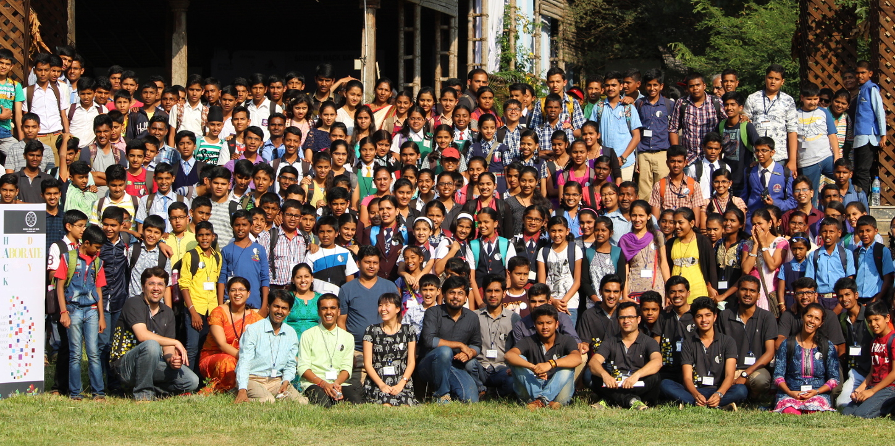
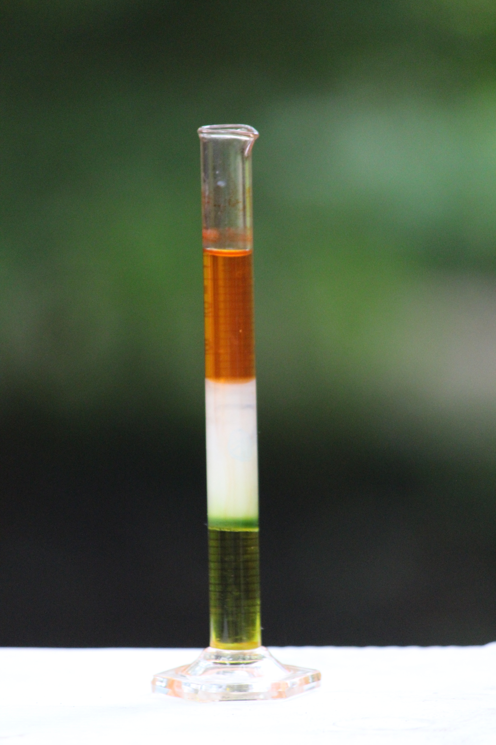
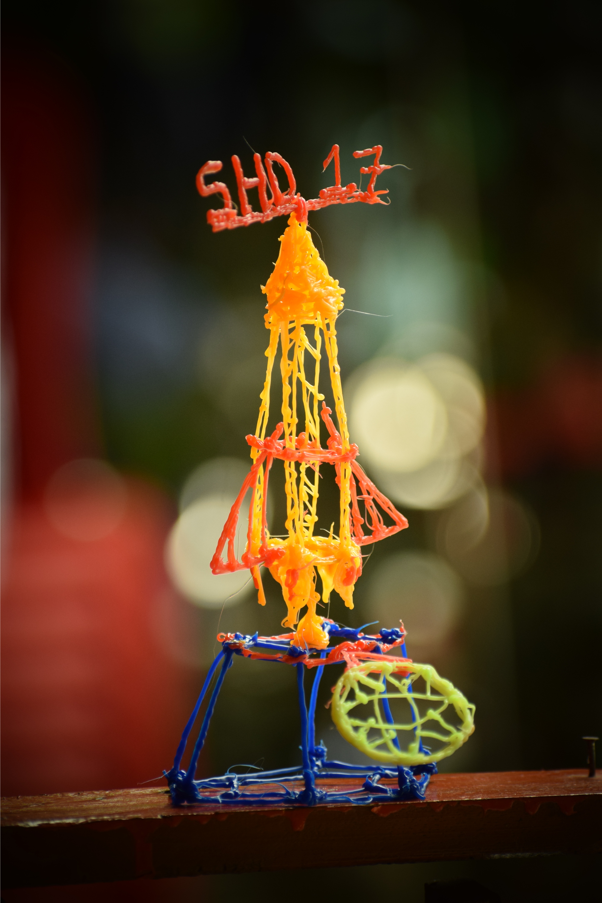

Contact Person (SHD Team)
Prof. S Y Prabhu +91 9845680553
...........................................................................
Gautam Samant +91 9845470292
...........................................................................
Praveen Patil +91 9482543803
...........................................................................Rahul Khanolkar +91 9986689985
...........................................................................

Website: http://sciencehackday.in Email: shdbelgaum@gmail.com
Twitter: @SHD_India Facebook: @sciencehackin

