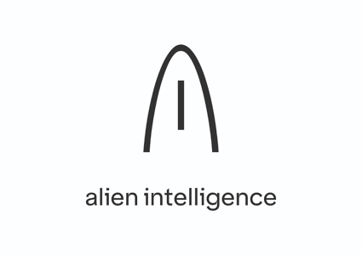

Submission Template
OpenAIRE AI Hackathon
Powered by Alien Intelligence and the OpenAIRE Graph

2026
Deadline: 20 August 2026, 23:59 CET · One submission = an artifact + a story
How to use this template
Fill in what applies to your submission. Word counts are suggested maximums, not minimums. Sections marked (optional) can be left empty if there is nothing to be filled from your side.
All submitted materials must be available under a CC-BY 4.0 licence.

How submissions will be judged
All submissions - code or not - are judged on the same six criteria. An artifact is not worth more than a methodology paper.
1. Use of AI MCP connector that uses the OpenAIRE Graph API
2. Usefulness and value - solves a real problem, unlocks a clear use case.
3. Originality - fresh approach, thoughtful design, unexpected combinations of sources or tools.
4. Responsible use of data- respects rights, provenance, source policies.
5. Reproducibility and interoperability - others can re-run, re-apply, re-extend it.
6. Clarity - simple story, clear demo, documented choices.
FAIRness is a running theme across all five criteria - favour submissions that are Findable, Accessible, Interoperable, and Reusable.
How it's judged.
Two panels review each theme in parallel:
Technical panel - assesses technical merit: how it’s built, whether it works, code/methodology quality (criteria 1,4,5,6)
Strategic panel - assesses value: fit with OpenAIRE and Open Science priorities, innovation, reuse potential, impact (criteria 2,3,5,6)
Both panels score independently before results are combined - a submission needs a reasonable bar on both scores, not just a high overall average, to be shortlisted. The scores are ranked from 1 (not good )- 5 (excellent) scale per criterion, reaching a maximum 6x5=30 points, and the best applications will be selected.
Minimum bar to be shortlisted.
A submission must score adequately across all five criteria above. A poor score on even one - no story, no licence declared, broken links, undocumented provenance - can keep an otherwise strong artifact out of the shortlist, regardless of how high it scores on the rest. Score well everywhere, not brilliantly on one axis.

0. Submission details
Submission title | Replication Radar: Find What's Been Checked, What's Worth Replicating, and How to Replicate It
Theme | ☐ A - Explore & Narrate ☑ B - Build ☐ C - Analyse ☐ D - Wildcard
Applicant / team name | Science Live Team
Type | ☐ Individual ☑ Team ☐ Startup / SME ☐ Company ☐ Research group ☐ Other:
Country / base of operations | Norway (contact: VitenHub AS); distributed team: Norway (Jean), UK (Saranjeet), Spain (Anne)
Contact person | Jean Iaquinta (VitenHub AS)
Contact email | jiaquinta@vitenhub.no

Team members (if any)
Name | Affiliation | Role in the submission | ORCID / GitHub (optional)
Anne Fouilloux | LifeWatch ERIC | Build: Radar web app + MCP, and the marine-heatwave replication | 0000-0002-1784-2920 / annefou
Jean Iaquinta | VitenHub AS | Lead & CEO; story, video and narration (voices the demo video) | 0000-0002-8763-1643
Saranjeet Kaur Bhogal | Imperial College London | RSE review & good-practice signals | 0000-0002-7038-1457

1. The solution

1.1 Overall
What did you build, produce or discover? What does it do, who is it for, and what problem does it address? Write for a reader who knows Open Science but not your specific field.
Suggested maximum: 400 words
The problem. A citation has always been shorthand for “someone checked this.” That shorthand is breaking. When anyone can generate a plausible paper and pad it with citations to work it has nothing to do with, counting citations, or walking the citation graph, tells you what is popular, not what is true. And a paper is not one thing you can trust: it buries many claims, and what you actually rely on is one claim. The unit that matters is the claim; the question that matters is has this claim been proven?
Replication Radar answers that on the OpenAIRE Graph. Search a field and, for each high-impact claim, it shows whether anyone has independently proven it: a signed Science Live replication verdict (validated / contested / refuted), read live from the nanopublication network, author-agnostic. Where the Graph knows only cited / not-cited, the Radar adds checked / not-checked.
If a claim has not been proven, the Radar hands you what you need to prove it: the independent, reusable software OpenAIRE holds for that field, ranked not by citations (useless for software) but by signals a one-off deposit can't fake (a resolvable repository · GitHub stars · Software Heritage archival · fair-software.eu + RSE good practice: documented · tested · CI · contributing), and, via the OpenAIRE MCP, independent data. You run the replication and publish the proof as a signed nanopublication constellation (claim → study → outcome → evidence) that the next person can cite. The proof, not the reputation.
It is for researchers deciding what to build on, research software engineers (whose work is finally seen and credited), meta-scientists mapping a field, and, as an MCP server run next to the OpenAIRE MCP, AI agents that need grounded, verified signals instead of guesses. Everything is grounded (every signal from a named source) and runs client-side against public APIs, with no login and no keys in the browser: a static site anyone can fork, plus a pip install-able MCP.
AI assists; people do the research. Every link in the chain is human work: the researcher who frames the claim, the fieldworkers who gather the data, the modellers, and above all the research software engineers who make software reusable. Making the chain checkable makes each of them visible and creditable.

1.2 Quick SWOT (optional)
Bullets, not paragraphs. Honest weaknesses read better than none.
 | Helpful to achieving the objective | Harmful to achieving the objective
Internal (your solution) | Strengths  • Builds on the OpenAIRE Graph and enriches it, joining live data the Graph alone doesn't hold (GitHub, Software Heritage, Zenodo, the nanopublication network)  • Answers two questions citations can't: has this claim been independently checked, and does its software follow good reuse practices (documented, tested, CI)?  • Verdicts are signed and claim-level: citable proofs, not opinions  • Fully grounded: every signal traces to a named public source; nothing is guessed  • The web app is hosted, so it opens in any browser on any OS (nothing to install); the MCP is a one-line pip / uvx install | Weaknesses  • Finds only what an OpenAIRE keyword search surfaces, so recall is limited  • Shows a verdict only where a replication has been published as a nanopublication, a young and thin corpus today  • The software score reads reuse signals (docs, tests, CI, archival) from a public repo; these predict reusability but do not prove it, which is confirmed only when the software is actually reused  • Covers only two trust signals (independent replication, and software reuse practices), not other dimensions of trustworthiness such as data quality or statistical rigour; a first step, not a complete trust layer  • Tested on Linux; the MCP is not yet verified on Windows or macOS (the hosted web app is unaffected)
External (the environment) | Opportunities  • A grounded foundation AI agents can build on: verified facts instead of guesses  • Broaden coverage by bringing existing replication corpora (curated databases, registered reports, retraction/erratum signals) into the same open format  • Could capture demand by letting people flag which claims they want replicated | Threats  • Its value grows only as more replications get published on the network  • Relies on external APIs (OpenAIRE, GitHub) staying stable and within rate limits  • Inherits quirks in OpenAIRE's own metadata (e.g. subject classifications)

1.3 The story - use case
This is the 1-2 page write-up required for every submission.
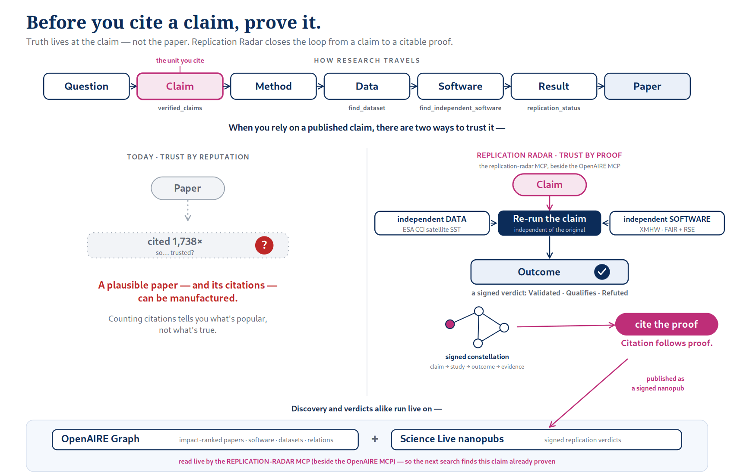
Figure 1. Two ways to trust a published claim: today, by reputation (citation counts, which can be manufactured); or with Replication Radar, by proof (re-run the claim with independent data and software, sign the outcome, and it becomes citable). Discovery and verdicts run live on the OpenAIRE Graph and the Science Live nanopublication network.
The question
What did you set out to find out or solve, and why does it matter?
When you cite a paper, what are you really citing? Not twenty pages, but one claim you've chosen to build on. For as long as science has had citations, your assurance that the claim is true has been that others cited it too: a citation as shorthand for someone checked this. That shorthand is breaking. When a plausible paper (and a wall of citations to work it has nothing to do with) can be generated on demand, counting citations, or walking the citation graph, tells you what is popular, not what is true.
So we set out to make the honest version workable on the OpenAIRE Graph: before you cite a claim, know whether anyone has independently proven it, and if no one has, be handed exactly what you need to prove it yourself. Truth lives at the claim, not the paper, so verification (and citation) belong there. It matters because everything downstream (the next study, the policy, the model an agent builds on) inherits the trust we place in that one claim.
The journey
What you actually did: the steps, the dead ends, what you changed course on, lessons learnt. A flow diagram or screenshot is welcome.
We started paper-first: rank the papers in a field worth replicating. It worked, but it only re-served the Graph's single signal, impact, and when we used it we hit a wall: on a live topic search, essentially no paper carries a linked code or data artefact, because OpenAIRE rarely links materials to a paper. The undervalued, actionable things weren't the papers; they were the software and the verdict.
Two turns followed. First, the verdict layer. A replication is not a paper: it earns no citations and has no node in the Graph. But Science Live publishes replication outcomes as signed nanopublications (the FORRT chain: Quote → Claim → Study → Outcome → CiTO). We overlay them live, matched by template, not by person (on the nanopublication trusty hash) so any signer's verdict counts, and retraction-aware, so each claim carries its verdict, right beside the paper. Second, the software. A research software engineer, Saranjeet Kaur Bhogal (Imperial College London), told us what an RSE actually looks for: not a single “FAIR” badge, but whether code is documented, tested, runs CI, invites contribution. So beside the papers we surface the reusable software OpenAIRE already holds for a field, ranked by signals a one-off study deposit can't fake (a resolvable repository · GitHub stars · Software Heritage archival · fair-software.eu + those RSE practices). We kept everything grounded: we even deleted a feature we'd built on a guess (a keyword-matched “relevant software” picker that surfaced off-topic repos) because guessing relevance isn't anchored in any named source.
Then we closed the loop, for real. An agent running the Radar beside the OpenAIRE MCP took a claim the Radar flags as high-impact but un-replicated: Oliver et al. 2018, marine heatwaves (Nature Communications, ~1,740 citations). It pushed back on our first data choice: ERA5's sea-surface temperature shares the original paper's HadISST lineage, so it isn't independent, and it switched to independent ESA CCI satellite SST, detecting events with the independent XMHW detector, cross-checked against the author's own code. The replication is now published as a signed constellation, and it holds: Validated. Marine-heatwave days rose 31.8 over 1982–2016 against the paper's 30 (within 6 %), frequency and duration agree, and the trend survives ENSO removal, independent in both data and code. We kept the scope honest: satellite SST only reaches back to ~1982, so this validates the satellite-era trend and leaves the paper's century-scale figure explicitly out of scope. The proof, its verdict, and plain-language retellings for citizens and for schools are a citable constellation on the network, not a claim taken on trust.
The insight
What you found, built or proved. Be specific - numbers, examples, a concrete before/after.
Truth lives at the claim, not the paper, so verification and citation belong there. Reliability (was it proven?) and reusability (is the software good?) are different categories of signal: you add them live on top of the Graph; you don't repair citation counts into them. A signed replication constellation turns a proof into a first-class, citable object, and the very same move finally makes research-software-engineering work visible and creditable, not invisible behind the paper authors' names.
And it's built to be read by humans as much as by agents: a person sees the software behind a claim and whether it's been checked; an agent, running the Radar beside the OpenAIRE MCP, gets both the structural graph and the verification-and-reuse layer, grounded data it can cite instead of hallucinate. AI assists (it finds, connects, drafts, checks) but people do the research. It's a first brick of a graph of verified, engineered knowledge for agentic science.
What others can reuse
The single most important part. What can another participant, researcher, user pick up and run tomorrow?
• The live web app: pure static, queries OpenAIRE + GitHub / Software Heritage / Zenodo + the nanopublication network from the browser; fork it and point it elsewhere.
• An MCP server (pip install replication-radar) exposing the same engine to any MCP-capable agent, to run beside the OpenAIRE MCP.
• A grounded software assessment: fair-software.eu recommendations plus RSE good-practice signals (documented / tested / CI / contributing), computed live from GitHub + Software Heritage + Zenodo, no third-party scorer.
• A reproducible, author-agnostic, retraction-aware verdict-index method: FORRT Outcome / CiTO nanopublications joined on the trusty hash.
• A machine-readable methodology & provenance spec (methodology.json, CC-BY): every signal's source and formula; plus a feasibility map of which open-science APIs are reachable and CORS-friendly.
Suggested maximum: 1–2 pages, plus visuals

2. Technical & scientific

2.1 How it works
Architecture, method or workflow. One diagram plus a short description is usually enough. For non-code submissions (Themes A and C), describe the method or analytical workflow instead.

Suggested maximum: 300 words + one visual
A static, client-side site (HTML/CSS/JS on Netlify) plus one serverless proxy for the GitHub / ScholeXplorer APIs that lifts the keyless rate limit and CORS while keeping any token server-side. Every signal is fetched live; the client holds no keys. The same engine ships as an MCP server (replication-radar, FastMCP).
Pipeline (see diagram). 1) Discover. OpenAIRE Graph REST API: papers (type=publication, BIP! impact C1–C5 + impulse) and reusable software (type=software, ranked by grounded reusability (resolvable repo · stars · fair-software.eu + RSE practices · Software Heritage), since citation class is useless for software). 2) Prove? Read replication outcomes live from the Science Live nanopublication network via SPARQL: FORRT Outcome + CiTO nanopublications (author-agnostic, by template), joined on the trusty hash, retraction-filtered via the admin graph, overlaid by DOI; each verdict carries the atomic claim it tested. 3) Assess software. For any resolvable repo, compute fair-software.eu + RSE practices + language / paid-runtime, live from GitHub (proxied), Software Heritage, Zenodo. 4) Connect. The paper↔software edge from the Graph's own relations (ScholeXplorer / OpenAIRE MCP) links the two lenses. 5) Prove & publish. The FORRT template scaffolds a replication; the proof is signed as a nanopublication constellation that re-surfaces on the Radar for the next person.
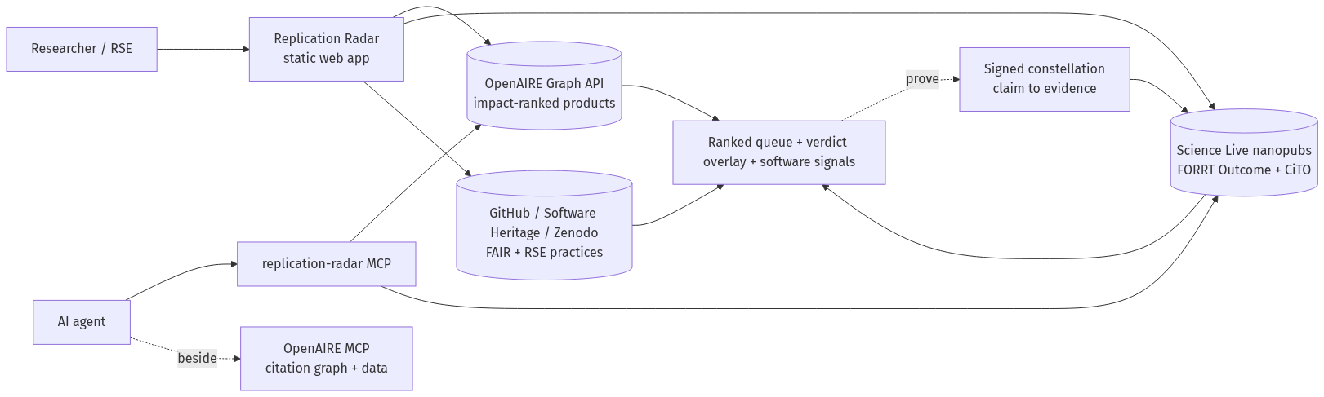
Figure 2. Replication Radar architecture. Two entry points (researcher on the web app, an AI agent on the MCP beside the OpenAIRE MCP) read the OpenAIRE Graph, Science Live nanopublications, and GitHub / Software Heritage / Zenodo into a ranked queue with verdicts and software signals; proving a claim publishes a signed constellation back to the network, closing the loop.

2.2 OpenAIRE Graph elements used
What you used | Details
OpenAIRE Graph API | Anonymous, CORS-enabled REST. Papers: GET api.openaire.eu/graph/v1/researchProducts?search=<topic>&type=publication&sortBy=influence DESC (paged). Reusable software: the same call with type=software. A claim's DOI is resolved to its OpenAIRE record via the dedup id ?id=doi_dedup___::md5(lowercased-doi)&pageSize=1. Funder context: GET /projects?search=<topic>.
MCP tool powered by Alien Intelligence | OpenAIRE MCP (Alien gateway, OAuth), run beside our own replication-radar MCP: explore_research_relationships for the paper↔software / dataset edges (e.g. isSourceOf), and a dataset lookup our find_dataset tool hands off to, to find an independent replication dataset with a citable DOI.
Entity types (publications, datasets, software, projects, organisations, persons…) | researchProducts of type publication, software and dataset; projects (funders).
Fields, indicators or vocabularies relied on | indicators.citationImpact.{influenceClass, citationClass, impulseClass, citationCount} (BIP! classes C1–C5); type; pids (DOI); subjects (FOS, SDG); openAccessColor; relation types (isSourceOf, isSupplementedBy, cites).
Other (external) data sources combined with OpenAIRE | Science Live nanopublication network (SPARQL query.knowledgepixels.com/repo/full + admin graph; read for FORRT Outcome hasValidationStatus / hasOutcomeRepository and CiTO verdict relations, matched to OpenAIRE products by DOI); GitHub REST API; Software Heritage API; Zenodo API; ScholeXplorer; Copernicus Marine (ESA CCI SST, for the replication).
Approximate scale (records queried / processed) | Impact-ranked over the full matching set per topic. Live product counts: search=species distribution model returns 61,284; machine learning climate 27,300; bumblebee decline 297. Verdicts read live from the nanopublication network (the set grows as replications publish); software assessed per resolvable repo (GitHub 60/hr unauthenticated, cached).
Be concrete. "Used the OpenAIRE Graph" tells an evaluator nothing; "queried research products filtered by rel_organization_id, ~40k records" tells them everything.

2.3 Documentation & reproducibility
How does someone else run this? README quality, dependencies, setup and configuration steps, environment requirements. For methodology or case-study submissions: what would someone need to repeat your analysis?
Suggested maximum: 250 words
Web app. Nothing to install: open https://openaire-hackathon.netlify.app. Locally: clone and serve site/ with any static server (python3 -m http.server); pure HTML/CSS/JS, no build.
MCP server. pip install replication-radar, register with any MCP client ({"mcpServers":{"replication-radar":{"command":"replication-radar"}}}). Tools: radar, replication_status, find_independent_software, verified_claims: public sources only.
Reproduce the demo. A step-by-step walkthrough (exact searches, prompts, results) at https://openaire-hackathon.netlify.app/demo.html.
Provenance. Every label/score is documented signal-by-signal in methodology.json (machine-readable, CC-BY), rendered at /methodology.html; /replicate.html explains the end-to-end prove-then-cite loop.
Repo. README + architecture; MIT LICENSE; CITATION.cff; deps in pyproject.toml; full history; no credentials. Archived on Zenodo every release: concept DOI https://doi.org/10.5281/zenodo.21850976 (latest v0.4.6).

3. Innovation & risks
What is new here
Most research-quality tools try to improve the metric. The Radar instead treats the claim, not the paper, as the unit of trust, and adds two categories the citation graph structurally can't hold: has this claim been independently checked, and does its software follow good reuse practices? Both are read live on top of the Graph. The verdict layer is claim-level, cryptographically-signed nanopublications read author-agnostically by template, so an LLM can cite it instead of hallucinating. Three moves are, to our knowledge, novel: (1) making OpenAIRE's software assessable, not just findable; (2) using the Graph's own relations to link a paper to its software (Soroye 2020, isSourceOf); and (3) packaging it as an MCP beside the OpenAIRE MCP, a first brick of verified knowledge for agentic science.
Limitations and known failure modes
The biggest limit is verdict coverage: today the overlay reflects only replications already published as nanopublications, a young and thin corpus, so many claims read as “not yet checked”. By design the overlay is source-agnostic (any signer, matched by template), so it grows as replications publish, and as existing replication corpora are minted into the same open format. Beyond that: discovery recall is keyword-bound; software assessment needs a public repo, and GitHub's 60/hr unauthenticated limit caps throughput (cached). A green CI run is a reproducibility signal, not independent reproduction, which the verdict covers separately. We add two of the missing layers, not the whole graph.
Use of AI
The artifact is deterministic: no LLM in the data path, nothing hallucinated on screen. AI enters two ways. (1) The deliverable is an MCP connector for any MCP-capable agent, run beside the OpenAIRE MCP, not tied to one model or vendor. (2) Development used Claude Code (Anthropic) throughout, including this write-up, always under human direction and review, with every data source verified against its live API before shipping. Human-in-the-loop by design: AI assists; people decide, do the research, and are credited.
Data protection & third-party content
No personal data is processed: only public scholarly metadata (OpenAIRE, the nanopublication network, GitHub / Software Heritage / Zenodo); no accounts or private data stored (the client holds no keys; the GitHub-proxy token is server-side). Third-party data and code are used within licence: OpenAIRE and the nanopub network are open; ESA CCI SST is cited by DOI; reused software is open-source, credited by repo. Materials: CC-BY 4.0 (write-up), MIT (code).

4. Links & artifacts
Every link must be publicly accessible, or reachable without a personal account (i.e. a Google Drive link, a Dropbox, etx.). If a login is unavoidable, provide test credentials under "Notes". Broken or private links are the single most common reason a good submission scores badly.
Item | Link | Status | Notes
Code repository (GitHub / GitLab) | https://github.com/ScienceLiveHub/replication-radar | ☑ Public | MIT
Live demo / deployed app | https://openaire-hackathon.netlify.app | ☑ Public | Static, client-side
Video walkthrough (max 3 min) | https://youtu.be/hVyLafY3Y3E | ☑ Public | 2:49
Main artifact (notebook, dashboard, dataset, methodology doc, case study) | https://openaire-hackathon.netlify.app | ☑ Public | The Replication Radar tool (opens on a live sample scan, as in the video); also a pip-installable MCP (pip install replication-radar)
Documentation / README | https://openaire-hackathon.netlify.app/replicate.html | ☑ Public | + reproduce-the-demo walkthrough /demo.html
Write-up from section 1.3 (PDF or in-repo) | https://openaire-hackathon.netlify.app/story.html | ☑ Public | The 1.3 story (CC-BY)
Archived version with DOI (Zenodo - optional, recommended) | https://doi.org/10.5281/zenodo.21850976 |  | Concept DOI (latest v0.4.6)
Other | https://annefou.github.io/marine-heatwave-replication/ |  | Example proof: independent replication of Oliver et al. 2018 (marine heatwaves), Validated in both data and code. Reproducible study (Jupyter Book); code + data at github.com/annefou/marine-heatwave-replication (Zenodo 10.5281/zenodo.21950032); signed constellation on the nanopublication network.
Signed nanopublications (the full marine-heatwave constellation, all published live on the nanopublication network):
• Quote + personal comment: https://w3id.org/sciencelive/np/RA1m-2tHCFBVjypflopbfGnuEpxrzPE_khGhss1FJMtbA
• AIDA sentence: https://w3id.org/sciencelive/np/RAmbschSgs8k_AoM34DgIWT0EMkrwKYKEWQFIXkslMtfM
• FORRT Claim: https://w3id.org/sciencelive/np/RAGw-EZjva3ybpqWtY3loRFToZrm6GSMQqamvoe-e-JjE
• FORRT Replication Study: https://w3id.org/sciencelive/np/RAdIP7v2kJyOD-hRDIKdZkjMfFHkOIKdWoSnvAeGasU_s
• FORRT Replication Outcome (Validated; the story apex): https://w3id.org/sciencelive/np/RAGjvtR-Pq6576AIEsj5CTiLW3yK0cPEbfgk7OjhxyVVM
• CiTO Citation (confirms Oliver 2018): https://w3id.org/sciencelive/np/RAnns3mUVRk1WNb6SAuAunHiGGZL4eD9c_Axx-8eCj0x4
• Story (the constellation): https://w3id.org/sciencelive/np/RAQfGMNmJiFt4KDDJE8dsiT3az4CRYehRuDFoa-tXGc8w
• Plain-language summary for the public: https://w3id.org/np/RAwGVnm2oxnLVNYR18dmkFqbqFL4ZYw3yX0x0CxXzdzS8
• Plain-language summary for schools: https://w3id.org/np/RAaYmBJ1IAyn75wkl_G3zDC7NmV7Rz2KlwU6J3f5JQujY

Repository checklist (if you submitted code)
☑ README explains what it is and how to run it
☑ LICENSE file present
☑ Dependencies listed (requirements.txt, package.json, environment file…)
☑ Commit history visible
☑ No credentials, API keys or personal data committed

5. Openness & licensing
Licence for written materials, documentation and media | CC-BY 4.0 (required) - ☑ confirmed
Licence for code (if applicable) | MIT
Licence for data / outputs produced (if applicable) | CC-BY 4.0
The submission may be published on OpenAIRE channels | ☑ confirmed
The submission may be included in community voting (21–29 August 2026) | ☑ confirmed
I have the right to submit all included material | ☑ confirmed

6. Feedback (optional)
Please note any issues you encountered on OpenAIRE Graph or on Alien MCP connector during the hackathon. Any gaps you spotted, anything to help us improve!

7. Before you submit - final check
☑ Theme selected
☑ Story (section 1.3) written and readable by a non-specialist
☐ Every link in section 4 opened in a private browser window and worked
☑ Video under 3 minutes and audible
☑ CC-BY 4.0 applied and stated
☑ Contact email correct and monitored through September 2026
☐ Submitted before 20 August 2026, 23:59 CET

Key dates
Submissions close | 20 August 2026, 23:59 CET
Community voting | 21-29 August 2026
Evaluation & finalist announcement | 20 August -5 September 2026
Awards ceremony (OpenAIRE Graph Community Call) | 16 September 2026

Useful links
- OpenAIRE Graph Forum - https://openaire.flarum.cloud/t/ai-hackathon
- Alien AI demo - https://demo.alien.club/openaire
- Hackathon page - https://innovation.openaire.eu/component/content/article/openaire-ai-hackathon.html?catid=8
- Sign-up - https://innovation.openaire.eu/component/content/article/hackathon-signup.html?catid=8
- OpenAIRE Graph website - https://graph.openaire.eu/
- OpenAIRE API documentation - https://api.openaire.eu/
- About CC-BY 4.0 - https://creativecommons.org/licenses/by/4.0/
Questions: contact the OpenAIRE Innovation team via https://innovation.openaire.eu/contact.html

