# Parts List

* Teensy 3.2 Board
* Teensy Audio Board
* 2 Push Buttons
* Elect Mic
* Rocker Switch
* Battery Pack for 3 AA Batteries
* MircoUSB cable (other end does not matter, will be connected to rocker switch for power)
* 12 pieces of 22-gauge wire (length is decided based on how much distance between MPR121 board and conductive materials, suggested around 70cm)
* 2.54mm wire to terminal blocks (amount depends on how wiring is decided)
* 12 tin crimps
* 2 4.7k resistors
* #24 0.21 mm^2 ferules for terminal blocks
* Heat shrink
* Breakout board
* Proto-board
* Audio Extension Cable
* Nylon Female Quick Disconnect Flag Crimps
* If building box:
  + Hammond NFG 1550G box
  + M3 Standoffs and screws for the Audio Board
  + M2 Standoffs and screws for the MPR 121 Board
  + Thumbscrews (4mm)
  + Adhesive Rubber Feet
  + Grommet

# Connections

List of wiring connections for Capacitive Keyboard. When constructing wiring it is important that any connecting wires to the Teensy Audio Board are kept short, otherwise audio becomes unclear.

|  |  |
| --- | --- |
| From | To |
| Teensy Audio Board Mic | Elect Mic Output |
| Teensy Audio Board Ground | Elect Mic Ground |
| MPR121 VIN | Teensy 3.2 3.3V |
| MPR121 GND | Teensy 3.2 GND |
| MPR121 SCL | Teensy 3.2 19 |
| MPR121 SDA | Teensy 3.2 18 |
| MPR121 IRQ | Teensy 3.2 17 |
| Button A (Switch Keyboards) | Teensy 3.2 16 and GND |
| Button B (Record) | Teensy 3.2 15 and GND |

Teensy Audio Board and Teensy 3.2 need pins 9,11,13,18,19,22,23,7,10,12,14 connected together

# Suggested Wiring Approach

## Teensy 3.2 and Audio Board

The simplest way to connect the Teensy 3.2 and the Audio Board is by soldering headers onto the Teensy 3.2 and sockets onto the Audio Board.

## MPR121 Board

### MPR 121 Wires to Conductive Material:

* Cut 12 pieces of 22 gauge wire around 70 cm long.
* On one end of each wire add crimps that can be inserted into the terminal blocks
* On the other end of each wire add tin crimps. These tin crimps can easily be inserted into conductive materials
* Lastly heat shrink each of the ends with tin crimps. This gives a cleaner look and also prevents any scratching from the tin crimps

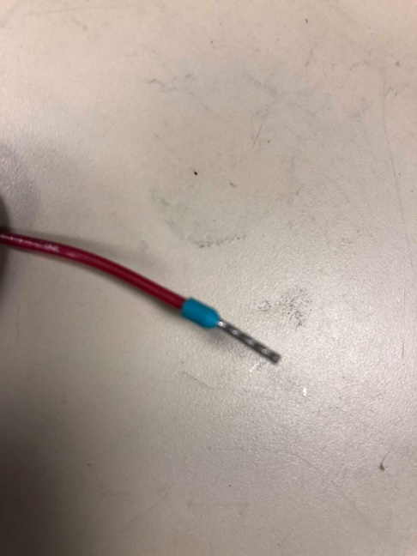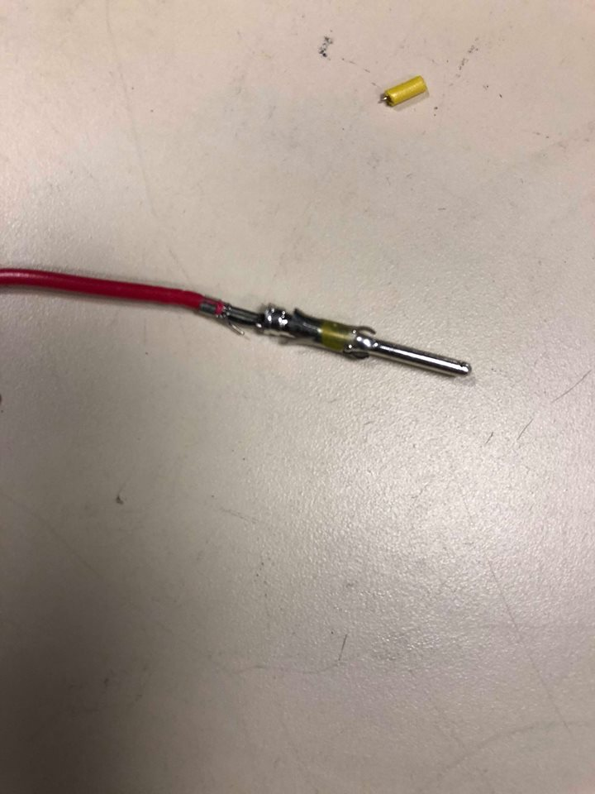

Other end of wire with tin crimp

Tin crimped side of wire after having heat shrink added

End of wire that will go into terminal block

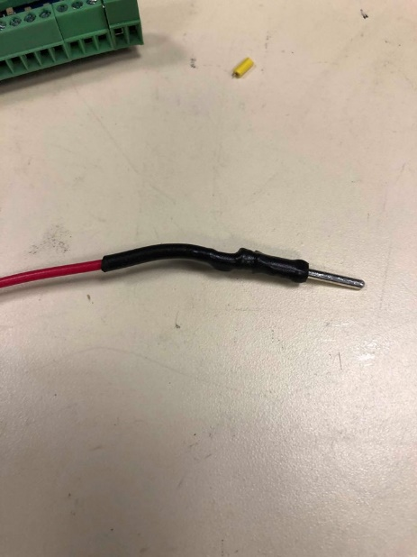

### MPR 121 Board:

* Solder Terminal Blocks onto the MPR121 board
* Cut 4 lengths of 22-gauge wire about 4 cm long each and 1 length of 22-gauge wire about 10 cm long
  + The 4 lengths of wire are for VIN, SCL, SDA, and IRQ
  + The longer 10cm length is for GND
* At the both ends of wires crimp on ferules for terminal blocks

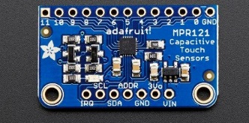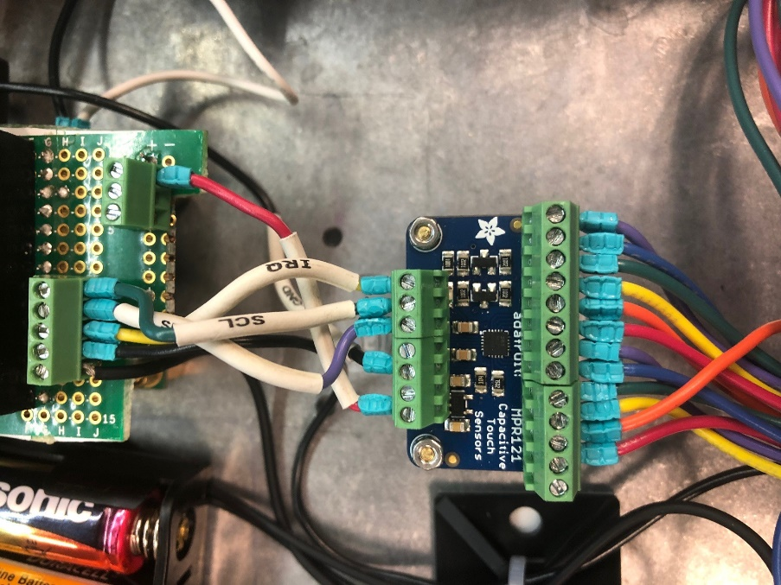

MPR 121 Board without Wires

Completed MPR 121 Wiring

## Mic

* Solder Mic onto a small breakout board
* Add a terminal block for 2 wires (GND and IN)
* Connect mic and terminal block using solder bridge
* Cut 2 short lengths of wire about 3 cm for GND and IN
* Crimp ferules onto both ends of each wire

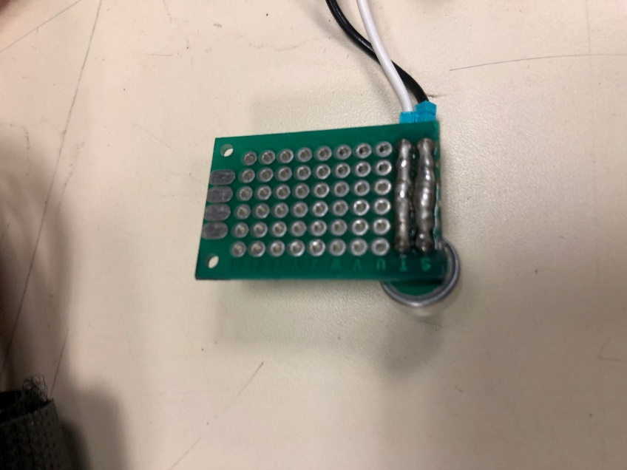

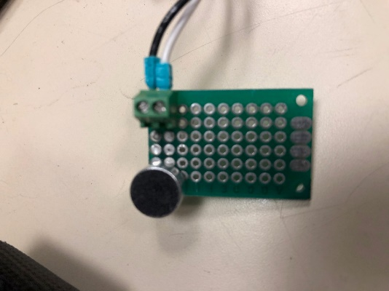

## Battery Pack

* Cut a microUSB cable, separate the GND and VCC wires.
  + As these wires are very thin, splice each wire onto a 5 cm length 22-gauge wire
  + Heat shrink the microUSB wire and the splices
* Extend the positive wire of the battery pack by splicing on a 5 cm length of 22-gauge wire
* Solder the GND of the battery pack together with the GND of the microUSB wire, heat shrink the connection
* Crimp a Quick Disconnect Flag Crimp onto the positive wire of the battery pack
* Crimp a Quick Disconnect Flag Crimp onto the VCC wire of the microUSB cable
* The Flag Crimps will fit onto the terminals of the rocker switch

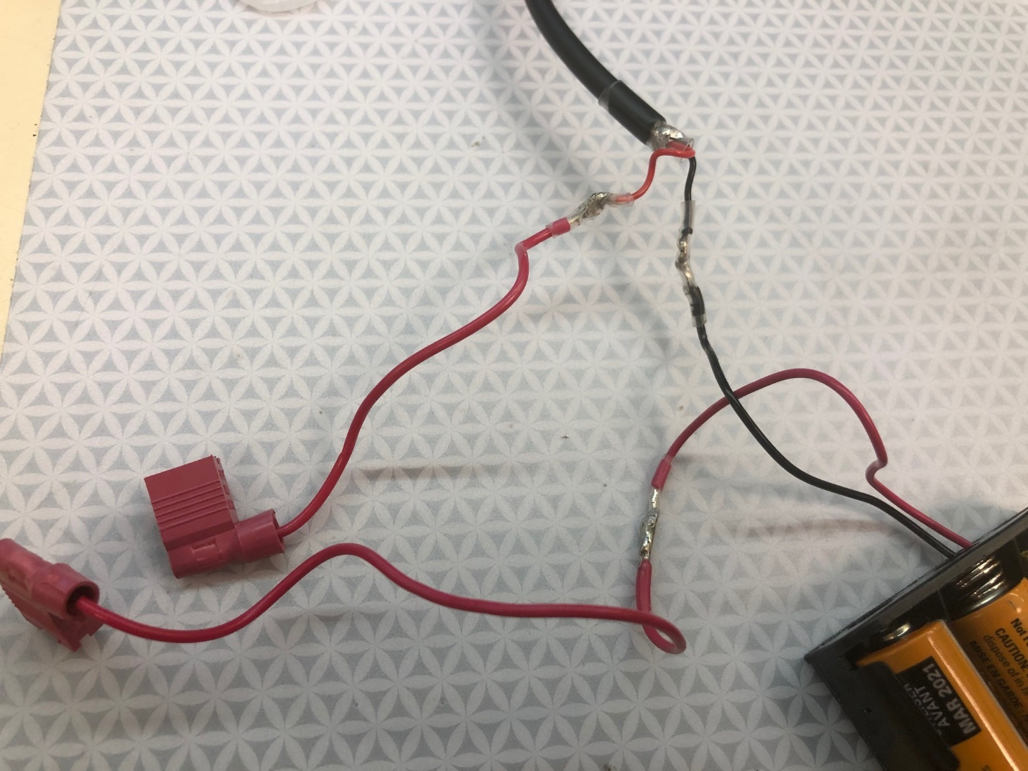

Wiring of Battery Pack

## Connecting MPR121, Teensy 3.2, Buttons and Audio Board

* Onto a Proto Board
  + add headers for the Teensy 3.2 and sockets for the Audio Board
  + Add terminal blocks for GND onto negative side of power rail and Vin onto positive side of power rail
  + Add a 5 input wide terminal block for MPR121 inputs and buttons (should match Teensy 3.2 pins 15-19)
  + Add 4.7k resistor from Teensy 3.2 pin 19 to positive side power rail
  + Add 4.7k resistor from Teensy 3.2 pin 18 to positive side power rail
  + 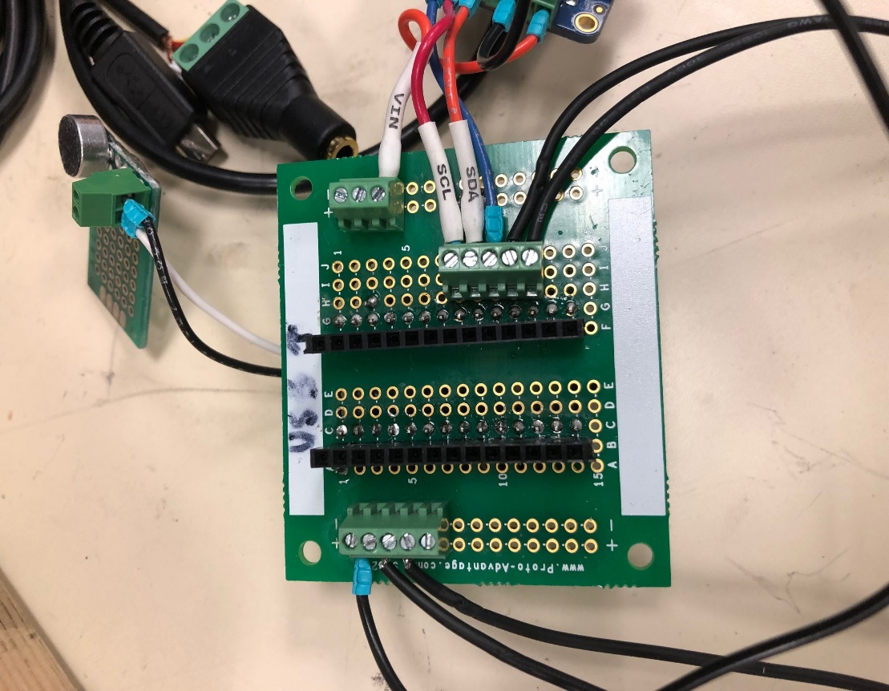Connect wire from GND side of power rail to Teensy 3.2 GND
  + Connect wire from positive side of power rail to Teensy 3.2 3.3 V

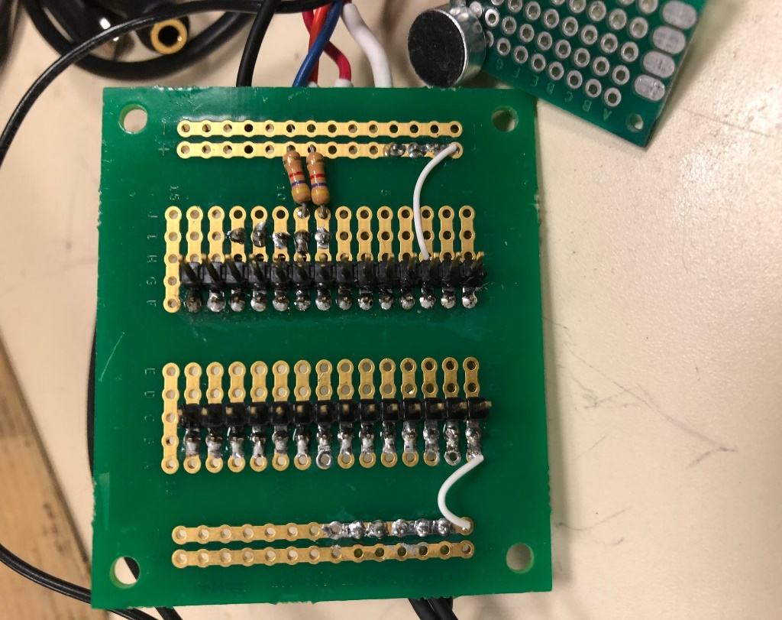

Front side of Proto board

Opposite Side of Proto board

Connecting Wires:

* MPR121 Vin onto positive power rail
* MPR121 SCL to Teensy 3.2 19
* MPR121 SDA to Teensy 3.2 18
* MPR121 IRQ to Teensy 3.2 17
* Switch Keyboard button to Teensy 3.2 16
* Record Button to Teensy 3.2 15
* Other ends of Buttons to GND side of power rail
* MPR121 GND to GND side of power rail

For connecting Buttons to terminal blocks either use ferule crimps or tin the ends of the wires to fit in the terminal blocks.

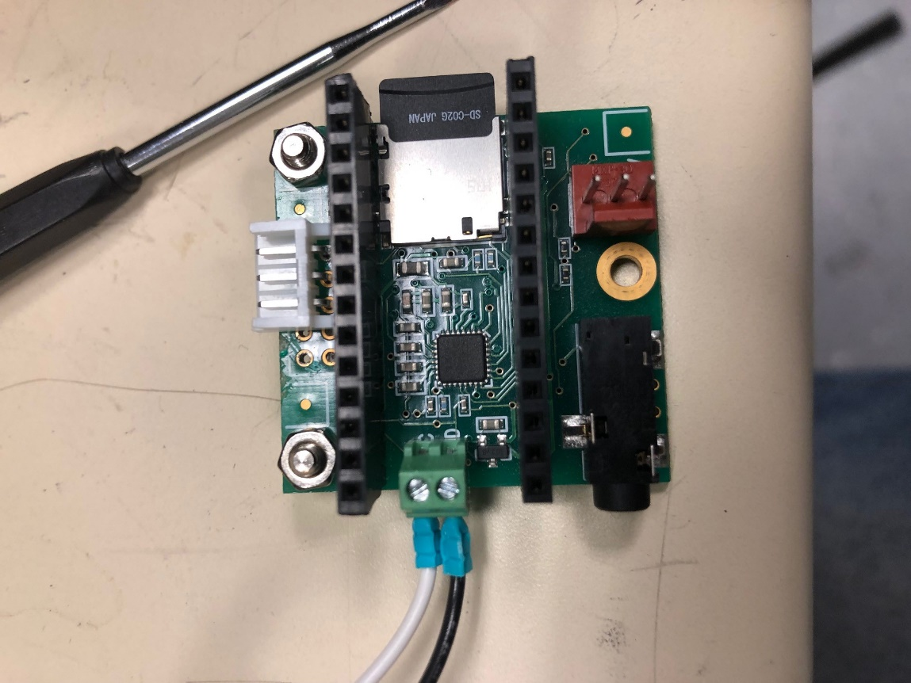Using a Proto board labelled A-J and 1-15:

* B1-B14 headers for Teensy 3.2
* C1-C14 sockets for Audio Board
* F1-F14 headers for Teensy 3.2
* G1-G14 sockets for Audio Board
* 5 input wide terminal block on I8-I13

Onto the Audio Board MIC and GND connections solder a 2 input wide terminal block

# Box Construction

The following modifications are made to a Hammond NFG 1550G box

* On base of box:
  + 3 holes for M3 standoffs for Teensy Audio Board
  + 2 holes for M2 standoffs for MPR121 board
* Forward face of box:
  + hole for MPR121 wires connecting to capacitive input (diameter depending on grommet, about 3cm)
* Backwards face of box:
  + Hole for rocker switch (about 22mm in diameter)
* Left face:
  + One hole for audio extension cable (depends on width of cable)
  + One hole for mic
* Right face:
  + 2 holes for buttons about 16mm wide
* Tap screw holes of box to fit M4 thumbscrews

Very Optional Step: Laser cut a clear acyclic lid for box

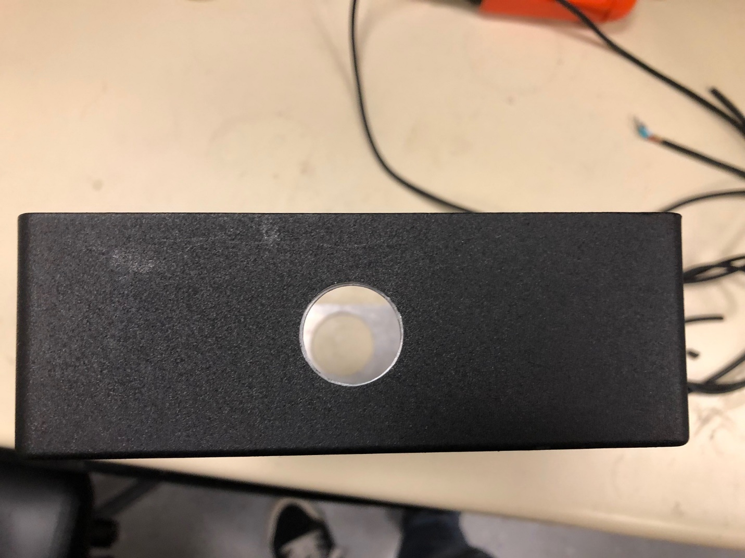

Hole for Rocker Switch

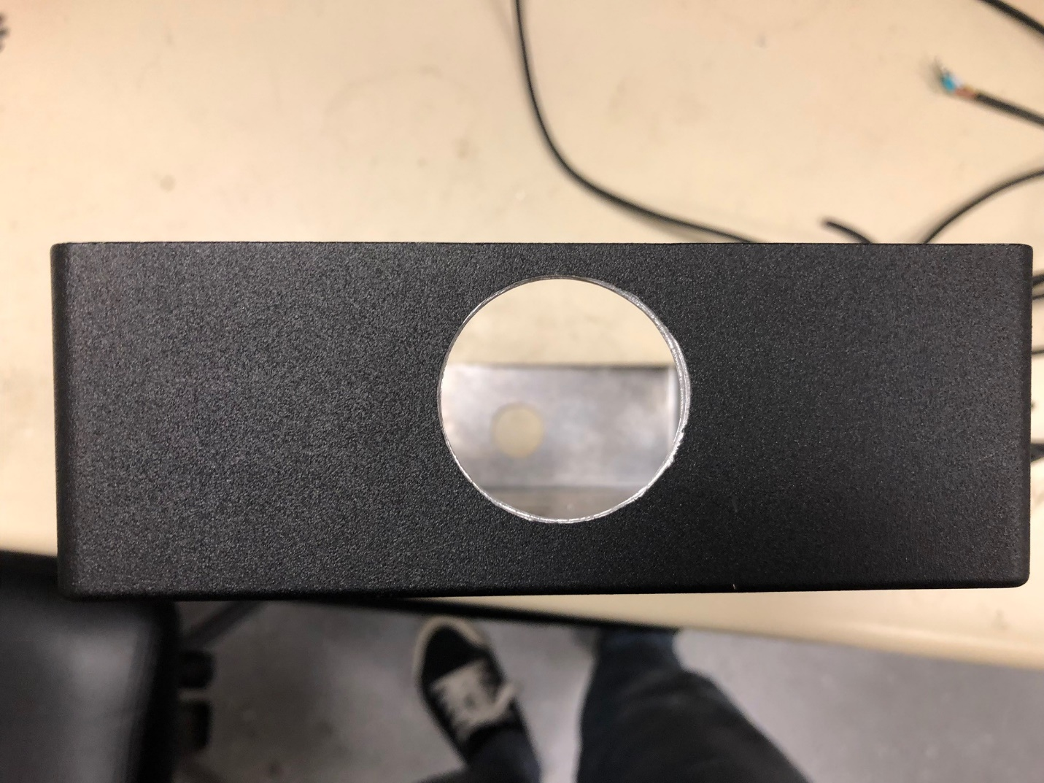

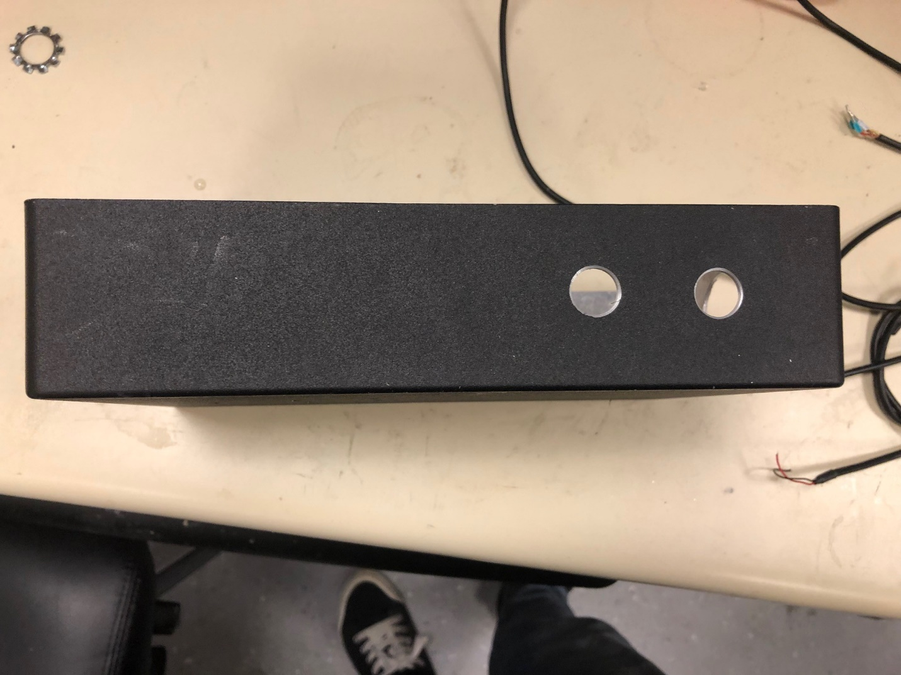Hole for Grommet (MPR121 wires to capacitive inputs)

Holes for Buttons

Holes for Buttons

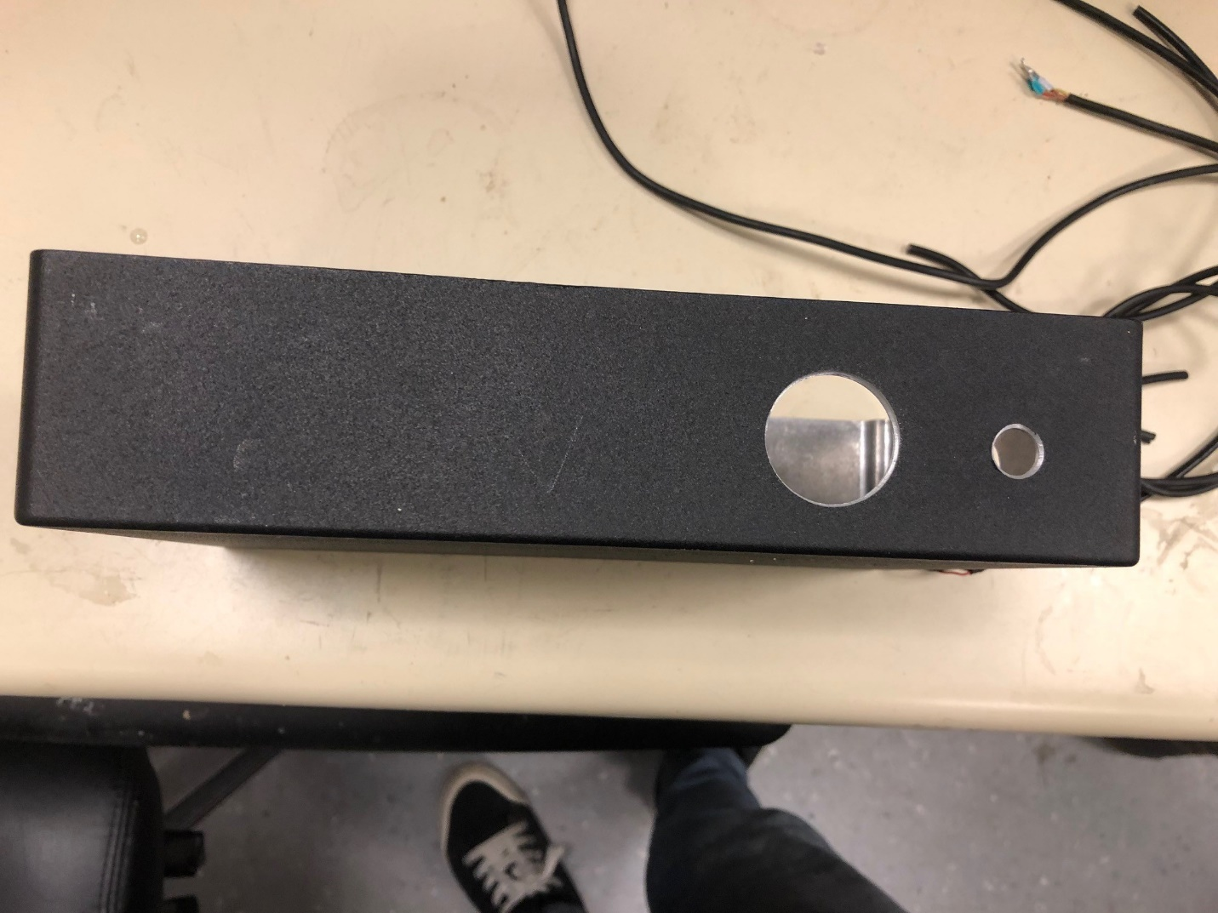

Holes for Mic and Audio Jack

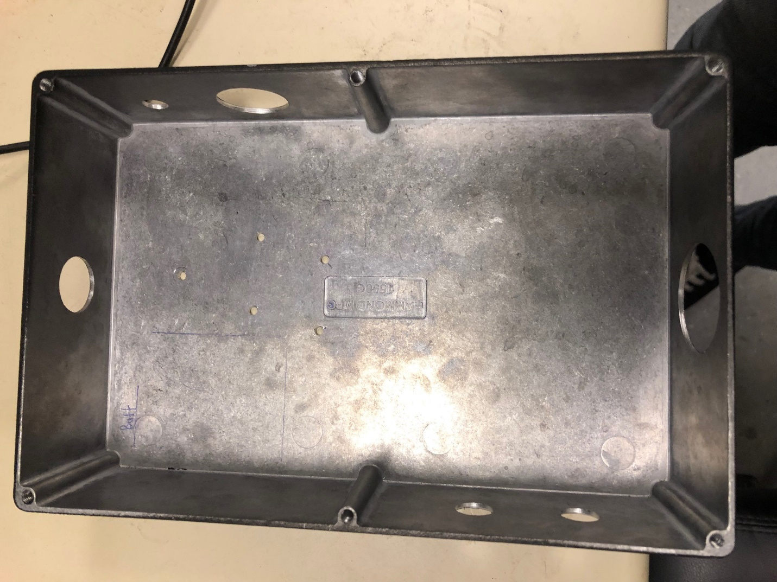

Box Layout with all holes cut out