EOSDIS

Earth Data (ED)

Federated Content Tool (FCT) -

User Guide

May 15, 2012 Version 1.0



**Document Version History**

|  |  |  |
| --- | --- | --- |
| **Version** | **Date** | **Revision Description** |
| Version 1.0 | May 15, 2012 | Initial Release |
|  |  |  |
|  |  |  |

**Table of Contents**

1.0 Overview 4

2.0 Terminology 5

3.0 Functionality 6

3.1 Content Producers Functionality Summary 6

3.2 Content Consumers Functionality Summary 7

3.3 Logging 7

3.4 Content Producers – Functionality Details 8

3.4.1 Create Content Feed 8

3.4.2 Import Content Feed 10

3.4.3 Manage Content Feed 10

3.4.4 Add Content Feed Item(s) 12

3.4.5 Manage Content Feed Item(s) 13

3.4.6 Publish Content Feed 14

3.5 Content Consumers – Functionality Details 15

3.5.1 View All Earth Data Feeds 15

3.5.2 Subscribe to a feed 16

3.5.3 Manage Subscription 18

3.5.4 Add Items to a Subscription 18

3.5.5 Manage Subscription Items 18

4.0 Categories / Terms 19

5.0 Tagging Feeds with Category Terms 20

6.0 Filtering 22

7.0 Publishing Subscription 22

# 1.0 Overview

The Earth Data Federated Content Tool (FCT) supports sharing and re-use of Earth Data content; sharing of Earthdata.nasa.gov content with the DAACs, sharing of DAACs content with Earth Data and sharing of content from DAAC to DAACs.

The Earth Data FCT allows existing content to remain at the original location while at the same time provides a unified solution for managing Earth Data content. It allows participating entities to retain a large measure of autonomy over the content they make available, as well as the content they choose to re-use. Finally, the FCT provides a common interface for all producers and consumers of Earth Data content.

The Earth Data FCT supports two roles: Content *Producer* and Content *Consumer*. The most common scenario is that the same person is both the Producer and the Consumer of Earth Data Content. Content Producers are able to use the tool to register/ingest their feeds into Earth Data and/or use the tool to create their feed(s) and tag them with the appropriate keyword tags that will be used in the keyword search. Content Consumers, are able to view all the feeds that are available and to subscribe to any or all the feeds available.

Content Providers (DAACs, Earth Data, and Others) register their feed(s) from existing content sources using standards defined by Earth Data. Earth Data aggregates all feeds and makes a single Earth Data feed available for consumption by Earth Data and others. Content Consumers may select pertinent stories from the Earth Data feed, and place them within their sites as desire. Some feeds (e.g. outages, meeting notification, system updates, etc.) may be required to be included on all EOSDIS website. Figure 1 depicts the Earth Data Federated Content Model.

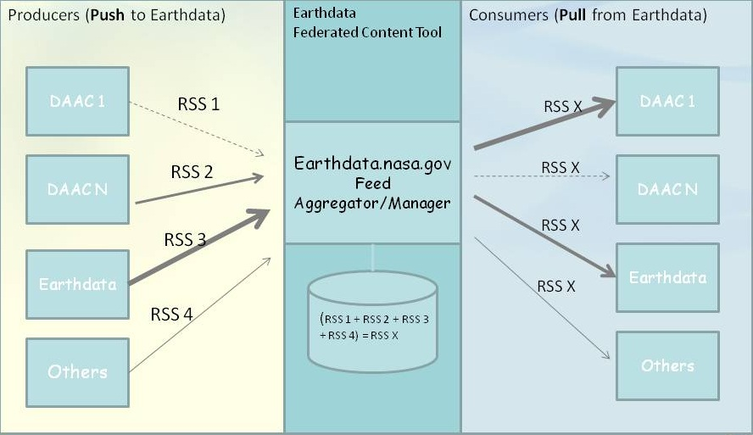

Figure 1 – Earth Data Federated Content Model

The Earth Data FCT uses Really Simple Syndication (RSS) content syndication tool (one-to-many), and augments the functionality to create federated content tool (many-to-many). This approach allows independent entities to work together exchanging content in a fully interoperable fashion and provides a unified solution for managing Earth Data science content across EOSDIS.

There are two ways for content producers to register their content into Earth Data: 1) If content producers already have an existing RSS feed, they can import their existing RSS feed into Earth Data FCT using the “Import feed from URL” command, and 2) by using the tool to create a feed using the “Add Feed” command.

Content consumers subscribe to Earth Data content via “subscriptions”. Consumers can have one subscription that contains all content items select, or can create several subscriptions and group content items by category (e.g. news subscription, mission subscription, instrument subscription, etc.)

# 2.0 Terminology

**Content Producer** – refers to the content owner (Earth Data, and DAACs), but it also refers to the role of the content owner person that uses the FCT to register and manage the federated content.

**Content Consumer** – refers to the user of the content (Earth Data, and DAACs), but it also refers to the role of the person that uses the FCT to subscribe to available content Feeds that have been registered in Earth Data.

**RSS Channel** – another name for RSS feed. In this document, “channel” and “feed” will be used interchangeably.

**Feed/ RSS Feed/ Web Feed** – feeds provide users with frequently updated content. Content Producers use the FCT to register their data for consumption by others (Earth Data, DAACs, etc). One or multiple feeds can be registered by a Content Producer.

RSS and Atom are two standard web feed content delivery vehicles. The FCT currently only supports the RSS (Really Simple Syndication) format feeds.

RSS feeds have two types of information: channel and item. An RSS feed is a container/channel that can have one item or a series of items. The channel name/feed title tells users how the items relate to each other, so it is important to have meaningful channel/feeds names. Both the channel and the items have three descriptive fields: title, description and URL link. Additional fields are available but not necessary. Figure 2 – The Anatomy of an RSS Feed provides a pictorial view of how items of an RSS feed are chained together to form a feed channel.

The Earth Data FCT shields the user from having to understand the RSS feed syntax and instead it provides users (producers and consumers) with fields to be filled out.

In Earth Data the feed title is the feed/channel name and it is a required field. Content Producers can choose to create only one feed with all the associated items, or create a feed for each content type (e.g. news, events, etc.). The feed/channel title is the only required field to define a feed/channel. However, adding a description is advisable. The Feed URL is the URL of the homepage URL (e.g. http://gesdisc.nasa.gov)

**Item –** feed item refers to an entry in the feed that defines an article or story; many items can be associated with a feed. In the tool, item title and item link (URL of article/item/story) are the only required fields for an item, and users of the tool do not need to worry about the xml format of the feed

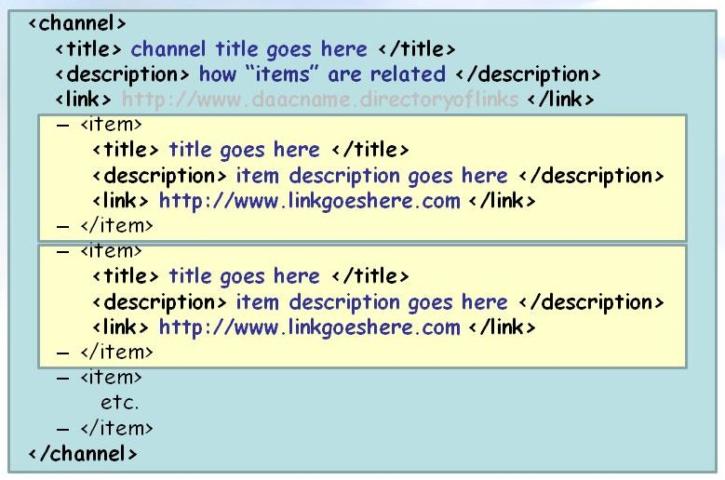

Figure 2 – The Anatomy of an RSS Feed

**Subscription** – refers to feed(s) selected from all available Earth Data feeds that are selected by “Consumers” for re-use on their websites. Content Consumers can create a feed or multiple feeds and aggregate items from the existing feeds to create a customized feed to be displayed on their websites.

**Tag** – tags are keywords or category labels assigned to an “item” or a “feed”. These are used to find feeds and items that are of interest easily. In addition tags are used to find similar items with similar qualities, organize feeds and subscription by categories of interest, and search by keyword.

**Source** – users of the FCT are assigned to a source group. Source groups are created as needed, but at a minimum there is a group for each DAAC and one for Earth Data. These serve several purposes. It allows multiple individuals to be content producers and consumers for one source group; it also can be used to filter the feeds based on the source of origin. Users are pre-assigned to a source group based on their organization.

# 3.0 Functionality

## 3.1 Content Producers Functionality Summary

*Add feeds* – Allows Content Producers to create/ingest their feeds into Earth Data

*My Feeds* Tab – Allows Content Producers to view all the feeds they have created/ingested

Manage Feed – Allows Content Produces to pre-view created/ingested feed by clicking at the feed “Title”, pre-view the RSS feed by clicking “*RSS*”, *edit* created/ingested feed channel information, and *delete* feed.

Manage Items – Allow Content Producers to *view items* within a channel/feed, and to *add item* to the channel/feed.

From manage items content producers can select individual items and “*Publish selected items*”, “*Unpublish selected items*”, “*Tag selected items*”, “*Untag selected items*” and *delete selected items*.

*Import feed from URL* – Content Producers can choose to ingest their existing feeds by directly importing them into the system using this command.

## 3.2 Content Consumers Functionality Summary

*My Subscriptions* Tab – Allows Content Consumers to view and manage existing subscriptions, and *add new subscriptions*.

Manage Subscriptions – Allows Content Consumers to pre-view their subscriptions by clicking *“Title”* and pre-view the RSS feed by clicking *“RSS”,* *edit* current subscriptions, and *delete* existing subscription(s).

Manage Subscribed Items – Allows Content Consumers to *view subscriptions* items and *add subscription*s items.

When viewing subscription(s) items / Feed Item Subscriptions page the user can *edit* any given item or *unsubscribe* to one or multiple items.

Subscribe items – Allows Content Consumers to select one or multiple item(s) from all available feed items and subscribe to them. Target items can quickly be identified by applying the left hand filters to the list of available feed items.

*All Feeds* Tab – Allows Content Consumers to view a list of All Feeds; if feed has not been published it will be gray-out, but content consumers are able to subscribe to them anyway. By clicking at the *“Title”* the feed can be preview, and by clicking *“RSS”* pre-view the RSS feed and by clicking *Subscribe to a feed* either by selecting *Add selected subscriptions to an existing created feed*, or by selecting *Create a new feed form the selected subscription*.

In addition Content Consumers can view if their feeds are published or unpublished.

## 3.3 Logging

You must have a valid NAMS account to access the Federated Content Tool (FCT); in addition you need to be identified as a FCT user. To request the content producer/consumer role, send an email to the Earth Data team at: [esdis-cw@lists.nasa.gov](mailto:esdis-cw@lists.nasa.gov) with your NAMS user id.

To access the tool go to: <https://earthdata-uat.nasa.gov/user> and login with the FCT username and password provided.

Upon successful login go to <https://earthdata-uat.nasa.gov/feed>

This is the Federated Content Tool dashboard. First time users will have no feeds or no subscriptions.

## 3.4 Content Producers – Functionality Details

3.4.1 Create Content Feed To create feed/channel, content producers, click the *Add Feed* link.

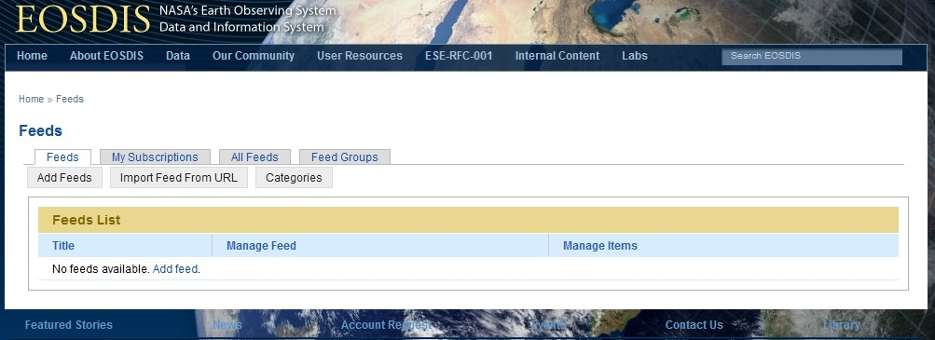

The only required field when adding a feed is the name of the feed. The logo field section is optional, but it is here where the content producer can associate an image with the feed being created.

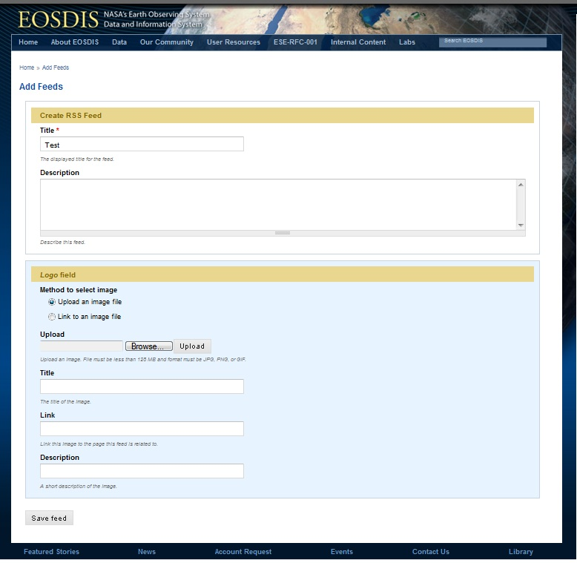

When the feed is saved, it will be displayed under the Feeds tab.

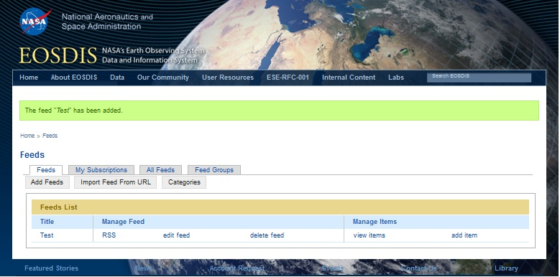

Content for the feed is be added after the feed/channel has been created, through the *add item* command (section 3.4.4)

3.4.2 Import Content Feed If content producers already have RSS feeds, they can create an Earth Data feed by importing their existing feed by clicking the *Import Feed From URL* tab link and completing the Import Feed form. Currently, Earth Data only support RSS feed format.

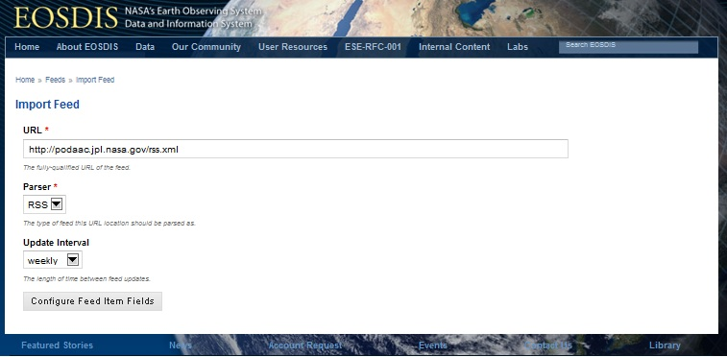

After selecting *Configure Feed Item Fields* the imported feed will show in the feeds list.

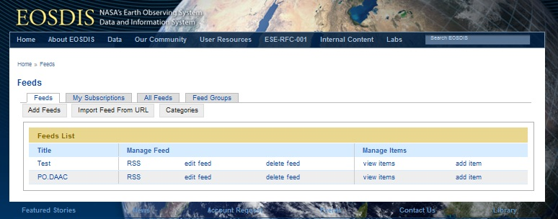

3.4.3 Manage Content Feed To preview the feed, click at the feed name/title. After clicking PO.DAAC, the imported PO.DAAC feed preview is displayed.

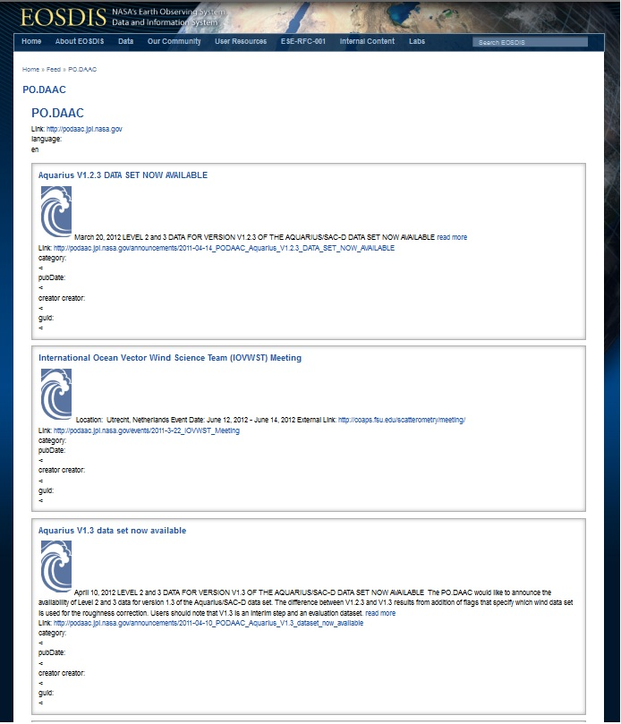

When clicking at *RSS* link for the feed, users can view the actual RSS feed and link.

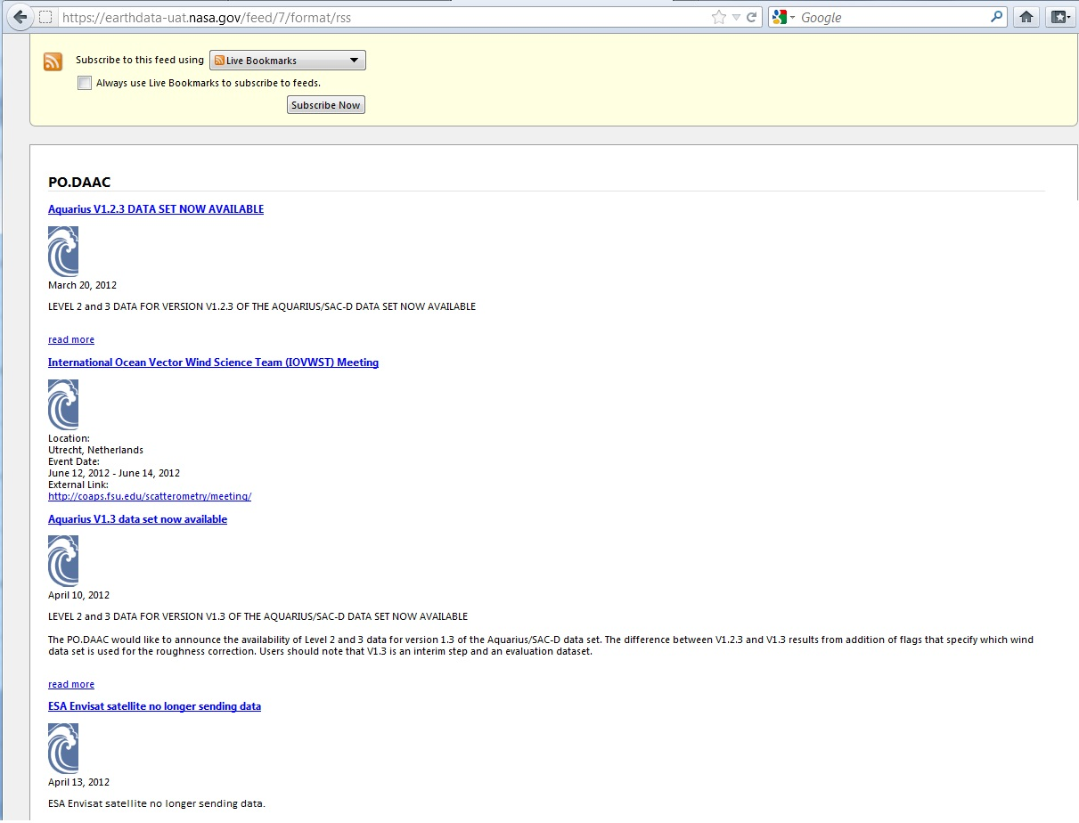

3.4.4 Add Content Feed Item(s) The test feed/channel has been created, but it is empty. To add content to the test feed/channel click the *add item* link.



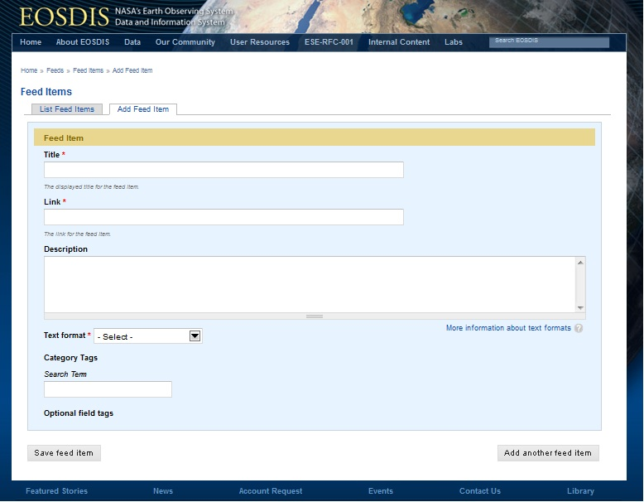

A feed can have one item, or multiple items. If only one item is entered, then click *Save feed item*. If multiple items are going to be added, click *Add another feed item* after the feed item information has been entered, repeat for each item in the feed, when all items have been entered click *Save feed item*.

3.4.5 Manage Content Feed Item(s) At any time, additional items can be added to a feed by clicking *Add Item*. By clicking View Item, users can Edit or Delete specific feed items.



In addition, users can Publish, Unpublished, Add Keywords (Tag), or remove Keywords (Untag) one or multiple items by clicking the *View Items.*

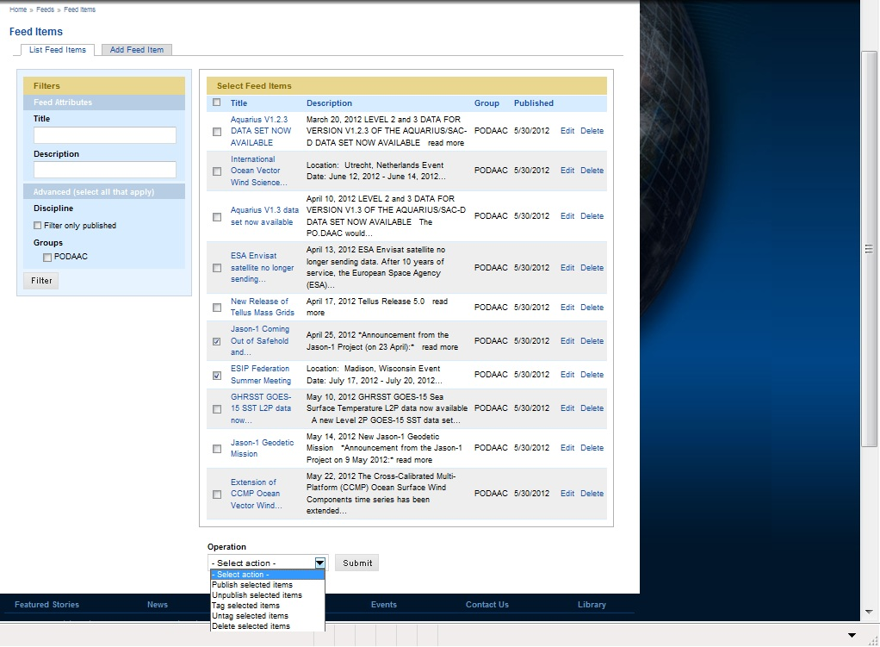

Users can filter the items on a feed using the various filters provided on the top of the left hand rail (see section 5.0)

3.4.6 Publish Content Feed Once a feed has been created, it needs to be published to make it available for others to use/consume.



Click *edit feed.* To publish all the items in the feed, select the *Title* box and all the items in the feed will be selected or select one or more feed items. Then go to the bottom of the page and click the *Operation* drop down menu and select *publish selected items*.

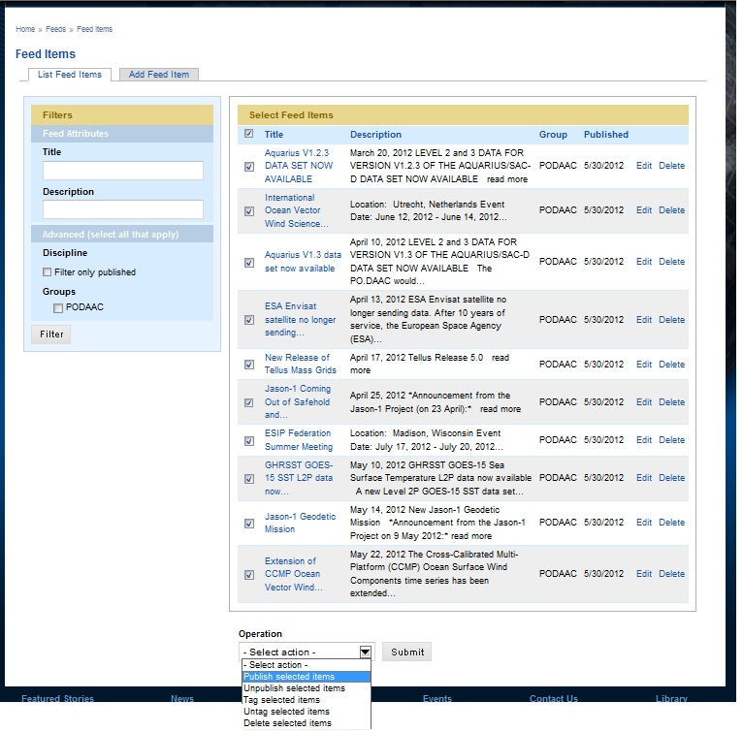

## 3.5 Content Consumers – Functionality Details

3.5.1 View All Earth Data Feeds Content consumers can view all published Earth Data Feeds by clicking the *All Feeds* tab link.

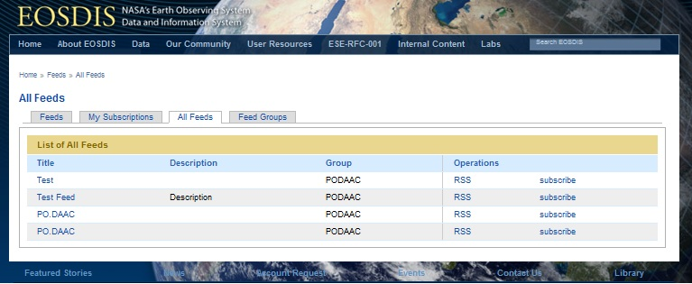

3.5.2 Subscribe to a feed Users can subscribe to any of the Earth Data feeds by clicking the *subscribe* link. Users can add the selected feed or selected feed items to an existing subscription or create a new subscription with the selected feed or feed items.

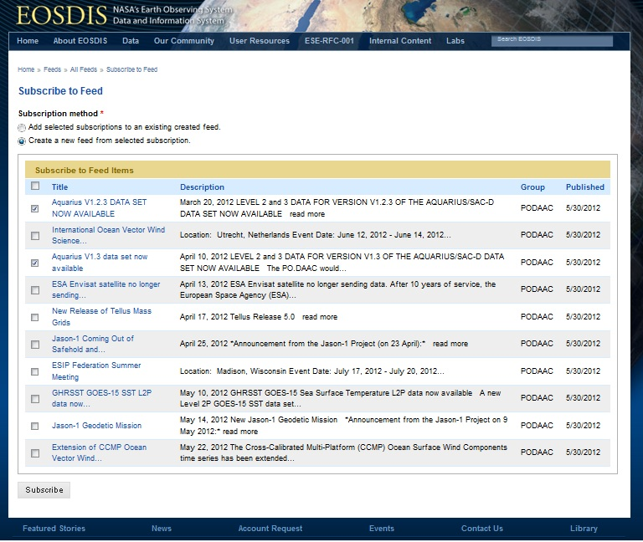

When creating a new feed/subscription from selected feeds, users can give their feed/subscription a meaningful name based on the items in the feed.

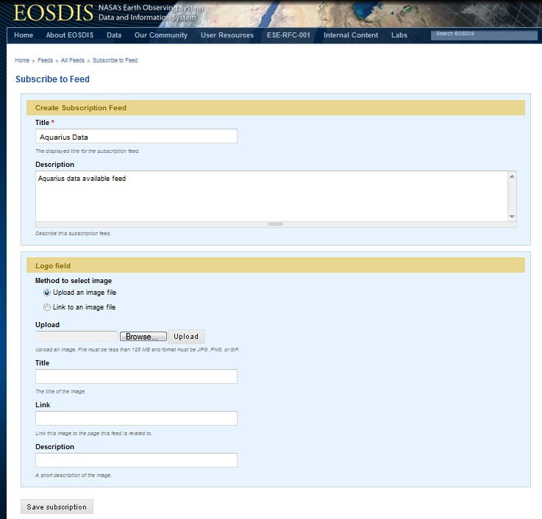

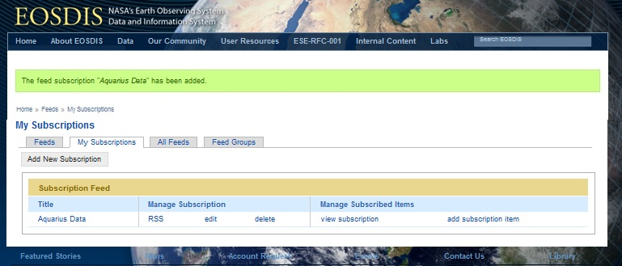

3.5.3 Manage Subscription All subscriptions are displayed under the My Subscriptions tab.

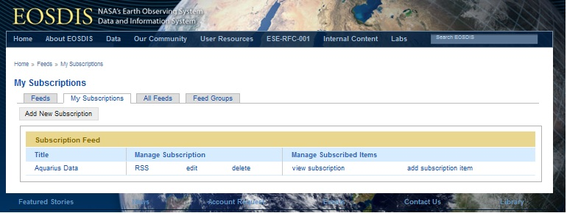

Users can *Manage Subscriptions* by clicking *edit* or *delete* a subscription. They can preview the subscription feed by clicking at the subscription name (e.g. Aquarius Data) and the actual subscription RSS feed by clicking the *RSS* link.

3.5.4 Add Items to a Subscription *Manage Subscribed Items* allows users to edit specific subscription items and unsubscribe to one or more subscription items. Once a subscription is created, users can add items/feeds to the subscription by clicking *add subscription item*.

TBD

3.5.5 Manage Subscription Items *Manage Subscribed Items* allows users to edit specific subscription items and unsubscribe to one or more subscription items.

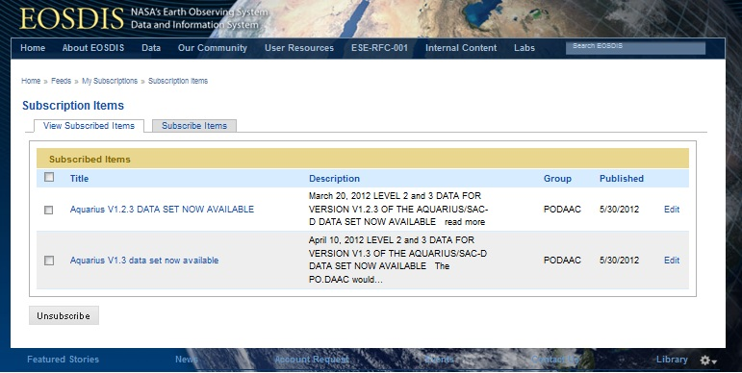

# 4.0 Categories / Terms

The tool has pre-defined high level categories: Disciplines, News, Events, etc. Content feeds can and should be properly tag with the right category terms. Each category has a list of “Terms” associated with that category. The current implementation of categories does not allow sub-categories, so users need to first select the discipline:ocean category/term and the select the ocean/sea surface temperature category/term combination. Similarly if a news item is also an event users may want to tag the event with news category and with events:conference.

Users are encouraged to use those predefined categories, but in the event a more specific tag is necessary, users can add terms to the existing categories and/or add new categories. From the Feeds page, select the Categories tab.



A list of all existing categories will be displayed’

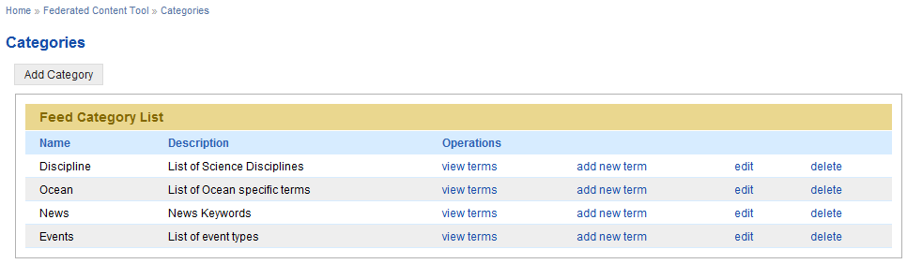

To view existing terms under a category use the *view terms* operations, you’ll be able to *add new terms* in the List Terms page or by selecting the *add new term* operation.

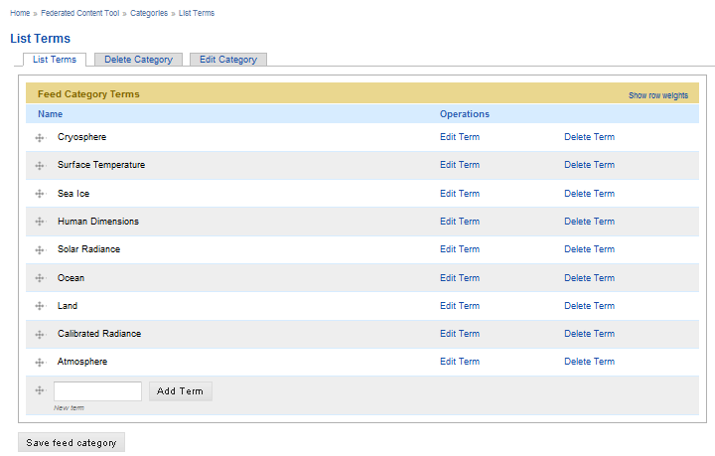

# 5.0 Tagging Feeds with Category Terms

We encourage the use of tags to facilitate finding and filtering feeds.

Tags can be added when an item is added to a feed (see section 3.4.4), or after the items are created by selecting *view items* in the *Feeds* tab.



Users can select to tag with a keyword or keywords individual items in the feed, or multiple items. First users select the item(s) to tag and then select *tag selected items* from the *operation* drop down menu, then add the tag/keyword(s) that apply.

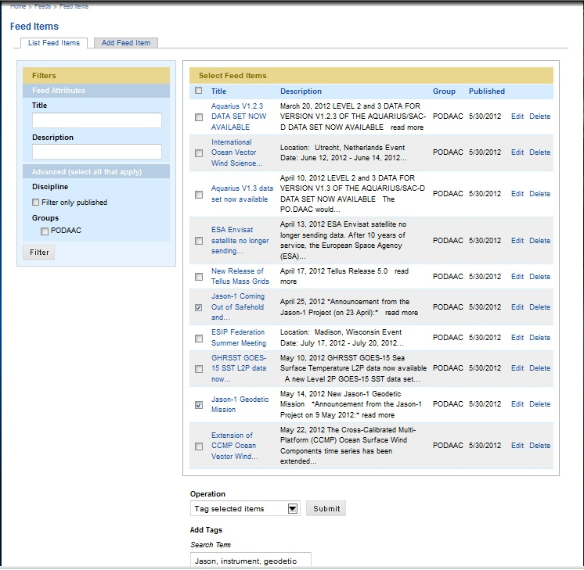

# 6.0 Filtering

Current filtering of feeds can be done, in the left rail, by using a keyword in the feed title or/and description. In addition, filtering can be done on the content source. As more usage of the tool increases, additional filtering options will be added as needed.

# 7.0 Publishing Subscription

A java script file is provided that can be dropped to publish the feed subscriptions, similar to the Top Hat implementation.