Homework/Pop Quiz #4 of the course: Theory of Computer Games.

(alpha-beta)
- For the following two-player search tree, assume that we only consider the window of (28, 32) starting from node a. Use mini-max alpha-beta search to solve it. (a) Use fail-hard version (F2' and G2') to solve it. (b) Use fail-soft version (similar to F3, which is a fail-soft version for nega-max). In this problem, you need to indicate the values (v, alpha, beta) for v = F2(p, alpha, beta) on each edge. In addition, also need to indicate whether branches are cut off.
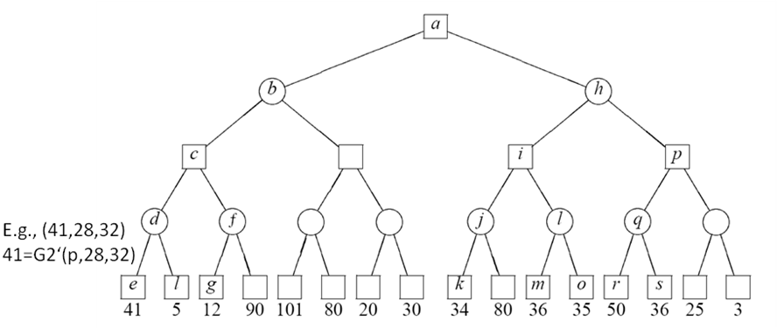
- Do the problem 1 again with window (45, 60) for fail-soft only.
- Do the AB-Dual* for the above tree (that is, MTD(− ∞)). Hint: draw all passes of the search, you may skip subtrees as in the handout.

(zhash)
- For Gomoku on a 15x15 board: (a) Design a Z-hashing function for any given position. (b) Furthermore, we want to distinguish a path P, defined a sequence of three consecutive positions, say (P_{i}, P_{i+1,} P_{i+2}). How do you define a new Z-hashing function for such a path? Hint: the key encoded from (p1, p2, p3) must be different from that for (p3, p2, p1).

