Homework 2: CFG

1. N.A.
2. 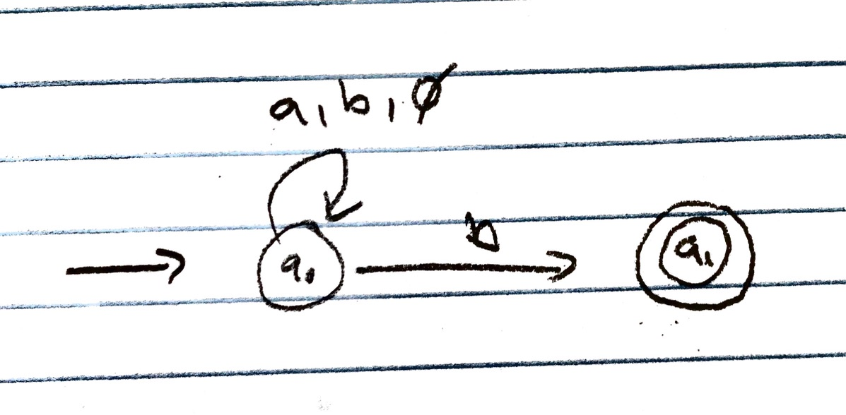 . (15) Show the NFA that results from applying the NFA construction method, discussed in the class, to the regular expression ( a | b | 0 )∧ b.
3. (40) Context Free Grammar.
   1. Write a context free grammar for arithmetic expressions which can use numbers, variables and operation + only
 $expr→expr+expr$

 $expr→var | num$

 $var→a \left| b \right|c$

$num→1 \left| 2 \right|…| 9$

2. Write a context free grammar for the arithmetic expressions above that captures right associativity.
 $expr→var+expr | num+expr$

 $var→a \left| b \right|c$

 $num→1 \left| 2 \right|…| 9$

3. Write a context free grammar for arithmetic expressions which can use numbers, variables and binary operations - and + only. Your grammar has to capture the precedence that - must be computed before +. Your grammar should also capture the left associativity of + and -. For example 5+5−5−5+6−5 should be computed as 5 + (5 − 5 − 5) + (6 − 5).
 $expr→operand | expr+group$

 $var→a \left| b \right|c$

 $operand→num | var$

$num→1 \left| 2 \right|…| 9$

$group→expr-expr | expr$

4. Refine your grammar above to allow parenthesis ( and ). Hint. Recall the techniques on how precedence and associativity were dealt with in the class.
$expr→operand \left| expr+group \right| expr+(group)$

$var→a \left| b \right|c$

$operand→num | var$

$num→1 \left| 2 \right|…| 9$

$group→expr-expr | expr$

4. (15) Given a grammar < P >→< S > < S >→ lrp < S > rrp < S > | lsp < S > rsp < S > | The terminals are defined as follows lrp → ( rrp → ) lsp → [ rsp → ] CS3361 Concepts of Programming Languages by Y Zhang, TTU, Spring 2021
   1. 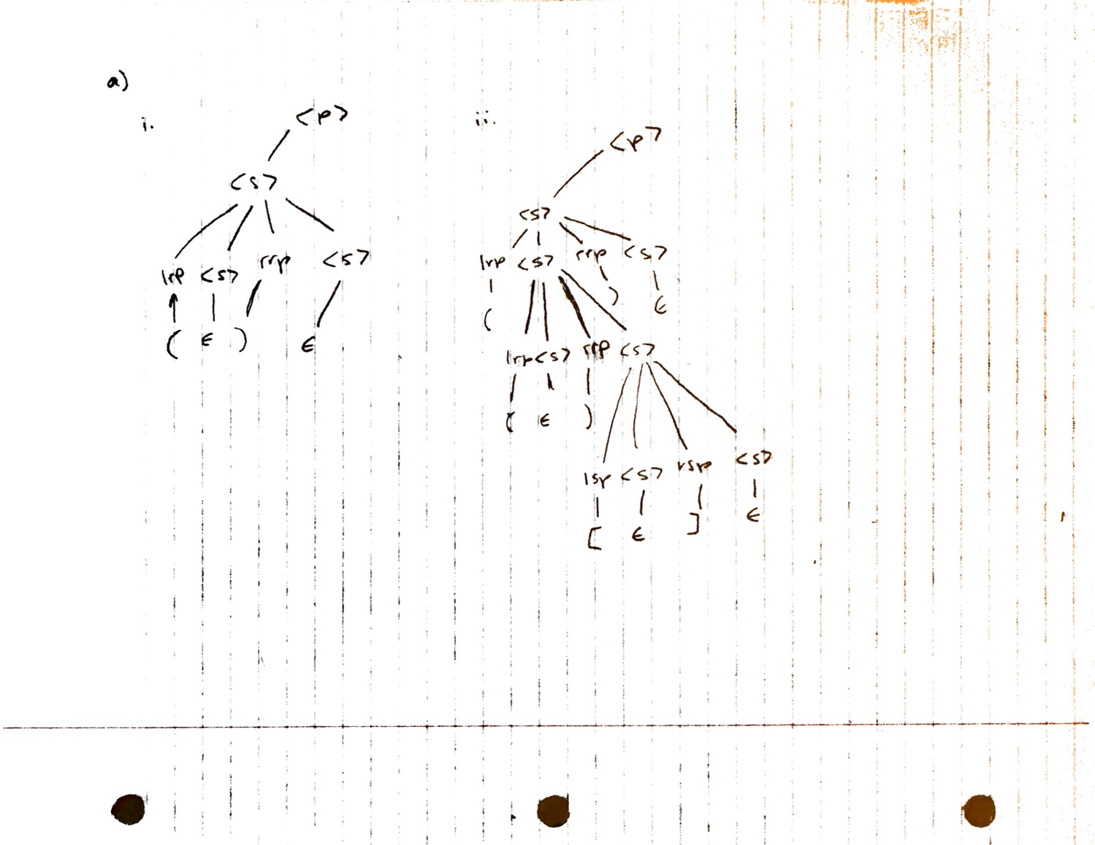Draw a parse tree for each of the sentences:
   2. Write a rightmost derivation for [].
$<P>→<S>$

$<S> →lsp<S>rsp<S>$

$→ lsp<S>rsp ϵ$

$→ lsp ϵ rsp ϵ$

$→lsp rsp$

5. Consider the CFG for in the slides (of L6) for parsing (Page 16), and an input program sum := A + B

