Proposal for Phase 1 Sanitary Sewer Evaluation Survey (SSES)
LaSalle Sewersheds – Niagara Falls Water Board
Submitted by Aurelia Digital Systems
Professional Engineering Services for Phase 1 SSES, Engineering Report, Corrective Action Plan, and Post-Construction Monitoring
with Options for Phase 2 and Phase 3

Executive Summary and Win Themes
The Niagara Falls Water Board (NFWB) is implementing a multi-phase sanitary sewer evaluation survey (SSES) program in the LaSalle sewersheds to eliminate sanitary sewer overflows (SSOs), reduce inflow and infiltration (I&I), and demonstrate compliance with its Order on Consent and New York State Department of Environmental Conservation (NYSDEC) expectations. Phase 1 focuses on the 91st & Luick and 81st & Frontier 1 sewersheds, with subsequent Phases 2 and 3 extending the program to additional LaSalle areas.
Aurelia Digital Systems (Aurelia) proposes to provide comprehensive professional engineering services to plan and execute Phase 1 SSES, prepare an Engineering Report and corrective action plan acceptable to NYSDEC, and perform post-construction monitoring to document I&I reduction by June 2024. Our approach is explicitly aligned to NYSDEC’s Engineering Report Outline for Wastewater Infrastructure Projects (October 1, 2022), NFWB’s Order on Consent milestones, and all requirements defined in this Request for Proposals (RFP).
Our win strategy is to be NFWB’s lowest-risk, highest-value partner by combining deep technical capability in sewer system evaluation with rigorous project management, strong governance, and advanced data and analytics. We will integrate flow, rainfall, CCTV, smoke testing, and weiring data in a unified analytical framework to target the most cost-effective corrective actions and to clearly demonstrate I&I reduction in the post-construction I&I Assessment and Cost Analysis Report.
- NYSDEC-compliant, audit-ready documentation mapped to the Engineering Report Outline and EPG requirements, including PE-stamped deliverables.
- On-time delivery of Phase 1 SSES, Engineering Report, and corrective action plan to support early 2023 NYSDEC review, 2023–early 2024 construction, and June 2024 post-construction monitoring.
- Data-driven I&I identification and reduction using integrated analysis of flow, rainfall, CCTV, smoke testing, and nighttime weiring results.
- Strong project governance and communication leveraging Aurelia’s Initiate–Discover–Design–Build–Deploy–Operate lifecycle with clear stage gates and RACI.
- Robust safety, security, and information governance practices that reduce operational and reputational risk for NFWB.
- Concrete plan to meet or exceed MWBE (30% combined) and SDVOB (6%) participation goals with transparent utilization tracking and reporting.
- Transparent pricing and effort estimation with not-to-exceed fees, clearly defined contingency for focused SSES activities, and options for Phases 2 and 3.
- Experienced, multidisciplinary team with proven success delivering sewer system evaluations and public-sector infrastructure projects.

High-Level Value to NFWB
Value Theme | Benefit to NFWB
Schedule certainty | Aligned to early 2023 NYSDEC review, 2023–early 2024 construction, and June 2024 post-construction monitoring milestones.
NYSDEC compliance | Engineering Report and Post-Construction Report structured to the NYS Engineering Report Outline and EPG guidance, PE-stamped and audit-ready.
I&I reduction | Targeted corrective actions prioritized by cost per gallon removed and ability to eliminate SSOs at 91st & Luick and 81st & Frontier 1.
MWBE/SDVOB participation | Credible utilization plan with identified roles for certified partners and monthly reporting cadence.

Summary of Key Mandatory Requirements and Proposal Cross-Reference
Requirement ID | Requirement Summary | Proposal Section
REQ-001 | Phase 1 SSES in 91st & Luick and 81st & Frontier 1 sewersheds | Phase 1 SSES Technical Approach and Scope of Services
REQ-002 | Option prices, schedules, and scopes for Phases 2 and 3 | Options for Phase 2 and Phase 3 SSES (Scope, Schedule, and Fees)
REQ-003 | Compliance with NYSDEC, EPG, and Engineering Report Outline | Regulatory and Standards Compliance Approach
REQ-016 | Phase 1 SSES report with corrective action plan | Phase 1 Engineering Analysis, Corrective Action Planning, and SSES Report
REQ-017 | Schedule aligned to early 2023 NYSDEC review and June 2024 monitoring | Schedule, Level of Effort, and Budget
REQ-020 | Comprehensive proposal content including schedule, effort, and budget | Multiple sections including Approach, Schedule, Team, and Options
Figure 1: Linkage between Phase 1 SSES, corrective actions, and post-construction monitoring
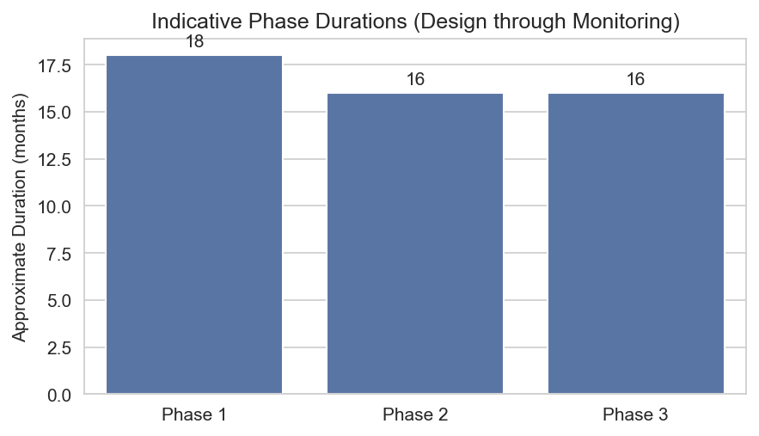
Figure 2: Indicative durations for Phases 1, 2, and 3

Understanding of NFWB Objectives, LaSalle Sewersheds, and Regulatory Context
NFWB’s overarching objective for the LaSalle sewersheds is to eliminate SSOs and achieve sustainable reductions in I&I such that the collection system and treatment facilities can reliably convey and treat wet-weather flows while complying with the Order on Consent and NYSDEC requirements. The LaSalle area includes multiple sewersheds that discharge to the Niagara Falls Wastewater Treatment Plant and historically have experienced wet-weather SSOs at 91st & Luick and 81st & Frontier.
Phase 1 focuses on the 91st & Luick and 81st & Frontier 1 sewersheds, which have the most acute SSO history and where prior I&I reduction efforts have already been implemented. Phases 2 and 3 extend similar SSES activities to the 81st & Frontier 2, 80th & Lindbergh, and Mang & 88th sewersheds to complete a comprehensive LaSalle program. Each phase must be sequenced to support design and construction of improvements and subsequent post-construction monitoring within NYSDEC’s expected timeframes.
We understand that NYSDEC expects Engineering Reports prepared under this program to follow the October 1, 2022 Engineering Report Outline, including documentation of existing conditions, regulatory drivers, alternatives analysis, recommended alternative, implementation schedule, and financial considerations. Our Phase 1 SSES report and Post-Construction I&I Assessment and Cost Analysis Report will be structured to this outline and will clearly demonstrate how recommended corrective actions address LaSalle SSO drivers.

Summary of LaSalle Sewersheds by Phase
Phase | Sewershed(s) | Representative Outfall/SSO | Key Issues | Prior I&I Work (Illustrative)
Phase 1 | 91st & Luick; 81st & Frontier 1 | SSOs at 91st & Luick and 81st & Frontier 1 | Wet-weather SSOs, high RDII, surcharging in local mains. | Targeted repairs, limited CCTV and manhole inspections, pump station control adjustments.
Phase 2 | 81st & Frontier 2; 80th & Lindbergh | Downstream of Frontier and Lindbergh areas | Capacity constraints, suspected private inflow sources. | Spot repairs, previous smoke testing in limited areas.
Phase 3 | Mang & 88th | Outfall near Mang & 88th | Localized basement backups, high groundwater I&I. | Isolated manhole rehabilitation, limited data on private inflow.
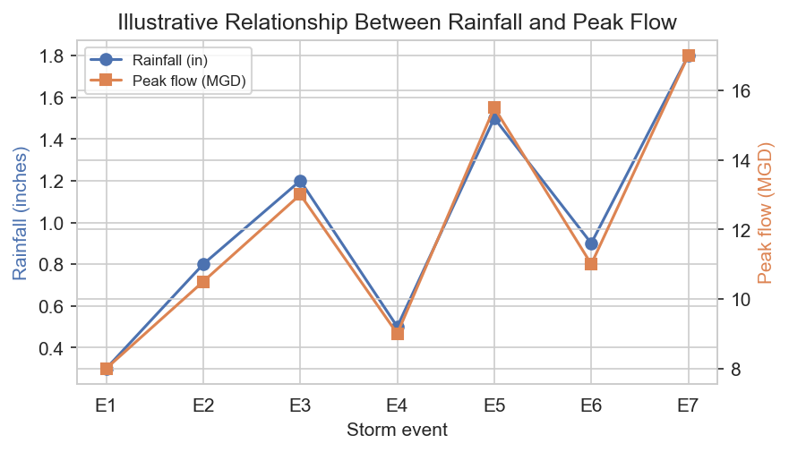
Figure 3: Conceptual relationship between rainfall and peak wet-weather flow

Regulatory and Standards Compliance Approach (NYSDEC, EPG, Engineering Report Outline)
Aurelia will structure all Phase 1 deliverables to fully comply with NYSDEC and Engineering Planning Guidance (EPG) requirements, including the Engineering Report Outline for NYS Wastewater Infrastructure Projects dated October 1, 2022. The Phase 1 SSES report and the Post-Construction I&I Assessment and Cost Analysis Report will be prepared, stamped, and dated by a New York State licensed Professional Engineer and will include sufficient documentation and analysis to support NYSDEC review and funding decisions.
Our internal quality management process includes structured technical reviews, compliance checklists mapped to the Engineering Report Outline, and formal PE review and approval prior to submittal. We will coordinate with NFWB and NYSDEC at key milestones to confirm expectations and minimize the risk of rework or schedule delay.

Engineering Report Outline Compliance Matrix (Excerpt)
Engineering Report Outline Element | Planned Report Section | Responsible Role
Project background and purpose | Introduction and Regulatory Context | Project Manager / Lead PE
Description of existing facilities and service area | Existing System and LaSalle Sewershed Description | Collection System Engineer
Regulatory and compliance requirements | Regulatory and Standards Compliance Approach | Lead PE
I&I analysis and SSES findings | Phase 1 Engineering Analysis and Findings | Hydraulic / I&I Specialist
Alternatives analysis and recommended improvements | Corrective Action Planning and Alternatives Evaluation | Lead PE with Cost Estimator
Implementation schedule | Implementation Plan and Schedule | Project Manager
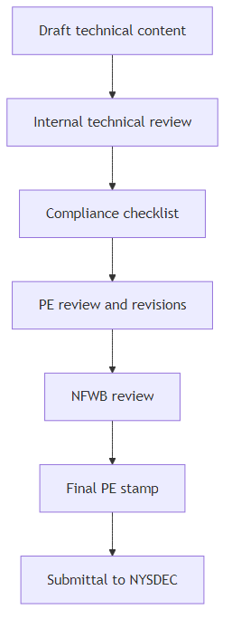
Figure 4: Internal quality and compliance review process for PE-stamped deliverables

Phase 1 SSES Technical Approach and Scope of Services
Our Phase 1 SSES approach is structured into clear tasks that align with the RFP requirements and NFWB’s Order on Consent milestones. We will perform a comprehensive investigation of the 91st & Luick and 81st & Frontier 1 sewersheds, including data review, field investigations (smoke testing, nighttime flow isolation and weiring, CCTV and manhole inspections, focused SSES activities), outfall/SSO assessment, engineering analysis and corrective action planning, and post-construction monitoring and reporting.

Phase 1 Tasks and Scope Summary
Task | Objective | Key Activities | Primary Deliverables
Task 1 – Project initiation and data review | Confirm scope and gain understanding of LaSalle sewersheds. | Kickoff meeting, review Order on Consent, prior reports, CCTV, manhole, SCADA, and NYSDEC correspondence. | Kickoff meeting notes, data gap assessment, refined work plan.
Task 2 – Smoke testing | Identify inflow sources such as cross-connections and illicit connections. | Plan test areas, notifications, field smoke testing, defect logging with photos and GIS coordinates. | Smoke testing field logs, GIS feature classes, summary memo.
Task 3 – Nighttime flow isolation and weiring | Quantify groundwater I&I by sewer reach. | Select weir locations, perform nighttime isolation, measure flows, calculate gpd/lf. | Weir measurement database, summary figures, infiltration rates by reach.
Task 4 – CCTV and manhole assessment | Assess structural and maintenance defects and confirm I&I sources. | Review existing PACP data, coordinate additional CCTV by NFWB crews, update condition ratings. | Updated PACP database, defect summaries, rehabilitation candidates.
Task 5 – Outfall/SSO assessment | Characterize performance of 91st & Luick and 81st & Frontier 1 outfalls. | Develop and execute Work Plan, monitor flows, document conditions. | Outfall assessment technical memo and GIS-compatible data.
Task 6 – Focused SSES (contingency) | Investigate specific I&I sources using targeted methods. | Dye testing, house inspections, targeted CCTV using $10,000 contingency upon NFWB approval. | Focused SSES logs, findings, and recommendations.
Task 7 – Engineering analysis and SSES report | Develop corrective action plan and PE-stamped SSES report. | Integrate data, evaluate alternatives, develop budgetary costs and schedule. | Phase 1 SSES Engineering Report and corrective action plan.
Task 8 – Post-construction monitoring and reporting | Document I&I reduction following construction. | Flow and rainfall monitoring, data normalization, cost-effectiveness analysis. | Post-Construction I&I Assessment and Cost Analysis Report.
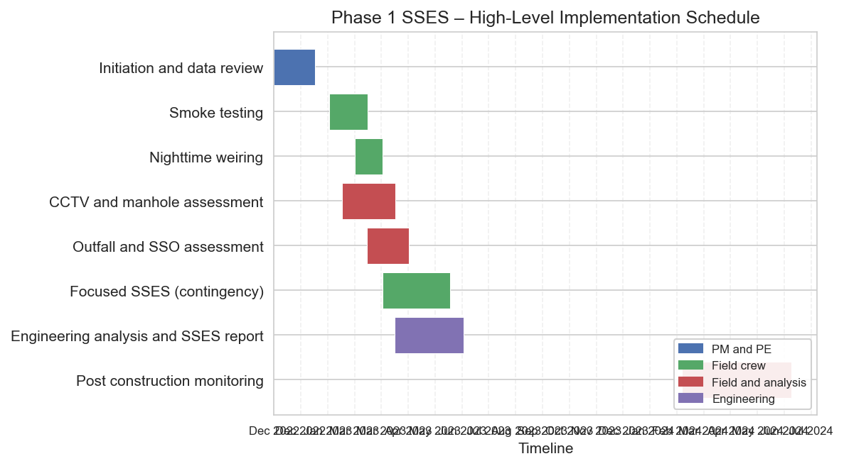
Figure 5: High-level implementation schedule for Phase 1 SSES

Data Review, Existing Information Assessment, and System Familiarization
Aurelia will begin Phase 1 with a structured data review and system familiarization process. We will compile and review all available information, including the Order on Consent, prior engineering reports, NYSDEC correspondence, existing CCTV and manhole inspection data (NASSCO PACP), SCADA data for lift stations, and any previous I&I studies in the LaSalle sewersheds. This review will identify data gaps and inform the targeting of field investigations.
We will hold a kickoff and technical workshops with NFWB staff to discuss system history, operational practices (including wet-weather operation of lift stations), known problem areas, and candidate locations for flow isolation and weiring. Our team will use GIS to integrate available mapping, asset data, and field results to support efficient planning and clear communication with NFWB and NYSDEC.

Existing Data Inventory and Intended Use
Data Type | Source | Intended Use in Analysis
Order on Consent and NYSDEC correspondence | NFWB / NYSDEC | Define regulatory drivers, milestones, and required reporting content.
System mapping and GIS data | NFWB | Define sewershed boundaries, asset locations, and connectivity for analysis and mapping.
CCTV inspection reports and videos (PACP) | NFWB / prior consultants | Assess structural and O&M defects, confirm I&I sources, prioritize rehabilitation.
Manhole inspection data | NFWB / prior consultants | Identify defects such as inflow sources, frame and cover issues, and groundwater infiltration.
SCADA data for lift stations | NFWB | Understand wet-weather operations, pump run times, and system response to storms.
Flow monitoring and rainfall data | NFWB / third-party meters | Quantify RDII, calibrate I&I models, and support pre- and post-construction comparisons.

Smoke Testing Plan and Methodology
Smoke testing is a core component of the Phase 1 SSES and will be used to identify direct inflow sources such as cross-connections, defective cleanouts, roof and yard drains, and other illicit connections. Aurelia will provide all staff, equipment, and materials necessary to perform smoke testing in the 91st & Luick and 81st & Frontier 1 sewersheds, in coordination with NFWB.
We will select test areas based on sewershed hydraulics, known SSO locations, and existing data. Testing will be conducted under dry weather conditions with advance resident notifications (2–4 days), coordination with local police and fire departments, and clear public information materials. Field crews will document each observed defect with photographs, GPS coordinates, and standardized defect codes, and will enter results into a GIS database for use in the engineering analysis.

Smoke Testing Procedures and Controls
Step | Description | Key Controls
Planning | Define test areas and schedule based on sewershed hydraulics and weather. | Confirm dry weather window, coordinate with NFWB operations.
Public notification | Distribute door hangers and public notices 2–4 days in advance. | Use clear messaging, provide NFWB contact, document addresses notified.
Agency coordination | Notify police, fire, and other stakeholders prior to testing. | Provide maps and schedule, maintain contact list in field vehicles.
Field setup | Stage blowers, smoke, and safety equipment. | Conduct tailgate safety briefing, verify PPE, review confined space procedures as applicable.
Testing | Introduce smoke into mains and observe emergence points. | Document each observation with photo, GPS, and standardized defect code.
Data entry | Upload field logs and photos to GIS database. | QA/QC by supervisor, cross-check with mapping and address lists.

Night-Time Flow Isolation and Measurement (Weiring) Approach
Nighttime flow isolation and weiring will be used to quantify groundwater infiltration in gallons per day per linear foot (gpd/lf) for key sewer reaches. Aurelia will review prior flow data and system configuration to select weir locations that allow effective isolation of subareas, while maintaining safe operations and access.
Our field teams will provide all necessary staff, equipment, traffic control, and confined space entry capabilities to perform nighttime measurements. We will coordinate with NFWB on resident notifications where nighttime work may affect access or create visible activity. Flow measurements will be recorded at high temporal resolution and analyzed to compute infiltration rates by reach, supporting prioritization of rehabilitation measures.

Conceptual Candidate Weir Location Criteria
Location Type | Selection Criteria | Constraints
Upstream subarea manhole | Isolates a discrete subcatchment, accessible for nighttime work. | Traffic control requirements, depth and confined space entry limitations.
Downstream trunk manhole | Aggregates flows from multiple upstream reaches for screening. | Hydraulic grade line, risk of surcharge during unexpected storms.
Near SSO location | Directly relates infiltration to observed SSO performance. | Proximity to residences and noise/light considerations.

CCTV, Manhole, and Focused SSES Activities (Dye Testing, House Inspections)
Aurelia will review all existing CCTV and manhole inspection data, including NASSCO PACP condition coding, to understand structural condition and potential I&I sources. We will coordinate with NFWB to prioritize additional CCTV work to be performed by NFWB crews, focusing on reaches with high infiltration or incomplete data.
Focused SSES activities such as dye testing and house inspections will be used selectively where data indicate likely private inflow sources or complex connectivity. These activities will be funded from the $10,000 contingency only upon NFWB approval, with clear documentation of scope, cost, and findings for each authorization.

NASSCO PACP Condition Grades and Recommended Actions (Summary)
PACP Grade | Condition Description | Typical Recommended Action
1–2 | Minor defects, low risk of failure. | Routine maintenance, monitor in future inspections.
3 | Moderate defects, potential for future issues. | Plan rehabilitation within program horizon, coordinate with other work.
4 | Significant defects, likely structural or I&I issues. | Prioritize rehabilitation or replacement in near term.
5 | Severe defects, imminent failure or major I&I. | Immediate repair or replacement, potential emergency response.

Outfall/SSO Condition Assessment for 91st & Luick and 81st & Frontier 1
The two Phase 1 outfalls at 91st & Luick and 81st & Frontier 1 are focal points for LaSalle SSOs and will be assessed in detail. Aurelia will develop a site-specific Outfall and SSO Assessment Work Plan, including review of existing data, site visits, and potential deployment of meters, gauges, dye testing, and CCTV in coordination with NFWB crews.
Assessment activities will be documented in GIS-compatible formats, including photographs, condition ratings, and flow monitoring results. We will develop recommendations to reduce extraneous flows and improve performance at each outfall, coordinated with upstream SSES findings and proposed corrective actions.

Phase 1 Outfall Assessment Summary
Outfall | Existing Issues (Illustrative) | Assessment Techniques | Expected Outputs
91st & Luick | Wet-weather SSOs, surcharging, evidence of high RDII. | Flow monitoring, dye testing, CCTV of connecting sewers, site inspections. | Quantified wet-weather performance, identification of key inflow sources.
81st & Frontier 1 | SSOs during moderate to large storms, limited storage. | Level/flow monitoring, SCADA data review, CCTV, site inspections. | Performance curves, recommended storage or conveyance improvements.

Phase 1 Engineering Analysis, Corrective Action Planning, and SSES Report
Aurelia will integrate all Phase 1 data—including smoke testing, nighttime weiring, CCTV and manhole inspections, outfall assessments, and focused SSES results—into a coherent engineering analysis. We will quantify RDII contributions by subarea, identify root causes of SSOs, and develop a prioritized corrective action plan that maximizes I&I reduction per dollar invested.
For each candidate corrective action (e.g., cured-in-place lining, point repairs, manhole rehabilitation, targeted inflow removal, outfall modifications), we will estimate I&I reduction, capital cost, constructability considerations, and schedule implications. Alternatives will be evaluated using transparent criteria and documented in the Phase 1 SSES Engineering Report, which will be structured to the NYS Engineering Report Outline and stamped by a New York State licensed Professional Engineer.

Corrective Action Alternatives Evaluation (Excerpt)
Alternative | Primary Application | Relative Effectiveness | Relative Cost | Typical Use in LaSalle
CIPP lining | Long segments with multiple defects and high infiltration. | High | High | Targeted trunk and collector sewers with Grade 4–5 defects.
Point repairs | Isolated structural defects. | Moderate | Moderate | Specific joints or cracks identified on CCTV.
Manhole rehabilitation | Leaking frames, covers, and walls. | Moderate | Low to Moderate | High groundwater areas with defective manholes.
Private inflow removal | Roof drains, yard drains, cross-connections. | High | Variable | Residential areas with significant smoke testing defects.

Post-Construction Monitoring and I&I Reduction Assessment
Following construction of Phase 1 improvements in 2023–early 2024, Aurelia will conduct post-construction monitoring to quantify I&I reduction and confirm that SSOs have been effectively mitigated. Monitoring will include flow and rainfall data collection at key locations within the 91st & Luick and 81st & Frontier 1 sewersheds, with data normalized for rainfall and seasonal conditions.
We will compare pre- and post-construction flow metrics (e.g., base infiltration, RDII volume, peak wet-weather flows) and calculate cost per gallon of I&I removed for major corrective action categories. Results will be summarized in the Post-Construction I&I Assessment and Cost Analysis Report for NYSDEC, including identification of the most effective techniques to inform Phases 2 and 3.

Illustrative Pre- and Post-Construction Flow Metrics (Conceptual)
Metric | Pre-Construction | Post-Construction | Change
Average dry-weather base infiltration (MGD) | 2.0 | 1.2 | 40% reduction
RDII volume for 1-inch storm (MG) | 10.0 | 5.5 | 45% reduction
Peak flow at 91st & Luick (MGD) | 16.0 | 9.5 | 40% reduction
Number of SSOs per year | 6 | 0–1 | Substantial reduction

Options for Phase 2 and Phase 3 SSES (Scope, Schedule, and Fees)
In addition to the base Phase 1 scope, Aurelia proposes optional services for Phase 2 (81st & Frontier 2 and 80th & Lindbergh sewersheds) and Phase 3 (Mang & 88th sewershed). Both options leverage the methods, tools, and lessons learned from Phase 1 to provide a consistent, efficient multi-phase program for NFWB.
Option 1 (Phase 2) includes all applicable SSES tasks except outfall/SSO assessment, as no outfall locations are identified in the RFP for Phase 2. Option 2 (Phase 3) includes all applicable SSES tasks, including outfall/SSO assessment for one outfall. For each option, we will provide a detailed scope, schedule aligned with NFWB’s overall LaSalle program, and not-to-exceed fees with task/hour estimate matrices.

Phase 1, Phase 2, and Phase 3 Scope Comparison
Element | Phase 1 | Phase 2 (Option 1) | Phase 3 (Option 2)
Sewersheds | 91st & Luick; 81st & Frontier 1 | 81st & Frontier 2; 80th & Lindbergh | Mang & 88th
Smoke testing | Included | Included | Included
Nighttime weiring | Included | Included | Included
CCTV and manhole review | Included | Included | Included
Outfall/SSO assessment | Two outfalls | Not applicable | One outfall
Focused SSES contingency | $10,000 | Similar contingency proposed | Similar contingency proposed

Project Management, Governance, and Communication Plan
Aurelia will designate a Project Manager (PM) as the primary point of contact for NFWB. The PM will be responsible for overall coordination, schedule and budget management, risk management, and communication with NFWB and NYSDEC. Our project governance model follows Aurelia’s Initiate–Discover–Design–Build–Deploy–Operate lifecycle, with clearly defined stage gates and decision points.
We will attend the mandatory pre-proposal information session, submit any questions through the authorized contact by the stated deadline, and acknowledge all addenda in Appendix E Form No. 1. If selected, we are prepared to participate in interviews or presentations with NFWB staff or the Board to discuss our concepts and methods.

Project Organization and Key Roles
Role | Primary Responsibilities | Representative Individual
Project Manager | Primary contact, schedule and budget management, coordination with NFWB and NYSDEC. | Senior civil engineer with SSES program experience.
Lead PE | Technical oversight, Engineering Report authorship, PE stamping. | New York licensed professional engineer.
I&I / Hydraulics Specialist | Flow and rainfall analysis, RDII quantification, alternatives evaluation. | Senior hydraulic engineer.
Field Operations Lead | Manage smoke testing, weiring, and focused SSES crews. | Field supervisor with SSES experience.
GIS / Data Analyst | Data integration, mapping, dashboards, and reporting. | GIS and data specialist.

Communication and Meeting Plan
Meeting / Communication | Frequency | Participants | Purpose
Project kickoff | Once at project start | NFWB, Aurelia PM and Lead PE | Confirm scope, schedule, roles, and communication protocols.
Biweekly progress meetings | Every two weeks during active work | NFWB project team, Aurelia PM and task leads | Review progress, risks, and upcoming activities.
Technical workshops | At key milestones | Subject matter experts from NFWB and Aurelia | Review findings, alternatives, and recommendations.
NYSDEC coordination calls | As needed at major milestones | NFWB, Aurelia PM/Lead PE, NYSDEC staff | Align on expectations, discuss report content and schedule.

Schedule, Level of Effort, and Budget (Including Contingency)
Our schedule is designed to deliver the Phase 1 SSES report in time for NYSDEC review in early 2023, supporting construction of recommended improvements in 2023–early 2024 and post-construction monitoring completed by June 2024. We will provide detailed bar chart schedules and task/hour estimate matrices as part of the final proposal package.
Fees will be proposed on a not-to-exceed basis, with a clearly defined $10,000 contingency for Task 6 focused SSES activities, to be used only upon NFWB approval. We will provide monthly invoices with supporting documentation and accept the Water Board’s 60-day payment terms. Our pricing will exclude sales tax in recognition of NFWB’s tax-exempt status.

Illustrative Task and Level of Effort Matrix (Phase 1)
Task | PM Hours | PE / Engineer Hours | Field Crew Hours | GIS / Analyst Hours
Task 1 – Initiation and data review | 40 | 80 | 0 | 40
Task 2 – Smoke testing | 24 | 40 | 240 | 24
Task 3 – Nighttime weiring | 24 | 40 | 200 | 24
Task 4 – CCTV and manhole assessment | 24 | 80 | 80 | 40
Task 5 – Outfall/SSO assessment | 16 | 40 | 80 | 24
Task 6 – Focused SSES (contingency) | 16 | 40 | 120 | 16
Task 7 – Engineering analysis and SSES report | 40 | 160 | 0 | 80
Task 8 – Post-construction monitoring | 32 | 80 | 80 | 40

Team Qualifications, Experience, and Staffing Plan
Aurelia Digital Systems is a privately held engineering and technology firm founded in 2016 with more than 120 professionals across Canada and the United States. Our team includes civil and environmental engineers, data and analytics specialists, project managers, and field staff experienced in SSES, I&I reduction programs, and public sector infrastructure projects.
We will provide a comprehensive statement of qualifications including our business structure, licensing, years in business, similar project experience with references, and details for any subcontractors performing more than 10 percent of the work. Key project professionals will be identified by name, with resumes included in the Appendices.

Key Personnel Qualifications (Summary)
Role | Education / Licenses | Relevant Experience | Representative Responsibilities
Project Manager | B.S. Civil Engineering, NYS PE | 15+ years managing SSES and I&I reduction programs for municipal clients. | Overall project management, client coordination, schedule and budget control.
Lead PE | M.S. Environmental Engineering, NYS PE | 20+ years wastewater and collection system design and planning. | Technical oversight, Engineering Report authorship, PE stamping.
I&I / Hydraulics Specialist | B.S. Civil Engineering | 10+ years flow monitoring and RDII analysis. | Flow and rainfall analysis, I&I quantification, alternatives evaluation.
Field Operations Lead | Associate degree, relevant certifications | 15+ years field supervision for SSES programs. | Manage smoke testing, weiring, and focused SSES crews.

MWBE and SDVOB Participation Strategy
Aurelia is committed to meeting or exceeding the RFP’s MWBE (30 percent combined) and SDVOB (6 percent) participation goals. We will partner with certified MWBE and SDVOB firms for specific scope elements such as field investigations, survey support, public outreach, and drafting. Utilization plans and, if necessary, waiver requests will be submitted with the proposal in accordance with Appendix F requirements.
We will track MWBE and SDVOB participation on a monthly basis and submit Workforce Employment Utilization Reports and MWBE-SDVOB reports as required. Our internal systems will align purchase orders, subcontractor invoices, and utilization reporting to provide NFWB with transparent, auditable records.

MWBE and SDVOB Utilization Plan (Conceptual)
Firm Type | Scope of Work | Approximate Share of Contract Value | Reporting Approach
Prime (Aurelia) | Project management, engineering analysis, reporting, data and GIS. | 60–65% | Track internal labor and expenses by task and phase.
MWBE subconsultant(s) | Field investigations, public outreach, drafting support. | 25–30% | Monthly utilization reports aligned to Appendix F requirements.
SDVOB subconsultant(s) | Specialty field services or analysis support. | 6–10% | Monthly utilization reports and workforce reporting as applicable.

Health, Safety, and Site-Specific Risk Management
Field activities for this project involve confined space entry, traffic control, nighttime work, and work near active sewers and outfalls. Aurelia maintains a comprehensive Safety Program and will prepare Site-Specific Health & Safety Plans (SSHSPs) for Phase 1 activities, addressing hazard identification, procedures, personal protective equipment (PPE), OSHA training, and monitoring requirements.
All field staff will hold required training and certifications, including confined space entry, traffic control, and first aid/CPR as applicable. Daily tailgate safety briefings will be conducted before field work, and safety performance will be reviewed regularly with NFWB. We will comply with all OSHA regulations and NFWB safety requirements.

Health and Safety Responsibilities by Role
Role | Key Safety Responsibilities | Example Activities
Project Manager | Overall safety oversight, ensure SSHSP implementation. | Review safety metrics, participate in incident reviews.
Field Operations Lead | Daily safety briefings, field supervision, stop-work authority. | Conduct tailgate talks, verify PPE, monitor conditions.
Field Crew Members | Follow SSHSP, report hazards, use PPE properly. | Inspect equipment, maintain safe work zones.

Security, Data Management, and Information Governance
Aurelia will manage all project data—including CCTV files, inspection databases, flow and rainfall data, GIS layers, and reports—in a secure, access-controlled environment. Data will be stored on encrypted platforms with role-based access, and transfers to NFWB will use secure methods. We will comply with NYS information security breach notification laws and any additional NFWB requirements.
We will maintain project records for at least six years after the calendar year in which they are created, and will support inspection and audit by the State Comptroller, Attorney General, and NFWB as required. FOIL-sensitive information will be clearly identified and handled in accordance with applicable law.

Data Categories, Security Controls, and Retention
Data Category | Security Controls | Typical Retention | FOIL Considerations
CCTV and inspection data | Encrypted storage, role-based access, secure file transfer. | Minimum six years after calendar year created. | May contain sensitive infrastructure details; mark as critical infrastructure information where applicable.
Flow and rainfall data | Controlled access, integrity checks. | Minimum six years after calendar year created. | Generally releasable; consider aggregation for public release.
Engineering analyses and reports | Version control, restricted editing rights. | Minimum six years after calendar year created. | Subject to FOIL; identify confidential business information as needed.

Commercial Terms, Insurance, and Legal Compliance
Aurelia accepts the Water Board’s general RFP conditions, including the Board’s rights to reject, modify, negotiate, and award; the requirement that proposals remain firm and irrevocable for 90 days; and the termination, governing law, venue, service of process, and non-waiver clauses in Appendix E.
We will procure and maintain required insurance coverages, including workers compensation, disability, employer’s liability, commercial general liability, automobile, umbrella/excess, and professional liability insurance, with limits meeting or exceeding RFP requirements. NFWB, the Niagara Falls Public Water Authority, and the City of Niagara Falls will be named as additional insureds, and certificates and endorsements will be provided with 30 days’ notice of change or cancellation.
Aurelia will comply with non-discrimination and sexual harassment prevention requirements, NYS Lobbying Law, non-collusion requirements, the Iran Divestment Act, International Boycott Prohibition, MacBride Fair Employment Principles, and prohibitions on the purchase of tropical hardwoods, as applicable. Required forms and certifications (Appendix E and Appendix F) will be completed and submitted with the proposal.

Insurance Coverage Summary
Coverage Type | Indicative Limit | Notes
Workers compensation and disability | As required by law | Statutory coverage for all employees.
Employer’s liability | $1,000,000 per accident | Covers employer liability for workplace injuries.
Commercial general liability | $1,000,000 per occurrence / $2,000,000 aggregate | NFWB and related entities named as additional insureds.
Automobile liability | $1,000,000 combined single limit | Covers owned, hired, and non-owned vehicles.
Umbrella / excess liability | $2,000,000 aggregate or greater | Provides additional limits above primary policies.
Professional liability (errors and omissions) | $2,000,000 per claim | Covers professional engineering services.

Administrative Requirements and Proposal Submission Plan
Aurelia will comply with all administrative instructions in the RFP. We will attend the mandatory pre-proposal information session at the Wastewater Treatment Plant on November 29, 2022 at noon, submit any written questions to the authorized Water Board contact by November 30, 2022 at 3:00 p.m., and acknowledge all addenda on Appendix E Form No. 1.
Our proposal package will include one clearly marked original and six copies, plus one electronic copy on CD or USB in a single PDF or clearly ordered files. Original signed appendices will be included only in the paper original. The outer envelope will be sealed and labeled with the contact name, proposer information, and RFP number and title. Any exceptions to RFP terms will be identified in a separate attachment titled “Exceptions”; unlisted exceptions will be deemed waived.

Proposal Submission Checklist
Item | Description | Included
Original proposal | One signed original with all required forms and appendices. | Yes
Proposal copies | Six paper copies of the proposal. | Yes
Electronic copy | One CD or USB with a single PDF or clearly ordered files. | Yes
Appendix E forms | All required standard terms, certifications, and acknowledgments. | Yes
Appendix F forms | EEO Staffing Plan, Workforce Employment Utilization Report, MWBE/SDVOB plans. | Yes
Exceptions attachment | Separate document titled “Exceptions” (if any). | If applicable

Required Forms and Certifications (Appendix E & F)
We understand that complete and accurate submission of all required forms and certifications is a condition of responsiveness. Aurelia will complete all Appendix E forms (Standard Terms, Conditions, and Requirements), including the EEO Policy Statement, Statement on Sexual Harassment, Certificate of Non-Collusion, and Lobbying Law Disclosure Statement, as well as any other required certifications.
We will also complete Appendix F forms related to Mandatory State Financial Assistance Terms and Conditions, including the EEO Staffing Plan, Workforce Employment Utilization Report, and MWBE and SDVOB utilization plans or waiver requests. These documents will be organized in the proposal to facilitate NFWB review.

Forms and Certifications Tracking
Form / Certification | Appendix | Responsible Party | Status at Submission
Standard Terms, Conditions, and Requirements (Form No. 1) | Appendix E | Aurelia contracts lead | Completed and signed
Certificate of Non-Collusion (Form No. 2) | Appendix E | Aurelia authorized signatory | Completed and signed
Lobbying Law Disclosure (Form No. 3) | Appendix E | Aurelia contracts lead | Completed and signed
EEO Policy Statement (Form No. 4) | Appendix E | Aurelia HR lead | Completed and signed
Statement on Sexual Harassment (Form No. 5) | Appendix E | Aurelia HR lead | Completed and signed
EEO Staffing Plan | Appendix F | Aurelia HR and PM | Completed and included
Workforce Employment Utilization Report | Appendix F | Aurelia HR and PM | Template prepared; to be updated during contract.
MWBE/SDVOB Utilization Plan or Waiver Request | Appendix F | Aurelia PM and MWBE coordinator | Completed and included

Appendices: Detailed Resumes, Reference Projects, and Supporting Materials
The appendices to this proposal will include detailed resumes of key staff, expanded descriptions of relevant reference projects, letters of commitment from any subconsultants, and additional technical materials supporting our approach. These materials will demonstrate Aurelia’s and our partners’ qualifications to successfully deliver the Phase 1 SSES, Engineering Report, corrective action plan, and post-construction monitoring, as well as optional Phases 2 and 3.

Representative Reference Projects (Summary)
Client | Project Description | Year(s) | Relevance to NFWB SSES
Regional wastewater authority | Multi-phase SSES and I&I reduction program with flow monitoring, smoke testing, and rehabilitation planning. | 2019–2022 | Demonstrates experience with phased SSES programs and regulatory reporting.
Mid-sized city utility | Collection system master plan including RDII analysis and capital improvement prioritization. | 2018–2021 | Experience integrating flow, rainfall, and inspection data for capital planning.
Water and sewer district | Targeted SSES and corrective action plan for SSO-prone basin. | 2020–2022 | Directly relevant to addressing chronic SSOs through data-driven I&I reduction.

