Proposal for Phase 1 Sanitary Sewer Evaluation Survey
LaSalle Area Sewersheds
Submitted to: Niagara Falls Water Board
Submitted by: Aurelia Digital Systems
Internal | Confidential

Executive Summary
Aurelia Digital Systems is pleased to submit this proposal to provide professional engineering services for the Phase 1 Sanitary Sewer Evaluation Survey (SSES) in the LaSalle area sewersheds of Niagara Falls. We understand that the Niagara Falls Water Board (NFWB) must complete an SSES and implement corrective actions that are acceptable to the New York State Department of Environmental Conservation (NYSDEC) under the existing Order on Consent, and that timely, defensible results are essential to enable construction of improvements in 2023–early 2024 and post-construction monitoring by June 2024.
Our team combines deep wastewater infrastructure expertise with rigorous data and analytics capabilities. We will execute a focused, standards-compliant SSES for the Phase 1 sewersheds (91st and Luick; 81st and Frontier 1), develop an engineering report and corrective action plan that align with the NYSDEC Engineering Report Outline dated October 1, 2022, and conduct post-construction monitoring and performance evaluation. We also provide clearly defined option scopes, schedules, and fees for Phases 2 and 3 to support a programmatic approach to LaSalle SSO abatement.
Key outcomes of our proposed engagement include:
- A complete Phase 1 SSES that identifies and quantifies inflow and infiltration (I&I) sources using smoke testing, night-time flow isolation and weiring, CCTV and manhole data review, and focused field investigations.
- An Engineering Report and Corrective Action Plan stamped by a New York State licensed Professional Engineer, suitable for NYSDEC submission and consistent with Order on Consent requirements and the October 1, 2022 Engineering Report Outline.
- A prioritized, cost-effective capital improvement and operational program with budgetary cost estimates, implementation timelines, and clear linkage to I&I reduction targets and SSO risk reduction.
- Post-construction I&I performance assessment and cost-effectiveness analysis documenting realized flow reductions and most effective techniques, meeting NYSDEC and Environmental Facilities Corporation (EFC) expectations.
- Optional Phase 2 and Phase 3 SSES services, aligned to the same technical standards and management framework, to address the 81st and Frontier 2, 80th and Lindbergh, and Mang and 88th sewersheds.
Aurelia will assign a dedicated Project Manager as the single point of contact for NFWB and NYSDEC coordination, supported by senior wastewater engineers and data specialists. Our delivery model emphasizes transparent communication, safety, regulatory compliance, and measurable performance. We are committed to meeting all mandatory requirements of the RFP, including MWBE/SDVOB participation goals, EEO and reporting obligations, insurance and indemnification provisions, and all Appendix E certifications.

Understanding of Requirements and LaSalle Context
NFWB is implementing a multi-phase sanitary sewer evaluation and abatement program for the LaSalle area sewersheds to reduce I&I and sanitary sewer overflows (SSOs) in accordance with an Order on Consent with NYSDEC. Phase 1 focuses on the 91st and Luick and 81st and Frontier 1 sewersheds, with subsequent phases addressing 81st and Frontier 2, 80th and Lindbergh, and Mang and 88th. The program must conform to NYSDEC and EFC requirements, including the Engineering Report Outline for New York State Wastewater Infrastructure Projects dated October 1, 2022 and the Mandatory State Financial Assistance Terms and Conditions.
The LaSalle area has a history of wet-weather SSOs driven by excessive I&I, legacy infrastructure, and complex interactions between gravity sewers, force mains, and SCADA-controlled lift stations. NFWB has already undertaken targeted I&I reduction projects and CCTV inspections, and has accumulated a significant body of data, including manhole inspections and prior flow monitoring. The Phase 1–3 SSES effort must leverage this existing information, fill critical data gaps, and provide a defensible basis for prioritizing capital and operational improvements.
We recognize that success will be evaluated not only on technical quality, but also on our ability to: (1) meet aggressive schedule milestones so that construction can be completed in 2023–early 2024 with post-construction monitoring by June 2024; (2) deliver reports and corrective action plans fully acceptable to NYSDEC; (3) manage public communication and safety during field activities; and (4) comply with all contractual, financial, and MWBE/SDVOB participation requirements.
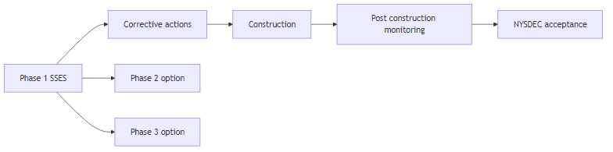
Figure 1: LaSalle SSES and abatement program overview

Project Approach and Scope of Services
Our approach is organized around clearly defined tasks that map directly to the RFP requirements and the NYSDEC Engineering Report Outline. We combine proven field methods for SSES with strong data management, GIS integration, and transparent coordination with NFWB and NYSDEC.

Task 1 – Project Initiation, Data Review, and Planning
Upon notice to proceed, we will confirm scope, roles, and communication protocols. Our Project Manager will serve as the dedicated primary contact for NFWB and NYSDEC, responsible for overall coordination, schedule, budget, and quality (REQ-004, REQ-007, REQ-008, REQ-039, REQ-053, REQ-057).
- Conduct a kickoff meeting with NFWB staff to review objectives, success metrics, safety expectations, MWBE/SDVOB utilization plans, and reporting requirements.
- Review existing data, including the Order on Consent, NYSDEC correspondence, prior SSES work, CCTV and manhole inspection reports, SCADA data, and historical I&I reduction projects for the LaSalle sewersheds (REQ-005, REQ-006, REQ-016, REQ-028).
- Develop a detailed Field Work Plan and Site-Specific Health and Safety Plan covering smoke testing, night-time weiring, confined space entry, traffic control, and public notification, consistent with OSHA and NFWB requirements (REQ-013, REQ-056).
- Confirm MWBE and SDVOB utilization plans and roles for any subconsultants, ensuring alignment with the 30 percent MWBE and 6 percent SDVOB goals and Appendix F requirements (REQ-042, REQ-043, REQ-044, REQ-045).

Task 2 – Smoke Testing in Phase 1 Sewersheds
We will perform smoke testing in the 91st and Luick and 81st and Frontier 1 sewersheds to identify direct inflow sources such as roof leaders, yard drains, and cross-connections (REQ-001, REQ-009, REQ-011).
- Prepare and distribute hand-delivered door hangers to residents 2–4 days before testing, assist NFWB with press releases, and coordinate with police and fire departments to ensure awareness and safety (REQ-010).
- Conduct smoke testing only under suitable weather and system conditions, documenting and photographing all observed defects, with locations logged in a GIS-compatible database (REQ-011, REQ-020).
- Provide all staff, equipment, and materials required for smoke testing, including traffic control where needed (REQ-009, REQ-013, REQ-053, REQ-056).

Task 3 – Night-time Flow Isolation and Weiring
We will perform night-time flow isolation and weiring to quantify base sanitary flow and groundwater infiltration by sewer reach, ensuring sufficient data density for accurate I&I analysis (REQ-012, REQ-015).
- Review prior flow monitoring data and SCADA records to identify candidate weir locations, then confirm final locations with NFWB staff (REQ-007, REQ-012).
- Provide trained crews with confined space entry credentials, gas monitoring, ventilation, and traffic control equipment to safely install and monitor weirs (REQ-013, REQ-053, REQ-056).
- Notify residents 2–4 days in advance of disruptive night work with door hangers and support NFWB in preparing press releases (REQ-014).
- Analyze weiring data to compute infiltration rates in gallons per day per linear foot of sewer main for each section, integrating results with GIS and CCTV findings (REQ-015, REQ-020).

Task 4 – CCTV, Manhole Data Integration, and Focused SSES
We will leverage NFWB-provided CCTV and manhole inspection data, supplemented by additional focused investigations where necessary, to pinpoint structural and connection-related I&I sources (REQ-016, REQ-017, REQ-021).
- Review NASSCO PACP-coded CCTV and manhole inspection reports, confirm repairs performed since inspections, and request supplemental CCTV from NFWB crews where gaps exist (REQ-016, REQ-017).
- Conduct targeted dye testing, house inspections, and additional CCTV in areas with high inferred I&I or uncertain conditions, using the Task 6 contingency only with NFWB approval (REQ-021, REQ-022).

Task 5 – Outfall and SSO Condition Assessment
For the two Phase 1 outfalls at 91st and Luick and 81st and Frontier 1, we will conduct Outfall and SSO condition assessments to understand hydraulic performance, backwater effects, and extraneous flow contributions (REQ-018, REQ-019, REQ-020).
- Review existing information for each outfall, including as-built drawings, prior inspection reports, and SSO event history (REQ-018, REQ-028).
- Develop an Outfall Assessment Work Plan that may include temporary flow meters, rain gauges, confined space entry, dye testing, and coordinated CCTV inspections, to be executed upon NFWB authorization (REQ-018, REQ-019).
- Document findings in GIS-compatible format and prepare recommendations to reduce extraneous flows entering the collection system (REQ-020).

Task 6 – Engineering Report, Corrective Action Plan, and Contingency
We will synthesize all SSES findings into a Phase 1 Engineering Report and Corrective Action Plan that complies with NYSDEC and EFC requirements and is suitable for submission to NYSDEC (REQ-003, REQ-023, REQ-024, REQ-026, REQ-029).
- Prepare the Phase 1 SSES report in accordance with the October 1, 2022 Engineering Report Outline for New York State Wastewater Infrastructure Projects, including problem definition, alternatives evaluation, recommended plan, implementation schedule, and financing considerations (REQ-003, REQ-023, REQ-024, REQ-029).
- Develop a Corrective Action Plan that prioritizes the most cost-effective flow reduction measures, with budgetary cost estimates and implementation timelines sufficient to support construction in 2023–early 2024 (REQ-023, REQ-025).
- Ensure the report is prepared, stamped, and dated by a New York State licensed Professional Engineer, and that it is coordinated with NYSDEC staff to confirm acceptability (REQ-023, REQ-024, REQ-026, REQ-008).
- Maintain a $10,000 contingency within Task 6 for focused SSES or other necessary work, to be expended only with NFWB approval (REQ-022).

Task 7 – Post-construction Monitoring and I&I Assessment
Following completion of Phase 1 corrective actions, we will conduct post-construction monitoring in 2024 (assuming 2023 construction) to quantify I&I reductions and assess the effectiveness of implemented measures (REQ-027).
- Design and implement pre- and post-construction flow and rainfall monitoring programs, leveraging existing SCADA data where appropriate (REQ-027).
- Prepare a Post-Construction I&I Assessment and Cost Analysis Report documenting realized I&I reductions, cost-effectiveness of measures, and recommendations for future phases (REQ-027, REQ-029).

Optional Tasks – Phase 2 and Phase 3 SSES
We propose optional scopes for Phase 2 (81st and Frontier 2; 80th and Lindbergh) and Phase 3 (Mang and 88th), aligned to the Phase 1 methodology (REQ-002, REQ-036, REQ-037).
- Option 1 – Phase 2: Perform all applicable Phase 1 tasks except the Outfall and SSO assessment (Task 5) in the 81st and Frontier 2 and 80th and Lindbergh sewersheds, with a tailored schedule to follow Phase 1 while leveraging shared mobilization and data management (REQ-036).
- Option 2 – Phase 3: Perform all applicable Phase 1 tasks, including an Outfall and SSO assessment for the Mang and 88th sewershed outfall, with a schedule that aligns with Phase 2 and overall Order on Consent milestones (REQ-037).
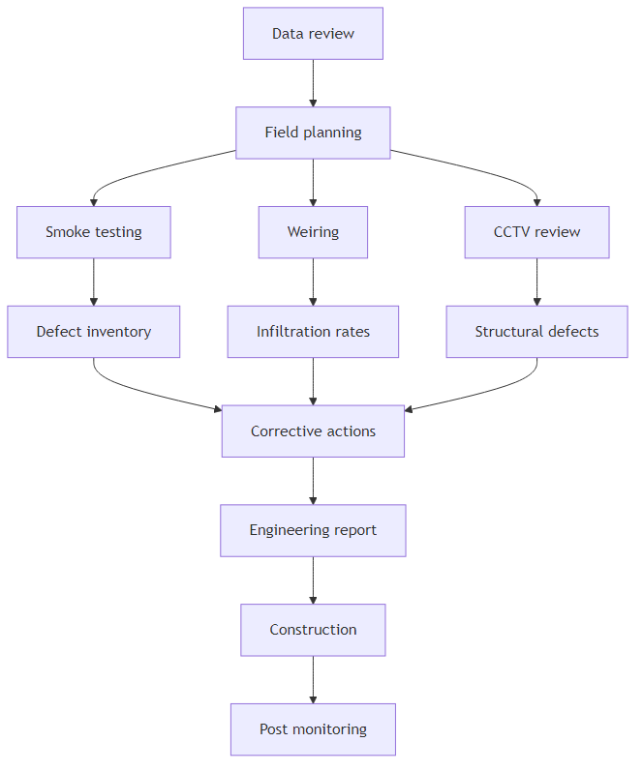
Figure 2: End-to-end SSES workflow and reporting

Technical Solution and Data Management
Our technical solution integrates field investigations, hydraulic and I&I analysis, GIS, and structured reporting. Aurelia brings strong capabilities in data engineering, analytics, and secure information management, which we apply to wastewater infrastructure projects to improve traceability and decision quality.

Field Methods and Analytics
We employ standard-of-practice field methods for smoke testing, weiring, and CCTV-based condition assessment, combined with quantitative analysis to prioritize corrective actions. Infiltration rates will be calculated in gallons per day per linear foot, and results will be aggregated by reach, sub-basin, and sewershed to support capital planning (REQ-015, REQ-020, REQ-023).

GIS and Reporting Integration
All defect observations, flow measurements, and outfall assessments will be stored in a GIS-compatible format, enabling mapping of I&I sources, smoke testing defects, CCTV ratings, and infiltration hot spots. The Engineering Report will incorporate these spatial outputs in figures and appendices, aligning with NYSDEC expectations for transparent, data-driven decision-making (REQ-003, REQ-020, REQ-023, REQ-024).
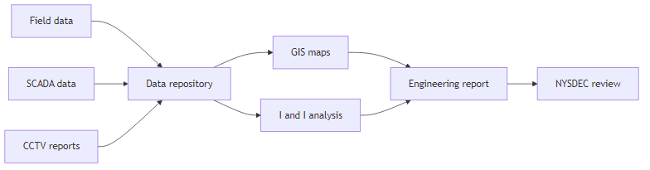
Figure 3: Data integration and reporting architecture

Implementation Plan and Schedule
Our implementation plan is structured to meet NFWB and NYSDEC milestones, with clear dependencies between tasks. The schedule below is illustrative and will be refined during project initiation in collaboration with NFWB. It is designed to support completion of the Phase 1 SSES report in time for NYSDEC review early in 2023, construction in 2023–early 2024, and post-construction monitoring by June 2024 (REQ-025, REQ-030, REQ-034).
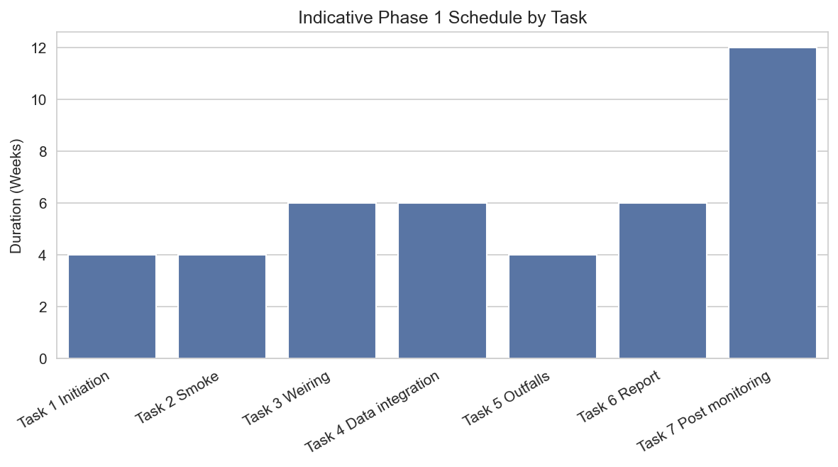
Figure 4: Indicative Phase 1 schedule by major task

Schedule Overview (Bar Chart Form)
The following table summarizes the planned sequencing for Phase 1 and the optional Phase 2 and Phase 3 scopes. Actual calendar dates will be aligned to the final notice-to-proceed and NYSDEC review timelines.
Task / Option | Description | Indicative Duration | Key Milestones
Phase 1 Task 1 | Project initiation, data review, planning | Weeks 1–4 | Kickoff; approved Field Work Plan and Safety Plan
Phase 1 Task 2 | Smoke testing in Phase 1 sewersheds | Weeks 3–6 | Public notifications; completion of field logs
Phase 1 Task 3 | Night-time weiring and flow isolation | Weeks 5–10 | Weir installation; completion of infiltration calculations
Phase 1 Task 4 | CCTV and focused SSES integration | Weeks 6–12 | Consolidated defect database and GIS layers
Phase 1 Task 5 | Outfall and SSO assessment | Weeks 8–12 | Outfall assessment memo and GIS updates
Phase 1 Task 6 | Engineering Report and Corrective Action Plan | Weeks 10–16 | Draft and final NYSDEC-ready report
Phase 1 Task 7 | Post-construction monitoring | 2024 (12 weeks) | Post-Construction I&I Assessment and Cost Analysis Report
Option 1 Phase 2 | SSES in 81st and Frontier 2; 80th and Lindbergh (no outfall assessment) | Parallel or following Phase 1 | Phase 2 SSES report and corrective actions
Option 2 Phase 3 | SSES in Mang and 88th (including outfall assessment) | Following Phase 2 | Phase 3 SSES report and corrective actions

Project Management and Governance
Aurelia uses a structured project management framework that combines iterative delivery with formal governance. For this engagement, we will designate a dedicated Project Manager as the primary point of contact responsible for scope, schedule, budget, and quality, and for coordination with NFWB and NYSDEC (REQ-004, REQ-007, REQ-008, REQ-030, REQ-053).
Key elements of our governance model include:
- Clear roles and responsibilities for NFWB, Aurelia, and any subconsultants, documented in a Responsibility Assignment Matrix.
- Regular progress meetings (biweekly during active field work) to review safety, field progress, data quality, and emerging findings, with action logs and risk registers.
- Formal stage gates at completion of major tasks (field work complete, draft report, final report) to confirm alignment with NFWB and NYSDEC expectations.
- Compliance with all communication restrictions during the Restricted Period, with all communications routed through the authorized Water Board contact in accordance with State Finance Law sections 139-j and 139-k (REQ-041, REQ-069).
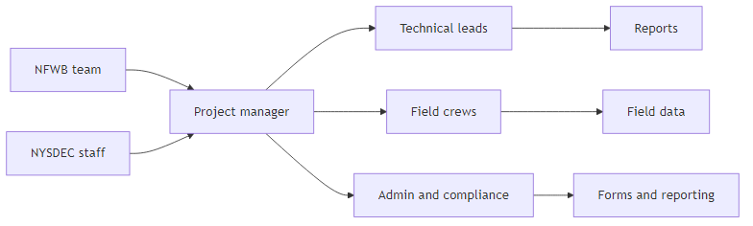
Figure 5: Project governance and communication structure

Security, Safety, and Regulatory Compliance
Aurelia operates with security-by-design and safety-first principles. While this engagement is focused on wastewater infrastructure rather than enterprise IT, our internal security and compliance practices support the protection of NFWB data and the integrity of project records. We will comply with all applicable NYSDEC/EFC requirements, information security laws, and contractual terms (REQ-003, REQ-024, REQ-029, REQ-038, REQ-041, REQ-042, REQ-043, REQ-044, REQ-045, REQ-054, REQ-055, REQ-059, REQ-060, REQ-061, REQ-064, REQ-065, REQ-066, REQ-067, REQ-068, REQ-069, REQ-070, REQ-071, REQ-072, REQ-073, REQ-074, REQ-075).

Health and Safety
We will develop a project-specific Safety Program and Site-Specific Health and Safety Plan that address smoke testing, night-time work, traffic control, confined space entry, and environmental conditions. All field staff will have appropriate OSHA training, PPE, and equipment, and we will fully comply with NFWB safety and orientation requirements (REQ-013, REQ-053, REQ-056).

Regulatory and Contractual Compliance
We will prepare all engineering reports in accordance with the NYSDEC Engineering Report Outline for New York State Wastewater Infrastructure Projects dated October 1, 2022, and with applicable NYSDEC/EFC guidance (REQ-003, REQ-023, REQ-024, REQ-026, REQ-027, REQ-029). Aurelia will submit all required Appendix E forms, including Acknowledgement of Addenda, Non-Collusion, Lobbying Law Disclosure, EEO Policy Statement, Sexual Harassment Statement, and the RFP Acknowledgement and Certification, with the original proposal (REQ-038, REQ-068, REQ-074, REQ-075).
We will submit MWBE and SDVOB utilization plans or waiver requests, EEO Staffing Plans, Workforce Employment Utilization Reports, and monthly MWBE-SDVOB reports as required, and acknowledge the potential for liquidated damages for willful failure to meet participation goals (REQ-042, REQ-043, REQ-044, REQ-045, REQ-061, REQ-062). We accept NFWB’s general conditions, including rights to reject proposals, award without discussion, retain portions of the scope, and accept non-lowest price proposals (REQ-049, REQ-071).
Aurelia maintains required insurance coverages, including workers’ compensation, disability, employer’s liability, general liability, auto, umbrella/excess, and professional liability, and will name NFWB, the Niagara Falls Public Water Authority, and the City of Niagara Falls as additional insureds on a primary and non-contributory basis, with waivers of subrogation where required (REQ-054, REQ-055).

Data Security and Confidentiality
If we handle NFWB data, we will comply with New York State information security breach and notification laws, and we will mark confidential and proprietary information consistent with FOIL-related requirements, recognizing that proposals may be discussed in public Board meetings (REQ-058, REQ-060). We maintain secure systems and audit-ready records, and will retain project records for at least six years beyond the calendar year of creation, making them available for audit by NFWB, the State Comptroller, Attorney General, and other authorized entities (REQ-059).

Team and Qualifications
Aurelia Digital Systems is a Canadian-headquartered engineering and technology firm with more than 120 professionals across Canada and the United States, including wastewater engineers, data and analytics specialists, and program managers. We have delivered complex infrastructure, utilities, and public sector projects that combine physical asset management with rigorous data and compliance requirements (REQ-028, REQ-031, REQ-046).

Key Personnel
Our proposed core team for this engagement includes: (names and specific resumes to be provided in the full proposal package).
- Project Manager – A senior wastewater engineer with 15+ years of experience managing SSES and I&I reduction programs, responsible for coordination with NFWB and NYSDEC, schedule, budget, and quality (REQ-004, REQ-033).
- Technical Lead, Collection Systems – A licensed Professional Engineer with deep experience in gravity and pressure sewer systems, SSES, and corrective action planning, responsible for technical oversight of smoke testing, weiring, and CCTV interpretation (REQ-026, REQ-033).
- I&I Data Analyst – A specialist in flow monitoring and data analytics, responsible for infiltration rate calculations, GIS integration, and development of I&I reduction metrics (REQ-015, REQ-020, REQ-027).
- Health and Safety Lead – An environmental health and safety professional with OSHA training experience, responsible for the Site-Specific Health and Safety Plan and field safety oversight (REQ-053, REQ-056).

Relevant Project Experience
Aurelia and our partners have delivered multiple projects involving I&I studies, SSO abatement planning, and wastewater infrastructure upgrades. Representative experience includes: (detailed project descriptions and references to be provided in the Statement of Qualifications section of the full proposal) (REQ-031, REQ-046).
Our experience in utilities operations enablement, public sector modernization, and data-driven infrastructure planning demonstrates our ability to combine engineering judgment with robust analytics, governance, and documentation, directly supporting the LaSalle SSES objectives (REQ-028, REQ-029, REQ-031, REQ-033).

Subconsultants and MWBE/SDVOB Participation
We anticipate engaging qualified subconsultants for specialized services such as field smoke testing crews, traffic control, or local survey support. Any subconsultant performing more than 10 percent of the work will be fully described in the proposal, including business structure, licensing, experience, key personnel, and contact information (REQ-032, REQ-047, REQ-057). We will align subconsultant selection with MWBE and SDVOB participation goals and will remain fully responsible for their performance (REQ-042, REQ-043, REQ-057).

Cost, Effort, and Commercial Terms
We will provide a detailed effort and budget breakdown in spreadsheet format as part of the final proposal submission, including task and hour estimates and a not-to-exceed fee for Phase 1, with separate option pricing for Phase 2 and Phase 3 (REQ-002, REQ-022, REQ-035, REQ-062, REQ-063). The table below illustrates the structure of our task/hour estimate matrix.
Task | Role | Hours | Rate | Subtotal | Phase / Option
Task 1 Initiation | Project Manager | 40 | $X | $X | Phase 1
Task 2 Smoke Testing | Field Crew | 120 | $X | $X | Phase 1
Task 3 Weiring | Field Crew | 160 | $X | $X | Phase 1
Task 4 Data Integration | I&I Analyst | 120 | $X | $X | Phase 1
Task 5 Outfall Assessment | Technical Lead | 80 | $X | $X | Phase 1
Task 6 Reporting | Project Manager | 160 | $X | $X | Phase 1
Task 6 Contingency | Various | As needed | — | $10,000 | Phase 1
Task 7 Post Monitoring | I&I Analyst | 160 | $X | $X | Phase 1
Phase 2 Option | Combined roles | TBD | TBD | TBD | Phase 2
Phase 3 Option | Combined roles | TBD | TBD | TBD | Phase 3
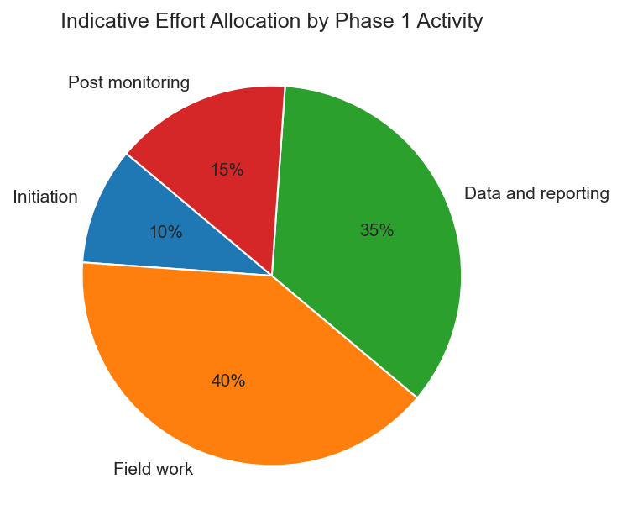
Figure 6: Indicative effort allocation for Phase 1
We acknowledge that the proposal will be firm and irrevocable for 90 days from the submission deadline unless extended by addendum (REQ-048). We will exclude New York State and local sales tax from our pricing, recognizing NFWB’s tax-exempt status (REQ-063). We accept net 60 payment terms with monthly invoices supported by appropriate documentation and compliance with prevailing wage and MWBE/SDVOB reporting requirements (REQ-061, REQ-062).

Assumptions, Risks, and Dependencies
Our proposal is based on the following key assumptions, risks, and dependencies. We will refine and validate these with NFWB during project initiation (REQ-030).

Assumptions
- NFWB will provide timely access to existing data, including Order on Consent documents, NYSDEC correspondence, CCTV and manhole reports, SCADA data, and prior I&I studies (REQ-005, REQ-016, REQ-017).
- NFWB will support public communications, including press releases and website notices, while Aurelia manages door hangers and coordination with public safety agencies (REQ-010, REQ-014).
- Field work can be scheduled to avoid extreme weather and flooding conditions that would compromise smoke testing and weiring results (REQ-011, REQ-012).

Risks and Mitigation
- Adverse weather or high groundwater levels may delay field activities or distort I&I measurements. We will mitigate this by building schedule contingency, monitoring weather forecasts, and coordinating closely with NFWB to adjust field windows.
- Access constraints (locked structures, traffic limitations, or resident concerns) may limit the ability to perform smoke testing or weiring at some locations. We will mitigate this through early public notification, flexible scheduling, and alternative investigation methods where needed.
- Changes in NYSDEC expectations or additional data requests may impact reporting scope. Our proactive engagement with NYSDEC, including interim check-ins on report structure and findings, will reduce this risk.

Proposal Administration and Submission Commitments
Aurelia will comply with all proposal submission, communication, and legal requirements specified in the RFP, including attendance at the mandatory pre-proposal information session, adherence to the Restricted Period communication rules, and completion of all required forms (REQ-038, REQ-039, REQ-040, REQ-041, REQ-050, REQ-051, REQ-052, REQ-069, REQ-071, REQ-072, REQ-074, REQ-075).
We will deliver one clearly marked original and six copies of the proposal, plus one electronic copy in a single document, arranged in the same order as the paper original. Only one original signed copy of each Appendix E form will be included in the paper original, with unsigned copies in the electronic version as appropriate (REQ-050, REQ-051). The proposal will be submitted in a sealed outer envelope addressed to the Water Board contact and clearly marked with our name, address, and the RFP number and title (REQ-052).
We acknowledge and accept the Water Board’s rights and general conditions, including rights to reject proposals, award without discussion, retain portions of the scope, terminate for cause or convenience, and apply debarment or other remedies for violations of Lobbying Law or other requirements (REQ-049, REQ-069, REQ-070, REQ-071, REQ-072, REQ-073). We further certify our compliance with the Iran Divestment Act, international boycott prohibitions, MacBride Fair Employment Principles, and prohibitions on the purchase of tropical hardwoods as applicable (REQ-066, REQ-067).

Compliance Matrix
The table below summarizes how this proposal addresses each RFP requirement. A more detailed traceability matrix can be provided in Excel format upon request.
Requirement ID | Category | Mandatory | Proposal Section / Response Summary
REQ-001 | Technical | Yes | Task 2, Task 3, Task 4 – Phase 1 SSES scope and methods
REQ-002 | Cost | Yes | Optional Tasks, Cost and Effort section – Option pricing for Phases 2 and 3
REQ-003 | Compliance | Yes | Tasks 6 and 7, Security and Compliance – NYSDEC Engineering Report Outline
REQ-004 | Management | Yes | Project Management and Governance – Dedicated Project Manager
REQ-022 | Cost | Yes | Task 6 and Cost section – $10,000 contingency for focused SSES
REQ-023 | Technical | Yes | Task 6 – SSES report and Corrective Action Plan
REQ-025 | Management | Yes | Implementation Plan and Schedule – NYSDEC review and construction timeline
REQ-027 | Technical | Yes | Task 7 – Post-construction monitoring and cost analysis report
REQ-034 | Management | Yes | Implementation Plan and Schedule – bar chart and table
REQ-035 | Cost | Yes | Cost, Effort, and Commercial Terms – task/hour matrix structure
REQ-038 | Compliance | Yes | Security, Safety, and Regulatory Compliance – Appendix E forms
REQ-042 | Compliance | Yes | Security, Safety, and Regulatory Compliance – MWBE/SDVOB plans
REQ-046 | Experience | Yes | Team and Qualifications – Statement of Qualifications
REQ-048 | Other | Yes | Cost, Effort, and Commercial Terms – 90-day firm offer
REQ-050 | Management | Yes | Proposal Administration – copies and electronic submission

Conclusion
Aurelia Digital Systems appreciates the opportunity to support the Niagara Falls Water Board in delivering a successful Phase 1 SSES and in planning for Phases 2 and 3. Our proposed approach combines proven collection system engineering practices with strong data integration, governance, and compliance discipline. We are committed to delivering NYSDEC-acceptable reports, actionable corrective action plans, and clear evidence of I&I reduction aligned with the LaSalle SSO abatement program.
We look forward to collaborating with NFWB staff and NYSDEC to advance this important program and to protect public health and the environment in Niagara Falls.

