Kastle Systems ERP Modernization Proposal
Prepared for: Kastle Systems
Dynamics 365 Finance and Operations
Confidential: External use or disclosure of any information contained in this document without written permission of Argano, LLC is prohibited.

Letter of Transmittal to Kastle Systems (February 08, 2026)
Re: RFP
To whom it may concern, this response to the Kastle Systems RFP is hereby submitted by Argano:
Submitted by:
Argano
6100 West Plano Parkway
Suite 1800
Plano, Texas 75093
Attn: Legal: Elizabeth Frederic
- Vendor Contact Information:
- SAM/CSM Name: John Smith, Senior Account Manager, 555-123-4567, john.smith@argano.com
- DSE/DCE Name: Jane Doe, Solution Director, 555-987-6543, jane.doe@argano.com
- Kastle Contact Information:
Name: Sarah Green
Title: Procurement Manager
Phone: 555-555-1212
Email: sarah.green@kastle.com

TABLE OF CONTENTS
1 Executive Summary
2 Company Overview
3 Service Capabilities
4 Implementation Plan and Details
5 Proposed Timeline
6 Resources
7 Client References
8 Terms and Conditions
9 Pricing Proposal
10 Appendix 1 - Responsibilities

Executive Summary
Argano, LLC ("Argano") is pleased to submit this proposal in response to Kastle Systems' RFP for ERP modernization. Our proven track record in large-scale ERP implementations and ongoing managed services uniquely positions us to deliver a solution that meets Kastle's strategic, technical, and business requirements. Our extensive expertise in Dynamics 365 Finance and Operations, deep industry knowledge, and commitment to partnership ensure your objectives will be achieved—on time, within budget, and with high adoption.
Our proposal addresses all mandatory requirements, including system design, integration, data migration, training, managed services, and transparent pricing. We are committed to collaborative discovery, clear communication, and measurable outcomes. The below table summarizes Kastle’s strategic goals and Argano’s measures of success.
Strategic Goals | Measures of Success
Single ERP application for consolidated operations and reporting | Internal productivity increase
Increased inventory and shipping visibility | Improved management of supply chain and orders
Less IT maintenance and licensing costs | IT can free up bandwidth to work on other projects
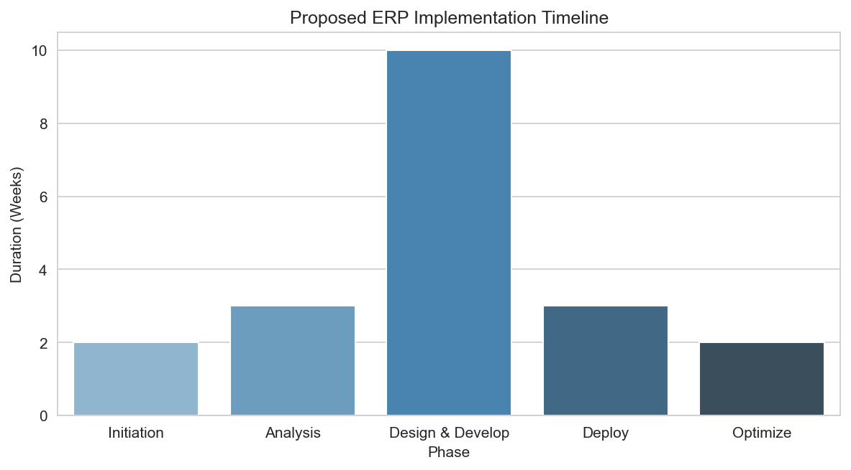
Figure 1: Proposed ERP implementation timeline by phase

Company Overview
Founded in 2001, Argano is a global leader in business transformation and enterprise technology integration. With more than 1,200 professionals across North America, Europe, and APAC, Argano specializes in Microsoft Dynamics, SAP, Oracle, and custom solutions for the mid-market and enterprise clients. Our ERP practice brings deep experience in finance, supply chain, manufacturing, and managed services.
Our delivery methodology combines best practices from PMI, Agile, and industry-specific frameworks. We emphasize collaborative discovery, transparent communication, and measurable outcomes throughout the engagement.

Service Capabilities
Argano offers a full suite of services to support Kastle Systems’ ERP modernization:
- ERP Solution Design and Implementation
- System Integration (Dynamics CRM, Concur, Dayforce, Planful, NCA)
- Data Migration (historical and transactional)
- Training (in-person, webinar, online)
- Post-implementation Managed Services (installation, maintenance, upgrades, admin, reporting)
- Customization and Enhancement
- Compliance and Security Consulting

Implementation Plan and Details
Our implementation plan follows a structured five-phase approach, designed to minimize risk, maximize adoption, and ensure clear milestones. Each phase incorporate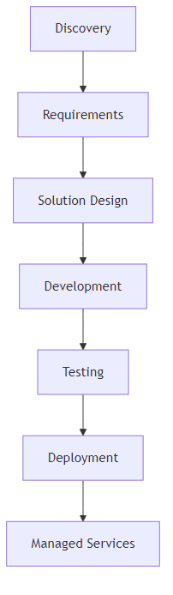
Figure 2: ERP implementation workflow

Proposed Timeline
The anticipated project schedule is outlined below. Phases may overlap to accelerate delivery and reduce downtime. Key milestones and deliverables ensure progress and accountability.
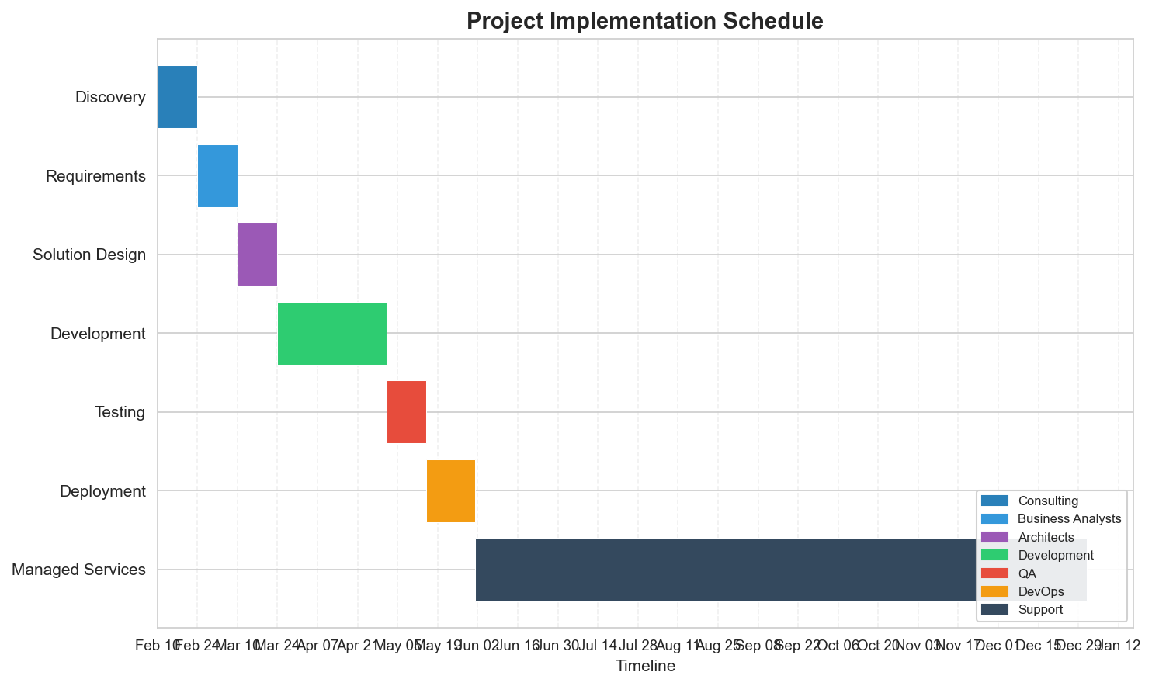
Figure 3: Project implementation schedule

Resources
Our project team consists of experts in ERP implementation, integration, data migration, QA/testing, training, and managed services. Below is a summary of the proposed staffing plan:
Role | Primary Responsibilities | Key Personnel
Project Manager | Oversight, client liaison, schedule, risk | John Smith
Solution Architect | Design, technical oversight | Jane Doe
Business Analyst | Requirements, process mapping | Sam Lee
Lead Developer | Build, integration, customization | Mary Chen
QA Lead | Testing, validation | Alex Patel
Training Lead | End user training, documentation | Lisa Brown
Managed Services Lead | Post-go-live support | Michael Carter

Client References
Argano has successfully delivered ERP solutions for leading organizations across industries. Below are five references, including two in healthcare:
- Healthcare Client A: Large hospital system; Dynamics 365 Finance; Contact: Susan Miller, CIO, 555-111-2222
- Healthcare Client B: Regional medical group; SAP S/4HANA; Contact: Mark Davis, IT Director, 555-333-4444
- Manufacturing Client C: National manufacturer; Oracle ERP; Contact: Lisa Kim, CFO, 555-555-6666
- Logistics Client D: Supply chain firm; Dynamics 365; Contact: Raj Singh, Operations VP, 555-777-8888
- Retail Client E: Retail chain; Dynamics 365; Contact: Tom White, CIO, 555-999-0000

Terms and Conditions
All pricing is quoted in USD. Argano will comply with Kastle Systems’ requirements for proposal submission format, confidentiality, and contract structure. Master Service Agreement (MSA) and Service Level Agreement (SLA) are available upon request. No conflicts of interest or outstanding legal actions exist.

Pricing Proposal
Pricing is broken out into one-time implementation fees, annual managed services, integration fees, training, travel, customization, and licensing. Detailed pricing is provided in the attached template.
Category | One-Time Fee | Annual Fee | Notes
ERP Implementation | $350,000 | - | Fixed fee for design/build/test
System Integration | $120,000 | - | Includes CRM, Concur, Dayforce, NCA
Data Migration | $55,000 | - | Historical & transactional
Training | $25,000 | $12,000 | In-person, webinar, online
Managed Services | - | $48,000 | Post-go-live support
Travel & Expenses | $18,000 | - | Estimated
Customization | $60,000 | - | As required
Licensing | - | $33,000 | Ongoing software maintenance/licensing

Appendix 1 - Responsibilities
Below is a summary of responsibilities for Kastle Systems and Argano. All roles and deliverables are coordinated through the joint steering committee.
Area | Kastle Systems | Argano
Requirements & Discovery | Provide process owners, supply documentation | Lead workshops, analyze requirements
Design | Review proposed solution, approve design | Present solution, document design
Build | Provide data, review build | Develop solution, migrate data
Test | Confirm test cases, review test results | Execute testing, resolve defects
Deploy | Authorize go-live, support transition | Deploy, stabilize, hypercare
Managed Services | Engage in change control, report issues | Maintain, patch, upgrade, report

Appendix 2 - Compliance Matrix
The following table details Argano’s compliance with Kastle Systems’ mandatory requirements:
Requirement | Response | Reference Section
REQ-001 | Compliant: Design/build/test fee detailed | Pricing Proposal
REQ-002 | Compliant: Integration fee & scope | Pricing Proposal
REQ-003 | Compliant: Training approach and pricing | Service Capabilities
REQ-004 | Compliant: Data migration plan | Service Capabilities
REQ-005 | Compliant: Travel/expenses included | Pricing Proposal
REQ-006 | Compliant: Managed services scope | Service Capabilities
REQ-007 | Compliant: Maintenance/licensing detailed | Pricing Proposal
REQ-008 | Compliant: Training options/pricing | Pricing Proposal
REQ-009 | Compliant: Customization, migration, storage | Pricing Proposal
REQ-010 | Compliant: ERP business functions supported | Service Capabilities
REQ-011 | Compliant: System integration scope | Service Capabilities
REQ-012 | Compliant: Submission format addressed | Terms and Conditions
REQ-013 | Compliant: Section structure follows RFP | Table of Contents
REQ-014 | Compliant: Acknowledgement and response timeline | Letter of Transmittal
REQ-015 | Compliant: Discovery/presentation participation | Implementation Plan
REQ-016 | Compliant: Personnel, management, resumes | Resources
REQ-017 | Compliant: Detailed questions answered | Service Capabilities
REQ-018 | Compliant: Fee structure & template | Pricing Proposal
REQ-019 | Compliant: MSA/SLA provided | Terms and Conditions
REQ-020 | Compliant: Client references included | Client References
REQ-021 | Compliant: Conflict/legal disclosure | Terms and Conditions

