Kastle Systems ERP Modernization Proposal
Prepared for: Kastle Systems
Submitted by: [Vendor Company Name]
Confidential: External use or disclosure of any information contained in this document without written permission is prohibited.

February 08, 2026
Letter of Transmittal to Kastle Systems
Re: Kastle Systems ERP Modernization RFP
To whom it may concern, this response to the Kastle Systems RFP is hereby submitted by [Vendor Company Name]:
Submitted by:
[Vendor Company Name]
6100 West Plano Parkway
Suite 1800, Plano, Texas 75093
Attn: Legal: [Authorized Officer Name]
Vendor Contact Information:
SAM/CSM Name, Position, Phone No., Email
DSE/DCE Name, Position, Phone No., Email
Kastle Contact Information:
Name:
Title:
Phone:
Email:

TABLE OF CONTENTS
1 Executive Summary
2 Company Overview
3 Service Capabilities
4 Implementation Plan and Details
5 Proposed Timeline
6 Project Management and Governance
7 Security, Privacy, and Compliance
8 Team and Qualifications
9 Assumptions, Risks, and Dependencies
10 Pricing Proposal
11 Client References
12 Appendices

Executive Summary
Kastle Systems seeks an experienced implementation partner to modernize its ERP and Field Service systems. Our proposal addresses Kastle’s requirements for end-to-end implementation, integration across business platforms, rigorous training, data migration, and ongoing managed services. We deliver cost-effective, scalable, and secure solutions leveraging deep Microsoft Dynamics expertise and proven delivery methodology.
Strategic Goals | Measures of Success
Single ERP application for consolidated operations and reporting | Internal productivity increase
Increased inventory and shipping visibility | Improved management of supply chain and orders
Less IT maintenance and licensing costs | IT can free up bandwidth to work on other projects
Our methodology brings strong discipline to ensure a successful implementation and eventual client ownership of the system. The proposed implementation timeline is outlined below.
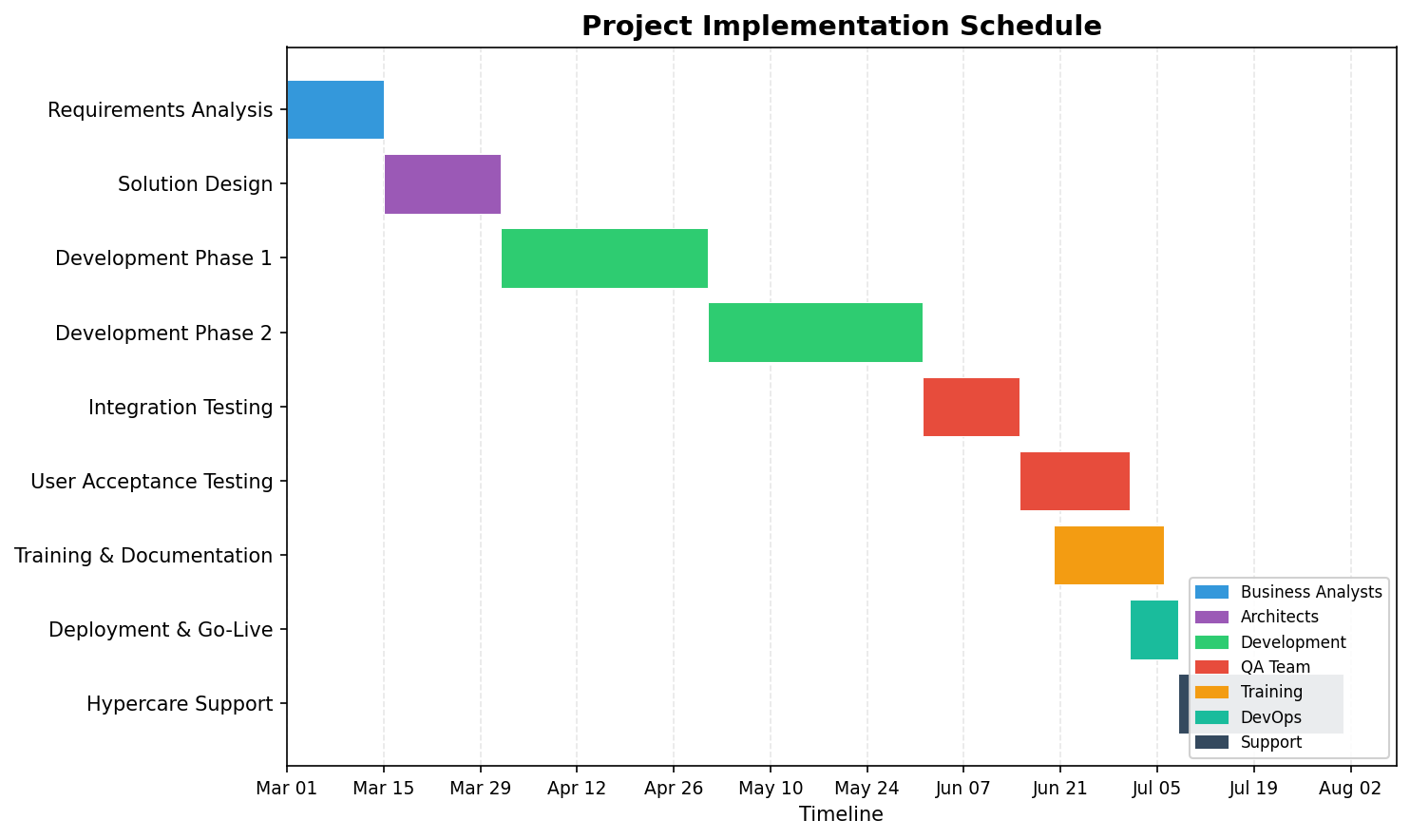
Figure 1: Project Implementation Schedule

Company Overview
Our company is a leading provider of ERP implementation services, specializing in Microsoft Dynamics platforms. With over 15 years of experience delivering complex modernization projects, we have a proven track record in optimizing operations for organizations across industries, including healthcare, manufacturing, and logistics.

Service Capabilities
We offer full lifecycle ERP services, including:
- ERP and Field Service system implementation
- Platform integration across business applications
- Data migration and conversion
- Managed services and ongoing support
- User training and adoption
- System maintenance and upgrades
- Reporting and analytics
- Security, compliance, and privacy management

Requirements Traceability Matrix
Requirement ID | Description | Reference Section
REQ-001 | Proposal follows RFP structure and requirements | Section: All
REQ-002 | Acknowledged receipt and intent to respond | Section: Executive Summary
REQ-003 | Participation in discovery sessions | Section: Implementation Plan
REQ-004 | Methodology covers all requested areas | Section: Service Capabilities
REQ-005 | Support for all major ERP functional areas | Section: Service Capabilities
REQ-006 | Transparent cost breakdowns | Section: Pricing Proposal
REQ-007 | Relevant customer references provided | Section: Client References
REQ-009 | Detailed implementation, testing, training, migration plans | Section: Implementation Plan
REQ-010 | Support model, help desk, SLA, scalability | Section: Project Management
REQ-011 | Confidentiality and non-disclosure compliance | Section: Security & Compliance
REQ-014 | Disclosure of conflicts, legal actions | Section: Appendices
REQ-016 | Proposal submission format and deadline | Section: Appendices
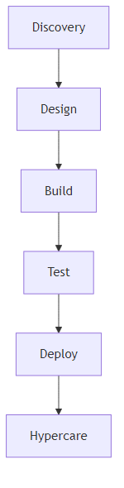
Figure 2: Project workflow from discovery to hypercare

Implementation Plan and Details
Our implementation plan is designed to accelerate delivery while minimizing disruption to business operations. The plan includes phased requirements gathering, solution design, iterative build, comprehensive testing, and robust deployment. Each phase is supported by dedicated teams and clear milestones.
Key milestones include:
- Requirements Analysis
- Solution Design
- Development Phase 1
- Development Phase 2
- Integration Testing
- User Acceptance Testing
- Training & Documentation
- Deployment & Go-Live
- Hypercare Support
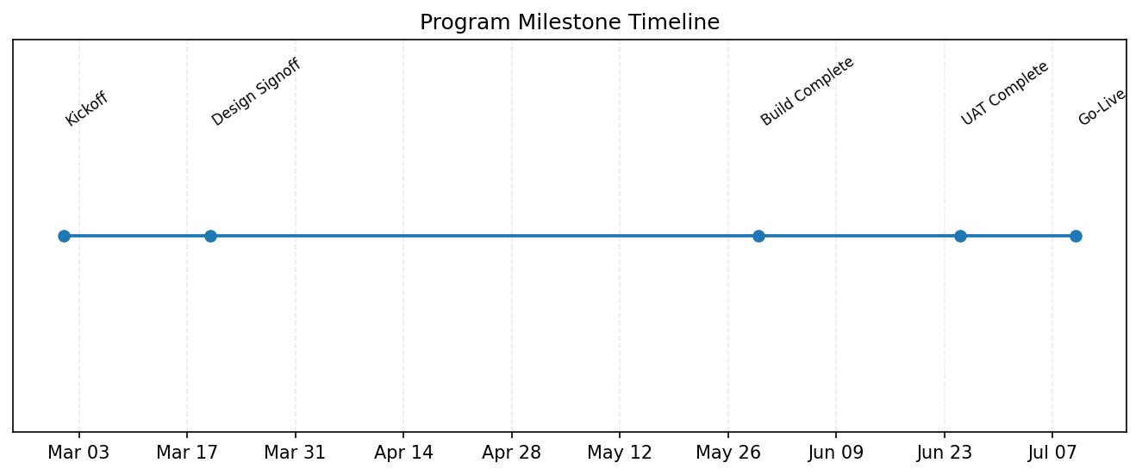
Figure 3: Program milestone timeline

Project Management and Governance
Our project management approach is based on PMI and Agile principles, ensuring clear communication, transparency, and rigorous reporting. Governance is structured with defined roles, escalation paths, and regular steering committee meetings. Risk management and change control are embedded throughout.

Security, Privacy, and Compliance
Security is integrated at each stage, leveraging industry standards such as ISO 27001 and SOC 2. Confidentiality, privacy, and regulatory compliance are maintained via technical safeguards, access controls, and clear data management policies. All proposal materials are marked for confidentiality as required.

Team and Qualifications
Our team consists of seasoned professionals with deep Microsoft Dynamics expertise, project management certifications, and industry experience. Key members include Solution Architects, Business Analysts, Senior Developers, QA leads, and Training Specialists.

Assumptions, Risks, and Dependencies
Key assumptions include timely access to Kastle Systems stakeholders, legacy system documentation, and test environments. Risks are managed through early identification, mitigation planning, and escalation procedures. Dependencies include third-party integrations, data migration readiness, and resource availability.

Pricing Proposal
Our pricing is transparent and itemized by implementation, integration, training, data migration, managed services, and ongoing costs. Pricing is subject to final scope and agreed deliverables. Detailed cost breakdowns are provided in the appendix.

Client References
References available upon request. Two references in healthcare and three additional relevant projects have been included in the appendix.

Appendices
Appendix A: Master Service Agreement and Service Level Agreement drafts
Appendix B: Client References and Contact Information
Appendix C: Proposal Submission and Confidentiality Details
Appendix D: Conflicts of Interest and Legal Action Disclosures

