Technical Implementation Details: SERMS & OCR Pipeline
System: Smart Expense & Reimbursement Management System (SERMS) & External AI OCR Microservice
Client / Partner: Science Biotech Specialties Inc. (SBSI)
Classification: Deep Technical Architecture & Code-Level Engineering Specification
Date: Nov 6, 2026 · Status: Complete Implementation Reference

1. System Topology & Cross-Network Execution Model
SERMS operates as a Modular Monolith deployed alongside an asynchronous, event-driven AI microservice (ocr-pipeline) over an isolated internal Docker bridge and a shared cross-project network. The client browser communicates with the SERMS Monolith via hybrid client-side encrypted payloads, while OCR and AI inferencing tasks are offloaded asynchronously via Celery queues and Redis brokers.
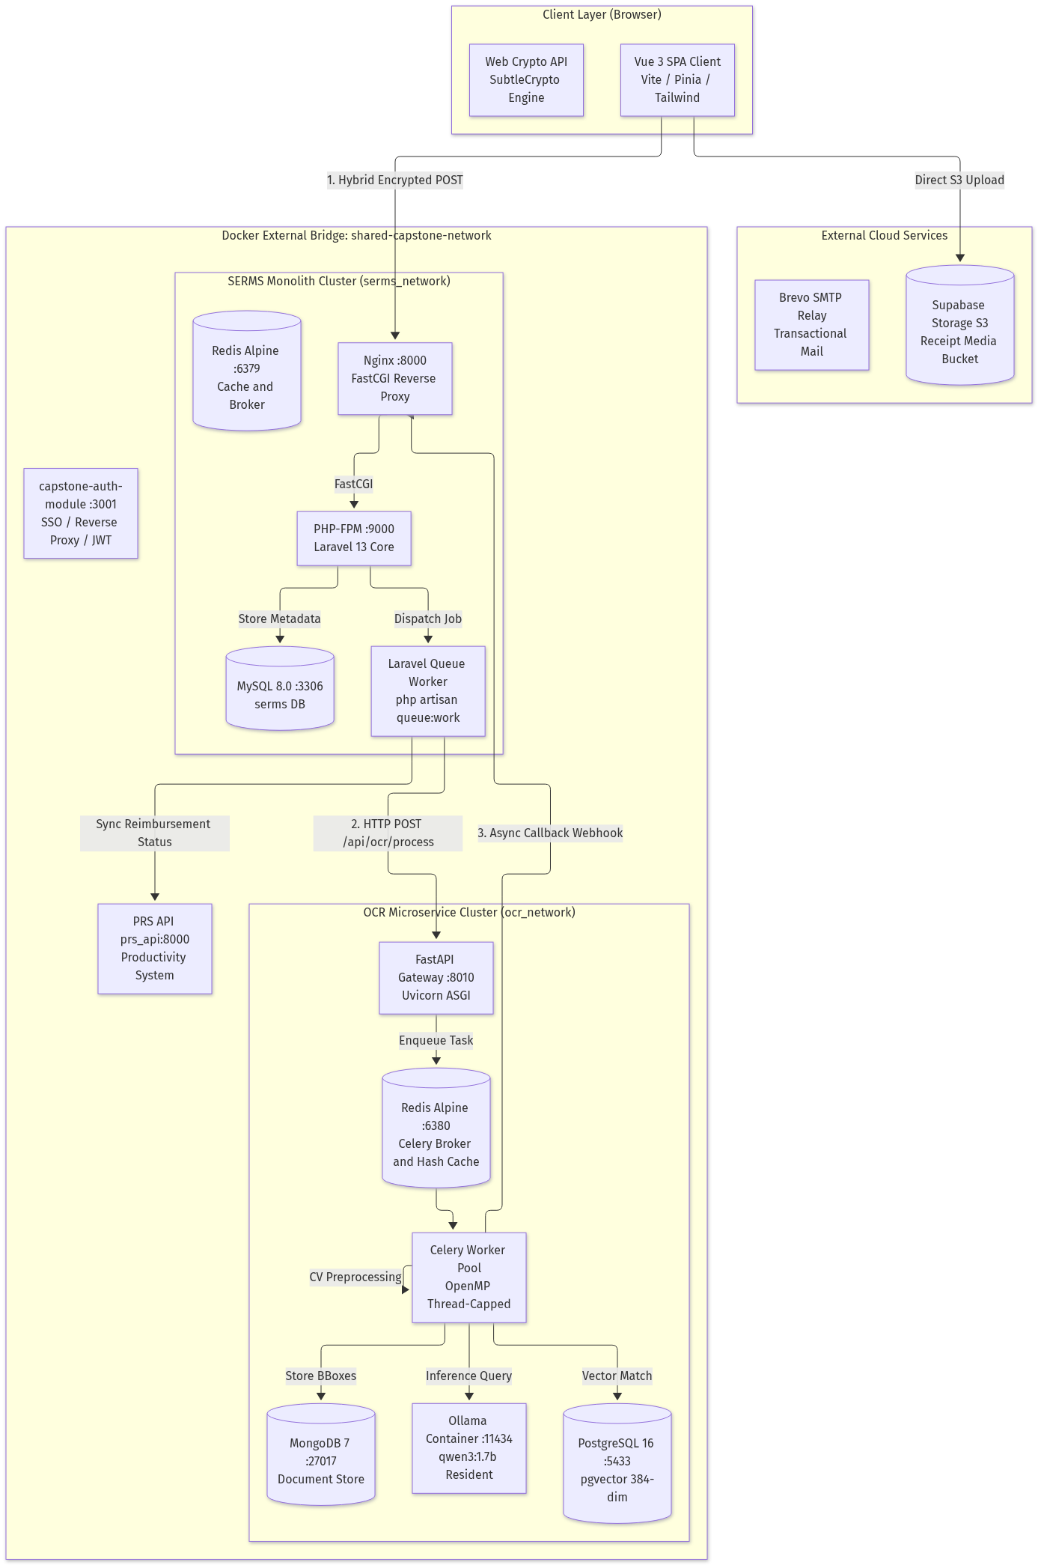
Figure 1: High-Level System Topology & Cross-Network Execution Model
2. Cryptography & Security Subsystem
2.1 Native Web Crypto Hybrid Pre-Encryption
To prevent plaintext leakage, memory snooping, or shoulder theft of sensitive financial mutations, the client implements hybrid envelope pre-encryption (apps/web/src/utils/crypto.js) prior to HTTP transmission.
- 1. Key Fetching: The client retrieves the server's public key from GET /api/crypto/key (cached in memory): Server Public Key in RSA-OAEP-2048, SHA-256.
- 2. Ephemeral Key Generation: For each mutation request, the browser generates an ephemeral symmetric key: K_AES <- AES-GCM-256, IV <- Random(12 bytes).
- 3. Payload Ciphertext: The payload is encrypted with AES-256-GCM using the ephemeral key: Ciphertext C = AES-256-GCM(JSON Payload) || Tag (16 bytes).
- 4. Key Wrapping: The symmetric key is encrypted using the server's public key: Wrapped Key W_K = RSA-OAEP-SHA256(ServerPubKey, K_AES).
- 5. Wire Envelope: Transmitted in a clean JSON wire envelope:
{
"encryptedKey": "base64(W_K)",
"iv": "base64(IV)",
"ciphertext": "base64(C)"
}

2.2 Server-Side Pure-PHP PKCS#1 v2.2 OAEP Decryption
PHP's native openssl_private_decrypt() only supports OAEP padding with SHA-1. Because modern browsers (Web Crypto API) mandate SHA-256 for RSA-OAEP, SERMS implements a pure-PHP PKCS#1 v2.2 decoding engine inside PayloadDecryptionService.php:
- 1. Raw RSA Operation: Decrypts ciphertext using OPENSSL_NO_PADDING: EM = RawRSA(W_K, K_private). If OpenSSL strips leading zero bytes, EM is left-padded to k = 256 bytes.
- 2. EME-OAEP Mask Generation (MGF1): Computes seedMask = MGF1(maskedDB, hLen, 'sha256') where hLen = 32 bytes; unmasks seed = maskedSeed XOR seedMask; computes dbMask = MGF1(seed, k - hLen - 1, 'sha256'); and unmasks DB = maskedDB XOR dbMask.
- 3. Plaintext Extraction: Validates that DB[0..hLen] == SHA256('') (empty label), scans DB for the 0x01 byte delimiter, and extracts K_AES from the remainder of DB.
- 4. Symmetric Decryption: Plaintext P = openssl_decrypt(cipherBytes, 'aes-256-gcm', K_AES, OPENSSL_RAW_DATA, IV, Tag_16B). Transparently injected into the request lifecycle by DecryptPayloadMiddleware.
2.3 Atomic Idempotency Middleware
Financial mutation endpoints are strictly protected by EnsureIdempotency middleware:
- Key Extraction: Reads X-Idempotency-Key or Idempotency-Key HTTP request header.
- Request Fingerprint: Deterministic payload signature H_req = SHA-256(Method || Path || JSON(ksort(Payload))).
- Atomic Pending Lock: Inserts a record into idempotency_keys with status = 'pending'. A concurrent duplicate request immediately triggers a MySQL unique key violation (QueryException), aborting the duplicate with 409 Conflict.
- Cached Replay: If a record exists with status = 'completed', the middleware verifies H_req matches and replays cached HTTP status, headers, and body with X-Idempotent-Replay: true header.
3. SERMS Financial Compliance & Business Math Engine
3.1 Daily Overdue Penalty Accrual
Automated via ComputeDailyPenalties.php running nightly at 00:00 (cron schedule). Calculates days overdue, accrues PHP 50.00/day penalties, and updates outstanding balances with complete transactional idempotency:
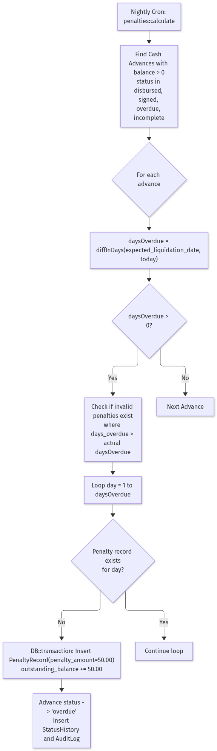
Figure 2: Daily Overdue Penalty Accrual & Reversion State Machine
- Overdue Day Calculation: D_overdue = max(0, floor((T_today - T_due) / 86400)).
- Penalty Accrual: Delta P = sum(d=1..D_overdue) [d not in Penalties(Advance)] * PHP 50.00; Balance_new = Balance_old + Delta P.
- Mathematical Reversion: If an administrator officially extends expected_liquidation_date in the database, invalid penalty records where days_overdue > D_overdue are summed, deleted in a transaction, and subtracted from outstanding_balance to guarantee zero mathematical drift.
3.2 Liquidation Variance Arithmetic
Handled inside LiquidationController.php:
Formula: Variance = Cash Advance Amount - Sum(Verified Receipt Amounts)
- 1. Overpayment Case (Variance > 0): The employee spent less than the cash advance. Status transitions to 'liquidated' once excess cash is remitted to company treasury.
- 2. Shortfall Case (Variance < 0): The employee spent out-of-pocket funds exceeding the cash advance. The system mandates a shortfall_explanation (minimum 20 characters) justifying the variance before the submission can be approved.
3.3 Philippine BIR 12% VAT Engine
Implemented in bir_validator.py for strict Bureau of Internal Revenue (BIR) tax compliance:
- TIN Validation: Philippine Tax Identification Numbers must match 9-3 or 9-5 digit configurations (12 or 14 total numeric digits): len(digits_only(TIN)) in {12, 14}.
- Registration Marker Hierarchy: To prevent column headings (like 'VATable Sales') from triggering false positives on Non-VAT receipts, marker precedence is strictly ordered: 1. 'NON-VAT REG' -> non-vat; 2. 'NOT VALID FOR CLAIMING INPUT TAX' -> non-vat; 3. 'VAT REG' -> vat; 4. Fallback keyword inspection.
- Mathematical Reconciliation: Net Sales = Gross Total / 1.12; VAT Amount (12%) = Gross Total - Net Sales.
3.4 Zero-Overhead Audit Trail Hydration
To eliminate secondary HTTP round-trips when rendering timeline modals, AuditLogService batch-hydrates models on index and show queries:
- Diff Sanitization: Strips metadata keys (id, created_at, updated_at, password) and maps raw field values into formatted currency strings.
- Privacy Masking: ip_address is exposed if User has serms.reimbursements.manage permission; otherwise masked to null.
4. ocr-pipeline Computer Vision & Deep Learning Engine
4.1 Pre-OCR Image Quality Gate & Anti-Fraud
Located in image_quality.py. Evaluates receipt images prior to resource-heavy deep learning OCR:
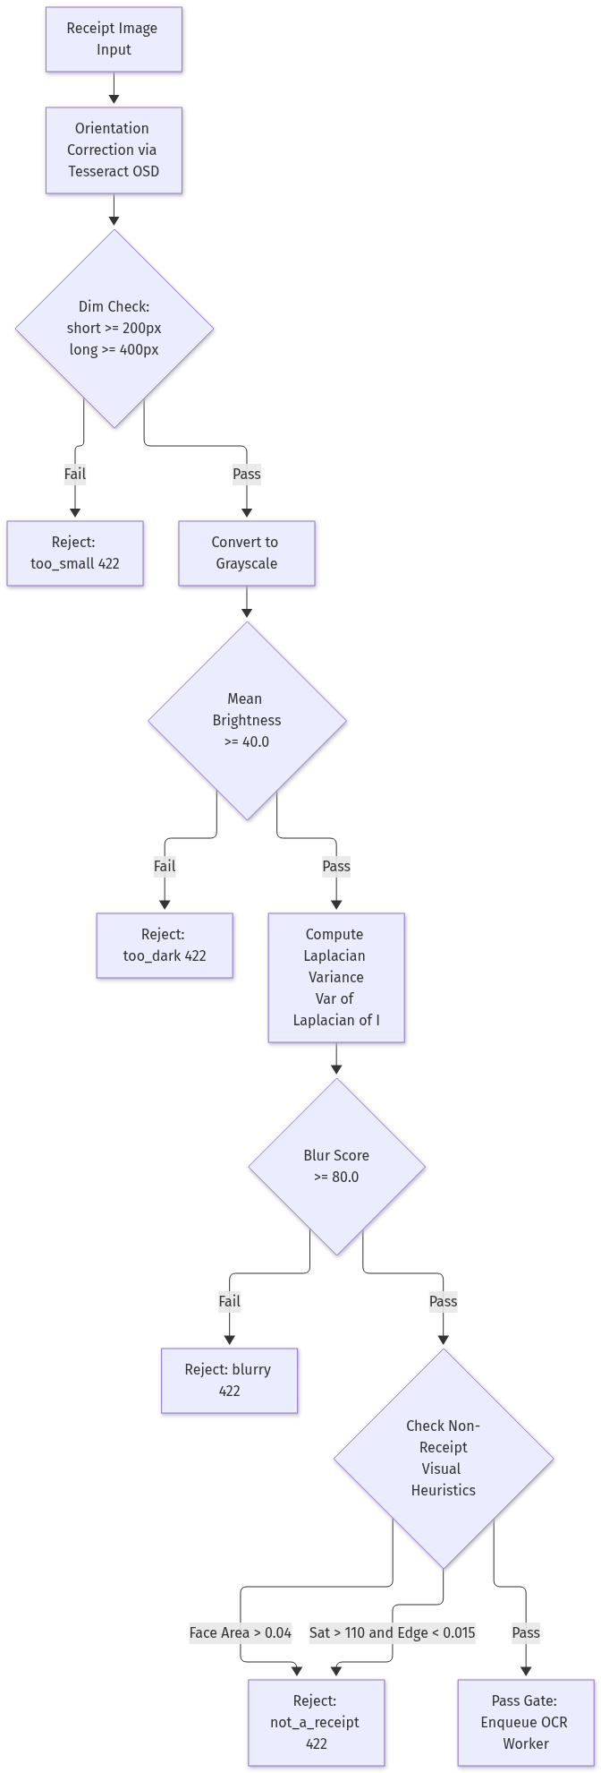
Figure 3: Multi-Stage Image Quality Gate & Anti-Fraud Pipeline
- 1. Blur Metric: Laplacian variance Var(Laplacian(I)). Rejected with 422 Unprocessable if Blur Score < 80.0.
- 2. Prominent Face Detection: Employs OpenCV Haar Cascade (haarcascade_frontalface_default.xml). If detected face area exceeds 4% of total image area (Area_face / Area_total >= 0.04), rejected as not_a_receipt.
- 3. Color Saturation vs Edge Density: Real printed receipts are largely desaturated with dense horizontal text lines. If Mean HSV Saturation > 110.0 and Horizontal Sobel Edge Density < 0.015, rejected as not_a_receipt.
4.2 Multi-Segment Auto-Tiling & Seam Stitching
Located in segment_merger.py for tall thermal receipts:
- Virtual Strip Slicing: Single tall receipts where height >= 1800px and aspect ratio >= 2.8 are sliced into overlapping horizontal strips (up to 10 strips) with a 15% vertical overlap margin.
- Seam Deduplication Algorithm: Extracts a fingerprint buffer of the last 30 lines of strip N and the first 30 lines of strip N+1. 7-digit barcode suffix matches award +3.0 score; exact line price match with RapidFuzz token set ratio >= 80% awards +2.5. The longest contiguous block with Score >= 2.0 defines the seam boundary.
4.3 Dual-Engine OCR & Thread Optimization
Located in ocr_engine.py:
- PaddleOCR 3.7 Primary: DBNet text detection + SVTR text recognition models evaluate upright text blocks and bounding boxes.
- Tesseract 5 Fallback: Invoked if PaddleOCR anchor score < 4.0 or money reconciliation fails.
- OpenMP Multi-Threading Fix: OpenCV and Tesseract default to multi-threaded OpenMP teams (8 threads/process). Concurrent workers thrash CPU cores, slowing execution from 12s to 309s (26x slower). Hard optimization strictly enforces OMP_NUM_THREADS=1 and OMP_THREAD_LIMIT=1, reducing grid execution time down to ~4 seconds with identical readings.
4.4 Local LLM Extraction Assist (Ollama)
Located in ollama_provider.py:
- Model Specification: qwen3:1.7b (or qwen2.5:1.5b) running via Ollama container on port 11434.
- Memory Residency: Auto-warmed on boot with keep_alive = -1 to eliminate cold-start weight loading.
- Prompt Compaction: Clamped to num_ctx = 2048: retains first 30 header lines (Merchant, TIN, Date, Invoice #) and last 35 footer lines (Subtotal, VAT, Total, Tender), keeping inference latency under 10 seconds.
- Soft-Fail Architecture: The LLM only assists with vendor normalization, category selection, and tax basis. If Ollama times out (> 20.0s) or generates invalid JSON, the pipeline falls back to deterministic regex extraction.
4.5 Vector Embeddings & pgvector Cosine Similarity
Located in similarity.py:
- Embedding Generation: Sentence-Transformers (all-MiniLM-L6-v2) generates a 384-dimensional normalized dense vector: v in R^384, ||v||_2 = 1.0.
- Cosine Similarity Lookup: Cosine Distance = 1 - (u · v) / (||u|| ||v||). Executed against PostgreSQL 16 via pgvector extension (<=> operator).
SELECT receipt_id, source_service, created_at,
(embedding <=> :query_vector) AS distance
FROM receipt_embeddings
WHERE source_service = :service
AND created_at >= NOW() - INTERVAL '90 days'
AND (embedding <=> :query_vector) <= 0.15
ORDER BY distance ASC
LIMIT 10;

A distance <= 0.15 (Semantic Similarity >= 0.85) within the 90-day window flags the receipt as a duplicate (rejection_code: 'duplicate').
5. End-to-End Execution Sequence & State Lifecycles
The complete cross-service orchestration sequence spans the Vue 3 SPA client, Supabase S3 storage, SERMS API monolith, Laravel queue worker, FastAPI gateway, Celery worker pool, Ollama LLM, and PostgreSQL pgvector store:
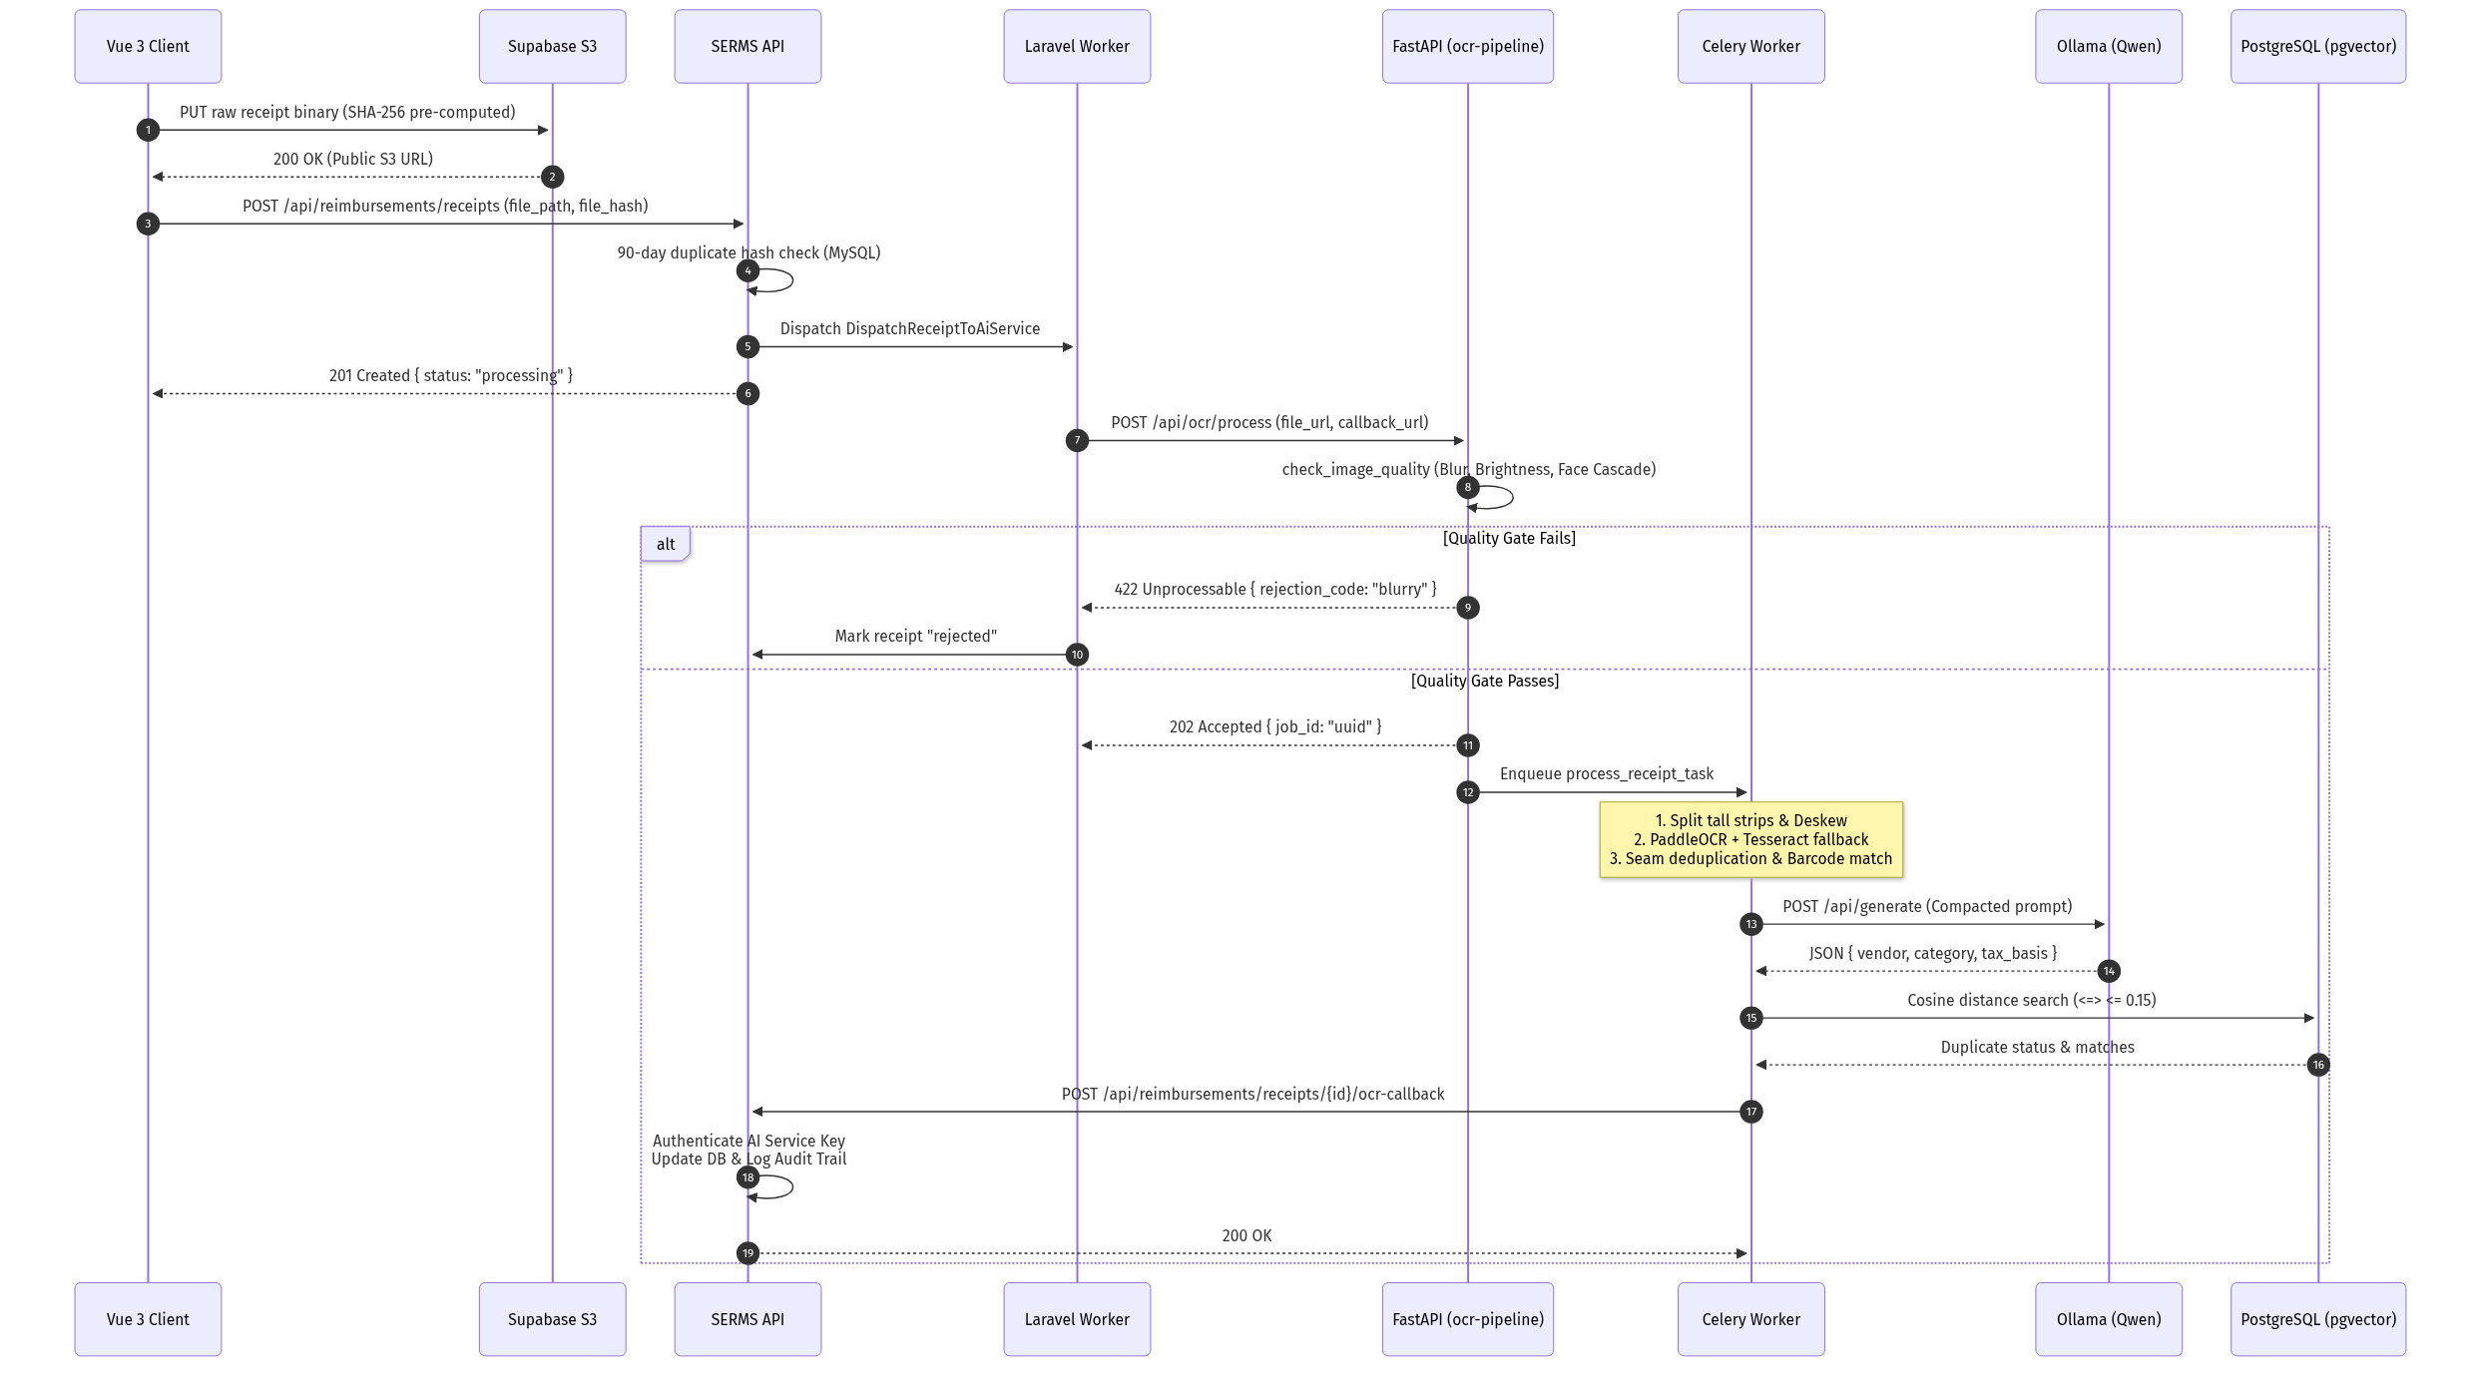
Figure 4: Asynchronous Cross-Service Receipt Processing Sequence
- 1. Binary Upload: Vue 3 client calculates SHA-256 binary hash and streams receipt file directly to Supabase S3 bucket.
- 2. Metadata Registration: Client transmits hybrid encrypted metadata payload (file_path, file_hash) to POST /api/reimbursements/receipts.
- 3. Monolith Dispatch: SERMS API validates 90-day SHA-256 hash duplication in MySQL, creates receipt record with status = 'processing', and dispatches DispatchReceiptToAiService background job.
- 4. AI Gateway Ingestion: Laravel queue worker sends asynchronous POST /api/ocr/process to FastAPI gateway with webhook callback URL.
- 5. Quality Evaluation: FastAPI performs synchronous Image Quality Gate. If image is blurry or contains faces, returns 422 Unprocessable immediately.
- 6. Worker Pool Execution: Gateway enqueues Celery task, which deskews image, runs PaddleOCR/Tesseract, stitches seams, queries Ollama for categorization, and checks pgvector duplicate similarity.
- 7. Webhook Resolution: Celery fires signed HMAC POST request to SERMS API callback endpoint /api/reimbursements/receipts/{id}/ocr-callback. API updates MySQL and appends immutable audit trail record.
6. Technical Implementation Summary Matrix
The following table provides an exhaustive technical mapping of all critical subsystems, implementation files, algorithms, and defensive guardrails across both repositories:
Subsystem | Core Implementation File | Primary Algorithm / Class | Performance / Security Guardrail
Payload Pre-Encryption | apps/web/src/utils/crypto.js | Native SubtleCrypto (AES-GCM + RSA-OAEP) | Client-side ephemeral keying; zero plaintext transmission.
Payload Decryption | PayloadDecryptionService.php | PKCS#1 v2.2 OAEP-SHA256 decoding engine | Pure PHP; circumvents OpenSSL SHA-1 limitation.
Idempotency | EnsureIdempotency.php | Atomic lock table idempotency_keys | MySQL unique constraint prevents double-charging.
Daily Penalties | ComputeDailyPenalties.php | penalties:calculate CLI command | Idempotent insertion; auto-reversion on date extension.
Audit Hydration | AuditLogService.php | enrichReimbursements, enrichCashAdvances | Single SQL batch enrichment; role-scoped IP masking.
Quality Gate | app/core/image_quality.py | Laplacian variance + Haar Cascade filter | Rejects blurry photos and non-receipt selfies at API gate.
Seam Stitching | app/core/segment_merger.py | 30-line fingerprint buffer + Barcode matcher | Prevents duplicate line items on folding receipts.
OCR Pool | app/core/ocr_engine.py | PaddleOCR primary + Tesseract OSD fallback | OMP_NUM_THREADS=1 eliminates 26x CPU thrash penalty.
LLM Semantic Assist | app/core/pipeline.py | Ollama qwen3:1.7b non-thinking JSON mode | Prompt head/tail compaction; fails soft to regex.
Vector Deduplication | app/embeddings/similarity.py | pgvector Cosine Distance (<=> <= 0.15) | 384-dimensional dense semantic matching over 90 days.

