ADARpro Research Strategy
Where the Next Significant Performance Gains Are Most Likely to Come From
A ranked decision framework across biology, AI, and biology × AI

Prepared from the current AdarEdit/ADARpro evidence base, the completed RBP-context analyses, and a targeted review of recent literature.
Version 1.0 — 21 August 2026

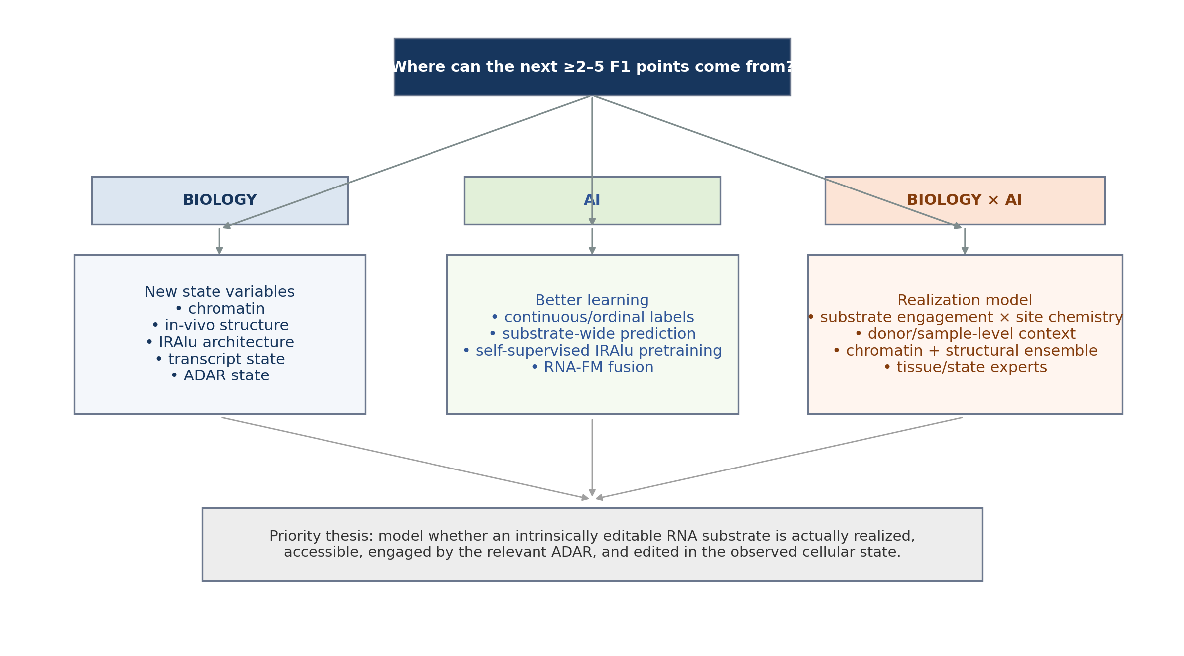

Executive Summary
Core conclusion: The most plausible route to a substantial improvement is not “a larger GNN” and not “more generic RBP features.” The highest-upside hypothesis is that AdarEdit already captures much of local intrinsic editability, while the remaining error is enriched for variables governing substrate realization: whether the duplex forms in vivo, is accessible, persists in the correct transcript state and compartment, encounters the relevant ADAR isoform/state, and is engaged long enough for editing to occur.

Three implications follow from the evidence accumulated so far:
- Pure architecture scaling is unlikely to generate a large jump by itself. The richer “bio-aware” model does not uniformly beat the compact Baseline GAT, suggesting that additional named features and extra capacity are not sufficient when they do not add the right missing information.
- The current RBP operationalization has already been tested seriously and is a negative result: eCLIP/PrismNet/RBPNet binding features combined with bulk GTEx abundance do not explain cross-tissue switch direction beyond tissue identity and slightly worsen the continuous paired EditingIndex task.
- The strongest remaining opportunities either add genuinely new biological state variables, exploit much richer supervision already present in the data, or explicitly decompose “substrate engagement” from “site-level chemistry.”
Working target: Treat a ≥2 absolute F1-point gain on the untouched canonical test as clearly meaningful. A 3–6 point gain would be a major result. The ranges and probabilities below are research-judgment estimates intended to rank experiments, not claims of measured likelihood.

1. What the Current Evidence Already Tells Us
Current baseline regime. The strict human benchmark contains 884 graph-buildable inverted-Alu substrates with a global pair-disjoint split. Across tissues, current held-out F1 values are roughly in the 0.81–0.87 range and AUROC roughly 0.87–0.93.
Important negative result. The matched cross-tissue experiment found a near-deterministic tissue hierarchy. Tissue identity alone achieved approximately AUROC 0.999, while PrismNet added only about +0.00008 AUROC with uncertainty crossing zero. eCLIP was effectively tied, and RBPNet, broader RBP panels, shuffled expression, permuted RBP identity, negative-control RBPs and matched random features did not improve the ceiling.
Continuous endpoint. Across 205,199 paired EditingIndex differences, the tissue-pair baseline achieved RMSE ≈12.535 percentage points and R² ≈0.070. No RBP modality improved RMSE; the combined panel was slightly worse. This is evidence against the current feature operationalization, not evidence that RBPs are biologically irrelevant.
Interpretation: The remaining headroom is more likely to come from variables that are absent from the current RNAfold-centered graph or from a more faithful formulation of the biology, rather than from adding still more versions of the same generic CLIP×bulk-expression signal.

2. Opportunity Map
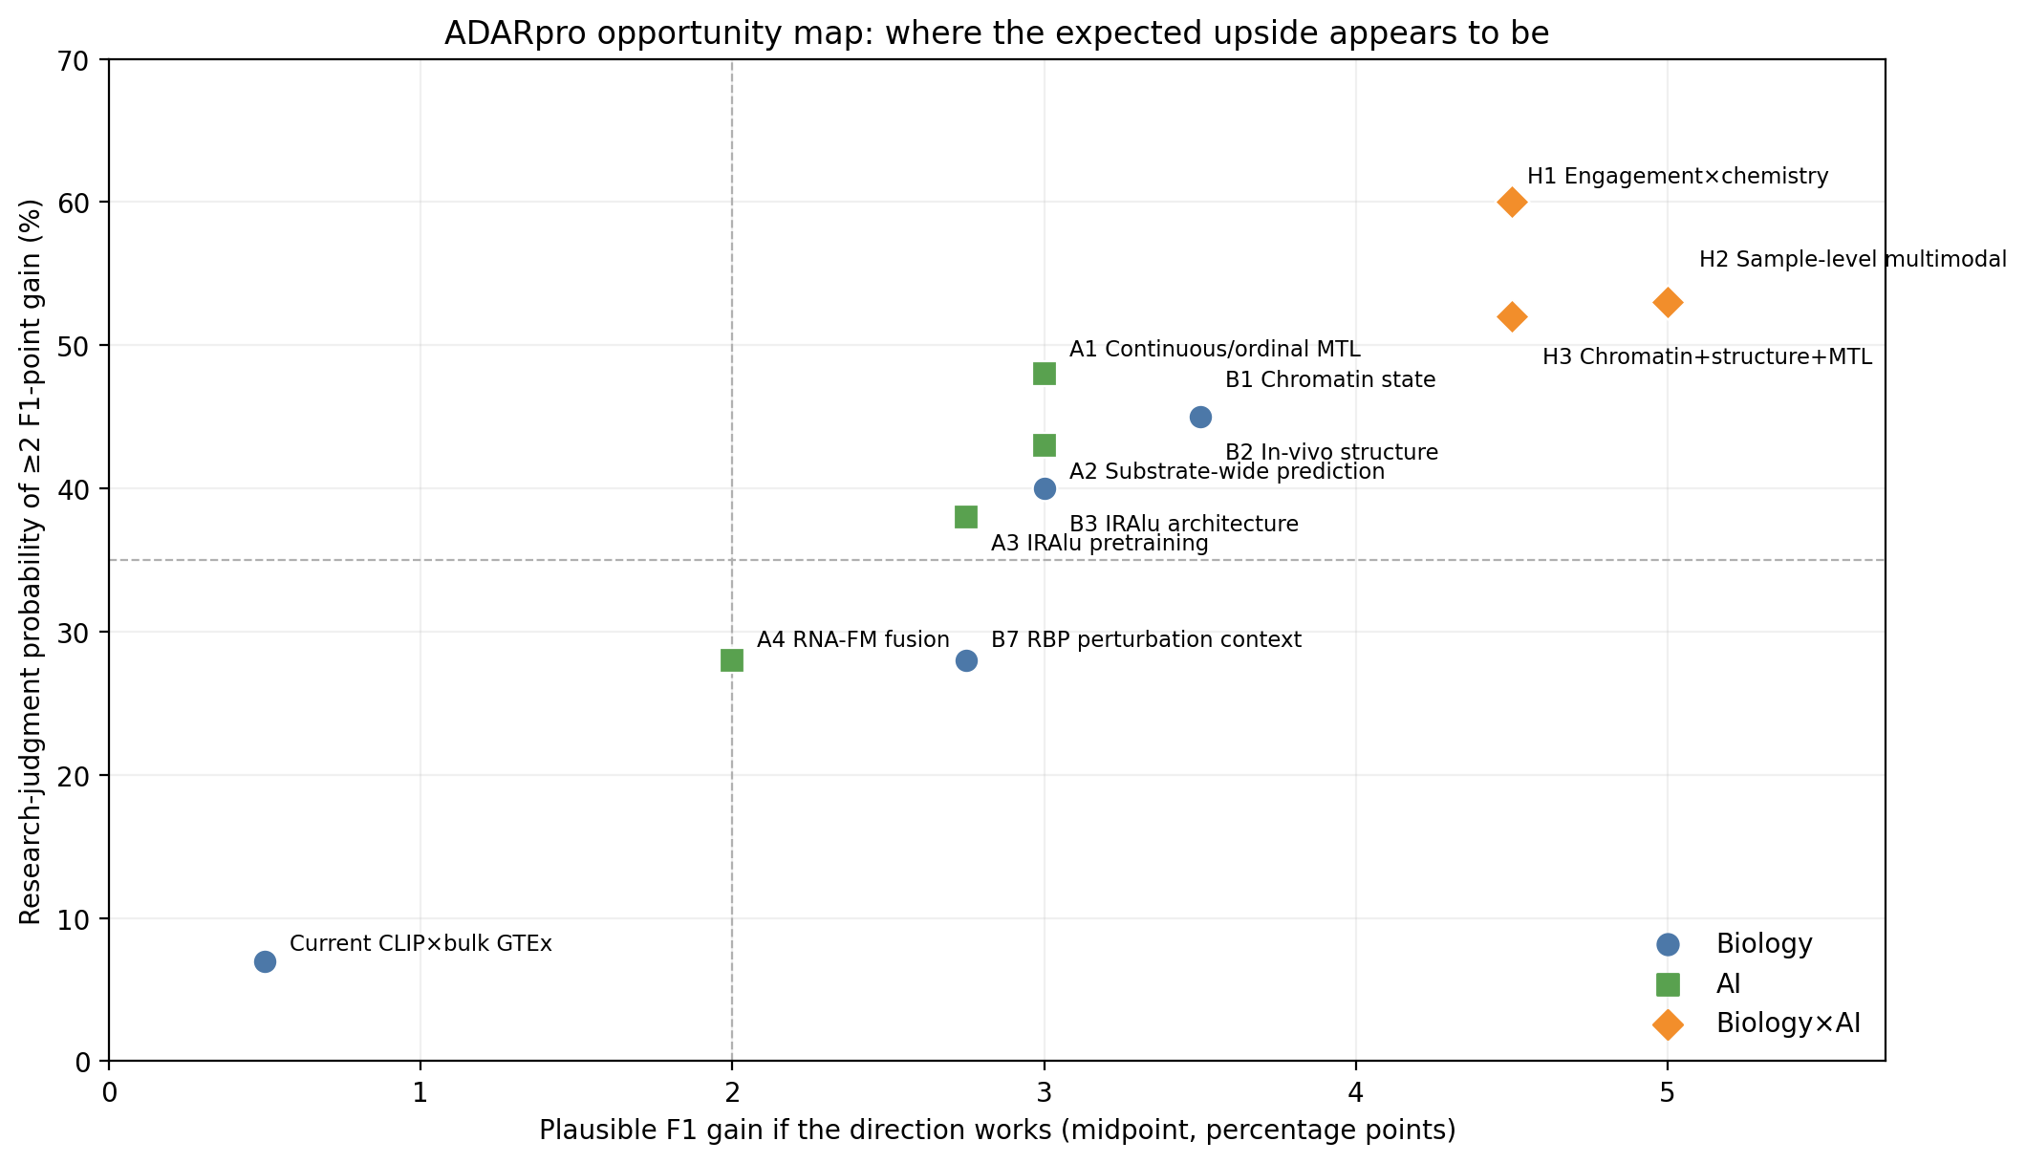
Figure 1. Research-judgment opportunity map. “Probability” and “gain” are prioritization estimates, not empirical confidence intervals.

3. Biology Frontier: New Information the Current Model Does Not See
Rank | Direction | Why it may add information | P(≥2 F1 pts) | Gain if it works | Priority
B1 | Chromatin / co-transcriptional state | H3K36me3, H2A.Z, accessibility and related marks can affect site-specific editing upstream of the RNA-only representation. | 40–50% | +2 to +5 | High
B2 | In-vivo RNA structure / structural ensemble | RNAfold supplies one predicted MFE structure; cellular RNA occupies a dynamic ensemble shaped by proteins, transcription and compartment. | 40–50% | +2 to +5 | High
B3 | IRAlu genomic architecture | Pair distance, same intron/exon, Alu subfamily, local repeat density, divergence and genomic organization are strong, cheap priors. | 35–45% | +2 to +4 | Very high
B4 | Transcript state | Isoform, intron retention, splicing kinetics, nuclear residence and processing state may determine how long an editable duplex exists. | 30–40% | +1.5 to +4 | Medium
B5 | ADAR state | p110/p150 balance, ADAR2/ADAR3, interferon response and localization may be more informative than total ADAR TPM. | 25–40% | +1.5 to +4 | Medium
B6 | Cell-type composition / single-cell state | Bulk tissue averages can obscure distinct editomes and regulatory states in specific cell populations. | 25–40% | +1.5 to +4 | Medium
B7 | Cell-matched / perturbation-derived RBP competition | The biology is credible, but the current measurement is mismatched. Perturbation-informed or cell-matched effects remain plausible. | 20–35% | +1.5 to +4 | Medium
B8 | More generic CLIP/predicted binding × bulk GTEx | Already tested in the most relevant matched analyses and did not add signal. | <10% | 0 to +1 | Low

3.1 Why IRAlu genomic architecture deserves an immediate test
This is the highest-value low-cost experiment. A classic genome-wide analysis of 203,798 Alu repeats found that distance to the closest reversely oriented Alu was the strongest global factor and alone explained about 28% of the variance in Alu editability. Same intron/exon placement, neighborhood repeat counts, expressed strand, Alu length and subfamily also contributed.
- Pair span and inter-Alu gap length
- Alu subfamily and divergence from consensus
- Same intron/exon versus different transcript segment
- Local inverted-Alu density and competing partners
- Transcript annotation, intronic/UTR/exonic context, and isoform compatibility
Why this matters: These variables describe whether a stable IRAlu duplex is likely to form at all. They are not equivalent to the final folded graph and may therefore explain substrate-level variation that a site-local message-passing model cannot reconstruct reliably.

3.2 Chromatin is the strongest new biological lead
A July 2026 preprint directly links chromatin state to site-specific A-to-I editing. Across multi-omics analyses, H3K36me3 emerged as a strong negative predictor and H2A.Z.1 as a positive association; perturbation experiments supported opposing effects. This is attractive for ADARpro because chromatin is an upstream state variable that an RNA sequence/structure graph cannot infer uniquely.

3.3 RBP biology should not be abandoned — but its measurement must change
The mechanistic literature remains strong. ILF2/ILF3/STRBP/ZFR and other RBPs have direct interaction, perturbation or occupancy evidence in ADAR regulation. Recent work supports ILF2/3 shielding of Alu dsRNA, and other studies show context-dependent competition and bidirectional regulation. The negative ADARpro result therefore argues that generic cell-line CLIP or predicted-binding multiplied by bulk tissue TPM is an inadequate proxy for the relevant molecular state.

4. AI Frontier: Better Learning from the Data We Already Have
Rank | Direction | Core idea | P(≥2 F1 pts) | Gain if it works | Priority
A1 | Continuous + ordinal + binary multi-task learning | Use EditingIndex directly and retain the 1–15% intermediate regime instead of discarding it. | 40–55% | +2 to +4 | Highest AI-only priority
A2 | Substrate-wide multi-A prediction | Predict all adenosines on an IRAlu substrate jointly so the model can learn a shared “substrate engagement/editability” latent state. | 35–50% | +2 to +4 | High
A3 | Self-supervised pretraining on large IRAlu/RNA corpora | Pretrain representations or graph objectives on orders of magnitude more unlabeled duplexes before supervised fine-tuning. | 30–45% | +1.5 to +4 | High
A4 | RNA foundation-model fusion | Fuse frozen or lightly tuned RiNALMo/ERNIE-RNA representations with the explicit AdarEdit graph. | 20–35% | +1 to +3 | Medium
A5 | Graph Transformer / GATv2 / richer message passing | Potentially better long-range interactions, but does not solve missing-information limitations. | 15–30% | +1 to +2.5 | Medium-low
A6 | Ensembling / calibration / stacking | Useful for incremental robustness and calibration, but unlikely to create a large conceptual gain. | 15–25% | +0.5 to +1.5 | Low
A7 | Simply making the GNN larger/deeper | Likely capacity without new signal; effective sample size remains limited by pair-level independence. | <10% | 0 to +1 | Very low

4.1 The strongest AI-only experiment: learn the continuous biology
The binary benchmark deliberately removes intermediate EditingIndex values. The development atlas contains tens of thousands of intermediate observations that are biologically informative but absent from the binary loss. A shared encoder can be trained jointly on continuous EditingIndex, ordinal state (absent/intermediate/high), and the canonical binary task. This increases supervision richness without requiring a new external dataset.

4.2 Predict the substrate first, then the site
A site-by-site classifier asks the wrong question when editing is clustered on dsRNA. A substrate-wide model can estimate a shared latent engagement state for the entire inverted-Alu duplex and then predict editing at every adenosine conditionally. This is a natural way to separate “is this substrate engaged by ADAR?” from “which adenosines are chemically favorable once engaged?”

4.3 Foundation models: auxiliary view, not replacement
RiNALMo and ERNIE-RNA make this direction worth testing, but not as a wholesale replacement for AdarEdit. RiNALMo is a 650M-parameter RNA language model trained on tens of millions of sequences and demonstrates strong structural generalization. ERNIE-RNA adds structure-enhanced attention priors. The most plausible use here is late fusion or per-nucleotide embeddings alongside an explicit structure graph, preserving the inductive bias that already works for the task.

5. Biology × AI: The Highest-Upside Directions
Rank | Integrated direction | What changes conceptually | P(≥2 F1 pts) | Gain if it works | Priority
H1 | Hierarchical substrate-engagement × site-chemistry model | Explicitly factor realized editability into a substrate-level engagement probability and a conditional site-level deamination probability. | 55–65% | +3 to +6 | Best overall bet
H2 | Donor/sample-level multimodal learning | Model site × sample using donor transcriptome, ADAR state, splicing/isoforms, cell composition and other state variables instead of a tissue average. | 45–60% | +3 to +7 | Moonshot / high upside
H3 | Chromatin + structural ensemble + continuous multi-task learning | Combine a genuinely new upstream biological state with richer supervision and explicit RNA structure. | 45–60% | +3 to +6 | High
H4 | ADAR isoform/IFN state × transcript compartment × mixture-of-experts | Use tissue/state-conditioned experts to represent distinct ADAR regimes rather than one pooled mechanism. | 35–50% | +2 to +4 | Medium-high
H5 | In-vivo structure × structure-aware graph/Transformer | Replace one static MFE graph with experimentally informed or ensemble-aware structure while retaining explicit graph reasoning. | 35–50% | +2 to +5 | Medium-high
H6 | Cell-type embedding × intrinsic AdarEdit | Condition intrinsic editability on a learned cell-state representation rather than tissue identity alone. | 30–45% | +2 to +4 | Medium
H7 | Perturbation-trained RBP competition × cellular state | Learn RBP effects from perturbation evidence, then transfer those signed effects to the target context. | 25–40% | +2 to +4 | Medium
H8 | ADAR–RNA structural contact geometry × local graph | Use mechanistic contact windows/bulge geometry as priors or features around the target site. | 20–35% | +1.5 to +4 | Exploratory

5.1 The leading thesis: realized editability is a product of two processes
Proposed decomposition: P(edit at site) ≈ P(substrate forms / persists / is accessible / is engaged by the relevant ADAR) × P(site is deaminated | substrate engaged).

The first term should consume substrate- and state-level information: IRAlu geometry, chromatin, transcript isoform, splicing/intron state, in-vivo accessibility, ADAR isoform/state, localization and cellular context.
The second term should consume site chemistry and local structure: local sequence preference, pairing state, bulges, structural geometry, target position and neighboring editable adenosines.
This formulation explains an otherwise puzzling observation: a richer GNN can fail if it merely adds detail to the second term while the dominant missing uncertainty is in the first.

5.2 Why sample-level modeling could create the largest jump
Tissue averages collapse the very variability we are trying to explain. If compatible donor-level editing estimates can be reconstructed, the unit of learning becomes site × donor/sample rather than one site with one tissue-averaged label. This creates much richer supervision and permits explicit conditioning on ADAR1/2/3, interferon programs, transcript isoforms, splice junctions, and inferred cell composition.
Critical guardrail: A sample-level study must remain leakage-safe at both the biological-substrate level and the donor/sample level. Otherwise a model can memorize pair, donor, or tissue identity and produce deceptively strong performance.

5.3 Mechanistic structural priors are becoming unusually actionable
Recent structural work provides a concrete reason to revisit local RNA geometry. A 2026 Cell study mapped functional ADAR1/ADAR2 interaction windows along dsRNA and showed that bulges within ADAR-binding regions modulate editing sensitivity and specificity. These rules could be encoded as engineered local descriptors, structural priors, or auxiliary losses rather than asking a generic GNN to rediscover them from a small supervised dataset.

6. Practical Decision Tree
- Finish the leakage-free residual experiment already in progress. If the current RBP context unexpectedly produces robust incremental signal, preserve it as a low-capacity post-hoc gate and do not immediately escalate model complexity.
- In parallel, run the cheapest high-prior biology experiment: IRAlu genomic architecture and transcript annotation features.
- Train continuous + ordinal + canonical-binary multi-task AdarEdit using all development observations, including the intermediate EditingIndex regime.
- Build a substrate-wide multi-adenosine model and test whether a shared substrate latent state improves the canonical task.
- Add chromatin/co-transcriptional features where tissue/cell-matched tracks are credible. Test them first as a simple residual layer before integrating them into a neural model.
- Only if at least one of steps 2–5 shows real incremental signal, build the hierarchical engagement × site-chemistry model.
- Treat donor/sample-level GTEx-style modeling as the high-cost, high-upside branch after the data mapping and leakage design are proven feasible.
- Return to RBP competition only with a materially better measurement: cell-matched occupancy, perturbation-derived signed effects, activity/localization, or a mechanistically trained competition model.

7. Recommended Experiment Portfolio
Order | Experiment | Cost | Risk | Why it belongs in the portfolio
1 | IRAlu genomic-context feature panel | Low | Very low | Strong prior, nearly free, can falsify a major missing-variable hypothesis quickly.
2 | Continuous + ordinal + binary multi-task model | Low–medium | Low | Uses information currently discarded; clean AI-only test.
3 | Substrate-wide multi-A prediction | Medium | Medium | Tests the engagement latent-state hypothesis without new external biology.
4 | Chromatin feature pilot | Medium | Medium | Strongest new biological lead; test via low-capacity residual model first.
5 | Hierarchical engagement × chemistry model | Medium–high | Medium | Most coherent integrated theory if upstream signal is observed.
6 | Donor/sample-level multimodal dataset | High | High | Largest potential data expansion and largest possible gain; requires careful cohort engineering.
7 | In-vivo/ensemble structure | High | Medium–high | Potentially fundamental but data mapping is nontrivial.
8 | Cell-matched perturbation RBP model | Medium–high | Medium | Biologically credible salvage path for RBP hypothesis; do not repeat generic CLIP×TPM.

8. What Not to Spend the Next Month Doing
- Do not scale the current GAT simply because more capacity is available. Without a new signal source, this is the lowest expected-value branch.
- Do not perform unrestricted feature selection over hundreds of sparse RBP channels. The effective independent sample size is pair-level, and the present matched analyses already warn that generic RBP feature expansion can fit noise.
- Do not interpret missing eCLIP peaks as biological absence in inverted Alu regions; repeat-aware mapping limitations make this especially unsafe.
- Do not let tissue identity masquerade as mechanism. The strict-switch direction task is almost saturated by the tissue hierarchy and is therefore a poor target for discovering subtle RBP effects.
- Do not open the canonical test set during iteration. The final scientific value of the project depends on preserving a true one-shot evaluation.

9. How to Interpret Future Results
Observed outcome | Interpretation | Action
ΔF1 < 0.5 point | Noise / minor engineering improvement | Do not build a new biological story around it.
ΔF1 ≈ 0.5–1.5 | Incremental improvement | Worth keeping if stable, calibrated and low-cost; not yet a new central mechanism.
ΔF1 ≥ 2 | Meaningful advance | Strong enough to justify deeper ablation and mechanistic analysis.
ΔF1 ≥ 3–5 | Major result | Potentially paper-defining if pair-bootstrap CIs, controls and untouched test all support it.
Large dev gain, weak frozen test | Likely selection/shift problem | Audit feature availability, leakage, context mismatch and effective sample size.
North-star claim: The most compelling endpoint is not “we added biological features and the score went up.” It is: AdarEdit captures intrinsic RNA editability, while a separately modeled substrate-realization layer explains a measurable portion of the remaining errors and improves prediction under strict pair-disjoint evaluation.

10. Selected Evidence Anchors
- AdarEdit reproducibility repository — https://github.com/Scientific-Computing-Lab/AdarEdit
- AdarEdit preprint, v2 — https://www.biorxiv.org/content/10.64898/2026.02.02.703375v2
- Cai et al. (2026), “Chromatin state shapes site-specific A-to-I RNA editing,” bioRxiv. DOI 10.64898/2026.07.27.740859 — https://doi.org/10.64898/2026.07.27.740859
- Bazak et al. (2014), “Genome-wide analysis of Alu editability,” Nucleic Acids Research. PMID 24829451 — https://pubmed.ncbi.nlm.nih.gov/24829451/
- Freund et al. (2020), “Unbiased Identification of trans Regulators of ADAR and A-to-I RNA Editing,” Cell Reports. DOI 10.1016/j.celrep.2020.107656 — https://doi.org/10.1016/j.celrep.2020.107656
- Quinones-Valdez et al. (2019), Communications Biology. DOI 10.1038/s42003-018-0271-8 — https://doi.org/10.1038/s42003-018-0271-8
- Park et al. (2026), ILF2/ILF3–Alu shielding preprint. DOI 10.64898/2026.01.14.699349 — https://doi.org/10.64898/2026.01.14.699349
- Yi et al. (2026), Nature Communications. DOI 10.1038/s41467-026-71207-3 — https://doi.org/10.1038/s41467-026-71207-3
- Song et al. (2026), “RNA structure programs endogenous ADAR for precise and efficient editing,” Cell. DOI 10.1016/j.cell.2026.04.047 — https://doi.org/10.1016/j.cell.2026.04.047
- Penić et al. (2025), “RiNALMo: general-purpose RNA language models can generalize well on structure prediction tasks,” Nature Communications. DOI 10.1038/s41467-025-60872-5 — https://doi.org/10.1038/s41467-025-60872-5
- ERNIE-RNA (2025), Nature Communications. DOI 10.1038/s41467-025-64972-0 — https://doi.org/10.1038/s41467-025-64972-0

11. Bottom Line
If the goal is a real step change rather than another fractional gain, the research program should broaden from “AdarEdit + RBP” to “ADARpro = a model of substrate realization.” AdarEdit asks whether an RNA configuration is intrinsically editable. The next layer should ask whether that configuration actually forms, persists, is accessible, encounters the relevant ADAR state, and is realized in the observed cell or tissue. The highest expected value lies in modeling those two stages explicitly and learning them with richer, multi-scale supervision.

