

Repo questions
CodeCanopy  Ask questions about the repo |  | Version 1.0  26 September 2026

Contents

Executive summary 2
Key findings and scope 3
User experience 4
Recommended technical design 5
API behavior 6
Reliability and cost controls 7
Acceptance and delivery 9
Appendix and sources 10
Read the scope and user flow first. The technical design, API behavior and release gates provide the implementation handoff. Source references distinguish product intent from inspected code.

Executive summary
Build Ask CodeCanopy as a repository-grounded question feature inside the existing workspace. A developer asks about the imported repository or selected source, receives a concise answer with evidence, and opens the exact cited lines. The feature helps the developer decide where to look and what to inspect before a change.
This PRD specifies the assigned feature “ask questions about the repo”. Its owner builds the frontend behavior and backend logic using the visualization owner’s shared UI. It preserves the master PRD’s Watson runtime, read-only behavior, bounded retrieval and honest uncertainty. Grepo is the earlier product name; the implementation and user-facing copy use CodeCanopy. [S1]

Outcome and scope
- Answer repository purpose, location, explanation and comparison questions from original source. Support follow-up questions on the same snapshot.
- For impact, reuse and cleanup questions, provide supported locations and limitations. Add resolved relationships only when a real analysis provider supplies them.
- A result is useful when its sources are correct and the user can inspect them. A plausible answer without valid evidence is not success.

What exists today
At commit 0625c2f26be94f16c9cc5bbf947b155acbdc4867, imports, immutable snapshots, workspace-scoped source access, the file tree and structural map are implemented. AskPage mounts ask.workspace, but no feature is registered. GET /ask and POST /answers return HTTP 501; the chat package contains empty request/result models and a service Protocol. No inference engine is present. [S2–S5]

Delivery decision
Implement one vertical slice: authorized source retrieval → Watson generation → evidence validation → answer and source navigation. Use the existing React/TypeScript/Vite frontend and FastAPI backend. Keep the model configurable; no exact model or vendor price is selected by this PRD.
Release only after a real provider call, cancellation, failure handling and the acceptance suite pass. The repository’s verification record describes the structural workspace; it is not evidence that Ask works. All new performance and quality numbers below are targets, not achieved results. [S3]

Key findings and scope
The master PRD supplies intended behavior. Current code establishes implementation status and integration constraints. Where they differ, retain the intended feature but implement against the current code. [S1–S5]
Area | Verified current state | Requirement for Ask
Entry point | Ask slot and 501 endpoints exist. | Replace only Ask placeholders with real behavior.
Graph | Containment edges only; Python syntax is not call resolution. | Do not describe structural edges as runtime dependencies.
Lifecycle | Source expires after 24 hours; deletion removes snapshot files. | Expire retrieval index, answers and source-bearing history with it.
Navigation | openSource validates selection and navigates to Map. | Citation clicks use this existing source viewer.
Feature loading | SlotMount may reload on selection or view changes. | Never attach paid generation to its automatic loader.

Required behavior
ASK-01 Snapshot scope. Bind every request, answer, source and follow-up to the authorized project and immutable snapshot. Switching snapshots cancels or detaches the old request and starts a fresh context.
ASK-02 Retrieval first. Retrieve allowed source before inference. ASK-03 Evidence validation. Verify canonical file identity, full-file SHA-256 and inclusive line ranges before publishing citations. ASK-04 Truth labels. Separate observed, resolved, inferred, unknown and hypothetical claims.
ASK-05 Constrained execution. Repository text cannot trigger shell commands or arbitrary network access. ASK-06 Follow-ups. Resolve “that file” from validated earlier subject IDs. ASK-07 Degraded mode. Preserve retrieved locations when the model fails. ASK-08 Abstention. State when evidence is insufficient. ASK-09 Idempotency. Repeated request IDs cannot create duplicate paid work. [S1 §14]

Scope boundary
P0 includes repository and selected-file/folder questions, bounded history, evidence navigation, cancellation, cost controls and useful failures. Summary and semantic graph inputs are optional when available. Web search, attachments, private GitHub access, code edits, proposal generation, universal call resolution, hosted vector databases and new offline-answer exports are outside this feature. Existing HTML exports remain structural and source-free.

User experience
Use the existing workspace shell and design tokens. Keep one composer, one answer area, expandable evidence and up to three follow-up prompts. The imported repository and revision remain visible. [S1 §§7, 26–27]
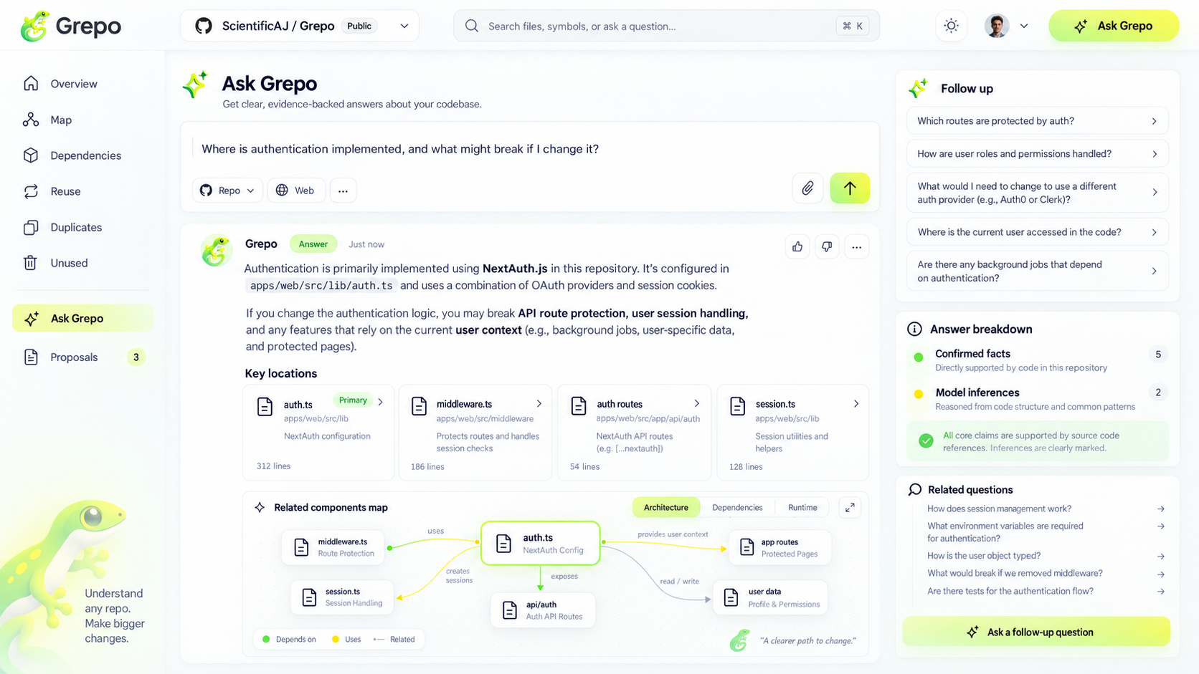
Design reference from the supplied master PRD. Its old name, auth example, counts and dependency edges are illustrative. Use CodeCanopy branding, hide Web and attachment controls, and render only data supported by the selected snapshot.

Primary flow
- Open Ask with an optional selected entity and line range shown in a removable context chip. Enter submits; Shift+Enter inserts a newline. Typing, selection changes and navigation incur no inference.
- Show Queued, Finding sources, Drafting, then Checking sources. Keep retrieved files available during generation. Cancel stops further work and suppresses late output.
- Present the direct answer first, then claim-level source links, uncertainty and follow-ups. A citation opens the exact range through openSource and synchronizes selection. Browser Back returns to the retained Ask conversation.

States and accessibility
Distinguish empty, busy, answered, insufficient evidence, partial coverage, provider failure, budget blocked, cancelled and expired. Disable duplicate submission while busy but keep the composer text. Keyboard users can submit, cancel and open citations; status updates use a polite live region. Text labels accompany truth categories. At 390 px width, source cards stack and the evidence panel becomes a disclosure. Do not display a confidence percentage or “all claims verified” badge.

Recommended technical design
Use a small server pipeline inside the existing API process: authorize → resolve scope → retrieve → reserve cost → generate → validate → publish. New code belongs in backend/app/features/codebase_chat and frontend/src/features/ask. Reuse snapshot_access, read_source_lines and the shared API client. [S4–S5]

Retrieval and evidence
Build a lazy, snapshot-local lexical index from allowed text only. Recommended implementation: SQLite FTS5 with BM25 ranking, plus exact path and symbol matches. Split snake_case and camelCase identifiers for recall while preserving original source. Parameterize SQL and safely quote search tokens; do not accept raw FTS syntax. Embeddings are optional. FTS5 availability must be checked in the deployed Python build. [S7]
Use Python symbol boundaries where available; otherwise use line-preserving windows of about 80 lines with 10-line overlap, also bounded by bytes. Proposed indexing limits are 25 MiB of allowed text and 20,000 chunks per snapshot; report omitted files/bytes as partial coverage. Never silently answer as though an incomplete index covered the whole repository.
Rank exact identifiers first, then lexical relevance, selected-context proximity and optional validated neighbors. Diversify across files and deduplicate overlapping spans. A selected-file/folder scope is a hard retrieval filter until the user broadens it. Paginate the full inventory; do not index only the small graph currently visible.
Select at most 12 chunks and 24,000 UTF-8 bytes in total, then fit within the configured model token limit including prompt, history and output reserve. Re-read selected spans through read_source_lines before generation. Server-issued evidence records carry snapshot_id, file_id, original path, inclusive range and the full-file content hash. [S1 §14]

Context and optional analysis
Treat question intent as a routing hint: purpose, location, explanation, relation, reuse, comparison, cleanup or proposed change. Use deterministic routing initially. Search summaries only when a real provider exists, then verify claims against source. Traverse at most three hops of validated semantic edges; current containment edges cannot satisfy a “what calls this?” question.
An impact answer may give an evidence-linked reading order, labeled suggested inspection. A resolved Change Trail requires an actual relationship service. If a pronoun has multiple plausible subjects, ask a short clarification without guessing. Retain at most the last six turns; prior model prose is context, never evidence.

API behavior
The routes below are proposed Ask additions. S means /api/v1/projects/{project_id}/snapshots/{snapshot_id}. Existing imports, shared contracts and unrelated slots retain their current behavior. [S4]
Method | Route | Result
GET | S/ask | 200 readiness and index coverage; no generation. 501 only while unconnected.
POST | S/answers | 202 with answer_id, snapshot_id and pending status. Requires Idempotency-Key.
GET | S/answers/{answer_id} | 200 AnswerState with current status and validated Answer when available.
POST | S/answers/{answer_id}/cancel | 200 current state; idempotent; terminal results remain terminal.

Request and response
QuestionRequest fields: question (trimmed, 1–4,000 characters), scope (repository, file or folder), subject_entity_id (required for file/folder), optional line_range and previous_answer_id. The server creates or resumes a conversation from the previous answer. IDs and ranges must belong to S and the current workspace. Ignore no unknown fields: reject them with 422.
AnswerState contains answer_id, snapshot_id, conversation_id, status, phase, answer (nullable), retrieved_evidence and error (nullable). Status is pending, draft, validated, failed or cancelled. Phases are queued, indexing, retrieving, generating and validating. Poll at 1 second, backing off to 3 seconds; stop at terminal state. Streaming is a later enhancement, not needed for P0.
The final Answer keeps the existing 1.0 fields: id, snapshot_id, status, question, claims, evidence, limitations, follow_ups, model_config_id and fixture_only, plus schema_version. The first claim(s) form the direct response; each claim carries text, basis and evidence_ids. No new answer_text field is required. Live results have fixture_only=false. “Validated” means structural and reference checks passed, not that an LLM’s reasoning is proven correct.

Lifecycle and errors
Persist the request and budget reservation before dispatch. Same workspace/snapshot/key and same payload returns the original answer ID; a changed payload returns 409. Keep a unique durable key for the snapshot lifetime. A restarted process marks interrupted work failed; it must not resubmit uncertain paid work automatically.
Reuse the v1 error envelope. Use 422 for invalid input, 404 for inaccessible IDs, 410 for expired snapshots, 409 for idempotency or state conflicts, 429 for capacity/quota, 503 for provider unavailability and 504 for deadline expiry. Budget rejection uses 429 with AI_BUDGET_EXCEEDED and retryable=false. The current status-only retryability helper needs a feature-specific override for this case.

Reliability and cost controls

Model and publication boundary
Use one server-side watsonx.ai adapter with configured URL, project/deployment context, model ID, context/output limits and credentials. IBM documents chat and asynchronous chat/streaming methods; support must be checked for the chosen model. Run a tiny capability smoke test before enabling repository inference. Override SDK retry defaults to prevent hidden resubmissions. [S6]
Send trusted instructions separately from the question and untrusted source excerpts. The model returns claim text, basis, evidence IDs, limitations and follow-ups; the server supplies IDs, paths, ranges and hashes. No tools, shell or generic fetch capability are exposed. Render text safely and never enable raw HTML. [S8]
Validate JSON, allowed fields, enums, output size and each claim’s evidence references. Require evidence for observed/resolved claims; reject unsupported resolved claims when no resolver exists. Unknown claims may have no evidence. Permit one constrained repair, then fail safely with retrieved locations. Recheck authorization, snapshot availability and cancellation immediately before publication; use a terminal-state compare-and-set so cancel/delete wins over a late model response.

Budgets and limits
Carry forward the master PRD’s $80 total project envelope, $45 inference allocation ($35 normal plus $10 evaluation), and $20 unallocated reserve. The per-question ceiling is $0.50 across generation and repair, not per attempt. These are planning caps, not prices. Paid AI remains disabled until actual rates, model limits and operator configuration are set. [S1 §23]
Atomically reserve the worst-case input/output cost for both permitted attempts before calling Watson. Reconcile returned usage; retain an unresolved reservation after ambiguous timeouts or cancellation. Do not claim cancelling a browser request stops provider billing. Unknown prices block paid calls. Share the global ledger with other AI features; never create an independent allowance that overspends the project budget.
Proposed defaults: two concurrent inference requests, four admitted Ask jobs, 90-second total deadline, 2,000 output tokens and 64 KiB final response. Reject overflow with actionable status. Target warm retrieval p95 under 2 seconds and final answer p95 under 30 seconds on a named ≤1,000-file/10 MiB demo repository, measured over 30 requests.

Storage and privacy
Store index, conversation and evidence under the authorized snapshot so deletion and 24-hour expiry purge source-bearing data. Cache by workspace, snapshot/manifest, policy, question/scope/history, retrieved hashes and model/prompt/retriever versions. Revalidate before serving cached evidence. Keep only source-free cost/idempotency tombstones as needed. Log IDs, latency, token usage and costs; raw prompts/source are off by default. Disclose that selected excerpts go to Watson; do not imply local deletion controls provider retention.

Acceptance and delivery
Every ASK requirement is a release gate. Tests must exercise real retrieval and source navigation, with mock inference used only for deterministic failure scenarios. A separate live Watson run proves provider integration. [S1 §§14, 28]
Gate | Test input or action | Required result
01 / 06 | Switch snapshots; ask “what uses that?” | No old citations; prior subject is resolved only within its original snapshot.
02 / 08 | Missing feature; text-only language | Explain coverage and missing evidence; invent no implementation or negative usage claim.
03 | Wrong file, SHA or line bounds | Reject before display; valid citation opens exact source lines.
04 | Dynamic import or change question | Inference/hypothetical labels; no guaranteed breakage or safe-to-delete claim.
05 | Prompt injection and HTML in source | No tool execution, external fetch or executable markup; secrets excluded.
07 | Provider timeout, bad JSON twice | Clear failure with validated retrieved locations; no fabricated answer.
09 | Double click, retry and process restart | One answer ID; no duplicate dispatch; uncertain billing stays reserved.
Isolation | Other workspace; delete while running | No cross-workspace content; late response cannot republish deleted evidence.
Costs | Parallel calls near cap; repair needed | Atomic reservations prevent overspend; both attempts count.
UX | Keyboard, Back, 390 px, cancel | Working controls, retained conversation, readable sources; no hidden paid calls.

Quality targets
Evaluate at least 30 hand-labeled questions on microfixtures, a polyglot fixture and pinned CodeCanopy. Require ≥90% correct primary locations on answerable questions, 100% structural citation integrity, zero invented paths, and explicit limitations for all intentionally unanswerable cases. A reviewer must assess whether cited lines support each claim; schema validity alone is insufficient. The 100% integrity gate strengthens the master PRD’s 95% target because invalid references can be rejected deterministically.

Implementation order
1. Retrieval and source tests. 2. Durable Ask lifecycle, idempotency and budget ledger. 3. Watson adapter and validator. 4. Register the interactive Ask component without a paid auto-loader. 5. End-to-end, negative and live-provider acceptance. Exact model and prices remain operator configuration; they gate paid execution, not implementation.
Demo: import pinned CodeCanopy, ask “Where is ZIP upload handled, and what should I inspect before changing upload limits?”, open real citations, ask a follow-up, then test a nonexistent NextAuth implementation. Report the workspace session code if relevant without confusing it with NextAuth.

Appendix and sources

Implementation seams
Frontend: keep AskPage as the slot host. Register an interactive component with registerSlot and no generation loader, because registerFeature currently requires an automatic load function. Submit and poll through an Ask adapter importing request and snapshotPath. Keep conversation state keyed by workspace/project/snapshot in memory across route navigation; clear it on session loss or expiry.
Backend: place request models, retrieval, generation, validation and durable Ask jobs in the codebase_chat feature package. Replace its 501 routes and add status/cancel routes. Import run_service is currently an import-specific executor; do not pass questions into it. A small separate Ask executor may share admission conventions while retaining one API worker.
Existing Answer and Evidence types are integration references. This PRD proposes new request/status resources in prose; it does not modify schema files. Stored paths and source navigation always come from the snapshot service, never model-generated paths.

Source register
Inspected 26 September 2026. Repository baseline: 0625c2f26be94f16c9cc5bbf947b155acbdc4867. The source links below are pinned to that revision. Recorded repository test results were read, not rerun for this documentation task.
S1 — Downloaded Grepo_PRD_Complete_Package.zip: Grepo_Master_PRD.md §§1, 14, 18, 20–24, 26–29 and UI-05. Defines intended scope, Watson, limits and corrected mockup behavior.
S2 — CodeCanopy README and implemented scope
S3 — Recorded workspace verification
S4 — Teammate integration guide
S5 — Code inspected: frontend AskPage, SlotMount, SlotRegistry, FeatureContracts, features/index and v1 API client; backend v1 slots/snapshots, codebase_chat, snapshot_service, graph_service, retention_service, run_service and main. Confirms placeholders, automatic loader behavior, source checks and errors.
S6 — IBM watsonx.ai ModelInference API
S7 — SQLite FTS5 and BM25 documentation
S8 — OWASP prompt injection prevention guidance
External documentation validates adapter and retrieval capabilities. Numeric defaults, endpoint additions and implementation sequencing in this feature PRD are design decisions, not vendor guarantees.

