SEP # 89: New tools for external modules

Version:1.0
Author: Serge Steer
State: DRAFT
Scilab-Version: Scilab 5.4.1
Created: Marsh 2nd, 2013

Abstract
The aim of this SEP is to make the development environment of an external module simpler and more coherent in particular with respect to the module loading process.

Rational

The current environment for building a module is quite good and homogeneous: There is one builder.sce main builder.sce file for the module that sequentially calls builder scripts in each sub-directory (src, macros, help, ...) and these sub-directories builder scripts may in turn call sub-sub-directories builder scripts.
- Here one can already see some in-homogeneity in the naming conventions of the builder files:
Illustration 1: A typical module hierarchy with builder scripts
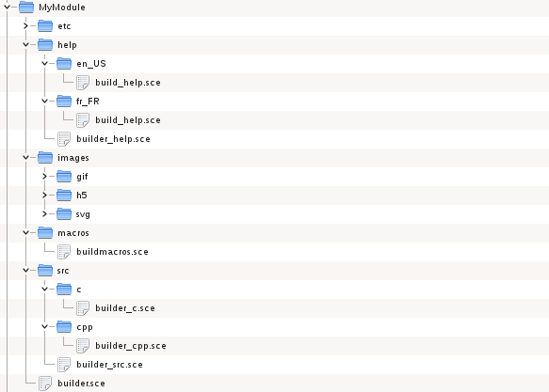
- all level 1 sub-directories builders are names builder_<subdir>.sce but the macros subdirectory named buildmacros.sce instead of builder_macros.sce.
- The level 2 sub-directories builders names are either of the form builder_<subdir> (src) or build_help (macros)

A first improvement should be to improve homogeneity. But changing the builder scripts file names requires to modify the corresponding tbx_builder_xxx functions with the constraint of keeping old style script file name working (This can be done by checking which script file exists). If such a modification is approved, the proposal here should be to name all builder scripts as “builder.sce”.
- The main complexity is however due to the loading process script. The /etc/xxx.start file handles each type of sub-directory in a specific manner:
  - For the src directories one has to execute all the level 2 subdirectories loader scripts (generated by the corresponding builder script):

exec(module_path+"src/c/loader.sce",-1);

exec(module_path+"src/cpp/loader.sce",-1);

...

  - For the macros directory one has to execute

modulelib=lib(module_path+""macros/"")

Or in case of multiple macros subdirectories:

moduleAlib=lib(module_path+""macros/A/"")

moduleBlib=lib(module_path+""macros/B/"")

...

  - For the help directory one has to execute

add_help_chapter(TITLE, module_path+"jar/", %F);

  - For loading the Xcos palettes if any the procedure is even more complex (see the xcos_toolbox_skeleton)

It should be simpler if the xxxx.start file has only to call

exec(module_path+"src/loader.sce",-1);

exec(module_path+"macros/loader.sce",-1);

exec(module_path+"help/loader.sce",-1);

And even, the xxxx.start file can, in such a case, be generated.

For that, the builder scripts should has to generate the associated loader scripts has the src sub-directories builder scripts already do. New functions in the module manager module should be wellcome:
- tbx_build_src_loader(src_path,subdirs) to be called by builder_src.sce to generate the loader_src.sce script
- tbx_build_macros_loader(macros_path,subdirs,libs_basename) to be called by builder_macros.sce (or buildmacros.sce) to generate the loader_macros.sce script
- tbx_build_help_loader(help_path,subdirs,TITLE) to be called by builder_help.sce to generate the loader_help.sce script. May be here the subdirs argument is not needed because add_help_chapter loads only the current languagepwd.
- tbx_build_pal_loader(macros_path,subdirs) to be called by builder_macros.sce (or buildmacros.sce) to generate the loader_pal.sce script

Sample code
- tbx_build_src_loader

function tbx_build_src_loader(src_path,subdirs)

f=["function src_loader()"

" src_path=get_absolute_file_path(""loader_src.sce"")"

" subdirs="+sci2exp(subdirs)

" for k=1:size(subdirs,""*"")"

" exec(""""+src_path+subdirs(k)+""/loader.sce""+"""")"

" end"

"endfunction"

"src_loader();clear src_loader"];

mputl(f,src_path+"loader_src.sce")

endfunction

- tbx_build_macros_loader.sce

function tbx_build_macros_loader(macros_path,subdirs,libs_basename)

if subdirs==[] then

f=["function macros_loader()"

" macros_path=get_absolute_file_path(""loader_macros.sce"");"

" execstr("""+lib_basename+"=resume(lib(macros_path))"");"

"endfunction"];

else

f=["function macros_loader()"

" macros_path=get_absolute_file_path(""loader_macros.sce"");"

" subdirs="+sci2exp(subdirs)+";";

" libs=list();"

" for k=1:size(subdirs,""*"")"

" libs($+1)=lib(macros_path+subdirs(k));"

" end"

" execstr(["+strcat(lib_basename+"_"+subdirs,",")+"]=resume(libs(:));"

"endfunction"

"macros_loader();clear macros_loader"];

end

f=[f;"macros_loader();clear macros_loader"]

mputl(f,macros_path+"loader_macros.sce")

endfunction

- tbx_build_help_loader.sce

function tbx_build_help_loader(macros_path,subdirs,title)

f=["function help_loader()"

" help_path=get_absolute_file_path(""loader_help.sce"");"

" module_path=part(help_path,1:length(help_path)-5;"

" add_help_chapter("+sci2exp(title)+", module_path+""jar/"", %F);"

"endfunction"

"help_loader();clear help_loader"];

end

mputl(f,help_path+"loader_help.sce")

endfunction

Changelog
1.0 – Initial Version

Copyright
This document has been placed under the license CeCILL-B.

