SEP # : 29

Title: datatips
Version: 0
Author: Serge Steer
Review:
Commented:
State:
Scilab-Version: 5.2
Vote:
Created: August 15, 2009

Abstract
Datatips are small text boxes that display data values at data cursor locations in graphic windows.

Rationale
Datatips are very convenient to inspect curve or surface value(s). They can also be used to hilite some particular point of a curve or surface.
A datatip consist of a small black square appears at the selected point of the curve together with a small text area containing the coordinates of the selected point. The text area is automatically located near the black square to keep it inside the axes rectangle (top-left, top-right, bottom-left or bottom right)

Specifications
- Creating a datatip
Datatips can be created either by program either interactively when the user enables this mode (calling a function or selecting a menu).
Setting a datatip by program can simply be done calling a function with the desired curve coordinates as arguments. In the following we concentrates on the interactive mode.
In the interactive mode, a datatip is created when the user clicks on a point of a curve or a surface. The datatip is drawn either on the nearest mesh point of the curve/surface or on a point interpolated from the 2 (4) nearest curve (surface) points. This depends on a mode that can be changed using the contextual menu.
A click on a point of a curve adds a new datatip
- Moving a datatip
A datatip can be moved along a curve or a surface, pressing the left mouse button on the small black square and then dragging the mouse up to the desired point, the datatip follows the curve from mesh point to mesh point or using interpolated positions depending on the selected mode. The displayed coordinates are refreshed during the movement.
- Removing a datatip
A datatip can be removed using a contextual menu that opens by a right click on the « black square ». This contextual menu may also propose to remove all the datatips of the current curve/surface
A left click far away all curves deletes all the datatips on all curves/surfaces
- Customizing datatips display
The legend format displayed in the text box can be customized. The customization menu is available through the contextual menu. This menu opens a Scilab function editor. The function takes as input the handle of the associated curve and the nearest selected point (interpolated point) and returns the string vector that has to be displayed. The customization may be different for each curve.
- Customizing datatips positioning
The text box can be placed in four different positions relative to the small square: "upper left" "upper right", "lower left", "lower right". By default the choice of the position is made by the program to avoid overlapping the plot boundaries. User may prefer to impose this positioning. To do that a click with the middle button opens a contextual menu.
- Dynamic link between curve and its datatips
It should be pleasant that the datatips of a given curve/surface may take into account the deletion , the visibility property change of the associated entity or to the modification of its data. To be able to implement callbacks that reacts to this events should be added to the entity properties. Note that it should be convenient to add these callbacks fields to all the entity types.

Datatips data structure implementation
As a consequence of the specifications a datatips data structure should be added to the polyline and surface entities as a specific field. In the current version the user_data field is used for that purpose.
The datatips data structure must have at least the following fields:
- tip_positioning mode (nearest or interpolated)
- new_tip_mode : erase previous tips or append a new tip
- update_function: function used to generate the text associated with the tips
- tips_array: a vector of handle on each tips data_structure
The parametric curves (or surfaces) poses a question: Suppose one has a curve y=Y(t) vs x=X(t) and wants the datatips display the 2 values t,x,y corresponding to the selected point. For that, it is mandatory that the t discretization is stored in the graphic data structure. For example the black or nyquist function should store the frequency discretization. It has been chosen to store these data in the datatips data structure itself.
In the current version the datatips data structure is a tlist ot type 'datatips' and with at least the following fields:
- interpolate : a boolean, if true the datatips may be positioned between two mesh points.
- replace: a boolean, if true, the addition of a new datatip erases the other datatips on the curve
- formatfunction: a function, the function used to format the string to be displayed
- tips: an array of handle on the tips associated with the curve. Each handle points to a compound entity.
Other fields may be added to store informations on the curve (name, parametric discretization, special value, …) These optionals fields are only used by the formatfunction.

Datatips functions
- datatipCreate: creates a datatip at the given location and returns its handle
- datatipEventhandler: eventhandler for interactive edition
- datatipLookfor: looks for a datatip in the neighborhood of a given point and if found it returns the handle on the curve and the tip index
- datatipMove: start interactive displacement of a given tip
- datatipRemove: remove a datatip given by its handle or its index
- datatipsDefaultDisplay: 2D curve default formatting function
- datatipSetOrientation: sets the positioning of a selected datatip around the curve point
- datatipsGetEntities: returns an array containing the handle of all entities supporting datatips in a given axes (currently: only polylines).
- datatipsGetStruct: gets the datatips data structure out of the given curve datatips field (currently user_data field)
- datatipsInitStruct: initialize the datatips data structure of the given curve
- datatipsManagerMode: toggle or sets the interactive mode for datatips edition. This function is called by the datatips menu callbacks.
- datatipsRemoveAll: remove all the datatips for the given curves
- datatipsSetDisplay: change the datatips visualization function for a given curve
- datatipsSetInterp: changes the interpolation mode for a given curve
- datatipsSetStruct: store the the datatips data structure into the the given curve datatips field
- datatipToggle: toggle the interactive mode for datatips edition

Example Usage
A simple case with one curve and multiple datatips. Note that the tips text has been customized using the function:
function str=ans(curve, index)
pt = string(round(100*curve.data(index, :)/100);
str = msprintf('x: %s\nsinc(x): %s', pt(1), pt(2))
endfunction

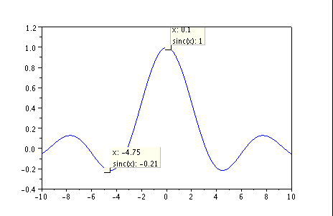

A second example with 2 subplots and a black graph of a 2 outputs system
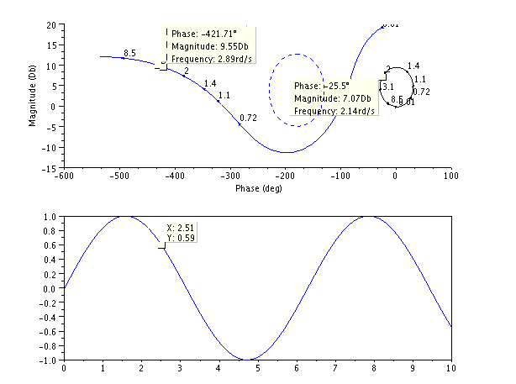

Changelog
  - – initial version
  - - Choice made, more details about implementation.

Copyright
Serge Steer INRIA

