SEP # 56: function nyquistfrequencybounds

Title: function nyquistfrequencybounds
Version:1.0
Author: Serge Steer, INRIA
Review:
Commented:
State:DRAFT
Scilab-Version:Scilab 5.3.x
Vote:No
Created:April 19th, 2011

Abstract
The Nyquist locus is the curve imag(H(s)) versus real(H(s)) for s=2*%i*%pi*f or s=exp(2*%i*%pi*f ) %f varying between fmin and fmax. This new function purpose is to compute fmin and fmax such that the nyquist locus is inside a given rectangle.

Rationale

For high definition zoom of the part of a Nyquist locus located inside a C plane rectangle [Rmin, Rmax]x[Imin,Imax], it is necessary to recompute the curve discretization as well as the curve label position for the part of the curve includes in the rectangle. Consequently it is necessary to kwon the first f for which the locus enters the rectangle as well the last f for which the locus leaves the rectangle.

The possible loops (part of locus going out of the rectangle to go in later) are supposed to be in the rectangle.

Algorithm

This can be done for continuous time solving the equations

(H(s)+H(-s))/2-R=0 for real axis bounds

(H(s)-H(-s))/2-%i*I=0 for imaginary axis bounds

For s=2*%i*%pi*f and f real and positive.

Or for discrete time

H(s)+H(1/z))/2-R=0 for real axis bounds

(H(s)-H(1/z))/2-%i*I=0 for imaginary axis bounds

For z=exp(2*%i*%pi*f) and f real and positive.

And similarly for discrete time system

These equations can be solved using polynomial roots

Calling Sequence

[fmin,fmax] = nyquistfrequencybounds(H,bounds)

bounds if the array [Rmin, Imin;Rmax, Imax]

Example Usage
s=%s
num=2+9*s-9*s^2-11*s^3+0.01*s^4;
den=43*s^2+65*s^3+34*s^4+8*s^5+s^6+0.1*s^7
H=syslin('c',num,den)-1

clf;set(gcf(),'axes_size',[805,549])
subplot(221)
nyquist(H)

subplot(222)
bounds=[-2 -2;2 2]
[fmin,fmax]=nyquistfrequencybounds(H,bounds)
nyquist(H,fmin,fmax)
title("bounds:"+sci2exp(bounds,0));

subplot(223)
bounds=[-1.3 -0.3;0 0.3]
[fmin,fmax]=nyquistfrequencybounds(H,bounds)
nyquist(H,fmin,fmax)
title("bounds:"+sci2exp(bounds,0));

subplot(224)
bounds=[-1.1 -0.1;-0.8 0.1]
[fmin,fmax]=nyquistfrequencybounds(H,bounds)
nyquist(H,fmin,1d8)
title("bounds:"+sci2exp(bounds,0));
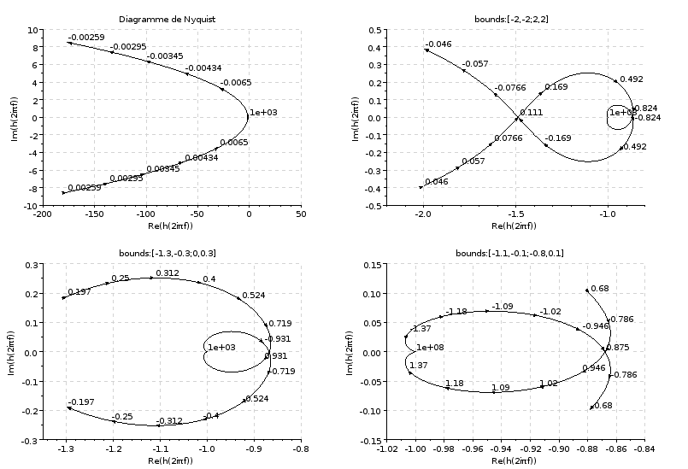

Changelog
1.0 – Initial Version

Copyright
This document has been placed under the license CeCILL-B.

