Software Requirements Specification
for
Cache write policies
Version 1.0 approved
Prepared by
Matteo Zini - 533197
Francesco Paladino - 530271
Raffaele Giannessi - 532978
Giulio Rossolini - 530244
Jacopo Malvatani - 533629

University of Pisa
08/05/2019
Table of Contents
Table of Contents ii
Revision History ii
1. Introduction 1
1.1 Purpose 1
1.2 Product Scope 1
2. Overall Description 1
2.1 Product Perspective 1
2.2 Product Functions 2
3. External Interface Requirements 2
3.1 User Interfaces 2
3.2 Hardware Interfaces 3
3.3 Software Interfaces 3
3.4 Communications Interfaces 3
4. System Features 3
4.1 Miss policies 3
4.1.1 Description and Priority 3
4.1.2 Write-allocate functional requirements 3
4.1.3 Write no-allocate functional requirements 4
4.2 Hit policies 4
4.2.1 Description and Priority 4
4.2.2 Write-back functional requirements 4
4.2.3 Write-through functional requirements 4

Revision History
Name | Date | Reason For Changes | Version
 | 08.05.2019 | First version | 1.0

Introduction

Purpose
<Identify the product whose software requirements are specified in this document, including the revision or release number. Describe the scope of the product that is covered by this SRS, particularly if this SRS describes only part of the system or a single subsystem.>

This document describes the implementation of the cache write policies module. This is a subsystem of the cache, which is part of the microprocessor architecture design.

Product Scope
<Provide a short description of the software being specified and its purpose, including relevant benefits, objectives, and goals. Relate the software to corporate goals or business strategies. If a separate vision and scope document is available, refer to it rather than duplicating its contents here.>

The software is intended to implement all the possible cache write policies in a microprocessor. The implemented policies are: write-through, write-back, write-allocate and write no-allocate.

Overall Description

Product Perspective
<Describe the context and origin of the product being specified in this SRS. For example, state whether this product is a follow-on member of a product family, a replacement for certain existing systems, or a new, self-contained product. If the SRS defines a component of a larger system, relate the requirements of the larger system to the functionality of this software and identify interfaces between the two. A simple diagram that shows the major components of the overall system, subsystem interconnections, and external interfaces can be helpful.>

The module is an extension of the basic 1-way cache module of a typical architecture of a microprocessor. The module is a component of the set-associative cache module which is part of a multilevel cache system. The basic scheme representing the position in the whole architecture of the designed module is shown in the following picture.
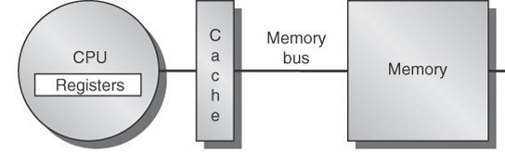

Product Functions
<Summarize the major functions the product must perform or must let the user perform. Details will be provided in Section 3, so only a high level summary (such as a bullet list) is needed here. Organize the functions to make them understandable to any reader of the SRS. A picture of the major groups of related requirements and how they relate, such as a top level data flow diagram or object class diagram, is often effective.>

This module is instantiated by the higher-level set-associative module for every cache way; the caller must provide to the constructor the desired write policy which must be followed.
In order to apply that policy, every write and read operation must be processed by this module and redelivered to the 1-way cache module.

The operations that this module provides are:
- Constructor: decide the write policies
- Read: read a word from the cache
- Write: write a word into the cache

External Interface Requirements

User Interfaces
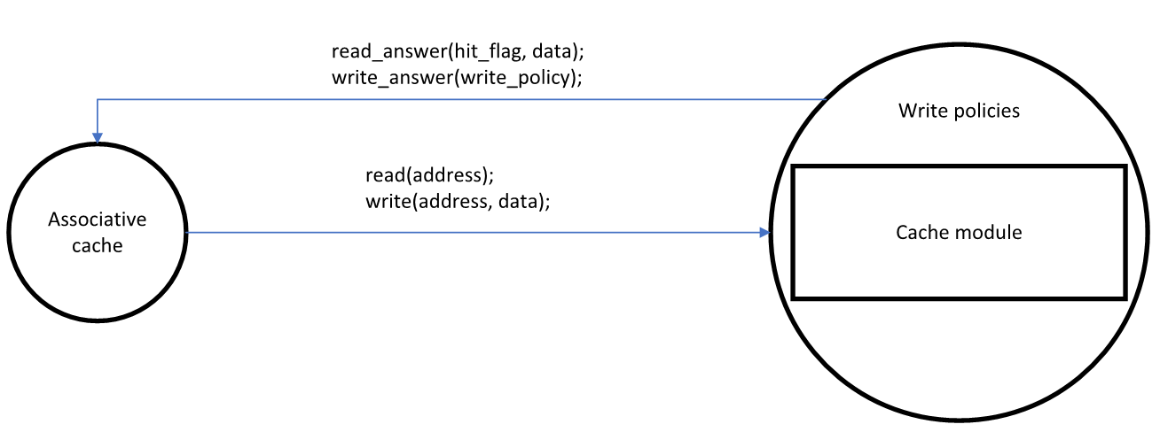
<Describe the logical characteristics of each interface between the software product and the users. This may include sample screen images, any GUI standards or product family style guides that are to be followed, screen layout constraints, standard buttons and functions (e.g., help) that will appear on every screen, keyboard shortcuts, error message display standards, and so on. Define the software components for which a user interface is needed. Details of the user interface design should be documented in a separate user interface specification.>
This module as a C++-class is an extension of the cache module

Software Interfaces
<Describe the connections between this product and other specific software components (name and version), including databases, operating systems, tools, libraries, and integrated commercial components. Identify the data items or messages coming into the system and going out and describe the purpose of each. Describe the services needed and the nature of communications. Refer to documents that describe detailed application programming interface protocols. Identify data that will be shared across software components. If the data sharing mechanism must be implemented in a specific way (for example, use of a global data area in a multitasking operating system), specify this as an implementation constraint.>

This module exchange messages between the higher-level set-associative module in order to execute the operation required. To make the communication between these two modules we define a format for the request and for the response.

The structure of the request has these fields:
- OpType op_type: this is the type of the operation requested
- uint16_t address: this is the address on which the operation has to be performed
- uint16_t* data: this field is used only in case of write

The fields “address” and “data” must be set differently with respect to the “op_type” and this has to be done according to the following list:
- SET_DIRTY: set the address of the cache line to set dirty
- CHECK_VALIDITY_DIRTY: set the address to check
- CHECK_DATA_VALIDITY: set the address to check
- INVALID_LINE: set the address to invalid
- LOAD: set the address of the block to load
- STORE: set the address where to store the block and its data
- WRITE_WITH_POLICIES: set the address where to store the word and its data

The structure of the response has these fields:
- In case of read
  - bool hit_flag
  - uint16_t* data
  - uint16_t address
- In case of write
  - WriteResponse wr

All those fields have different means with respect to the “op_type” requested previously and this is chosen according to the following list:
- SET_DIRTY: address of the dirty cache line and the hit flag: 0 if the line is invalid
- CHECK_VALIDITY_DIRTY: address of the checked cache line and the hit flag: 1 if the line is dirty
- CHECK_DATA_VALIDITY: address of the checked cache line and the hit flag: 1 if the line is valid
- INVALID_LINE: address of the invalidated cache line and the hit flag: 0 if the line was already invalid
- LOAD: address of the requested cache line, hit flag (1 in case of hit) and the read data (null in case of miss)
- STORE: address of the written cache line
- WRITE_WITH_POLICIES:
if (hit_flag == 1)
address: the address of the written word
else
if (the block is invalid)
address: the address of the word to be written
else
address: the address of the block which is occupying the requested location
wr: action that the caller must perform, depending on the write policy

Required Interface
<Describe the requirements associated with any communications functions required by this product, including e-mail, web browser, network server communications protocols, electronic forms, and so on. Define any pertinent message formatting. Identify any communication standards that will be used, such as FTP or HTTP. Specify any communication security or encryption issues, data transfer rates, and synchronization mechanisms.>

Since the cache write policies module extends the direct-mapped cache module, this interface is required:
- Load(address) : data
- Store(address, data) : result
- Invalid_line(address) : void
- Check_data_validity(address) : result
- Set_dirty(address, value) : void
- Check_validity_dirty(address) : value

System Features
<This template illustrates organizing the functional requirements for the product by system features, the major services provided by the product. You may prefer to organize this section by use case, mode of operation, user class, object class, functional hierarchy, or combinations of these, whatever makes the most logical sense for your product.>

Miss policies

Description and Priority
<Provide a short description of the feature and indicate whether it is of High, Medium, or Low priority. You could also include specific priority component ratings, such as benefit, penalty, cost, and risk (each rated on a relative scale from a low of 1 to a high of 9).>

Through a parameter passed to the constructor of this module, it’s possible to choose between two different behaviors in case of miss:
- Write-allocate
- Write no-allocate

Write-allocate functional requirements
When a word needs to be written, it can happen that there’s not a copy of it in the cache memory. If this policy must be followed, the operation cannot be completed until the word is transferred into the cache. In order to do it, this module replies to the caller with a code which means that before serving the request, it must copy that word into the cache.

Write no-allocate functional requirements
When a word needs to be written, it can happen that there’s not a copy of it in the cache memory. If this policy must be followed, the operation must “skip” the cache, and so it must be directly handled by the main memory. That’s why this module replies with a code which means that the operation must be “propagated” to the lower level in the memory hierarchy.

Hit policies

Description and Priority
Through a parameter passed to the constructor of this module, it’s possible to choose between two different behaviors in case of hit
- Write-back
- Write-through

Write-back functional requirements
When a word needs to be written, it can happen that there’s a copy of it in the cache memory. If this policy must be followed, the word must be written into the correspondent cache location. In this case the word in the main memory is not updated.

Write-through functional requirements
When a word needs to be written, it can happen that there’s a copy of it in the cache memory. If this policy must be followed, the word must be written both into the correspondent cache location and into the lower level in the memory hierarchy.

