Software Requirements Specification
for
Cache write policies
Version 1.0 approved
Prepared by <author>
<organization>
<date created>
Table of Contents
Table of Contents ii
Revision History ii
1. Introduction 1
1.1 Purpose 1
1.2 Document Conventions 1
1.3 Intended Audience and Reading Suggestions 1
1.4 Product Scope 1
1.5 References 1
2. Overall Description 2
2.1 Product Perspective 2
2.2 Product Functions 2
2.3 User Classes and Characteristics 2
2.4 Operating Environment 2
2.5 Design and Implementation Constraints 2
2.6 User Documentation 2
2.7 Assumptions and Dependencies 3
3. External Interface Requirements 3
3.1 User Interfaces 3
3.2 Hardware Interfaces 3
3.3 Software Interfaces 3
3.4 Communications Interfaces 3
4. System Features 4
4.1 System Feature 1 4
4.2 System Feature 2 (and so on) 4
5. Other Nonfunctional Requirements 4
5.1 Performance Requirements 4
5.2 Safety Requirements 5
5.3 Security Requirements 5
5.4 Software Quality Attributes 5
5.5 Business Rules 5
6. Other Requirements 5
Appendix A: Glossary 5
Appendix B: Analysis Models 5
Appendix C: To Be Determined List 6

Revision History
Name | Date | Reason For Changes | Version

Introduction

Purpose
<Identify the product whose software requirements are specified in this document, including the revision or release number. Describe the scope of the product that is covered by this SRS, particularly if this SRS describes only part of the system or a single subsystem.>

This document describes the cache write policies module implementation. This is a subsystem of the cache, which is part of the microprocessor architecture design.

Product Scope
<Provide a short description of the software being specified and its purpose, including relevant benefits, objectives, and goals. Relate the software to corporate goals or business strategies. If a separate vision and scope document is available, refer to it rather than duplicating its contents here.>

The software is intended to implement all the possible cache write policies in a microprocessor. The implemented policies are: write-through, write-back, write-allocate and write no-allocate.

Overall Description

Product Perspective
<Describe the context and origin of the product being specified in this SRS. For example, state whether this product is a follow-on member of a product family, a replacement for certain existing systems, or a new, self-contained product. If the SRS defines a component of a larger system, relate the requirements of the larger system to the functionality of this software and identify interfaces between the two. A simple diagram that shows the major components of the overall system, subsystem interconnections, and external interfaces can be helpful.>

The module is an extension of the basic 1-way cache module of a typical architecture of a microprocessor. The module is a component of the set-associative cache module which is part of a multilevel cache system. The basic scheme representing the position in the whole architecture is shown in the following picture.
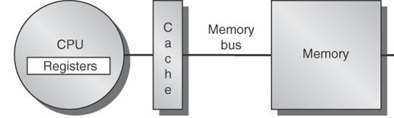

Product Functions
<Summarize the major functions the product must perform or must let the user perform. Details will be provided in Section 3, so only a high level summary (such as a bullet list) is needed here. Organize the functions to make them understandable to any reader of the SRS. A picture of the major groups of related requirements and how they relate, such as a top level data flow diagram or object class diagram, is often effective.>

This module is instantiated by the higher-level set-associative module for every cache way; it must provide to the constructor the desired write policy which must be followed.
In order to apply that policy, every write and read operation must be processed by this module and redelivered to the 1-way cache module.

The operations that this module provides are:
- Constructor
- Read
- Write

External Interface Requirements

User Interfaces
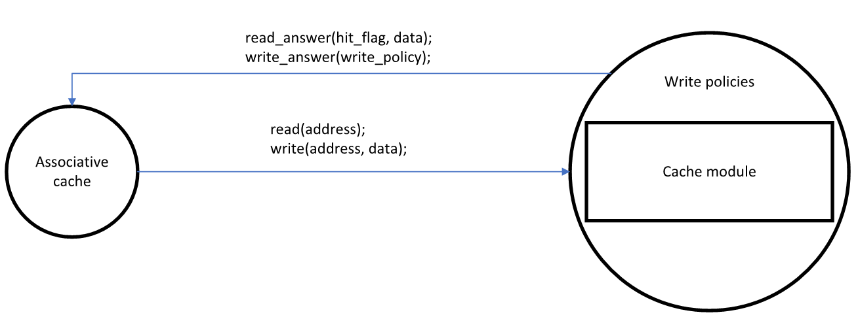
<Describe the logical characteristics of each interface between the software product and the users. This may include sample screen images, any GUI standards or product family style guides that are to be followed, screen layout constraints, standard buttons and functions (e.g., help) that will appear on every screen, keyboard shortcuts, error message display standards, and so on. Define the software components for which a user interface is needed. Details of the user interface design should be documented in a separate user interface specification.>
This module as a C++-class is an extension of the cache module

Software Interfaces
<Describe the connections between this product and other specific software components (name and version), including databases, operating systems, tools, libraries, and integrated commercial components. Identify the data items or messages coming into the system and going out and describe the purpose of each. Describe the services needed and the nature of communications. Refer to documents that describe detailed application programming interface protocols. Identify data that will be shared across software components. If the data sharing mechanism must be implemented in a specific way (for example, use of a global data area in a multitasking operating system), specify this as an implementation constraint.>

Communications Interfaces
<Describe the requirements associated with any communications functions required by this product, including e-mail, web browser, network server communications protocols, electronic forms, and so on. Define any pertinent message formatting. Identify any communication standards that will be used, such as FTP or HTTP. Specify any communication security or encryption issues, data transfer rates, and synchronization mechanisms.>

System Features
<This template illustrates organizing the functional requirements for the product by system features, the major services provided by the product. You may prefer to organize this section by use case, mode of operation, user class, object class, functional hierarchy, or combinations of these, whatever makes the most logical sense for your product.>

Miss policies
<Don’t really say “System Feature 1.” State the feature name in just a few words.>
4.1.1 Description and Priority
<Provide a short description of the feature and indicate whether it is of High, Medium, or Low priority. You could also include specific priority component ratings, such as benefit, penalty, cost, and risk (each rated on a relative scale from a low of 1 to a high of 9).>

In case of miss we can have two different behaviours:
- Write-allocate
- Write no-allocate

4.1.2 Write allocate functional requirements

4.1.3 Write no-allocate functional requirements

4.1.3 Functional Requirements
<Itemize the detailed functional requirements associated with this feature. These are the software capabilities that must be present in order for the user to carry out the services provided by the feature, or to execute the use case. Include how the product should respond to anticipated error conditions or invalid inputs. Requirements should be concise, complete, unambiguous, verifiable, and necessary. Use “TBD” as a placeholder to indicate when necessary information is not yet available.>

<Each requirement should be uniquely identified with a sequence number or a meaningful tag of some kind.>

REQ-1:
REQ-2:

Hit policies

