Shape-Restricted Detection of  Natural Product Hormesis: An  Re-analysis of Complex Botanical | Journal Title  XX(X):2–16  ©The Author(s) 2026 Reprints and permission: sagepub.co.uk/journalsPermissions.nav DOI: 10.1177/ToBeAssigned www.sagepub.com/
SAGE

Mixtures

Ying Jin¹,Cynthia Rider², Ruili Huang³, Menghang Xia³, Helene Langevin⁴, Shanshan Zhao¹, and Daniel Zilber¹

Abstract
Botanical supplements are consumed to improve health despite the mystery of their mechanisms. These products are often minimally processed, complex mixtures of the whole plant rather than isolated active ingredients. One possible health effect is hormesis, defined as a beneficial and stimulatory health effect at a low dose and inhibitory effect at a high dose, or vice versa. Hormesis is usually discovered by manually examining the shape of dose-response curves, which is not scalable to the large number of chemical-assay combinations found in high-throughput screening (HTS) results. We proposed a semi-automatic statistical testing procedure to quickly evaluate large-scale dose-response data, accompanied by an R package shorm for easy implementation. The nonparametric shape tests we utilized are more flexible than parametric models, with few assumptions on the data. We also developed a new visualization method to represent both the test conclusions and their uncertainties simultaneously. This scalable and interpretable representation highlights both significant and ambiguous findings for efficient examination. We applied this method to a data set of over 5000 dose-response pairs and identified 562 (12%) dose-response curves showing statistically significant hormesis. Turmeric most frequently tested positive for hormesis (58.5%) among botanical groups, and the antioxidant response element (ARE-BLA-P1) showed hormesis most frequently (43.33%) among assays.

Keywords
hormesis, shape constrained regression, botanical, mixture, statistical testing
[Version: 2017/01/17 v1.20]

Introduction
Natural products including botanicals and other dietary supplements are widely consumed by the public for their perceived health effects. Perhaps surprisingly, some of their benefit arises from phytochemicals that induce mild cellular stress, thereby triggering adaptive protective responses (Son et al. 2008). This principle may also explain mechanisms of Traditional Chinese Medicine and Ayurveda (Yuan et al. 2016). In some cases, the efficacy of a natural product has been studied enough to isolate its active ingredients and characterize their mechanisms of action, such as opium from poppy flowers or the precursor to aspirin derived from willow bark. In other cases, pharmacological paradigms centered on single molecules acting in isolated pathways do not reflect the multifactorial complexity that may result from the mixture of chemicals in natural products. Even with an understanding of the mode(s) of action, proper dosage requires more granular experimentations that is not typically carried out for supplements. Hence, botanicals and supplements are practical examples in which non-monotonic responses are biologically plausible but not explored, motivating the re-evaluation of response data conducted here.
A direct way to measure the effect of natural products is to perform in-vitro cell-based experiments with a range of assays, as illustrated with high-throughput screening (HTS) results from the Toxicology in the 21st Century program (Tox21) (Thomas et al. 2018). These data quantify exposure-induced transcriptional change across assays that represent toxicological related pathways. Hubbard et al. (2019) evaluate a variety of common botanical products of interest to the American consumer using Tox21 data. They fit parametric models to the HTS concentration response data and report metrics like the concentration at which half the maximum response is reached (EC₅₀). They also compare extracts to purified active ingredients. Their findings provide valuable evidence towards identifying potential toxicities at high concentrations and effects of the raw mixtures versus isolated ingredients. However, to understand the health effect of a supplement, we may need to focus on low dose behavior. This motivates us to explore the concept of hormesis.
Hormesis is a type of dose-response action in which a biological system exhibits a stimulatory response to sufficiently low but stressful doses of an exposures while higher doses result in inhibitory responses, or vice versa. This is a highly conserved evolutionary adaptation observed across plants and animals (Calabrese and Mattson 2017). Two common examples of hermetic stressors are exercise and fasting, where high doses can be harmful but low doses can improve health (De Cabo and Mattson 2019). Hormetic compounds are of particular interest for further studies into potential health benefits, due to their differential effects across dose ranges. Specifically, for chemicals that are harmful at high dose, the

¹National Institute for Environmental Health Sciences, National Institutes of Health
²Division of Translational Toxicology, National Institutes of Health
- National Center for Advancing Translational Scencies, National Institutes of Health
- Osher Center for Integrative Health, University of Vermont
Corresponding author:
Daniel Zilber, National Institute of Environmental Health Sciences, 111 TW Alexander Dr, Durham, NC 27709 USA. Email: daniel.zilber@nih.gov
presence of hormesis suggests potential beneficial effects at low doses. Some estimates suggest that up to 40% of dose-response relationships derived from sources like Tox21 may exhibit hormesis within the range of experimental doses (Calabrese and Mattson 2017). Identifying such responses may therefore help identify low-dose benefits of compounds.
In practice, hormesis is often identified manually by plotting a dose response curve and observing a J or inverted J-shape rather than a monotonic S-shape. The magnitude of the dip in the J-shape is expected to range from 30-60% beyond the baseline response to be classified as hormesis (Calabrese 2014). While manual inspection is reasonable for single-compound experiments, it is not feasible for HTS involving thousands of chemical-assay combinations. Visual classifications can also suffer from uncertainties due to data noise, making it preferable to rely on statistical testing instead of visual cues.
A common statistical testing approach is to fit a parametric dose response model that accommodates hormesis and tests the corresponding hormesis term. The Brain-Cousens dose-response model (Brain and Cousens 1989) allows an additional linear term to capture hormetic effect, which was later extended by (Cedergreen et al. 2005) with a nonlinear hormetic term to improve interpretability. In both models, an F-test can be performed to assess the presence of hormesis under the null assumption that the hormesis parameter is 0. However, parametric methods impose rigid assumptions on dose-response curves, and model misclassification could lead to unreliable statistical testing results.
To address this challenge, we propose a shape-based testing approach that directly evaluates monotonicity and concavity of the observed data, which defines a hormetic dose-response curve. This approach makes minimal assumptions about the underlying dose-response relationship while still quantifying uncertainty through p-values associated with specific curve shapes. Our main contribution in this study is formulating the identification of hormesis in a rigorous statistical framework and performing a shape-based test to assess hormesis in botanical dose response data, along with the development of a software package for statistical analysis and summary visualization of significance for large sets of chemical-assay pairs.

Method and Material

Data
We used the same dataset curated from the Tox21 program to evaluate the safety of common botanical ingredients as described in Hubbard et al. (2019). The dataset includes concentration-response measurements for both whole plant botanical samples and purified active ingredients. By testing both whole and purified ingredients of botanicals, Hubbard et al. (2019) assessed if the response is from the whole-plant mixture or a single active ingredient, and followed the same idea. The dataset contains 19 botanical groups (Table 1) evaluated through 90 different preparations. Preparations from each botanical groups can vary in form (e.g. extract, constituent, oil), supplier or sample lot and are shown on the left side of results in Figure 4.
To evaluate safety, Hubbard et al. (2019) employed a panel of 19 assays to cover many standard toxicity-related pathways. Examples are the aryl hydrocarbon receptor (AhR), antioxidant response element (ARE), and aromatase receptor activity (Table 2). These assays are expanded into 54 screening results, depending on reporter type (luciferase LUC, beta lactamase BLA, or viability VIA) and time course. LUC and VIA results were collected through a single channel, while BLA measurements were collected through two channels and analyzed as a ratio. The time-course assay measured viability/cytotoxicity in liver or kidney cells after incubation periods ranging from 0 to 40 hours in 8-hour increments. Three replicates were available for each experiment and all replicates were pooled together for analysis.

Statistical Testing
As described above, we discover hormesis by searching for dose-response curves with J or inverted J shape. Figure 1 (a) shows an example of an inverted J-shape with a low dose interval of increasing response followed by a decreasing tail at higher doses. Mathematically, it is a concave decreasing curve. Thus we can test hormesis by testing for concavity with a decreasing trend. For the J shape, we look for convexity with an increasing trend, where a general increasing trend is shown in Figure 1 (b). Note that testing for monotonicity is not sufficient: while all hormetic curves are non-monotonic, not all nonmonotonic curves will have a J shape. Figures 1 (c) and (d) are not monotonic, but neither showed the J or inverted J shape. Furthermore, a dose response curve may be convex or concave without having a J shape, such as Figures 1 (c) with an inverted U shape. Therefore, it is important to check for the presence of increasing/decreasing trend through a monotone regression. For example, a Hill function is a widely used dose-response curve but it is a non-increasing convex curve when the dose is not high enough to reach saturation. To summarize, if a test shows evidence of a convex monotonically increasing trend, or a concave curve with monotonically decreasing trend, the shape being tested could be categorized as hormesis.
We utilize the semiparametric Shape-Restricted Mixed Effects Regression Splines, a shape-based test developed by Yin et al. (2021) that can be abbreviated to SHApe Restricted Procedure (SHARP). Two models are fit with different splines X_{IS} and X_{CS}, to assess monotonicity and convexity respectively, as follows:
Monotonicity: y = X_{IS}β_{IS} + X_{IF}β_{IF} + Zb_{I} + ϵ_{I} (1)
Convexity : y = X_{CS}β_{CS} + X_{CF}β_{CF} + Zb_{C} + ϵ_{C} (2)
In both models, y represents the response. The monotonicity model uses quadratic I-spline basis functions (Ramsay 1988) denoted X_{IS} and constructed on the dose data. If the coefficients β_{IS} are all positive (negative), the resulting curve will be monotone increasing (decreasing). X_{IF} and β_{IF} are potential confounders and their corresponding coefficients respectively. Z and b_{I} are the random effect covariates and coefficients, and ϵ_{I} is the random error. Here b_{I} and ϵ_{I} are assumed to follow independent zero mean Gaussian distributions. The convexity equation is similar and fits a cubic C-spline basis (Meyer 2008) X_{CS} over dose, with confounders X_{CF}, random effects Z, and corresponding coefficients β_{CS}, β_{CF} and b_{C}, and random error \epsilon_C. Similar to monotone regression, convexity (concavity) is realized when all coefficients β_{CS} are positive (negative).
When each regression is fit, there are two sets of coefficients: β^{ˆ}_{IS} and β^{ˆ}_{CS}. Under a null hypothesis of no response, each coefficient vector is tested against two alternatives:
H₀ : β = 0 vs H_{A+} : β ∈R₊ or H_{A−} : β ∈R₋
The alternatives test if the coefficients are all positive or all negative. The two tests for each shape regression results in four separate p-values: p_{in}, p_{de}, p_{cx}, and p_{cv}. The p-values p_{in} and p_{de} are the result from testing if the monotone regression coefficients β_{IS} are all non-negative or all non-positive respectively, thus corresponding to non-decreasing and non-increasing curves. Similarly, p_{cx} and p_{cv} are p-values for convexity and concavity. Since we are testing four hypotheses simultaneously, we adjust for multiple comparisons using the Holm method (Holm 1979), which ranks the p values and rejects each hypothesis sequentially.
In practice, the null distribution of coefficient estimates, and consequently the test statistic, doesn’t have a closed-form solution. The statistic is estimated through bootstrap, by drawing random samples repeatedly from the current sample. This random sampling procedure can lead to different p-values when the SHARP test is applied repeatedly to the same data set. When the true p-value is near the significance threshold (0.05), it is likely that observed p values will fall on both sides of the threshold, causing an ambiguous test conclusion. Ideally there are many observations and/or increased iterations of random sampling to avoid the problem. Realistically, the former is difficult to achieve under resource constraints for many reasons (e.g. small number of replicates, sparse or skewed dose grid, etc.) while the later will significantly increase the computation time. As a robust work around, the testing output is stabilized by implementing the SHARP test on each dose-response pair repeatedly and taking the median p-value across repetitions. An alternative is to use a “voting” rule for decision making, taking the shape with maximum votes across all repetition as the final classification. In practice, the two rules lead to nearly identical conclusions, and we use the median p-value rule.
Equations (1) and (2) are presented as they appear in Yin et al. (2021). In this paper we do not utilize the confounder terms or random effects. We have modeled the dose-response curves with the spline basis terms X_{IS} and X_{CS} only. For more details about the testing procedure, please refer to the appendix.

Scalability and Visualization
Despite the mathematical complexity, SHARP is parallelizable and efficient, which enables automated evaluation of hormesis on large toxicology datasets with many chemical-assay pairs such as Tox21. However, SHARP returns four p-values for each does-response curve, and a large-scale toxicology dataset often includes thousands of curves (for example, more than 5000 curves in Tox21). It is tedious to examine these p-values curve by curve. Instead, we develop a visual summary of testing results that can provide a concise and comprehensive view of the test outputs to highlight findings.
Our novel visualization scheme integrates the test p-values and shape conclusions for multiple curves on one 2D surface. The surface is divided into four panels defined by two axes: convex vs. concave (horizontal) and decreasing vs. increasing (vertical) (Figure 3a). Each chemical-assay pair is indicated by a point, whose position is determined by the four p-values from SHARP test values p_{in},p_{de},p_{cx},p_{cv} as follows:
Vertical : | Y = I(p_{in} < p_{de})(1 − p_{in}) + I(p_{in} > p_{de})(p_{de} − 1) + I(p_{in} = p_{de})0 | (3)
Horizontal : | X = I(p_{cv} < p_{cx})(1 − p_{cv}) + I(p_{cv} > p_{cx})(p_{cx} − 1) + I(p_{cx} = p_{cv})0 | (4)
As Equations (3) and (4) show, the relative magnitude (?) between p-values determines which subspace the chemical assay pair belongs to, and the absolute magnitude of the p-values determines how far it is from the plot border. When
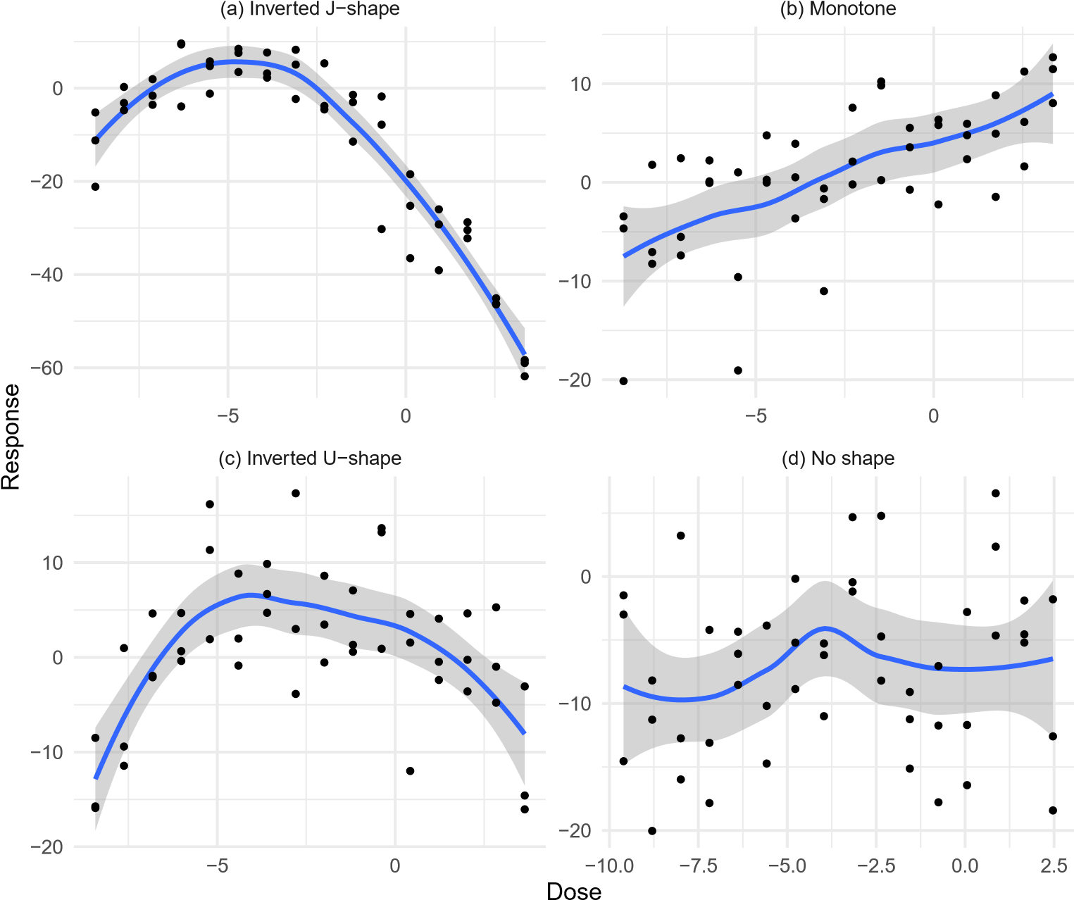
Figure 1. Examples from the motivational dataset that have been classified into the four categories: a concave-decreasing hormesis curve, a monotonically increasing curve, a concave U-shape curve and a curve with unclear signals. Curves with significant monotonicity (p_{in} < 0.05 or p_{de} < 0.05) but not convexity (p_{cv} > 0.05 and p_{cx} > 0.05) are monotone, corresponding to a regular toxicity pattern. Curves with significant convexity/concavity (p_{cx} < 0.05 or p_{cv} < 0.05) but insignificant monotonicity (p_{in} > 0.05 and p_{de} > 0.05) are of U-shape. Curves that are either convex with increasing trend (p_{cx} < 0.05 and p_{in} < 0.05) or concave with decreasing trend (p_{cv} < 0.05 and p_{de} < 0.05) are of J-shape, indicating a possible hormetic pattern. Curves that are insignificant have no specific toxicity signals.
p_{in} < p_{de}, the point will be placed on the upper half of the plot, and when the inequality is reversed the point is in the lower half of the plane. Similarly, p_cv and p_cx determines the horizontal position as in Equation 4. In this way, we create an interpretable layout by placing smaller, more significant p values toward the edges of the plot. For the pairs of opposing shapes (convex vs concave or decreasing vs increasing), only one shape can be significant at a time, so the shape with the smaller p-value is taken as the identified shape.
onvex
C
Conc
ave
ase
Decre
ease
Incr
−1.0
−0.5
0.0
0.5
1.0
−1.0
−0.5
0.0
0.5
1.0

fill
Hormesis
U shape
Monotone
Uncertain
No shape

Figure 2. Subspaces in the SHARP scatterplot and their corresponding shape classification. The origin represents a p-value of 1 and the dotted lines intersect each axis at ±0.95, which is the significance threshold after the positioning transform. The axis is linearly scaled so that the outer region corresponds to p-values between (0, 0.05) and the inner box corresponds to (0.05, 1).
We plot four dashed lines corresponding to the p-value significance threshold α = 0.05, which further divides the plot into a center square and eight edge regions. Figure 2 illustrates these regions and their respective curve shape labels. If SHARP detects a significant shape, the point will be positioned on the edge regions, while points with insignificant shapes are positioned in the center region. Points near the significant threshold need further investigation.
Figure 3 shows an example of visualizing test scores of Turmeric (lot90H73) between six different assays. In Figure 3a, the shape classification made by SHARP is plotted with each assay given a different color, and points with the same color are the repeated tests for the same dose-response data. Since the replicated SHARP tests cluster tightly, using a median value is a reasonable estimate of the true p-value. For example, rt-viability-hepg2-glo-0h (pink points) fall in the lower right corner beyond the significance threshold, which is the region of hormesis with concave curves with decreasing trend. The corresponding dose-response data is shown in Figure 3b with the same color and illustrates the inverted or decreasing J-shape. Similarly, rt-viability-hek293-flor-p1 0h (teal points) fall in the upper left corner, indicating hormesis with increasing J-shape. For both assays, their clusters of points fall in one region, reflecting high certainty of shape classification. In contrast, aromatase-er-aromatase-p1 luc (red points) falls on the significance boundary of concavity. This means that across repetitions, the test conclusion alternates between concave with decreasing trend and decreasing alone. The shape may be hormetic in a general sense but a U-shaped classification is debatable, especially given the corresponding plot in Figure 3b.
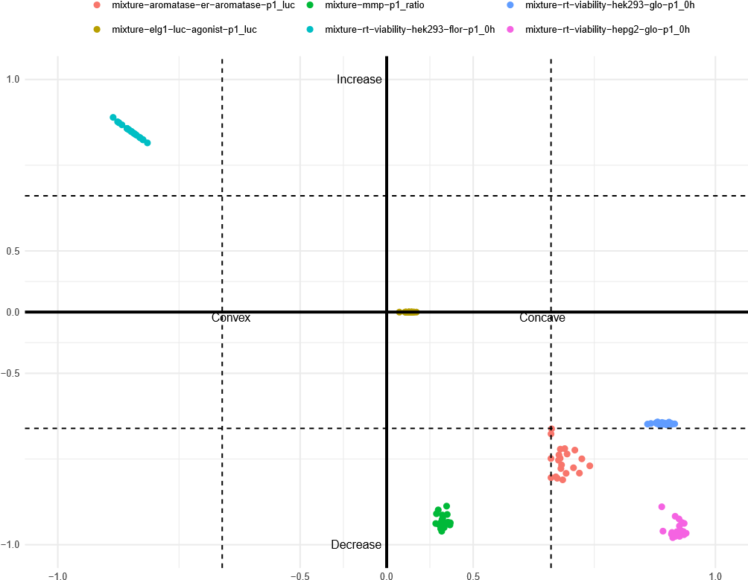

- P-value plot showing replicated SHARP tests. Clustering of repeated p-values suggests that the median value is a robust estimate. The origin represents a p-value of 1 and the dotted lines intersect each axis at 0.95. The axis is linearly scaled so that the outer region corresponds to p-values between (0, 0.05) and the inner box corresponds to (0.05, 1).
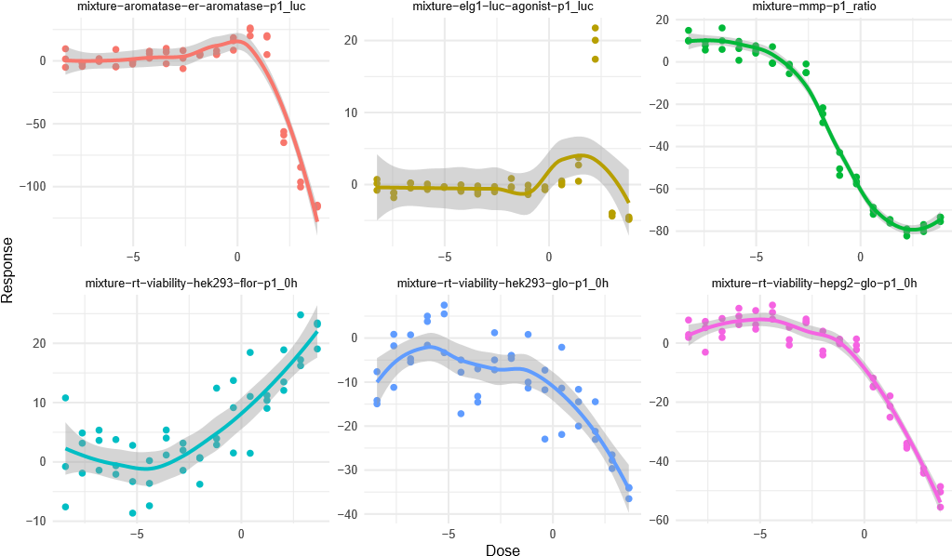
- Data corresponding to each SHARP test cluster.
Figure 3. An example of visualizing SHARP test results of Turmeric (lot 90H73) and five assays. Each color represents a different assay with its shape classification. Points with the same color are repeated tests on the same dose-response curve.

Results
We applied the shape test to all the assays, and summarize our results into a heatmap (Figure 4), where hormetic assays are colored orange.
There is significant structure in the figure in the form of horizontal and vertical patterns. This structure
Table 1. Count of Hormetic Curves by botanical group. These curves test as either increasing convex or decreasing concave, suggesting a J shape curve and hormesis. Turmeric and Ginkgo showed the greatest level of hormetic activity.
Botanical Group | Hormetic Curve Count (%)
Turmeric | 158 (58.52%)
Ginkgo Biloba | 91 (18.72%)
Goldenseal | 65 (12.04%)
Gum Guggul | 53 (12.27%)
Kava Kava | 39 (12.04%)
Milk Thistle | 29 (5.97%)
Resveratrol | 28 (17.28%)
Grape Seed | 24 (11.11%)
Annatto | 21 (3.24%)
Citral | 13 (4.81%)
Cedarwood Oil | 12 (11.11%)
Chitosan | 12 (11.11%)
Pine Bark | 6 (5.56%)
Corn oil | 5 (4.63%)
Comfrey Root | 2 (1.85%)
Safflower oil | 2 (1.85%)
Black Walnut | 1 (0.37%)
Echinacea purpurea | 1 (1.85%)
Olive oil | 0 (0%)
TOTAL | 562 (12%)
implies some assays or chemicals are consistently hormetic. A large swath of assays for viability shows hormesis for the turmeric botanical group and quercetin, a key isolate of gingko. Goldenseal shows consistent hormetic activity across AHR, ARE, and MMP assays, while the ARE assay also shows activity for gum guggul, kava kava, and citral.
Summary counts for curves by assay or botanical group classified as hormetic are provided in Tables 1, 2, and 3. A total of 562 (12%) of the assay-chemical pairs tested positive for hormesis.
Turmeric occurred most often as a hormetic chemical. In addition to the time course viability assays, there was hormetic activity for the androgen and aromatase assays.
Quercetin, a flavonoid found in onions, kale and capers, as well as being a major and purportedly active constituent in gingko, showed the next greatest activity for hormesis. Similar to turmeric, there were many hits for time course viability, aromatase, ARE, and AR, but also ELG.
We use our novel p-value plot to show the strength of signals, which provides additional insights into the summary heatmap and tables. In Figure 5, we illustrate the ARE assay results, showing the high frequency of convex increasing dose responses but also the relative strength (top left corner) or ambiguity (points on the dotted lines) of the shape classification. P-value plots for all chemicals are available in the supplement.

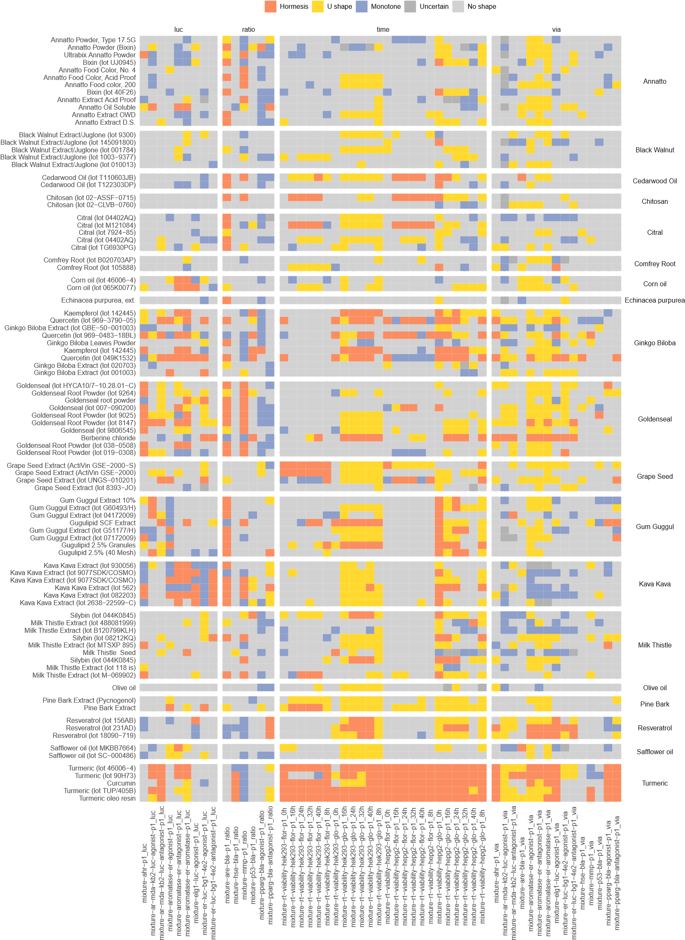

Prepared using sagej.cls
Figure 4. Results from Shape Analysis. Assays are clustered by type and chemicals are clustered by botanical group. Hormesis is detected along vertical patterns (assays) and horizontal patterns (botanicals).
Table 2. Count of hormetic curves by assay. The antioxidant response element assay (ARE) showed the greatest count and percent of results with hormesis. The viability column represents a secondary assay performed with each primary assay cell type to measure cell death. The viability results do not correlate strongly with the assay results.
Assay | Assay Type | Count | Count (Viability)
ahr-p1 |  | 16 (17.78%) | 10 (11.11%)
ar-mda-kb2-luc-agonist-p1 |  | 9 (10%) | 1 (1.11%)
ar-mda-kb2-luc-antagonist-p1 |  | 11 (12.22%) | 3 (3.33%)
aromatase-er-agonist-p1 | Luciferase | 9 (10%) | 8 (8.89%)
aromatase-er-antagonist-p1 |  | 18 (20%) | 5 (5.56%)
aromatase-er-aromatase-p1 |  | 20 (22.22%) | 8 (8.89%)
elg1-luc-agonist-p1 |  | 7 (7.78%) | 13 (14.44%)
er-luc-bg1-4e2-agonist-p1 |  | 7 (7.78%) | 4 (4.44%)
er-luc-bg1-4e2-antagonist-p1 |  | 7 (7.78%) | 3 (3.33%)
are-bla-p1 |  | 39 (43.33%) | 4 (4.44%)
hse-bla-p1 |  | 4 (4.44%) | 1 (1.11%)
mmp-p1 | Beta-Lactamase | 23 (25.56%) | 3 (3.33%)
p53-bla-p1 | (Ratio) | 6 (6.67%) | 1 (1.11%)
pparg-bla-agonist-p1 |  | 2 (2.22%) | 8 (8.89%)
pparg-bla-antagonist-p1 |  | 6 (6.67%) | 9 (10%)
Table 3. Count of hormetic curves by time course assays (transposed for clarity). The cells were treated then assayed after the time specified. Finding hormesis in these curves means there is a J-shaped curve with respect to concentration for the given time point, rather than a J-shaped curve over the time period.
Time (h) | hek293-flor-p1 | hek293-glo-p1 | hepg2-flor-p1 | hepg2-glo-p1
0h | 9 (10%) | 7 (7.78%) | 9 (10%) | 34 (37.78%)
8h | 9 (10%) | 10 (11.11%) | 9 (10%) | 14 (15.56%)
16h | 9 (10%) | 10 (11.11%) | 10 (11.11%) | 16 (17.78%)
24h | 10 (11.11%) | 14 (15.56%) | 12 (13.33%) | 18 (20%)
32h | 11 (12.22%) | 16 (17.78%) | 12 (13.33%) | 11 (12.22%)
40h | 13 (14.44%) | 19 (21.11%) | 9 (10%) | 6 (6.67%)

Potential Hormetic Curves
In the heatmap shown in Figure 4, hormesis curves are often detected with other significant shapes within the same assay or botanical group. For example, the aromatase assays for goldenseal and turmeric show clusters of U-shaped and hormetic dose-responses. The Kava Kava group with luciferase assays show co-occurence of monotonic and hormetic curves. As illustrated in Figure 6 below, the U-shaped curves could reveal hormetic dose responses with higher doses. Similarly, monotone curves could be hormetic with more data at lower doses. The time course assay for kidney cells, hek293-glo may also be suggestive of hormesis. Looking across all botanicals, there are many U-shaped curves detected alongside J-shape and/or monotone curves. Higher doses may reveal hormesis for in these kidney viability assays across many botanicals.
mixture−are−bla−p1_ratio
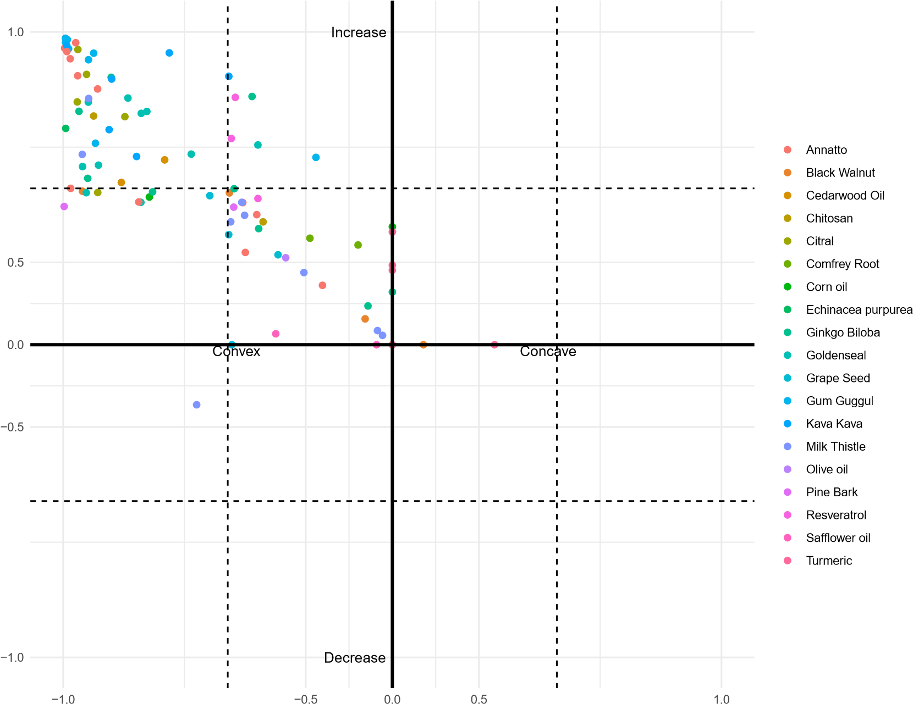

Figure 5. Shape P-value plot. Results across all shape statistics are plotted simultaneously, with the dotted line representing significance. The origin here represents a pvalue of 1 and the dotted lines intersect each axis at 0.05. The axis is linearly scaled so that the outer region corresponds to pvalues between (0, 0.05) and the inner box corresponds to (0.05, 1). Since a shape cannot be both increasing and decreasing or concave and convex, only half a plane is needed for each p-value. The antioxidant response element (ARE) assay shows many hormetic chemicals, suggesting that ARE is a common pathway for hormesis.

Discussion
In this work we applied SHARP, a shape-based statistical test (Yin et al. 2021), to automatically determine which botanical ingredient or constituent concentration response curves exhibit hormesis. The testing procedure does not require specifying a parametric form for the dose response, which offers flexibility and avoids restrictions to very specialized formulas that allow for hormesis. Out of roughly 5000 dose response curves, we find about 500 that are significant for a J-shape, which we interpret as hormetic.
Undetected hormesis
increase: p>0.999
decrease: p=0.522
convex: p=0.002
concave: p>0.999
increase: p<0.001
decrease: p>0.999
convex: p>0.999
concave: p=0.076
0.6
0.7
0.8
0.9
1.0
0.00
0.25
0.50
0.75
1.00
Dose
Response

Monotone
U shape
Figure 6. Potential hormetic curves. U-shaped curves detected from the red points may prove hormetic with higher doses while monotone curves detected from the blue dots may reveal hormesis with low doses. A similar effect can happen within each dose range, but is less likely: a monotone curve may appear J-shaped if a few key doses are missing, and vice versa
This quantity of hormetic curves is in line with estimates of hormetic behaviors that are hidden in dose response repositories like Tox21.
Some of our identified hermetic pathways from the Tox21 data are known in the literature. For example, the stress signaling assay for the antioxidant response element (ARE) pathway is commonly associated with hormesis (Son et al. 2008) and was a hit for many botanicals. The aryl hydrocarbon receptor (AhR) showed activity for goldenseal and is known to exhibit hormesis in the Tox21 dataset (Zhao 2021). Endocrine disrupting chemicals are known to have non-monotonic dose-responses for the estrogen receptor (ER) (Shi et al. 2022) and the androgen receptor (AR) (Klimenko 2021), and we can find examples of hormesis across both assays.
The method we propose requires some care for edge cases where one shape transitions to another. The p-values and results can be ambiguous, so we recommend review of any significant findings. The scatterplot introduced in Section 2 can greatly improve the efficiency of this examination process as it highlights all the significant results (edges) and highly ambiguous results (near significant thresholds). The SHARP test itself must perform an approximation to the test distribution to determine the p-value, so there is some variability across tests and it is recommended to run the test ten to twenty times and utilize the median p-value or the most frequent shape category returned as the mode. Specifying hormesis more precisely is a direction for future work: in addition to reducing the variability of the testing procedure with SHARP, it may be helpful to explicitly test for a J-shaped curve rather than the less precise increasing-convex or decreasing-concave approach. It is also not clear how to handle replicates, where each replicate may have a different shape.
One issue we do not delve into is controlling the family-wise error rate across the combinations of assay and chemical. The SHARP method corrects for the multiple tests conducted for a specific dose response, but those tests are still specified with a significance threshold. A simple but conservative Bonferroni correction or a more precise method like Benjamini-Hochberg correction could be applied for the number of tests we are performing but is left for future work.
A natural direction for future work is the extension into mixtures of chemicals or temporal effects. Given a higher-dimensional dose-response surface, it is possible that some slices will be hormetic, suggesting a beneficial proportion of ingredients. The general shape of the surface may classify as easily as the 1D cases, but it is possible that the surfaces will vary from concave to convex or increasing to decreasing and not be well defined. Temporal effects may be more difficult to ascertain but would align with the interpretation that complex physiological effects resulting from the ingestion of hormetic natural products could provide increased resilience to intense stress after some initial exposure to mild stress. Thus, a more nuanced analysis with respect to hormesis may reveal that “more is not necessarily better” when it comes to ingesting botanical products, and that the most beneficial doses to support health may not be the highest ones.
Another direction for future work is further clarifying the uncertainty in the shape result. Some dose response curves show a J-shape after an initial region of no response, which does not fall into the categories we specified for hormesis. Generalizing the classification for hormesis or developing a preprocessing pipeline to isolate doses of significant behavior may improve detection results.

Code Availability
Code for performing the analysis described in this manuscript is publicly available at https://github.com/YinglJin-0203/shorm. This software is written in the R programming language and is available through R shorm package.

Acknowledgements
This study was supported in part by the Intramural Research Program of the National Center for Advancing
Translational Sciences (NCATS) and the Interagency Agreement IAA #NTR 12003 from the National Institute of
Environmental Health Sciences/Division of Translational Toxicology Program to the NCATS, National Institutes of Health. The contributions of the NIH authors were made as part of their official duties as NIH federal employees, are in compliance with agency policy requirements, and are considered Works of the United States Government. However, the findings and conclusions presented in this paper are those of the authors and do not necessarily reflect the views of the NIH or the U.S. Department of Health and Human Services.
We thank Eric Bair, Shail Choksi, Betsy Scholl, and Bekki Elmore for their assistance in publishing the shorm package to CRAN.

References
Brain P and Cousens R (1989) An equation to describe dose responses where there is stimulation of growth at low doses. Weed research 29(2).
Calabrese EJ (2014) Hormesis: a fundamental concept in biology. Microbial cell 1(5): 145.
Calabrese EJ and Mattson MP (2017) How does hormesis impact biology, toxicology, and medicine? NPJ aging and mechanisms of disease 3(1): 13.
Cedergreen N, Ritz C and Streibig JC (2005) Improved empirical models describing hormesis. Environmental Toxicology and Chemistry 24(12): 3166–3172.
De Cabo R and Mattson MP (2019) Effects of intermittent fasting on health, aging, and disease. New England Journal of Medicine 381(26): 2541–2551.
Holm S (1979) A simple sequentially rejective multiple test procedure. Scandinavian journal of statistics : 65–70.
Hubbard TD, Hsieh JH, Rider CV, Sipes NS, Sedykh A, Collins BJ, Auerbach SS, Xia M, Huang R, Walker NJ et al. (2019) Using tox21 high-throughput screening assays for the evaluation of botanical and dietary supplements.
Applied In Vitro Toxicology 5(1): 10–25.
Klimenko K (2021) Examining the evidence of non-monotonic dose-response in androgen receptor agonism highthroughput screening assay. Toxicology and Applied Pharmacology 410: 115338.
Meyer M (2008) Inference using shape-restricted regression splines. The Annals of Applied Statistics 2. DOI:
10.1214/08-AOAS167.
Ramsay J (1988) Monotone regression splines in action. Statistical Science 3. DOI:10.1214/ss/1177012761.
Shi Z, Xia M, Xiao S and Zhang Q (2022) Identification of nonmonotonic concentration-responses in tox21 highthroughput screening estrogen receptor assays. Toxicology and applied pharmacology 452: 116206.
Son TG, Camandola S and Mattson MP (2008) Hormetic dietary phytochemicals. Neuromolecular medicine 10(4):
236–246.
Thomas RS, Paules RS, Simeonov A, Fitzpatrick SC, Crofton KM, Casey WM and Mendrick DL (2018) The us federal tox21 program: A strategic and operational plan for continued leadership. Altex 35(2): 163.
Yin Q, Xun X, Peddada SD and Adibi JJ (2021) Shape detection using semi-parametric shape-restricted mixed effects regression spline with applications. Sankhya B 83(Suppl 1): 65–85.
Yuan H, Ma Q, Ye L and Piao G (2016) The traditional medicine and modern medicine from natural products.
Molecules 21(5): 559.
Zhao Y (2021) Computational Analysis and Modeling of Tox21 AhR Activation High-Throughput Screening Assays.
Master’s Thesis, Emory University.

Appendix - Methodology Details
The shape-restricted regression spline Yin et al. (2021) tests against four possible dose response shapes: increasing or decreasing and concave or convex. The method relies on fitting the data with appropriate splines (I-splines for monotonicity, C-splines for convexity) and comparing the coefficients (β^{ˆ}_{i}) to models where the coefficients are subsequently projected onto strictly positive or strictly negative domains. The test statistic is
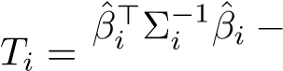 argmin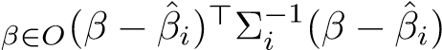
βˆi⊤Σ−i 1βˆi
Theorem 1 of Yin et al. (2021) provides the distribution of the test statistic under the null hypothesis, so the significance (ie probability) of the test statistic can be evaluated. When the parameter covariances Σ_{i} are known, the test statistic has a beta-bar distribution under the null hypothesis that the coefficients are 0. When the true covariances are not known, the distribution is asymptotically a beta-bar distribution. The beta-bar distribution is essentially a weighted sum of beta cumulative distribution functions, with weights that depend on the covariance.
Test Uncertainty Although the SHARP method performs a test against a null distribution that is asymptotically correct, it is difficult to compute probabilities from the distribution. The heart of the issue is the projection step, which maps some fitted coefficients to 0 and is used for the weights in the null distribution. These weights encode the number of non-zero terms and need to be simulated even when the true parameter covariance is known. When the true covariance is not available and the sample covariance used, the distribution further needs to be estimated with bootstrapping since it is only asymptotically correct. We take 1000 bootstrap samples and repeat the test 21 times, taking the median test statistic as a robust estimate of the true test statistic. While generally of little consequence, it is possible that the set of sampled p-values straddles the significance threshold, in which case there is ambiguity about the result.

