PH3120 – Computational Physics Laboratory 1 CPL104 – Vectors and Matrices Section 1 & 2
1.Vectors
I).
(a)

Scalar Quantity | Vector Quantity
Has only magnitude | Has both magnitude and direction
No direction | Always has a direction
Represented by a number and unit | Represented by an arrow (magnitude + direction)
Examples : Speed, Mass, Temperature, Time, Energy | Examples :Velocity, Displacement, Force, Acceleration
(b)
$$\vec{V}=Xi+Yj+Kz$$

Magnitude of $\vec{V}$ :
$$\left|\vec{V}\right|= \sqrt{X^{2}+Y^{2}+K^{2}} \\ (c) if \vec{A},\vec{B}$$ are vectors ,
$\vec{A}. \vec{B}=\left|a\right||b|cosθ$
a= Magnitude value of $\vec{A}$
b= Magnitude value of $\vec{B}$
d)
$\vec{A},\vec{B}$ are vectors ,
$$\vec{A} × \vec{B}=\left|a\right|\left|b\right|sinθ \tilde{n}$$
OR

$\vec{A}$= (A₁, A₂, A₃)
$\vec{B}$= (B₁, B₂, B₃)
Then the cross product is:
$\vec{A} × \vec{B}= \left|\begin{matrix}i & j & k \\ A_{1} & A_{2} & A_{3} \\ B_{1} & B_{2} & B_{3}\end{matrix}\right|$ = i($A_{2}$​$B_{3}$​−$A_{3}B_{2}$​​) − j($A_{1}$​$B_{3}$​−$A_{3}B_{1}$​) + k($A_{1}$​$B_{2}$-$A_{2}$​$B_{1}$)
e)
$\vec{A}. \vec{B}=\left|a\right|\left|b\right|cosθ$

$θ=\cos^{-1}\{\frac{\vec{A}. \vec{B}}{\left|a\right|\left|b\right|}$}
f) $$unit vector of \vec{V}=\frac{ \vec{V}}{| \vec{V}|}$$
II).
a)
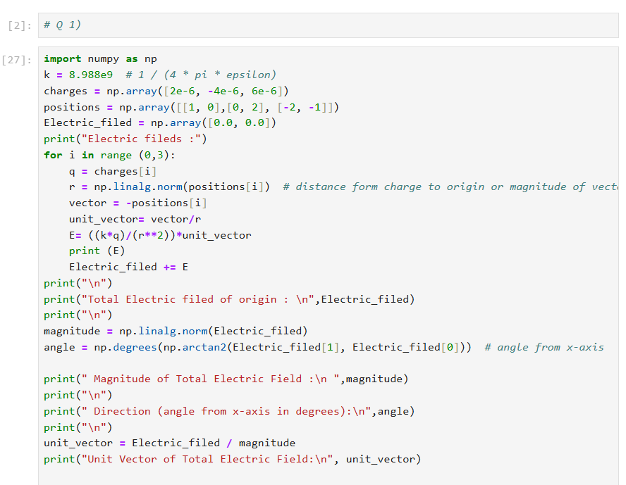
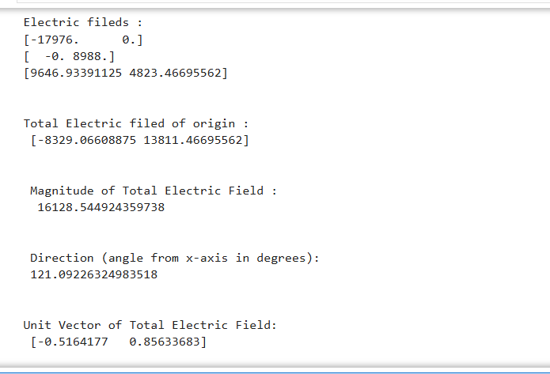
b)
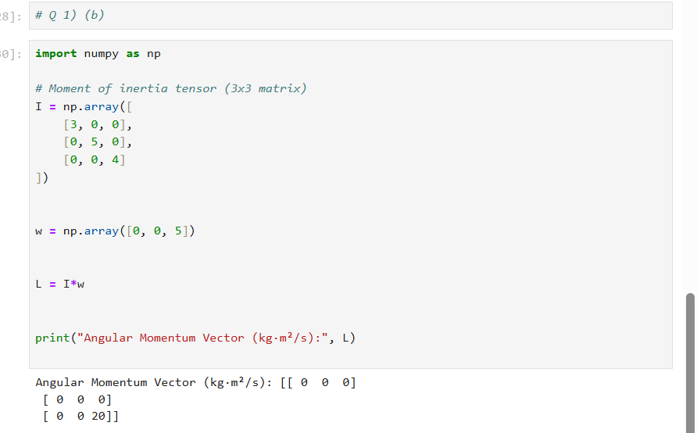
c)
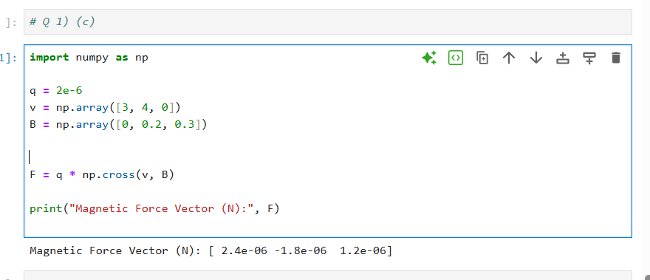
2)
I. (a)
matrix addition | matrix multiplication
Commutative A+B = B+A | Associative Property A(BC)=(AB)C
Associative (A+B)+C=A+(B+C) | Distributive Property A(B+C) = AB + AC
Additive Identity A+0 = A | Multiplicative Identity AI=IA= A
Additive Inverse A + (-A) = 0 | Not Commutative AB≠BA
(b)
Matrix transposition (A^{T}) = It means flipping a matrix over its diagonal. Rows become columns, and columns become rows.

Effect on Dimensions - If matrix A is m × n, then A^{T} becomes n × m.

(c)
The inverse of a matrix A, written as A⁻¹, is a matrix that "undoes" the effect of A.
It satisfies:
A. A⁻¹ = A⁻¹.A=I
Where III is the identity matrix.
Conditions to have an inverse:
- Should be a square matrix.
- It’s determinant is not be zero.
(d).
A square matrix has the same number of rows and columns.
But a rectangular matrix has a different number of rows and columns. And only square matrices can have properties like determinant or inverse.
(e).
A diagonal matrix is a square matrix where all off-diagonal elements are zero.
Only the numbers on the main diagonal (top-left to bottom-right) can be non-zero.
Ex :
$\left[\begin{matrix}6 & 0 & 0 \\ 0 & 5 & 0 \\ 0 & 0 & 10\end{matrix}\right]$
(f)
An identity matrix is a square matrix with:
- 1's on the main diagonal
- 0's everywhere else
It’s like the number 1 for matrices.
(g)
The rank of a matrix is the number of linearly independent rows or columns.
It tells:
- How much useful (non-redundant) information is in the matrix.
- The dimension of the space spanned by its rows or columns.

Relationship to Linear Independence:
- If columns (or rows) are linearly independent, they contribute to the rank.
- If a column is a combination of others, it does not increase the rank.
(h)
Yes, the rank of a matrix can change depending on the operation.
Addition – can be change. Depends on how matrices cancel out.
Multiplication – Can be change. Rank can decrease
Inversion – Can’t be change. Only invertible (full-rank) matrices

3)
d) Given a square matrix A, a non-zero vector v is called an eigenvector if:
Av=λv
Here:
- λ is a scalar called the eigenvalue
- v is the eigenvector
- This means: multiplying A by v just stretches or shrinks v, without changing its direction.
e)
The characteristic equation is a special equation used to find the eigenvalues of a square matrix.
To find eigenvalues:
- Start with:
Av=λv
Rewriting:
(A−λI)v=0
- For a non-zero v to exist, the matrix (A−λI) must be singular (not invertible), so:
det(A−λI)=0
- This is called the characteristic equation. Solving it gives the eigenvalues λ
f).
- Matrix transformation changes a vector’s direction and length.
- Eigenvectors are special: when transformed, their direction doesn’t change, only their length is scaled by the eigenvalue.
If A represents a transformation (like stretching or rotating):
- Eigenvectors = directions that stay the same
- Eigenvalues = how much those directions are stretched or shrunk
4)
I. a)
A system of linear equations can be written as:
b)
For a square coefficient matrix A (same number of equations as variables), the determinant det (A) tells us:
  - If det(A)≠0 , then A is invertible, and the system has a unique solution.
  - If det(A)=0, the matrix is singular, and the system may have no solution or infinitely many solutions (depending on consistency).
c)
If A is invertible (det(A)≠0), then:
Ax =b ⟹ x=A⁻¹b
where A⁻¹ is the inverse of matrix A.

