Fract(x)

Mod(x,y)

Mix(a,b,t)

dFdf()

dFdy()

step(edge,x)

smoothstep (edge0,edge1,x)

Without mipmapping

GL_NEAREST

GL_LINREAR

With mipmapping

GL_NEAREST_MIPMAP_ NEAREST

GL_LINREAR_MIPMAP_ NEAREST

GL_NEAREST_MIPMAP_ LINREAR

GL_LINREAR_MIPMAP_ LINREAR

glTexParameterf(GL_TEXTURE_2D, GL_TEXTURE_WRAP_S,mode)

mode -> GL_REPEAT / GL_CLAMP_TO_EDGE

Vertex Shader

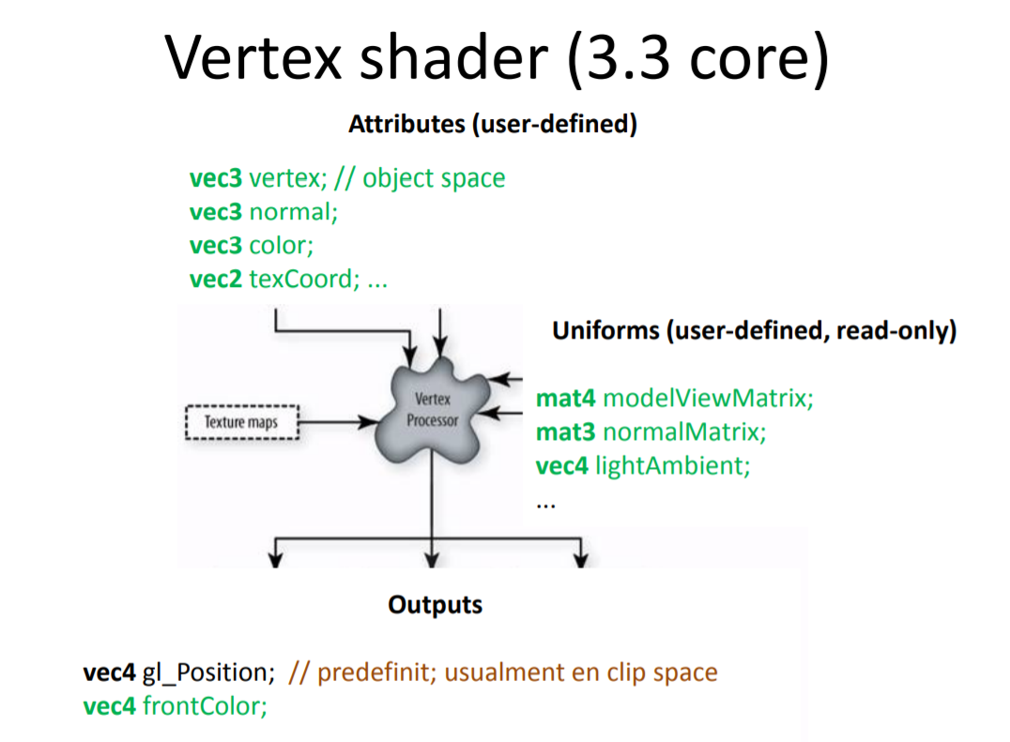

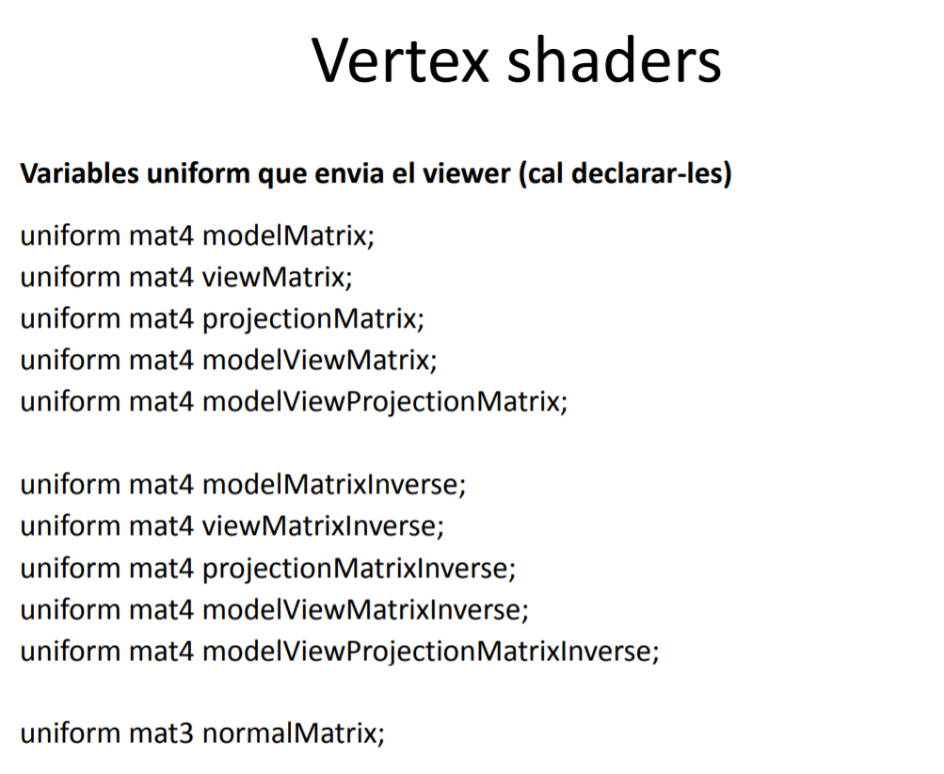

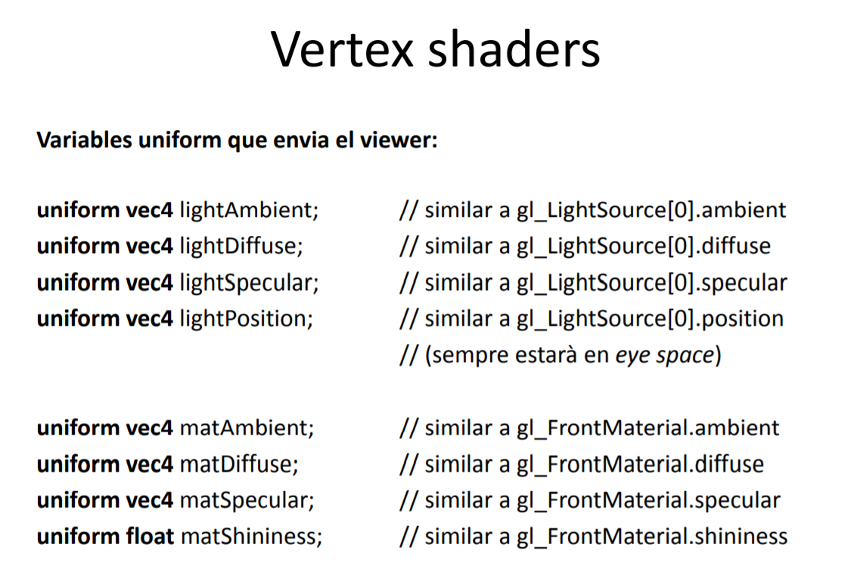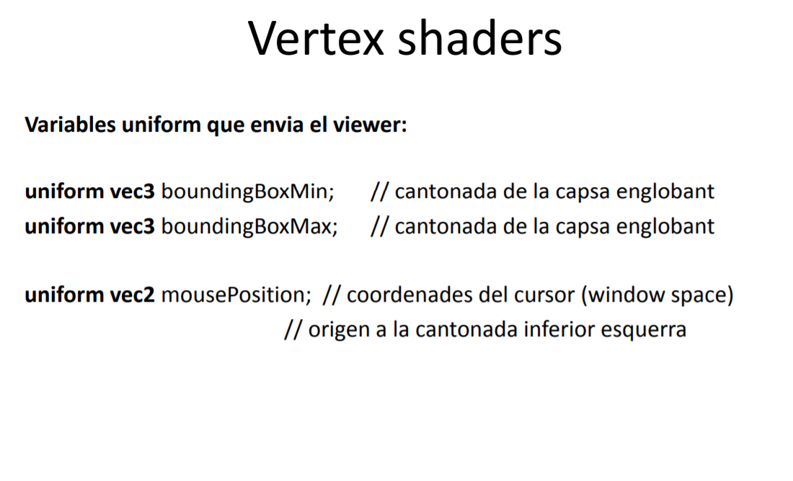

Fragment Shader

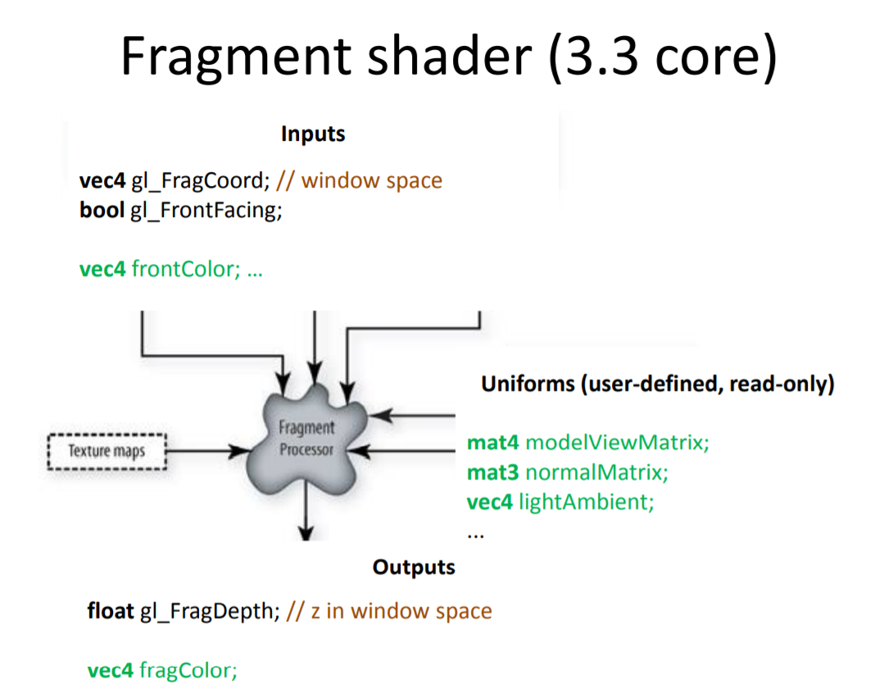

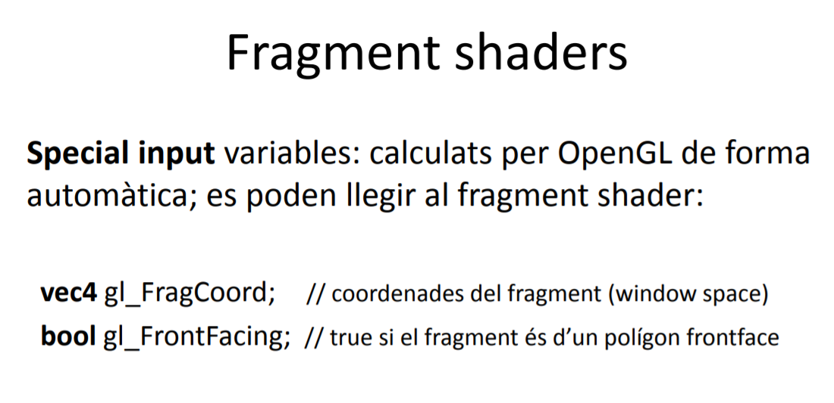



Geometry shader

Gl_PrimitiveIDIn