PLETHEM Workflow Tutorial Series

Using forward dosimetry to generate biomonitoring equivalents

# Introduction

Biomonitoring equivalents (BEs) are defined as the concentration of a chemical (or metabolite) in a biological medium (blood, urine, human milk, etc.) consistent with defined exposure guidance values or toxicity criteria including reference doses and reference concentrations (RfD and RfCs), minimal risk levels (MRLs), or tolerable daily intakes (TDIs).[1] Physiologically Based Pharmacokinetic (PBPK) models can be parameterized to generate a distribution of biomarker concentrations and then be compared to measured biomonitoring data. In this case study, we will be modeling trichloroethylene (TCE) kinetics using PLETHEM. We are estimating the biomonitoring equivalents for two reference exposures—an IRIS-recommended reference concentration value and an upper 95th percentile exposure estimate from the SEEM3 exposure estimation tool.

# What this tutorial covers

Forward dosimetry is the default workflow for PBPK modeling. It allows users to establish internal concentrations from external exposure metrics by accounting for route-of-exposure effects and the distribution, metabolism, and excretion of the chemical in the body. PLETHEM uses a generalized PBPK model description that simulates all major organs in the body and can be used to predict internal dose metrics following external exposure.

In this case study, we go through the steps of parameterizing a model for TCE. We use two sources of exposure information, a reference concentration from the IRIS assessment done by the EPA ([Link](https://cfpub.epa.gov/ncea/iris2/chemicalLanding.cfm?substance_nmbr=199)) and an environmental exposure estimated by EPA’s SEEM3 exposure prediction tool. A database containing SEEM3 estimates for multiple chemicals can be downloaded [here](https://scitovation-my.sharepoint.com/:u:/p/spendse/Ed4-LBItFRVGqS9ofSG6zC4BBb6LLsZOK-CRIrCKfaAyYg?e=81KMnM).

Most workflows in PLETHEM will require users to parameterize a rapidPBPK model through the steps outlined below.

# Parameterizing the TCE model

The rapidPBPK model within PLETHEM is parameterized as a TCE model using chemical-specific values parameters and QSAR models.

**NOTE**: Some system configurations lead the file location browser dialog boxes to open behind the PLETHEM browser window. If you do not see the “Select Folder”, “Save As”, or “Open” dialogs, and the RShiny dock icon is bouncing when you mouse-over it in OSX, or the Browse For Folder icon appears on the Windows taskbar, the dialog may have opened behind the browser window. Clicking the RShiny dock Browse for Folder icon or moving the PLETHEM browser window out of the way will reveal the dialog box.

## Create a new project

### For Windows users

1. Load the PLETHEM package using “library(plethem).”
2. Launch the PBPK modeling workflow by typing interactivePBPK() in the R console. This launches the forward dosimetry user interface in the default browser.
3. Under the file menu, select “New” to create a PLETHEM project file to which the model can be saved.
4. This opens the “New Project” dialog so you can name the project. Let’s name this one “TCE Forward Dosimetry.”
5. Click the “OK” button. PLETHEM will now ask you to select a location for the new project file.
6. Select the directory in which you wish to store the project file and click “OK.”

### For MacOS users

1. Load the PLETHEM package using “library(plethem).”
2. Launch the PBPK modeling workflow by typing “interactivePBPK()” in the R console.
3. This launches the forward dosimetry user interface in the default browser.
4. 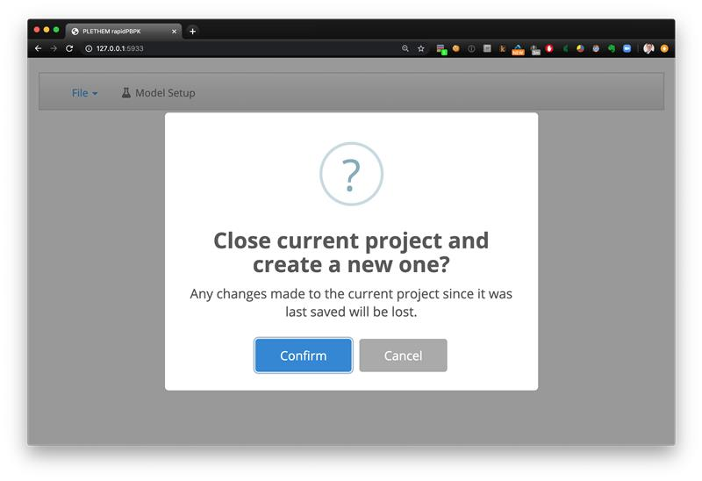Under the file menu, select “New” to create a PLETHEM project file to which the model can be saved. The new project dialog box that opens will not have a specific input element as for Windows users.
5. Click the “Confirm” button to open the “Save As” dialog for MacOS.
6. 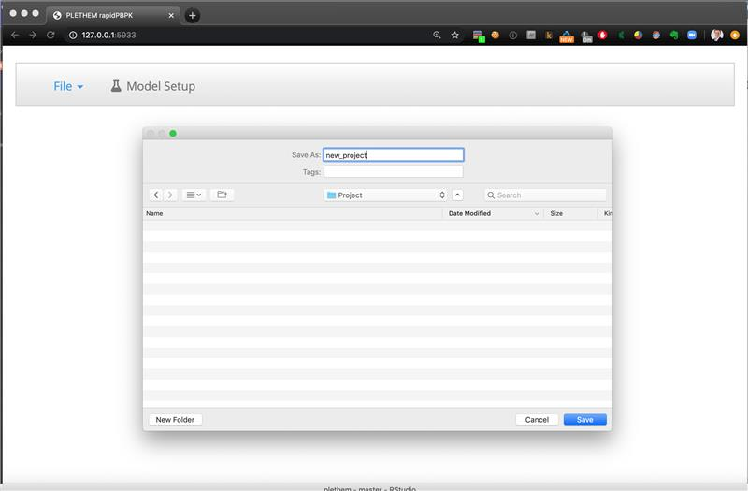Name the file “TCE Forward Dosimetry.Rdata” and click “Save” to save the project file and open a new project.

After the project has been established, we can start creating parameter sets for the model. PLETHEM uses a database to save all the parameter sets that users create for a project. The parameters can be exported for later use by selecting “Save” from the “File” menu. The project file allows users to export the project to a RData file that can be shared with other PLETHEM users. PLETHEM autosaves changes made to the project to the project file.

## Create an exposure set

Here, we will create three exposure sets, one corresponding to the IRIS Reference Concentration (RfC) and two corresponding to the SEEM3 exposure estimates.

We will use the IRIS continuous chronic RfC value of 0.004 ppm exposed at 24h/day for 7 days a week and save it as an exposure set called “IRIS Inhalation Exposure TCE.”

1. Navigate to the “Model Setup” tab.
2. Navigate to the “Exposure” tab in the user interface.
3. Select “Inhalation” from the sidebar to show inhalation-exposure inputs.
4. Set the “Inhalation Exposure” to 0.004 ppm, “Duration of Inhalation Exposure” to 24 h/day and ”Exposure days in a week” to 7.
5. Click the “Save As” button to save the set and name it “IRIS Inhalation RfC.” Click “Add” to save the exposure.

Next, we import SEEM3 estimates into PLETHEM using the Import Data wizard.

1. 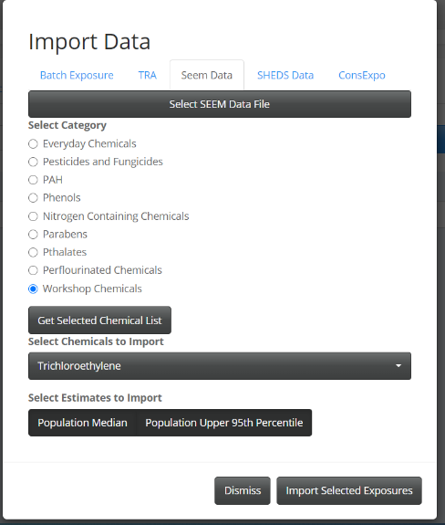Click on the “Import Data” button and select the “SEEM Data” tab.
2. If you haven’t already, download the SEEM exposure estimates from this [link](https://scitovation.sharepoint.com/:u:/g/EYl07GDnuNFAi9sV_NGG38YB725YXzv5tngMy9Dx0JdcZQ) and save them on your computer
3. Click the “Select SEEM Data File” button and navigate to the location where SEEM.sqlite is stored. Click “Open” to read the data file.
4. Select “Workshop Chemicals” from the radio button list under “Select Category” and click the “Get Selected Chemical List” button.
5. Select “Trichloroethylene” from the “Select Chemicals to Import” drop-down menu and click the “Population Upper 95th Percentile” and “Population Median” buttons.
6. Click the “Import Selected Exposures” button. This imports the exposure into the project and creates a new exposure set for it.

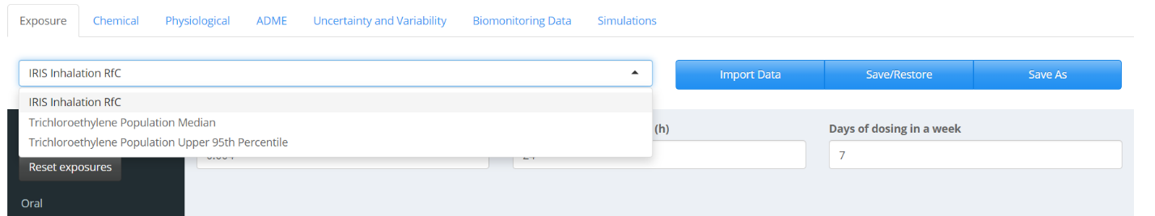The three exposures are now a part of the project in PLETHEM. Please note that the project file at the location saved in Step 3.1 is not changed. The parameter sets created here are saved to the internal project database in PLETHEM.

## Create a chemical set

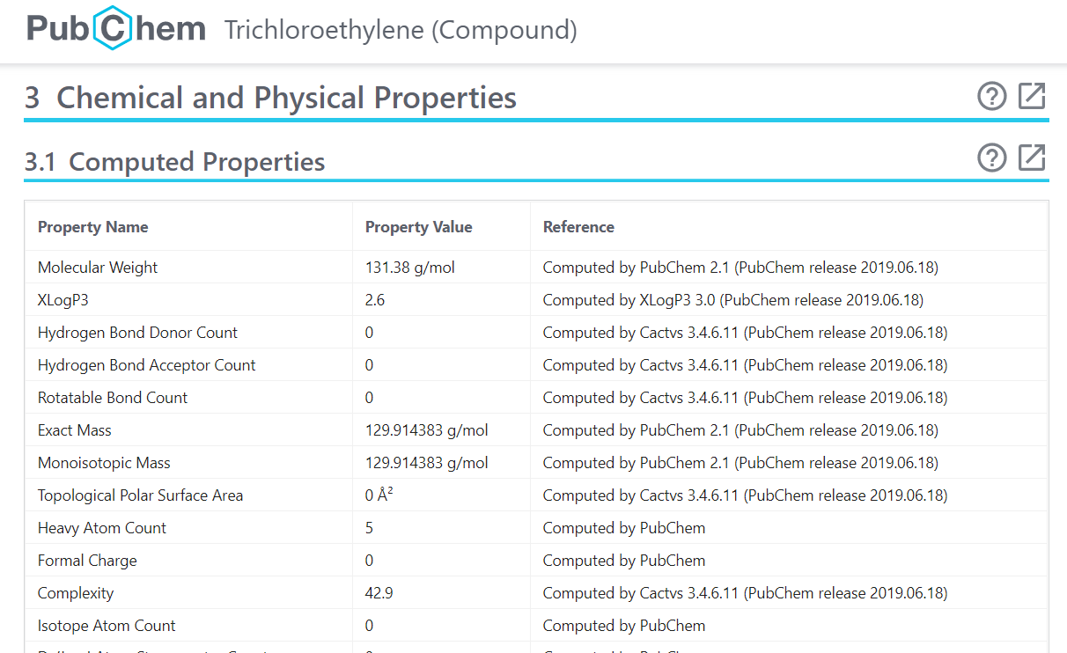PLETHEM uses QSAR models to estimate partition coefficients for distribution of the chemicals. The QSAR models use physical-chemical properties of the substance to estimate these values. We used PubChem and the EPA Comptox dashboard to obtain these values for TCE.

The values from these data sources are then used to populate the user interface.

1. Navigate to the “Chemical” tab in the user interface.
2. 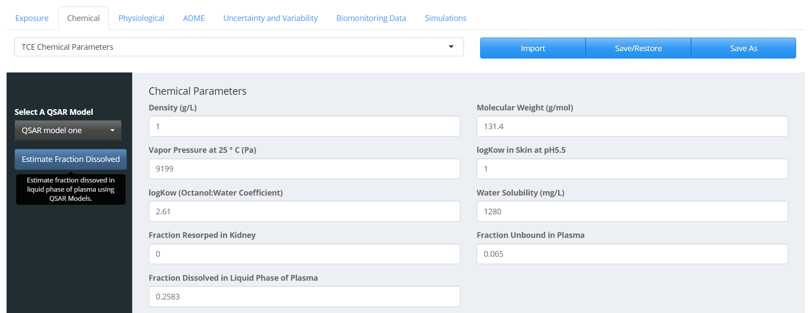Enter the appropriate input values as shown in the figure below except the “Fraction Dissolved in Liquid Phase of Plasma” value, which will be populated in the next step.
3. Click on the “Estimate Fraction Dissolved” button to estimate fraction of the chemical dissolved in the liquid phase of plasma. The “Fraction Dissolved in Liquid Phase of Plasma” box value should match the figure above.
4. Click “Save As” to save the parameter set as “TCE Chemical Parameters.” Click “Add” to save chemical parameters.

## Create a physiological set

We simulate an adult human male in this case study. To create a standard adult human male physiology description:

1. Navigate to the “Physiological” tab in the user interface.
2. Select “Human” and “Male” under the “Organism” and “Gender” drop-downs menus, respectively. Set “Age” to “25.”
3. Click the “Calculate Physiological Parameters” button to parameterize the model using life-course equations in PLETHEM. The values should match the figure below.
4. 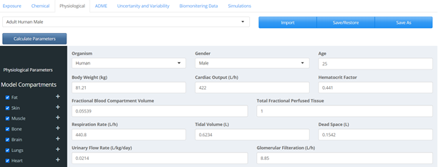Click the “Save As” button to save the parameter set. Name the set “Adult Human Male.” Click “Add” to save the physiological parameters.

## Create an ADME set

In PLETHEM, the ADME set is used to specify parameters related to absorption, distribution, metabolism, and excretion. They need to be defined for a specific combination of chemical, metabolite, exposure, and physiology. In this case study, we are not tracking the metabolite of TCE in the model. Hence, the metabolite selection is set to “No Metabolite.”

The “Absorption” and “Excretion” parameters in this case study are left to their default values. The tissue partitioning is calculated at the partition tab by taking the following steps:

1. Navigate to the “ADME” tab in the user interface.
2. Select the “Distribution” tab.
3. Select “QSAR Model One” to be used for estimating partitioning. The “QSAR Model One” refers to the default QSAR model in PLETHEM, which is adapted from the algorithm published by DeJongh et al. 1997.[2]
4. 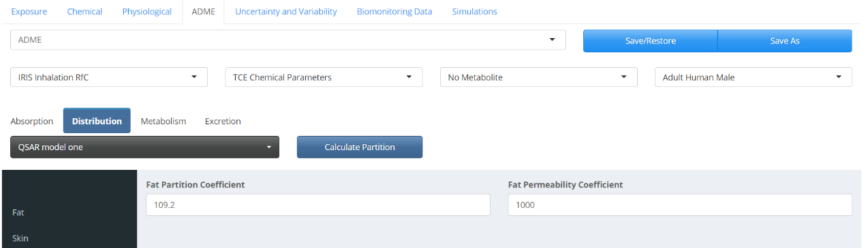Click the “Calculate Partition” button to estimate partition coefficients for all tissues that are part of the model. The values should match the figure below.

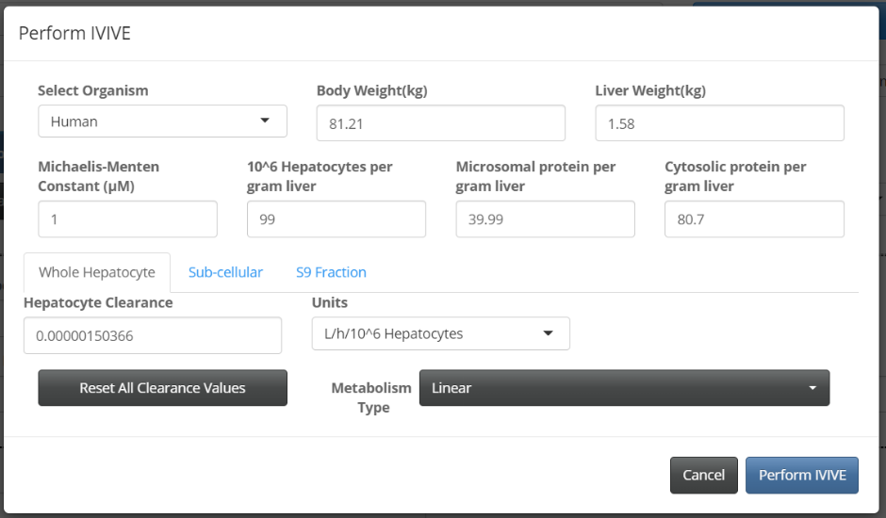TCE metabolism is defined under the “Metabolism” tab in the ADME user interface. We use the IVIVE algorithm within PLETHEM to scale the intrinsic clearance predicted by the OPERA models (1.50366e-6 L/h/106 Hepatocytes) to intrinsic clearance in vivo.

* 1. Select the “Metabolism” tab to display metabolism-related inputs.
  2. Click the “Perform IVIVE” button to open the IVIVE interface.
  3. Under the “Hepatocyte Clearance,” enter the value of 1.50366e-6 and choose the appropriate units from the “Units” drop-down menu (L/h/10^6 Hepatocytes).
  4. Select “Metabolism Type” to be linear.
  5. Click the “Perform IVIVE” button to extrapolate intrinsic clearance in vitro to intrinsic clearance in vivo.

The entire ADME set is then saved along with the chemicals, physiology, and exposure set it represents. This will be used later to filter the appropriate ADME set for selection when creating a simulation from these building blocks. Because we have two exposure scenarios, we need to create two ADME sets—one for each exposure scenario to account for any differences.

1. For the first ADME set, we will use the IRIS Inhalation exposure, which can be selected from the drop-down menus located in the “ADME” user interface. See the figure below.

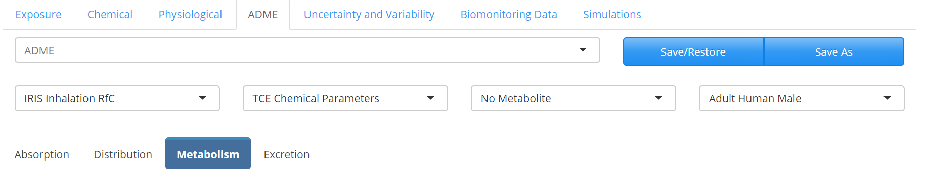

1. Click “Save As” to save the exposure scenario. Name the scenario “ADME Set for IRIS Inhalation Exposure.” Click “Add” to save the exposure.
2. For the second ADME set, we select the “Trichloroethylene Population Upper 95th Percentile.” See the figure below. 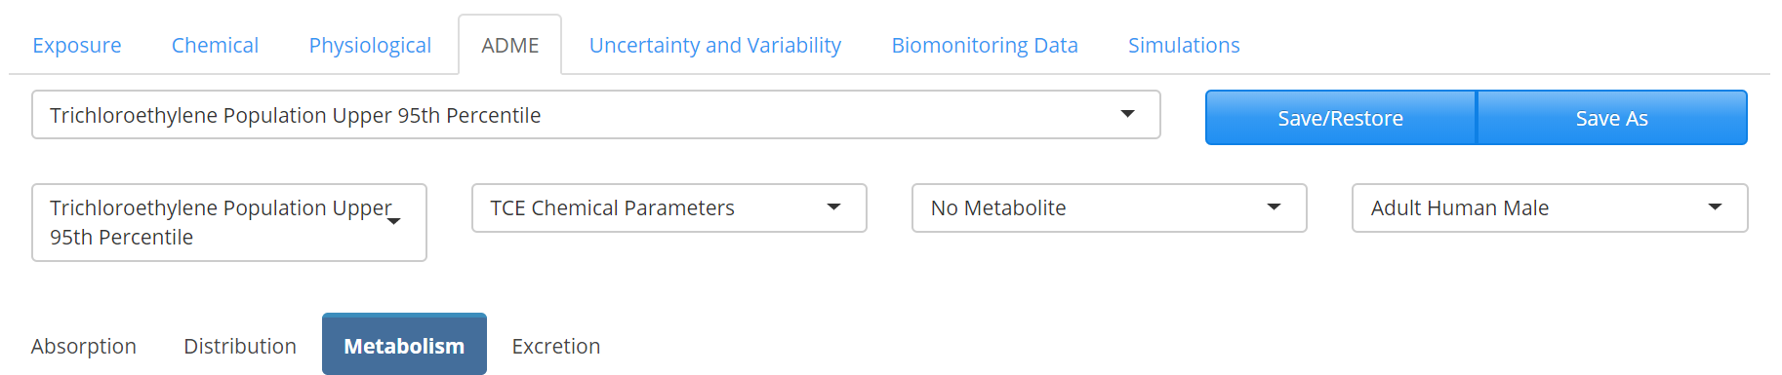
3. Click the “Save As” button to save the exposure scenario. Name the scenario “Trichloroethylene Population Upper 95th Percentile.” Click “Add” to save the exposure.

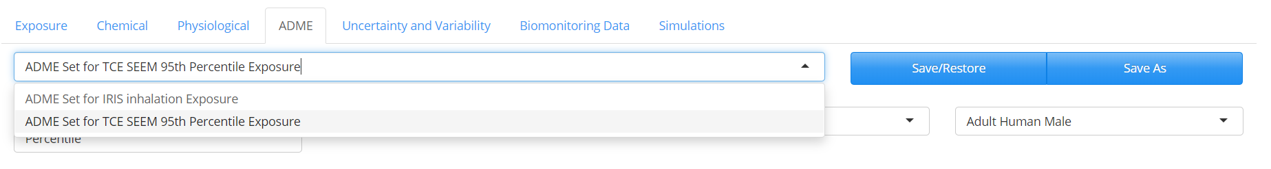You should now be able to see both exposures in the drop-down menu.

In this case, the ADME sets have different absorption-related parameters because they have distinct routes of exposure. While modeling with PLETHEM, the user may choose to create multiple ADME sets for the same chemical, exposure, and physiology to investigate the differences in ADME processes.

## Define variability

For this model, we account for differences in body weight, cardiac output, tissue volume, blood flow, and respiratory rate between individuals. Variability is defined in PLETHEM as an uncertainty and variability set for parameters in each of the four previously defined sets. This set is saved as a physiological variability set.

1. Navigate to the “Uncertainty and Variability” tab in the user interface.
2. Select “Physiological” from the sidebar.
3. Click on the “New” button to open the variability interface. Name this set “Physiological Variability.”
4. Select “Body Weight,” “Cardiac Output” and “Respiration Rate” from the drop-down menu located under the “Select Parameters to Assign Variability” and click the “Update List” button. This will also lead to different tissue volumes and blood flows to be scaled appropriately.
5. Assign “Coefficient of Variation” and “Type of Distribution” to the parameters as shown in the figure below.

Click “Done” to save the variability set. 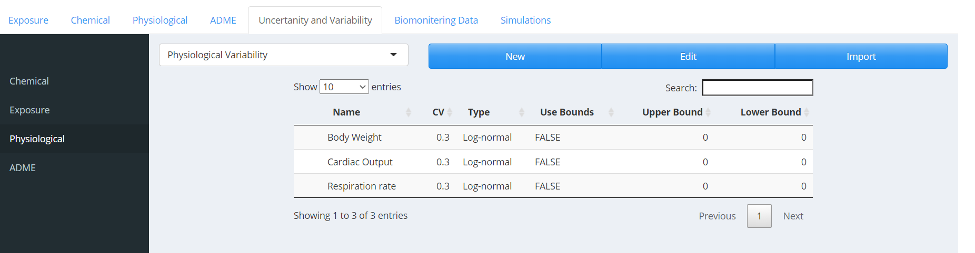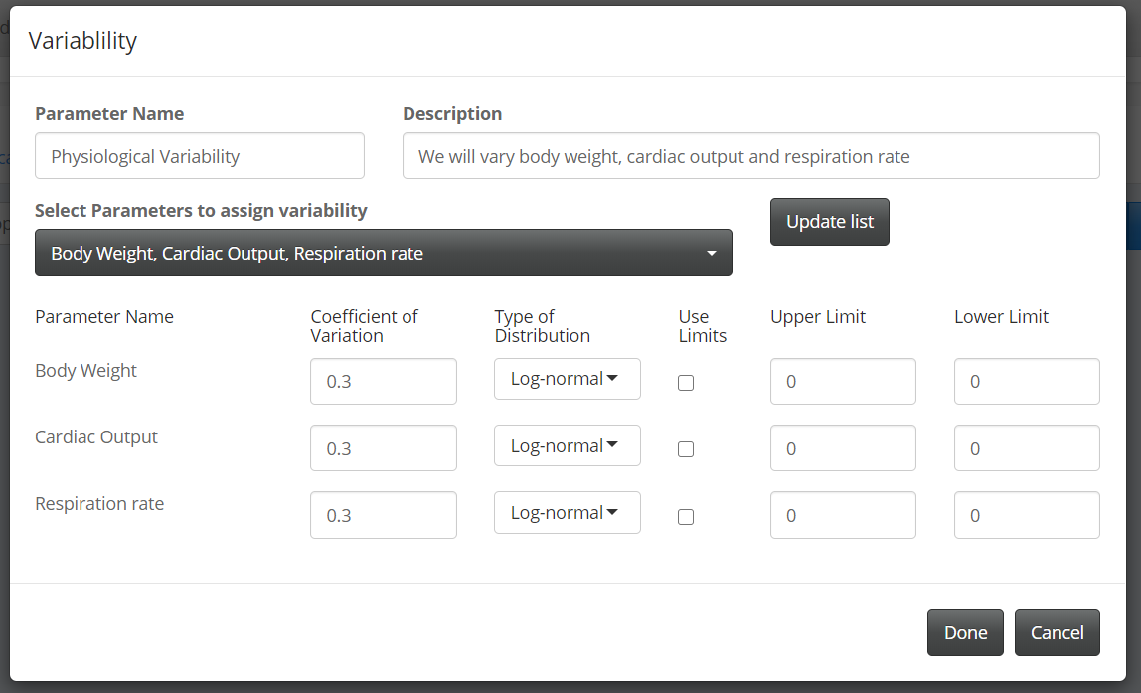 At this point it is a good idea to save the entire project by clicking the “Save” button in the “File” menu.

## Create a simulation

All the sets are put together to create a simulation. We will create two simulations, one with inhalation exposure and one with SEEM exposure estimate.

1. Navigate to the “Simulations” tab in the user interface.
2. Click “New” to launch the “Simulation” dialog.
3. Name the simulation “TCE Simulation for Inhalation RfC” and add a description. The description field is used by PLETHEM when generating a report of the simulation but is not required.
4. Select “Forward Dosimetry with Monte Carlo” as the “Simulation Type.”
5. Under the “Parameters” tab, make sure the appropriate “Exposure,” “Parent Chemical,” “Physiology,” and “ADME” tabs are selected. For the first simulation, we will select “IRIS Inhalation RfC” as the “Exposure.”
6. Under the “Variability” tab, make sure “Physiological Variability” is selected under the “Physiology” menu. Remember we are only varying the physiology in this simulation.
7. Under the “Simulation” tab, set the “Simulation Start Time” to 0, “Simulation Duration” to 1, and “Duration Units” to Days. Effectively, we will be running a 24h simulation starting at 0. The default number of Monte Carlo runs is set to 1000.
8. Click the “Create Simulation” button to save the simulation.
9. Create another Monte Carlo simulation following the same steps with the SEEM exposure instead and name it “TCE Simulation for 95th Percentile SEEM Exposure.”

We can now choose one of the simulations and select the “Run” button to conduct a Monte Carlo simulation and generate a concentration distribution.

## Running the simulation

1. Select the simulation you wish to run from the drop-down menu.
2. Click the “Run” button. Because the selected simulation here is a Monte Carlo simulation, a progress bar will appear above the “Run Simulation” as the simulation proceeds in the bottom right corner.
3. After the simulation is complete, PLETHEM will switch over to the “Model Outputs” tab.

## Viewing and exporting simulation results

The “Model Output” tab allows users to view and export simulation results such as tissue concentrations and amounts. It also contains interfaces for importing datasets to plot against simulation results for viewing the results from Non-compartmental Analysis. For this case study, we look at the arterial concentration of TCE and several tissues following the exposure we selected.

1. Select the “Plots” tab on the “Model Outputs” page.
2. Select the “Concentration” panel and select “Arterial Plasma,” “Liver Tissue,” “Rapidly Perfused Total,” and “Slowly Perfused Total” from the multiple selection menu on the left.
3. 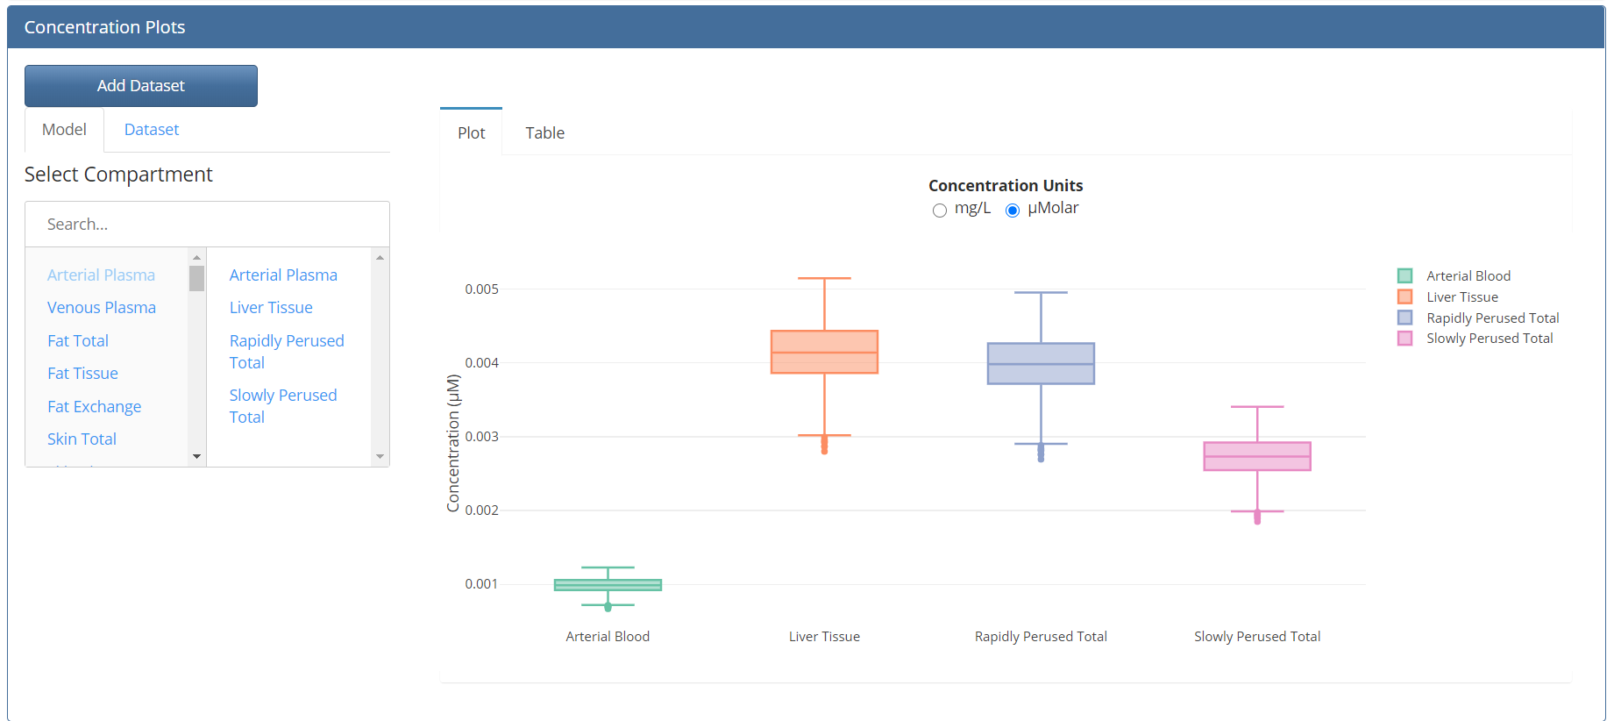This creates a box plot for the arterial plasma concentration and liver, rapidly and slowly perfused tissue concentrations in the plot window on the right. You should see the figure below.
4. 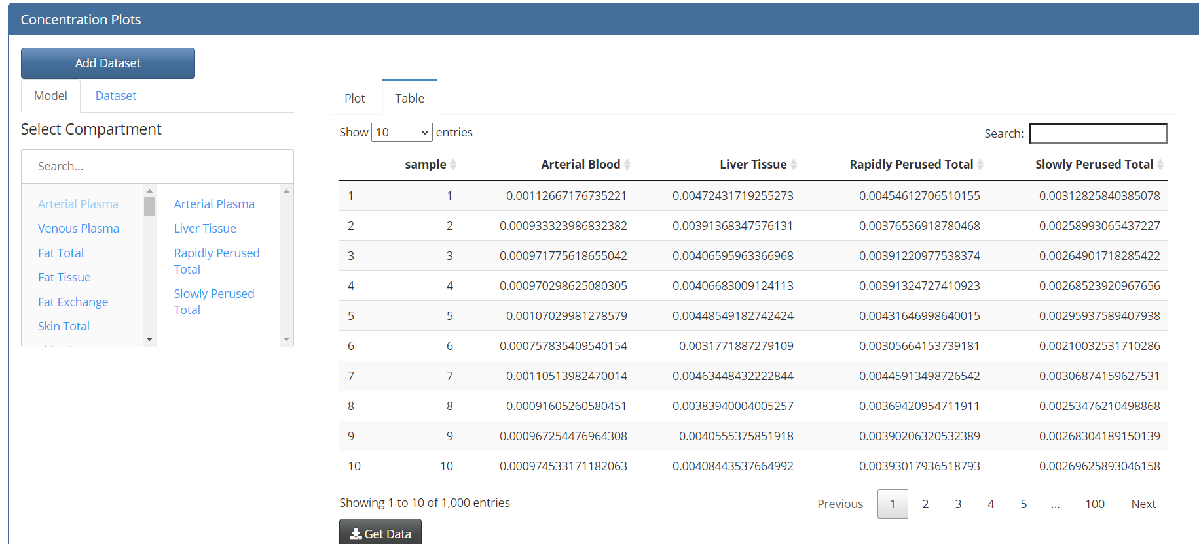Selecting the “Table” tab on the concentration panel brings up the actual Cmax values behind the box plot. These Cmax values can be exported by clicking on the “Get Data” button below the table.

## Save the project and quit the user interface

To save the project, navigate to the location first selected when creating the project and click the “Save” button from the file menu. To quit the app, click the “Quit” button on the file menu.

1. Hays, Sean M., et al. *Regulatory Toxicology and Pharmacology* 47.1 (2007): 96-109.
2. DeJongh, J., H.J. Verhaar, and J.L. Hermens, A quantitative property-property relationship (QPPR) approach to estimate in vitro tissue-blood partition coefficients of organic chemicals in rats and humans. Arch Toxicol, 1997. 72(1): p. 17-25.