PLETHEM Workflow Tutorial Series

This document is part of series of worked examples intended to demonstrate key functionalities of the Population Lifecourse to Health Effects Modeling (PLETHEM) Suite. This document should be treated as draft and is currently released as a *public beta*.

Documentation can be found at <https://scitovation.com/plethem>

Questions and comments about PLETHEM or about this document are welcomed at [plethem@scitovation.com](mailto:plethem@scitovation.com)

*PBPK Model and Route-to-Route Extrapolation Workflow*

# Introduction

Often a defined exposure guidance value, such as reference dose or tolerable daily intake levels, is expressed as an oral exposure in mg/kg body weight/day. However, the chemical being examined may be exposed along a different route of exposure that does not have a defined reference dose. Route-to-route extrapolation is used in these cases to estimate exposure through a different route that still gives the same internal plasma concentration. One approach to these estimations is to parameterize a Physiologically Based Pharmacokinetic (PBPK) model that can simulate both the original and extrapolated route of exposure. The PBPK model is then simulated with the original exposure route to obtain the distribution of plasma concentration for the chemical in question. This distribution is treated as a biomonitoring dataset for running a reverse dosimetry workflow using the same model, but with a different route of exposure. In this case study, we use the PBPK interface to parameterize a trichloroethylene (TCE) PBPK model with an oral route of exposure. We then use the route-to-route extrapolation workflow within PLETHEM to estimate an inhalation exposure that leads to a distribution of arterial blood concentration similar to the oral route. The Route-to Route Extrapolation workflow within PLETHEM uses the Discretized Bayesian Approach (DBA) for estimating a different route of exposure. This approach requires us to create a PBPK model that includes population-level variability.

# What this tutorial covers

Route-to-route extrapolation is useful for estimating dose through routes of exposure for which a reference dose has not or cannot be established through traditional toxicological assessment. The underlying assumption is that both the reference dose and the extrapolated dose result in similar internal points of departure for an observed effect. This requires a human PK or PBPK model for a specific compound to describe the relationship of a biomarker of exposure and an external dose along the two routes of exposure involved.

It is impractical to “reverse” the model description to predict exposure from a distribution of biomarkers in the body. Instead, the approach used in PLETHEM iteratively runs forward dosimetry simulation and uses statistical tools to estimate exposure along a different route of exposure. Some information on the nature of the exposure to be examined is still provided by the user, such as the source, frequency, and duration of exposure. It is also important to consider uncertainty and variability in human exposure and pharmacokinetics. This is the role of the Monte Carlo analysis.

In this case study, we first parametrize a TCE model using the PBPK interface in PLETHEM. This parameterized model is used to generate the two datasets—distribution of an internal biomarker at reference exposure and multiple distributions of the same biomarker across a range of doses along the second route of exposure.

# Parameterizing the TCE Model

The rapidPBPK model within PLETHEM was parameterized as a TCE model using chemical-specific values and QSAR models.

**NOTE**: Some system configurations lead the file location browser dialog boxes to open behind the PLETHEM browser window. If you do not see the “Select Folder”, “Save As”, or “Open” dialogs, and the RShiny dock icon is bouncing when you mouse-over it in OSX, or the Browse For Folder icon appears on the Windows taskbar, the dialog may have opened behind the browser window. Clicking the RShiny dock Browse for Folder icon or moving the PLETHEM browser window out of the way will reveal the dialog box.

## Create a new project

### For Windows Users

1. Load the PLETHEM package using “library(plethem).”
2. 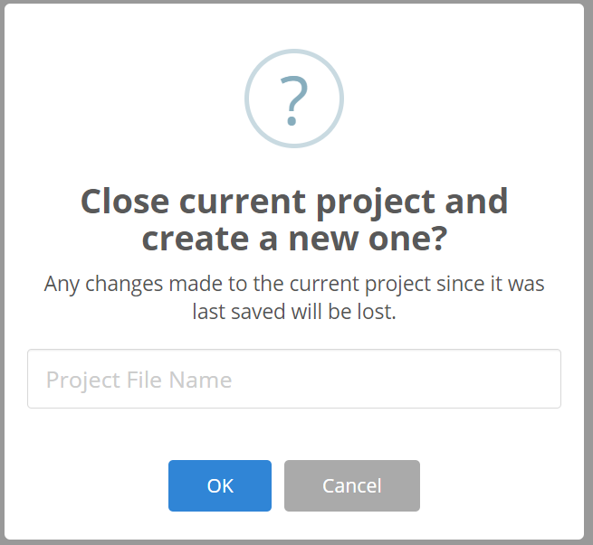Launch the PBPK modeling workflow by typing interactivePBPK() in the R console. This launches the forward dosimetry user interface in the default browser.
3. Under the file menu, select “New” to create a new PLETHEM project file to which the model can be saved.
4. This opens the “New Project” dialog. Name the project as in our example, “TCE Route to Route Extrapolation.”
5. Click the “OK” button. PLETHEM will now ask you to select a location for the new project file.
6. Select the directory in which you wish to store the project file and click “OK.”

### For MacOS Users

1. Load the PLETHEM package using “library(plethem).”
2. Launch the PBPK modeling workflow by typing interactivePBPK() in the R console. This launches the forward dosimetry user interface in the default browser.
3. Under the file menu, select “New” to create a new PLETHEM project file to which the model can be saved.
4. 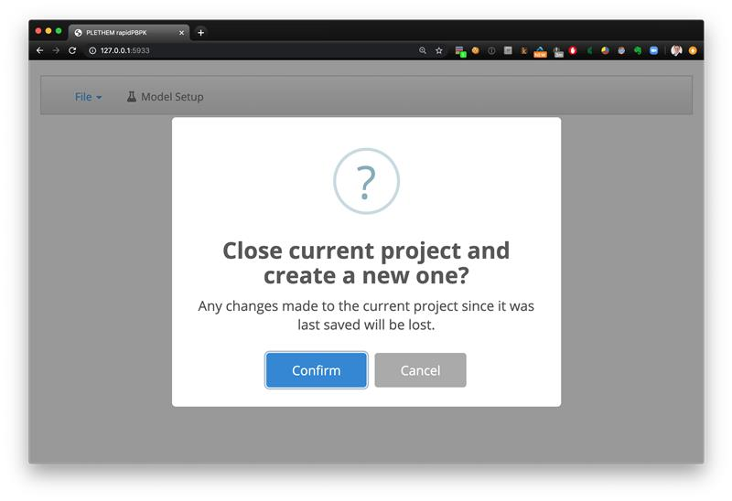The new project dialog box that opens does not have a specific input element like above. Click the “Confirm” button to open the “Save As” dialog for MacOS.
5. 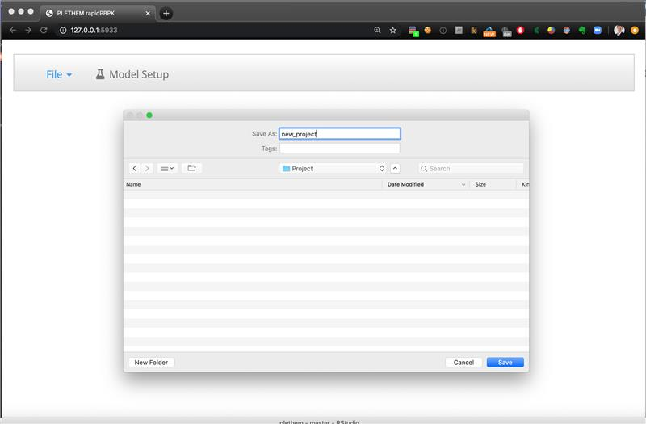Call the file “TCE Route to Route Extrapolation.Rdata” and click “Save” to save the project file and open a new project.

We have now created a new PBPK modeling project. The parameter sets for the model can now be created from the interface. PLETHEM uses a database to save all the parameter sets a user creates for a project to the project file we just created. The parameters can be exported for later use by selecting “Save” from the “File” menu. The project file allows users to export the project to an RData file that can be shared with other PLETHEM users.

## Create an exposure set

We will create an exposure set for the reference route of exposure using the TCE oral RfD value of 0.0005 mg/kg BW/day from EPA IRIS assessment.[1]

1. Navigate to the “Model Setup” tab.
2. Navigate to the “Exposure” tab in the user interface.
3. Select “Oral” from the sidebar to show oral exposure inputs.
4. Set the “Daily Oral Dose” to 0.0005 mg/kg BW, “Duration of Exposure per Day (h/day)” to 1h/day, and “Number of Boluses per Day” to 1.
5. Click the “Save As” button to save the exposure set by the name “IRIS Oral RfD.” Click “Add” to save the exposure.
6. Click the “Reset Exposures” button on the left side menu when finished or you will not be able to add additional parameters.

## Create the extrapolation exposure set

We will use the route-to-route extrapolation workflow to estimate inhalation exposure to TCE. The workflow will estimate the exposure for a given set of exposure conditions. In the case of inhalation exposure, we must specify the length of inhalation exposure, hours per day, and the number of days of dosing per week. We assign a dummy exposure value of 1 ppm as PLETHEM requires exposure sets to have an exposure value.

1. Navigate to the “Model Setup” tab.
2. Navigate to the ““Exposure” tab” in the user interface.
3. Click the “Reset Exposures” button to set all exposure values on the UI to 0. PLETHEM can simulate only one active route of exposure at a time. If the exposure values for multiple routes are set, PLETHEM will show an alert and will not allow users to save exposure sets until the error is resolved.
4. Select “Inhalation” from the sidebar to show inhalation exposure related inputs.
5. Set the “Inhalation Exposure” to 1ppm, “Duration of Inhalation Exposure” to 8 h/day, and “Exposure days in a week” to 5.
6. 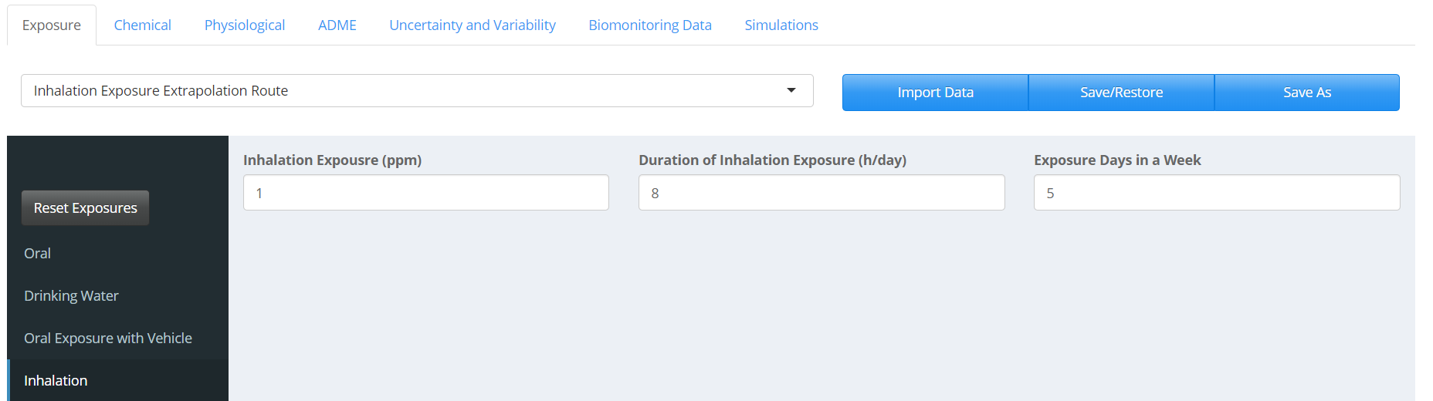Click the “Save As” button to save the exposure set, naming it “Inhalation Exposure Extrapolation Route.” Click “Add” to save the exposure.

## Create a chemical set

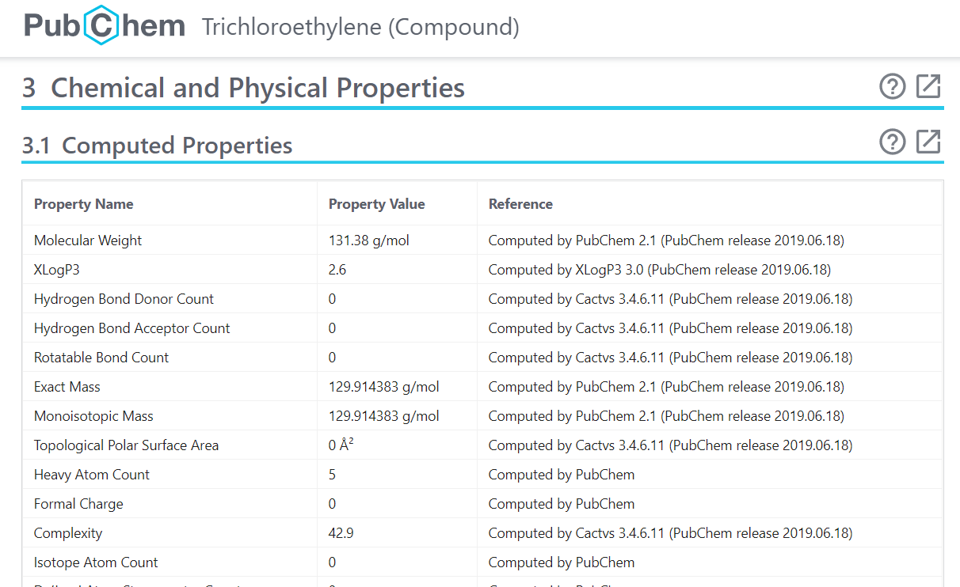PLETHEM uses QSAR models to estimate partition coefficients for distribution of chemicals. The QSAR models use physical-chemical properties of the substance to estimate these values. We used PubChem and the EPA Comptox dashboard to obtain these values for TCE.

The values from these data sources are then used to populate the user interface.

1. Navigate to the “Chemical” tab in the user interface.
2. Enter the appropriate input values from PubChem and Comptox Dashboard as show in the figure below. The value for “Fraction Dissolved in Liquid Phase of Plasma” will be estimated using QSAR models in the next step.
3. Click on the “Estimate Fraction Dissolved” button to estimate fraction of the chemical dissolved in the liquid phase of plasms.
4. 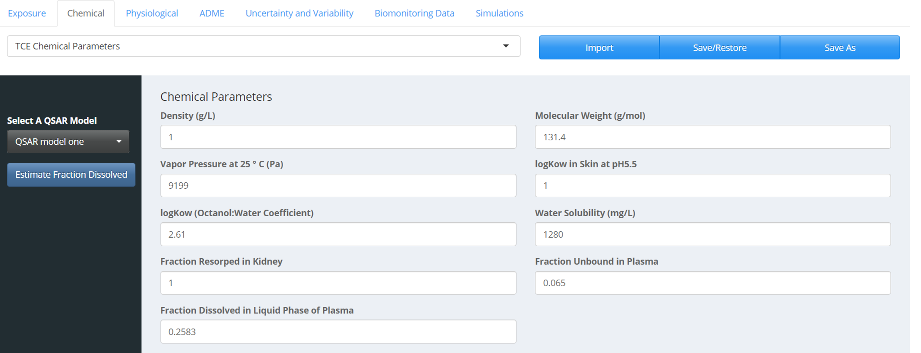Click “Save As” to save the parameter set as “TCE Chemical Parameters.” Click “Add” to save chemical parameters.

## Create a physiological set

We simulate an adult human male in this case study. To create this standard adult human male physiology description:

1. Navigate to the “Physiological” tab in the user interface.
2. Select “Human” and “Male” under the “Organism” and “Gender” drop-downs respectively. Set “Age” to “25.”
3. Click the “Calculate Physiological Parameters” button to parameterize the model using life-course equations in PLETHEM. The values should match the figure below.
4. 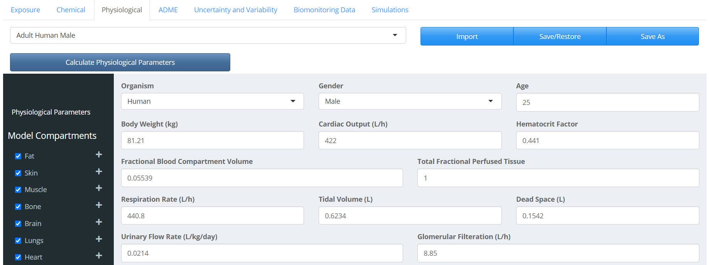Click the “Save As” button to save the parameter set. Call the set “Adult Human Male.” Click “Add” to save physiological parameters.

## Create an ADME set

In PLETHEM, the ADME set is used to specify parameters related to Absorption, Distribution, Metabolism, and Excretion. While parameters need to be defined for a specific combination of chemical, metabolite, exposure and physiology, we are not tracking the metabolite of TCE in the model. So, our metabolite selection is set to “No Metabolite.”

The “Absorption” and “Excretion” parameters in this case study are left to their default values. Tissue partitioning is calculated by taking the following steps.

1. Navigate to the “ADME” tab in the user interface.
2. Select the “Distribution” tab.
3. Select the QSAR model to be used for estimating partitioning. “QSAR model one” refers to the default QSAR model in PLETHEM, which is adapted from the algorithm published by DeJongh et al 1997.[2]
4. Click the “Calculate Partition” button to estimate partition coefficients for all tissues in the model. You can click on the various tissue to see the calculated partition coefficients. The value for fat should match the figure below.

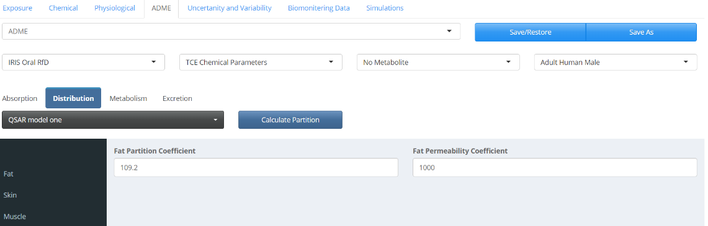TCE metabolism is defined under the metabolism tab. We use the IVIVE algorithm within PLETHEM to scale the intrinsic clearance predicted by the OPERA models (0.00000150366 L/h/10^6 Hepatocytes) to intrinsic clearance in vivo.

1. Click on “Metabolism” to display metabolism-related inputs.
2. Click the “Perform IVIVE” button to open the IVIVE interface.
3. Under the “Hepatocyte Clearance” tab, enter the value of 1.5e-6 and choose the appropriate units from the “Units” drop-down menu (L/h/10^6 Hepatocytes).
4. Select “Metabolism Type” to be linear.
5. 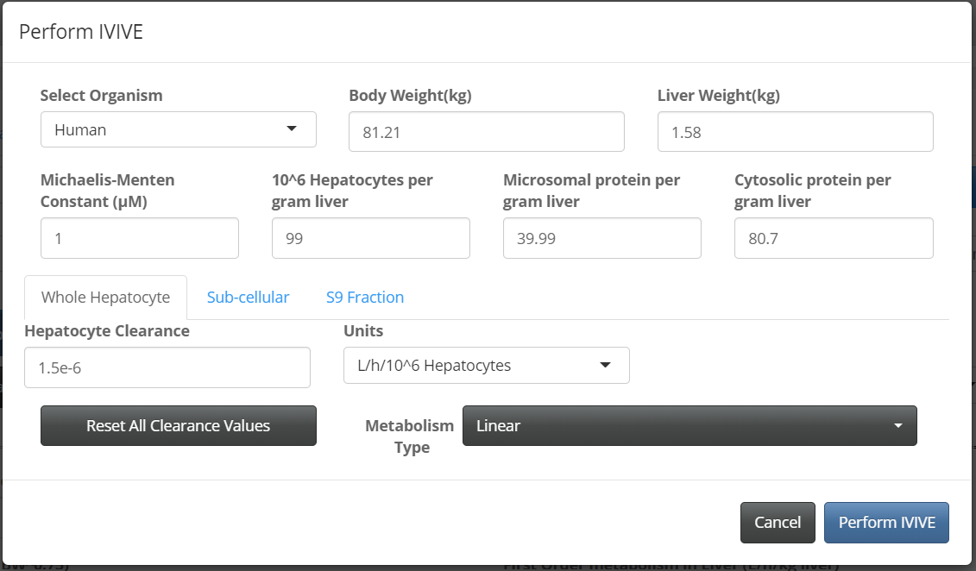Click the “Preform IVIVE” button to extrapolate intrinsic clearance in vitro to intrinsic clearance in vivo. You will be returned the Metabolism tab, where the “First Order metabolism in Liver (L/h/kg liver)” value should now be 0.1485.

The entire ADME set is then saved along with the chemicals, physiology, and exposure set it represents.

1. Click the “Save As” button and name the set as “ADME for TCE with Oral Exposure.” Click “Add” to save the set.

## Define variability

For this model we are accounting for differences in bodyweight, cardiac output, and respiratory rate between individuals. Variability is defined in PLETHEM as an uncertainty and variability set for parameters in each of the four previously defined sets. This set is saved as a physiological variability set.

1. Navigate to the “Uncertainty and Variability” tab in the user interface.
2. Select “Physiological” from the side bar.
3. Click on the “New” button to open the variability interface. Let’s call this set “Physiological Variability.”
4. Select “Body weight,” “Cardiac Output,” and “Respiration Rate” from the drop-down menu located under the “Select Parameters to Assign Variability” and click the “Update List” button.
5. 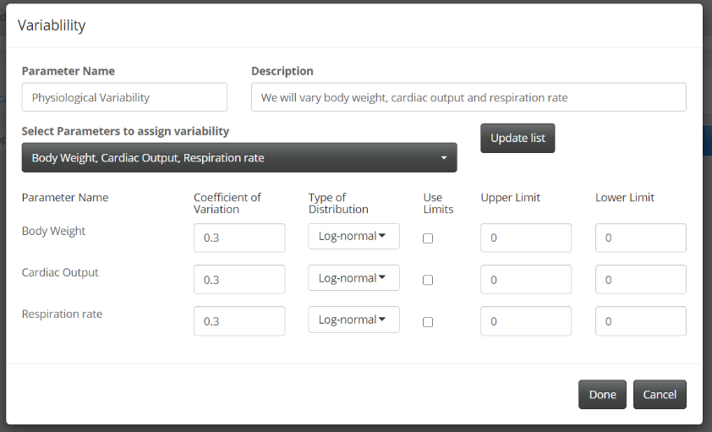Assign “Coefficient of Variation” and “Type of Distribution” parameters as shown in the figure.
6. 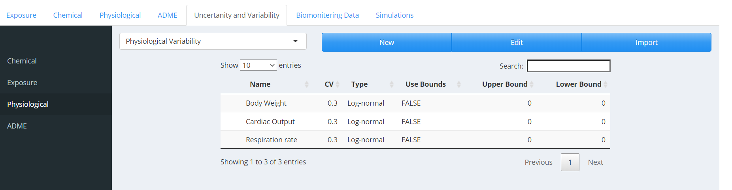Click “Done” to save the variability set. At this point it is a good idea to save the entire project by selecting the “File” menu and clicking “Save”.

## Create a simulation

All the sets can now be put together to create a simulation.

1. Navigate to the “Simulation” tab in the user interface.
2. Click “New” to launch the new “Simulation” dialog.
3. Give the simulation a name “Route to Route Exposure for TCE” and a description “Extrapolating Oral Exposure to Inhalation Exposure Using the Route to Route Extrapolation Workflow.”
4. Select “Route to Route Extrapolation” as the “Simulation Type.”
5. Under the “Parameters” tab, make sure the appropriate “Exposure” as IRIS Oral RfD, “Parent Chemical” as TCE Chemical Parameters, “Physiology” as Adult Human Male, and “ADME” as ADME for TCE with Oral Exposure tabs are selected. If our project contained multiple sets, we could select the set of our choosing from the drop-down menu.
6. Under the “Variability” tab, make sure that “Physiological Variability” is selected. Since we have not defined variability for other sets, we will leave them at “No Variability Set Found”. Since we will be estimating exposure, we cannot include exposure related variability in this workflow
7. The “Workflow Specific Inputs” tab allows users to define inputs and select data sets specific for the given simulation type. For route to route extrapolation, we need to select the starting exposure route, and estimate for the range of exposures and the number of exposures to run within that range for the Discretized Bayesian Approach (DBA) algorithm.
8. For this study we will set the “Exposure range” from 0.001 ppm to 0.05 ppm. We will discuss the reasons behind selection of this range at the end of this guide.
9. 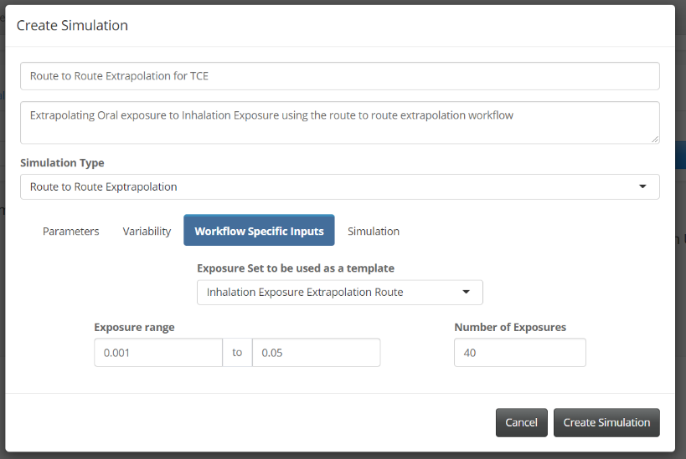Select the number of doses to simulate within this range. Usually this number should be at least 20. We will select 40 for this simulation.
10. Under the “Simulation” tab, set the “Simulation Start Time” to 0, “Simulation Duration” to 1 and duration units to Days from the “Duration Units” drop-down menu. Effectively we will be running a 24h simulation starting at 0. The default number of Monte Carlo runs is set to 1000.
11. Click the “Create Simulation” button to save the simulation.

## Running Route-to-Route Extrapolation.

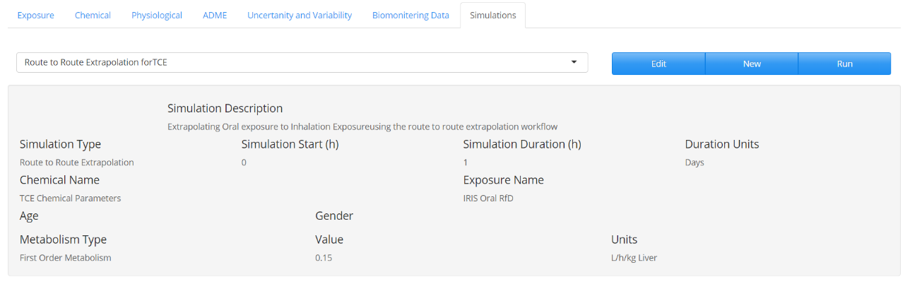The simulation we created will be selected by default in the drop-down menu. If you create other simulations, they can be selected from the drop-down menu. To run the route-to-route extrapolation, select the “Route-to-Route Extrapolation for TCE” and click “Run.”

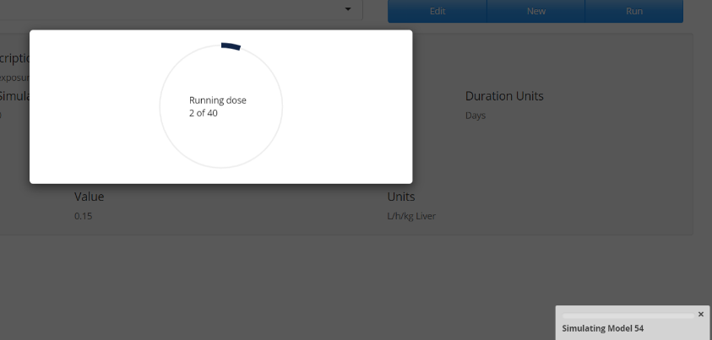PLETHEM will first simulate the model with oral exposure to generate a reference plasma concentration. Then PLETHEM will run the Monte Carlo simulations needed to run the DBA algorithm for estimating inhalation exposure. In this case we will run 40,000 simulations to get the necessary plasma concentrations to estimate exposure. This process can take a long time. The progress bar will update users on the number of exposures the model has run. After the calculations are complete, PLETHEM will navigate to the Model output tab to display the results.

## Route-to-Route extrapolation results

After the simulation is complete, PLETHEM runs the reverse dosimetry algorithm on the back end and creates a Cumulative Distribution Function (CDF) plot and a Probability Distribution Function (PDF) plot for the expected exposure. If the dose ranges used are adequate, the graphs both the upper and lower tails of the distributions as in the figure below.

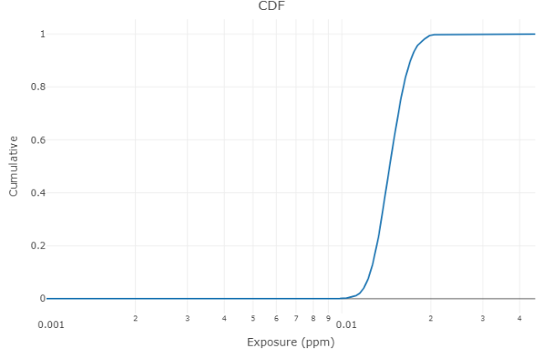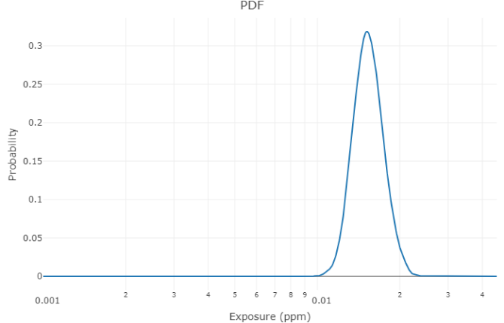

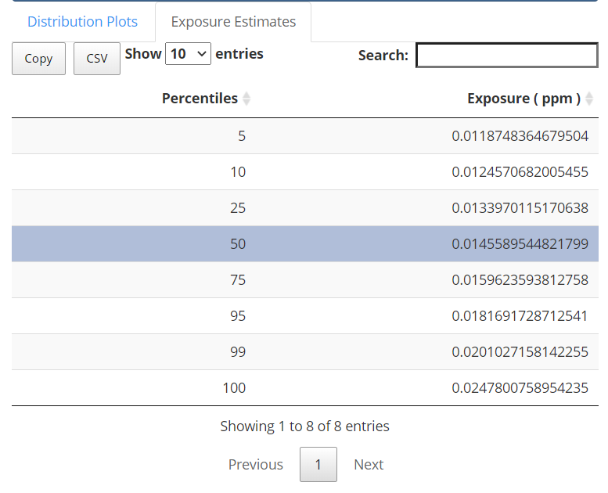

The percentile values for the expected exposure are displayed on the Exposure Estimates tab. Using the model we parameterized, we expect the extrapolated median inhalation exposure for the population to be 0.0145ppm.

## Save the project and quit the user interface

To save the project at the location first selected for the new project, click the “Save” button from the file menu.

To quit the app, click the “Quit” button from the file menu.

## Iteratively approaching the correct dose range

The dose ranges and number of doses selected are driven by a general understanding of the model and scale of biomonitoring results. The DBA is an iterative algorithm for reverse dosimetry. It is very likely that in the initial range selected, either the range is too wide or the extremes are too high or too low to estimate an exposure. The CDF and PDF graphs from the outputs are useful in refining this initial dosage range. If the CDF has a long tail on one end and does not plateau on the other end, that indicates the expected exposure is outside the range currently selected. If the CDF has a long tail at the lower exposure, that means the expected exposure is higher than current dose range; the reverse is true if the tail is at the higher exposures. For this case study, we started with a dose range of 0.001 ppm to 0.05 ppm and then progressively reduced the range unti the CDF included both the lower and upper tails of the distribution.

1. <https://cfpub.epa.gov/ncea/iris2/chemicalLanding.cfm?substance_nmbr=199>
2. DeJongh, J., H.J. Verhaar, and J.L. Hermens. A quantitative property-property relationship (QPPR) approach to estimate in vitro tissue-blood partition coefficients of organic chemicals in rats and humans. Arch Toxicol, 1997. 72(1): p. 17-25.