PLETHEM Workflow Tutorial Series

*Using HT-IVIVE to estimate equivalent applied dose and margin of exposure from in vitro data*

1. Introduction

High-Throughput In Vitro to In Vivo Extrapolation (HT-IVIVE) is a valuable tool that quickly extrapolates an in vitro point of departure to an equivalent applied dose in vivo. HT-IVIVE converts active concentrations from an in vitro assay to a human equivalent dose or human exposure that should produce concentrations in an exposed individual equal to the active concentration from the in vitro study.[1] The equivalent applied dose can then be compared to an estimated exposure to obtain a margin of exposure (MOE) for in vitro Point of Departure (POD). In this case study we establish a margin of exposure for coumarin.

# What this tutorial covers

In vitro assays are becoming more widespread for estimating hazard posed by the chemical being studied. They offer the ability to estimate hazard along specific modes of action at a fraction of the cost of traditional risk assessments. HT-IVIVE was developed as a way to extrapolate this in vitro POD to its equivalent value in vivo. These equivalent exposures can then be compared to environmental exposures to obtain a risk metric for the chemical. HT-IVIVE requires clearance data, physical-chemical parameters, and physiological information about target species to extrapolate in vivo exposures.

In this case study, we will use PLETHEM to extrapolate in vitro POD for Coumarin into an equivalent applied dose in vivo. PLETHEM consists of a standard parameter set for human physiology. However, it does not contain information on the physical chemical properties of Coumarin. We have created a user database ([link](https://scitovation-my.sharepoint.com/:u:/p/spendse/EQc87XMV20FFgIMAoHJA2P0BUZAh2PUmYkKv61vkYi55Wg?e=vM6QgE)) called WorkshopDb.sqlite that contains this information. Please download the file from the link and save it to your computer before continuing with the tutorial.

In addition, we will use clearance data from the literature and in vitro POD from ToxCast to obtain an equivalent exposure in vivo. We will then compare this to expected environmental exposure generated by SEEM3 to obtain a margin of exposure.

# Performing the case study

**NOTE**: Some system configurations lead the file location browser dialog boxes to open behind the PLETHEM browser window. If you do not see the “Select Folder”, “Save As”, or “Open” dialogs, and the RShiny dock icon is bouncing when you mouse-over it in OSX, or the Browse For Folder icon appears on the Windows taskbar, the dialog may have opened behind the browser window. Clicking the RShiny dock Browse for Folder icon or moving the PLETHEM browser window out of the way will reveal the dialog box.

## Start a new HT-IVIVE interface

1. Load the PLETHEM package using “library (plethem)”
2. Start a new HT-IVIVE project by interactiveHT() on the R console
3. This launches the HT-IVIVE user interface in the default browser

## Import chemicals in the project

To perform HT-IVIVE, first we must import chemicals via the following steps:

1. Click the “Import Chemical” in the UI. This opens the chemical import interface.
   1. *Some configurations cause a “Invalid user database selected” message to appear. This can be safely ignored.*
2. Select the “User Database” tab.
3. Download the user database “WorkshopDb.sqlite” from this [link](https://scitovation.sharepoint.com/:u:/g/EY1N4aHhvGRJkjdazVeQBFsBlZ5wV6I4VFu-NRRA9tfomA) and save it to your computer.
4. Click the “Select User Database” button, navigate to the “WorkshopDb.sqlite” file and select it.
5. Select “Coumarin” from the “Select Chemical” drop-down.
   1. Note that the window to select the database may appear behind your browser window. Just minimize the Rstudio and Browser windows and you should be able to see it.
6. 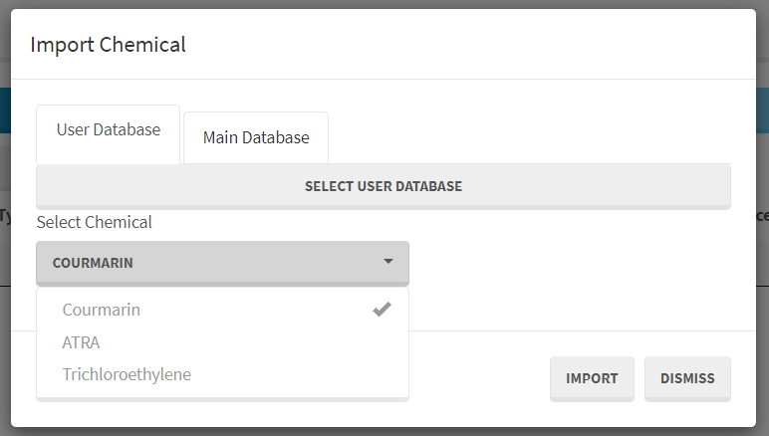Click the “Import” button to import the chemical into the interface.

The selected chemical is now a part of this HT-IVIVE project. We will now parameterize the HT-IVIVE model for Coumarin.

## Enter Physiological and Chemical Parameters

1. To create a new model, click the “Add New Row” button in the user interface. This launches a new dialog box for parameterizing the HT-IVIVE model. The dialog box has tabs for the different inputs needed for the HT-IVIVE model. Most values are auto-filled based on the parameter sets within PLETHEM and the selected chemical.
   1. *Hovering over some input boxes results in the appearance of a popup text box suggesting valid inputs. These suggestions have not been calibrated for all inputs and can be ignored at this time. This will be addressed in upcoming versions of the tool.*
2. Navigate to the “Physiological and Chemical Parameters” tab in the dialog window.
3. Enter 0.15 as the value for “Fraction Unbound in Plasma”.
4. Enter the exposure estimate for this chemical in the “Environmental Exposure (mg/kg/day)” box. We will enter the upper 95th percentile Coumarin exposure estimate from SEEM3: 0.000435 mg/kg/day.
5. Finally give this estimate a name – “Coumarin MOE for SEEM and ToxCast”

## Enter the in vitropoint of departure

Next, we enter the in vitro point of departure for Coumarin. In this case study, we will enter the 5th percentile in vitro POD value for all Coumarin assays in ToxCast (13.9 µM).

1. 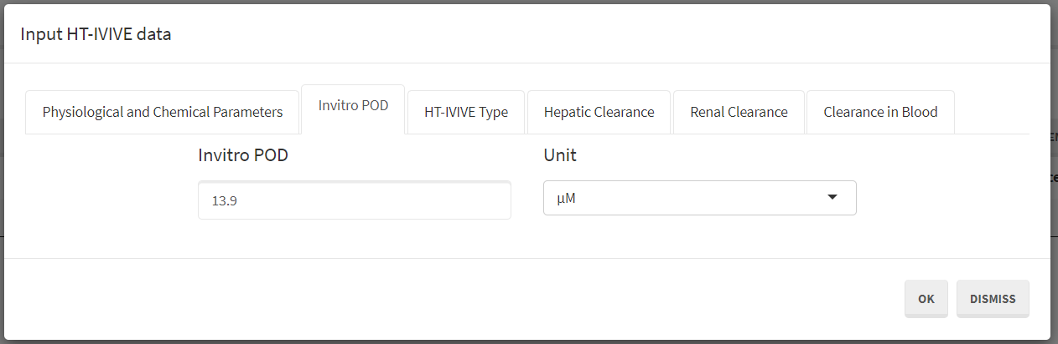Navigate to the “Invitro POD” tab in the dialog window and enter “13.9” in the “Invitro POD” box. Make sure the appropriate unit is selected from the “Unit” drop-down menu, “µM.”

## Select HT-IVIVE Type

1. 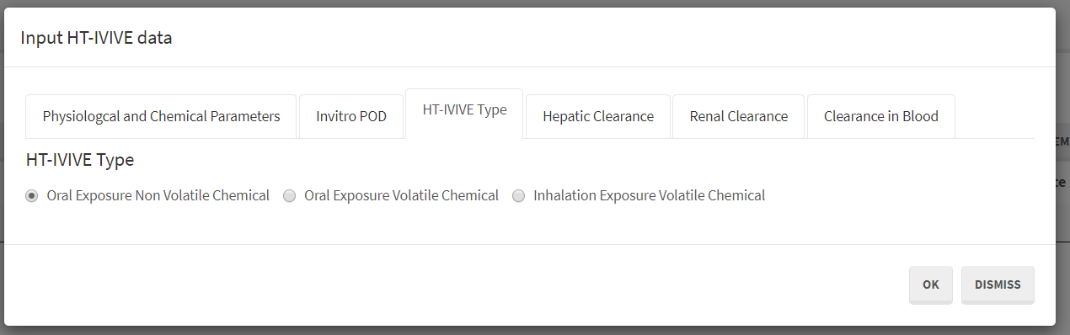Navigate to the “HT-IVIVE Type” tab in dialog window and select “Oral Exposure Non Volatile Chemical” using the radio button as the “HT-IVIVE Type.”

## Parameterize Clearance Models

For metabolism, the model includes options for clearance in the liver, urine, and blood. For coumarin, we will use the in vitro liver microsomal clearance value of 9.49e-5 µmol/min/mg microsomal protein from Draper et al. 1997. We will also include renal clearance in this case study. We will assume that coumarin is not metabolized in the plasma.

1. Navigate to the “Hepatic Clearance” tab, select “Subcellular Clearance” in the dialog window, and enter “0.0000949” in the “Measured Microsomal Clearance” box. Make sure the appropriate units are selected, “µmol/min/mg Protein”.
2. Leave the clearance scaling selection at “Rowland Equation”.
3. Navigate to the “Renal Clearance” tab in the dialog window and check the “Include Renal Clearance box.”
4. In the “Clearance in Blood” section, leave the “Measured Plasma Clearance” set to zero.
5. 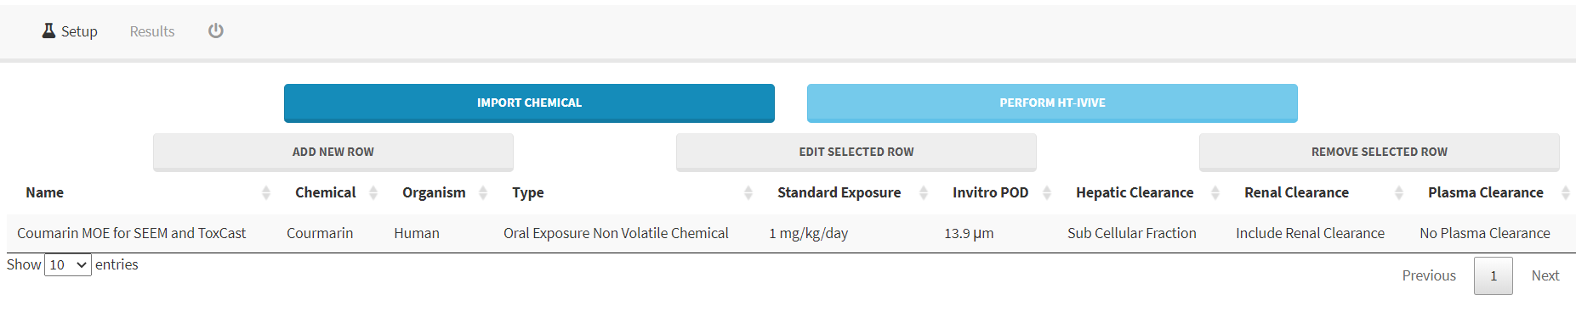Click “OK” to parameterize the model with the values you just entered. The parameterized model is added as a row in the table on the “Setup” tab of the interface.

## Running the model and viewing results

At this point you can continue to add more chemicals into the project or add more points of departure for chemicals already in the project. After creating a model for each chemical and POD combination for which you want to calculate an equivalent applied dose, click the “Perform HT-IVIVE” button to run the HT-IVIVE model. Once completed, PLETHEM switches to the results tab.

The results tab is a table that summarizes the input that went into the model along with certain calculated values from the model itself.

The calculated parameters include:

* Actual Hepatic/Renal/Plasma Clearance—the in vivo clearance in L/h that is calculated by scaling in vitro values to in vivo values.
* CSS—the steady-state plasma concentration in vivo that will result from the standard 1 mg/kg/day exposure. The CSS for coumarin is 0.0738 mg/L.
* Equivalent dose—the equivalent applied dose in vivo that would generate a CSS equal to the observed point of departure in vitro. In this case study, that value is an oral exposure of 27.52 mg/kg/day.
* Margin of Exposure—the ratio of the estimated in vivo exposure to the equivalent dose corresponding to the in vitro POD. In this case study, the upper 95th percentile of exposure is estimated to be 0.000435 mg/kg/day. However, an exposure of 27.52 mg/kg/day is needed to achieve a steady state plasma concentration that corresponds to the in vitro point of departure.

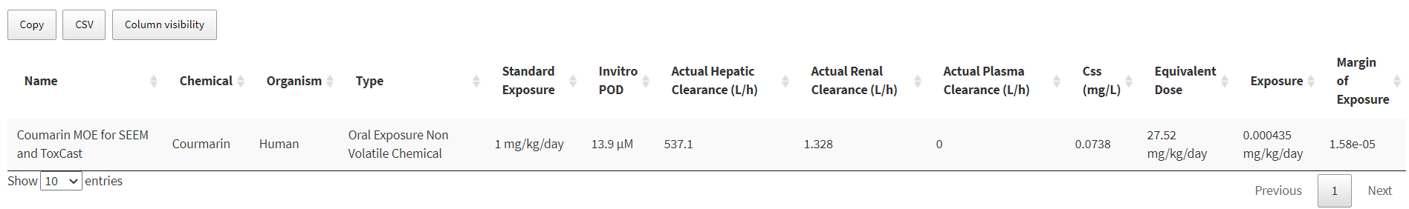The table can be copied to the clipboard for pasting into another program (e.g., Excel) using the “Copy” button, or downloaded as a “csv” file using the CSV button on the screen.

1. Wambaugh, JF., et al. *Toxicological Sciences* 163.1 (2018): 152-169.