PLETHEM Workflow Tutorial Series

PBPK Modeling and Reverse Dosimetry Workflow

# Introduction

Biomonitoring is an important tool to understand the prevalence of environmental chemicals in the human population. However, biomonitoring data only quantifies the internal dose without giving indications of the link between external dose, internal dose, and biologically effective dose leading to biological effects. Reverse dosimetry is useful to estimate exposures (external dose) that can lead to observed levels of chemicals or metabolites in the matrix of choice (blood or urine). In this case study, we use biomonitoring data collected as part of the National Health and Nutrition Examination Survey (NHANES) on plasma concentration of toluene in 10,000 individuals. We use the PLETHEM interface to parameterize a toluene PBPK model. The model will then be used in conjunction with the biomonitoring data in the reverse dosimetry workflow to estimate toluene exposure in the general population. The reverse dosimetry workflow within PLETHEM uses the Discretized Bayesian Approach (DBA) to estimate exposure. This approach requires us to create a PBPK model that includes population-level variability in the model.

# What this tutorial covers

Doing reverse dosimetry requires a human pharmacokinetic (PK) or physiologically based pharmacokinetic (PBPK) model for a specific compound to describe the relationship between a biomarker of exposure and an external exposure. Because of the complexity of reverse dosimetry simulations and multiplicity of potential solutions, it is impossible to perform a deterministic simulation that calculates exposure from a biomarker concentration. Rather, it “reverses” forward dosimetry using statistical tools.

Some information on the nature of the exposure is needed including the route, frequency, and duration of exposure. It is also important to take into account uncertainty and variability in human exposure and pharmacokinetics. This will be the role of the Monte Carlo (MC) analysis.

The current approach involves the use of PK models in two steps:

* Elucidating the time-course dose-biomarker relationship under the conditions of realistic exposure scenarios using available exposure data and PK modeling.
* Conducting reverse dosimetry calculations from PK model simulations using statistical tools in PLETHEM (MC, Bayesian analysis).

# Parameterizing the Toluene model

The rapidPBPK model within PLETHEM was parameterized as a toluene model using chemical-specific parameters and QSAR models.

**NOTE**: Some system configurations lead the file location browser dialog boxes to open behind the PLETHEM browser window. If you do not see the “Select Folder”, “Save As”, or “Open” dialogs, and the RShiny dock icon is bouncing when you mouse-over it in OSX, or the Browse For Folder icon appears on the Windows taskbar, the dialog may have opened behind the browser window. Clicking the RShiny dock Browse for Folder icon or moving the PLETHEM browser window out of the way will reveal the dialog box.

## Create a new project

### For Windows Users

1. Load the PLETHEM package using “library(plethem).”
2. Launch the PBPK modeling workflow by typing interactivePBPK() in the R console. This launches the forward dosimetry user interface in the default browser.
3. Under the file menu, select “New” to create a new PLETHEM project file to which the model can be saved.
4. This opens the “New Project” dialog so you can name the project. Let’s call this one “Toluene Reverse Dosimetry.”
5. Click the “OK” button. PLETHEM will now ask you to select a location for the new project file.
6. Select the directory in which you wish to store the project file and click “OK.”

### For MacOS Users

1. Load the PLETHEM package using “library(plethem).”
2. Launch the PBPK modeling workflow by typing interactivePBPK() in the R console. This launches the forward dosimetry user interface in the default browser.
3. Under the file menu, select “New” to create a new PLETHEM project file to which the model can be saved. 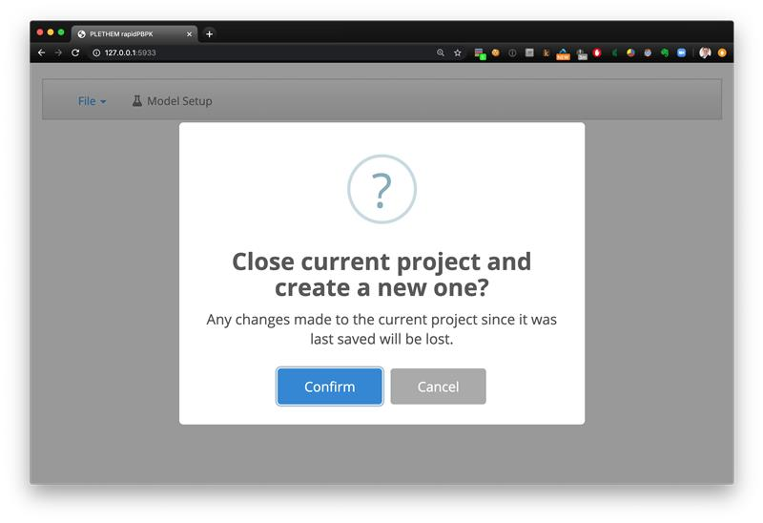The new project dialog box that opens does not have a specific input element as in Windows.
4. Click the “Confirm” button to open the “Save As” dialog for MacOS.
5. 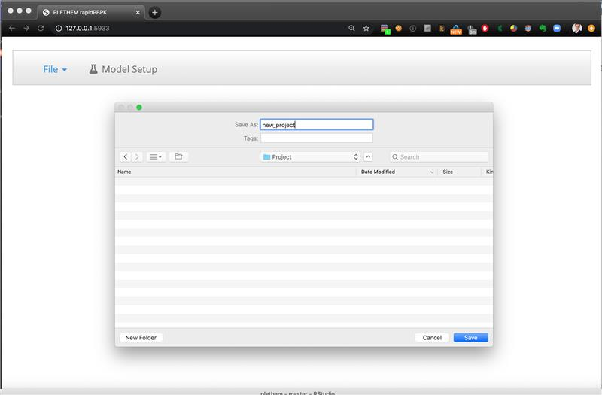Name the file “Toluene Reverse Dosimetry.Rdata” and click “Save” to save the project file and open a new project.

After the new project has been established, we can start creating parameter sets for the model. PLETHEM uses a database to save all the parameters sets that users create for a project. The parameters can be exported for later use by saving the changes to the project file by selecting “Save” from the “File” menu. The project file allows users to export the project to an RData file that can be shared with other users of PLETHEM. PLETHEM autosaves changes made to the project to the project file.

## Create an exposure set

We will be using the reverse dosimetry workflow to estimate inhalation exposure to toluene. The workflow will estimate the exposure value for a given set of exposure conditions. In the case of inhalation exposure, we must specify the duration of inhalation exposure (number of hours per day) and the number of days of dosing per week. These parameters are used by the reverse dosimetry workflow to estimate exposure. We will assign a dummy exposure value of 1 ppm as PLETHEM requires exposure sets to have an exposure value.

1. Navigate to the “Model Setup” tab.
2. Navigate to the “Exposure” tab in the user interface.
3. Select “Inhalation” from the left sidebar to show inhalation exposure related inputs.
4. Set the “Inhalation Exposure” to 1 ppm, “Duration of Inhalation Exposure” to 6 h/day and “Exposure days in a week” to 7.
5. 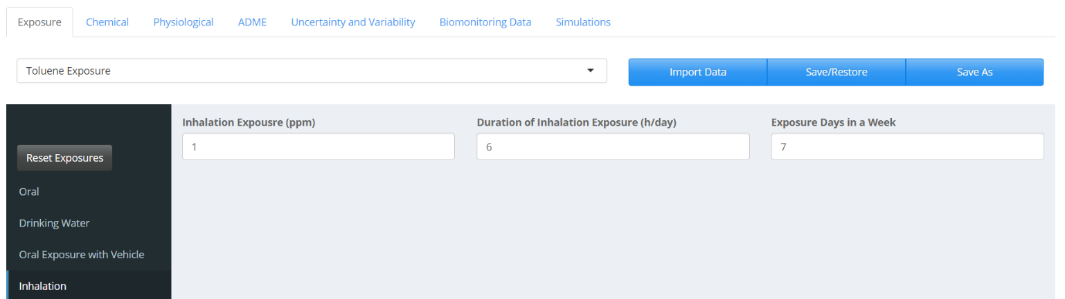Click the “Save As” button to save the exposure set by the name “Toluene Exposure.” Click “Add” to save the exposure.

## Create a chemical set

PLETHEM uses QSAR models to estimate partition coefficients for distribution of the chemicals in different tissues. The QSAR models use the physical-chemical properties of the substance to estimate these values. We used the PubChem and the EPA Comptox dashboard to obtain these values for toluene. The values from these data sources are then used to populate the user interface.

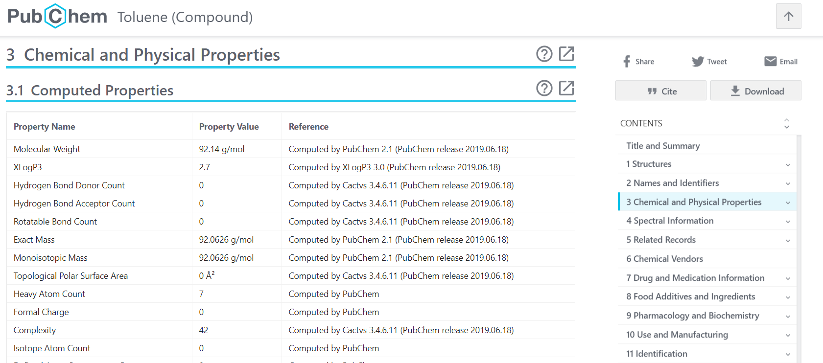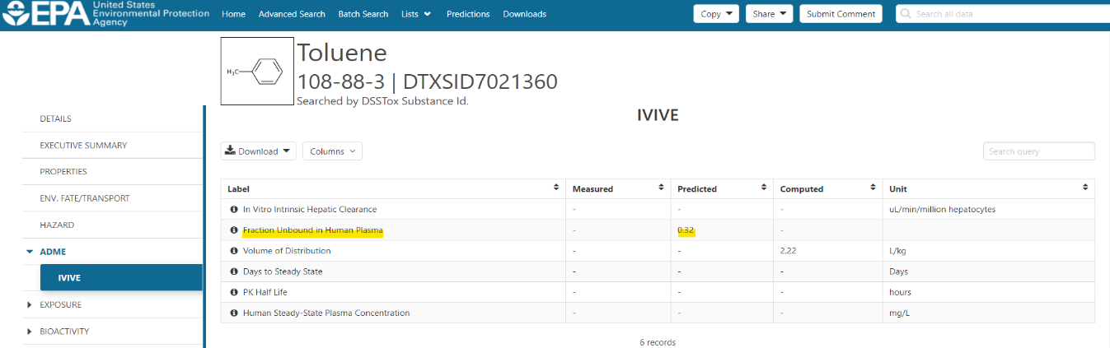

1. Navigate to the “Chemical” tab in the user interface.
2. Enter the appropriate input values as show in the figure below except “Fraction Dissolved in Liquid Phase of Plasma”. The value for “Fraction Dissolved in Liquid Phase of Plasma” will be estimated using QSAR models in the next step.
3. Click on the “Estimate Fraction Dissolved” button to estimate fraction of the chemical dissolved in the liquid phase of plasma. The “Fraction Dissolved in Liquid Phase of Plasma” box value should match the figure below.
4. 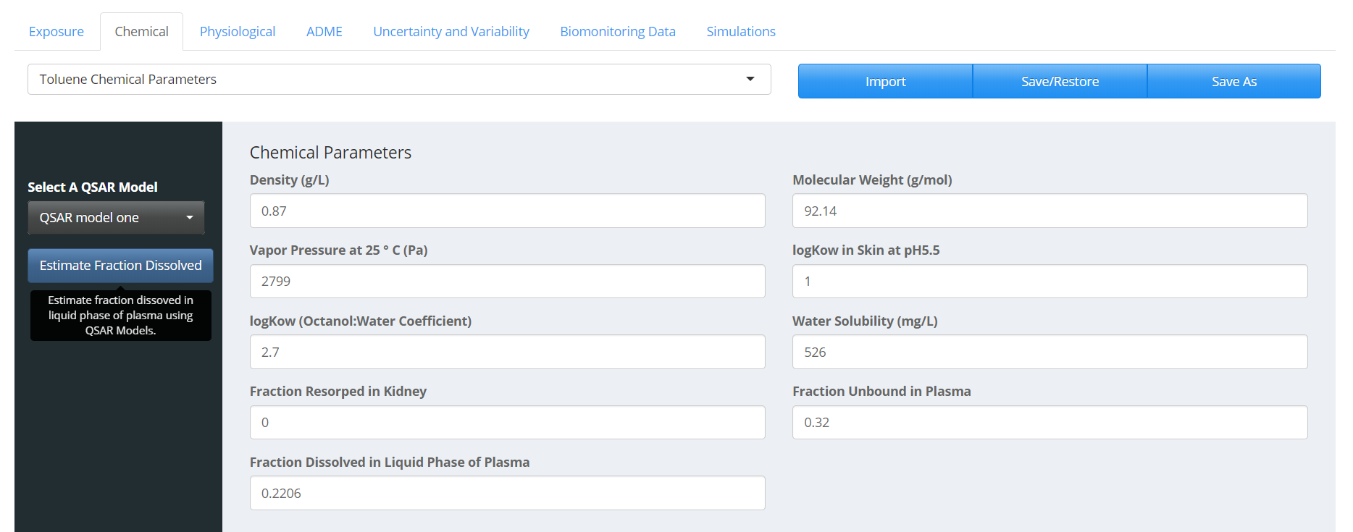Click “Save As” to save the properties set as “Toluene Chemical Properties.” Click “Add” to save the chemical properties.

## Create a physiological set

We simulate an adult human male in this case study. In reverse dosimetry modeling, we need to define a population for the PBPK model that resembles the population from which our biomonitoring data was obtained. To create a standard adult human male physiology description:

1. Navigate to the “Physiological” tab in the user interface.
2. Select “Human” and “Male” under the “Organism” and “Gender” drop-down menus respectively. Set “Age” to “25.”
3. Click the “Calculate Physiological Parameters” button to parameterize the model using life-course equations in PLETHEM. The values should match the figure below.
4. 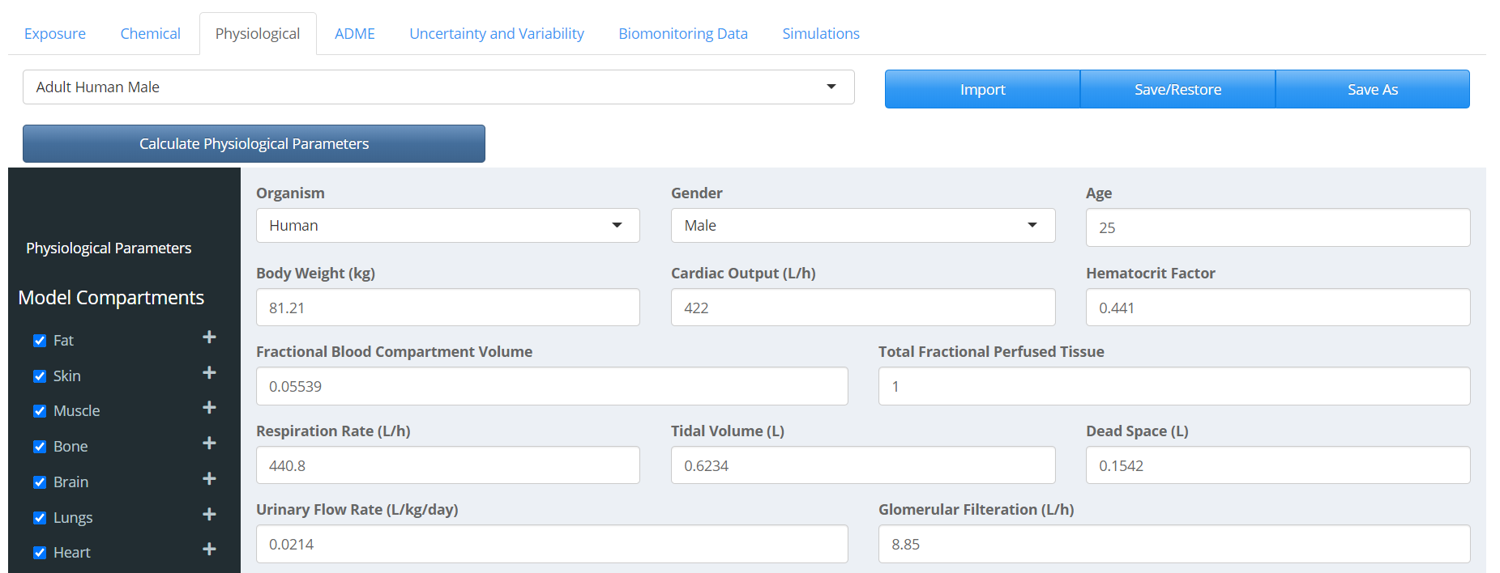Click “Save As” to save the parameter set. Name the set “Adult Human Male.” Click “Add” to save the physiological parameters.

## Create an ADME set

In PLETHEM, the ADME set is used to specify parameters related to absorption, distribution, metabolism, and excretion. They need to be defined for a specific combination of chemical, metabolite, exposure, and physiology.

For inhalation, the “Absorption” parameter is the plasma:air partition coefficient. This value will be calculated along with the other partition coefficients on the “Distribution” tab. “Excretion” parameters in this case study are left to their default values. In this case study, we are not tracking the metabolite of toluene in the model. Hence, the metabolite selection is set at “No Metabolite.” The air and tissue partitioning is calculated at the “Distribution” tab by taking the following steps:

1. Navigate to the “ADME” tab in the user interface.
2. Select the “Distribution” tab.
3. Select the “QSAR model one” to be used for estimating partition. The “QSAR model one” refers to the default QSAR model in PLETHEM which is adapted from the algorithm published by DeJongh et al. 1997.[1]
4. 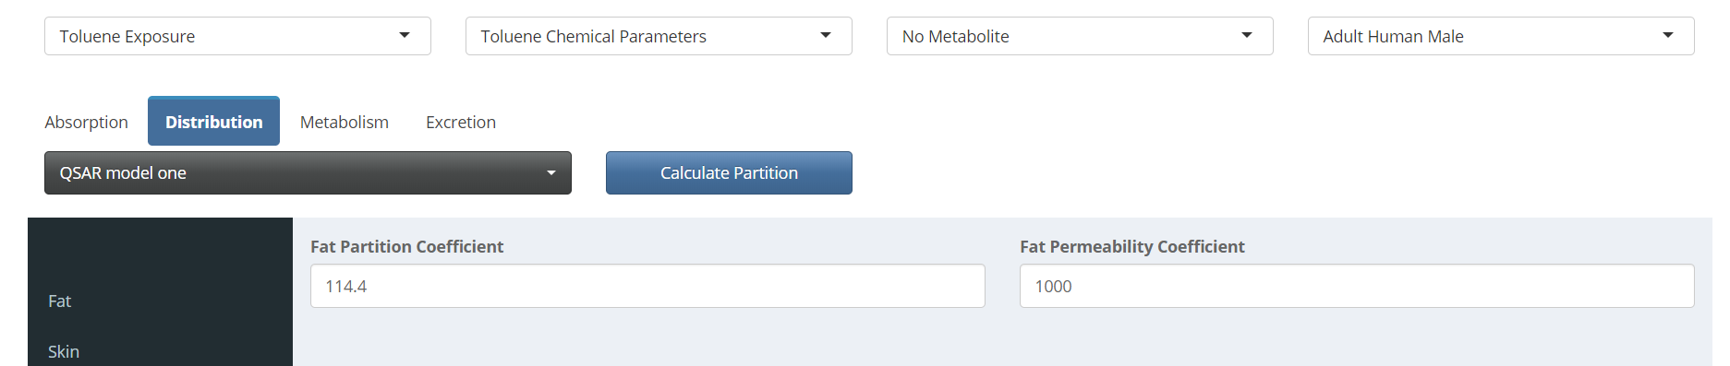Click the “Calculate Partition” button to estimate partition coefficients for all tissues that are part of the model. The values should match the figure below.

Toluene metabolism is defined under the “Metabolism” tab. We use metabolism values from Marchand et al. 2015 in our model. The paper provides values for saturable metabolism of toluene to 1 metabolite. Measured or predicted in vitro metabolism values can also be extrapolated using the IVIVE module under the Metabolism tab.

1. Click on “Metabolism” tab to display metabolism-related inputs.
2. Enter the input values as shown in the figure below.
3. 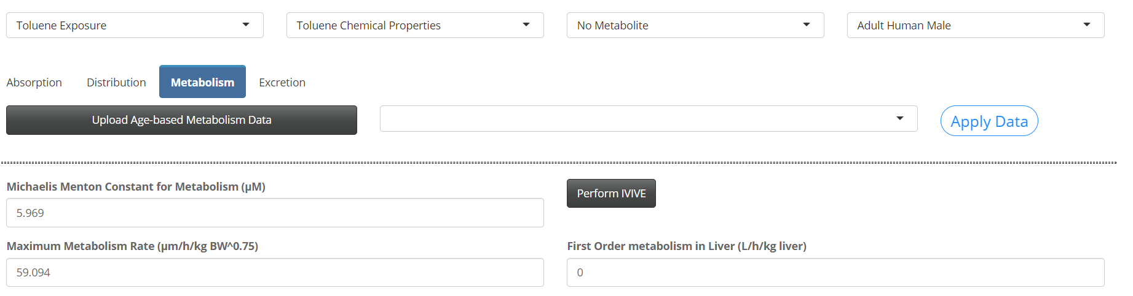We use default metabolism values for all other inputs.

The entire ADME set is then saved along with the chemicals, physiology, and exposure set it represents. This will be used later to filter the appropriate ADME set for selection when creating a simulation from these building blocks.

1. Click “Save As” and name the set “ADME for Toluene.” Click “Add” to save the set.

## Define variability

We now need to define population variability for our parameters. For this model, we are accounting for differences in body weight and cardiac output between individuals. This will also lead to different tissue volumes and blood flows to be scaled appropriately. Variability is defined in PLETHEM as an uncertainty and variability set for parameters in each of the four previously defined sets. Since we are only accounting for variabilities in body weight and cardiac output, we will save this as a physiological variability set.

1. Navigate to the “Uncertainty and Variability” tab in the user interface.
2. Select “Physiological” from the sidebar.
3. Click on the “New” button to open the variability interface. Name this set “Physiological Variability.”
4. Select “Body weight” and “Cardiac Output” from the drop-down menu located under the “Select Parameters to Assign Variability” and click the “Update List” button.
5. Assign “Coefficient of Variation” and “Type of Distribution” parameters as shown in the figure below. Tissue volumes and blood flows to be scaled appropriately.

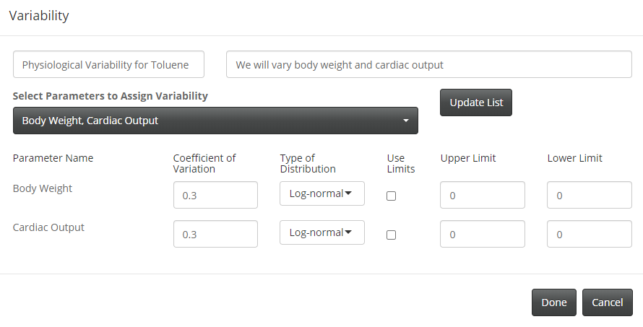

1. 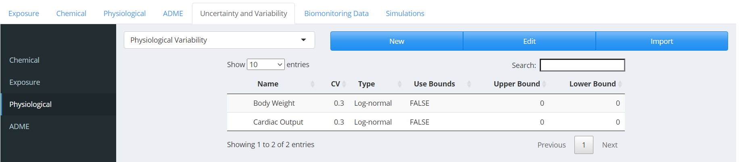Click “Done” to save the variability set.

## Upload biomonitoring data

We will use the data collected as a part of the NHANES survey to perform reverse dosimetry. The biomonitoring data is obtained from the following [link](https://scitovation.sharepoint.com/:f:/g/EkojNg07qoBAt0zUOlsJWXsBhswsKgHMKrZ06UYzueQpWw). Save the file “Toluene_mgL_Biom.csv” on your computer.

1. Navigate to the “Biomonitoring Data” tab in the user interface.
2. 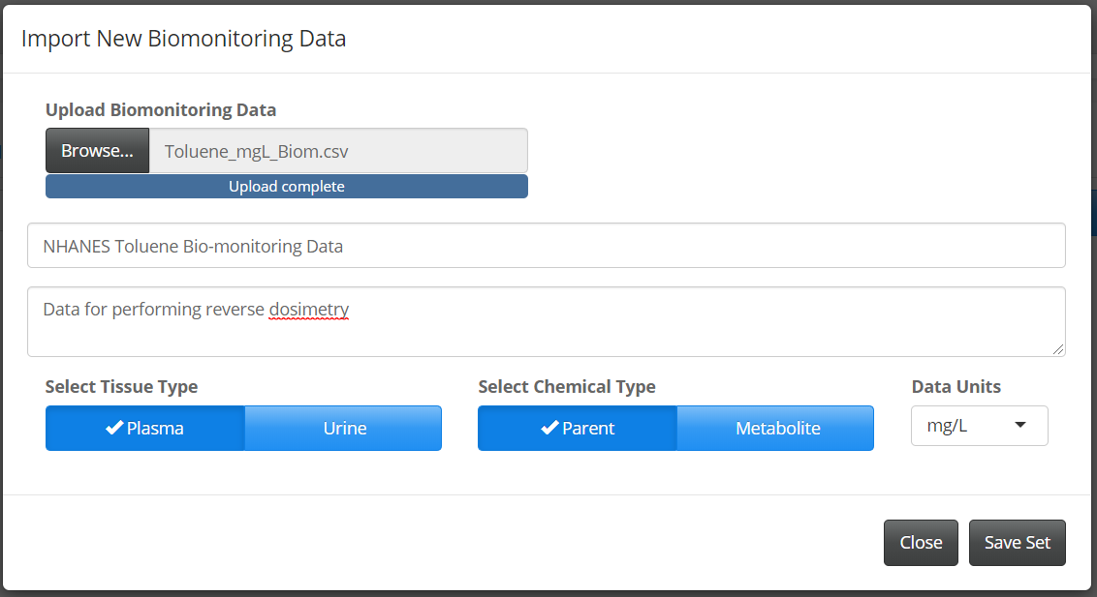Click the “New” button to launch the import Biomonitoring Data Dialog.
3. Click browse to find and upload the file obtained from the link.
4. Name it “NHANES Toluene Biomonitoring Data” and add a description
5. The data represents plasma concentration of the parent compound in mg/L. Select the appropriate units from the drop-down menu under “Data Units” and click the appropriate buttons to select “Plasma” and “Parent” for tissue and chemical type.
6. 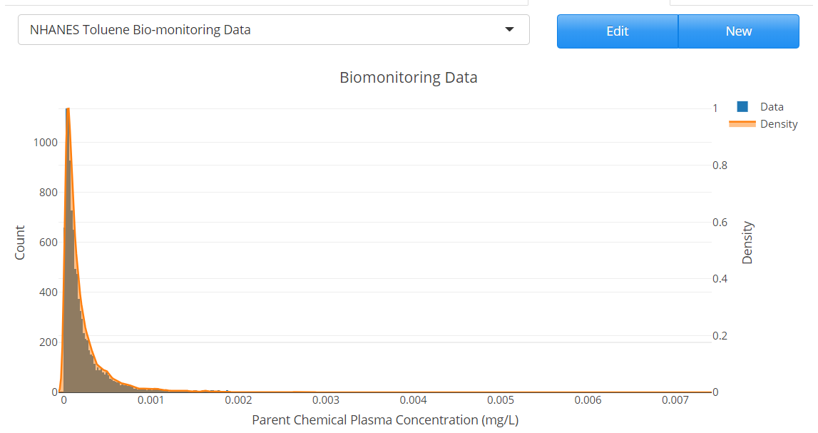Click “Save Set” to save the biomonitoring data.

## Create a simulation

All the sets created above are put together to create a simulation.

1. Navigate to the “Simulations” tab in the user interface.
2. Click “New” to launch the “Simulation” dialog.
3. Name the simulation “Toluene Reverse Dosimetry Simulation” and add a description, “Estimating inhalation exposure using NHANES Biomonitoring Data.”
4. Select Reverse Dosimetry under the “Simulation Type” in the drop-down menu.
5. Under the “Parameters” tab, make sure the appropriate “Exposure,” “Parent Chemical,” “Physiology,” and “ADME” sets are selected. If a project contains multiple sets, you can select the appropriate one for the simulation you wish to perform using the drop-down menus.
6. Under the “Variability” tab, make sure that “Physiological Variability” is selected as we are only varying the physiology in this simulation.
7. The “Workflow Specific Inputs” tab allows users to define inputs and select datasets specific to the given simulation type. For reverse dosimetry, we need to define the biomonitoring dataset to use, an estimate for the range of exposures, and the number of exposures to run within that range for the DBA algorithm.
8. For this study, we set the “Exposure range” from 0.0001 ppm to 0.2 ppm. We will discuss the reasons behind selection of this range at the end of this guide.
9. Select the number of doses within the range for which to perform Monte Carlo calculation. Ideally this number is between 20 and 40. We will select 25 for this simulation.
10. Under the “Simulation” tab, set the “Simulation Start Time” to 0, “Simulation Duration” to 1, and duration units to Days from the “Duration Units” drop-down menu. Effectively we will be running a 24h simulation starting at 0. The default number of Monte Carlo runs is set to 1000.
11. 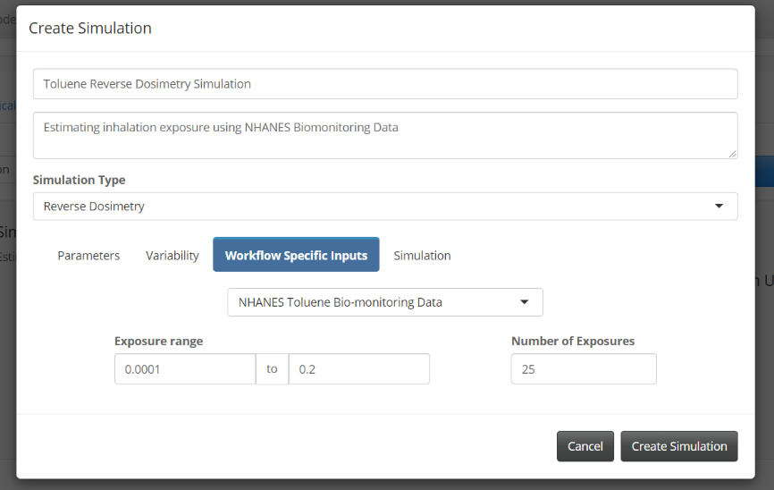Click “Create Simulation” to save the simulation.

## Running reverse dosimetry

The simulation we created will be selected by default in the drop-down menu. If you have created other simulations, they can also be selected from the drop-down menu. To run reverse dosimetry, select “Toluene Reverse Dosimetry Simulation” and click the “Run” button. This will start the Monte Carlo simulations needed to run the DBA algorithm. In this case, we will be running 25,000 simulations to get the necessary parent plasma concentrations to estimate exposure. This process can take a long time. The progress bar will update the users on the number of exposures the model has run. After the calculations are complete, PLETHEM will automatically navigate to the “Model Output” tab to display the results.

## Reverse dosimetry results

After the simulation is complete, PLETHEM runs the reverse dosimetry algorithm at the back end and creates a Cumulative Distribution Function (CDF) plot and a Probability Distribution Function (PDF) plot for the expected exposure. If the dose ranges are adequate, the graphs resemble CDFs and PDFs for log-normal distributions as in the figure below. You may not get the same results as shown below due to us running Monte Carlo Simulations.

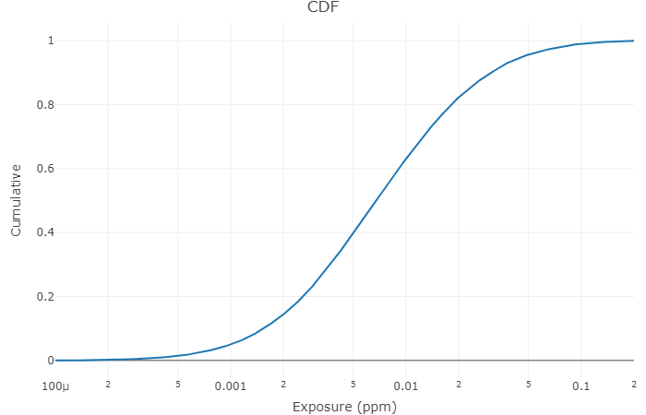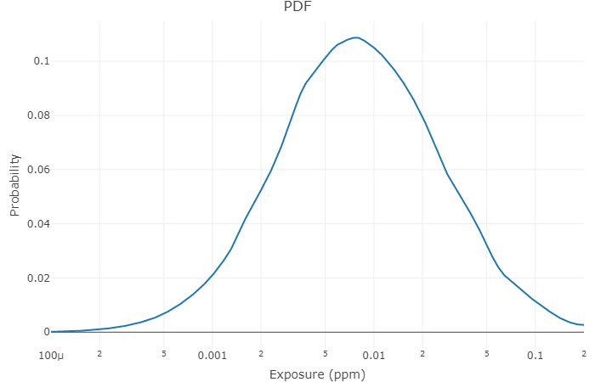

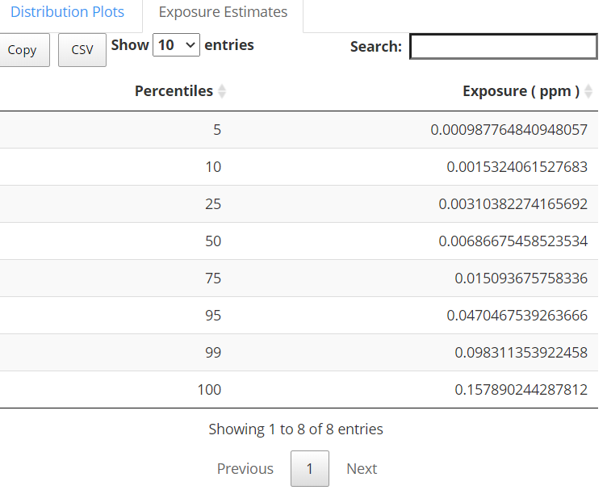The percentile values for the expected exposure are displayed under the “Exposure Estimates” tab. In this case study, using the model we parameterized, we expect the median exposure for the population to be approximately 0.0069ppm.

## Save the project and quit the user interface

To save the project, navigate to the location first selected when creating the new project and click “Save.” To quit the app, click the “Quit” button from the file menu.

## Iteratively approaching the correct dose range

The selected dose ranges and number of doses are driven by a general understanding of the model and scale of biomonitoring results. The DBA is an iterative algorithm for performing reverse dosimetry. It is very likely that in the initial range selected, either the range is too big or the extremes are too high or too low to estimate an exposure. The CDF and PDF graphs from the outputs are useful for refining this initial dose range. If the CDF has a long tail on one end and does not plateau on the other end, that indicates that the expected exposure is outside the range currently selected. If the CDF has a long tail at the lower exposure, that means the expected exposure is higher than the current dose range. The reverse is true if the tail is at the higher exposures. For this case study, we started with a dose range of 0.01ppm to 1ppm and then progressively reduced the dose range until the CDF resembled the one from a normal distribution.

1. DeJongh, J., H.J. Verhaar, and J.L. Hermens, A quantitative property-property relationship (QPPR) approach to estimate in vitro tissue-blood partition coefficients of organic chemicals in rats and humans. Arch Toxicol, 1997. 72(1): p. 17-25.