PLETHEM Workflow Tutorial Series

Kinetically Derived Maximum Tolerated Dose Workflow

# Introduction

Maximum tolerated dose estimation is used in *in-vivo* studies to determine the highest level of dose the animals should be exposed to. Traditionally, this is estimated by conducting a pilot study and using criteria based on adverse physiological effects such as large changes in body weight. Often at these doses there exists nonlinear dose-dependent kinetics related to absorption, distribution, metabolism, or excretion (ADME). For example, it is not uncommon for high doses of test article to saturate gut absorption processes. In such a scenario, exposure to increasing test article above the saturating dose yields no (or sub-linear) increase in systemic or target tissue concentration (Figure 1). Adverse effects above the saturating dose are likely not specific to the test article’s activity. These high-dose data then have limited value to human risk assessment as they are no longer representative of toxicity caused due to potentially conserved modes of action, but rather due to physiological differences in the species. This concept and the mathematical procedure for its application to a pharmacokinetic study, have been described previously[1]. The point at which the pharmacokinetics diverge from linearity is known as the kinetically derived maximum tolerated dose (KMD).

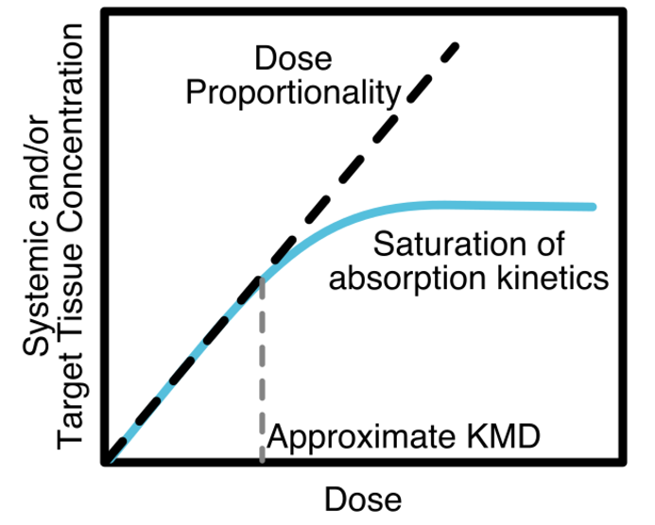

Figure . Depiction of Kinetically-derived Maximum Tolerated Dose (KMD) for a system featuring saturation of gut absorption.

# What this tutorial covers

KMD analysis uses statistical tools to quantify deviation from linearity in a dose response. This deviation can be in either direction of the expected response if dose-response linearity is assumed. The algorithm assumes that no response can be measured in the absence of an exposure. It then uses this null condition and the response at the lowest dose to establish the linear dose-response relationship.

This case study estimates the KMD in Sprague Dawley rats following exposure to 2,4-Dicholorophenoxyacetic Acid (2,4-D). The KMD workflow within PLETHEM was used to run this case study and data was obtained from the manuscript *“Life-Stage-, Sex-, and Dose-Dependent Dietary Toxicokinetics and Relationship to Toxicity of 2,4-Dichlorophenoxyacetic Acid (2,4-D) in Rats: Implications for Toxicity Test Dose Selection, Design, and Interpretation”[2]*. The case study examines the dose-response relationship between exposure and 24 hour Area Under the Curve (AUC) for plasma concentration of 2,4-D.

# Template for the KMD workflow in PLETHEM

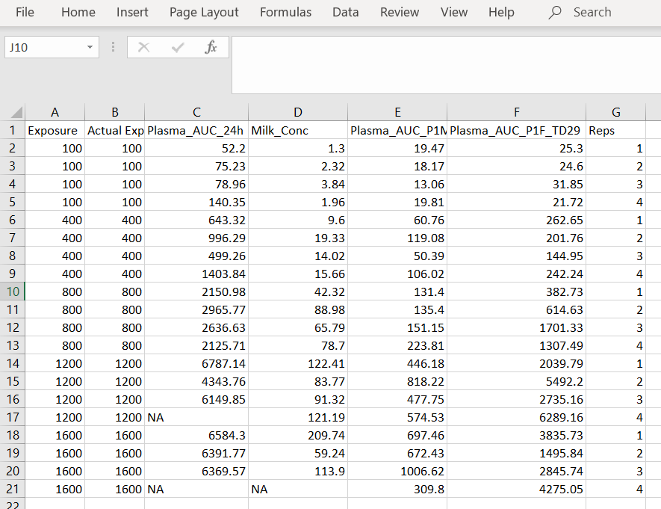Data for the KMD workflow in PLETHEM is defined in the excel template “KMD Data Template.xlsx” that can be downloaded from the app itself. Figure 1 is a screenshot of the excel file with data from this study filled in. The first two columns represent the nominal and actual exposure value for the experiment. The design of this inhalation study meant that the rats’ exposure as per the study design (nominal exposure) and the exposure to the rodents in the study (actual exposure) were the same. The last of column of the spreadsheet is the replicate number for each exposure. PLETHEM needs this column to group the measured study values by exposure. The rest of the columns are for measured study values. For this case study we used a small number of data points that were measured in the study. It is important to note that all the data was not collected in a single experiment. Also, there were some replicates where values were not measured (encoded “NA”).

Figure . Template for loading data into the KMD workflow.

# KMD workflow in PLETHEM

**NOTE**: Some system configurations lead the file location browser dialog boxes to open behind the PLETHEM browser window. If you do not see the “Select Folder” or “Save As” dialog, and the RShiny dock icon is bouncing when you mouse-over it in OSX, or the Browse For Folder icon appears on the Windows taskbar, the dialog may have opened behind the browser window. Clicking the RShiny dock Browse for Folder icon or moving the PLETHEM browser window out of the way will reveal the dialog box.

We used the PLETHEM KMD web application ([Link](https://scitovation.shinyapps.io/plethem-MTD/)) for this case study. This workflow is also incorporated into the R package. However, since this workflow is entirely independent of the PBPK model in PLETHEM, it is best suited as a standalone tool that is available for use without needing to install R, Rstudio, and the PLETHEM package.

## Accessing the web application

1. Open a web browser (preferably Google Chrome).
2. Navigate to <https://scitovation.shinyapps.io/plethem-MTD/>
3. 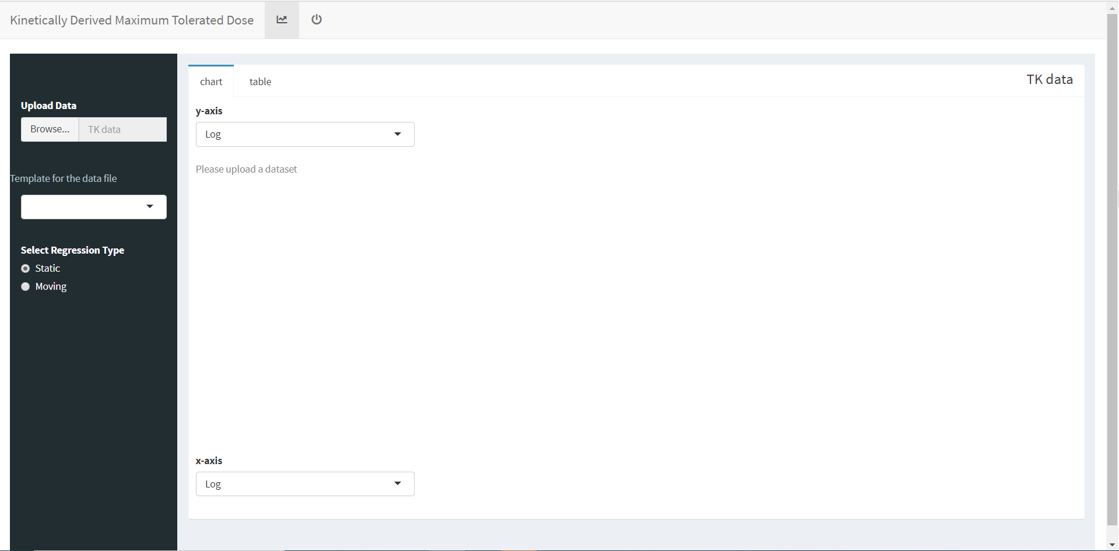This opens the PLETHEM KMD web application.

Figure . User interface for performing KMD in PLETHEM.

## Upload the filled template

1. Download the data file from this [link](https://scitovation.sharepoint.com/:x:/g/Ecq_ZlDG1HRCl1mhOnVfcYYBZCVWzCQET8x9vegICpta1g) and save it as a csv file on your computer.
2. Click the “Browse…” button to open an upload file window.
3. Navigate to the location on your computer where you have stored the template file downloaded in step 1.
4. Select the file to upload it to the web-app. You will get a notification “Upload complete” under the “Browse...” tab.
5. 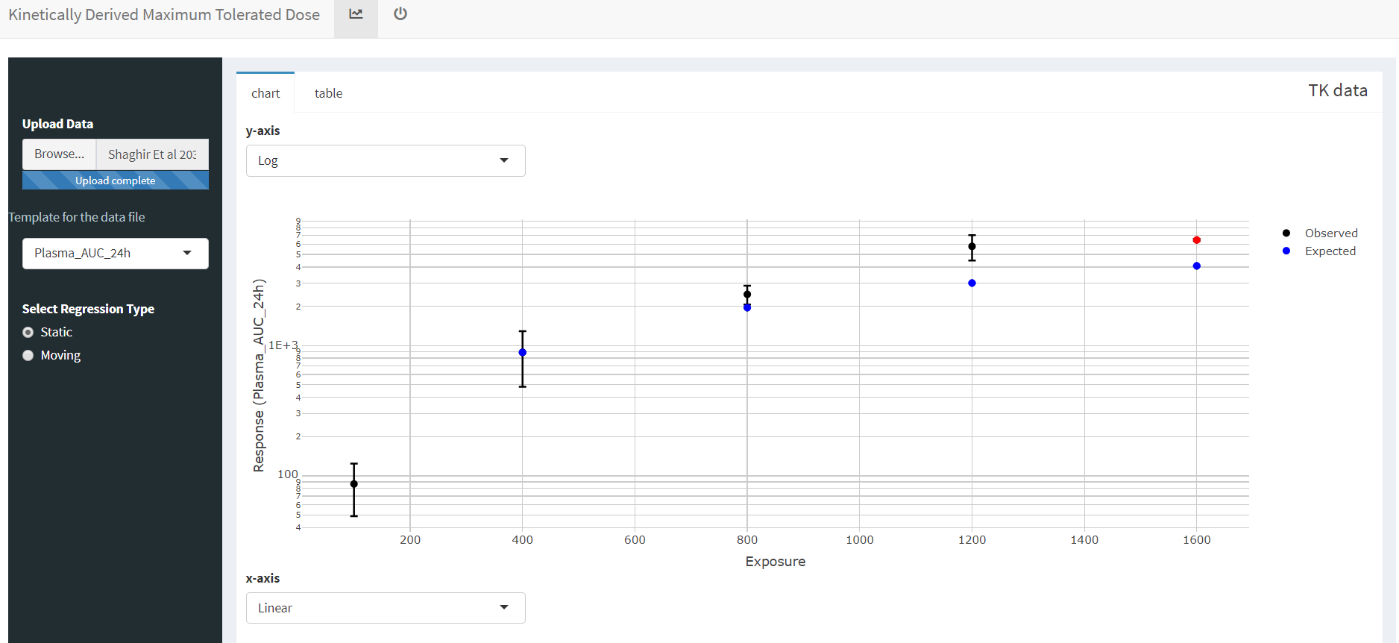The file will be uploaded and PLETHEM will run the KMD workflow for the first series of measurements.

Figure . KMD workflow with pharmacokinetic data uploaded.

## Interpreting the results

For this case study we will be looking at one measurement in particular – Plasma AUC in Female Rats.

Figure . Measured vs Expected Plasma AUC in Female Rats at Test Day 29.

1. Select the appropriate axis type by selecting “Log” under the “y-axis” drop-down menu and “Linear” under the “x-axis” drop-down menu.
2. 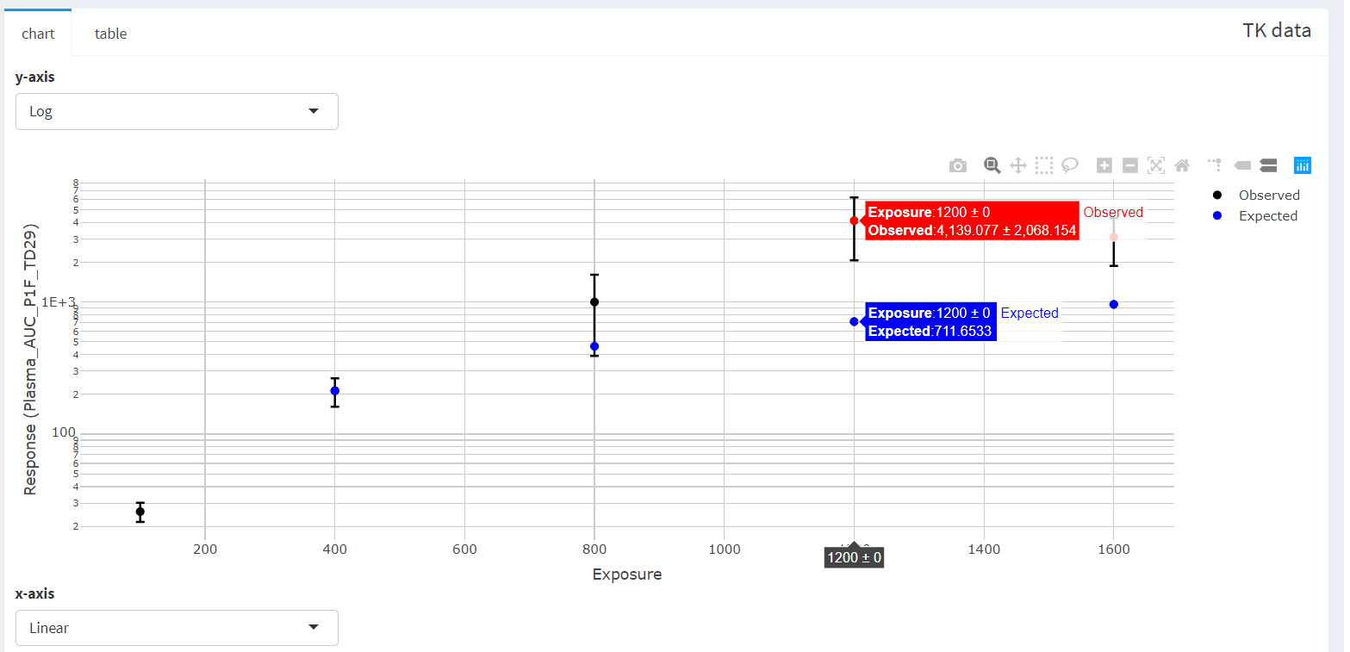From the left side menu choose “Plasma_AUC_P1F_TD29” under the “Select response endpoint” drop-down menu. You will be able to see the values for each data point by navigation your mouse over the data point at each exposure.

The blue circles in both figures (“Plasma_AUC_24h” and “Plasma_AUC_P1F_TD29”)represent the expected value of the measured endpoint if the dose response for the parameter was linear in the given dose range. The red circles represent measured values that are significantly different (either higher or lower) than the expected value. This indicates points at which the response no longer follows a linear dose response relationship and hence any doses beyond this range cannot be used for assessing human risk.

The KMD table provides more detailed information on the statistics of nonlinearity.

Figure . Table for KMD data. The response ratio is the ratio between measured and expected values.

1. 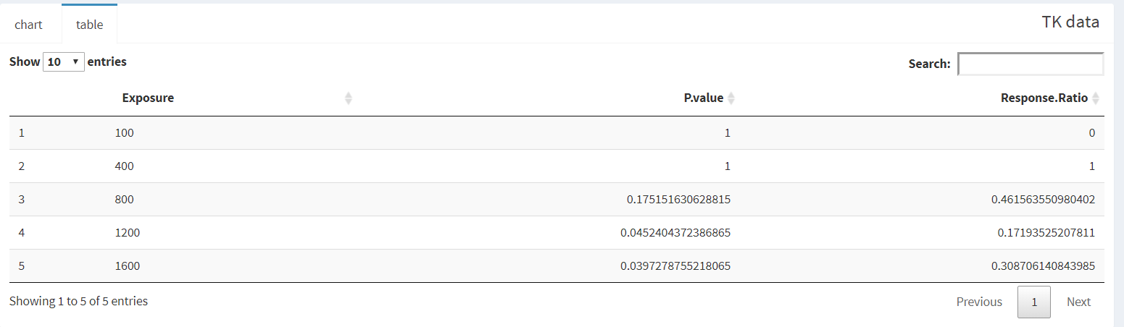Choose the “table” tab above the graph to see the table.

As the study indicates, the rats were exposed to increasing concentrations of TCDD up to 1600 ppm. None of the rats in the study showed any significant change in the body weight throughout the study. Using classical Maximum Tolerated Dose (MTD) analysis, a top dose of 1600 ppm would have been used to perform further response in a lifetime study. However, the toxicokinetic profile shows a non-linearity in the dose response at 1200 ppm as seen both here and in the manuscript. This indicates that the kinetics of 2,4-D are no longer valid for extrapolation to humans beyond a highest dose of 1200 ppm – the kinetically derived maximum tolerated dose. This dose then should be used as the top dose in future studies.

1. [Saghir SA](https://www.ncbi.nlm.nih.gov/pubmed/?term=Saghir%20SA%5BAuthor%5D&cauthor=true&cauthor_uid=22440553) et al. [Regul Toxicol Pharmacol.](https://www.ncbi.nlm.nih.gov/pubmed/22440553/) 2012 Jul;63(2):321-32. doi: 10.1016/j.yrtph.2012.03.004
2. [Saghir SA](https://www.ncbi.nlm.nih.gov/pubmed/?term=Saghir%20SA%5BAuthor%5D&cauthor=true&cauthor_uid=22440553) et al. Toxicol Sci. 2013 Dec;136(2):294-307. doi: 10.1093/toxsci/kft212