**Stellarium Extra Credit Assignment**

**Due at the end of the semester, max 1.5% extra credit towards final grade**

1) Download and install Stellarium, available from http://www.stellarium.org

The program is free and will work on either a Mac or a PC

Follow these directions and answer some questions about the sky.

First, set the Location to South Carolina, or have the program auto-detect your location. If you bring your cursor to the left side of the screen, a menu will appear. At the top is the tab for setting location. Start typing “Columbia" for the city and then a magnifying glass should appear in the Search menu. T

**Now go back to “Western” constellations**

Question: **Circumpolar** constellations are constellations that never rise and set, just go in a circle around the North Star (Polaris) each day. (They won’t be seen in the day when the Sun is out but they are still there.) Which constellations are circumpolar here in Michigan?

Here is how to figure that out:

Turn on the constellation shapes and labels using the tab on the bottom.  
Turn on the Equatorial Grid.  
Press the fast-forward button a few times to speed up the passage of time. If it goes too fast, press rewind to slow it down.  
From the Equatorial Grid, you will notice that constellations *within a certain angle* of the North Star never rise or set.  
What is that angle? ___-30o___________  
Write down the constellations that are always partly in the sky here in South Carolina.  
  
  
  
____________Ursa Minor________________  
_____________Cepheus_______________  
_____________Draco_______________  
_____________Cassiopeia_______________  
_____________Ursa Major_______________  
_____________Lynx_______________  
____________Orion________________  
____________Gemini________________

What's your "astrological" sign?

Note that astrology and horoscopes to predict your future are NOT part of the science of astronomy.  
Sign: _Sagittarius_______________________

Set the TIME of the sky using Stellarium to your birthday this year. (Happy birthday!) You set the time by choosing the tab on the left with the clock icon. Set it to around noon, 12:00 in 24-hour time. Turn off the atmosphere's light from blocking the view of the daytime stars.

Is the Sun in the constellation of your astrological sign? _Yes_______________  
If not, how far is it? (Is it in the sky? A constellation over?) ________________

Now set the date to 6 months from your birthday. (Happy half-birthday!) Set the time to midnight or 0:00 on a 24-hour scale. Is your constellation out in the sky on this night?

__No___________  
  
  
How far North or South is your constellation from the Celestial Equator? Click on a star in the constellation and where it says RA/DEC (J2015), write down the second number, the Declination. That is how far north or south from the Celestial Equator the star is.

__-34______ degrees __23____arcminutes __8.7__ arcseconds

If the number is negative, it means your constellation is South of the Celestial Equator, and if it is positive, your constellation is North of the Celestial Equator.

What season were you born in (Fall, Winter, Spring, Summer)? __Winter_________

Summer Zodiac constellations should be further north (the Sun on the ecliptic is further above the Celestial Equator then) and Winter Zodiac constellations further south. Does that make sense with your astrological sign?

**Now this is a fun part.**

**Different cultures saw different patterns in the sky and recorded different constellations. Turn on “Star Lore” from the “Sky and Viewing Options” menu on the left of the screen, and go through and select different cultures. Stellarium will tell you something about the culture.**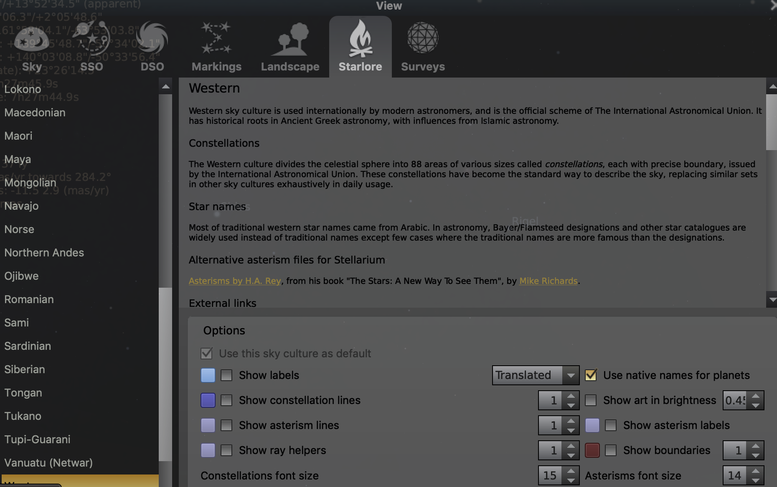

**Make sure you have set in the bottom of your screen for constellations to appear with lines, labels, and artwork.**

**Look towards the SouthWest at 7:30-8:00 pm. Find the constellations of Orion (the hunter) and Taurus (the bull). What do they appear in the store lore of other cultures? Orion is known as a magic archer in Hungarian culture. Taurus relates to Zeus in Greek culture.**

**Which culture sees Orion as:**

**A Hand - Lakota**

**A Man Missing a Thigh - Greeks**

**Find an interesting constellation to share. Note that some Southern Hemisphere cultures may have more constellations in the Southern sky, so set your location to Australia or South Africa or South America to view those.**