Q1. Server was started on port 50000

Screenshot 1

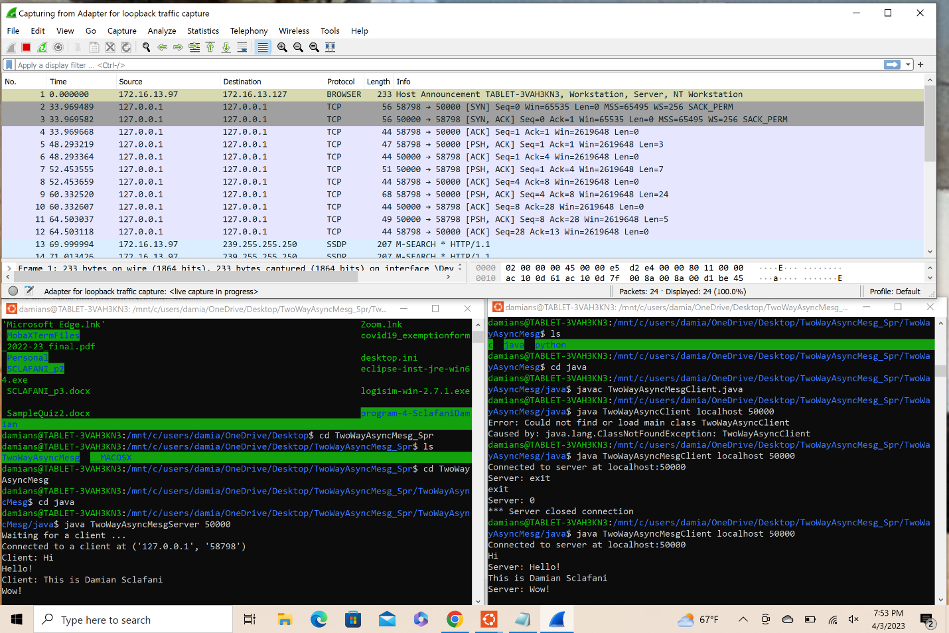

Screenshot 2

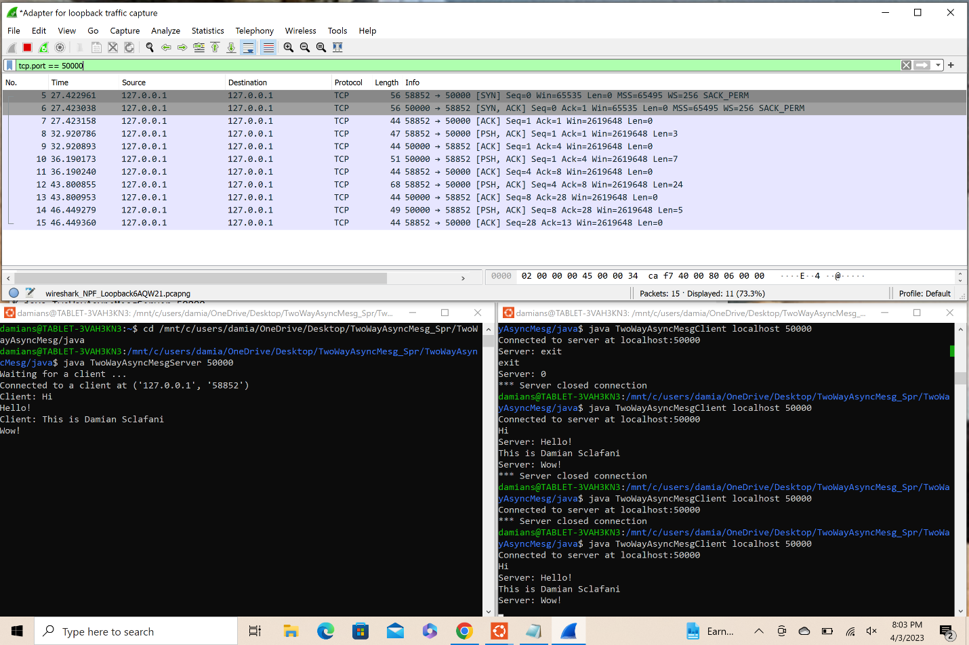

Q2. Client’s TCP Source Port 58914

Screenshot 3

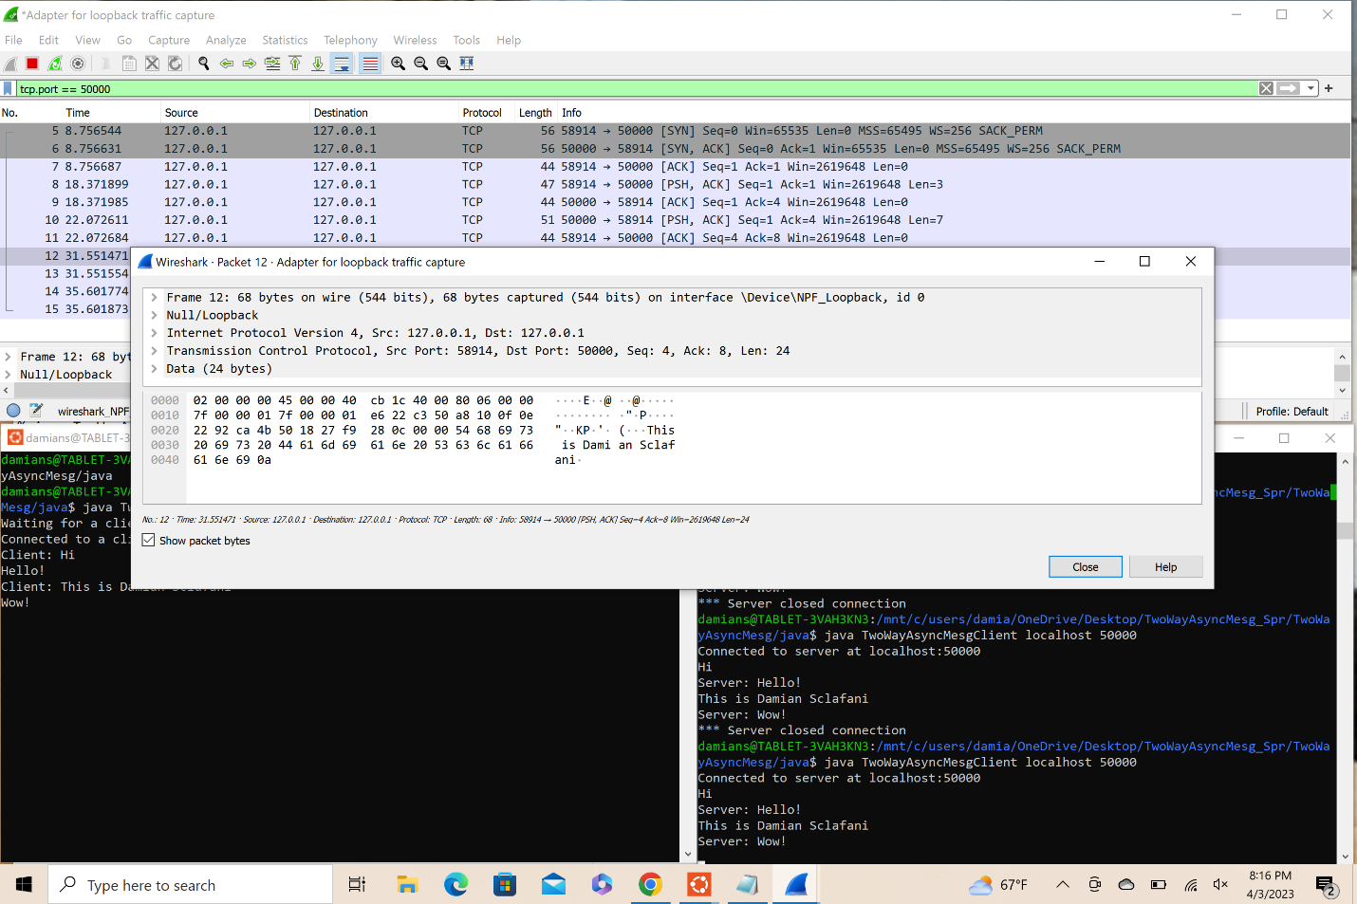

Q3. TCP Sequence numbers don’t always start at 0 because the sequence numbers relate to the characters being used.

Screenshot 4

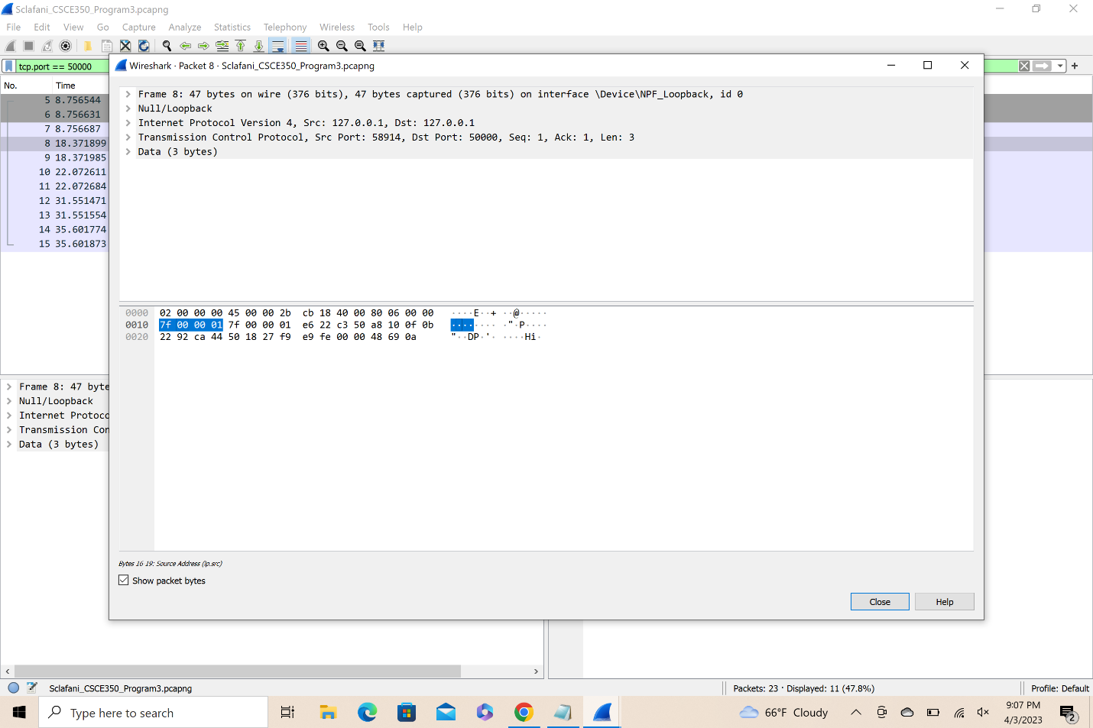

Screenshot 5

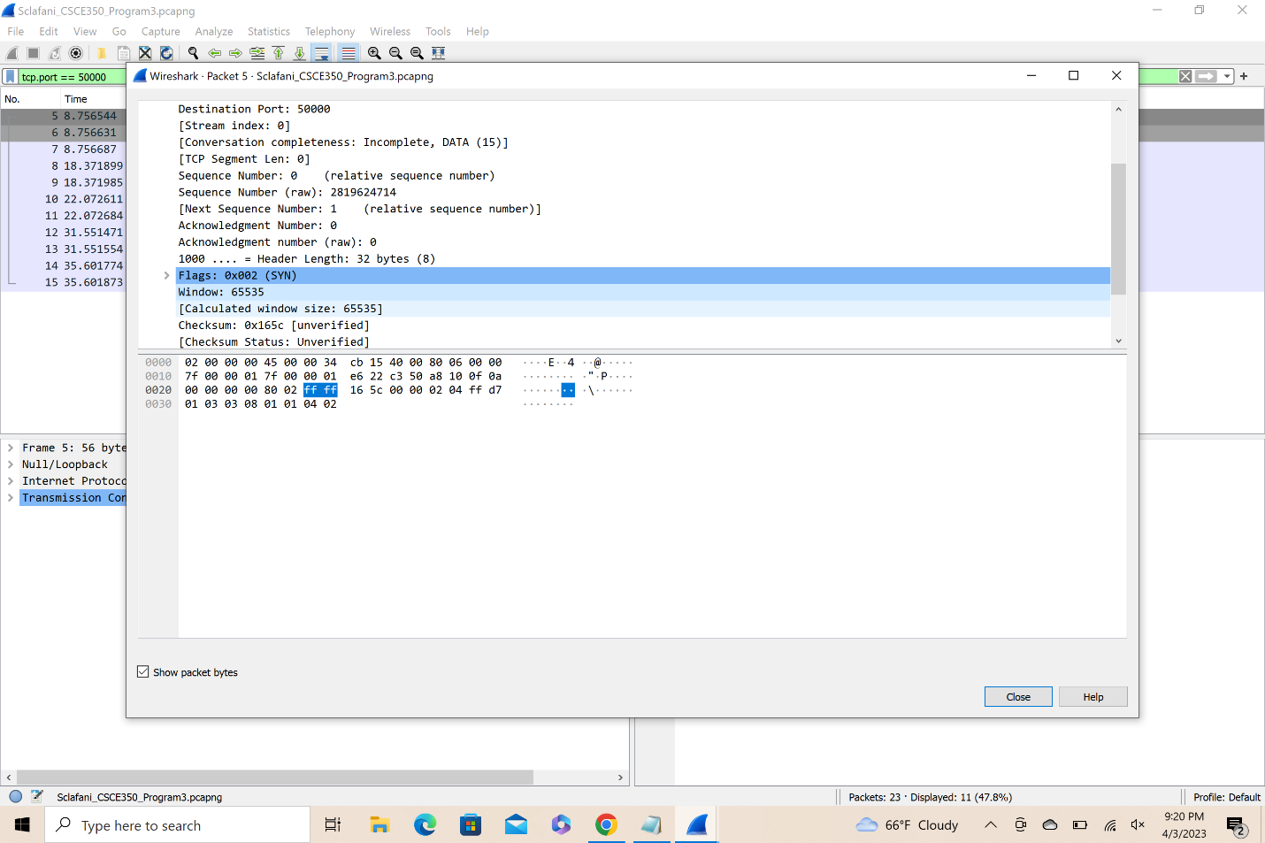

Q4. The Window Scale Factor is for setting the number of bits that the TCP window is to be adjusted. The windows scale extension uses a scale factor to carry out the bits in the window field of the TCP header.