**Architecture**

**System**

All processes are fully connected and each pair is connected with uni-directional links.

According to the Byzantine fault tolerance, the amount of faulty processes is 3f+1.()

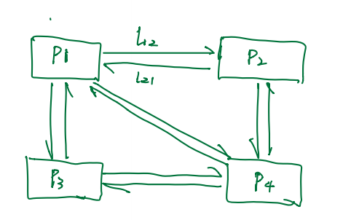

In this figure, if there are four processes in this system, one process could suffer from byzantine failure.

**Time**

A non-byzantine clock sets the count of the round r and the duration of each round is maximum delay donated by d.

In order to reach real-time and reliable, the loss and delay of a message leads to omission.

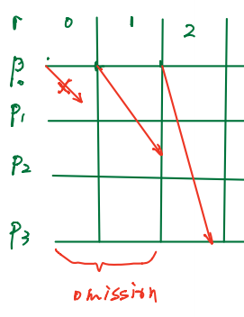

**Functions**

**Aggregates signature**

In this function, a process will verify each process before indeed signed a given message and append its signature on it.

At the beginning, there would be an initialized data set Msg[][] to store the message sent by the first process $p_{i}$ and checked by the last process $p_{k}$

When a message received by process $p_{j}$ matches the value in Msg[][], $p_{j}$ will append a signature on this message and update Msg[][].

When a message received by process $p_{j}$ does not matches the value in Msg[][], $p_{j}$ will first check the pervious process received the message or not and then append a signature on this message and update Msg[][].

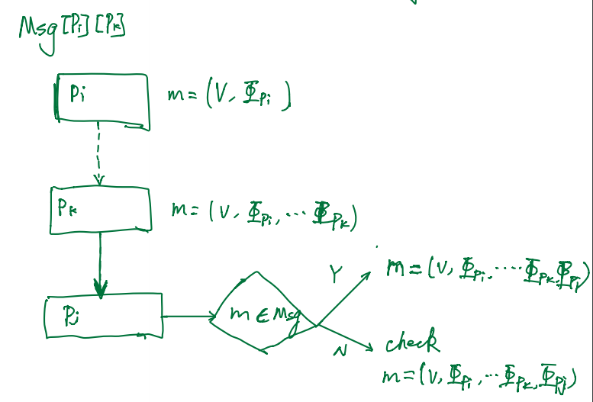

**Proof of life**

A process sends its own heartbeats which contains a value and $p_{i}$’s signature in each round to all other processes.

When process $p_{j}$ receives process $p_{i}$ heartbeat at round r, it will aggregate signatures and appends its own signature, then periodically echoes the heartbeat by sending it to all other processes. If $p_{i}$ failed to receive 2f+1 echoes at the end of the period R, it will crash itself.

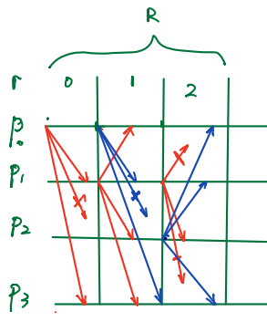

**Broadcast**

All processes are executing proof of life function before a process $p_{i}$ sends a message contains a specialized value v with its signature.

*#When $p_{j}$ receives an echo from $p_{k}$,*

*# If $p_{j}$ is not echoing, If it has echoed $p_{i}$ and the number of signatures >2f, it will it will deliver the broadcast message(check $p_{i}$? Broadcast?) for $p_{i}$. If has not echoed $p_{i}$ and the number of signatures <2f+1, it will echo $p_{i}$.*

When $p_{j}$ receives an echo from $p_{k}$,

If the number of signatures >2f, it will it will deliver the broadcast message(check $p_{i}$? Broadcast?) for $p_{i}$. If the number of signatures <2f+1, it will echo $p_{i}$.

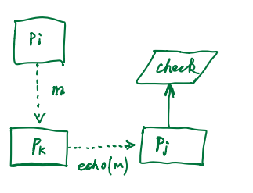

When $p_{j}$ receives the delivered message from $p_{k}$,

it will signature the message and then broadcast.

