**RSA**

Set a list to store the private key (not safe)

Broadcast with public key

## ****ECDSA****

## ****DSA****

Question:

Signature: sign what?

1. Name
2. cMessage-------probably right (need to sign the message and others’ sigs)
3. map<string,string> how to add signatures? One process---one map?

If so, generate maps from the beginning?

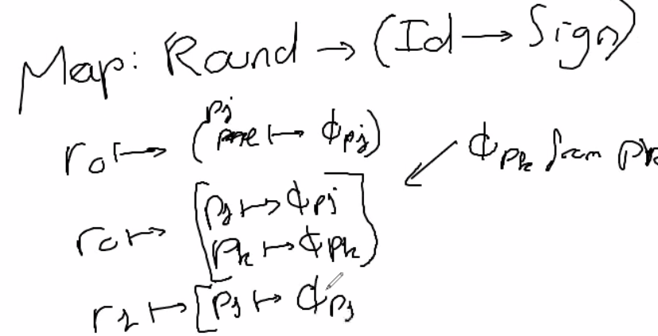

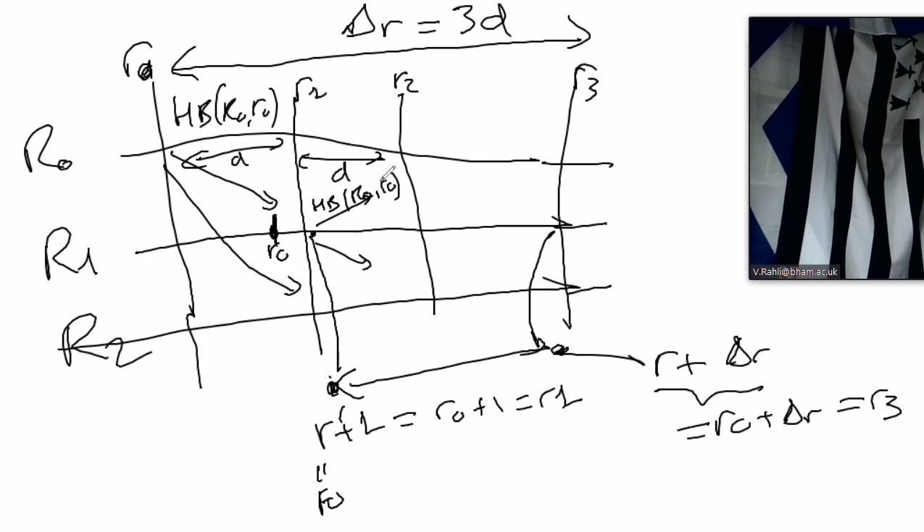

Map in a map

2 periods :

1 sending heartbeats

2 echos