terminate called after throwing an instance of 'omnetpp::cRuntimeError'

what(): Object round over is currently in (omnetpp::cEventHeap)simulation.scheduled-events, it cannot be deleted. If this error occurs inside omnetpp::cEventHeap, it needs to be changed to call drop() before it can delete that object. If this error occurs inside omnetpp::cEventHeap's destructor and round over is a class member, omnetpp::cEventHeap needs to call drop() in the destructor

I had a meeting with Vincent on Thursday last week. Vincent pointed out the problems I overlooked in my function and I realized my progress is slower than planned. I mainly fixed the problems in the function and started writing the architecture part of the report. It is expected to be finished before Thursday.

I am not sure if there are other problems in this function, because I started to know Omnet and C++ in this project and the function is not fully realized. I want to check it while moving on to keep up to the pace.

Literature review

What has been done before similar paper

Achieve validi integrity

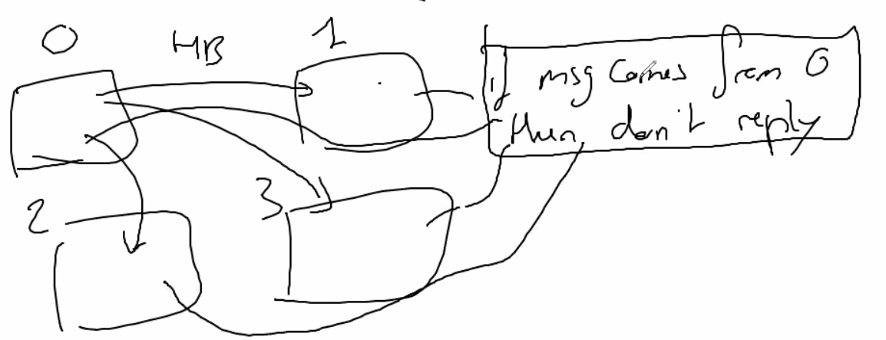

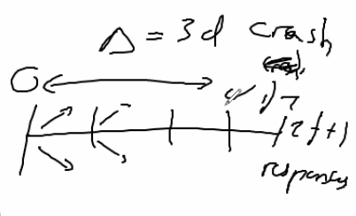

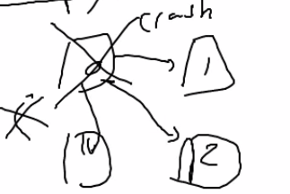

Debug for crash

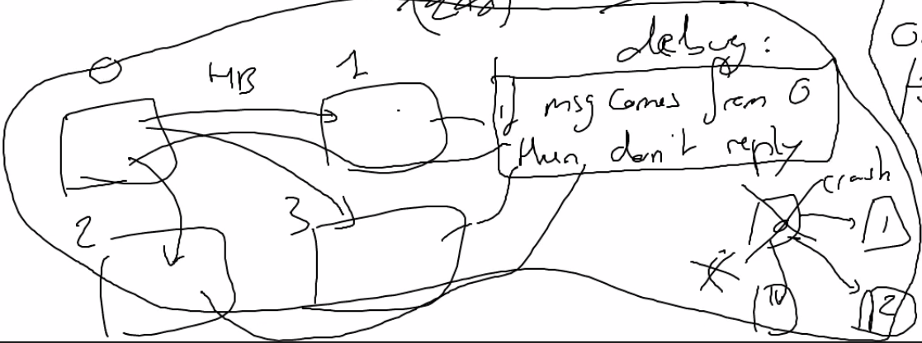

2 watch hbcount

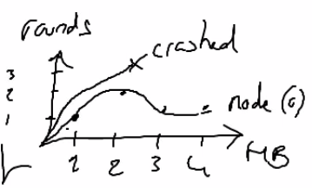

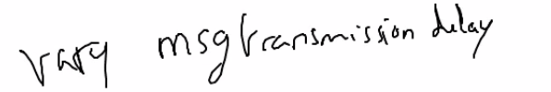 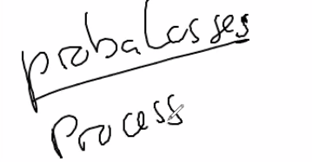model msg bing loss

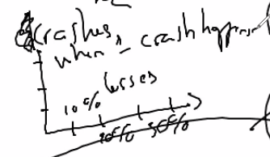

Create diagram

gnuplot